BlockChain Enhanced Brain Tumor Detection

## AUTHOR 1)Uday Deore

Department of Computer engineering

Sandip Institute of Technology and Research Centre,Nashik

## AUTHOR 2)Mrunal Sathe

Department of Computer engineering

Sandip Institute of Technology and Research Centre,Nashik

## AUTHOR 3) Komal Patil

Department of Computer engineering

Sandip Institute of Technology and Research Centre,Nashik

Prof. Pramod Patil , Department of Computer engineering Sitrc,Nashik

***Abstract*—** **Brain tumors can be categorized into two distinct classifications: benign and malignant. Malignant brain tumors, in particular, represent the most prevalent and aggressive diseases within this domain, often leading to significantly reduced life expectancy when reaching an advanced stage. Consequently, the meticulous planning of treatments assumes paramount importance in enhancing the quality of life for affected patients. Nevertheless, certain constraints exist, such as the limited provision of precise quantitative measurements for a restricted number of frames. To address this critical issue, the development of a dependable and automated classification system is imperative in mitigating the mortality associated with these conditions.Blockchain technology has swiftly emerged as a burgeoning field of scientific inquiry, exerting substantial influence across diverse sectors, including education, banking, and healthcare. In the realm of healthcare, numerous health ailments stem from the dual factors of misdiagnosis by healthcare practitioners and a lack of awareness regarding symptoms by patients. Foremost among these contemporary health challenges is the formidable specter of cancer. The manifestation of a brain tumor typically unveils itself through symptoms such as persistent and severe headaches, unexplained bouts of nausea or vomiting, alongside potential indicators like blurred vision, double vision, and, at times, a gradual loss of peripheral vision. In this research endeavor, we propose a groundbreaking approach that leverages blockchain technology for the precise diagnosis and management of brain tumors.**

*Keywords: Security, Reliability, Data Integrity, Block chain, health care, brain tumor.*

**I.**

# Introduction

Brain tumor can be divided into two types: benign and malignant. Brain tumors are the most common and aggressive disease, which in the highest stage leads to a very short life expectancy. Thus, treatment planning is a key phase for improving patients' quality of life. However, it has some limitations (ie, accurate quantitative measurements are provided for a limited number of frames). Therefore, a reliable and automatic classification system is necessary to prevent human mortality. Blockchain technology is an emerging field of science that plays a major role in every application field of science, including education, banking, and healthcare. . In the healthcare industry, most health problems are caused by the doctor's neglect of the correct diagnosis and the patient's ignorance of the symptom. The most common disease today is called cancer. A brain tumor usually has symptoms such as frequent headaches, unexplained nausea or vomiting. Sometimes he may also have blurred vision,double vision and sometimes loss of peripheral vision. In this project we will diagnose tumor using blockchain strategy

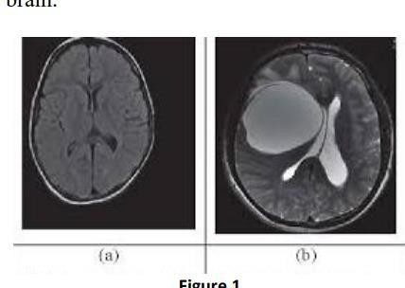

Figure-1: Example of an MRI report showing the presence of tumor in brain with solid white color mass.

# Literature Survey

Author I, Nitin Satpute, proposed a paper titled "Utilizing Blockchain Strategy for Brain Tumor Detection." The realm of medical image processing has witnessed a profusion of diverse and innovative research in recent times. This domain has evolved into a melting pot of expertise, attracting scientists from various disciplines, including computer vision and machine learning. In our quest for the most proficient and cutting-edge techniques, we meticulously scrutinized recent studies. Devkota et al. [1] developed a comprehensive segmentation process, integrating Mathematical Morphological Operations and the spatial Fuzzy C-Means (FCM) technique. This approach effectively reduces computational complexity, although its efficacy has not yet undergone rigorous evaluation. Notably, it achieves a malignancy detection accuracy of 92% and a labeling accuracy of 86.6%. Dr. Chinta Someswararao's research [2] introduces a hybrid Convolutional Neural Network (CNN) classifier model in tandem with machine vision for brain tumor detection from MRI scans. The model exhibits a significantly higher accuracy than the baseline threshold of 50%, albeit further improvements may be achievable through augmented training data and alternative modeling strategies.In another innovative approach, Badran et al. [3] combined an astute edge detection technique with adaptive thresholding to extract the Region of Interest (ROI) from a dataset comprising 102 images. The image preprocessing sequence involved the application of the Canny algorithm for edge detection, followed by adaptive thresholding in subsequent layers of the neural network. This method simplifies the automated and efficient removal of brain tumors. Khurram Shahzad and Imran Siddique [4] revolutionized tumor removal by employing morphological gradients, thresholds, and operations like erosion and dilation. The morphological gradient calculation facilitates the establishment of a threshold, leading to the appearance of tumors and extraneous noise when the image is converted to black and white. The image is then refined through compression and the application of erosion techniques to eliminate noise and insignificant elements. Subsequently, dilation is employed to restore the portions of the tumor that were inadvertently removed during the erosion process.

Authour II) C. Sowmiya and Dr. P. Sumitra have introduced a groundbreaking paper titled "Leveraging Blockchain Strategy for Brain Tumor Detection," aiming to excel in the realm of machine vision-based systems. In a parallel endeavor, Muhammed Talo and colleagues [5] devised the architecture known as AlexNet, a Convolutional Neural Network (CNN) structure. The scarcity of pre-tagged datasets emerges as a primary impediment hindering the advancement of deep learning techniques within the medical sector. To enhance overall accuracy, a data augmentation strategy is employed, effectively expanding the dataset through the incorporation of annotated images from easily accessible sources. Transfer learning models stemming from convolutional neural networks exhibited promising performance, especially when weight sharing facilitated the construction of a sufficiently large network capable of automating malignancy detection or prediction via Computed Tomography data.In a separate study conducted by Ravikumar Guruswamy and Dr. Vijayan Subramaniam [7], MRI image characteristics were meticulously reprocessed and retrieved. This research encompassed the utilization of both real-time and simulated visual data. A rigorous preprocessing regimen was subsequently applied to eliminate unwanted disturbances.

Author III, Aditya Gupta, presents an innovative approach for noise removal, image retrieval, and malignancy identification within MRI images, achieving a notable success rate that fortifies the overall reliability of the system. Joseph et al. [8] employed Lloyd's algorithm (k-means) and Support Vector Machine algorithms for segmentation and pattern maintenance. They established a relationship between Support Vector Machine techniques and skull masking strategies, amalgamating Lloyd's segmentation and Support Vector Machine techniques with skull masking to yield superior results. Furthermore, they innovatively modified the feature extraction approach, departing from the conventional Lloyd's k-means method, to conceal a greater portion of cranial tissue, thereby enhancing the precision of tumor detection scans. This innovative approach opens the door to the identification of tumor type, location, and staging, a frontier yet to be precisely delineated but harboring immense potential.

Author IV, Venkatesh Lotlikar, articulates the principal aim of their research as the segregation of malignant cells from the BRATS 2018 dataset. They leverage a spectrum of variables, encompassing age, contours, and volumetric factors, to prognosticate the overall survival rate of patients. In addition to addressing the intricate task of distinguishing brain cancer types and estimating survival rates, they employ a multifaceted approach, evaluating the accuracy of each method to enable potential enhancements. Notably, their proposed method exhibits a commendable trait, as it utilizes a reduced feature set while achieving superior accuracy when juxtaposed with contemporary state-of-the-art approaches.

Author V, Dr. Manoj S. and Yuvaraju B, venture into a nuanced realm by categorizing mortality prognosis into three distinct categories, predicated on factors such as age and tumor type: short-term, medium-term, and long-term survivors. The domain of brain tumor classification and detection has witnessed a profusion of research papers, with some researchers opting for traditional classifiers and others embracing deep learning techniques. While some endeavors employing traditional methods yield significant outcomes, others may not. However, it is discernible from these findings that deep learning consistently outperforms traditional classifiers, owing to its intricate learning process and the judicious utilization of network memory resources.

# A.Problem Definition:

The principal objective of this endeavor is to establish a predictive model capable of discerning the presence of cancer within MRI images. We successfully crafted and fine-tuned a model adept at tumor detection, thus providing an efficient and potent solution to facilitate the segmentation and identification of brain tumors, obviating the necessity for laborious manual intervention. Upon an exhaustive examination of the results from various tests, a discerning pattern emerged, revealing that specific models exhibited superior performance in terms of accuracy and loss metrics..

# Proposed Methodology:

Within this study, the overarching aim is to enhance performance and mitigate the complexity associated with CT scan images. Brain tumors, traditionally identified through manual expert examination of CT scan images, undergo a preprocessing phase, ultimately yielding precise and accurate results.

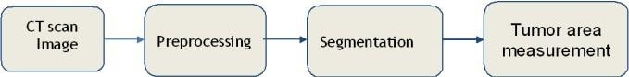

Fig 1. Methodology of Brain Tumor Detection

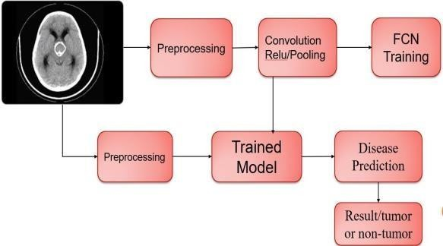

Fig 2Architecture of Brain Tumor Detection system

* ***CT SCAN IMAGE:***

The term "computed tomography," commonly referred to as CT, denotes a computerized X-ray imaging technique characterized by the precise focusing of a narrow X-ray beam onto a patient's body. This beam is swiftly rotated around the subject, generating signals that are subsequently processed by the machine's computer. The result of this intricate process is the creation of cross-sectional images, often referred to as "slices," of the body. These tomographic images encompass a level of detail far surpassing that of conventional X-rays. As the machine accumulates a series of successive slices, the computer digitally amalgamates them, constructing a three-dimensional representation of the patient. This three-dimensional image not only facilitates the easier identification and precise localization of fundamental anatomical structures but also serves as a valuable tool for detecting potential tumors or abnormalities.

* Preprocessing

Once the image has been successfully segmented, the subsequent phase involves post-processing. The pre-processing stage entails a sequence of steps aimed at assessing both the size and type of the tumor. Furthermore, pre-processing may encompass the utilization of various optimization techniques designed to enhance the final outcome.

Preprocessing is consist of three steps:

Gray-level

conversion.Resizing of image. Median filtering.

* Segmentation:

The process of splitting an image into multiple parts is known as segmentation. It creates various sets of pixels within the same image. Segmenting an image makes it easier for us to further analyze and extract meaningful information from it. It is also described as “The process of labeling each pixel in an image such that they share the same characteristics”. The process results in pixels sharing a common property.

* Tumor Area Measurement:

In this study, two CT scans were obtained from each of the 31 patients. Five observers then utilized a computer interface to delineate tumor contours on three specific CT sections from each baseline scan. Additionally, four observers created corresponding follow-up scan tumor contours for the same set of 31 patients. Area measurements extracted from these delineated contours were meticulously compared using a random effects analysis of variance model, thereby evaluating the relative inter-observer variability. Furthermore, the cumulative sums of section area measurements were subject to analysis, as these aggregate area measurements hold greater clinical significance when assessing treatment response.

# Block chain

The diagnosis of brain tumors primarily relies on the analysis of brain tumor images obtained through medical imaging. The accuracy of this analysis is pivotal in determining a patient's condition, making the precise detection of brain tumor images a matter of paramount significance. Brain MRI images are primarily employed to detect tumors and model the progression of such tumors. The information derived from these images serves as a linchpin in the processes of tumor detection and treatment. MRI images offer a more comprehensive view of medical data compared to CT scans or ultrasound images. They furnish intricate details about brain structure and facilitate the detection of anomalies within brain tissue.

Over time, scholars have devised a multitude of automated methods for detecting brain tumors and categorizing their types using brain MRI images. Neural Networks (NN) and Support Vector Machines (SVM) have emerged as the prevailing methods due to their commendable performance in recent years. In light of these advancements, we propose a system that leverages MRI or CT scan images as input and employs Machine Learning techniques in conjunction with Blockchain technology to detect brain tumors in patients. The Convolutional Neural Networks (CNN) algorithm will be instrumental in training our model, while Blockchain technology will assume a pivotal role in facilitating the secure and efficient transfer of data using specific blocks, ushering in a new era of precision and reliability in brain tumor diagnosis.

# Flow Chart of the System

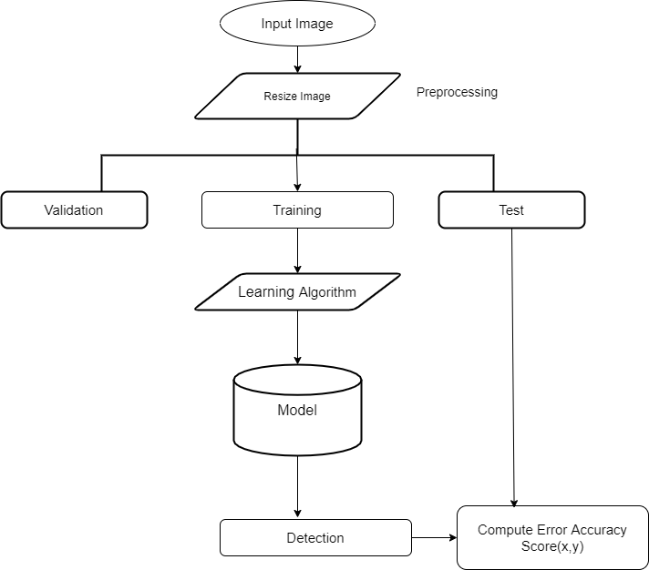

1. **Advantages**

The doctor identify the disease earlier and improve patient outcomes drastically. Today, advanced Medical Imaging offers numerous benefits to both the healthcare providers and the patients. CNN is the best approach for medical image processing to find accurate and quick result. Following some advantages of our system is helpful for:

1. Better Diagnosis
2. Complicated Surgeries
3. Affordable Health Care Costs
4. Safe & effective
5. File-sharing Ecosystem & Data Privacy
   * High Accuracy.
   * Less efficient.

# Applications

* Leaf Disease Detection.
* Medical image processin

# Conclusion

The primary objective of this research endeavor is to devise a highly efficient automatic brain tumor classification system, characterized by exceptional accuracy, performance, and minimal complexity. This project encompasses a comprehensive description of the model employed for brain tumor detection utilizing MRI images from both normal individuals and those afflicted with brain tumors. The practical application of this model in real-time scenarios could prove invaluable, as it has the potential to facilitate timely and cost-effective brain tumor diagnoses. In the event that the model confirms the presence of a brain tumor, the affected individual can expeditiously seek medical attention at the nearest healthcare facility. This streamlined approach holds the promise of significant cost savings for patients.Recognizing the pivotal role of data in the realm of deep learning models, the accuracy of the model hinges on the specificity and precision of the data concerning brain tumor symptoms. More precise and symptom-specific data holds the potential to greatly enhance the model's accuracy, thereby delivering superior results in real-time applications. This approach promises to be a noteworthy step forward, both in terms of medical diagnostics and cost-effective healthcare practices..

|  |  |  |  |  |  |
| --- | --- | --- | --- | --- | --- |
| Algorithm | Accuracy | loss | Epoch | Batch size | Learning Rate |
| CNN | 89% | 11% | 50 | 16 | 0.001 |

*A. Dataset*

1. **Result**

***References***

The Database was gathered from Kaggle, named ‘Brain MRI Images for brain tumor Detection’ By Navoneel Chakrabarty.[6] The dataset comprises 253 Brain MRI Images in the folders yes and no. The folder yes contains 155 timorous brain MRI images, whereas the folder no has 98 non-timorous brain MRI images.

Experiments were conducted on 2065 photos, 1085 of which had malignancies and 980 of which did not. The dataset is further split as: 70% as training, 10% as validation, and 20% as testing; each experiment was conducted for up to 50 epochs with early stopping to control overfitting. On the 32nd epoch, the model had a test accuracy of 89% and a test loss of 0.3033, learning rate is0.001.

1. Nowak R D, Wavelet-based radian noise removal for magnetic resonance imaging. IEEE Trans Image Processing 1999; 8(10):1408- 1419.
2. White D, Houston A, Sampson W, Wilkins G. Intra and inter-operator variations in region-of- interest drawing and their effect on the measurement of glomerular filtration rates 1999; 24:177–81
3. UDUPA, J. K., LEBLANC, V. R., ZHUGE, Y., IMIELINSKA, C., SCHMIDT, H., CURRIE, L. M., “A

framework for evaluating image segmentation algorithms,” Computerized Medical Imaging and Graphics, 30:75-87, 2006.

1. Zhuang AH, Valentino DJ, Toga AW. Skull stripping magnetic resonance brain images using a model-based level set. Neuro Image 2006;32(1):79-92.
2. Angelini E D, Clatz O, Mandonnet E, Konukoglu E, Capelle L, Duffau H. Gli-oma dynamics and computational models: a review of segmentation, registration, and in silico growth algorithms and their clinical applications. Curr. Med. Imaging 2007; 3: 262–

76

1. Rajesh Dass, Priyanka, Swapna Devi, “Image Segmentation Techniques”, IJECT Vol.3, Issue 1, Jan- March 2012.
2. Bauer S, Wiest R, Nolte L, Reyes M. A survey of MRI-based medical image analysis for brain tumor studies. Phys Med Biol.2013;58:97129
3. Gordillo N, Montseny E, Sobrevilla P. State of the art survey on MRI brain tu-mor segmentation.Magn Reson Imaging 2013; 31(8):1426–38
4. Savita Agrawal and Deepak Kumar Xaxa, “Survey on Image Segmentation Techniques and Color Models,” International Journal of Computer Science and Information Technologies (IJCSIT), Vol. 5 (3), 3025-

3030, 2014

[10]D. Kwon et al. Combining generative models for multifocal gioma segmentation and registration. Medical Image Computing and Computer-Assisted Intervention– MICCAI 2014. Springer, 2014:763– 770.

1. Liu J, Wang J, Wu F, Liu T, Pan Y. A survey of MRI-based brain tumor segmentation methods. Tsinghua Science and Technology 2014;19(6):578-595.
2. Urban G. et al. Multi-modal brain tumor segmentation using deep convolution-al neural networks. MICCAI Multimodal Brain Tumor Segmentation Challenge (BraTS) 2014:31–35.
3. Zikic D. et al. Segmentation of brain tumor tissues with convolutional neural networks. MICCAI Multimodal Brain Tumor Segmentation Challenge (BraTS) 2014:36–39.

[14 ]Davy A. et al. Brain tumor segmentation with deep neural networks. MICCAI Multimodal Brain Tumor Segmentation Challenge (BraTS)2014:1–5.

[15] Riddhi.S.Kapse, Dr. S.S. Salankar, Madhuri.Babar “Literature Survey on Detection of Brain Tumor from MRI Images” IOSR Journal of Electronics and Communication Engineering (IOSR-JECE) e-ISSN: 2278- 2834,p- ISSN: 2278-8735.Volume 10, Issue 1,

Ver. II (Jan - Feb. 2015), PP 80-86

[16]A.Sindhu, S.Meera “A Survey on Detecting Brain Tumor in MRI Images Using Image Processing Techniques” International Journal of Innovative Re- search in Computer and Communication Engineering Vol. 3, Issue 1, January 2015

1. Menze B, et al. The Multimodal brain tumor image segmentation benchmark (brats). IEEE Trans Med Imaging 2015; 34(10):1993- 2024.
2. Rao V, Sarabi M S, Jaiswal A. Brain tumor segmentation with deep learning. MICCAI Multimodal

Brain Tumor Segmentation Challenge (BraTS) 2015:56– 59.

1. Anitha and S. Murugavalli, “Brain tumor classification using twotier classifier with adaptive segmentation technique,” IET Computer Vision, 2016, vol. 10(1), pp. 9-17.
2. Havaei M, Davy A, Farley W D, Biard A, Courville A, Bengio Y, Pal C, Jodoin PM, Larochelle H. Brain tumor segmentation with deep neural net-works. Medical Image Analysis 2016, DOI:10.1016/j.media.2016.05.004.