AN ARTIFICIAL NEURAL NETWORK APPROACH FOR BRAIN EMULATION - ANALYSIS OF THE BLUE BRAIN PROJECT
Rekha Kulkarni
Asst. Professor, Department of ECE, KEC Kuppam
rekhakulkarni2022@gmail.com

Abstract – A human being is called intelligent because of the brain. The knowledge of a human brain is retained till the existence of the human being’s life; but few brains of extraordinary humans may be required to be used for the development of the human society. Hence, there is a need to emulate the human brain and develop a virtual brain using a supercomputer for the sole purpose of preserving the intelligence, knowledge, memory and skill of a person forever. A virtual brain is a machine that can function as a human brain - it can take decisions, it can think, it can respond, and also it can keep things in memory. Neural network theory revolves around the idea that certain key properties of biological neurons can be extracted and applied to simulations, thus creating a simulated brain. An Artificial Neural Network approach is used to simulate and construct sizeable networks of artificial neurons with the ultimate goal to emulate the biological neurons in the entire human brain. This paper analyses one such brain emulation project called the “BLUE BRAIN”- the name of the world’s first virtual brain.

Keywords – Neuron, Synapse, Neocortical Column, Cortical microcircuit, Nanobots, Blue Gene

INTRODUCTION

The brain essentially serves as the body’s information processing centre. The brain consists of about 10¹⁰ basic units, called neurons; each is connected to about 10⁴ others. The brain receives signals from sensory neurons in the central and peripheral nervous systems, and in response it generates and sends new signals that instruct the corresponding parts of the body to move or react in some way. It also integrates signals received from the body with signals from adjacent areas of the brain, giving rise to perception and consciousness. There are three functions that the human brain puts into action: sensory input, integration, motor output.

  - Sensory Input: Receiving input such as sound, image, etc through sensory cells.
  - Interpretation: Interpretation of the received input by the brain by defining states of neurons in the brain.
  - Motor Output: Receiving of electric responses from the brain to perform any action.
In the human brain, a typical neuron collects signals from others through a host of fine structures called dendrites. The neuron sends out spikes of electrical activity through a long, thin stand known as an axon, which splits into thousands of branches. At the end of each branch, a structure called a synapse converts the activity from the axon into electrical effects that inhibit/ excite activity from the axon into electrical effects that inhibit/excite activity in the connected neurons. When a neuron receives excitatory input that is sufficiently large compared with its inhibitory input, it sends a spike of electrical activity down its axon. Learning occurs by changing the effectiveness of the synapses so that the influence of one neuron on another changes.
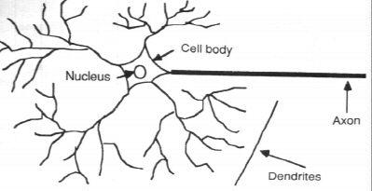

Fig 1: Components of a Neuron

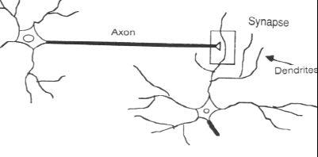

Fig 2: The Synapse

An artificial neural network (ANN) is an interconnected group of processing elements called artificial neurons that uses a mathematical or computational model for information processing. The inspiration for an ANN came from biological neural network - the brain. In an ANN, simple artificial nodes, called "neurons", "neurodes", "processing elements" or "units", are connected together to form a network of nodes, which mimics the vast network of neurons in the living brain.
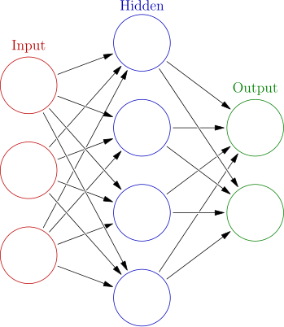

Fig 3: An Artificial Neural Network

An ANN learns by example–a neural network is an adaptive system that changes its structure during a learning phase. ANNs are used to model complex relationships between inputs and outputs or to find patterns in data. Learning in ANNs involves adjustments to the synaptic connections that exist between the neurons. The components of an artificial neural network are an attempt to recreate the computing potential of the human brain. Essential elements of neural network connectivity are:

- Connection strengths - It tells how strongly one neuron influences those
neurons connected to it. They are the real information holders in the brain.

- Excitation/Inhibition distinction - In human brains, each neuron is either excitatory or inhibitory, that is, its activation will either increase the firing rates of connected neurons, or decrease the rate, respectively. The amount of excitation or inhibition produced is dependent on the connection strength - a stronger connection means more inhibition or excitation, a weaker connection means less.

- Transfer Function- This component is used for determining a neuron's response. The transfer function describes how a neuron's firing rate varies with the input it receives. A very sensitive neuron may fire with very little input, for example. A neuron may have a threshold, and fire rarely below threshold, and vigorously above it.

Using these three concepts, artificial neural networks are constructed. An artificial neuron captures all the important elements of a biological one. Nodes are connected to each other and the strength of that connection is normally given a numeric value between -1.0 for maximum inhibition, to +1.0 for maximum excitation. The transfer function in artificial neurons whether in a computer simulation, or actual microchips wired together is typically built right into the nodes' design.

TRANSITION FROM LIVING BRAIN TO VIRTUAL BRAIN

The human brain is very difficult to study, both from a technical perspective, and a moral one. A virtual model, however, makes direct observations possible. Researchers hope to gain a better understanding of how the brain works (and malfunctions) by creating simulations. A model can provide insight at all levels, from the biochemistry and neurochemical behavior of individual cells to the behavior of networks of neurons in the cortex and other parts of the brain.

2.1. Natural (Living) Brain vs. Simulated (Virtual) Brain

A comparative discussion of Natural Brain and Simulated Brain is given below.

2.2 Motivation for Brain Emulation

By creating a computer simulation of an entire human brain, the aim is to discover profound insights into what makes us human to develop new treatments for brain diseases and build revolutionary new computing technologies.
Broad motivations behind the Brain Emulation are:


To retain the intelligence, knowledge and skill of a person forever.
Natural Brain | Simulated Brain
Input  The neurons in the nervous system receive the input by sensory cells and these cells produce electric impulses. The neurons transfer these electric impulses to the brain. | Input  Artificial neurons are created with the silicon chip. The electric impulses produced from sensory cells are received by artificial neurons and send to a supercomputer for the interpretation.
Interpretation  The interpretation in the brain is accomplished using different states of neurons. | Interpretation  The interpretation of the electric impulses received by the artificial neuron can be done by means of a set of registers. The different values in these registers will represent  different states of the brain.
Output  Based on the states of the neurons, the brain sends the electric impulses representing the responses which are further received by the sensory cells of our body to respond. | Output  Similarly based on the states of the registers, the output signal can be given to the artificial neurons which will be received by the sensory cells.
Memory  There are certain neurons in our brain which represent certain states permanently. When required theses states are interpreted by our brain and we can remember the past things. | Memory  The required states of the registers can be stored permanently, and when required these information can be retrieved and used.
Processing  Logical and arithmetic calculations are done in our neural circuitry. The past experience stored and the current inputs received are used and the states of certain neurons are changed to give the output. | Processing  The decision making can be done by the computer by using some stored states and the received input by performing some arithmetic and logical calculations.

Treatment for Brain diseases like Parkinson's disease, Autism and Alzheimer’s disease.
To facilitate the deaf to hear via direct nerve stimulation.
Scientific curiosity about consciousness and the human mind.
Progress towards building thinking machines.

THE BLUE BRAIN PROJECT

One of the greatest challenges in neuroscience is to identify the map of synaptic connections between neurons, called the "connectome," that will explain how information flows in the brain. The Blue Brain Project is an attempt to create a synthetic brain by reverse-engineering the mammalian brain (Human or any living entity’s brain) down to the molecular level in order to explore how it functions and to serve as a tool for neuroscientists and medical researchers. The project was founded in May 2005 by the Brain and Mind Institute of the Ecole Polytechnique Federal De Lausanne’s (EPFL), Switzerland in collaboration with IBM, and is headed by the Institute's director, Henry Markram. The aim of the project is to create a biologically accurate, functional model of the brain using IBM's Blue Gene supercomputer. Hence, the project is named "Blue Brain". The simulation software is based on Michael Hines's NEURON, together with other custom-built components.

Objectives of the Blue Brain Project

The objectives of this ambitious initiative are to simulate the brains of mammals with a high

level of biological accuracy and, ultimately, to study the steps involved in the emergence of biological intelligence. The Blue Brain Project is mainly an attempt to create a physiological simulation of a mammalian brain for biomedical applications, and then to enhance the same principles on a human brain. Goals of the project are to provide the scientific community with a simulation tool:

 To gain a complete understanding of the brain for developing basic and clinical research into its structure and function.
To enable better and faster development of brain disease treatments.
To be able to understand and reproduce human consciousness.

How the Blue Brain Project works?

The research involves studying data about the geometrical and electrical properties of different neuron types, obtained from experimentation on slices of living brain tissue using microscopes and patch clamp electrodes. The project identifies key principles that determine synapse- scale connectivity by virtually reconstructing a cortical microcircuit. These principles make it possible to predict the locations of synapses or neural connections in the cerebral cortex. Each neuron in the circuit is reconstructed into a 3D model on a powerful Blue Gene supercomputer. About 10,000 of virtual neurons are packed into a 3D space in random positions according to the density and ratio of morphological types found in the corresponding living tissue. The researchers will then compare the model back to an equivalent brain circuit from a real mammalian brain.

Uploading Human Brain

The blue brain project is an attempt to create a virtual brain that is a physiological simulation of the human brain. For this, the human brain needs to be uploaded using very small robots known as the nanobots or nanoids. Nanobots are incredibly tiny robots, down at a microscopic scale. The name comes from a combination of the nanometer (the scale the
devices are built at) and a robot. These devices are equipped with a variety of sensors and stimulators and communicate wirelessly with computers outside of the body. These robots are small enough to travel throughout our circulatory system. Nanobots are introduced into the human brain noninvasively through the capillaries. Traveling into the spine and brain, they will be able to monitor the activity and structure of our central nervous system. Nanobots carefully scan the structure of our brain, providing a complete readout of the connections between each neuron, and also record the current state of the brain. This information, when entered into a computer, could then continue to function as a human brain. Thus the data stored in the entire brain will be uploaded into the computer. Brain- penetrating nanobots have the ability to provide virtual-reality environments from within the nervous system.
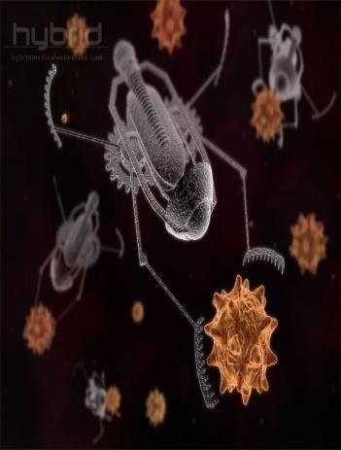

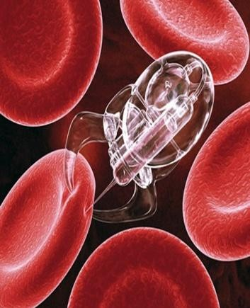

Fig 4: Images of Nanobots
Creation of a virtual brain

There are three main steps required for building a virtual brain:


Data Acquisition Simulation Visualization of Results.

Data Acquisition

Data acquisition involves taking brain slices (i.e. synapses or neural circuits), placing them under a microscope, and measuring the shape and electrical activity of individual neurons. The neurons are typed by morphology (i.e. their shape), electrophysiological behavior, location within the cortex, and their population density. These observations are translated into mathematical algorithms that describe the form, function, and positioning of neurons. The algorithms are then used to generate biologically-realistic virtual neurons ready for simulation.

Simulation and Simulation Workflow

The primary software used by the Blue Brain Project for neural simulations is a package called NEURON, a simulation environment for modeling individual neurons and networks of neurons. The simulation process involves synthesizing virtual cells using simulation algorithms. The algorithms and parameters are adjusted for the age, species, and disease stage of the brain being simulated. All the processors of the Blue Gene supercomputer are pressed into service, in a massively parallel computation solving the complex mathematical equations that govern the electrical activity in each neuron when a stimulus is applied. As the electrical impulse travels from neuron to neuron, the results are communicated via inter-processor communication. The simulation workflow is as follows:
 First a network skeleton is built from all the different kinds of synthesized neurons.
 Then the cells are connected together according to the rules that have been found experimentally.
Finally the neurons are functionalized and the simulation brought to life.

Visualization of Results

The patterns of emergent behavior are viewed with visualization software. RTNeuron is the primary software used for visualization of neural simulations. This allows researchers to watch as activation potentials propagate through a neuron and between neurons. The animations can be stopped, started and zoomed, thus letting researchers interact with the model. The visualizations are multi-scale that is they can render individual neurons or a whole cortical column.
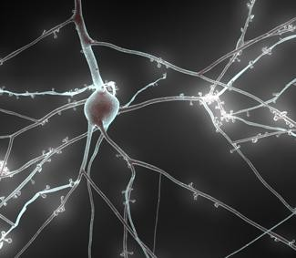

Fig 5: RTNeuron- Visualization of a Neuron

Hardware and Software Requirements

The motivation to model the entire human brain in all its intelligent, emotional complexity is supported by supercomputers of hitherto unseen power, and also by highly efficient and robust simulation software. The main hardware and software requirement specifications for implementing this project are discussed below.

Blue Gene Supercomputer

The primary machine used by the Blue Brain Project is a Blue Gene supercomputer built by IBM. This is where the name "Blue Brain" originates from. IBM agreed in June 2005 to supply EPFL with a Blue Gene/L as a

"technology demonstrator". In June 2010 this machine was upgraded to a Blue Gene/P. It is a supercomputer of hitherto unseen power, having memory with a very large storing capacity, and a very high power processor.
4 racks, one row, wired as a 16x16x16 3D torus
1 PB of disk space, GPFS parallel file system
Operating system: Linux SuSE SLES 10

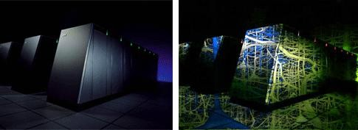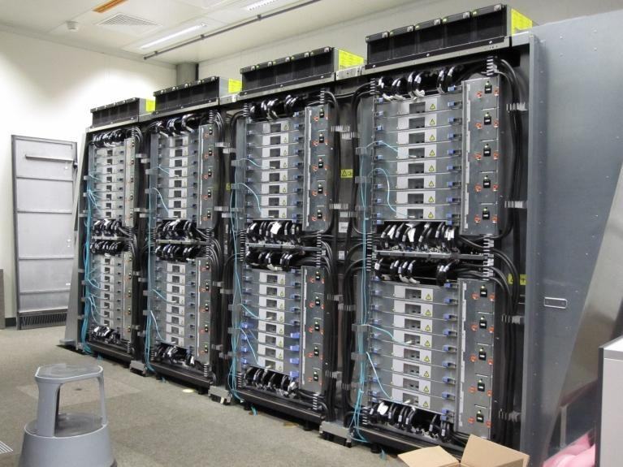

Fig 6: The EPFL Blue Gene supercomputer
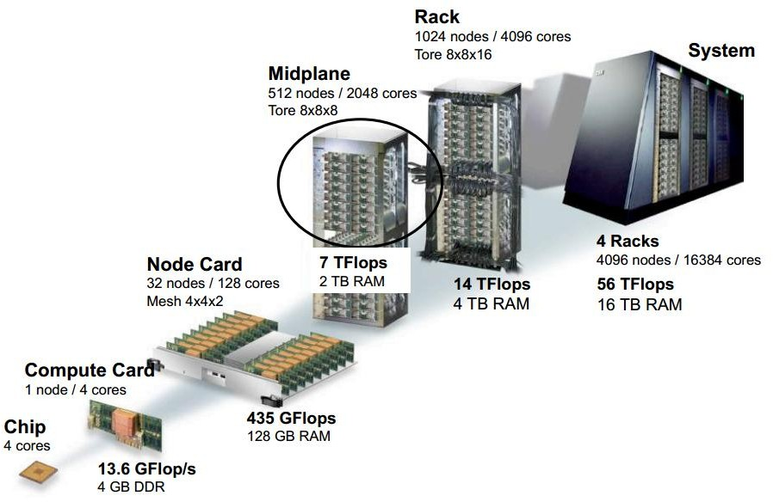
Fig 7: Architecture of the Blue Gene/P Supercomputer

Blue Gene/P technical specifications:

4,096 quad-core nodes (16,384 cores in total)
Each core is a PowerPC 450, 850 MHz Total: 56 teraflops, 16 terabytes of memory

Fig 8: The Blue Gene/P Cabinet

Silicon Graphics

A 32-processor Silicon Graphics Inc. (SGI) system with 300 GB of shared memory is used for visualization of results.

Nanobots

Very powerful Nanobots act as the interface between the natural brain and the computer. Nanobots are typically devices ranging in size from 0.1-10 micrometers and constructed of nanoscale or molecular components.

NEURON Software

NEURON is a program to convert the electric impulses from the brain to input signal, which is to be received by the computer, and vice versa. It was developed by Michael Hines at Yale University and John Moore at Duke University. It is written in C, C++, and FORTRAN. It is free and open source software, currently available in version7.2. The BBP-SDK (Blue Brain Project - Software Development Kit) is a set of classes that allows researchers to utilize and inspect models and simulations. The SDK is a C++ library wrapped in Java and Python.

RTNeuron Software

RTNeuron is the primary software used by the Blue Brain Project team to visualize, navigate and interact with cortical neuron circuit models and corresponding simulation results. The software was developed internally by the Blue Brain Project team. It is written in C++ and OpenGL. Detailed and statistically varying shapes of the neurons are used to layout a cortical circuit and establish synapses, the connections between neurons. Eventually, the simulation is run in a super computer and different variables, such as membrane voltage and currents, spike times are reported. The outcome of these simulations is analyzed in several ways, including direct visualization of the simulator output.

APPLICATIONS OF THE BLUE BRAIN PROJECT

Cracking the Neural Code and understanding Neocortical Information Processing

The Neural Code refers to how the brain builds objects using electrical patterns. In the same way that the neuron is the elementary cell for computing in the brain, the neocortical column (NCC) is the elementary network for computing in the neocortex. The neocortical column is the basic functional unit of the brain. Iterations between simulations and experiments are essential to build an accurate copy of the NCC, which helps us to reveal how the neocortex processes, stores and retrieves information. These iterations are, therefore, expected to reveal the function of individual elements (neurons, synapses, ion channels, and receptors), pathways (mono-synaptic, disynaptic, multisynaptic loops) and physiological processes (functional properties, learning, reward, and goal-oriented behavior).

A Novel Tool for Drug Discovery for Brain Disorders

Understanding the functions of different elements and pathways of the NCC will provide a concrete foundation to explore the cellular and
synaptic bases of a wide spectrum of neurological and psychiatric diseases, such as autism, depression, Parkinson's, and Alzheimer's. It will give us new ways of testing drugs and understanding the way they work. It will provide a test platform for new drugs that directly target the causes of disease and that have fewer side effects than current treatments. It will allow us to design prosthetic devices to help people with disabilities.

A Brain Simulation Facility

A software replica of a NCC will allow researchers to explore hypotheses of brain function and dysfunction, thus, accelerating research. Simulation runs could determine which parameters should be used and measured in the experiments. An advanced 2D, 3D and 3D immersive visualization system will allow imaging of many aspects of neural dynamics during processing, storage and retrieval of information. Such imaging experiments may be impossible in reality or may be prohibitively expensive to perform.

A Foundation for Whole Brain Simulations

An accurate replica of an NCC is required in order to generate models that retain the brain’s critical functions and computational capabilities, which can be duplicated and interconnected to form neocortical brain regions. Knowledge of the NCC architecture can be transferred to facilitate reconstruction of sub-cortical brain regions.

A Foundation for Molecular Modeling of Brain Function

An accurate cellular replica of the NCC will provide the first and essential step to a gradual increase in model complexity moving towards a molecular level description of the neocortex with biochemical pathways being simulated. A molecular level model of the NCC will provide the substrate for interfacing gene expression with the network structure and function. The NCC lies at the interface between the genes and complex cognitive functions. Establishing this
link will allow predictions of the cognitive consequences of genetic disorders and allow reverse engineering of cognitive deficits to determine the genetic and molecular causes. This level of simulation will become a reality with the most advanced phase of Blue Gene development.

EVALUATION OF BLUE BRAIN PROJECT

The Blue Brain Project integrates knowledge from all the specialized branches of neuroscience, to derive from it the fundamental principles that govern brain structure and function, and ultimately, to reconstruct the brains of different species - including the human brain. The Project timeline for the progress of the Blue Brain Project is:

2002 | Henry Markram founds the Brain Mind Institute (BMI) at EPFL.
2005 | 6th June - EPFL and IBM agree to launch Blue Brain Project. IBM installs Blue Gene/L supercomputer with enormous computing power. Basic simulation of single neurons achieved.
2006 | In February, the project takes shape and Henry Markram publishes an article about the Blue Brain project in Nature Reviews Neuroscience. A model of the basic functional unit of the brain, the neocortical column is created using a simplified neuronal model. In December, an auto-generated cortical column is completed. It is a biologically valid model, from a neuronal standpoint.
2007 | On November 26, the end of the first phase - the modeling and simulation of the first mammalian cortical column, is announced.
2008 | Electro physical, anatomical and genetic laboratory experiments are used to test the data-driven auto-generation process for neurons. The research on determining position and size of functional cortical columns is carried out.

2009 | June - BlueGene/L replaced by BlueGene/P, doubling of processors Simulations of cortical construction  continue
2010 | In December, with a large group of partners, the Blue Brain Project applies to the European Commission (Seventh Framework Programme - FP7) for financing a larger project that aims to continue the work and simulate an entire brain, specifically a human brain.
2011 | In May the work on the Human Brain Project (HBP) preparatory study starts, together with many other European partners. Throughout the year, the Blue Brain Project publishes several high impact papers on the application of the previously developed methods for the generation of cell models as well as on virtual brain tissue models.
2012 | In April, the preparatory study for the  Human Brain Project is concluded and a publically available report is published.

FUTURE ENHANCEMENTS

In future, the Blue Brain Project could be used to study the effect of new pharmaceutical compounds on virtual brains of any species, irrespective of their age, and stage of brain diseases. The project aims to provide a centrally coordinated resource for the neuroscientists all over the world by building a bigger, better platform for them to experiment on. The project is becoming a brain simulation facility that will be accessible to all. It is expected to achieve high performance computing through remote interactive simulation, visualization and analytics on supercomputers. The Brain Simulation Platform will extend the scope of simulation to multiple levels of biological organization such as effects on cell morphology, synaptic transmission, the electrical dynamics of neuronal microcircuits, effects on the
functionality of brain systems, thus, making it possible to map the brain’s critical vulnerabilities.
The Blue Brain Project timeline for future enhancements is given below.

2013 | The Blue Brain Project becomes a National Research Infrastructure funded by the ETH Board. Decision expected on Human Brain Project funding of €1 billion over 10 years from the European Union. Simulations using NEURON software are to be ported to the Blue Gene/Q system at the Jülich Research Center in Germany.
2014 | Cellular-level simulation of the entire mammalian brain neocortex, ~100 mesocircuits to take place. NEURON simulation software to be ported to the DEEP (Dynamical Exascale Entry Platform), an exascale supercomputer to be built at the Jülich Research Center in Germany. It is a prototype supercomputer that will perform at 100 petaflops and is hoped to be built by the end of 2014. The DEEP prototype will help test the  system's performance.
2020 | Exascale simulations start on the DEEP Cluster-Booster production system in Jülich
2023 | If successful, a future exascale version of the DEEP machine could provide the 1 exaflops of performance required for a complete cellular-level simulation of the  entire human brain.

CONCLUSION

The Blue Brain Project is not an attempt to create a brain. This is a visionary project grounded in experimental analysis and computational synthesis of neural properties and connectivity at the scale of a cortical column, in which a neural network is generated from stored data and simulations run to investigate systematically the performance of the network. The Blue Brain will provide a huge leap in our understanding of the brain’s function and dysfunction and help us understand the root
causes of intractable problems in mental health and neurological diseases and hence, could provide a new foundation for a new generation of information-based, customized medicines. The project will also throw new light on frequently asked questions - What does it mean to perceive, to think, to remember, to learn, to know, to decide? What does it mean to be conscious? In summary, the Blue Brain Project has the potential to revolutionize technology, medicine, neuroscience, and society.

REFERENCES

- Henry Markram, “The Blue Brain Project”, Nature Reviews Neuroscience, Volume 7, February 2006.

- The Blue Brain Project, http://bluebrainproject.epfl.ch

- Blue Gene http://www.research.ibm.com/bluegene

- Artificial Brains – The quest to build sentient machines http://www.artificialbrains.com/blue-brain- project

- Brain Emulation Challenges, http://synapticlink.org/Brain%20Emulation%20 Challenges.pdf

- Eurographics Symposium on Parallel Graphics and Visualization (2012)
H. Childs and T. Kuhlen

- R. Beale & T. Jackson: Neural Computing, an Introduction. Adam Hilger Ed., Bristol,
Philadelphia and New York, 1990

- Science Daily http://www.sciencedaily.com/releases/2012/09/1 20917152043.htm

- Scientific American http://www.scientificamerican.com/article.cfm? id=bluebrain-documentary-premiere

- HBP- The Human Brain Project http://www.humanbrainproject.eu/introduction. html

