**ONLINE VOTING USING ENHANCED SECURITY SYSTEM**

Ms.M.Buvana(AP/IT)

Boopathi.K,Hemalatha.J,Magibalan.S

BACHELOR OF TECHNOLOGY - SECOND YEAR

DEPARTMENT OF INFORMATION TECHNOLOGY

SRI SHAKTHI INSTITUTE OF ENGINEERING AND TECHNOLOGY

(AUTONOMOUS)

COIMBATORE-641062

**ABSTRACT:**

This abstract introduces an Online Voting System developed using the CodeIgniter framework, aimed at providing a reliable and user-friendly platform for conducting elections in a digital environment .The rapid evolution of technology has paved the way for advancements in various domains, including the electoral process. The traditional methods of voting are being reconsidered, and there is a growing interest in exploring secure and efficient alternatives.

**CHAPTER 1**

**INTRODUCTION**

**1.1.Overview**

The primary objective of this Online Voting System is to address the challenges associated with conventional voting methods, such as long queues, geographical constraints, and manual counting errors and the people who were working in the foreign countries (Non residential Indians) can’t able to vote because of some kind of situations. By employing CodeIgniter, the development team aims to harness the framework's capabilities to streamline the voting process, enhance the security of ballots, and provide real-time visibility into election results. This introduction sets the stage for a detailed exploration of the key components, features, and advantages that the Online Voting System, developed using CodeIgniter, brings to the forefront of democratic practices.

**CHAPTER 2**

**LITERATURE SURVEY**

**2.1.DIGITIZATION OF VOTING PROCESSES.**

The digitalization of the voting process represents a transformative shift in the way societies engage in democratic practices. Embracing technological advancements, this evolution aims to enhance the accessibility, efficiency, and transparency of elections. By introducing online voting systems, individuals gain the flexibility to cast their ballots securely from the convenience of their homes, potentially increasing voter turnout. The shift towards digital platforms also holds the promise of faster and more accurate results tabulation, minimizing the margin for error inherent in manual counting.

**2.2. VOTING MANAGEMENT SYSTEMS.**

A Voting Management System is a comprehensive and technologically-driven platform designed to streamline and enhance the entire electoral process. This system plays a pivotal role in managing various aspects of elections, from voter registration and candidate nomination to result tabulation. Leveraging advanced software solutions, it facilitates efficient voter database management, ensuring accurate and up-to-date information. The system also provides a user-friendly interface for both administrators and voters, offering features such as secure authentication, candidate registration, and real-time result tracking.

**2.3 VIRTUAL VOTING AND REMOTE VERIFICATION**

Virtual voting, coupled with remote verification, represents a paradigm shift in the electoral landscape, offering an innovative approach to exercising democratic rights. Virtual voting allows individuals to cast their ballots using online platforms, eliminating the need for physical presence at polling stations. This method introduces convenience and flexibility for voters, especially those facing geographical or logistical constraints. Simultaneously, remote verification employs secure authentication processes to ensure the legitimacy of voters participating from various locations.

**2.4. LEGAL TECH AND DATA SECURITY.**

Legal tech and data security play pivotal roles in shaping the landscape of online voting systems. In the realm of legal technology, advancements are crucial for developing robust frameworks that adhere to electoral laws and regulations, ensuring the integrity of the voting process. Simultaneously, data security is paramount in the context of online voting, where sensitive voter information and election results are transmitted electronically. Implementing state-of-the-art encryption, secure authentication methods, and robust firewalls are essential measures to safeguard against potential cyber threats and unauthorized access.

**CHAPTER 3**

**SYSTEM MODULES**

**3.1.SYSTEM ARCHITECTURE AND TECHNOLOGIES:**

A well-organized system architecture that combines multiple technologies to provide smooth user experiences forms the foundation of a voting system. the front-end design process using HTML, CSS, JS, and Bootstrap to produce a user-friendly and responsive interface. PHP servers are used to link the frontend to the database, while MySQL is used to maintain the database on the backend. APIs make it possible for components to be integrated seamlessly. ensuring smooth data transfer between the front end and the back end.

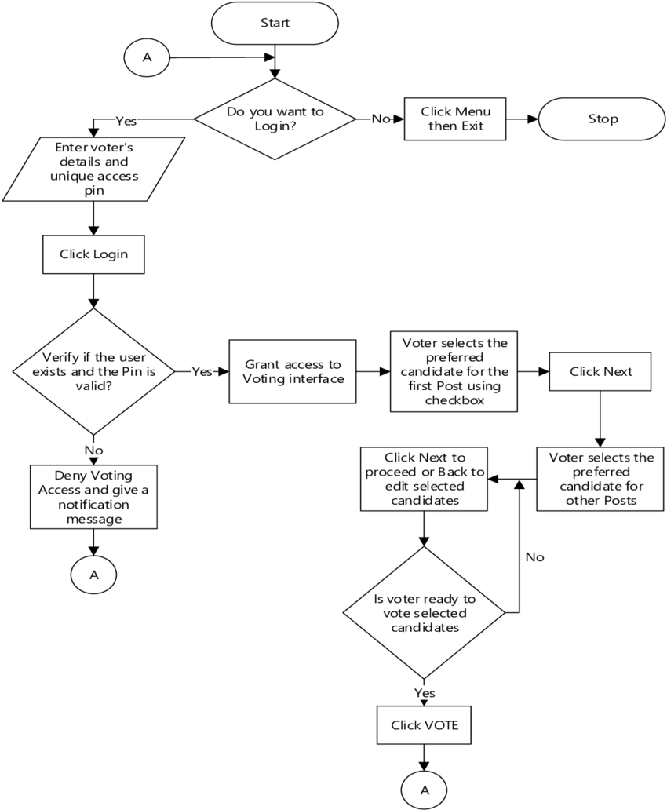

**3.2. Admin Authentication and Interface**

The admin authentication page and interface are crucial components that ensure secure access to and control over the administration tasks of a voting management system. Authorized administrators can access this component by going to the login page and entering their unique credentials, which are often a username and password, to begin the authentication process. A verification procedure compares the accuracy of the information supplied with stored data to ensure that only authorized users can use the system. Furthermore, different administrators could be given varying privileges and responsibilities based on differing degrees of authority. Ensuring vital tasks can only be performed by

An additional advantage of this security precaution is that it assigns competent persons to roles within the online voting administration system, safeguarding sensitive data related to voter details as well as candidate and voter information.

**3.3.Dashboard:**

Our online voting system's dashboard acts as the core hub, giving consumers a clear and thorough picture of the whole voting procedure. Voters are welcomed with an aesthetically pleasing and intuitive interface upon logging in, which presents pertinent data including forthcoming elections, candidate biographies, and voting instructions. The dashboard ensures accountability and transparency in the electoral process by providing real-time updates on voter turnout. Voters can access their individualized ballots, cast secure ballots, and traverse the system with ease. The dashboard also has features that promote trust and confidence in the integrity of the online voting system, such as election results and voter verification status.The dashboard makes voting more accessible and effective for all participants with its user-friendly design and strong functionality.

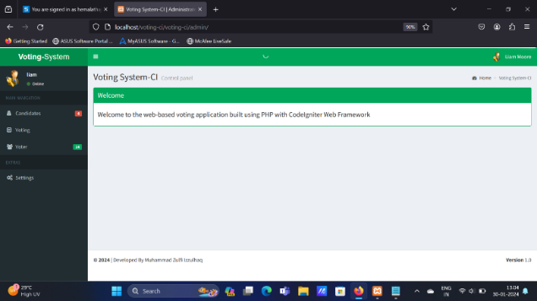

**3.4.Database for online voting system:**

Maintaining our database is essential to making sure our online voting system runs smoothly and securely. Our committed staff takes proactive steps on a regular basis to maintain the database's dependability and integrity. To ensure the system's resilience against potential problems and prevent data corruption, scheduled maintenance procedures include index rebuilding, optimization, and data backups. Voter data is kept private and confidential by applying security patches and upgrades as soon as possible to protect against threats and vulnerabilities. On election days, for example, there is constant monitoring to spot and resolve any anomalies or performance problems to ensure peak response. Strict testing protocols are employed to verify data quality and consistency, providing a stable base for the whole online voting system.All things considered, the smooth operation of the online voting process, system stability, and data security are given top priority by our strict database maintenance methods.

**3.5.Authentication:**

One of the essential elements of our online voting system that most significantly enhances election security and integrity is authentication. After each voter's identity has been confirmed using contemporary cryptography techniques, they are permitted to access the voting platform. By requiring users to submit several forms of identity, such as passwords and unique numbers texted to their registered devices, multi-factor authentication adds an extra layer of security. Voter verification is made more reliable with biometric authentication, such as fingerprint or facial recognition. Additionally, authentication data is transmitted via secure, encrypted channels to prevent tampering or interception.

Strong authentication processes, which guarantee secure and uncompromised voting, are crucial in promoting voter confidence in the online voting system, as well as validating voter identities.

**3.6.Settings and Customization:**

Customers can personalize and have freedom with our online voting system's settings and customization options, which creates a personalized and user-friendly experience. Using the options menu, voters can modify their notification preferences, language choices, and accessibility settings. The ballot interface is another example of personalization; users can alter the display's format to fit their preferences. Administrators benefit greatly from strong customization choices because they make it simple for them to set up candidate profiles, voting schedules, and election criteria. Security settings like password management and two-factor authentication offer an additional layer of protection. By considering the many requirements and inclinations of users, the user-centric approach to customization and settings enhances accessibility and fosters inclusivity in the online voting system.

**CHAPTER 4**

**SCREENSHOT OF THE WEBSITE:**

**4.1.LOGIN:**

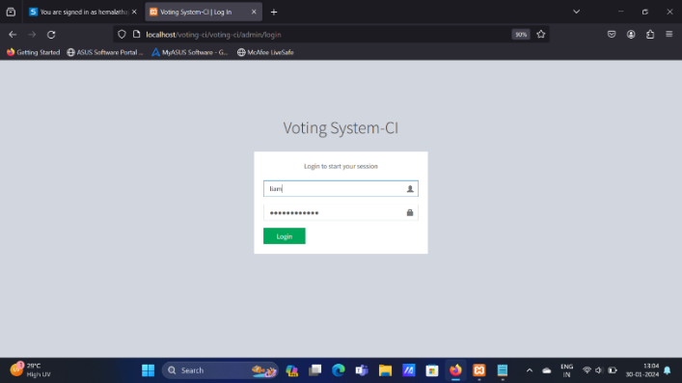

**4.2.DASHBOARD:**

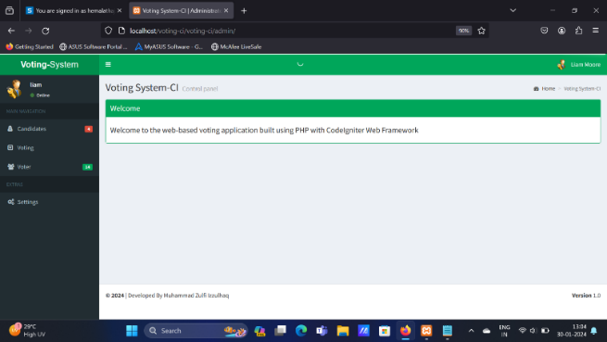

**4.3.ADDING CANDIDATES:**

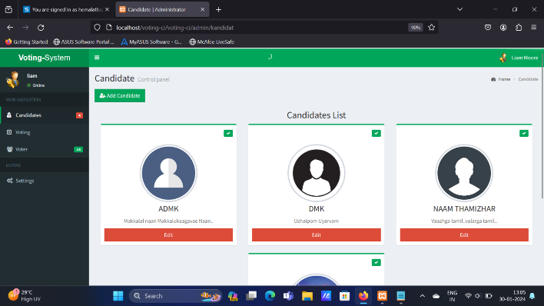

**4.4.ADDING VOTERS:**

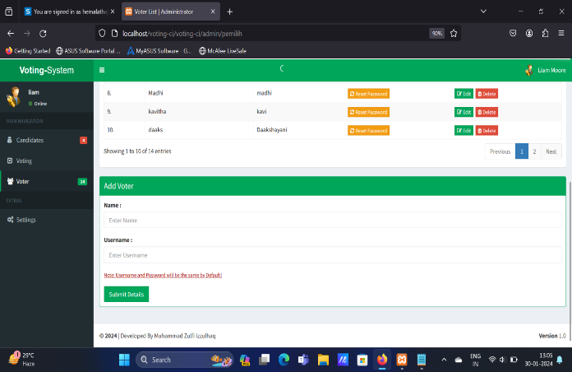

**4.5.USER LOGIN:**

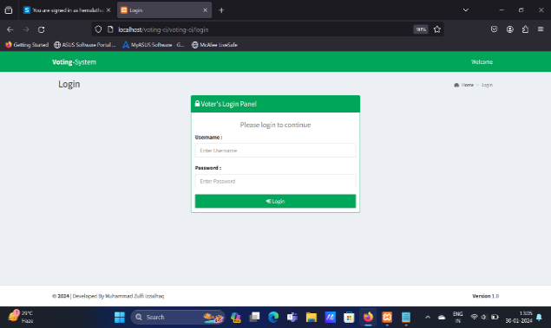

**4.6.CONFIRMATION:**

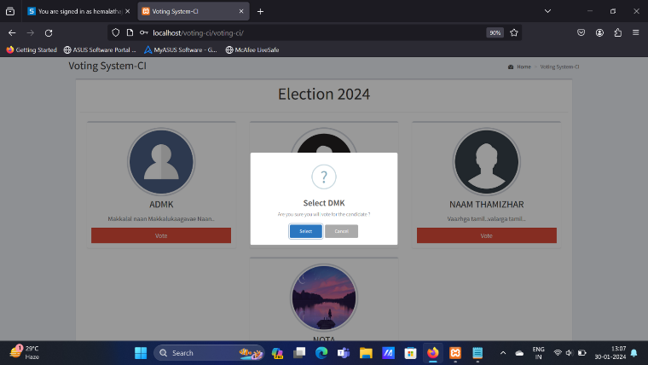

**4.7.VOTED:**

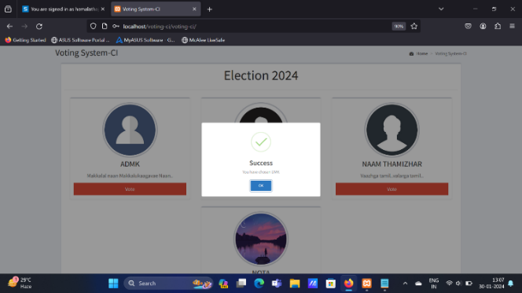

**4.8.VOTED SUCCESSFULLY:**



**FUTURE ENHANCEMENT:**

Future improvements to our online voting system, which prioritize greater accessibility, security, and engagement, have the potential to completely transform the election process. By adding state-of-the-art technology such as blockchain for transparent and unchangeable vote records, we want to strengthen the system's integrity even further. The development of biometrics will be essential to improving voter authentication and guaranteeing a reliable and secure identification procedure. Artificial intelligence integration will also improve user experience by offering real-time support and customized vote recommendations. Our upcoming improvements will put an emphasis on creating user-friendly interfaces that are compatible with a variety of devices and accessibility features in order to support inclusion. To increase voter knowledge and involvement, creative communication methods and social media integration will be used.

**References:**

* The Federal Constitutional Court Press Release No. 19/2009. Use of voting computers bundestag election unconstitutional, March 3 2009.
* Jussi Aaltonen. Electronic voting case law in Finland. In Ardita Driza / Jordi Barrat, editor, E-Voting Case Law. A Comparative Analysis, pages 173–181.Farnham: Ashgate, 2015.
* ABC News. Computer voting may feature in March NSW election,February 4, 2015.
* Rishab Bailey and Rohit Sharma. E-voting case law in India. In Ardita Driza/ Jordi Barrat, editor, E-Voting Case Law. A Comparative Analysis, pages 89–104. Farnham: Ashgate, 2015.
* Josh Benaloh. Simple verifiable elections. In USENIX/Accurate Electronic Voting Technology Workshop, pages 5–5. USENIX Association, 2006