**Stock Market Trend Prediction**

**Prof.K.M.Kamale, Vaibhav Satish Shinde, Jayesh Gorakshnath Bhoknal, Abhishek Meghraj Gamane, Pushpak Arun Mahajan**

1Professor, Information Technology, Sandip Foundation's Sandip Polytechnic, Nashik, Maharashtra, India.

2,3,4,5Student, Information Technology, Sandip Foundation's Sandip Polytechnic, Nashik, Maharashtra, India.

**ABSTRACT**

An This Project report is on the topic “Stock Market Trend Prediction”. Stock market is a great platform for investment and now a days lots of people has started trading. So In this Project we have created a working system which predict the movement of stocks from Indian stock exchange. For this we have created a prediction module using moving average indicator. The goal of this project is to give predicted movement of stocks. And those prediction should be as accurate as possible to increase the probability of profit in trade. We created this system various programming languages such as python, JavaScript, php, etc.

**Keywords:** Stocks, Stock Market, Trade, Moving Average (MA), Bullish, Bearish

1. **INTRODUCTION**

This project is based on Indian stock market. A stock market, equity market, or share market is the aggregation of buyers and sellers of stocks (also called shares), which represent ownership claims on businesses; these may include securities listed on a public stock exchange, as well as stock that is only traded privately, such as shares of private companies which are sold to investors through equity crowdfunding platforms. Investment in the stock market is most often done via stockbrokerages and electronic trading platforms. Investment is usually made with an investment strategy in mind. National Stock Exchange of India Limited (NSE) is the leading stock exchange of India, located in Mumbai, Maharashtra. It is under the ownership of some leading financial institutions, banks, and insurance companies. NSE was established in 1992 as the first dematerialized electronic exchange in the country. NSE was the first exchange in the country to provide a modern, fully automated screen-based electronic trading system that offered easy trading facilities to investors spread across the length and breadth of the country.

1. **METHODOLOGY**

Stock prediction using moving average In this project we implement a system which can predict the movement of a stock in Indian share market. We have created web application which can be used to study the charts of various stock and see there predicted move for medium term range. In this we have created a prediction module using technical indicator called moving average Moving average (MA) is mathematical technical analysis tools that traders and investors use to analyse the past and anticipate future price trends and patterns. Where fundamentalists may track economic data, annual reports, or various other measures, quantitative traders and analysts rely on the charts and indicators to help interpret price moves. Applying the moving average crossover strategy to a price chart allows traders to identify areas where the trend changes the direction creating a potential trading opportunity. As many experienced trader use it in non-technical method. We tried to bring same method to give calls in technical way and in more accurate way than humans. 2.2.2 Why our approach is better? Moving average is spine of our project. It is one of the indicator which has been used by many experienced traders.it has long history of showing more than average calls. So, we used this indicator to enhance its quality little bit more.

1. **MODELING AND** **ANALYSIS**

* **Modeling**

**User registration**: The user first registers with the system by providing their credentials. This could include their name, email address, and password.

**Login**: Once the user is registered, they can log in to the system using their credentials.

**Search stock**: The user can then search for the stock that they want to make a prediction about. The system will provide a list of possible matches.

**Select stock**: The user selects the stock that they are interested in from the list of matches.

**Show charts**: The system shows the user a chart of the stock's historical price data. This data can be used by the user to make an informed prediction about the stock's future price.

**Prediction module**: The user enters their prediction into the prediction module. The prediction module may use a variety of factors to make its own prediction, such as the stock's historical price data, news articles about the company, and analyst ratings.

**Database**: The prediction module stores the user's prediction in the database. The database can also be used to store the system's own predictions.

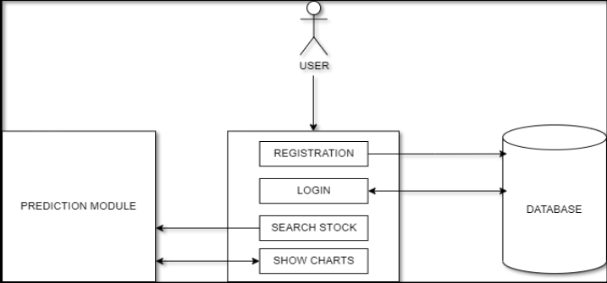

**Figure 1:** Model for project.

* **ANALYSIS**

The objective of the proposed work is to study and analyse stock market chart and to predict the stock movement. The main focus of this project is to provide stock market prediction. The system must be able to access a list of historical prices. It must calculate the estimated movement of stock based on the historical data. It must also provide an instantaneous visualization of the market index.

1. **RESULTS AND DISCUSSION**

* **Watchlist**

A watchlist is crucial for trading as it helps traders monitor and analyze specific assets of interest. By focusing on a select group of securities, traders can efficiently track price movements, conduct in-depth research, and make well-informed decisions. This tool enhances efficiency, aids in risk management, and ensures traders stay aligned with their overall trading strategy. Additionally, watchlists often include alert features, enabling timely responses to market developments.

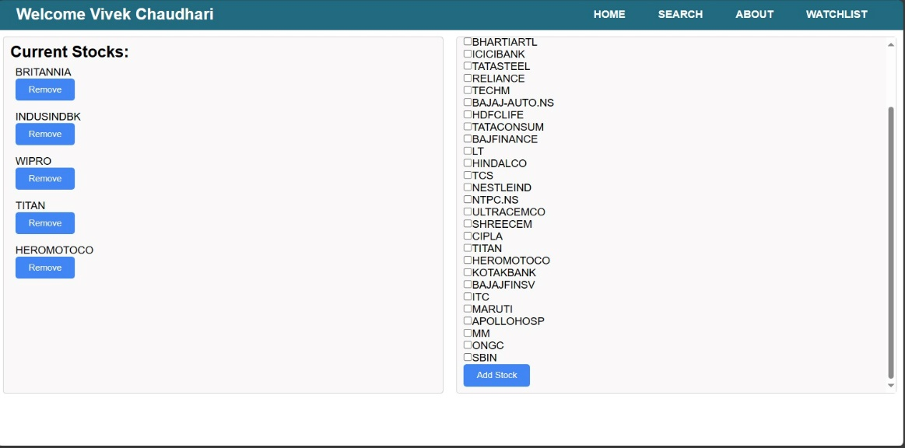

* **Showing**

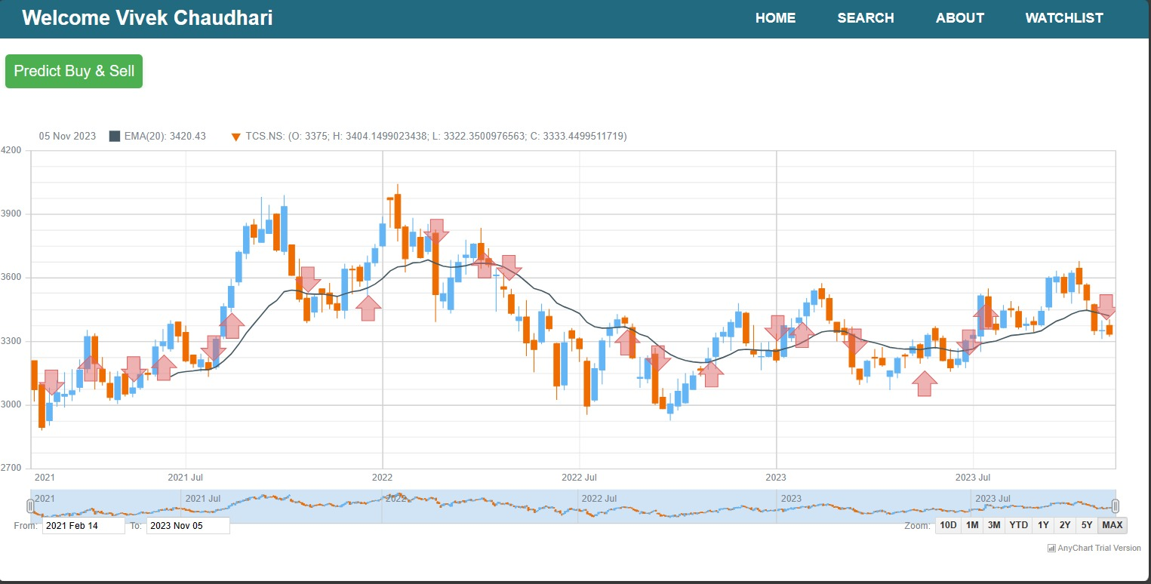

1. **CONCLUSION**

So, in this project we have created stock prediction website application which predicts the movement of stocks from Indian Stock market. It was made for educational purpose. We took help from various sites to build our web application in terms of design, features, working etc. This web application uses prediction module created with the most famous and effective indicator moving average. It also uses chart api called anychart, database of MySQL from xampp, etc. Overall creating this project was too much fun and hardship at same time. As a beginner In field of coding it gave as lot of experience for managing project, managing team, allotting work, etc. This project may not provide 100% accurate prediction but gives more than 50% accurate prediction which increases the probability of profit gain in stock market.

1. **REFERENCES**

1) Ouahilal M, El Mohajir M, Chahhou M, El Mohajir BE. Optimizing stock market price prediction using a indictor In 2016 4th IEEE International Colloquium on Information Science and Technology (CiSt) 2016 Oct 24 (pp. 290294). IEEE.

2) oish Bosco (Author)Fateh Khan (Author), 2018, Stock Market Prediction and Efficiency Analysis, Munich, GRIN Verlag

3) B. BOL LO BAS , O . R . 2003. Robustness and vulnerability of scale-free random graphs. Internet Mathemat-ics 1, 1, 1–35.

4) <https://www.moneycontrol.com>

5) <https://www.screener.in>

6) Apps: Zerodha kite, Upstox PRO Trading App. Sharekhan Mobile Trading App.