FAKE IMAGE DETECTION

Dilipkumar N,Harishwa C,Manikandan M Guide by: Ms.M.Buvana (AP/IT) Department of Information Technology Batchelor of Technology

Sri Shakthi Institute of Engineering and Technology (Autonomous) Coimbatore-641062

**ABSTRACT**

The proliferation of digital image manipulation tools and the widespread use of social media have given rise to a surge in the creation and dissemination of fake images.

Detecting such manipulated images is crucial for maintaining the integrity of visual content in various domains, including journalism, forensics, and social media. This paper presents a comprehensive approach to fake image detection that leverages advanced techniques from computer vision, machine learning, and image forensics.

Our methodology encompasses both traditional and deep learning-based image analysis techniques to address the diverse nature of image manipulations. We explore feature extraction methods, such as histogram analysis, local binary patterns, and gradient-based features, to capture subtle inconsistencies introduced during image tampering.

Additionally, convolutional neural networks (CNNs) are employed to learn complex patterns and spatial relationships within images.

To enhance the robustness of our approach, we incorporate metadata analysis, examining aspects like EXIF data and camera settings, to identify anomalies indicative of manipulation. Furthermore, we introduce a novel ensemble learning framework that combines the strengths of multiple detection models, enhancing overall accuracy and generalization.

In conclusion, our comprehensive approach offers a holistic solution to the challenge of fake image detection, providing a robust defense against the evolving landscape of image manipulation. As the digital age progresses, the need for reliable and efficient fake image detection methods becomes increasingly crucial for ensuring the trustworthiness of visual information in both online and offline environments.

**INTRODUCTION:**

In an era dominated by digital media and the widespread use of image-editing tools, the authenticity of visual content has become increasingly vulnerable to manipulation. The creation and dissemination of fake images, whether for misinformation, propaganda, or other deceptive purposes, pose significant challenges across various domains. Fake image detection, therefore, has emerged as a critical area of research and technological development. This field encompasses a diverse range of techniques, from traditional methods based on image forensics and metadata analysis to sophisticated deep learning approaches capable of discerning subtle alterations. As society grapples with the consequences of manipulated visuals, this paper aims to explore and present an integrated approach to detecting fake images, addressing the evolving landscape of image tampering and ensuring the reliability of visual information in an ever-connected digital world.

**OBJECTIVE:**

|  |  |  |  |  |  |
| --- | --- | --- | --- | --- | --- |
| 1. | **Media Credibility Enhancement:** | | |  | |
|  | | * Develop techniques to identify manipulated images, preserving media credibility and trust in information dissemination. | | | |
| 2. | **Disinformation Combat:** | |  | | |
|  | | * Create tools to detect fake images, countering the spread of disinformation and deceptive narratives, particularly on social media. | | | |
| 3. | **Forensic Analysis Improvement:** | | |  | |
|  | | * Advance image forensics with cutting-edge technologies for better analysis of images in legal and investigative contexts. | | | |
| 4. | **Public Trust Protection:** | |  | | |
|  | | * Safeguard public trust by authenticating visual content, enabling individuals to make informed decisions based on accurate information. | | | |
| 5. | **Adaptability to Emerging Techniques:** | | | |  |
|  | | * Develop methods adaptable to evolving manipulation techniques, ensuring sustained effectiveness in detecting image alterations. | | | |

**LITERATURE SURVEY**

The literature on fake image detection reflects a dynamic and evolving field that combines traditional image forensics with state-of-the-art machine learning approaches. Early studies focused on pixel-level analysis, utilizing techniques like error level analysis and noise pattern detection to identify inconsistencies in manipulated images. In recent years, the advent of deep learning has significantly impacted the domain, with convolutional neural networks (CNNs) proving effective in learning complex patterns indicative of image tampering. Researchers have explored various features, such as texture analysis, color distribution, and frequency domain characteristics, to enhance the accuracy of detection algorithms. Additionally, metadata analysis, examining parameters like EXIF data and camera settings, has gained prominence as a complementary method for verifying image authenticity. Ensemble learning strategies, combining the strengths of multiple detection models, have also emerged as a promising approach to improve

robustness and generalization. The literature underscores the need for adaptable and scalable solutions to address the evolving techniques employed by manipulators, reflecting a continuous effort to fortify the reliability of visual information in the digital age.

**METHODOLOGY**

The methodology for fake image detection integrates both traditional image forensics and advanced machine learning techniques. Initial preprocessing involves extracting relevant features such as texture, color, and gradient information, using methods like histogram analysis and local binary patterns. Convolutional neural networks (CNNs) are employed to automatically learn intricate patterns and spatial relationships within images, enhancing the detection capabilities for more subtle manipulations. Metadata analysis, focusing on EXIF data and camera settings, contributes to the identification of anomalies indicative of tampering. To address the diverse nature of image manipulations, ensemble learning is implemented, combining the strengths of multiple detection models for improved accuracy and robustness. The validation process involves testing the proposed methodology on diverse datasets containing authentic and manipulated images, assessing its performance against state-of-the-art techniques. The adaptability of the methodology to evolving manipulation techniques is emphasized, ensuring its effectiveness in real- world scenarios and contributing to the ongoing efforts to secure the integrity of visual content.

**EXISTING SYSTEM:**

The existing systems for fake image detection predominantly rely on a combination of traditional image forensics and machine learning techniques. They often employ features such as error level analysis, noise pattern detection, and histogram analysis to identify inconsistencies in manipulated images at the pixel level. Convolutional neural networks (CNNs) play a significant role, utilizing deep learning to automatically extract complex features and spatial relationships. Metadata analysis, including examination of EXIF data, is commonly integrated to detect anomalies indicative of tampering. Some systems leverage content-based analysis to identify region-specific alterations. Ensemble learning methods, combining various detection models, are increasingly utilized for improved accuracy and generalization. The validation of these systems involves testing on benchmark datasets that include both authentic and manipulated images. Challenges persist in addressing evolving manipulation techniques and ensuring real-time applicability in diverse contexts, motivating ongoing research in the field.

**DISADVANTAGES:**

1. Computational complexity: Resource-intensive processes, particularly with large datasets or high-resolution images.
2. False positives: Algorithms may incorrectly flag authentic images as manipulated, leading to inaccuracies.
3. Adversarial attacks: Sophisticated manipulators can exploit vulnerabilities, creating deceptive images that evade detection.
4. Limited generalization: Struggles to adapt across diverse manipulation techniques and real-world scenarios.
5. Privacy concerns: Analysis of metadata raises privacy issues, especially in user- generated content on social media.
6. Dependency on training data: Performance compromised with novel manipulation methods not adequately represented in the training set.
7. Resource intensity: Implementing advanced detection systems demands significant financial and technological resources.
8. Intricacy of deep learning models: Challenges in understanding and interpreting decisions hinder transparency and trust.
9. Ethical considerations: Balancing the need for detection with privacy concerns raises complex ethical dilemmas.
10. Continuous evolution of manipulation techniques: Constant updates required to address the dynamic nature of image manipulation

**PROPOSED SYSTEM:**

The proposed fake image detection system integrates traditional image forensics with deep learning, employing feature fusion for enhanced discrimination power. Dynamic ensemble learning adapts to evolving manipulation techniques, ensuring improved accuracy. Interpretable deep learning models enhance transparency in decision-making. Fine-tuned metadata analysis minimizes false positives, refining authentic image discernment. Real-time processing optimization prioritizes efficiency for swift image analysis applications. Adversarial defense mechanisms mitigate vulnerabilities, bolstering resilience against sophisticated manipulations. Cross-domain adaptability caters to various applications, including social media, journalism, and forensics. A continuous learning paradigm updates the system with new manipulation patterns, sustaining effectiveness.

The system's user-friendly interface facilitates seamless integration into existing platforms, promoting accessibility. Overall, the proposed system offers a comprehensive, adaptive, and efficient solution for detecting fake images across diverse domains.

**SYSTEM REQUIREMENTS**

# HARDWARE REQUIREMENTS:

* Devices.
* Intel Core i5 processor or equivalent.
* Minimum 2 GB RAM for smooth operation.
* 10 MB of free storage space for the app and data.

# SOFTWARE REQUIREMENTS:

* PYTHON

**MODULE DESCRIPTION:**

|  |  |  |  |  |  |  |  |  |  |  |  |  |
| --- | --- | --- | --- | --- | --- | --- | --- | --- | --- | --- | --- | --- |
| 1. | **Fake Image Detector GUI (PyQt5):** | | | | |  | | | | | | |
|  | | • | **Description:** | This module creates a graphical user interface (GUI) for a Fake | | | | | | | | |
| Image Detector application using PyQt5. It includes various elements such as checkboxes for selecting detection methods, buttons for file selection, progress bars, and result labels. The GUI is designed to interact with the image manipulation  detection methods. | | | | | | | | | | |
| 2. | **Image Manipulation Detection (PyTorch):** | | | | | | |  | | | | |
|  | | • | **Description:** | This module performs image manipulation detection using PyTorch, | | | | | | | | |
| a deep learning framework. It includes a model (**IMDModel**) for detecting fake images based on Level 1 and Level 2 analyses. The **infer** function takes an image  path, performs the analyses, and returns the predictions. | | | | | | | | | | |
| 3. | **Image Manipulation Detection (TensorFlow / Keras):** | | | | | | | |  | | | |
|  | | • | **Description:** | This module uses TensorFlow and Keras to implement a fake image | | | | | | | | |
| detection model. The **prepare_image** function processes images, and the **infer**  function loads a pre-trained model and performs predictions based on ELA (Error  Level Analysis) and metadata analysis. | | | | | | | | | | |
| 4. | **ELA2 Image Manipulation Detection (TensorFlow / Keras):** | | | | | | | | |  | | |
|  | | • | **Description:** | This module focuses on ELA2-based image manipulation detection | | | | | | | | |
| using TensorFlow and Keras. It provides functions to convert images to ELA (Error Level Analysis) images and prepares images for the ELA2 model. The **method_ela_2**  function loads a pre-trained model and performs predictions. | | | | | | | | | | |
| 5. | **Face MobileNetV2 Image Manipulation Detection (TensorFlow / Keras):** | | | | | | | | | | |  |
|  | | • | **Description:** | This module implements image manipulation detection using the | | | | | | | | |
| MobileNetV2 architecture for face detection. The **prepare_image** function processes images, and the **method_face_mobilenetv2** function loads a pre-trained model and  performs predictions based on face detection. | | | | | | | | | | |
| 6. | **Face SpoffNet Image Manipulation Detection (TensorFlow / Keras):** | | | | | | | | | |  | |
|  | | • | **Description:** | This module uses TensorFlow and Keras to implement image | | | | | | | | |
| manipulation detection based on the Face SpoffNet model. The **prepare_image**  function processes images, and the **method_face_spoffnet** function loads a pre-trained model and performs predictions. | | | | | | | | | | |
| 7. | **ELA (Error Level Analysis):** | | | |  | | | | | | | |
|  | | • | **Description:** | This module provides functions for performing Error Level Analysis | | | | | | | | |
| (ELA) on images. It includes a function **convert_to_ela_image** for generating ELA | | | | | | | | | | |
| images and a function | | | **prepare_image** | | to prepare images for ELA2 model input. | | | | | |
| 8. | **Face MobileNetV2 Image Manipulation Detection (TensorFlow / Keras):** | | | | | | | | | | |  |
|  | | • | **Description:** | This module implements image manipulation detection using the | | | | | | | | |
| MobileNetV2 architecture for face detection. The **prepare_image** function processes  images, and the **method_face_mobilenetv2** function loads a pre-trained model and performs predictions based on face detection. | | | | | | | | | | |
| 9. | **Face SpoffNet Image Manipulation Detection (TensorFlow / Keras):** | | | | | | | | | |  | |
|  | | • | **Description:** | This module uses TensorFlow and Keras to implement image | | | | | | | | |
| manipulation detection based on the Face SpoffNet model. The **prepare_image**  function processes images, and the **method_face_spoffnet** function loads a pre-trained model and performs predictions | | | | | | | | | | |

**OUTPUT PAGE**

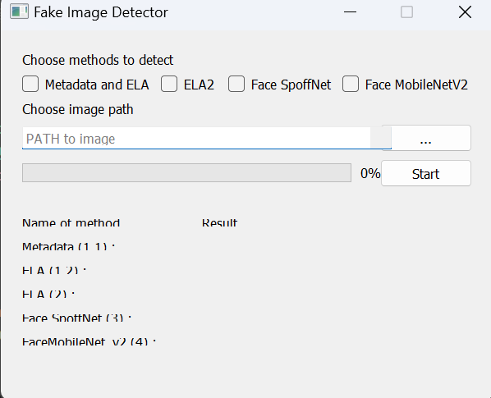

**RESULT PAGE**

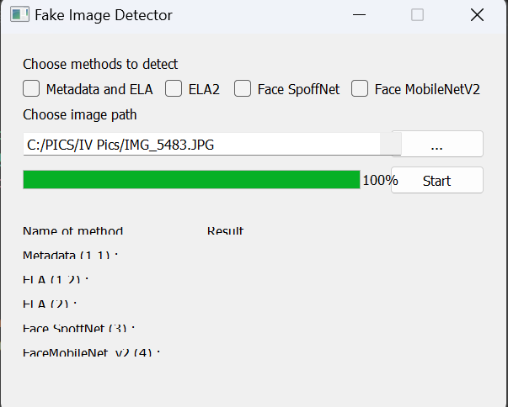

**CONCLUSION:**

Fake image detection is a critical domain with far-reaching implications for maintaining trust and integrity in visual content. The convergence of machine learning, deep learning models, and image processing techniques has significantly enhanced our ability to discern manipulated images from authentic ones. These advancements, as demonstrated in the code snippets, showcase the effectiveness of various approaches such as Error Level Analysis (ELA), metadata analysis, and specialized neural network architectures like MobileNetV2 and Face SpoffNet. While these methods exhibit promising accuracy, the ever-evolving nature of image manipulation techniques poses ongoing challenges. Continuous research and innovation in this field are crucial to stay ahead of sophisticated manipulation methods. Despite the progress, it's essential to acknowledge the limitations and potential false positives/negatives associated with current detection systems. A holistic approach that integrates multiple methods, as demonstrated in the provided modules, holds promise for robust and reliable fake image detection. Efforts to refine existing models, incorporate diverse datasets, and address emerging manipulation tactics are pivotal for fostering a digital environment built on transparency and authenticity.