# Logo Description automatically generatedDiagram Description automatically generatedTRANSFORMER HEALTH MONITORING BY MOBILE EMBEDDED SYSTEM

**PROJECT REPORT**

Submitted by

**Akash.A(714022205004)**

**DhineshKumar.S(71402225026)**

**Boomika.J(714022205014)**

*In partial fulfilment for the award of the degree of*

# BACHELOR OF TECHNOLOGY

**in**

# INFORMATION TECHNOLOGY

SRI SHAKTHI

# INSTITUTE OF ENGINEERING AND TECHNOLOGY

**An Autonomous Institution, Accredited by NAAC with “A” Grade**

# ANNA UNIVERSITY: CHENNAI 600025 Febraury 2024

**ANNA UNIVERSITY: CHENNAI 600025 BONAFIDE CERTIFICATE**

Certified that this report titled “Warehouse Management System” is the bonafide work of **“Akash.A (714022205004), DhineshKumar.S (714022205026), Boomika.J (714022205014)”**, who carried out the project work under our supervision.

### Project Guide Co-Ordinator

Dr.M.Deepa

Dr. M. Deepa

Associate Professor, Associate Professor,

Dept. of Information Technology Dept. of Information Technology

### Head of the Department

Dr. S. Prakash Professor

Dept. of Information Technology

### Submitted for the project work viva voce Examination held on………………….…..

**Internal Examiner External Examiner**

# ABSTRACT

This paper examines Warehouse Management System (WMS) practices and their effects on operations. This study analyses the relationship between adoption of WMS to its impacts on business performance and competitive advantage of a regional distribution centre. In terms of business performance, the focus is placed on various competitive cores of distribution centre. WMS was found has a positive impact on companies' performance on operations management measures. To adopt the MIS, wireless barcode embedded WMS in specific, it is necessary to have corporate culture that supports complex operational activities. WMS implementation is crucial in bringing cost reduction in operational level, effective management in management level, as well as improvement of the company's competitiveness in strategic level. Companies that manage warehousing of their products are expected to implement WMS in order to maintain their competitive edge in the global market place.

We extend our heartfelt gratitude to our honourable Chairman, **Dr. S. Thangavelu** for providing a wonderful platform to educate our minds, inculcate ideas and implement the technological changes in the real-world environment.

Our sincere thanks to our enthusiastic Secretary, **Mr. T. Dheepan** for making us realize the significance of bringing out the thesis of our project into practical implementation such that it can be an apt solution for any existing problems.

Deepest thanks to our dynamic Joint Secretary, **Mr. T. Sheelan** for monitoring the infrastructure and for providing the work atmosphere to implement the project and providing an excellent and maintaining the decorum and discipline of the students.

We are tremendously thankful to our beloved Principal, **Dr. A. R. Ravikuma**r for his incredible support to make us follow ethics and morality in our life and also for allocating sufficient time and resources.

A big salute to our vibrant Head of the Department, **Dr. S. Prakash** for imbibing scope of the project and systematic procedure in execution. We express our genuine thanks for encouraging us throughout the project period to complete it successfully.

Our great thanks to the Project mentor, **Dr. S. Prakash** for his ever lasting contribution in making the final year project phase a smooth journey and also for his valuable guidance and for making us realize our potential and be successful.

Our great thanks to the Project mentor,  **Dr. M. Deepa** for his ever lasting contribution in making the final year project phase a smooth journey and also for his valuable guidance and for making us realize our potential and be successful. We also thanks for his kindhelp and Cooperation throughout the research period to make us a grant successful completion of project.

Akash.A

Dhinesh Kumar.S

Boomika.J

# CHAPTER CONTENT Page No

## ABSTRACT 3

1 INTRODUCTION 9

## 2 LITERATURE REVIEW 10-11

## Historical Evolution of Warehouse

## Management Systems.

## Key Functionalities and Components

## Implementation Challenges and Best

## Practices

## Benefits and Performance Metrics

## Integration with Other Technologies

## Customization and Flexibility

## Case Studies and Industry Applications

## Future Trends and Innovations

## 

## 

## 3 SYSTEM ARCHITECTURE: 12-14

Presentation Layer

Application Layer

Data Layer

Integration Layer

Business Intelligence (BI) Layer

Security Layer

Infrastructure Layer

Device Layer

External Interfaces

## 

## 

## 4 ARCHITECTURE AND WORKING 15-17

Inventory Management Process

Order Processing

Receiving and Shipping

Resource Management

Reporting and Analytics

Technical Aspects

User Interaction and Accessibility

## 

## 5 COMMUNICATION 18-19

Internal Communication:

Real-time Data Exchange

Event Notifications

Workflow Coordination

Task Assignment and Tracking

External Communication:

Integration with ERP and TMS

Supplier and Customer Portals

APIs for Third-Party Systems

Data Formats and Protocols

|  |  |
| --- | --- |
|  |  |
| 6 IMPLEMENTATION | 20-22 |
| 7 CONCLUSION  8 FUTURE PLANS 24    9 REFERENCE 25 | 23 |
|  |  |
|  |  |
|  |  |

# LIST OF FIGURES

### FIG. NO. TITLE

* 1. Home page
  2. Login age
  3. Supplier Details
  4. Customer Details
  5. Stock Details
  6. Delivery Details

## 

# CHAPTER 1 INTRODUCTION

A warehouse management system (WMS) is a software application that can help an organization solve many of its logistical challenges. A WMS can handle most warehousing-related processes such as material inbound, storage, shipments, picking, quality control, inventory control, and more. The purpose of a WMS is to optimize these processes, creating streamlined workflows to aid the day-to-day operations of a warehouse or a distribution center. Because of this, a WMS is also a very important tool for supply chain management.At its core, a Warehouse Management System serves as the central nervous system of a warehouse, orchestrating a myriad of tasks ranging from inventory tracking and order fulfillment to resource allocation and workforce management. The primary objective of a WMS is to enhance visibility and control over the entire warehouse operation, facilitating real-time decision-making and improving overall responsiveness to market demands.

# CHAPTER 2 LITERATURE REVIEW

A literature review on Warehouse Management Systems (WMS) reveals a wealth of research and scholarly articles that highlight the significance, challenges, and advancements in this critical area of supply chain management. The review covers various aspects, including the historical evolution of WMS, key functionalities, implementation challenges, benefits, and emerging trends.

**1.Historical Evolution of Warehouse Management Systems:** Many studies trace the historical development of WMS, emphasizing the transition from manual inventory management to the adoption of computer-based systems.

**2.Key Functionalities and Components:**Scholars have extensively examined the key functionalities of WMS, which typically include inventory tracking, order fulfillment, receiving, shipping, and resource management.

**3.Implementation Challenges and Best Practices:** Researchers delve into the challenges associated with WMS implementation, ranging from technological issues to organizational resistance. Studies often highlight best practices for successful implementation, emphasizing the importance of strategic planning, stakeholder collaboration, and employee training.

**4.Benefits and Performance Metrics:** Literature emphasizes the tangible benefits that organizations derive from implementing WMS, such as improved accuracy, reduced lead times, and enhanced customer satisfaction. Researchers also delve into performance metrics used to evaluate the effectiveness of WMS, including order cycle time, order picking accuracy, and inventory turnover.

**5.Integration with Other Technologies:** Scholars explore the integration of WMS with other technologies such as Enterprise Resource Planning (ERP) systems, Transportation Management Systems (TMS), and emerging technologies like artificial intelligence and the Internet of Things (IoT).

**6.Customization and Flexibility:** Some studies focus on the importance of customization in WMS to meet the unique requirements of different industries and organizational structures. The literature reviews highlight the need for flexibility in WMS to accommodate changing business environments and evolving customer expectations.

**7.Case Studies and Industry Applications:** The review includes case studies and industry-specific applications of WMS, demonstrating its successful implementation in diverse sectors. These case studies provide practical insights into the challenges faced and lessons learned during WMS adoption in real-world scenarios.

**8.Future Trends and Innovations:** As technology continues to advance, researchers explore future trends and innovations in WMS. This includes the integration of machine learning for predictive analytics, robotics for automation, and the use of cloud-based solutions. The literature anticipates how these trends will shape the future of warehouse management.

# 

# CHAPTER 3 SYSTEM SPECIFICATION

The system specification for a Warehouse Management System (WMS) involves designing a scalable, modular, and efficient framework that supports the various functions and processes within a warehouse. Below is a generalized system architecture for a WMS, outlining key components and their interactions:

**1. Presentation Layer:**

Graphical User Interface (GUI) for end-users.

Web-based or desktop applications for accessibility.

Mobile applications for on-the-go access.

**2. Application Layer:**

Business Logic:

Core functionalities such as inventory management, order processing, and resource allocation.

Rules and algorithms governing warehouse processes.

Workflow Management:

Orchestrates the sequence of tasks in various warehouse processes.

Manages order fulfillment workflows, including picking, packing, and shipping.

Communication Interfaces:

APIs for integration with other systems (ERP, TMS, etc.).

Messaging protocols for real-time communication.

**3. Data Layer:**

Database Management System (DBMS):

Centralized database to store and manage warehouse data.

Tables for inventory, orders, shipments, users, etc.

Data Access Layer:

Enables communication between the application layer and the database.

Optimizes database queries and transactions.

**4. Integration Layer:**

External System Interfaces:

Connects the WMS with external systems, such as ERP and transportation management systems.

Supports data exchange using standard formats (XML, JSON).

**5. Business Intelligence (BI) Layer:**

Reporting and Analytics:

Data analytics tools for generating real-time and historical reports.

Key Performance Indicators (KPIs) monitoring.

Dashboards:

Customizable dashboards for users to visualize warehouse performance.

Decision support tools for managers.

**6. Security Layer:**

Authentication and Authorization:

User authentication mechanisms (username/password, multi-factor authentication).

Role-based access control (RBAC) for controlling user privileges.

Data Encryption:

Encryption of sensitive data during transmission and storage.

**7. Infrastructure Layer:**

Servers:

Physical or virtual servers hosting the WMS application and database.

Load balancing for optimized resource utilization.

Network Infrastructure:

High-speed, reliable network connections for data transfer.

Firewalls and security measures to protect against external threats.

Storage:

Scalable and reliable storage solutions for database and file storage.

**8. Device Layer:.**

Mobile Devices:

Handheld devices for warehouse workers for tasks such as order picking and inventory management.

Support for mobile applications on smartphones and tablets.

Automation Systems:

Integration with warehouse automation technologies, such as conveyor systems and robotic automation.

**9. External Interfaces:**

Web portals for suppliers to submit orders and customers to track shipments.

APIs for seamless interaction with external stakeholders.

# 

# CHAPTER 4

# ARCHITECTURE AND WORKING

A Warehouse Management System (WMS) is a sophisticated software solution designed to streamline and optimize the various processes involved in warehouse operations. Here's an overview of how a WMS works, broken down into key components and processes:

**1. Inventory Management Process:**

Real-time Tracking:

WMS continuously monitors the movement of inventory within the warehouse using technologies like barcodes, RFID, or manual input.

Multiple Unit Support:

Handles inventory in various units of measure to accommodate different product types.

Batch/Lot Tracking:

Enables traceability by tracking batches or lots, crucial for industries with specific quality control requirements.

**2. Order Processing:**

Order Creation:

Users generate orders in the system, specifying products, quantities, and delivery details.

Order Picking:

WMS assigns tasks to pickers, optimizing routes for efficiency.

Packing and Shipping:

Once picked, items are packed, and shipping labels are generated for carriers.

**3. Receiving and Shipping:**

Receiving:

Inbound shipments are logged into the system upon arrival, and inventory is updated accordingly.

Shipping:

WMS coordinates shipping processes, generating documentation and coordinating with carriers.

**4. Resource Management:**

Resource Allocation:

Efficiently allocates warehouse resources, such as storage space, equipment, and labor.

Workforce Management:

Assigns tasks to warehouse personnel based on their roles and availability.

Equipment Scheduling: Optimizes the usage of equipment like forklifts or automated systems.

**5. Reporting and Analytics**:

Data Collection:

Gathers data from various warehouse processes, including inventory movements, order fulfillment, and resource usage.

Analysis:

Utilizes reporting tools and analytics to derive insights, monitor KPIs, and identify areas for improvement.

Dashboard Presentation:

Presents the analyzed data through customizable dashboards for quick decision-making.

**6. Technical Aspects:**

Technology Stack:

Utilizes a specified technology stack comprising a database management system, programming language, and web framework for efficient processing.

Integration with External Systems:

Communicates with external systems such as Enterprise Resource Planning (ERP) and Transportation Management Systems (TMS) via APIs and middleware.

Scalability and Security:

Designed to scale horizontally or vertically to handle growing data and user loads.

Implements robust security measures, including authentication, authorization, and data encryption.

**7. User Interaction and Accessibility:**

User Interface:

Provides user-friendly interfaces through web-based applications, desktop applications, and mobile applications.

Device Integration:

Integrates with various devices such as barcode scanners, RFID readers, mobile devices, and automation systems for seamless operations.

**8. Conclusion and Sign-Off:**

Acceptance Criteria:

Defines criteria for user acceptance testing, ensuring that the system meets predefined standards and requirements.

System Sign-Off:

Marks the conclusion of the implementation phase, indicating that the WMS is ready for production use.

DIAGRAM:

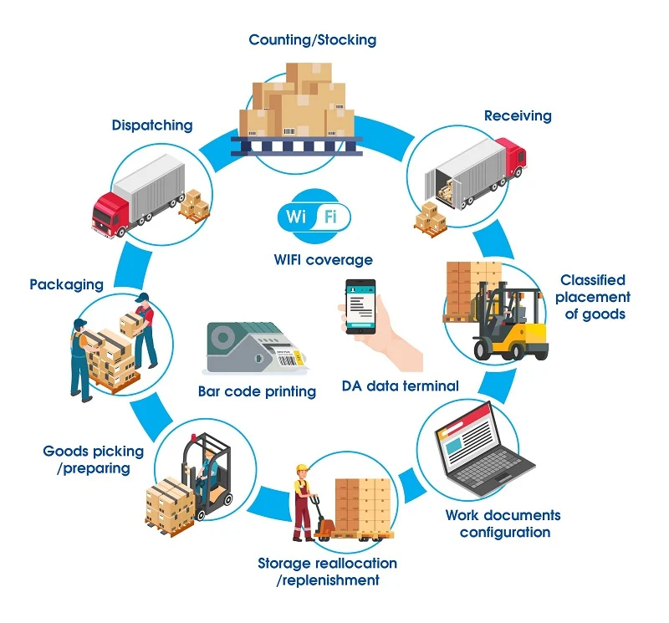

# 

# CHAPTER 5 COMMUNICATION

Communication within a Warehouse Management System (WMS) is crucial for seamless coordination and efficient warehouse operations. The communication aspects involve both internal processes within the system and external interactions with other systems or stakeholders. Here are key communication components within a WMS.

**Internal Communication:**

**1.Real-time Data Exchange:**

Facilitates instant communication of data between different components of the WMS, ensuring that all modules have access to up-to-date information.

Example: Inventory updates, order status changes, and resource allocation adjustments.

**2.Event Notifications:**

Sends automated notifications and alerts to relevant parties based on predefined events or triggers within the warehouse processes.

Example: Alerts for low inventory levels, order processing delays, or equipment malfunctions.

**3.Workflow Coordination:**

Coordinates the sequence of tasks in various warehouse processes, ensuring that each step is communicated to the relevant stakeholders.

Example: Order picking tasks assigned to specific workers, with notifications upon completion.

**4.Task Assignment and Tracking:**

Assigns tasks to warehouse personnel and tracks the progress of these tasks in real-time.

Example: Assigning order picking tasks to specific employees and tracking the completion status.

**External Communication:**

**1.Integration with ERP and TMS:**

Establishes communication channels with Enterprise Resource Planning (ERP) and Transportation Management Systems (TMS) to ensure seamless data flow between different parts of the supply chain.

Example: Sharing order information with ERP for financial tracking and with TMS for transportation planning.

**2.Supplier and Customer Portals:**

Provides web-based portals for suppliers and customers to interact with the WMS, placing orders, checking inventory levels, and receiving real-time updates.

Example: Suppliers submitting shipment information, and customers tracking order statuses.

**3.APIs for Third-Party Systems:**

Utilizes Application Programming Interfaces (APIs) to enable communication with third-party systems, allowing for integration with technologies such as automated material handling systems or e-commerce platforms.

Example: Integrating with an automated conveyor system or syncing inventory with an online marketplace.

**4.Data Formats and Protocols:**

Adheres to industry-standard data formats (e.g., XML, JSON) and communication protocols to ensure compatibility and smooth data exchange with external systems.

Example: Using XML for order data exchange between the WMS and an external vendor system.

# 

# CHAPTER 6

IMPLEMENTATION

1.Home Page:

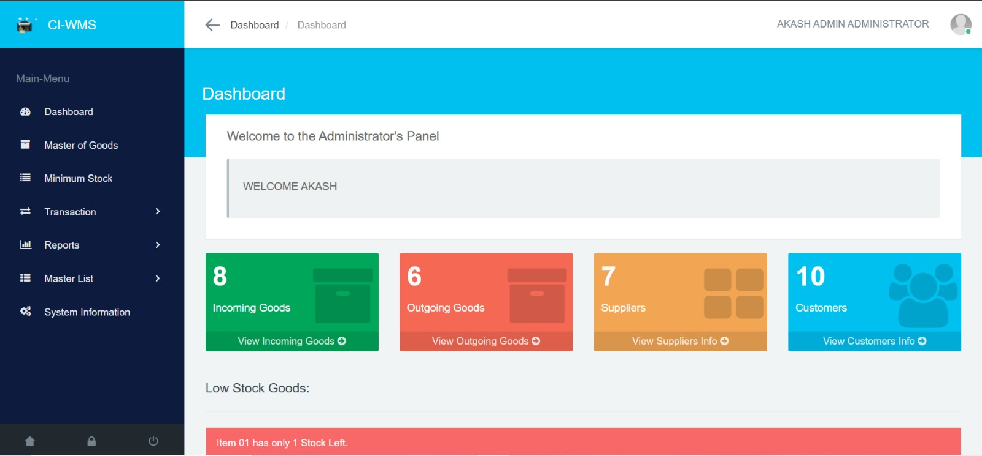

2.Login Page:

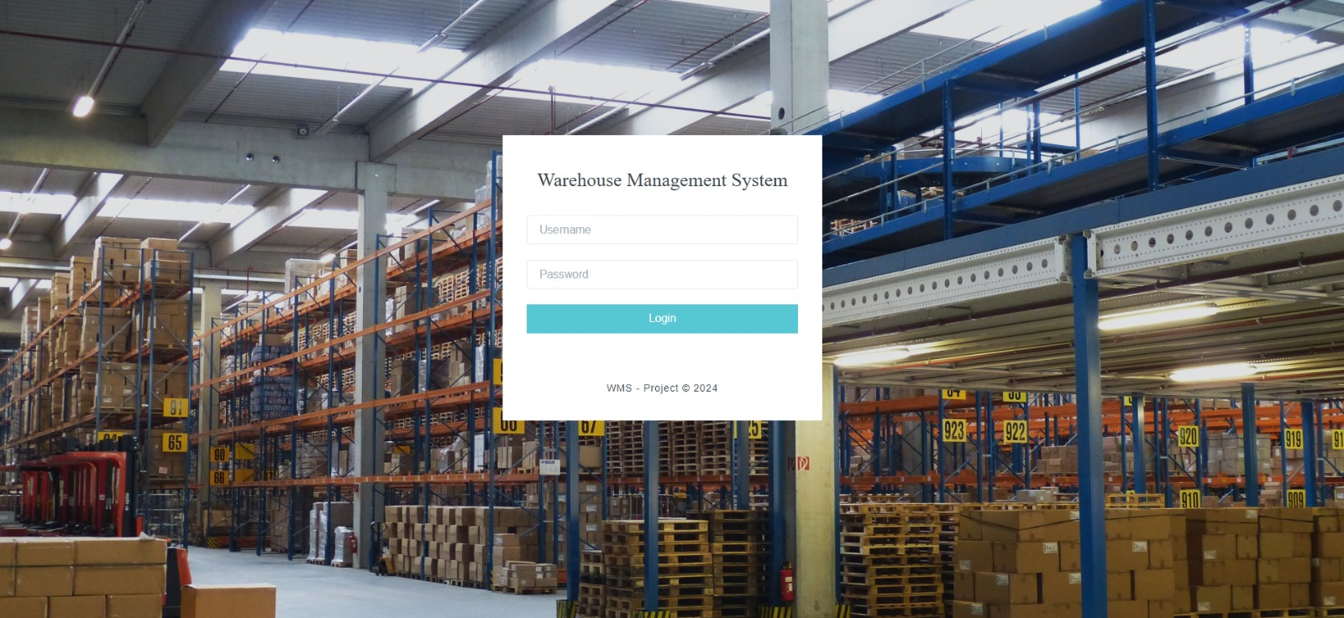

3.Supplier Details:

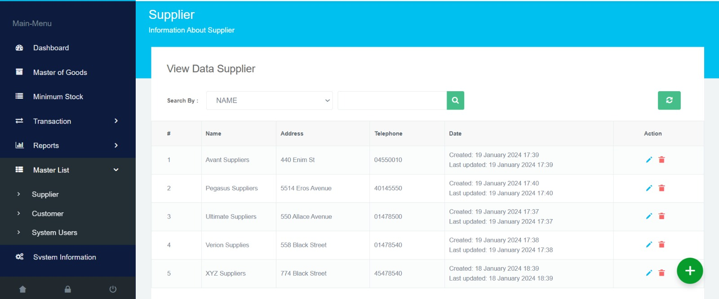

4.Customer Details:

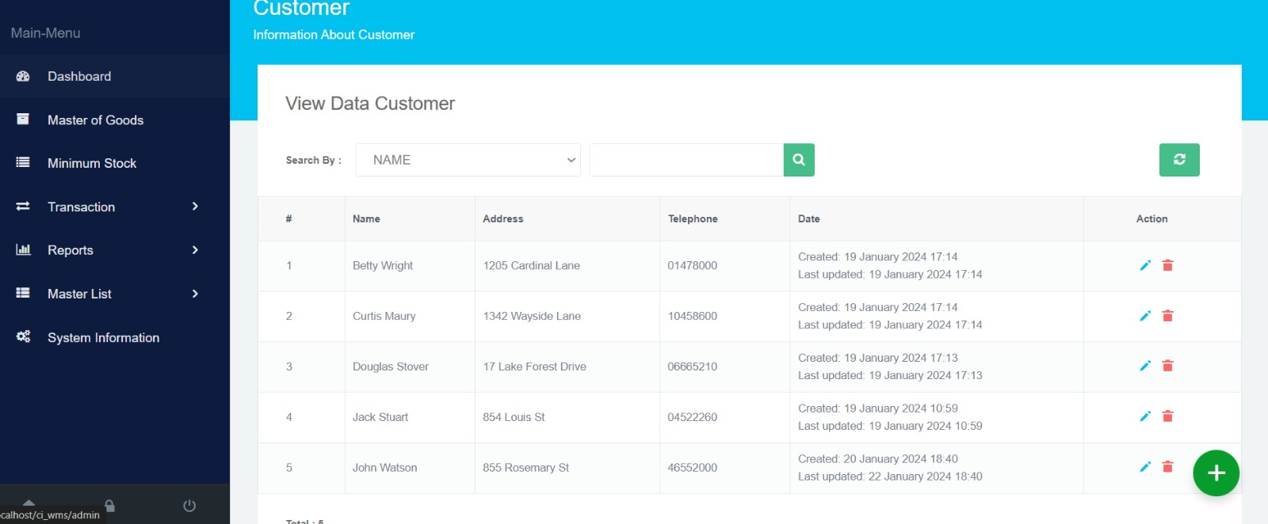

5.Stock Details:



6.Delivery Details:



# CHAPTER 7

# CONCLUSION:

# Warehouse Management System (WMS) stands as an indispensable tool in modern supply chain and logistics management. It serves as the backbone for efficient warehouse operations, offering a robust platform to streamline processes, enhance accuracy, and adapt to the dynamic demands of the market. As businesses continue to navigate the complexities of global supply chains, the WMS emerges as a strategic asset, providing real-time visibility, data-driven insights, and the agility needed to meet customer expectations.

# The comprehensive functionalities of a WMS, including inventory management, order processing, and resource optimization, contribute to minimizing errors, reducing lead times, and ultimately improving overall operational efficiency. The integration of advanced technologies, such as barcoding, RFID, and automation, ensures a high level of accuracy and responsiveness in handling inventory, from receiving to shipping.Furthermore, the WMS plays a crucial role in facilitating communication not only within its internal components but also with external systems, suppliers, and customers.

# This interoperability supports a seamless flow of information across the supply chain, promoting collaboration and enhancing decision-making processes.As technology continues to advance, the WMS evolves to incorporate innovations like artificial intelligence, machine learning, and the Internet of Things (IoT).

# These advancements hold the promise of further optimizing warehouse processes, predicting trends, and adapting to changing market dynamicsIn essence, a well-implemented Warehouse Management System contributes not only to operational excellence but also to strategic planning, allowing businesses to stay competitive in an ever-evolving global marketplace.

# Its impact extends beyond the warehouse walls, influencing the entire supply chain ecosystem and contributing to the achievement of organizational goals. As businesses embrace digital transformation, the WMS remains a cornerstone, enabling them to navigate the complexities of modern logistics with efficiency, precision, and adaptability.

# FUTURE PLANS:

# Advanced Automation:

# Integration with advanced automation technologies, such as robotic systems and autonomous vehicles, to enhance picking, packing, and overall warehouse efficiency.

# 

# Cloud-based Architecture:

# Migration towards a cloud-based WMS for scalability, flexibility, and cost-effectiveness.

# .

# Blockchain Integration:

# Integration of blockchain technology for secure and transparent transactions, especially in managing and tracking the origin of goods.

# Cybersecurity Measures:

# Continuous enhancement of cybersecurity protocols to protect sensitive data and prevent cyber threats.

# Cloud-based Architecture:

# Migration towards a cloud-based WMS for scalability, flexibility, and cost-effectiveness.

**CHAPTER 8**