ONLINE EXAMINATION PLATFORM

Mervin J, Jayendhran K.M, Brundha R Guided by:Ms.N.G.Dharaniya AP/IT Department of Information Technology Batchelor of Technology

Sri Shakthi Institute of Engineering and Technology (Autonomous) Coimbatore-641062

**ABSTRACT**

The Online Exam Platform redefines the examination experience by utilizing modern technologies, signifying a paradigm shift in the education assessment industry. The platform, which is designed with efficiency and security in mind, creates an easy-to-use environment that facilitates the smooth administration of exams, test distribution, and reliable evaluation and grading procedures. By placing a strong emphasis on user management, it expedites the registration and authentication processes and guarantees a seamless user experience. Security is still of the utmost importance, and extensive safeguards are in place to protect the integrity of evaluations. Proficient reporting and analytics features offer significant perspectives, enabling instructors and administrators to make knowledgeable choices. The platform's easy-to-use admin dashboard provides a thorough overview of user actions and setups while acting as a primary point for system management. The platform offers customized experiences and addresses the distinct needs of its users. The platform is dedicated to providing customized experiences and meets the specific requirements of educators, administrators, and students. This platform strives to improve the entire educational assessment process by putting efficiency and user experience first. This will make the process not only safe and dependable but also easy to use and accessible for all parties involved.

# INTRODUCTION:

An important first step toward modernizing conventional techniques of evaluation in educational settings is the launch of an online testing platform. This platform aims to offer a contemporary, effective, and user-focused approach to administering exams in a digital setting in response to the rapidly changing world of education and technology. Through the use of web technologies, the platform provides features like secure user authentication, adaptive testing, and randomization of questions in an effort to speed the assessment process. Accessibility is given first priority in its design, making it easy for administrators, teachers, and students to navigate tests and results. Focusing on scalability, data security, and an easy-to-use interface, the online test platform aims to improve the entire educational assessment experience while meeting the modern expectations of digital learning.

***Keywords:*** Online Examination, Digital Assessment, E-Learning, Educational Technology, Remote Examination, Examination Management, Exam Security, Student Evaluation

# OBJECTIVE:

1. Facilitate an easy shift from traditional paper-based assessments to an online platform, enhancing the efficacy of the testing process.
2. Establish robust authentication and anti-cheating protocols to ensure the security and academic integrity of assessments administered online.
3. To meet a variety of educational demands, develop a scalable platform that can manage varying user counts and provides flexible exam scheduling.
4. When creating an interface, prioritize the needs of teachers, administrators, and students; make it simple to use and intuitive.
5. Utilize state-of-the-art analytics solutions to learn about general assessment trends, question complexity, and student achievement. This will support educators in making data-driven choices.
6. To keep ahead of the curve, use cutting-edge technologies like machine learning algorithms, artificial intelligence, virtual proctoring, and adaptive testing.

# LITERATURE SURVEY

In the area of online education and assessment, a thorough analysis of previous studies, articles, and scholarly publications is part of the literature study for the online testing platform. The purpose of this investigation is to comprehend the background, developments, obstacles, and patterns related to the creation and application of online testing systems.

The survey explores the development of e-learning as well as how technology has revolutionized conventional techniques of evaluation. It looks at several strategies, approaches, and technology

used in current online testing platforms. The literature review also looks into the benefits and drawbacks of the platforms that are currently in use, covering topics like security, scalability, and adaptability to different learning environments.

This literature review attempts to find common themes, new practices, and creative methods in the field of online exams by examining a variety of academic works. Moreover, it aims to draw attention to gaps in the existing literature by offering insights that can guide the creation of an online examination platform that is more efficient, safe, and user-focused. The goal of this survey is to expand on the body of knowledge held by scholars and professionals in the field of education, helping to further the ongoing development of digital assessments.

# METHODOLOGY

To ensure a reliable and efficient system, the process for creating an online exam platform is methodical and staged. The procedure starts with a detailed examination of the platform's specifications, pinpointing the unique demands of users and the features they want. The foundation of the system architecture is then established by selecting an appropriate technology stack that includes frontend and backend technologies. In order to maximize the user experience across the board, the design phase concentrates on developing user-friendly interfaces for instructors, administrators, and students.

Implementing server-side features like grading, user authentication, and exam management is included in backend development. For effective data storage and retrieval, integration with a database system is essential. The integrity of assessments is then protected by the implementation of security elements like HTTPS. To guarantee the platform's performance, security, and functioning under many circumstances, extensive testing is carried out.

To help users use the platform, extensive documentation is created that includes FAQs and troubleshooting procedures. Using tools like Docker to facilitate deployment, the platform is hosted on a scalable cloud-based architecture during deployment. In order to track system performance and quickly resolve problems, ongoing maintenance and monitoring are crucial. Administrators and users are introduced to the platform's functionality through user training sessions.

Feedback gathering is an ongoing process that informs iterative platform enhancements depending on suggestions from users and new requirements. From initial analysis to continuous refinement, this methodology guarantees an organized and responsive development process that keeps the online examination platform up to date with changing requirements and technical innovations.

# EXISTING SYSTEM:

The current system, in the context of online test platforms, is made up of many different approaches and solutions that have evolved over time. Currently, businesses and academic institutions employ a range of methods to conduct exams in online environments. These could be stand-alone

applications, learning management systems (LMS), or platforms created specifically for them. Commonly found in current systems are feature sets such question banks, exam scheduling, and result management. However, issues with scalability, security, and adaptability to changing educational demands remain roadblocks. Understanding these systems' benefits and drawbacks is crucial to developing a better online testing environmentAn examination of the current environment serves as the foundation for identifying areas in need of innovation and development in order to create a more effective, secure, and user-friendly system that can adapt to the ever- changing requirements of educational assessment.

# DISADVANTAGES:

* Danger of exam cheating when taking it online.
* Possible illegal access and breaches in data security.
* Server failures, system crashes, or platform outages.
* Problems with specific devices' or browsers' compatibility
* Rigidity in allowing for several types of exams.
* Difficulty in developing exams that are suited to certain courses or instructional strategies.
* Hefty navigation and interfaces.
* More difficult learning curves for both teachers and students.
* Having trouble managing many users at once during test periods of high demand.
* Inadequate and ineffective technical assistance.
* Restricted resources for administrators' and users' training.
* Impersonation and fairness in remote exams are difficult to ensure.
* High initial cost, which could be unaffordable for businesses with tight budgets or smaller educational institutions.

# PROPOSED SYSTEM:

In order to improve the entire assessment experience, the suggested system introduces novel features while addressing the shortcomings of current systems. It anticipates a transformational approach to online examination platforms. Based on state-of-the-art technology and user-centered design, the suggested solution aims to provide a seamless, secure, and adaptable setting for performing digital exams. To assure the integrity of examinations, key elements include AI-driven proctoring methods, adaptive testing algorithms, and enhanced question randomization. Prioritizing user accessibility and engagement, the system will integrate mobile compatibility and responsive design. Furthermore, strong analytics tools will give teachers insightful knowledge

about assessment trends and student performance. With an emphasis on security, scalability, and a dynamic user interface, the suggested solution seeks to completely transform the internet.

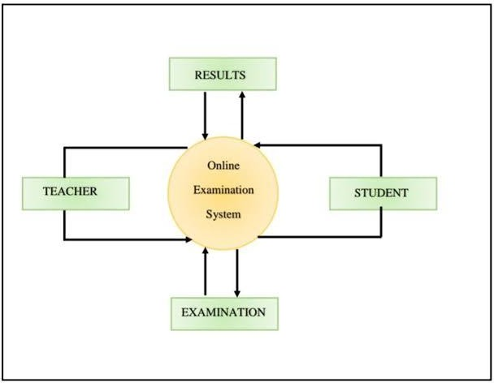

# SYSTEM REQUIREMENTS

## HARDWARE REQUIREMENTS:

* Devices.
* Intel Core i5 processor or equivalent.
* Minimum 2 GB RAM for smooth operation.
* 100 MB of free storage space for the app and data.
* Internet Connection.

## SOFTWARE REQUIREMENTS:

* HTML
* CSS
* BOOTSTRAP
* JAVASCRIPT
* MYSQL
* XAMPP
* PHP

# MODULE DESCRIPTION:

1. User Authentication Module:
   * Responsible for verifying the identity of users (students, teachers, administrators) during login.
   * Implements secure authentication mechanisms to protect user accounts and prevent unauthorized access.
2. Exam Management Module:
   * Facilitates the creation, scheduling, and management of exams by administrators.
   * Allows educators to set parameters such as duration, question types, and difficulty levels.
3. Question Bank Module:
   * Stores and manages a repository of questions categorized by subject, topic, and difficulty.
   * Enables educators to efficiently select and assemble questions for exams.
4. Exam Delivery Module:
   * Manages the secure delivery of exams to students during scheduled times.
   * Implements features like question randomization to enhance exam integrity.
5. Results and Grading Module:
   * Automates the process of grading objective questions.
   * Gives teachers a safe and effective way to check and finalize grades Presents findings in a timely and straightforward manner to teachers and students.
6. Control Panel for Users:
   * Manages roles, permissions, and user profiles (administrator, teacher, and student).
   * Gives administrators the ability to create, edit, or remove user accounts.
7. Anti-cheating and Security Module:
   * Puts policies in place to guarantee the security and integrity of online tests.
   * Has attributes include biometric authentication, plagiarism detection, and secure browser lockdown.
8. Reporting and Analytics Module:
   * Compiles and examines information on test-taking patterns, question complexity, and student achievement.
   * Produces informative reports that help administrators and educators make data-driven decisions.
9. Accessibility Module:
   * Guarantees that users with a range of needs, including those with disabilities, may utilize the platform.
   * Puts into practice functions like keyboard navigation and screen reader compatibility.
10. Mobile Compatibility Module:
    * This module makes the platform mobile-friendly so that users can access exams and results on tablets and smartphones.
11. Survey and Feedback Module:
    * Allows users to comment on the features and usability of the site.
    * Uses surveys to collect data for ongoing development.
12. Integration with Learning Management Systems (LMS):
    * Ensures seamless data exchange between the online examination platform and existing LMS. - Facilitates a unified experience for educators and students.
13. Administration and Configuration Module:
    * Provides administrators with tools to configure system settings, manage user roles, and customize the platform according to institutional requirements.
14. Continuous Improvement Module:
    * Facilitates ongoing updates and improvements based on user feedback, emerging needs, and technological advancements.
    * Supports the integration of new features and functionalities over time.

# LOGIN PAGE

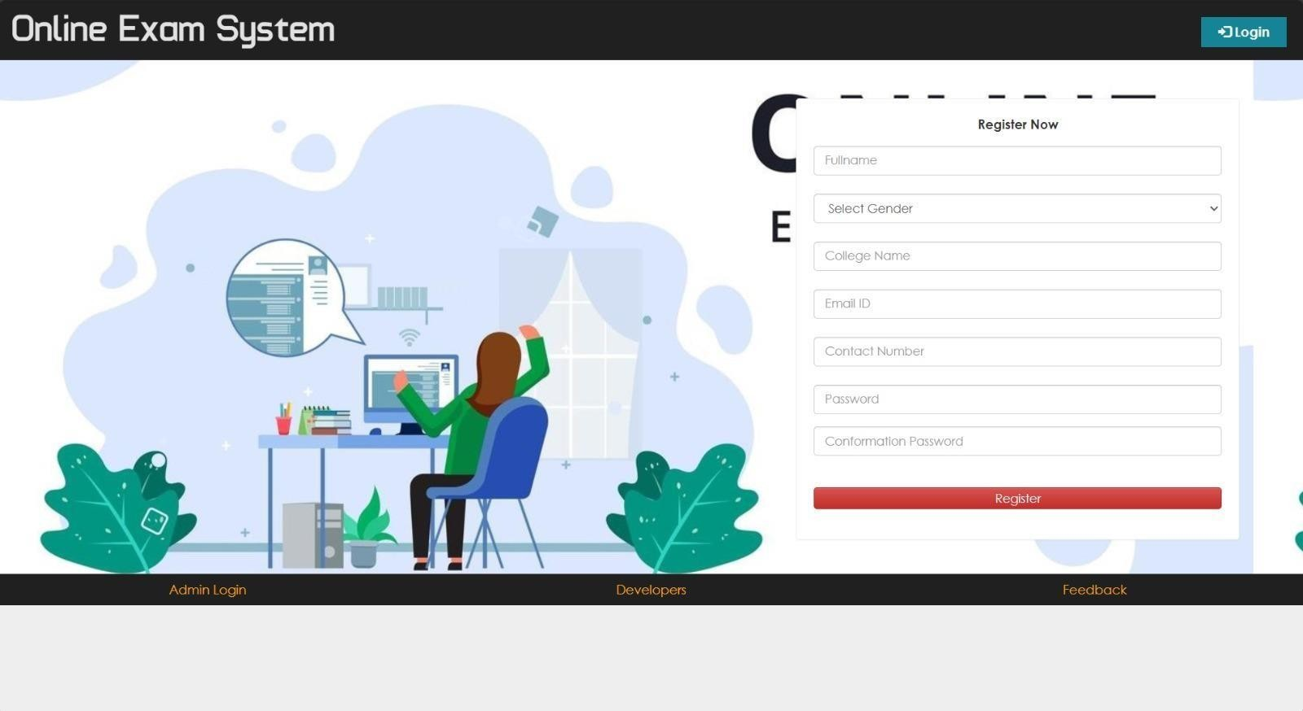

**HOME PAGE**

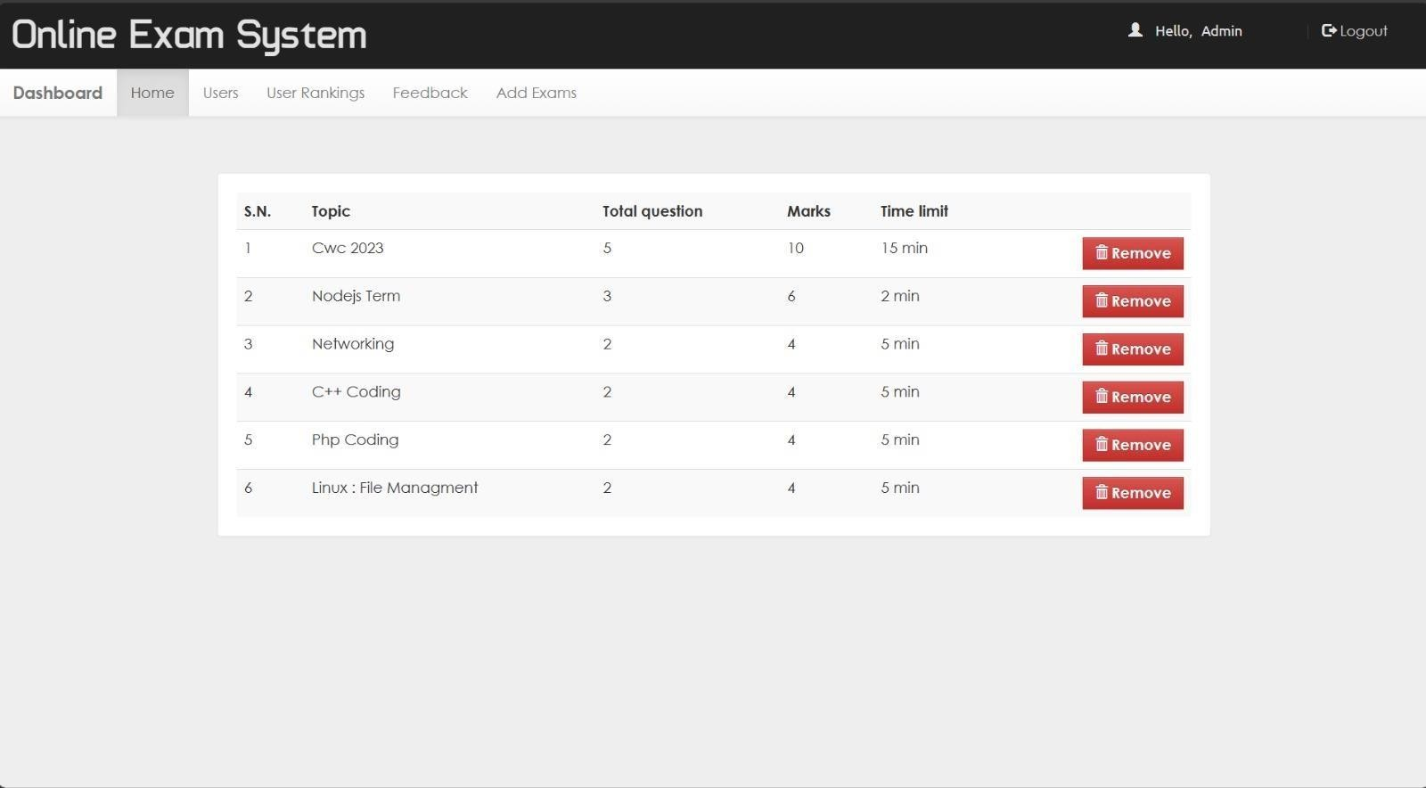

# CONCLUSION:

In summary, a major advancement in modernizing the educational assessment process has been made with the creation and deployment of an online testing platform. With a focus on user experience, the platform is intended to offer a safe and easy-to-use setting for administering tests online.System architecture has been carefully considered throughout the development lifecycle to ensure scalability, responsiveness, and effective data management. The foundation of the platform is the integration of a strong technology stack, which includes JavaScript, HTML, CSS, Node.js, Express.js, and MongoDB. This allows for a dynamic and engaging user experience. To ensure the integrity of evaluations and secure user data, security features like HTTPS, two-factor authentication, and anti-cheating systems have been carefully put in place.

## REFERENCES:

1. Source: "Difficulties associated with web-based assessment," by Richard M. Luecht, Proceedings of the 2001 National Council on Measurement in Education (NCME) Annual Meeting, Vol 2.
2. Y. Zhenming, Z. Liand, and Z Guohua, "A Novel Web Based Online Examination System for Computer Science Education," 33rd ASEE/IEEE Frontiers in Education Conf., S3F-7-S3F-10, 2003.
3. Project SIETTE, M. Trella, E. Guzman, R. Conejo, and E. Millan. Self-Evaluation in a Feasible, Adaptive Web-Based Testing System.
4. Management System." The authors of the text are Mahmoud S. Kandil, Ahmed E. Hassan, Mahmoud A. Zaher, and Magdi Z. Rashad. pages 48–55.
5. The International Journal of Electrical & Computer Sciences published the paper "An Arabic Web-Based Exam [5] Management System" in 2010. Mahmoud S. Kandil, Ahmed E. Hassan, Mahmoud A. Zaher, and Magdi Z. Rashad wrote it. pages 48–55.
6. Jim Ricker, Sean McCusker, and Daniel Pead. (2004). Evaluation of the Available Literature.

D. Zahirul Islam, Md. Mostafizur Rahman, and Md. Kabirul Islam published. International Journal of Science, Environment, ISSN 2278-3687 (O) and Technology, Vol. 2, No. 3, 2013, 351–359.

1. Alice M., Adebisi Baale, and Fagbola Oke (2013). A computer-based test (CBT) technology is used for the University Academic Enterprise Examination.
2. Hemant B. Shinde, Himangi Rinwa, Rohan Ranjan, Rohit Singh, and Varun Ringnekar. "Exam Conduction and Proctoring System Using Face Detection," Vol. 6, No. 1, 2022.