**DYNAMIC CLOUD WORKLOADS: A COMPREHENSIVE EXPLORATION AND DEEP DIVE INTO ADVANCED LOAD BALANCING TECHNIQUES FOR OPTIMAL RESOURCE MANAGEMENT**

**P.Prema1, K.Kala2, Dr.M.Deepa3, Dr.K.Vimala4**

1Student, Department of Computer Science, Pavai Arts & Science College for Women, Namakkal,

2,3,4Assistant Professor, Department of Computer Science, Pavai Arts & Science College for Women, Namakkal, Tamilnadu, India

**ABSTRACT**

In the rapidly evolving landscape of cloud computing, efficient resource management is paramount for ensuring optimal performance and scalability. This publication embarks on a comprehensive exploration of advanced load balancing techniques tailored for dynamic cloud workloads. The narrative unfolds with foundational concepts, establishing a solid understanding of the challenges posed by fluctuating demands in cloud environments. The deep dive into advanced load balancing techniques forms the core of this work, delving into innovative strategies designed to dynamically allocate resources in response to changing workloads. The publication addresses real-world scenarios, providing insights into practical implementations and their impact on resource optimization. From heuristic algorithms to machine learning-driven approaches, the reader is guided through a spectrum of cutting-edge techniques. The overarching goal is to equip professionals, researchers, and enthusiasts with a comprehensive toolkit for navigating the complexities of dynamic cloud workloads, ultimately contributing to enhanced resource efficiency and performance in cloud computing environments. This work seeks to be an invaluable resource for those seeking a nuanced understanding of advanced load balancing strategies and their pivotal role in optimal resource management within dynamic cloud ecosystems.

Keywords: Dynamic Cloud Workloads, load Balancing Techniques, Resource Management, Cloud Computing, Scalability, Performance Optimization

1. **INTRODUCTION**

In the dynamic realm of cloud computing, where the only constant is change, the ability to manage workloads effectively becomes a linchpin for success. This introduction sets the stage for our exploration into the intricacies of dynamic cloud workloads and the indispensable role played by advanced load balancing techniques in achieving optimal resource management. The digital era has witnessed an unprecedented surge in the adoption of cloud technologies, redefining the landscape of information technology. Cloud environments offer unparalleled flexibility and scalability, but they also present unique challenges, particularly in the face of fluctuating workloads and unpredictable demands. The need to orchestrate resources dynamically, ensuring that they align seamlessly with varying application requirements, has become a critical imperative.

Our journey begins with a fundamental acknowledgment of the dynamic nature inherent in modern cloud workloads. Unlike traditional computing paradigms, where resources could be provisioned statically, cloud environments demand a more adaptive and intelligent approach. The stakes are high — the efficient allocation of resources directly translates into performance, scalability, and cost-effectiveness.The primary focus of this comprehensive exploration is advanced load balancing techniques, positioned at the forefront of addressing the challenges posed by dynamic cloud workloads. As we delve into this subject, we will traverse the spectrum of load balancing, from classical algorithms to cutting-edge machine learning-driven strategies. Each facet is meticulously examined to provide a nuanced understanding of their applications, strengths, and limitations.[1]

Auto-scaling mechanisms, heuristic algorithms, and adaptive resource provisioning take center stage in our deep dive. These techniques not only respond to workload fluctuations in real-time but also lay the groundwork for intelligent resource management. The intricate interplay between load balancing and overall system performance forms a central theme throughout our exploration, emphasizing the symbiotic relationship between efficient resource utilization and the success of cloud-based applications. Practicality is the hallmark of our approach. [1]. The integration of theoretical concepts with real-world case studies and implementations ensures that our readers gain not only theoretical insights but also a pragmatic understanding of how these advanced load balancing techniques can be applied in diverse scenarios.

This work aims to serve as a beacon for professionals, researchers, and enthusiasts navigating the evolving contours of cloud computing. As we unravel the intricacies of advanced load balancing, our ultimate goal is to empower readers with the knowledge and tools necessary to optimize resource management in dynamic cloud environments, fostering a new era of efficiency and performance. The landscape of cloud workloads is marked by fluctuations in demand, varying resource requirements, and the constant quest for scalability. Traditional load balancing approaches often fall short in adapting to the rapid changes inherent in dynamic cloud environments. This publication seeks to bridge this gap by offering a thorough exploration of advanced load balancing techniques that are designed to dynamically allocate resources, ensuring efficiency and optimal system performance.

The exploration begins with a foundational understanding of dynamic cloud workloads, highlighting the unique challenges posed by their fluid nature. It then progresses into a deep dive into advanced load balancing strategies that go beyond conventional methods. From heuristic algorithms that adapt in real-time to machine learning-driven models capable of predictive resource allocation, the content unfolds to provide a comprehensive toolkit for navigating the complexities of dynamic cloud workloads. Building upon the foundational knowledge established in the previous chapters, this section takes a meticulous dive into advanced load balancing techniques. From heuristic algorithms that dynamically adapt to workload fluctuations to machine learning-driven strategies that intelligently predict resource needs, readers are exposed to a spectrum of cutting-edge approaches. Real-world case studies and practical implementations offer a hands-on understanding of how these techniques can be effectively integrated into cloud architectures. At the heart of the dynamic cloud ecosystem lies the pivotal role of load balancing. This chapter delves into the fundamentals of load balancing, elucidating its significance in distributing workloads evenly across servers to prevent bottlenecks and ensure optimal resource utilization. From traditional methods to contemporary approaches, the chapter provides a comprehensive overview of load balancing techniques, setting the stage for a deep dive into advanced strategies [2].

The complete article is organized as follows: Section two covers a literature review on cloud computing, load balancing, deep learning and optimization methods in load balancing and their challenges. Section three presents materials and techniques which offer the proposed model's working, design, procedures, and parameters. Section four covers the experimental results and comparison of the proposed model and existing solutions; this section also covers a discussion subsection. Section five covers the conclusion and future direction of the research, limitations and critical aspects

1. **LITERATURE REVIEW**

The challenges associated with consolidating cloud data centers warrant careful examination. The amalgamation of virtual machines (VMs) is achievable through virtualization, enhancing resource utilization and diminishing energy consumption. Cloud service providers deploy numerous virtual machines on a single physical host. This article segment focuses on the latest energy-efficient techniques for integrating virtual machines into data storage processors, encompassing cloud-based data centers. Additionally, this section conducts various comparative analyses to assess research gaps identified in prior studies.

A technique for resource-efficient and dynamic consolidation of virtual machines was developed as outlined in [1]. This method, based on four algorithms designed for different phases of VM fusion, presents a cutting-edge solution for VM load balancing in cloud-based data centers, taking into account SLAs and power consumption, as discussed in [2]. To address the identification of overloaded and underloaded VMs, a VM distribution method using a reliable basic PSO was proposed. Additionally, a model incorporating learning automation through GA and ACO knowledge was introduced in [12] to further enhance distribution and reduce energy consumption. This model employs the GA method to match specific workloads with suitable machines in the cloud. In the context of a cloud-based system, an ACO workload distribution approach was introduced in [3]. This research primarily focuses on reducing energy consumption and improving workload distribution efficiency, striving to complete tasks at high performance levels. The study establishes lower criteria for overall workload utilization within the data center and employs ant colony optimization to minimize the frequency of VM movements. Further exploration into optimization and machine learning-based workload distribution in the cloud environment is discussed in [4]. The proposed model utilizes a bee colony optimization method and includes an energy utilization calculation for cloud data centers, utilizing a Planet Laboratory with numerous virtual machines under large-scale modeling configurations.

For prospective resource utilization forecasting, a discrete-time systems Markov chain model was introduced in [5]. This model suggests that the Host's reliability framework can be employed for a more precise classification of hosts based on their states. Subsequently, researchers proposed a multi-objective virtual machine positioning method that utilizes the dominance-based multiple-purpose Ant Bee Colony methodology to find optimal VMs for host mappings. This comprehensive approach brings together various advanced algorithms and techniques to address the challenges and intricacies of virtual machine management in cloud-based environments. A recurrent LSTM neural network model was introduced to propose a forecasting algorithm for predicting future HTTP workloads. This method involves the utilization of an ANN to address elastic acceleration and automatic deployment-related scaling. In [6], a multi-objective adaptive algorithm was implemented to estimate memory and CPU utilization, along with energy consumption for the upcoming time slot. The approach put forward by the researchers in [7] focuses on forecasting the workload of cloud data centers, leveraging an LSTM network for constructing the forecasting method. Forecasting of data demand stored in the cloud center was suggested in [8,9] with the article's approach relying on a network incorporating LSTM.

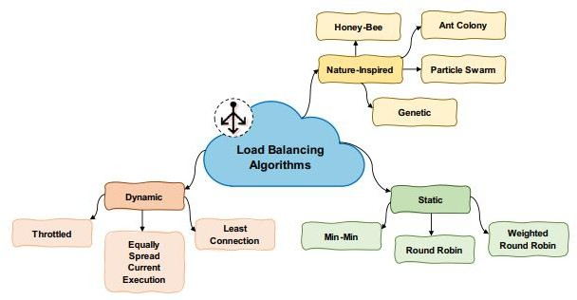Addressing load estimation in cloud data centers, the article [10] employs an LSTM network to develop a computational load forecasting model. Results from experiments indicate that the proposed approach demonstrates superior accuracy in forecasting compared to alternative methods considered. Additionally, the article points out that many cloud service providers rely on user-defined resource criteria for auto-scaling features, posing limitations on the ability to construct models based on diverse workload factors. To enhance forecast precision, a combination of seven distinct prediction algorithms spanning statistical time series analysis, linear regression, and artificial intelligence domains is integrated. In the context of forecasting server workload patterns within a cloud-based storage center, this study introduces a cloud load prediction method utilizing a weighted fractal support vector machine algorithm [11]. The research incorporates parametric optimization through a technique called the particle optimization technique. Another approach [12] focuses on predicting mega-variant resource consumption in data centers of the cloud, encompassing network bandwidth, processor, and storage resources. This method leverages CNN and LSTM models to indicate resource usage, employing the matrix auto-regression approach to filter linear connections with mega-variant data in the initial phase.

Figure 1: load balance in cloud

Previous methods primarily emphasized limiting the number of actively processing physical machines (PMs) to address energy usage and load variability issues in VM provisioning. Introducing a novel approach, AFED-EF (Adaptive energy-aware VM allocation and deployment mechanism) [13] is proposed for IoT applications. This approach effectively addresses virtual machine allocation and placement, demonstrating competence in managing load fluctuations through a comprehensive experimental study using a real-world workload comprising over a thousand PlanetLab VMs. Comparative analysis with other energy-aware methods revealed AFED-EF's superior performance in terms of overall energy usage, SLA violations, and overall system performance. In the realm of Software-Defined Data Centers (SDDC) operating in a Cyber-Physical System (CPS) environment, an article [14] introduces an energy-efficient virtual machine cluster placement technique named EVCT. Employing a weighted directed network model, EVCT leverages VM similarity to tackle the VM deployment challenge. Using the "maximum flow and minimum cut theory" to segment the graph into directed segments, EVCT considers traffic across VMs to achieve high energy-efficient positioning. The suggested approach exhibits improved energy cost consumption, enhanced scalability, and exceptional service levels for consumers. Rigorous testing confirms the effectiveness of EVCT in handling real-world loads.

Addressing the challenge of reducing excessive energy consumption in cloud data centers while mitigating SLA breaches, another study [15] delves into novel adaptive algorithms. Existing energy resource management methods in cloud data centers often focus on reducing power usage. However, the proposed adaptive algorithms consider application types, in addition to CPU and memory resources, during virtual machine deployment. The research covers cloud data center SLA and violation rate analysis, demonstrating that the proposed methods effectively reduce energy consumption within cloud data centers while maintaining low SLA violations, outperforming existing energy-saving solutions.Top of Form

1. **METHODOLOGY**

In this study, an effort has been undertaken to decrease the number of fitness calculations for each bee, thereby enhancing the overall processing time. This enhancement is accomplished by integrating ABC with the CBLB algorithm. In this refined algorithm, instead of choosing food sources randomly, the selection is performed in a sequential order based on the CBLB algorithm. Opting for food sources through the CBLB algorithm elevates the likelihood of bees obtaining favorable fitness in the initial selections. Consequently, this minimizes the redundant selection of food sources and the need for fitness calculation for a single task. Furthermore, it contributes to the reduction of allocation time, thereby improving the overall processing efficiency. The procedural steps of this enhanced algorithm are detailed in the pseudocode provided below.

1. Top of Form

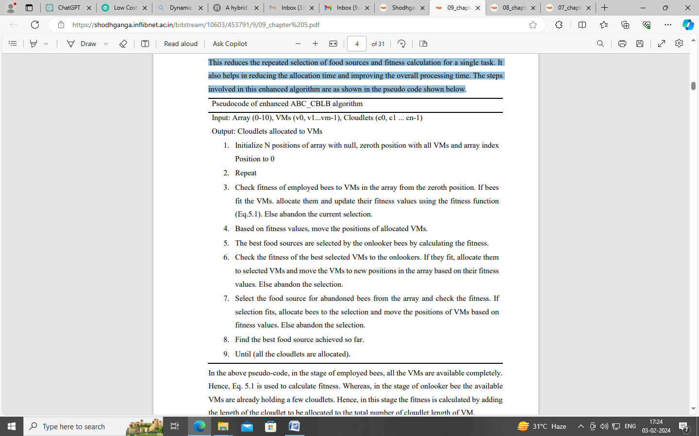

The algorithm is subjected to a comparison with the established general load balancing Throttled algorithm. Simulations and AWS implementations are conducted for both homogeneous and heterogeneous setups, focusing on parameters such as makespan, average response time, and throughput. Across both environments, Cloud-Based Load Balancing (CBLB) exhibits nearly identical behavior. It demonstrates a reduced makespan and increased throughput across all cloudlet length ranges compared to Throttled. Notably, as cloudlet length ranges increase, CBLB showcases an enhancement in average response time. Similar patterns are observed for dynamic load scenarios. The AWS implementation results align closely with the simulation outcomes, affirming the algorithm's performance.In addition to the specified parameters, CPU utilization in AWS CloudWatch indicates superior CPU utilization by CBLB compared to Throttled. The analysis extends to evaluating CBLB's capacity to distribute load among multiple Data Centers (DCs) and in an elastic environment by varying the number of DCs and VMs, respectively. Results affirm CBLB's competence in load distribution across any number of DCs and within an elastic cloud environment. Furthermore, the algorithm's effectiveness is assessed in various capacity homogeneous setups, consistently outperforming Throttled. These findings collectively underscore CBLB's capability to efficiently distribute load in dynamic cloud environments, surpassing the existing Throttled algorithm.

**4. RESULTS AND DISCUSSION**

In the initial phases of these experiments, the group size 11 is initially considered in the CBLB algorithm. Subsequently, it is implemented with varying group sizes, specifically 6 and 20, to assess their relative efficiency. After a thorough comparison of results, the group size 11 is identified as the optimal choice for the CBLB algorithm. As the research progresses, the natural phenomena-based ABC algorithm undergoes enhancement through integration with the proposed CBLB algorithm. The outcomes of this enhanced algorithm are then compared with those of the basic ABC algorithm. Similar to the CBLB, the results of the enhanced algorithm are validated for both homogeneous and heterogeneous setups across metrics such as makespan, average response time, average waiting time, and throughput.

The ABC_CBLB exhibits improvements over the basic ABC in both setups for all parameters, albeit with minor variations. Despite the improvement, the increased cloudlet length has led to a reduction in the percentage of improvement for average response time and average waiting time. Nevertheless, when considering overall results, the performance of ABC_CBLB surpasses that of the basic ABC.Furthermore, the efficiency of ABC_CBLB is tested across varied numbers of Data Centers (DCs) and Virtual Machines (VMs). Interestingly, the increased number of DCs does not impact ABC_CBLB's enhancement over the basic ABC, and this enhancement persists with varying numbers of VMs. Additionally, varying the capacity of VMs in the homogeneous setup also demonstrates the superiority of the ABC_CBLB over the basic ABC algorithm.

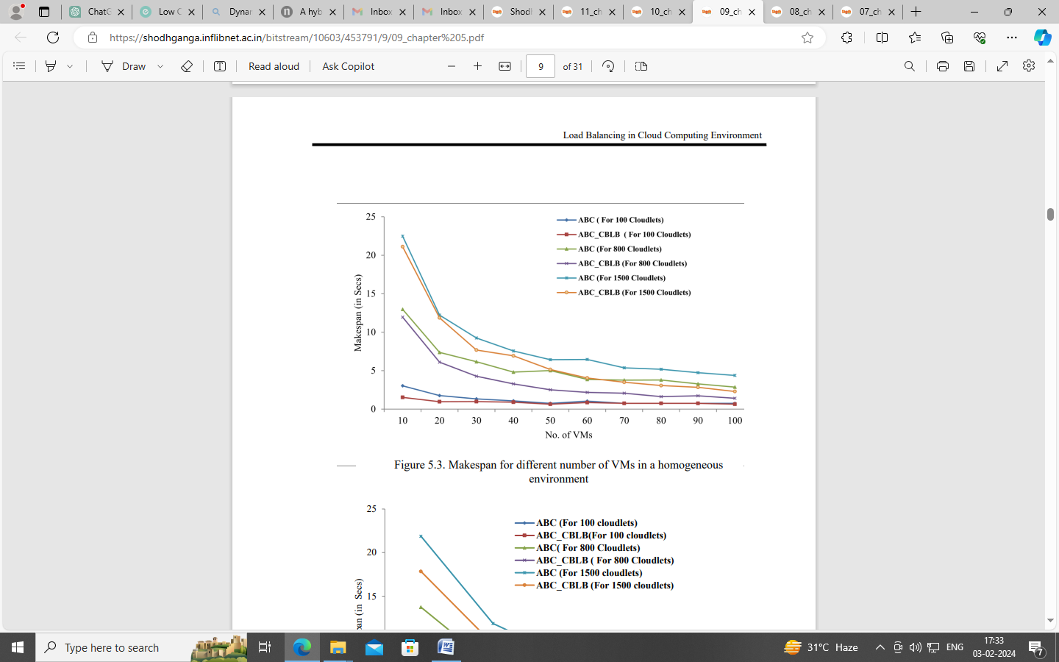

**Figure 2: Different Numbers of VMs**

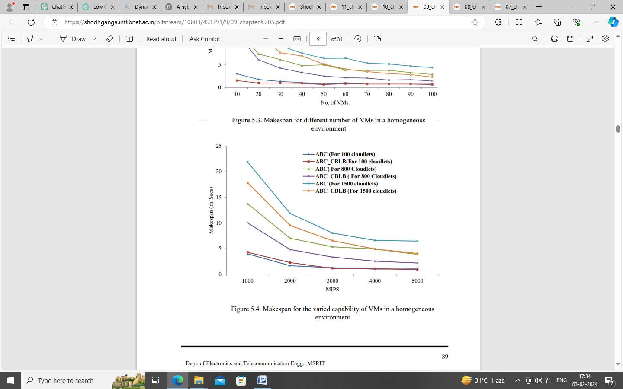

**Figure 3: Various Capability of VMs**

The results of the algorithms are studied for the different capacity VMs as well and are shown in Figure 2. These results are obtained for varied VM capacities from 1000 to 5000 MIPs. When there are 100 cloudlets, both the algorithms have given almost the same makespan for all capacity VMs. There is a slight improvement in the makespan of the ABC_CBLB for 2000 MIPS. But for cloudlets 800 and 1500, the ABC_CBLB has given less makespan than the ABC in all capacity VM homogeneous setups. When the capacities of VMs are 4000 and 5000 MIPS, the makespan of the ABC_CBLB and ABC are the same for 1500 and 800 cloudlets respectively. This shows that at a given time duration the ABC_CBLB can process additional cloudlets compared to the ABC algorithm. It shows the ability of the ABC_CBLB to handle more cloudlets compared to ABC in the large capacity homogeneous cloud setup. The comparison of the algorithms for average response time for different cloudlet length ranges is shown in Figure 3. In all the ranges, the average response time of ABC_CBLB is lesser than the ABC. But a noticeable improvement can be seen in the 500-1500 cloudlet length graph. This signifies that the ABC_CBLB gives a better response time for the small cloudlet length range than that of the larger length.

The compatibility of the ABC_CBLB for the elastic nature of cloud computing is tested by varying the number of VMs from 10 to 100 and results are plotted in Figure 2. The ABC_CBLB has taken less time to process 100 cloudlets than the ABC. Whereas, both the algorithms are having more or less the same makespan for a large number of VMs. The ABC_CBLB has a good makespan for 800 and 1500 cloudlets. Though it has better makespan than ABC for almost all the VM numbers, compared to more VMs, a vast improvement can be noticed for fewer VMs. Up to 40 VMs, the time taken by ABC_CBLB to process 1500 cloudlets is less than the time taken by ABC to process 800 cloudlets. Few more observations that can be made from the graph are: increased number of VMs has not brought much difference in the makespan of the ABC_CBLB, whereas there is a drastic reduction in the makespan of the ABC. Though varied VM numbers have brought improvement in the makespan of the ABC it is not better than ABC_CBLB. Therefore, the enhanced algorithm is much more suitable for the elastic cloud computing environment than the basic one.

1. **CONCLUSION**

Achieving enhanced system performance can be realized through load balancing, a solution that effectively distributes the workload across all available resources. This optimization strategy involves adding or removing resources as needed, ensuring efficient system performance. Numerous research endeavors aim to develop efficient load balancing algorithms for distributing workloads among resources. This study contributes to this field, focusing on three categories: general algorithms, those inspired by natural phenomena, and cluster-based cloud load balancing. The market offers various open-source simulators for cloud computing, providing environments for both infrastructure and application services. Many of these simulators, derived from CloudSim, serve diverse purposes. CloudSim, as a foundational simulator, enables users to evaluate different cloud computing scenarios, especially in terms of resource provisioning. Consequently, the contributions in this thesis are implemented and tested within the CloudSim simulator. In addition to simulation implementation, the general and natural phenomena-based methodologies are executed and their results cross-verified in a real cloud environment. AWS, recognized for its flexibility and dominant position in the public cloud infrastructure market, is chosen among top public cloud service providers for the real cloud implementations in this research. This multi-faceted approach ensures a comprehensive evaluation of the proposed load balancing techniques, spanning simulation environments to real-world applications in the AWS cloud infrastructure.

1. **REFERENCES**
2. Tabrizchi, H., Razmara, J. & Mosavi, A. Thermal prediction for energy management of clouds using a hybrid model based on CNN and stacking multi-layer bi-directional LSTM. Energy Rep. 9, 2253–2268 (2023).
3. Gan, Z., Chen, P., Yu, C., Chen, J. & Feng, K. Workload prediction based on GRU-CNN in cloud environment. In 2022 International Conference on Computer Engineering and Artificial Intelligence (ICCEAI), 472–476 (IEEE, 2022).
4. Mukherjee, D., Ghosh, S., Pal, S., Aly, A. A. & Le, D.-N. Adaptive scheduling algorithm based task loading in cloud data centers. IEEE Access 10, 49412–49421 (2022).
5. Zeng, J., Ding, D., Kang, K., Xie, H. & Yin, Q. Adaptive DRL-based virtual machine consolidation in energy-efficient cloud data center. IEEE Trans. Parallel Distrib. Syst. 33(11), 2991–3002 (2022).
6. Jamal, M. H. et al. Hotspot-aware workload scheduling and server placement for heterogeneous cloud data centers. Energies 15(7), 2541 (2022).
7. Lilhore, U. K., Simaiya, S., Garg, A., Verma, J. & Garg, N. B. An efficient energy-aware load balancing method for cloud computing. In 2022 4th International Conference on Artificial Intelligence and Speech Technology (AIST), 1–5 (IEEE, 2022).
8. Sharma, M. & Garg, R. HIGA: Harmony-inspired genetic algorithm for rack-aware energy-efficient task scheduling in cloud data centers. Eng. Sci. Technol. Int. J. 23(1), 211–224 (2020).
9. Lilhore, U. K., Simaiya, S., Maheshwari, S., Manhar, A. & Kumar, S. Cloud performance evaluation: hybrid load balancing model based on modified particle swarm optimization and improved metaheuristic firefly algorithms. Int. J. Adv. Sci. Technol. 29(5), 12315–12331 (2020).
10. Ghasemi, A. & Haghighat, A. T. A multi-objective load balancing algorithm for virtual machine placement in cloud data centers based on machine learning. Computing 102, 2049–2072 (2020).
11. Boveiri, H. R., Khayami, R., Elhoseny, M. & Gunasekaran, M. An efficient swarm-intelligence approach for task scheduling in cloud-based internet of things applications. J. Amb. Intell. Hum. Comput. 10, 3469–3479 (2019).
12. Pawar, N., Lilhore, U. K. & Agrawal, N. A hybrid ACHBDF load balancing method for optimum resource utilization in cloud computing. Int. J. Sci. Res. Comput. Sci. Eng. Inf. Technol. 3307, 367–373 (2017).
13. Naik, B. B., Singh, D. & Samaddar, A. B. FHCS: Hybridized optimization for virtual machine migration and task scheduling in cloud data center. IET Commun. 14(12), 1942–1948 (2020).
14. Sardaraz, M. & Tahir, M. A parallel multi-objective genetic algorithm for scheduling scientific workflows in cloud computing. Int. J. Distrib. Sens. Netw. 16(8), 1550147720949142 (2020).
15. Zhou, Z., Shojafar, M., Alazab, M., Abawajy, J. & Li, F. AFED-EF: An energy-efficient VM allocation algorithm for IoT applications in a cloud data center. IEEE Trans. Green Commun. Netw. 5(2), 658–669 (2021).
16. Zhou, Z., Shojafar, M., Li, R. & Tafazolli, R. EVCT: An efficient VM deployment algorithm for a software-defined data center in a connected and autonomous vehicle environment. IEEE Trans. Green Commun. Netw. 6(3), 1532–1542 (2022).
17. Zhou, Z. et al. Minimizing SLA violation and power consumption in Cloud data centers using adaptive energy-aware algorithms. Future Gener. Comput. Syst. 86, 836–850 (2018).