**An Integrated Examination of Ayodhya's Significance in Shaping Uttar Pradesh's Economic Terrain**

**\*Dr. Daya Shanker Kanaujia**

**Abstract**

The economic landscape of Uttar Pradesh, India, reflects a dynamic and diverse environment poised for significant growth and development. This paper provides a comprehensive analysis of key economic indicators and strategic initiatives that shape Uttar Pradesh's economic trajectory. With a population of nearly 200 million, Uttar Pradesh is the most populous state in India, contributing substantially to the nation's Gross State Domestic Product (GSDP). The state's economic journey, spanning from FY 2012-2022, showcases a remarkable increase in GSDP, emphasizing its resilience and potential for sustained growth.

Tourism emerges as a key driver of economic activity, with iconic landmarks such as the Taj Mahal drawing both domestic and international tourists. The state's commitment to infrastructure development, renewable energy, and support for startups further positions Uttar Pradesh as a hub for investment and innovation. The agricultural sector, a cornerstone of the state's economy, plays a pivotal role in ensuring food security for the nation.

This paper offers insights into the challenges and opportunities facing Uttar Pradesh, suggesting strategic recommendations to capitalize on its strengths. Diversification of tourism offerings, accelerated adoption of renewable energy, and modernization of agriculture are key focal points for future growth. Strengthening connectivity, promoting cultural exchanges, and prioritizing environmental sustainability will contribute to Uttar Pradesh's holistic and inclusive development.

**Keyword**- Uttar Pradesh Economy, GSDP Growth, Renewable Energy Initiatives, Infrastructure Development

## *Assistant Professor, Department of Commerce, Lucknow Public College Of Professional Studies, Lucknow

**Introduction**

Ayodhya, a city resonating with historical, cultural, and religious echoes, stands at the crossroads of tradition and modernity in the heart of Uttar Pradesh, India. Revered as the birthplace of Lord Rama, Ayodhya has long been a symbol of religious harmony and cultural heritage. However, the city's significance extends beyond its spiritual roots, as it increasingly plays a pivotal role in shaping the economic terrain of Uttar Pradesh. This research paper seeks to provide an in-depth examination of Ayodhya's integrated impact on the economic dynamics of the state.

For centuries, Ayodhya has been a center of pilgrimage, drawing devotees from across the globe. The confluence of spirituality and culture has imbued the city with a unique charm, making it a beacon for religious tourism. Recent years have witnessed a transformative shift, as Ayodhya's economic importance has gained prominence alongside its cultural and religious standing. The city's influence is not confined to its sacred precincts; it permeates various facets of Uttar Pradesh's economic landscape, influencing sectors such as tourism, infrastructure development, and local craftsmanship.

The objective of this research paper is to unravel the intricate connections between Ayodhya's multifaceted significance and the economic fabric of Uttar Pradesh. By adopting an integrated approach, we aim to explore the historical roots, the economic repercussions of religious tourism, the impact of infrastructure development, and the role of Ayodhya as a cultural and handicraft hub. Additionally, we will delve into the challenges and opportunities that arise from Ayodhya's evolving role in shaping the economic destiny of the state.

As Uttar Pradesh undergoes rapid urbanization and economic transformation, Ayodhya's unique position demands scholarly attention. Understanding the interplay between the city's cultural heritage and economic development is crucial for formulating policies that ensure sustainable growth, preserve cultural identity, and foster community well-being. This research aspires to contribute valuable insights to the discourse surrounding Ayodhya's role in shaping Uttar Pradesh's economic terrain, paving the way for informed decision-making and inclusive development strategies.

**Research Objectives**

1. Investigate Ayodhya's historical evolution, tracing origins and cultural milestones.

2. Quantify the economic impact of religious tourism, analyzing revenue and tourist trends.

3. Examine infrastructure projects in Ayodhya, evaluating their impact on the local economy.

4. Explore Ayodhya's role as a cultural and handicraft hub, assessing economic significance.

5. Identify challenges and opportunities for sustainable economic growth, considering cultural preservation and community involvement.

**Uttar Pradesh economic**

Uttar Pradesh (UP), one of India's most populous states, stands as a critical player in shaping the economic landscape of the nation. With a rich historical and cultural heritage, UP's economy is a mosaic of diverse sectors contributing to its growth and development. This essay provides a comprehensive examination of the key aspects driving Uttar Pradesh's economy, including its major industries, challenges, and the strategies employed for sustainable growth.

Uttar Pradesh, the most populous state in India, with nearly 200 million people, is a vibrant tapestry of diverse sectors contributing to its economic vitality. Bordered by Nepal to the north and surrounded by Indian states like Uttarakhand, Himachal Pradesh, Haryana, Delhi, Rajasthan, Madhya Pradesh, Chhattisgarh, Jharkhand, and Bihar, Uttar Pradesh is a key player in shaping India's economic landscape.

As of the current financial year 2023-24, the gross state domestic product (GSDP) of Uttar Pradesh is estimated to be Rs. 24.39 trillion (US$ 295.48 billion). Projections suggest a robust Compound Annual Growth Rate (CAGR) of 9.01% from 2018-19 to 2023-24, reflecting the state's sustained economic expansion.

Uttar Pradesh is renowned as a favored tourist destination, boasting iconic landmarks such as the Taj Mahal in Agra, one of the Eight Wonders of the World. In 2021, domestic tourist arrivals reached 109.71 million, the second-highest in the country, while foreign tourist arrivals stood at 44,737, ranking seventh nationally. The state government's commitment to promoting tourism is evident in initiatives like establishing four new heliports to enhance accessibility.

The state's energy landscape is marked by an installed power generation capacity of 29,913.48 MW as of April 2023. Thermal power dominates with 21,417.26 MW, followed by hydropower (3,424.02 MW), nuclear power (289.48 MW), and renewable power (4,782.72 MW). Uttar Pradesh is making strides in renewable energy, with the draft of its Solar Energy Policy-2022 aiming to produce 16,000 MW of renewable energy by 2026–27.

Uttar Pradesh stands as the largest producer of food grains in India, contributing about 17.83% to the country's total food grain output in 2016-17. The state's diverse agricultural production includes rice, wheat, maize, millet, gram, pea, lentils, pulses, and vegetables.

The state government supports businesses through various policies and incentives, such as the Industrial and Service Sector Investment Policy, 2004, and Infrastructure and Industrial Investment Policy, 2012. In recent years, FDI inflows in Uttar Pradesh have totaled US$ 1,301.36 million, ranking 11th in India.

Merchandise exports from Uttar Pradesh reached US$ 21.03 billion in FY22 and US$ 9.53 billion in FY23. The state government has rolled out policies like the New Electronics Manufacturing Policy, 2020, and Uttar Pradesh Startup Policy, 2020, to boost local manufacturing and support startups.

Recent developments highlight the state's commitment to growth across sectors. Projects worth Rs. 7,000 crore (US$ 8.5 billion) were announced for Uttar Pradesh's infrastructure. The state also took significant steps in education, healthcare, and road development, demonstrating a holistic approach to progress.

As Uttar Pradesh continues to evolve, the state's economic dynamism, coupled with proactive policies and strategic investments, positions it as a key contributor to India's growth story. The state's rich cultural heritage, combined with forward-looking initiatives, creates a promising trajectory for the economic future of Uttar Pradesh.

domestic product (GSDP) of Uttar Pradesh, India, witnessed substantial growth over the period from fiscal year 2012 to fiscal year 2022. In the financial year 2022, the GSDP for Uttar Pradesh amounted to approximately 18.6 trillion Indian rupees, marking a noteworthy increase from seven trillion rupees in the fiscal year 2012.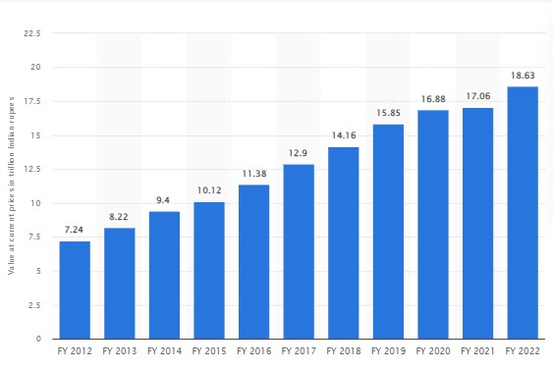

**Source**- Statista.com

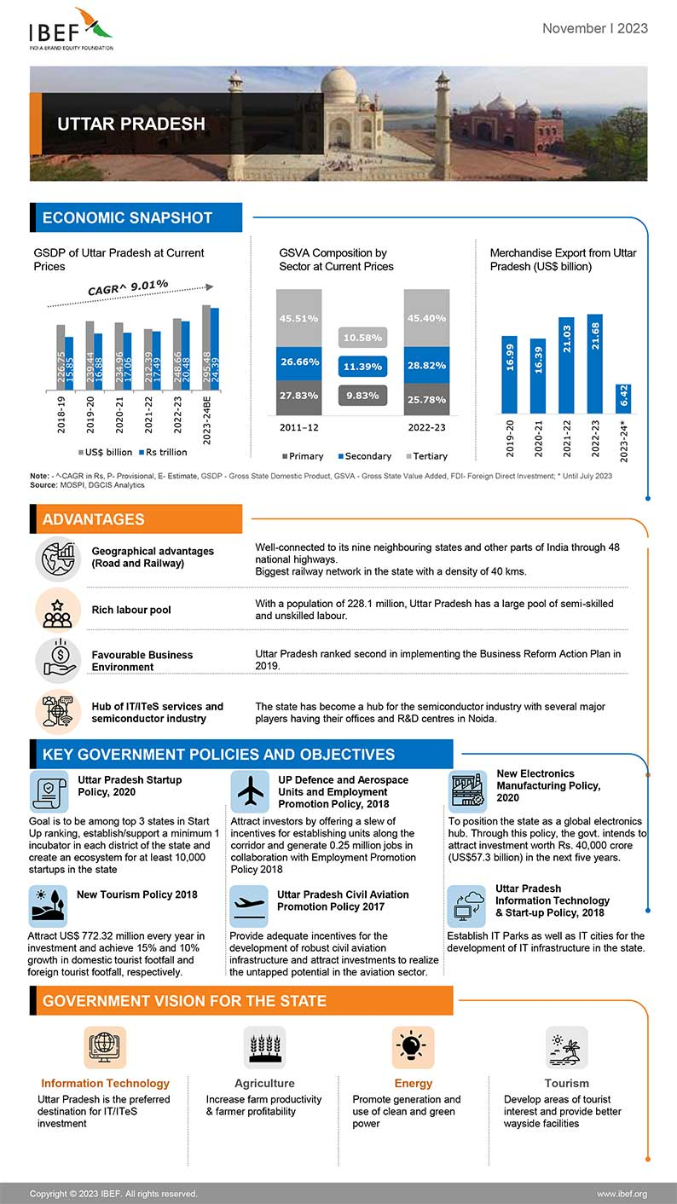

**According to data published by Manya Rathore on May 15, 2023**, the gross state

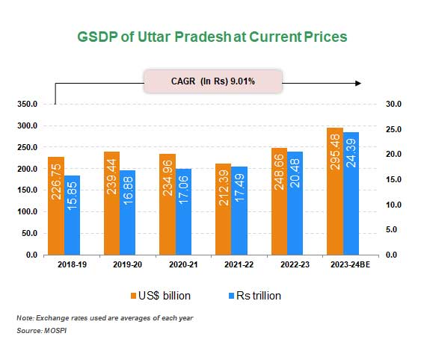

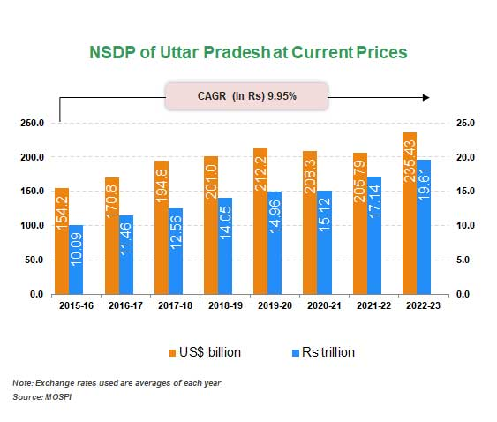**Economic Structure and Key Industries:**

Uttar Pradesh's economy exhibits a diverse structure, encompassing agriculture, manufacturing, services, and a burgeoning informal sector. Agriculture, a traditional cornerstone, remains vital, contributing significantly to the state's economy. The fertile Gangetic plains facilitate the cultivation of crops such as wheat, rice, sugarcane, and pulses.

The manufacturing sector plays a crucial role, with Uttar Pradesh hosting industrial hubs such as Kanpur, Noida, and Ghaziabad. The state has witnessed substantial growth in sectors like textiles, leather, chemicals, and electronics. The establishment of industrial corridors, including the Delhi-Mumbai Industrial Corridor (DMIC), has further bolstered Uttar Pradesh's industrial prowess.

The services sector, including information technology (IT), education, and healthcare, is also expanding. Cities like Noida and Lucknow are emerging as IT and educational hubs, attracting investments and skilled professionals. The service sector's growth contributes significantly to the state's GDP.

**Agricultural Challenges and Initiatives:**

Despite the prominence of agriculture, Uttar Pradesh faces challenges such as fragmented land holdings, dependence on monsoons, and issues related to outdated farming practices. The state government has initiated schemes to address these challenges, focusing on modernization, irrigation facilities, and the adoption of technology to enhance agricultural productivity.

**Infrastructure Development:**

Infrastructure development is a key focus area for Uttar Pradesh's economic progress. The state government has undertaken initiatives to improve connectivity, including the construction of expressways and the expansion of airports. The development of the Agra-Lucknow Expressway and the Purvanchal Expressway are examples of transformative projects enhancing transportation and connectivity within the state.

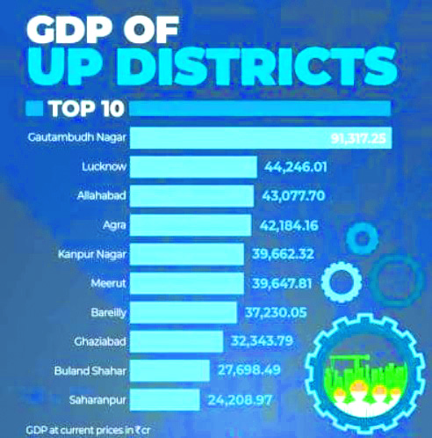

**Tourism and Cultural Heritage:**

Uttar Pradesh, with its historical and cultural richness, attracts tourists from around the world. The presence of iconic landmarks such as the Taj Mahal in Agra, the spiritual city of Varanasi, and the evolving significance of Ayodhya contribute significantly to the tourism sector. Investments in the tourism infrastructure and promotion of heritage sites are bolstering this sector, generating employment and revenue.

**Challenges and Future Prospects:**

Despite significant strides, Uttar Pradesh faces challenges, including unemployment, poverty, and socio-economic disparities. Addressing these issues requires a holistic approach, combining economic policies, skill development initiatives, and social welfare programs.

The future prospects for Uttar Pradesh's economy remain promising. Strategic investments, leveraging the state's demographic dividend, and fostering innovation can contribute to sustained growth. Moreover, continued emphasis on infrastructure development, skill enhancement, and inclusive economic policies will be instrumental in steering Uttar Pradesh towards becoming a key driver of India's economic progress.

**Uttar Pradesh Tourism**

Uttar Pradesh, the heartland of India, boasts a rich tapestry of history, culture, and spirituality that makes it a captivating destination for tourists. From iconic landmarks to sacred rivers, Uttar Pradesh's tourism sector showcases the essence of the country's diversity. This essay delves into the multifaceted dimensions of Uttar Pradesh tourism, exploring its historical treasures, religious sanctuaries, and the cultural kaleidoscope that attracts millions of visitors each year.

**Historical Splendors:**

Uttar Pradesh serves as a custodian of India's historical legacy, with Agra being home to the world-renowned Taj Mahal, a UNESCO World Heritage Site. The city stands as a testament to Mughal architecture and love, drawing tourists from across the globe. Additionally, Fatehpur Sikri, another UNESCO heritage site, and the majestic Agra Fort offer a glimpse into the grandeur of bygone eras.

**Religious Pilgrimage:**

The state is synonymous with spirituality, housing some of Hinduism's holiest cities. Varanasi, situated on the banks of the Ganges, is a city of eternal significance, where the ancient ghats and religious rituals mesmerize visitors. Ayodhya, the birthplace of Lord Rama, and Mathura-Vrindavan, associated with Lord Krishna, are pilgrimage sites resonating with devotion and cultural richness.

**Cultural Extravaganza:**

Uttar Pradesh's cultural fabric unfolds through vibrant festivals, traditional arts, and folk performances. The city of Lucknow, with its Nawabi heritage, offers a glimpse into classical dance, music, and the opulence of Awadhi cuisine. The Ram Lila performances in Ayodhya during Navaratri showcase the cultural fusion of spirituality and the performing arts.

**Tourism Initiatives and Infrastructure Development:**

To harness the tourism potential, the Uttar Pradesh government has undertaken initiatives to enhance infrastructure and promote key destinations. The development of expressways, such as the Agra-Lucknow Expressway and the Purvanchal Expressway, facilitates easier access to various attractions. Furthermore, the government's focus on Ayodhya's development as a cultural and religious hub aims to enrich the tourism experience.

**Religious and Spiritual Tourism:**

Uttar Pradesh's allure extends beyond historical monuments to encompass a diverse spiritual panorama. The Kumbh Mela, held at the confluence of the Ganges, Yamuna, and Saraswati rivers in Prayagraj, stands as the largest peaceful gathering in the world. The city becomes a celestial hub during this event, attracting millions of pilgrims seeking spiritual cleansing.

**Challenges and Opportunities:**

While Uttar Pradesh's tourism sector flourishes, challenges such as infrastructure gaps, waste management, and the need for sustainable practices persist. Addressing these challenges is essential to ensure a seamless and eco-friendly experience for visitors. Additionally, opportunities lie in the untapped potential of lesser-known destinations, cultural festivals, and eco-tourism initiatives.

**Ram Mandir will be the game changer in the economic development of Ayodhya.**

The construction of the Ram Mandir is poised to be a transformative force in Ayodhya's economic development. Projections suggest that the temple, along with other planned tourism initiatives, could significantly augment Uttar Pradesh's tax revenue by an estimated Rs 20,000-25,000 crore. Additionally, the collective impact of the temple and various governmental endeavors may contribute an extra Rs 25,000 crore in tax revenue for the state by FY25. Beyond its fiscal implications, the temple has garnered funding for diverse developmental and infrastructural projects, catalyzing Ayodhya's emergence as a regional growth hub. The recently inaugurated Ayodhya Dham Station is set to enhance connectivity, linking Ayodhya with other parts of the country. Moreover, the temple's presence has spurred a notable real estate upswing in Ayodhya, with land prices surging, in some instances, five to 10 times the rates observed four to five years ago.

The Ram Mandir and other tourism initiatives in Ayodhya have the potential to significantly elevate Uttar Pradesh's tax revenue, with projections indicating an increase of Rs 20,000-25,000 crore. Furthermore, the temple and various initiatives by the Uttar Pradesh government may contribute an additional Rs 25,000 crore in tax revenue for the state in the fiscal year 2025. Beyond financial gains, the temple has attracted funding for diverse developmental and infrastructural projects, positioning Ayodhya as a burgeoning regional growth hub. The recently inaugurated Ayodhya Dham Station, aimed at connecting Ayodhya with other parts of the country, is a testament to the city's expanding connectivity. Additionally, the temple's presence has sparked a real estate boom in Ayodhya, with land prices experiencing a surge, reaching levels five to 10 times higher than those observed four to five years ago.

**Finding**

**1. Robust Economic Growth:** Uttar Pradesh has experienced robust economic growth, as evidenced by the estimated Gross State Domestic Product (GSDP) of Rs. 24.39 trillion (US$ 295.48 billion) in the fiscal year 2023-24. The consistent Compound Annual Growth Rate (CAGR) of 9.01% from 2018-19 to 2023-24 reflects the state's resilience and expansion.

**2. Tourism as a Driving Force:** The state's tourism sector emerges as a significant driver of economic activity. Iconic landmarks like the Taj Mahal contribute to Uttar Pradesh's appeal, with substantial domestic and international tourist arrivals. The government's initiatives, such as establishing heliports, underscore the commitment to fostering tourism.

**3. Diverse Energy Landscape:** Uttar Pradesh's energy sector showcases a diverse mix of power sources, with thermal power dominating the state's installed power generation capacity. The emphasis on renewable energy, as highlighted in the Solar Energy Policy-2022, aligns with global trends and positions the state as a player in sustainable energy development.

**4. Agricultural Dominance:** The state's agricultural sector remains a powerhouse, contributing significantly to the country's total food grain output. The production of a variety of food grains, pulses, and vegetables emphasizes Uttar Pradesh's pivotal role in ensuring food security for the nation.

**5. Investment and Trade Hub:** Uttar Pradesh attracts Foreign Direct Investment (FDI) and is ranked 11th in India in terms of FDI inflows. The state government's policies, such as the Electronics Manufacturing Policy and Startup Policy, contribute to creating a favorable business environment, fostering local manufacturing and supporting the startup ecosystem.

**6. Strategic Infrastructure Development:** The announcement of new projects in road transport and high-level investments in road development reflects the state's commitment to enhancing infrastructure. These initiatives are crucial for improving connectivity, driving economic activities, and creating employment opportunities.

**7. Government Commitment to Social Sectors:** The state's budget allocation for key sectors like education, health, and urban development underscores the government's commitment to holistic development. Substantial investments in these areas aim to improve the quality of life and well-being of the population.

**8. Initiatives for Sustainable Development:** Uttar Pradesh's focus on renewable energy, commitment to family welfare, and efforts to create digital libraries reflect a proactive approach toward sustainable development. These initiatives align with global sustainability goals and contribute to long-term environmental and societal well-being.

Based on the findings and the economic landscape of Uttar Pradesh, several key suggestions emerge to further enhance the state's growth, sustainability, and overall economic well-being:

**Suggestion**

**1. Diversification of Tourism Offerings:**

Explore opportunities to diversify tourism offerings beyond existing landmarks. Develop and promote lesser-known destinations, cultural festivals, and eco-tourism initiatives to attract a broader range of tourists.

**2. Investment in Renewable Energy:**

Continue and expand efforts to achieve the renewable energy goals set in the Solar Energy Policy-2022. Encourage private sector participation in renewable energy projects and explore innovative financing models to accelerate the transition to sustainable energy sources.

**3. Infrastructure Expansion and Connectivity:**

Accelerate infrastructure projects and invest in the expansion of connectivity, including roads, airports, and railways. This will not only facilitate easier access to tourist destinations but also foster economic activities and regional development.

**4. Agricultural Innovation and Modernization:**

Promote agricultural innovation and modernization to enhance productivity and ensure sustainable practices. Invest in research and development, irrigation facilities, and the adoption of technology to improve the overall efficiency of the agricultural sector.

**5. Enhanced Support for Startups:**

Strengthen support for startups through the effective implementation of policies like the Uttar Pradesh Startup Policy, 2020. Facilitate a conducive ecosystem, provide financial incentives, and offer mentorship programs to foster innovation and entrepreneurship.

**6. Focus on Skill Development:**

Prioritize skill development initiatives to equip the workforce with the necessary skills for emerging industries. Collaborate with educational institutions and industry players to align education with market needs, ensuring a skilled and adaptable workforce.

**7. Environmental Conservation and Sustainability:**

Intensify efforts toward environmental conservation and sustainability. Implement policies that encourage responsible environmental practices, waste management, and conservation of natural resources to ensure the long-term well-being of the state.

**8. Promotion of Cultural Exchanges:**

Encourage cultural exchanges and collaborations to promote Uttar Pradesh's rich heritage. Foster partnerships with cultural organizations, both nationally and internationally, to showcase the state's diverse cultural offerings and attract a global audience.

**9. Public-Private Partnerships:**

Explore opportunities for public-private partnerships in key sectors such as infrastructure development, tourism, and renewable energy. Leveraging private investments can expedite project implementation and bring in expertise and efficiency.

**10. Regular Review and Adaptation of Policies:**

Establish a mechanism for regular review and adaptation of existing policies based on evolving economic trends and global best practices. Ensure that policies remain responsive to changing circumstances and continue to foster a conducive business environment.

These suggestions aim to build upon Uttar Pradesh's strengths and capitalize on emerging opportunities, fostering a sustainable, inclusive, and resilient economic growth trajectory for the state.

**Conclusion**

In conclusion, the economic landscape of Uttar Pradesh portrays a state poised for dynamic growth, backed by a diverse array of sectors and strategic initiatives. The findings underscore Uttar Pradesh's pivotal role in India's economic narrative, driven by robust GDP growth, a flourishing tourism sector, and a commitment to sustainable practices.

The state's emphasis on infrastructure development, renewable energy, and support for startups aligns with the evolving demands of a globalized economy. The cultural richness, historical significance, and agricultural prowess of Uttar Pradesh contribute to its unique identity, making it a compelling destination for investment, tourism, and innovation.

To propel Uttar Pradesh into a new phase of sustainable and inclusive development, it is imperative to act on the suggested recommendations. Diversifying tourism offerings, accelerating renewable energy adoption, modernizing agriculture, and fostering a supportive ecosystem for startups are key focal points. Strengthening connectivity, promoting cultural exchanges, and prioritizing environmental sustainability will further enhance the state's economic resilience.

As the state continues to evolve, the synergy between public and private sectors, coupled with adaptive policies, will be instrumental. Uttar Pradesh's journey towards becoming an economic powerhouse is not only an opportunity for the state but also a significant contributor to India's overall growth story.

In essence, Uttar Pradesh stands at the cusp of transformative change, and with strategic interventions, it has the potential to become a beacon of sustainable development, cultural vibrancy, and economic prosperity, setting an inspiring example for regions across the globe. The collective efforts of government, businesses, and the community will play a pivotal role in shaping the future trajectory of Uttar Pradesh's economic success.

**Reference**

* Pandey, A. K. (2012). Uttar Pradesh: State Economy (AT A Glance).
* Kingdon, G., & Muzammil, M. (2009). A political economy of education in India: The case of Uttar Pradesh. *Oxford Development Studies*, *37*(2), 123-144.
* Agarwal, M. K. (1996). *Agriculture Industry Linkages in the Economy of Uttar Pradesh*. Northern Book Centre.
* Waseem, K., & Ahmad, A. S. (2018). Does agriculture matter for economic growth of Uttar Pradesh (India)?. *Экономика региона*, *14*(3), 1029-1037.
* Kaur, H., & Mishra, P. K. (2017). Socio-economic development of Uttar Pradesh: an empirical analysis. *Indian Journal of Economics and Development*, *5*, 8.
* Rasul, G., & Sharma, E. (2014). Understanding the poor economic performance of Bihar and Uttar Pradesh, India: a macro-perspective. *Regional Studies, Regional Science*, *1*(1), 221-239.
* Pandey, A., & Raman, R. (2012). Rural non-farm economy in India: A study of Uttar Pradesh. *Journal of Community Positive Practices*, (2), 222-239.
* Neale, W. C. (1962). Economic change in rural India. Land tenure and reform in Uttar Pradesh, 1800-1955. *Economic change in rural India. Land tenure and reform in Uttar Pradesh, 1800-1955.*
* Upadhyay, M. (2015). Perspectives of Growth in Uttar Pradesh (India). *International Journal in Management & Social Science*, *3*(8), 228-244.
* Pai, S., Sharma, P., Kanungo, P., & Mukherji, R. (2005). Uttar Pradesh in the 1990s: Critical perspectives on society, polity and economy. *Economic and Political Weekly*, 2144-2147.
* Singh, A. K. (2007). The economy of Uttar Pradesh since the 1990s: Economic stagnation and fiscal Crisis. *Political Process in Uttar Pradesh*, 273-294.
* Jain, S. K., & Singh, P. (2000). Economic analysis of industrial agroforestry: poplar (Populus deltoides) in Uttar Pradesh (India). *Agroforestry systems*, *49*, 255-273.
* Pandey, A. (2012). An Overview of Rural Non-Farm Economy in Uttar Pradesh. *The Indian Economic Journal*, *60*(1), 67-87.