Real-Time IoT Monitoring for Fatigue Indicators in Wind Turbines

Budumuru Giri Teja1, U D Prasan2

1Department of CSE, Aditya Institute of Technology and Management, Tekkali, India

**Abstract:**

**In the current age of technological progress, industries prioritize real-time asset monitoring through the Internet of Things (IoT). This involves continuous tracking of crucial machinery to prevent expensive maintenance and part replacements. Renewable energy, specifically wind mills, faces efficiency challenges due to external fatigue factors like atmospheric variations and mechanical vibrations. Traditional periodic checks by maintenance workers leave room for potential damage. To address this, the proposal suggests using IoT-connected sensors on wind mills for real-time monitoring. These sensors link to an onboard microcontroller through GSM or Wi-Fi, enabling remote access to live data for performance evaluation. This technology implementation aims to reduce damage risks and enhance wind mill efficiency.**

***Keywords:*** ***IoT, Windmill, Fatigue Factors, GSM, Wi-Fi, Efficiency, Microcontroller, Sensors.***

1. **Introduction**

The growing importance of wind turbines in renewable energy calls for meticulous attention to their operational efficiency, given the impact of environmental factors like wind speed, temperature, and vibrations on potential fatigue failure. To address this, a proposed real-time monitoring system leveraging Internet of Things (IoT) technology is introduced. Advanced sensors strategically placed on the wind turbines continuously gather precise data on key parameters. This data, including wind speed, temperature, and vibration levels, is crucial for assessing fatigue factors. The IoT technology allows seamless communication between sensors, a central monitoring unit, and a cloud-based platform, ensuring swift transmission of collected data for processing and analysis.

The system employs advanced algorithms to analyse real-time data, utilizing machine learning to swiftly detect anomalies. This capability allows for prompt identification and alerts to any deviations, ensuring timely intervention. Beyond detection, the system incorporates fatigue life calculation models, estimating the remaining lifespan of critical wind turbine components based on collected data. This predictive approach enables proactive planning for maintenance and replacement, optimizing turbine performance and longevity. Through the integration of IoT, sensors, and analytical algorithms, this proposed system offers a comprehensive solution for continuous monitoring, addressing fatigue factors and enhancing the overall efficiency and lifespan of wind turbines in sustainable energy generation.

1. **Literature Review:**

1. **Sensor Development:** Develop sensors to monitor various fatigue factors like atmospheric temperatures, pressures, and mechanical vibrations within wind mills. Specify sensor types and placements for comprehensive data collection.

2. **IoT Connectivity**: Establish connectivity between sensors and an onboard microcontroller using IoT technology, with options for GSM or Wi-Fi, facilitating real-time data transmission.

3. **Remote Monitoring:** Enable remote access to real- time sensor data from wind mills, allowing operators to remotely monitor performance, assess efficiency, and identify potential issues.

4. **Damage Detection:** Implement algorithms capable of identifying signs of potential damage or abnormal behaviour in wind mills based on sensor data. This enables preventive actions or scheduled maintenance to avoid serious damage.

5. **Data Transmission:** Implement a secure and reliable communication protocol (GSM or Wi-Fi) to transmit collected sensor data from wind mills to a central monitoring location.

6. **Efficiency Optimization:** Utilize collected sensor data to analyse wind mill operational efficiency, identifying areas for improvement and optimizing maintenance costs.

The NREL's Combined Experiment Rotor (CER) is utilized in current computations to investigate diverse blade aerodynamic properties. With its carefully crafted design and cutting-edge testing facilities, CER's results have extensively validated various theoretical models. Featuring two 5.03 m (16.5-foot) span blades, the rotor experiences fatigue stress in both flap- and edge-wise directions due to vertical wind shear, influencing yawing and tilting moments

In this research, the efficiency of the power command output is explored through simulation, contrasting the suggested technique with traditional pitch angle control for constant power. Simulation settings for the wind turbine, induction generator, and controller are detailed in Table II, accounting for the impact of wind shear. Results from the simulation determine crucial controller parameters and utilize a least-squares approach for unknown output power error parameters. The proposed technique, illustrated, involves adding compensation (u2) to the standard system. If instability arises, u2 is removed. The study evaluates a fuzzy logic pitch angle control strategy using a 2.68 kW PMSG wind turbine system, comparing it with a PI controller at a rated wind speed of 12 m/s. Notably, the suggested fuzzy control approach shows reduced ripple components, 1.38% more average generating power during the full-load interval, and maintains a high-power conversion coefficient in the partial-load area by adjusting the pitch angle to meet rated levels.

The IBP controller, developed with the same linear model as the CBP SS controller, showed superior performance in control objectives. However, a periodic link between the restoring pitching moment and an induced rolling moment increased platform rolling motion. To address this, the IBP controller was enhanced by adding the roll DOF and the first tower side-side DOF, resulting in a four-DOF controller. Additionally, to reduce shaft fatigue stresses, drive-train flexibility was incorporated, making the final IBP controller a five-DOF controller with ten states.

The fatigue analysis was conducted by running the computer code 50 times, revealing estimated blade lifespans ranging between 18.66 and 24 years, with an average of 21.33 years. The associated standard deviation of 1.59 years indicates proper fatigue modelling, considering unpredictable wind patterns and applied loads in the studied region (Manjil). To verify code performance, one result was randomly chosen, and the step-by-step progression of fatigue failure was accurately predicted and demonstrated

1. 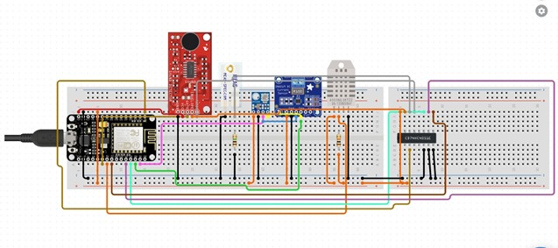**METHODOLOGY**

Fig1: Iot Infrastructure Setup

1. **IOT Infrastructure Setup:**

To create a comprehensive IoT infrastructure for real-time monitoring of wind mill fatigue factors, a network must be constructed. This network includes sensors, gateways, and a cloud-based platform, strategically deploying sensors for accurate data collection on wind speed, temperature, vibrations, and strain. Gateways act as intermediaries, facilitating communication between sensors and the cloud-based platform, which must be scalable, reliable, and secure to handle high volumes of real-time data. The cloud platform should use advanced data processing techniques for meaningful insights, ensuring compatibility and interoperability among IoT components. Efficient communication protocols and data formats are crucial for seamless data transmission and analysis. This meticulous setup enables organizations to establish a robust system, enabling proactive maintenance, enhancing efficiency, and facilitating cost-effective decision-making,

**Alert and notification system:**

. Implement a responsive alert and notification system that actively identifies and informs relevant stakeholders when fatigue factors in the wind mill exceed predefined thresholds or show unexpected patterns. This system acts as an early warning mechanism, enabling timely interventions and proactive maintenance actions to address potential risks and enhance the overall operational efficiency of the wind mill.

**Sensor selection and Deployment:**

Conduct a meticulous assessment to select sensors with the ability to accurately measure essential fatigue factors like wind speed, temperature, vibration, and strain. Consider factors such as accuracy, sensitivity, durability, and compatibility with IoT systems during the sensor selection process. Deploy these sensors strategically at specific locations throughout the wind mill to ensure thorough data capture, fostering a comprehensive understanding of operational conditions and supporting well-informed decision-making.

**Visualization and Reporting:**

Create a user-friendly interface to visually present real-time and historical data from wind mill sensors. Enable convenient access and analysis of collected data. Develop interactive reports and dashboards highlighting fatigue factors for informed decision-making and efficient maintenance planning, optimizing wind mill efficiency.

**Data Acquisition and Transmission:**

Establish a system for actively collecting real-time data on fatigue factors by deploying sensors. Utilize protocols such as Wi-Fi or cellular networks to transmit the gathered data to either a cloud-based platform or a centralized monitoring system. Implement data compression techniques to optimize data transmission efficiency, ensuring swift and seamless delivery. To prioritize data security, integrate encryption methods to protect the transmitted data from unauthorized access or breaches. This holisticapproach ensures both efficient and securedata transmission, enabling precise analysis and monitoring of fatigue factors in windmills.

1. **DESCRIPTION:**

Using IoT technology for real-time monitoring of fatigue factors in wind mills involves integrating interconnected systems to gather and analyse data, ensuring efficient turbine operation.

Sensors strategically placed within the wind mill capture vital fatigue factors like wind speed, temperature, vibration, and strain. Chosen for precision and compatibility with IoT, these sensors transmit data via Wi-Fi or cellular networks to a cloud-based platform or centralized monitoring system, allowing instant analysis.

Seamless data integration offers insights into wind mill performance. Data transmission efficiency is enhanced through data compression, reducing bandwidth requirements.

Robust encryption methods secure transmitted data, protecting it from unauthorized access. The system uses advanced algorithms to evaluate data, detect irregularities, and generate real-time alerts for prompt intervention.

The monitoring system features an intuitive interface presenting real-time and historical data visually. Performance metrics and trends empower operators to make informed decisions, optimize maintenance schedules, and enhance overall wind mill performance.

1. **Essential Elements:**

* Sensors
* IoT Infrastructure
* Data Storage and Processing
* Data Transmission
* Maintenance And Decision support

1. **MATERIALSANDMODELS:**

* Nodemcu ESP8266
* Vibration identification sensor:
* Current Sensor:
* Voltage Sensor
* Current Sensor
* Sound Sensor

1. **CONCLUSION:**

Through the utilization of IoT and data analytics, organizations have the opportunity to cultivate distinctive advantages, such as enhancing performance, proactively mitigating risks, making well-informed decisions, implementing cost-effective maintenance strategies, prolonging equipment lifespan, ensuring regulatory compliance, and achieving data-driven optimization. This strategic integration enables the unlocking of the complete potential of wind mills, fostering increased efficiency, sustainability, and profitability in the realm of renewable energy generation.

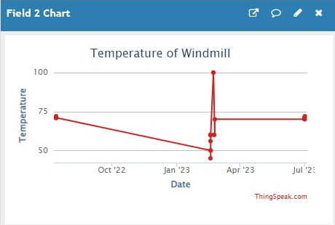

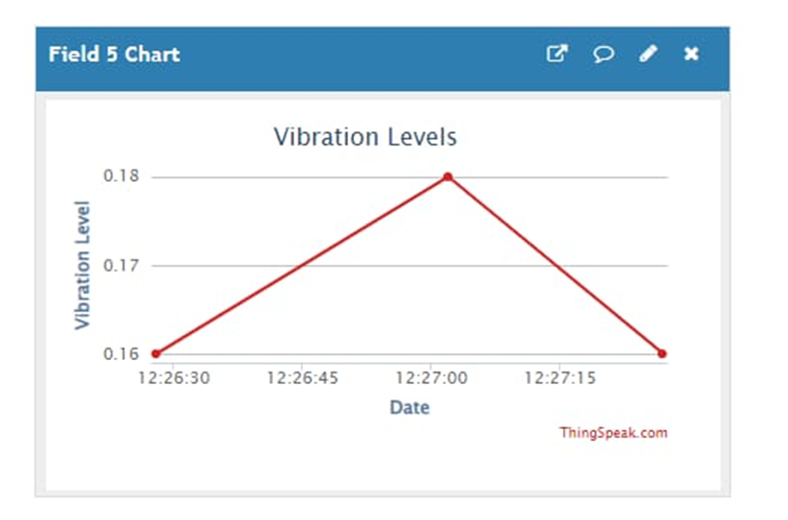

1. **References:**

1.Hyers, R. W., J. G. McGowan, K. L. Sullivan, J. F. Manwell, and B. C. Syrett. "Condition monitoring and prognosis of utility scale wind turbines." Energy materials 1, no. 3 (2006): 187-203.

2.Márquez, Fausto Pedro García, Andrew Mark Tobias, Jesús María Pinar Pérez, and Mayorkinos Papaelias. "Condition monitoring of wind turbines: Techniques and methods." Renewable energy 46 (2012): 169-178.

3. Hu, Yaogang, Hui Li, Pingping Shi, Zhaosen Chai, Kun Wang, Xiangjie Xie, and Zhe Chen. "A prediction method for the real-time remaining useful life of wind turbine bearings based on the Wiener process." Renewable energy 127 (2018): 452-460.

4. Hossain, Md Liton, Ahmed Abu-Siada, and S. M. Muyeen. "Methods for advanced wind turbine condition monitoring and early diagnosis: A literature review." Energies 11, no. 5 (2018): 1309.

5.Wang, Hao, Bendong Xiong, Zutao Zhang, Hexiang Zhang, and Ali Azam. "Small wind turbines and their potential for internet of things applications." Iscience 26, no. 9 (2023).