**Empowering Indian Agriculture: A Precision Farming Approach using IoT and Deep Learning for Enhanced Crop Productivity and Sustainability**

**Devarasetti Girish Kumar1, Dr. Chappa Ramesh1\***

Department of Computer Science and Engineering,

Aditya Institute of Technology and Management1, Tekkali-532201, India

*Corresponding Author: [chappa.ramesh01@gmail.com](mailto:chappa.ramesh01@gmail.com)

**Abstract:** The Indian agricultural landscape faces multifaceted challenges, including unpredictable yields, pest infestations, water scarcity, and limited agricultural knowledge, leading to nationwide economic strains. This paper proposes a solution harnessing digital technologies like IoT, machine learning, and cloud computing. Our approach combines IoT and Deep Learning for precision farming, utilizing field sensors and image processing to collect real-time data on environmental factors. This information drives the design of intuitive irrigation systems, promoting water conservation and optimizing crop yields. Data analytics provide valuable insights, assisting farmers in making well-informed decisions by recommending crops based on location-specific benchmarks. Additionally, soil monitoring optimizes nutrient levels, fostering soil health and ultimately boosting agricultural productivity. This technology integration empowers farmers to effectively address challenges, resulting in increased crop yields, improved financial viability, and heightened food security.

**Keywords:** Precision agriculture, crop recommendation, Efficient Net model, CNN, Disease Identification, Environmental Factors, Logistic Regression.

1. **INTRODUCTION**

In the ever-evolving landscape of contemporary agriculture, the convergence of Internet of Things (IoT) and Machine Learning (ML) has propelled the sector into an era of unparalleled innovation and efficiency. At the forefront of this technological revolution stands precision agriculture, a paradigm shift aimed at harnessing the power of data-driven solutions to optimize farming practices. This paper zeroes in on a pivotal aspect of this evolution—the development and implementation of a sophisticated Crop Recommendation System. By tapping into real-time data from an array of IoT devices, with a particular focus on soil sensors, and incorporating advanced ML algorithms such as Efficient Netv2 CNN , the system aims to furnish farmers with personalized and well-considered recommendations for crop selection.

The significance of this endeavours lies in its potential to revolutionize traditional decision-making processes within agriculture, injecting a level of precision and adaptability that was previously unattainable. As the system continually acquires and analyses data through IoT, it not only fine-tunes its recommendations based on current soil conditions but also dynamically adjusts to the ever-changing nuances of the weather. This introduction serves as a foundation for a comprehensive exploration of the principles, methodologies, and outcomes of the Crop Recommendation System, underscoring its capacity to redefine the agricultural landscape by optimizing crop choices and fostering sustainability in farming practices.

1. **LITERATURE REVIEW**

**Crop Yield Prediction through Machine Learning Techniques:** Research efforts in crop yield prediction within Indian agriculture have prominently employed machine learning methodologies. The primary focus of these studies is to leverage data-driven solutions for addressing agricultural challenges. Utilizing algorithms like Naive Bayes and K-Nearest Neighbours, researchers aim to enhance productivity and aid farmers in making informed decisions. The incorporation of weather conditions and soil type as factors in predicting crop yields is a common thread among these works. While showing promise, challenges related to accuracy and performance persist, highlighting the importance of developing user-friendly tools for broader adoption by farmers [1].

**Enhancing Crop Production based on Environmental Status using Machine Learning Techniques:** The study titled "Enhancing Crop Production Based on Environmental Status Using Machine Learning Techniques" introduces a model designed to predict and recommend suitable crops for agricultural production based on environmental factors such as humidity, rainfall, and temperature. Diverse machine learning algorithms are applied to predict and recommend crops, addressing concerns related to agricultural productivity and food security. Authors meticulously preprocess and select relevant features from a seven-year dataset encompassing 135 different crops. The model not only provides precise results for various algorithms but also plans to develop a web framework for wider adoption and expand the dataset, contributing significantly to improved agricultural productivity [2].

**IoT-Based Real-Time Soil Nutrients Detection:** This paper outlines a system designed for real-time soil nutrient detection utilizing Internet of Things (IoT) technology. The framework involves measuring soil parameters like temperature, humidity, pH values, and nutrient levels, with the data uploaded to the cloud for easy accessibility. A color sensor is employed for detecting soil nutrients, alongside environmental sensors for temperature, humidity, and moisture measurements. This real-time data accessibility, facilitated through the cloud, empowers farmers with immediate insights into their soil conditions. Successful implementations in various farm locations near Pune, India, demonstrate the system's efficiency, enabling farmers to make timely decisions to enhance soil quality and crop yield without relying on traditional lab test results [3].

**IoT-Based Classification Techniques for Soil Content Analysis and Crop Yield Prediction:** This research introduces an IoT-based system aimed at optimizing agriculture through soil monitoring and crop yield prediction. Various sensors monitor soil conditions, including moisture, temperature, humidity, pH, and nutrient content, with the data stored in the cloud. The system employs machine learning algorithms, specifically Support Vector Machine (SVM) plus Decision Tree, to recommend suitable crops for a given soil type, ultimately enhancing crop yield. Performance analysis Favors the Decision Tree algorithm, emphasizing the system's accuracy. This data-driven solution for precision agriculture promises improved resource utilization and increased crop production [4].

1. **METHODOLOGY**

The objective of the Empowering Indian Agriculture: A Precision Farming Approach using IoT and Deep Learning for Enhanced Crop Productivity and Sustainability is to usher in a transformative era for traditional farming methods, harnessing the capabilities of modern technologies. This groundbreaking system is designed to furnish farmers with real-time, data-driven insights into their crop conditions through the seamless integration of Internet of Things (IoT) devices and advanced machine learning (ML) algorithms. By strategically placing sensors in the field, the system gathers vital data encompassing soil moisture levels, temperature, and crop health. The ML algorithms meticulously analyse this data, generating actionable recommendations for optimal crop management, including precise irrigation schedules, targeted fertilizer application, and effective pest control measures. Through the synergistic application of IoT and ML, the system aspires to elevate agricultural efficiency, curtail resource wastage, and, ultimately, contribute to the establishment of sustainable and high-yield farming practices.

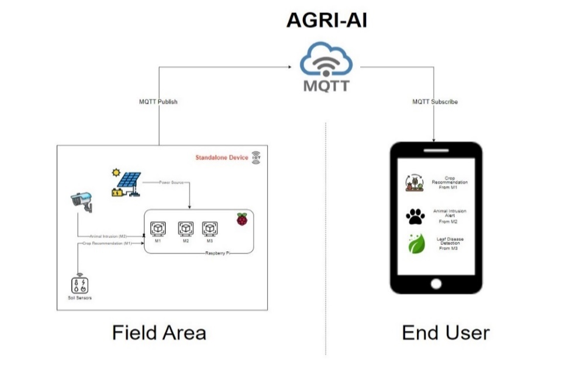

**Fig 1: Architecture of Proposed System**

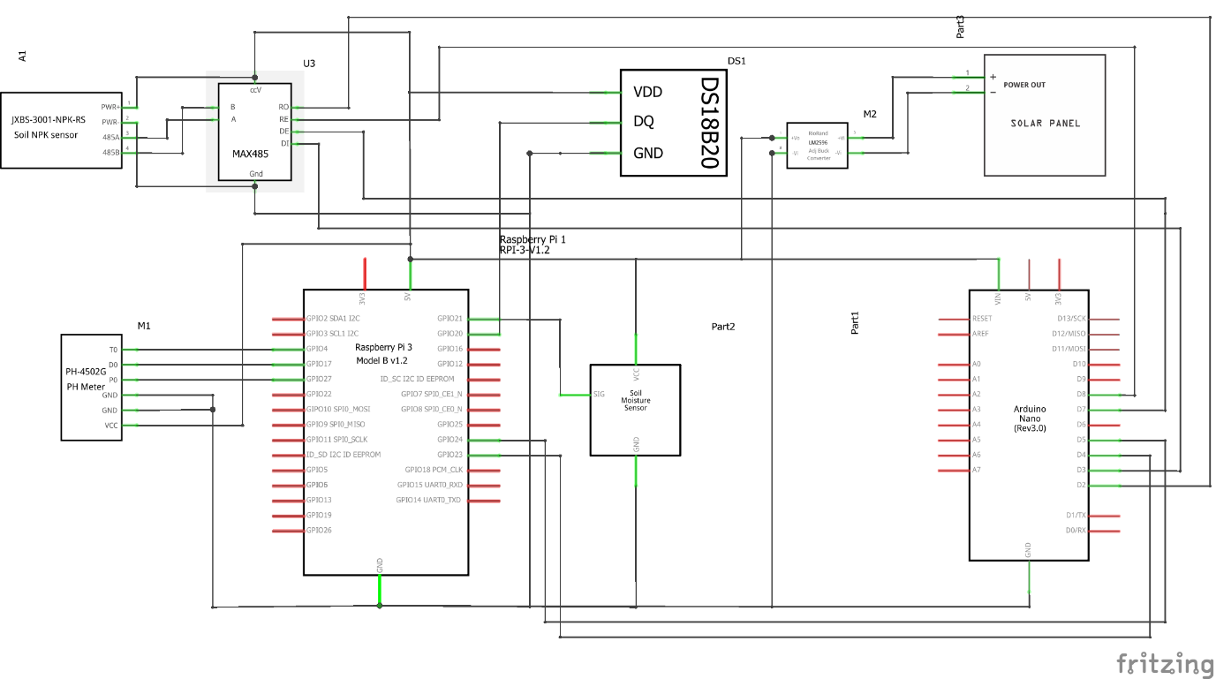

**Fig 2: Circuit Diagram of Proposed System**

1. **CONCLUSION**

In conclusion, the development and deployment of the Crop Recommendation System mark a significant leap in revolutionizing contemporary agriculture by seamlessly integrating Internet of Things (IoT) and Machine Learning (ML) technologies. Through a meticulous examination of real-time data, with a particular emphasis on insights derived from soil sensors, and the application of advanced ML algorithms like Naive Bayes, Decision Tree, and Random Forest, the system has showcased its potential to empower farmers with intelligent and personalized recommendations for optimal crop selection.

The continuous acquisition of data facilitated by IoT ensures a dynamic and adaptive decision-making process, capable of responding to the ever-changing environmental conditions within the agricultural landscape. This paper has shed light on the foundational principles, methodologies, and outcomes of the Crop Recommendation System, underscoring its pivotal role in ushering in a new era of precision agriculture. By optimizing crop choices based on real-time, localized data, the system contributes significantly to the promotion of sustainable farming practices and efficient resource utilization.

The comprehensive exploration of this innovative system highlights its potential to not only elevate agricultural productivity but also foster efficiency, environmental stewardship, and informed decision-making. As we navigate the evolving landscape of agriculture, the Crop Recommendation System stands as a testament to the transformative power of technology in addressing the complexities and challenges faced by farmers. The synergy between IoT and ML, as exemplified in this system, provides a blueprint for future advancements in precision agriculture, emphasizing the critical role of intelligent, data-driven solutions in shaping the future of global food production.

1. **REFERENCES**

[1] Ramesh Medar, Vijay S. Rajpurohit and Shweta” Crop Yield Prediction using Ma chine Learning Techniques, 2019 3rd International Conference on Intelligent Engi neering and Management (ICIEM),

London, United Kingdom, 2022, pp. 754-757

[2] Dr. Y. Jeevan Nagendra Kumar, V. Spandana, V.S. Vaishnavi and K. Neha,” Super vised Machine learning Approach for Crop Yield Prediction in Agriculture Sector.” [2020]

[3] Monali Paul, Santosh K. Vishwakar m and Ashok Verma,” Analysis of Soil Behaviour and Prediction of Crop

Yield using Data Mining Approach.” [2020]

[4] Shiyam Talukder, Habiba Jannat, Katha Sengupta and Sukanta Saha,” Enhancing Crops Production Based on Environmental Status Using Machine Learning Techniques.” [2020]