# **Ev Dhekho**

**Prof. N.G. Pathak, 1. Aishwarya Chandu Suryawanshi, 2. Aarti Anil Mundhe, 3. Sahil Chandrakant Chinchole, 4. Harshwardhan Sanjay Jadhav**

**ABSTRACT**

*The "EV Dekho" Android application acts as a centralized hub for electric vehicle (EV) enthusiasts, seamlessly connecting prospective buyers with showroom dealers. It provides a user-friendly platform to access comprehensive information about various EV models and showroom locations. What sets "EV Dekho" apart is its unique feature to estimate charging costs based on the chosen EV model and electricity distributor, offering valuable insights into ongoing operational expenses. By consolidating this data, the application mitigates information fragmentation, making it a convenient and informative resource for those keen on adopting EVs. This streamlined tool simplifies decision-making, fosters eco-friendly mobility solutions, and encourages sustainable transportation choices. "EV Dekho" not only empowers users with the necessary knowledge but also plays a vital role in promoting the broader adoption of electric vehicles for a greener and more efficient future on the road.*

**Keywords:** "EV Dekho" Android application, Centralized hub, Electric vehicle (EV) enthusiasts, Prospective buyers, Showroom dealers.

1. **INTRODUCTION**

Electric vehicles (EVs) represent a transformative force in the automotive industry, ushering in an era of sustainable transportation. As the world increasingly embraces the environmental and economic benefits of EVs, there arises a pressing need for accessible and reliable information to guide consumers and businesses. The existing system, however, grapples with multiple user-based challenges, hindering the seamless integration of electric vehicles into our daily lives.

The EV industry's rapid expansion is accompanied by several user-centric problems. Accessibility is often compromised, with existing interfaces lacking user-friendliness, making it challenging for potential buyers to navigate the complex world of EVs. Information fragmentation compounds these issues, as crucial data is scattered across disparate sources, leading to confusion and uncertainty.

.

1. **SYSTEM ARCHITECTURE AND METHODOLOGY**

The "EV Dekho" system boasts a sophisticated architecture and methodology meticulously designed to offer a seamless experience for electric vehicle (EV) enthusiasts. At its core, the Android application features an intuitive frontend, allowing users to explore a comprehensive database of EV models and showroom locations. The backend services manage user accounts, EV model data, showroom information, and the critical charging cost estimation algorithm. Through strategic external integrations, the system fetches real-time electricity pricing data from distributors. The user journey begins with a streamlined onboarding process, and as users interact with the platform, they input preferences for personalized charging cost estimations. The decision support system, an integral part of the methodology, empowers users with informed insights, aiding in their decision-making process. Rigorous security measures safeguard sensitive user data, and thorough testing ensures the application's reliability. "EV Dekho" follows a systematic deployment approach, with regular updates to keep information current and the user experience optimal. In essence, the system stands as a powerful tool, harmonizing architecture and methodology to foster a user-centric environment for embracing eco-friendly mobility through electric vehicles.

Agile Methodology for "EV Dekho" App Development: We have chosen the Agile software development process model for the development of the "EV Dekho" application because of its inherent flexibility, user-centric focus, and ability to adapt to changing requirements. Agile allows us to prioritize customer needs, continuously gather and incorporate feedback, and deliver incremental improvements in short development cycles. Given the dynamic nature of the electric vehicle industry and the evolving user requirements, Agile is the ideal model for ensuring that our application remains responsive to user needs and delivers a highly user-friendly and efficient solution. This approach aligns perfectly with our goal of promoting EV awareness and environmental conservation by providing a constantly improving platform for users in the rapidly changing world of electric mobility.

**1. Problem Definition and Prioritization:**

Problem Identification: Define and prioritize identified user-centric issues in the EV industry.

Problem Mapping: Create user stories for each problem, focusing on their impact and importance.

-Agile Step: Aligns with Agile's customer-centric approach in backlog refinement.

**2. User Stories and Backlog:**

User Story Creation: Transform each problem into a user story, outlining user needs and context.

Backlog Prioritization: Rank user stories based on urgency and importance.

-Agile Step: Establish a backlog of user stories, central to Agile development.

**3. Sprint Planning:**

-Sprint Goals: Define a sprint goal, such as addressing complex interfaces, for each development cycle.

-Sprint Backlog: Select user stories to tackle in the sprint.

-Agile Step: Reflects Agile's sprint planning for setting achievable goals in fixed timeframes.

**4. Development and Iteration:**

-User Interface Redesign: Simplify interfaces for user-friendliness.

-Database Centralization: Centralize data management for efficiency.

-Real-Time Updates: Develop real-time data updates.

-Enhanced Deal Visibility: Improve visibility of deals and new models.

-Streamlined Communication: Implement a messaging system for efficient communication.

-Comprehensive Information: Develop sections for detailed model information.

-Charging Station Locator: Create a tool for locating charging stations.

-Range Estimation: Implement range estimation features.

-User Guidance: Provide a dedicated section for user guidance.

-Financial Insights: Offer insights into financial aspects of EV ownership.

Agile Step: This phase embodies Agile's iterative development approach, delivering incremental improvements with each sprint.

**5. Testing and Validation:**

-Functional Testing: Verify app features function as intended.

-User Testing: Invite users to validate user-friendliness and problem resolution.

Agile Step: Testing is an ongoing Agile process, ensuring quality and user satisfaction.

**6. Review and Retrospective:**

-Sprint Review: Review progress and gather stakeholder and user feedback.

-Sprint Retrospective: Identify improvements for future sprints based on lessons learned.

Agile Step: These activities ensure continuous improvement, a core Agile principle.

**7. Deployment and User Training:**

-Deployment: Launch the "EV Dekho" app to the target audience.

-User Training: Provide resources and guides for app usage.

Agile Step: Deployment marks the completion of a sprint, delivering value to users.

**8. Ongoing Iteration and Improvement:**

-Regular Updates: Continuously improve the app based on user feedback and changing requirements.

Agile Step: Agile promotes ongoing refinement and adaptation in response to user needs.

Through this Agile methodology, "EV Dekho" is efficiently developed, directly addressing the identified problems in the electric vehicle industry. It ensures flexibility, user-focused development, and continuous improvement, aligning with the app's mission of promoting EV awareness and environmental conservation.

1. **MODELING AND ANALYSIS**

The "EV Dekho" project is an Android application designed to serve as a centralized hub and a comprehensive resource for electric vehicle (EV) enthusiasts. The primary goal is to seamlessly connect potential buyers with showroom dealers, creating a user-friendly platform that facilitates access to detailed information about various EV models and their corresponding showroom locations.

**• Modules**

**1. Problem Definition and Prioritization:**

Problem Identification: Define and prioritize identified user-centric issues in the EV industry.

Problem Mapping: Create user stories for each problem, focusing on their impact and importance.

-Agile Step: Aligns with Agile's customer-centric approach in backlog refinement.

1. **User Stories and Backlog:**

User Story Creation: Transform each problem into a user story, outlining user needs and context.

Backlog Prioritization: Rank user stories based on urgency and importance.

-Agile Step: Establish a backlog of user stories, central to Agile development.

1. **Sprint Planning:**

-Sprint Goals: Define a sprint goal, such as addressing complex interfaces, for each development cycle.

-Sprint Backlog: Select user stories to tackle in the sprint.

-Agile Step: Reflects Agile's sprint planning for setting achievable goals in fixed timeframes.

1. **Development and Iteration:**

-User Interface Redesign: Simplify interfaces for user-friendliness.

-Database Centralization: Centralize data management for efficiency.

-Real-Time Updates: Develop real-time data updates.

-Enhanced Deal Visibility: Improve visibility of deals and new models.

-Streamlined Communication: Implement a messaging system for efficient communication.

-Comprehensive Information: Develop sections for detailed model information.

-Range Estimation: Implement range estimation features.

-User Guidance: Provide a dedicated section for user guidance.

-Financial Insights: Offer insights into financial aspects of EV ownership.

Agile Step: This phase embodies Agile's iterative development approach, delivering incremental improvements with each sprint.

1. **Testing and Validation:**

-Functional Testing: Verify app features function as intended.

-User Testing: Invite users to validate user-friendliness and problem resolution.

Agile Step: Testing is an ongoing Agile process, ensuring quality and user satisfaction.

1. **Review and Retrospective:**

-Sprint Review: Review progress and gather stakeholder and user feedback.

-Sprint Retrospective: Identify improvements for future sprints based on lessons learned.

Agile Step: These activities ensure continuous improvement, a core Agile principle.

1. **Deployment and User Training:**

-Deployment: Launch the "EV Dekho" app to the target audience.

-User Training: Provide resources and guides for app usage.

Agile Step: Deployment marks the completion of a sprint, delivering value to users.

1. **Ongoing Iteration and Improvement:**

-Regular Updates: Continuously improve the app based on user feedback and changing requirements.

Agile Step: Agile promotes ongoing refinement and adaptation in response to user needs.

Through this Agile methodology, "EV Dekho" is efficiently developed, directly addressing the identified problems in the electric vehicle industry. It ensures flexibility, user-focused development, and continuous improvement, aligning with the app's mission of promoting EV awareness and environmental conservation.

**ER Diagram :-**

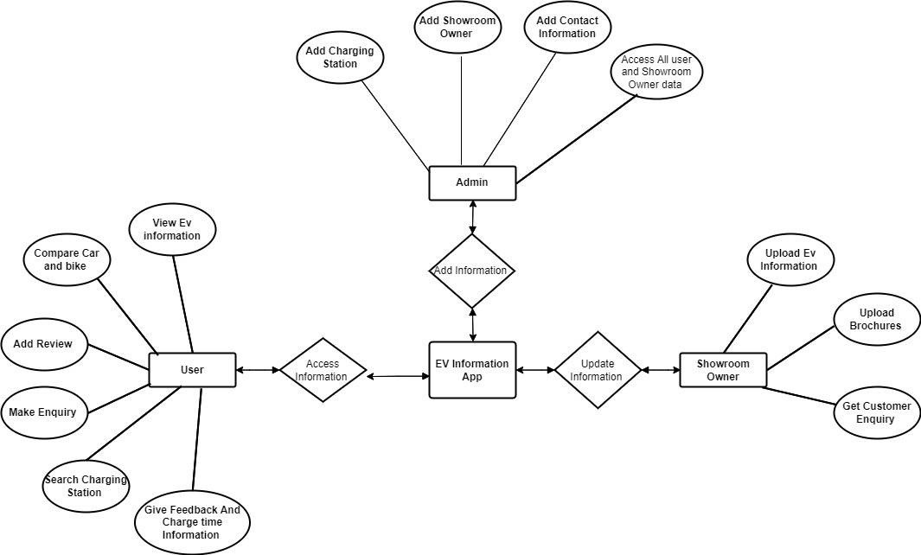

**Figure 1:** E-R Diagram

**Use Case Diagram :-**

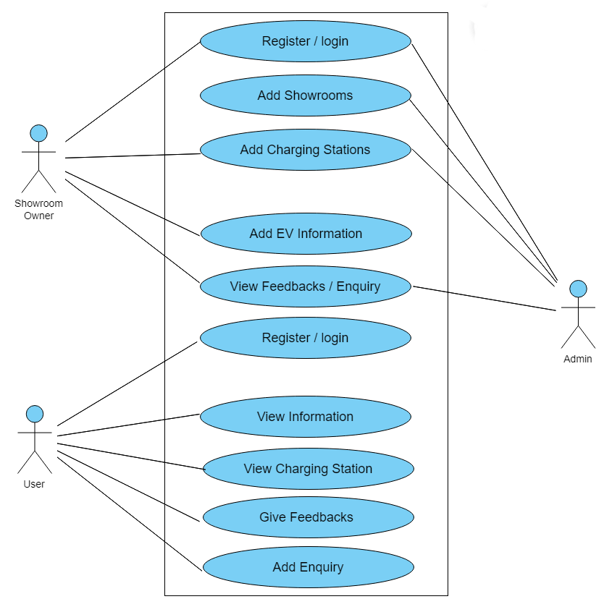

**Figure 2:** Use Case Diagram

**DFD Diagrams :-**

**Figure 3:** Level 1 Data Flow Diagram (DFD)

The administration panel oversees the entire system, managing user roles, permissions, and system settings while also monitoring system activities. Showroom registration involves manual entry of showroom details such as name, location, and contact information. Charging stations are added after admin approval, with details stored in the system. EV information is sourced externally or added manually by the admin or showroom owners, including model name, battery capacity, and specifications. Users can submit reviews and feedback for EV models, which are stored for reference. The Vehicle Information Module compiles data from diverse sources to furnish users with details about various electric vehicle models.

1. **RESULTS AND DISCUSSION**

The "EV Dekho" app serves as a comprehensive platform tailored to the needs of electric vehicle (EV) enthusiasts and potential buyers. Offering a range of features, the app facilitates informed decision-making in the transition towards sustainable transportation options. Users benefit from a seamless interface that allows for effortless comparison of various EV models based on crucial factors such as price, range, performance, and features. Moreover, the app provides invaluable insights through user reviews and expert ratings, guiding individuals towards selecting the most suitable EV for their preferences and requirements. Crucially, the app integrates essential tools like a charging station locator, ensuring users can easily identify nearby charging points and access crucial information about charging infrastructure. Additionally, the app serves as a hub for the latest EV news and updates, empowering users with knowledge about technological advancements, new models, and pertinent industry developments. With a cost calculator feature, users can accurately estimate the total cost of ownership for different EV models, including considerations such as purchase price, fuel savings, maintenance expenses, and available incentives. Furthermore, the app fosters community engagement through forums and discussion boards, enabling users to share experiences, insights, and tips within a vibrant and supportive community of EV enthusiasts. In essence, the "EV Dekho" app emerges as a pivotal tool in driving the adoption of electric vehicles, offering a user-centric and information-rich platform that empowers individuals to embrace sustainable mobility solutions.

1. **CONCLUSION**

"EV Dekho" emerges as a comprehensive and innovative Android application that plays a pivotal role in the electric vehicle (EV) ecosystem. With its user-friendly interface, the platform effectively connects prospective buyers with showroom dealers, providing a centralized hub for accessing detailed information about various EV models and showroom locations. The standout feature of estimating charging costs, based on chosen EV models and electricity distributors, sets "EV Dekho" apart by offering valuable insights into ongoing operational expenses. EV Dekho stands as a beacon in the realm of EV adoption, promoting accessibility, information transparency, and informed decision-making to propel the shift towards sustainable and environmentally conscious mobility.

1. **ACKNOLEDGMENT**

With profound gratitude, we extend our sincere thanks to Prof. P. M. Dharmadhikari, Principal of Sandip Polytechnic, Nashik, for his insightful guidance and generous permission, integral to the success of our project planning. Our heartfelt appreciation also goes to Prof. N.G Pathak and the dedicated staff of the Computer Engineering Department for their unwavering support. We extend special thanks to colleagues, industry experts, and lab technicians, whose collaborative efforts enriched our project with practical insights. Their contributions have added depth and real-world relevance to our planning process.

1. **REFERENCES**

* https://e-amrit.niti.gov.in/benefits-of-
* the%20fuel%20to%20the%20 wheels.
* https://en.wikipedia.org/wiki/Electric vehicle
* https://afdc.energy.gov/fuels/electricity research.html
* <https://www.charzer.com/blog/2021/09/15/price-to-charge-an-electric-scooter/>
* https ://ieeexplore.ieee.org/document/5228598
* https 2://ieeexplore.ieee.org/document/7531925
* https://ieeexplore.ieee.org/document/4156566