**SOLAR POWER OPERATED CYCLE**

1. **GADADE R. A. 2) GAIKWAD N. B. 3) NIMGAONKAR S. S.**

HOD, Mechanical Department, Aditya Polytechnic, Beed, Mahaashtra, India

Lecturer Mechanical Department, Aditya Polytechnic, Beed, Mahaashtra, India

Lecturer Mechanical Department, Aditya Polytechnic, Beed, Mahaashtra, India

**ABSTRACT**

An electric bicycle is a tool that is produced from a combination of a bicycle as a means of transportation which is added with an electric component as its driving force. It is known that bicycles can still be used even without electrical components. However, with the presence of an electrical component, the human power that is expended can be minimized. The current environment has undergone various changes. This is intended because of changes that occur because of humans. By using a qualitative descriptive method, this study is expected to provide knowledge about the impact on the environment from using an electric bicycle. And the result is that currently, the diversity of electric bicycles does not only provide the development of the bicycle itself.

**Keywords:** Cycle, Battery, Controller, Solar Panel .Gear,throtal,support.

1. **INTRODUCTION**

**C**urrently, there are many developments in the field of mobility and technology so indirectly it can encourage people to create tools that are often included with innovation . Besides, the presence of various environmental issues has shifted human focus from using fuel oil to towards energy saving. This also has an impact on the presence of various kinds of transportation that are environmentally friendly and energy-efficient .

**LITERATURE SURVEY**

The research method used in this research is descriptive qualitative. This is because the qualitative method aims to understand social phenomena or phenomena by focusing more on a complete picture of the phenomena being studied rather than breaking them down into interrelated variables. The hope is that a deep understanding of phenomena will be obtained and then a theory is produced . The method of analysis is described as an attempt to decompose a problem or focus of study into parts (decomposition) so that the arrangement, order of the form of something that is parsed is clearly visible and therefore the meaning can be more clearly and clearly captured or can be understood more clearly the sit of the case.

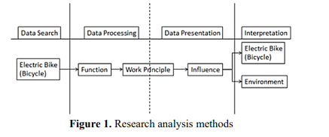

###### POWER UNIT

###### Battery:

Battery is the main component in e-bikes. There are many types which have been tested until this time but the popular ones are NiMH, Ni, or Lithium-ion Batteries. The battery capacity varies in bicycles. In general the storage energy mostly up to about 400 Watt hour22 . Battery quality is measured by how many cycles they can be charged, and how much percentage it works still after a fixed duration length, which is measured by comparing with the original capacity at the manufacturing time. In NiMH batteries, around 400 to 800 cycles of recharging is possible where as in Lithium batteries it can be even 1000 cycles. The charging time essentially depends upon the types of batteries that is used and accordingly it can be 2 to 9 hours.

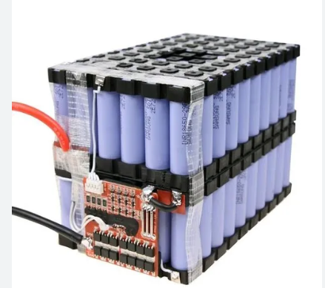

**Figure 2:** BATTERY

The most trustable battery at this moment is Lithium-ion battery, it is light, that what makes the efficiency of the e-bikes to rise. Besides it is durable and importantly can deliver longer power into the system.

###### How can we charge the battery, and improve its efficiency level?

In some system it may be possible to charge the battery in three different ways, one is by using the 220V AC socket, another one is by using the solar panel attached to the bicycle carriage, (which is then used to convert solar power into electricity and that generated electricity is stored into the battery continuously, and that accumulated power helps to increase the efficiency of the battery, as it improves the durations). Finally, the experimental option of recharging the battery can also be done by using dynamo. It is placed in such a way that it starts revolving as soon as tires move, and all these rotations produce electricity to enhance battery power. It can have different variations, but it must be said that it is not applicable so widely because the power it generates is not so enough than the hindrance it creates, that is why it is still in the experimental stage.

In our bicycle, we do not use any external charging unit attached to the bicycle. It is just that battery which is charged when it seems empty, by using normal electric socket that is available in houses. We simply take out the battery and recharge when the Power is too low to drive the bicycle easily.

1. **SOLAR PANEL**

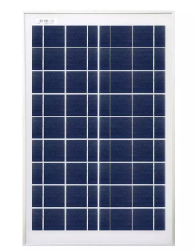

Fig-2(A) SOLAR PANEL

A solar panel of 20W is specifically designed for powering small electrical items or devices. Some common devices that a 20W panel can power are cell phones, digital and security cameras, and lights. Besides, such a type of solar panel is also suitable for use on the go, such as when you are camping. Solar power is clean & sustainable energy. A 20 watt solar panel is one of the most innovative options to use solar power when you’re travelling.

You can charge your mobile phones or run your garden lights and security cameras using these solar panels.

1. **CONTROLLER**

There are mainly two types of controllers which are designed to be effective on two types of motor, one is brushed, and another is brushless. According to the motor in use the controller function also varies. Brushless motors are popular nowadays because of high efficiency and durability, and it is also supported by the reduced cost factors, whereas brushed motors because of less complex controller mechanism, is still in use fairly.

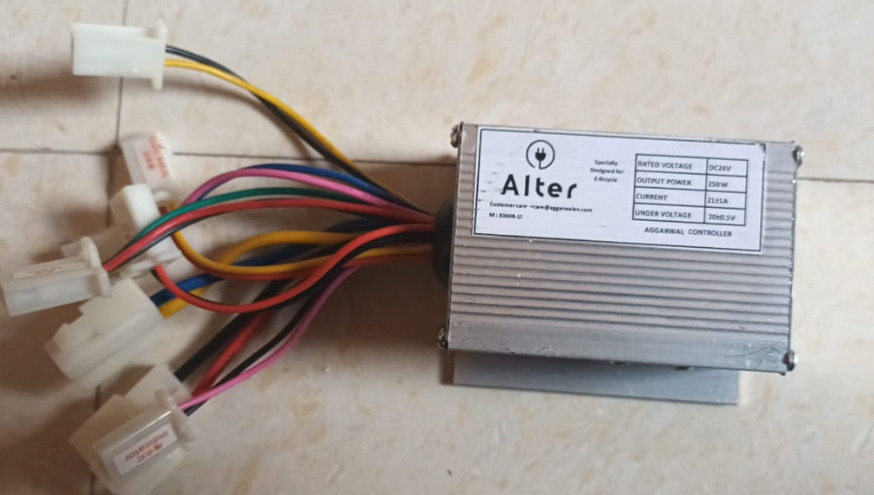

**Figure 3:** CONTROLLER

**Controllers used in brushless motors:** There are various sensors used to check and control the speed movements. To do this quite efficiently, Hall sensor is used. The reason is also that e-bike requires strong initial torque to complement the low powered motor, this mechanism to control with safe the speed, the sensor has special functions to monitor the speed accurately. Various electronic controllers provide real time data input to the controller to react according to the situation.

**Controllers used in brushed motors:** Brushed motors are still in used because of low cost and less burden to the controllers because of simple mechanism applied, but in its weakness there is low efficiency because the brushed wires in constant rubbing lead it to low durability. The best part in this is the controller has simple function and economically cheaper as there do not require hall sensor feedback to pass the signal, and it works on open-loop controllers usually.

1. **MOTOR**
2. **It is an 24V Dc geared motor.**
3. **Which is used to drive the cycle.**
4. **Which is controlled by controller.**
5. **And its accelerated by throttle.**

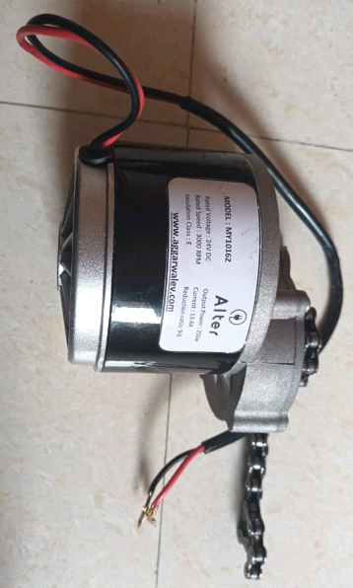

**Figure 4:** MOTOR

How Motors Work: Motor is made up of skilful wrapping of coils on a stator, a rotor for the rotation, and magnets to influence the rotations. The magnets used their work electromagnetically. That means electricity influences this iron to behave like a magnet, having both attraction and repulsion characteristics of a magnet into this, thereby helping it to generate the motion accompanying this. The principle in this is to switch the direction of the forces to keep the motor to move continuously, once it is started until the time it is stopped.

There are two types of motors commonly used in e-bikes, one is brushed motor and another is brushless.

1. **SUPPORT**

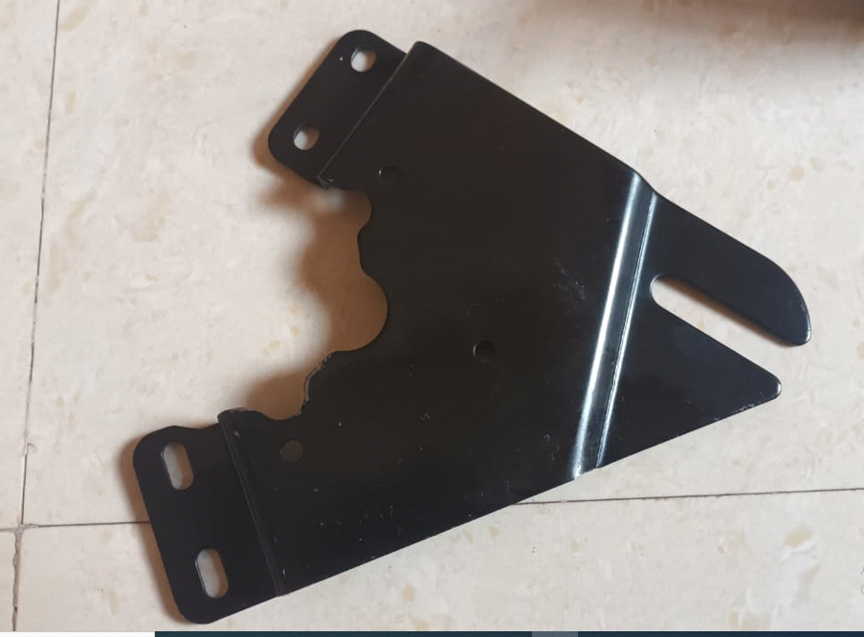

**Figure 5:** SUPPORT

1. THROTTLE

The concept is pretty much the same as in a common motorcycle. These allow to directlycontrol the amount of power that the motor is producing in real-time. There are several types, as thumb throttles (the throttle is engaged by pushing the lever forward with your thumb), full twist throttles (the throttle is engaged by twisting the throttle grip, seen in most motorcycles) or half twist throttles (the throttle is engaged by twisting the throttle grip,which is this case is just half of the grip.

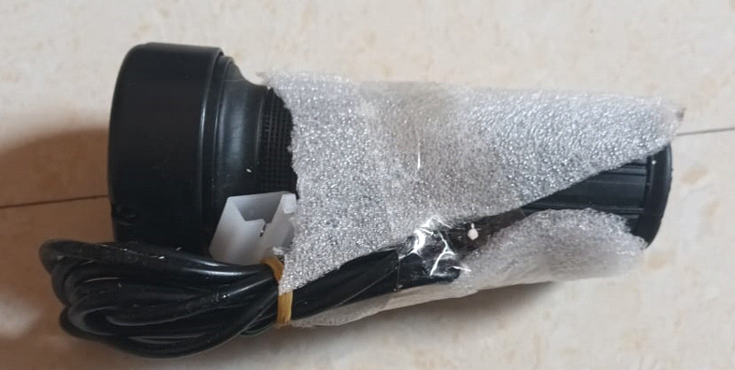

**Figure 6:** THROTTLE

1. **SPUR GEAR**

Spur gears are a cylindrical shaped toothed component used in industrial equipment to transfer mechanical motion as well as control speed, power, and torque. These simple gears are cost-effective, durable, and reliable and provide a positive, constant speed drive to facilitate daily industrial operations. For Transfer Mechanical motion as well as Control Speed, Power and Torque. Its Operate by Chain.



**Figure 6:** GEAR

1. **MODEL**

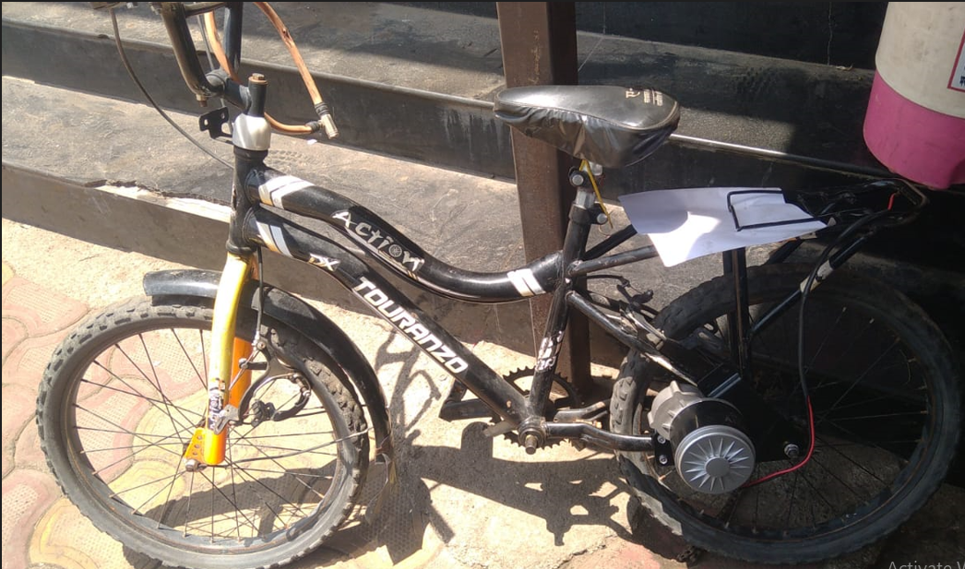

1. **CONCLUSION AND FUTURE SCOPE**

In modern context, there are so many developments going on every direction. Taking into account theses progressive trends in the developed countries, we cannot ever imagine that there could be any shortage of energy in this world or there should be necessary for other solutions. Considering the developments, it seems that everything is going smoothly and this energy crisis seems to be unreal.

1. **REFERENCES**

.

[1] Ramadhan A and Pertiwi Y M 2019 Ragam Modifikasi Ruang Dalam Angkutan Kota Untuk Meningkatkan Pelayanan Dan Kenyamanan NARADA J. Desain dan Seni vol 6 no 1 97–128.

[2] M James C 1977 Pedal power in work, leisure, and transportation. Pennsylvania: Rodale Press.

[3] Dill J and Rose G 2012 Electric bikes and transportation policy: Insights from early adopters Transp. Res. Rec vol 2314 no 1 1–6.

[4] W Zhongxia X, Ruifen X, Yan B and Xiaofan 2011 Optimal Design of Bicycle Parameters Considering Biomechanics Chinese J. Mech. Eng. vol 24 no 1.

[5] Johnson M and Geoff R 2015 Extending life on the bike: electric bike use by older Australians J. Transp. Heal. vol 2 no 2 276–283.

[6] Matey S, Prajapati D R, Shinde K, Mhaske A, and Prabhu A 2017 Design and fabrication of electric bike Hand vol 27 no 250 40.