**Effect of Input Parameters on Strength to Weight Ratio on AB P430 Material**

1. **GADADE R. A. 2) GAIKWAD N. B. 3) P.S.THIGLE**

HOD, Mechanical Department, Aditya Polytechnic, Beed, Mahaashtra, India

Lecturer Mechanical Department, Aditya Polytechnic, Beed, Mahaashtra, India

Lecturer Mechanical Department, Aditya Polytechnic, Beed, Mahaashtra, India

**Abstract:** Aerospace industry is an industry which is the fastest adopter of inventions and investigations. Higher Strength at lower weight of each component in aircraft is the main aspect of its design. 3D polymer-based printers have become easily accessible to the public. Usually, the technology used by these 3D printers is Fused Deposition Modelling (FDM). The majority of these 3D printers mainly use acrylonitrile butadiene styrene (ABS) and polylactic acid (PLA) to fabricate 3D objects. In order for the printed parts to be useful for specific applications, the mechanical properties of the printed parts must be known.

The aim of the study to determine the strength to weight ratio by changing the input parameters such as, layer thickness, speed of deposition and infill percentage are some of prominent parameters which are considered as input parameters. The Taguchi method is used to determine the Design of the Experimentation

**Keywords:** 3D printing, layer thickness, speed of deposition, infill percentage, Strength to weight ratio, taguchi

1. **INTRODUCTION**

Aerospace industry is an industry which is the fastest adopter of inventions and investigations. Higher Strength at lower weight of each component in aircraft is the main aspect of its design. The manufacturing time and cost is also important factor in aerospace industries. Minimum manufacturing time leads to reduce its manufacturing cost. The optimization with respect to higher strength at lower weight of each component used in aerospace can be achieved broadly in three phases of design. First one is selection of most suitable material considering all required properties along with its manufacturing method, second one is testing its strength experimentally and the third one it to optimize its structure to reduce weight for a higher strength. Use of design and analysis computer software play vital role in such design and manufacturing stages [1].

The advantages of this technology are as follows, with the event of 3D printing, an outsized number of processes are developed that allow the utilization of a spread of materials and methods. Amongst these technologies, one of the most commonly used is fused deposition modelling (FDM), a layer-by-layer additive manufacturing technique, based on computer-aided design (CAD) and computer-aided manufacturing (CAM)[2].

The advantages of 3D printing are as follows,

1. Material can change easily
2. Less maintenance
3. No need of supervision
4. Portable
5. Temperature is low.

However, the most disadvantage of FDM is that the narrow range of obtainable materials. A 3D printer generally prints:

Acrylonitrile Butadiene Styrene (ABS)

Or poly (lactic acid) (PLA).

And the manufactured are generally used for demonstration [3]. This limits the utilization of FDM in industrial applications. Recently many companies developed new materials for 3D printing like AB PLUS P430 with base material as ABS, HIPS, are some new materials introduced in recent years. These materials are required to be tested considering aerospace applications [4].

1. **GEOMETRY AND MANUFACTURING OF TEST SPECIMEN**

The specimens were made as per ASTM standard D 638 Type –IV sample [9]. The dimensions are provided in the Table 1.

**Table 1:** Specimen dimensions as per ASTM standard D 638 Type –IV

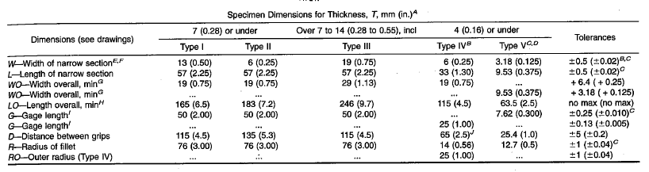

**The procedure to make the specimen is as follows,**

• Study of selection of specimen dimension as per standard

• Drawing the specimen using software Catia V5

• Converting the drawing into .stl format

• Importing to 3D printer to slice it

• Setting the process parameters as per design of experimentation

• Printing specimens

• Cleaning specimen

The thickness of specimen was 4 mm, width was 6 mm and gauge length was 25 mm for testing purpose.

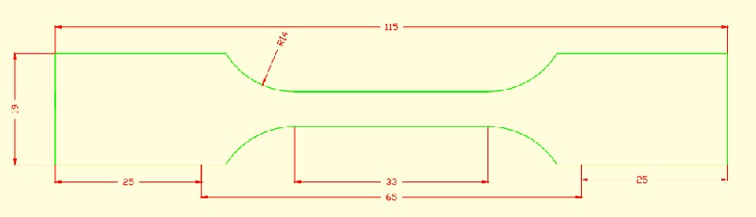

**Fig. 1:** Dimensions of specimen as per ASTM standard D 638 Type –IV

**3. MATERIAL**

The material selected was an ABS based advance material i.e. AB PLUS P430. This material was developed by University of Science and Technology Beijing, China. It is Acrylonitrile Butadiene Styrene Terpolymer based thermoplastic. Few important properties of AB PLUS P430 [7].

1. **PROCESS PARAMETERS**

The selected process parameters are layer thickness, speed of deposition and percentage infill with fix flat build orientation. The detail discussion about these parameters are explained in next section.

**4.1 Build orientation**

Prior to the additive build-up, the part(s) is (are) oriented with appropriate software. Today, the main target mostly is on an efficient build-up, which suggests that the part is oriented such a minimum of support material is required and therefore the part is built up in the shortest time possible. Concurrently there's disregarded, that additive manufactured parts aren't isotropic thanks to the layered build-up and should have totally different material behaviours than conventionally produced parts. Thus, different persons have tried to work out, how the mechanical properties of additive manufactured parts change thanks to the orientation within the build-up volume. Therefore, tensile specimens can be produced as oriented flat, edgewise and straight up. The layers are always parallel to the platform. The three possible build orientations are shown in Fig. 4.2. Flat orientation is selected being higher strength component as per previous studies.

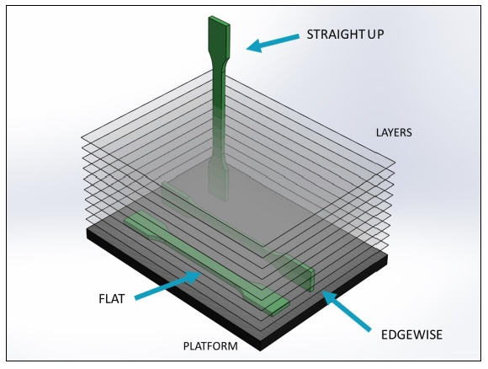

**Fig.2:** Build orientation of specimen [8]

**4.2 Layer thickness**

A more controversial parameter is the layer thickness. Some researchers found that the optimal set of parameters for maximum performance of their model always include the smallest layer thickness With increase in the layer thickness tensile strength primarily increasing and then decreasing.

Fig 3 shows the concept of layer thickness. The possible layer thicknesses by Zortrax M200 are 0.14, 019 and 0.29 mm. With increase in the layer thickness tensile strength primarily increasing and then decreasing.

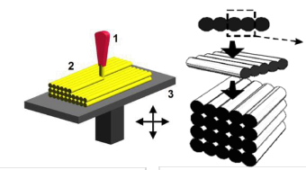

**Fig.3:** Layer thickness and speed of deposition of specimen

**4.3 Speed of deposition**

The speed of deposition is also an important parameter in 3D printing. The possible speeds of deposition are 50mm/sec and 100mm/sec. The above Fig. 4.3 shows concept of speed of deposition.

**4.4 Percentage infill**

In any industry amount of material used for any product affects its cost. In optimization process, material saving can be possible with the help of infill percentage. The infill variety with the help of Zortrax M 200 type printer are possible as 80%, 85% and 90% infill.

1. **MEASUREMENT OF OUTPUT PARAMETERS**

The strength and weight are output parameters. Strength of specimen is measured on Universal Testing Machine and weight is measured by electronic weighing machine.

1. **DESIGN OF EXPERIMENTATION USING TAGUCHI APPROACH**

Robust design is an engineering methodology for improving productivity during research and development so that high-quality products can be produced quickly and at low cost.

**6.1 Selection of Orthogonal Array for Experimentation**

Selection of an orthogonal array depends on the selection of the number of factors, their operating levels. On the basis of literature survey and machine constraints, the variables selected are layer thickness, speed of deposition of material and infill percentage. The levels selected are on the basis of preliminary experimentation. The possible layer thicknesses produced by 3D printer are 0.09, 0.14, 0.19, 0.29 and 0.39 mm. Considering Taguchi design, 0.19, 0.29 and 0.29 mm are selected. Only three speeds of deposition are possible i.e. 50mm/sec, 100mm/sec and 150mm/sec. The possible infill percentage steps selected as 80%, 85% and 90%. On the basis of all above parameters and levels, Taguchi orthogonal array L9 design of experimentation is selected for flat orientation. The variables and their respective levels are shown in Table 4.5 for flat orientation.

**Table 2:** Process parameters and levels

|  |  |  |  |
| --- | --- | --- | --- |
| **Levels** | **layer thickness in mm** | **speed of deposition in mm/s** | **Infill percentage** |
| 1. | 0.14 | 50 | 80 |
| 2. | 0.19 | 100 | 85 |
| 3. | 0.29 | 150 | 90 |

After testing using UTM machine, the values for strength are shown in Table 3

The strength and weights are found for each trial.

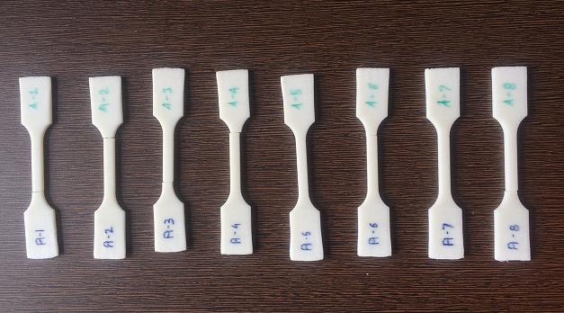

**Fig. 4:** Test specimen sample set A

Fig. 4 shows test specimen after braking on UTM for set A.

Eight trials are conducted and every trail is repeated for three times and average values are recorded in Table 3

**Table 3:** Experimental results

|  |  |  |  |  |
| --- | --- | --- | --- | --- |
| **Trial No** | **% Infillment** | **Layer Thickness(mm)** | **Rate of Deposition(mm/sec)** | **Tensile Stress(N/mm2)** |
| 1 | 80 | 0.14 | 50 | 1.46138 |
| 2 | 80 | 0.19 | 100 | 20.1063 |
| 3 | 80 | 0.29 | 150 | 28.0706 |
| 4 | 85 | 0.14 | 100 | 18.5067 |
| 5 | 85 | 0.19 | 150 | 26.7388 |
| 6 | 85 | 0.29 | 50 | 9.06665 |
| 7 | 90 | 0.14 | 150 | 22.0966 |
| 8 | 90 | 0.19 | 50 | 29.4704 |
| 9 | 90 | 0.29 | 100 | 22.3198 |

The measured average weights of specimens are shown in Table 4

**Table 4.** Average Weights

|  |  |  |  |  |
| --- | --- | --- | --- | --- |
| **Trial No** | **% Infillment** | **Layer Thickness** | **Rate Of Deposition** | **Weight in gms** |
| 1 | 80 | 0.14 | 50 | 4.89 |
| 2 | 80 | 0.19 | 100 | 9.66 |
| 3 | 80 | 0.29 | 150 | 12.42 |
| 4 | 85 | 0.14 | 100 | 10.42 |
| 5 | 85 | 0.19 | 150 | 13.73 |
| 6 | 85 | 0.29 | 50 | 4.34 |
| 7 | 90 | 0.14 | 150 | 8.49 |
| 8 | 90 | 0.19 | 50 | 12.42 |
| 9 | 90 | 0.29 | 100 | 11.04 |

The values of strength to weight ratio are reported Table 5

**Table 5:** Strength to weight ratio

|  |  |  |  |  |
| --- | --- | --- | --- | --- |
| **Trial No** | **% Infillment** | **Layer Thickness** | **Rate Of Deposition** | **Strength to Weight Ratio** |
| 1 | 80 | 0.14 | 50 | 0.2988 |
| 2 | 80 | 0.19 | 100 | 2.08139 |
| 3 | 80 | 0.29 | 150 | 2.26011 |
| 4 | 85 | 0.14 | 100 | 1.77607 |
| 5 | 85 | 0.19 | 150 | 1.94747 |
| 6 | 85 | 0.29 | 50 | 2.08908 |
| 7 | 90 | 0.14 | 150 | 2.60266 |
| 8 | 90 | 0.19 | 50 | 2.372818 |
| 9 | 90 | 0.29 | 100 | 2.02172 |

1. **RESULT AND DISCUSSION**

From above Table 5, it is clear that that range of strength to weight ratio is highest in range for edgewise orientation followed by flat wise and straight up orientation. It shows that the edgewise orientation component is most suitable for aerospace application**.** The reason for getting highest strength might be due to the type of structure generated, bonding and position of load applied. Hence, modeling and optimization is done for edgewise orientation.

**REFERENCES**

|  |  |
| --- | --- |
| [1] | M. Iliescu, E. Nuţu and B. Comanescu, “Applied Finite Element Method Simulation in 3D Printing”, ‘*International Journal of Mathematics and Computers in simulation*’, Issue 4, Volume 2, (2008), pp. 305-312 |
| [2] | Mohammad Vaezi and Chee Kai Chua, ‘Effects of layer thickness and binder saturation level parameters on 3D printing process’, *‘International Journal of Advance Manufacturing and Technology’* (2011) 53, pp.275–284 |
| [3] | Ivan Gajdos, and Jan Slota*, “*Influence of printing conditions on structure in FDM prototypes” , ‘*Tehnicki vjesnik’* 20, 2(2013), pp.231-236 |
| [4] | Tomislav Galeta, Ivica Kladari}, Mirko Karaka, ‘Influence of processing factors on the tensile strength of 3D Printed models”, ‘*Materials and technology’* 47 (2013) 6, pp.781–788 |
| [5] | B. M. Tymrak, M. Kreiger and J. M Pearce, “Mechanical Properties of Components Fabricated with Open-Source 3-D Printers Under Realistic Environmental Conditions”, *‘Materials & Design’*, 58, (2014), pp.242-246 |
| [6] | David D. Hernandez, “Factors Affecting Dimensional Precision of Consumer 3D Printing, International Journal of Aviation”, ‘*Aeronautics, and Aerospace”*, Vol. 2 (2015), Issue 4, Art. 2 |
| [7] | F. Roger and P. Krawczak, “3D-printing of thermoplastic structures by FDM using heterogeneous infill and multi-materials: An integrated design-advanced manufacturing approach for factories of the future”, ‘*22ème Congress Françsis de Mechanic’*, Vol-24, (2015), pp. 1-7 |
| [8] | Wenzheng Wu, Peng Geng, Guiwei Li, Di Zhao, Haibo Zhang and Ji Zhao, “Influence of Layer Thickness and Raster Angle on the Mechanical Properties of 3D-Printed PEEK and a Comparative Mechanical Study between PEEK and ABS”, ‘*Materials*’ (2015), 8, pp.5834-5846 |
| [9] | Aaron M. Forster, “Materials Testing Standards for Additive Manufacturing of Polymer Materials State of the Art and Standards Applicability”, ‘*National institute of standard and technology’*, Vol. May ( 2015),pp. 1-45 |