“Development And Manufacturing of Emergency Door Lock For Dizziness Suffering Patients”
Mr. Gaffar G. Momin [1] (gaffar.momin@pccoepune.org),
Mr.Atharva P. Chaudhari [2] (chaudhariatharv11@gmail.com)
[1]Assistant Professor in Mechanical Engineering, Department of Mechanical Engineering, Pimpri
Chinchwad College of Engineering, Nigdi, Pune-411044
[2] Student of Mechanical Engineering, Department of Mechanical Engineering, Pimpri Chinchwad
College of Engineering, Nigdi, Pune-411044

Abstract
The emergency door lock is intended to give a safe and secure method for dizzy patients to lock their bathroom or toilet door from the inside while allowing someone to unlock the door from the outside in an emergency. A caregiver or any person outside the bathroom or toilet can engage the emergency release mechanism. For dizzy patients, the emergency door lock is a crucial safety feature. It can help to keep people from becoming trapped in the restroom or toilet during a dizzy spell. The lock can also provide caregivers and family members peace of mind, knowing the patient is safe and secure. This paper presents designing and implementing a low-cost yet flexible and secure emergency door lock system for dizziness-suffering patients.
Key Words: Emergency Door Lock; An Additive Manufacturing Machine; Polylactic Acid
1. Introduction :
Dizziness is a frequent symptom that can occur at any age. Various circumstances, including inner ear issues, migraines, and certain drugs, can cause it. Dizziness can make walking or standing difficult, and it can also raise the risk of falling.
Everyday chores like using the restroom or toilet might be dangerous for dizzy persons. If the patient has a dizzy spell in the bathroom, they may fall and hurt themselves. If the door is locked, they may be unable to leave the bathroom.
For dizzy patients, the emergency door lock is a crucial safety feature. It enables patients to lock the bathroom or toilet door from the inside while allowing someone outside to open it in an emergency.
The emergency door lock is simple to operate. To engage the lock, the patient must turn it. If the patient requires assistance, a caregiver or another person can use the emergency release mechanism to open the door from the outside.
For dizzy patients, an emergency door lock is a must-have safety measure. It can assist in reducing falls and injuries and offer caregivers and family members peace of mind.
1.1 Features
1)It can be easily used.
2)It can be fitted on most bathroom and toilet doors.
3)Allows the patient to lock the door from the inside.
4)Allows someone to unlock the door from the outside in an emergency.
5)Provides caregivers and family members with peace of mind.
1.2 Benefits
1)Aids in the prevention of falls and injuries.
2)Provides a safe and secure manner for dizzy patients to lock the bathroom or
toilet door.
3) provides caregivers and family members with peace of mind.
Dizziness is a frequent symptom that can occur at any age. Various factors, including inner ear issues, migraines, and certain drugs can cause this. Dizziness can make walking or standing difficult and increase the risk of falling.
Simple tasks like going to the bathroom or using the toilet can be risky for vertigo patients. Patients who grow dizzy in the bathroom risk falling and injuring themselves. They are unable to exit the bathroom if the door is locked.
Emergency door locks are a crucial safety precaution for dizzy patients. This allows patients to lock the bathroom or toilet door from the inside while yet allowing someone from the outside to unlock the door in an emergency.
The emergency door lock is simple to operate. To engage the lock, the patient turns it. If the patient requires assistance, a caregiver or another person can use the emergency release system to open the door from the outside.
Emergency door locks are a vital safety item for dizzy patients. This can help prevent falls and injuries while providing caregivers and family members with peace of mind.
2. Review of Literature
F. Aman and C. Anitha ( 2017) described about smart locks that were used to enhance the security features of the house [1].
Sami El Mur Abdallah Kassem, and Georges Jamous (2016), described an intelligent digital door lock system for any lock system. A digital door lock system is any equipment that uses digital information, such as a secret code, instead of the legacy key system [2].
More research is needed to determine the usefulness of emergency door locks for dizzy individuals. However, existing research indicates that these devices can be an effective safety measure.
One study published in the journal Occupational Therapy in Health Care in 2017 discovered that emergency door locks reduced the likelihood of falls and injuries in dizzy patients. Patients who utilized emergency door locks were less likely to fall in the bathroom or toilet and were less likely to be hurt if they did fall, according to the study.
Another study, published in Geriatrics in 2018, discovered that emergency door locks can help dizzy individuals and their caregivers enhance their quality of life.
According to the study, patients who utilized emergency door locks felt more comfortable and secure, and they were less likely to suffer from anxiety and sadness. Patients' caregivers who employed emergency door locks reported feeling less stressed and anxious.
Overall, the study demonstrates that emergency door locks can be an essential safety measure for dizzy patients. These devices can assist in reducing the risk of falls and injuries, as well as improve the quality of life for patients and caregivers by reducing anxiety and sadness.
Literature survey is tabulated in following table 1.
Table 1

Serial no | Title of paper | Author name | Publication year | Conclusion
1 | 3D PRINTING TECHNOLOGIES IN  VARIOUS APPLICATIONS | 1 A. Ramya  2 Sai leela Vanapalli | June 2016 | 3D printing is shifting from prototyping to producing low-volume, custom parts for industries like life sciences (implants) and automotive (vintage car spares)
2 | An Overview on 3D Printing Technology: Technological, Materials,  and Applications | 1 N. Shahrubudina  2 T.C. Leea  3 R. Ramlana | 2019 | 3D printing, or additive manufacturing, builds objects layer-by-layer from digital designs, offering mass customization and open-source possibilities.  Applications are booming in diverse fields like agriculture, healthcare, and transportation (automotive, locomotive, aviation)
3 | The Impact and Application of 3D Printing Technology | Cephas Mawere | June 2014 | 3D printing, the layer-by-layer creation of objects from digital designs, transcends industries like manufacturing, healthcare, and beyond. Its versatility extends to diverse materials (plastic, metal, nylon etc.) and offers cost-effective solutions across fields. As applications continue to expand, 3D printing's future holds immense potential for innovation and disruption
4 | 3D Printing Technology and its Applications in Real-World Scenario | 1 Nandkishor Dhawale  2 Nitesh Chavan | Feb 2022 | 3D printing's adaptability, ease of adoption, and growing popularity hold the potential to revolutionize supply chains, but achieving technological maturity and infrastructure readiness is crucial
5 | CROWDSOURCED DESIGN PRINCIPLES FOR LEVERAGING THE CAPABILITIES  OF ADDITIVE MANUFACTURING | 1 Katja Hölttä-Otto  2 Kristin Lee Wood | Jan 2015 | This research identified 23 key design principles, from general to specific, to unlock the full potential of additive manufacturing, offering valuable guidance for designers and maximizing the technology's capabilities.
6 | MODERN RAPID 3D PRINTER - A DESIGN  REVIEW | T. Prabhu | 3, May–June 2016 | By continuing to explore and refine 3D printing technology, we can unlock its vast potential for creating customized objects, fostering innovation, and transforming manufacturing as we know it
7 | The Processes and Technologies of 3D Printing | 1 JABBAR QASIM AL-MALIKI  2 ALAA JABBAR QASIM AL-MALIKl | October 2015 | 3D printing is rapidly evolving and becoming increasingly accessible, opening up a world of possibilities for design, prototyping, and manufacturing. As the technology continues to develop, we can expect even more exciting applications and advancements in the years to come
8 | Parametric Optimization of The Process of Fused  Deposition Modeling In Rapid Prototyping  Technology- A Review | 1 Vishal N. Patel  2 Kamlesh P. Kadia | December 2014 | FDM part quality significantly depends on factors like layer thickness, air gap, raster width, contour width, and raster orientation.
9 | A Review of Additive Manufacturing | 1 Kaufui V. Wong  2 Aldo Hernandez | 16 Aug 2012 | Overcoming existing hurdles and embracing technological advancements will be crucial for wider adoption in mainstream manufacturing
10 | Recent advances in 3D printing of biomaterials | 1 Helena N Chia  2 Benjamin M Wu | 2015 | Exploring biocompatible and multifunctional materials, optimized printing parameters, and advanced bioprinting techniques hold immense potential for creating functional tissues and organs
11 | Application and Performance of 3D Printing in Nanobiomaterials | 1 Wenyong Liu  2 Ying Li  3 Jinyu Liu  4 Xufeng Niu  5 Yu Wang  6 Deyu Li | Sept 2013 | This study explored the performance of 3D printing (3DP) in fabricating nanobiomaterials and devices, specifically analyzing its influence on performance and safety. The key findings of the research can be summarized as follows
12 | Fused Deposition Modeling – A Rapid Prototyping technique for  Product Cycle Time Reduction cost effectively in Aerospace  Applications | Prof. Deepa yagnik | 2014 | FDM is a cost-effective and versatile RP technique suitable for creating intricate aerospace components.  The case study of Kaveri engine development demonstrates the significant time and cost savings achieved through FDM-based prototyping
13 | Importance and utilization of 3D printing in various applications | 1 Shivraj Narayan Yeole  2 Sri Nidhi Hrushi Kesav Regula  3 Y. Shivraj Narayan | January 2016 | Its applications range from simple everyday objects to advanced aerospace components and medical devices.  Continuous advancements in materials, technology, and software hold immense promise for future innovation
14 | 3D Printing Technology, Material Used For Printing and its Applications | 1 Ajay Anil Shinde  2 Ashutosh Dandekar  3 Rahul Patil  4 Nandkishor Dhawale | July 2020 | paper highlights the extensive range of applications where 3D printing excels. From rapid prototyping and customized object fabrication to complex industrial prototypes and medical devices, the technology's reach extends across various sectors. This wide-ranging applicability reinforces the immense potential of 3D printing in revolutionizing design, manufacturing, and product development processes
15 | Additive Manufacturing (AM) Design Principle Cards | 1 K Blake Blake Perez  2 Kristin Lee Wood | January 2019 | This research paper addresses the critical need for new sources of design knowledge specifically tailored to additive manufacturing (AM). Recognizing the unique capabilities of AM technologies, the authors propose an innovative methodology for extracting and formalizing AM design principles
16 | On Design Rapid Prototyping and Testing  of IoT Enabled Sensors Using Open Source  Tools | 1 Dr. Nandkishor M. Dhawale  2 Ms. Sneha A. Patil  3 Mr. Aditya R. Rajput  4 Mr. Kiran A. Shinde  5 Mr. Rohan S. Kulkarni  6 Mr. Nitesh R. Chavan | 10 Oct 2021 | This research paper tackles the challenge of rapid prototyping and testing an IoT-enabled sensor device using readily available open-source tools. The authors address the need for a structured set of instructions within the vast knowledge base on IoT, often scattered and lacking practical implementation details
17 | RAPID PROTOTYPING TECHNOLOGY: APPLICATIONS, ADVANTAGES AND  LIMITS -A REVIEW | 1 Boini Sriharsha  2 P. Sudhakar Rao | December 2018 | this paper offers a valuable roadmap for navigating the often-fragmented landscape of IoT development. By providing a practical and open-source framework, the authors contribute to accelerating the creation and testing of innovative IoT solutions
18 | An Optimization Approach for Components Built by Fused Deposition Modeling with Parametric Internal Structures | 1 L Villalpando  2 Hasti Eiliat  3 Ruth Jill Urbanic | May 2014 | This research paper delves into the optimization of internal support structures in Fused Deposition Modeling (FDM) for additive manufacturing. Recognizing the limitations of existing solid and shell approaches, the authors propose a novel strategy utilizing reconfigurable parametric internal structures
19 | Application and Performance of 3D Printing in Nanobiomaterials | Xiaoming Li | Sept 2013 | This research paper investigates the application of 3D printing (3DP) in the fabrication of nanobiomaterials and devices, highlighting its potential and challenges
20 | Models of the emergence and diffusion of mass customization | Maciej Walczak | 2014 | This research paper explores the concept of mass customization, a contemporary strategy aiming to reconcile the benefits of both mass production and tailored products
21 | Product development for future using rapid prototyping techniques | 1 Jayant Morey  2 Sandeep Kongre | Dec 2017 | application of rapid prototyping techniques extremely promising for future product development. The ability to quickly and iteratively create physical models from 3D models offers numerous advantages over traditional methods
22 | Feasibility Study on 3D Printed Patterns in Casting | 1 Aby K Abraham  2 Vinay Pramod  3 Abhijith Baiju  4 Akash Babuji  5 Rijo Plathanam | June 2015 | The ability to rapidly create complex geometric forms with FDM technology offers intriguing possibilities for patternmaking, potentially saving time and resources compared to traditional methods
23 | Component Replication using 3D Printing Technology | 1 Dr. B.Satyanarayanaa  2 Kode Jaya Prakashb | December 2015 | This research paper demonstrates the promising potential of 3D printing technology for component replication, specifically in the context of creating duplicate keys
24 | Application of 3D Printing for Human Bone Replacement | 1 Azem Yahamed  2 Pavel Ikonomov  3 Paul D. Fleming | June 2021 | this research represents a significant step forward in exploring the potential of 3D printing for human bone replacement. As an engineer, I see numerous challenges and opportunities ahead
25 | Metallization on FDM Parts Using the Chemical Deposition Technique | 1 Azhar Equbal  2 Anoop Kumar Sood | September 2014 | This research offers valuable insights into metallization of ABS parts fabricated using FDM technology for potential electrical applications
26 | Investigation of the effect of built orientation on mechanical  properties and total cost of FDM parts | 1 Sandeep Rauta  2 VijayKumar S. Jattib  3 Nitin K. Khedkar  4 T.P.Singh | December 2014 | This research effectively demonstrates the significant impact of build orientation on both the mechanical properties and total cost of FDM-printed ABS parts
27 | Parameter Optimization of ABS-M30i Parts Produced by Fused Deposition  Modeling for Minimum Surface Roughness | Dinesh Kumar S | April 2014 | This research investigates the effect of various FDM process parameters on the surface roughness of parts built with a novel ABS-M30i biomedical material.
28 | The priorities of elderly patients suffering from  dizziness: A qualitative study | 1 Carsten Kruschinski  2 Gudrun Theile  3 Sabine Dorothee Dreier  4 Eva Hummers-Pradier | Jan 2010 | This study, conducted among elderly patients experiencing dizziness, highlights the importance of patient-centered communication in managing this common complaint. Through interviews, researchers identified key priorities and concerns expressed by these patients
2.1 Additional Benefits of Emergency Door Locks for Dizziness-Suffering
Patients
Aside from the safety benefits, emergency door locks can give various other advantages to dizzy patients, including:
1. Peace of mind: Knowing that the patient is safe and secure in the bathroom or toilet can provide patients and caregivers with peace of mind.
2. freedom: Emergency door locks can assist dizzy patients in maintaining their freedom and dignity. Patients can use the restroom or toilet without fear of becoming confined or falling.
3. Reduced danger of social isolation: Emergency door locks can enable dizzy patients to participate in social activities more fully. Patients can visit restaurants, cafes, and other public locations without fear of becoming stuck in the restroom or toilet.
Emergency door locks are an essential safety precaution for dizzy patients. These devices can assist in reducing the risk of falls and injuries, as well as improve the quality of life for patients and caregivers by reducing anxiety and sadness.
4. Materials And Method
The material used for manufacturing of emergency door locks is Polylactic Acid, which is, in short, written as PLA. It is a thermoplastic derived from renewable, organic sources such as corn starch or sugar cane. Using biomass resources makes PLA production different from most plastics, which are produced using fossil fuels through the distillation and polymerization of petroleum. PLA material is wound on a bobbin which is represented in fig.1.
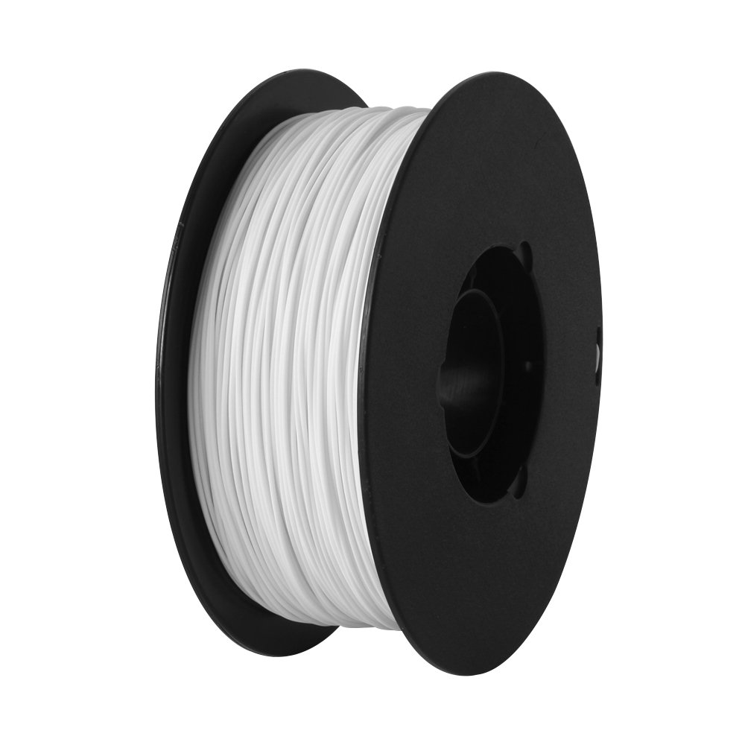
Fig.1 Bobbin of PLA material
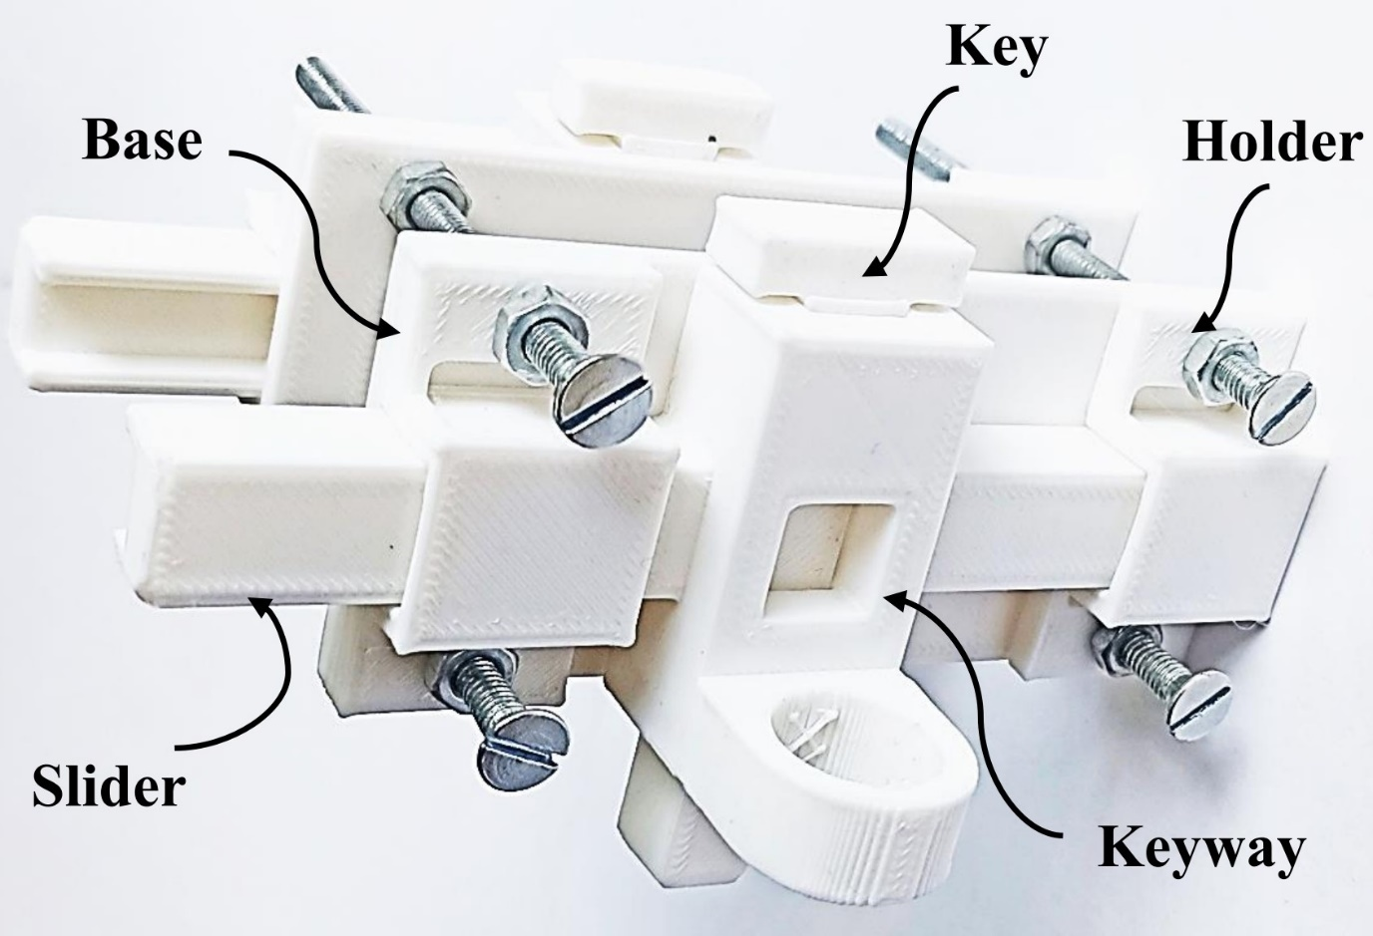
Fig.1 Assembly Drawing for Emergency door lock
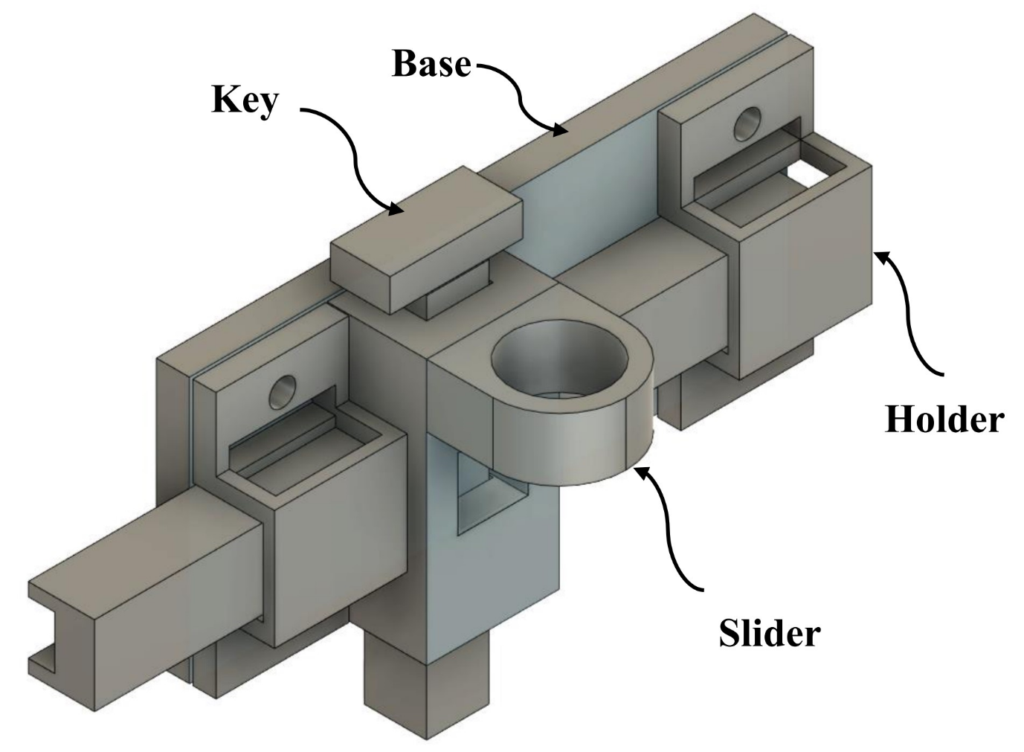
Fig.3 Side Assembly for Emergency Door Lock
The material utilized is PLA ( Polylactic Acid) , a long-lasting and inexpensive filament that is ideal for 3D printing. Autodesk Fusion 360, a popular CAD software that can output STL files, is used to construct the design. The STL file was then sliced with Creality slicer, which generates G-code files for 3D printers. The door lock parts are manufactured once the G-code files are placed into a 3D printer. After printing, the parts are assembled with assembly tools. The end product is a valuable and cost-effective method for fastening emergency doors.
The door lock is designed with Autodesk Fusion 360, a popular CAD software that can export STL files. STL files are a standard 3D printing format that can be imported into any slicing software.
The STL door lock file is then sliced with Creality slicer, which creates G-code files for 3D printers. G-code is a programming language used to control the movements of 3D printers.
The door lock parts are manufactured once the G-code files are placed into a 3D printer. The door lock parts took roughly 4 hours to produce.
After printing, the parts are assembled with assembly tools. The assembling process is quite simple and takes about 30 minutes.
Fig.2 represents the assembly drawing for the Emergency Door Lock. Fig.3 represents the Side assembly for the Emergency Door Lock.
Table No.1 shows the material properties of material for PLA + plastic which is utilized for manufacturing of the Emergency Door Lock.
Table 2
Sr.No. | Property | Value
1 | Heat Deflection Temperature(HDT) | 52⁰ C
2 | Density | 1.24 g/cm²
3 | Tensile Strength | 50 Mpa
4 | Flexural Strength | 80 Mpa
5 | Impact Strength (Unnotched) IZOD ( J/m) | 96.1
6 | Shrink Rate | 0.37-0.41 inch/min

The machine utilized for the emergency door lock is represented in Fig. 4. This machine is an Additive Manufacturing Machine.
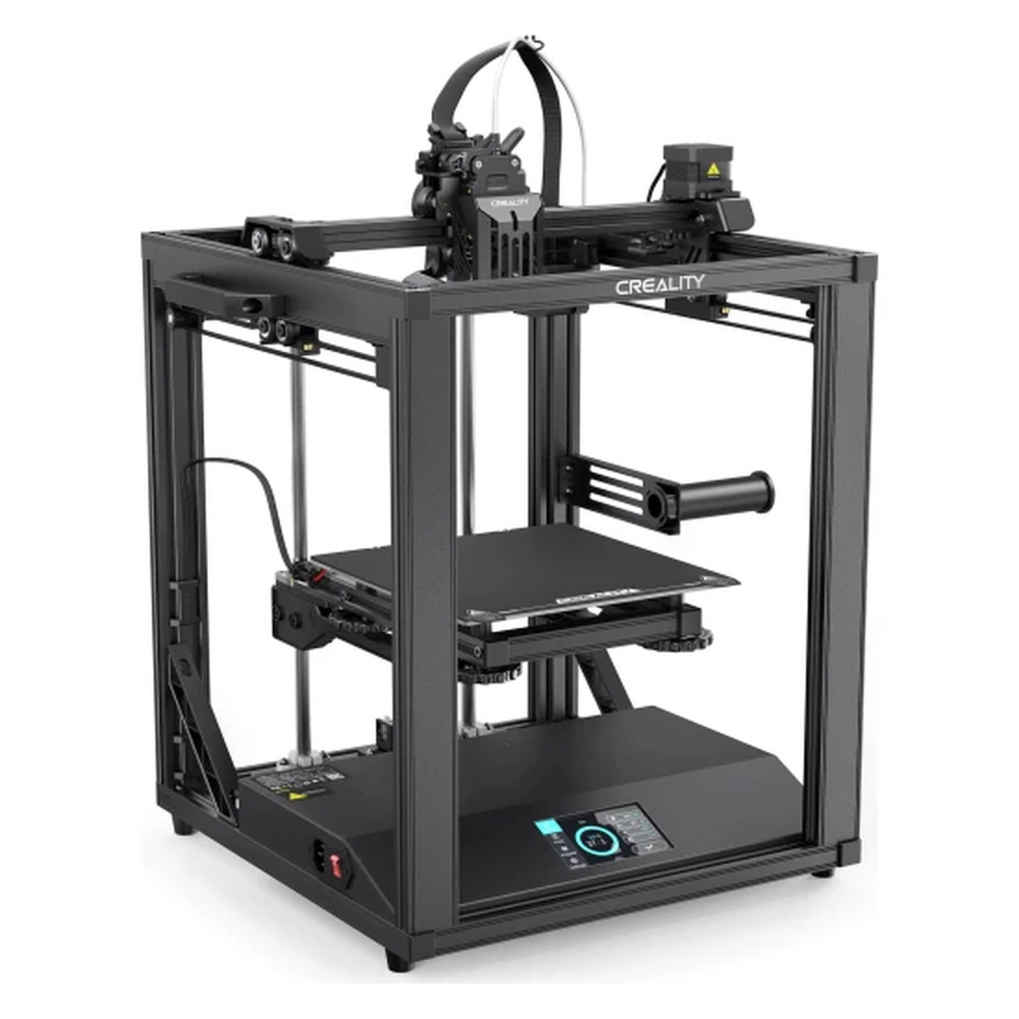
Fig.4 An Additive Manufacturing Machine
5. Result and Discussion
The emergency door lock is a secure and effective technique for dizzy patients to lock their bathroom or toilet door from the inside while yet allowing someone to unlock the door from the outside in the event of an emergency.
For dizzy patients, the emergency door lock is a crucial safety feature. It can help to keep people from becoming trapped in the restroom or toilet during a dizzy spell. The lock can also give caretakers and family members peace of mind, letting them know their loved one is safe and protected.
The emergency door lock is simple to install and use. It is also reasonably priced.
The emergency door lock is a helpful alternative for dizzy people who live alone or with caregivers who may not be able to respond to an emergency right away.
Overall, the emergency door lock is an important safety feature for dizzy patients. It is safe, effective, and simple to apply.
The emergency door lock could be improved further by including the following features:
1. A sensor that detects if the patient has fallen and automatically unlocks the door.
2. In an emergency, a two-way communication system allows the sufferer to communicate with someone outside the bathroom or toilet.
3. A backup power system in case of a power outage.
Regardless of these prospective enhancements, the emergency door lock is a crucial safety measure for dizzy patients in its current state.
5. Conclusion
For dizzy patients, the emergency door lock is a crucial safety feature. It enables patients to lock their bathroom or toilet door from the inside while yet letting someone to unlock it from the outside in the event of an emergency. This can assist prevent patients from becoming confined in the case of a dizzy episode and provide caregivers and family members with peace of mind.
For dizzy patients, the emergency door lock is a crucial safety feature. It is safe, effective, and easy to use. The emergency door lock can help to prevent patients from getting trapped in the bathroom or toilet in the event of a dizzy spell. It can also provide peace of mind for caregivers and family members, knowing that the patient is safe and secure.
We encourage all dizziness-suffering patients to consider installing an emergency door lock in their bathroom or toilet. It is a small investment that can make a big difference in your safety and well-being.
6. Future Scope
Manual door locks have a limited future because they are very basic mechanisms. There are, however, a few possible areas for improvement.
Security Manual door locks are susceptible to lock picking and lock bumping. Manufacturers of manual door locks may design new locking systems that are more resistant to these attacks in the future.
Convenience: Manual door locks can be difficult to use, particularly for persons with impairments or restricted mobility. Manufacturers of manual door locks may create new features that make it easier to unlock and lock doors in the future, such as voice-activated locks or locks that can be opened with a smartphone app.
Affordability: Although manual door locks are generally inexpensive, there is always space for improvement. Manual door lock manufacturers may create new manufacturing techniques or employ new materials in the future to make their goods even more affordable.
The future of manual door locks is quite restricted in general, however there are a few potential areas for improvement. Manual door lock makers can continue to add value to their products by focusing on security, simplicity, and cost.
Another possible area of improvement for manual door locks is in the field of sustainability. In the future, makers of manual door locks may create new products produced from recycled materials or driven by renewable energy sources.
7.References
1. F. Aman and C. Anitha, "Motion sensing and image capturing based smart door system on android platform", 2017 International Conference on Energy Communication Data Analytics and Soft Computing (ICECDS), pp. 2346-2350, 2017.
2. Sami El Mur Abdallah Kassem, Georges Jamous, Elie Saad and Marybelle Geagea, "A smart lock system using Wi-Fi security", 3rd International Conference on Advances in Computational Tools for Engineering Applications (ACTEA), 2016.
3.H. A. Alabbasi and F. Moldoveanu, "Human face detection from images based on skin color", 2014 18th International Conference on System Theory Control and Computing (ICSTCC), pp. 532-537, 2014.
4.R. Karunamoorthi, Mohit Tiwari, Tripti Tiwari, Radha Kuruva, Arvind K. Sharma, M. Jemimah Carmichael, et al., "Design and development of IoT based home computerization using Raspberry pi", Materials Today: Proceedings, 2020, [online] Available: https://doi.org/10.1016/j.matpr.2020.10.673, ISSN 2214-7853.
5.A. Chen, A. Gil-de-Castro, E. J. Palacios-Garcia, J. M. Flores-Arias and F. J. Bellido-Outeirino, "In-home data acquisition and control system based on BLE", 2015 Int. Symp. Consum. Electron, pp. 1-2, 2015.
6.O. Berat Sezer, S. Z. Can and E. Dogdu, "Development of a smart home ontology and the implementation of a semantic sensor network simulator: An Internet of Things approach", 2015 Int. Conf. Collab. Technol. Syst, pp. 12-18, 2015.
7. A. Rezgui and M. Eltoweissy, "Service-oriented sensor-actuator networks: Promises challenges and the road ahead", Computer Communications, vol. 30, no. 13, pp. 2627-2648, 2007.
8. M.T. Rahman and N. Kehtarnavaz, "Real-time face-priority auto focus for digital and cell-phone cameras", IEEE Trans. Consum. Electron, vol. 54, pp. 1506-1513, 2008.
9.Y. Lihong and W. Jianxin, "The Design of Intelligent Automatic-Door Based on AT89S52", 2016 International Conference on Robots & Intelligent System (ICRIS), pp. 428-431, 2016.
10. C. Suh and Y. Ko, "Design and implementation of intelligent home control systems based on active sensor networks", IEEE Transactions on Consumer Electronics, vol. 54, no. 3, pp. 1177-1184, August 2008.
11.J.-C. Yang, C.-L. Lai, H.-T. Sheu and J.-J. Chen, "An Intelligent Automated Door Control System Based on a Smart Camera", Sensors, vol. 13, pp. 5923-5936, 2013, [online] Available: https://doi.org/10.3390/s130505923.
12.Yong Park, Pranesh Sthapit and Jae-Young Pyun, "Smart digital door lock for the home automation", pp. 1-6, 2009.
13.Malabika Sarma, Amlanjyoti Gogoi, Rahul Saikia, Dibya Bora and Bora, Fingerprint Based Door Access System using Arduino, 2020.
14.R. Piyare and M. Tazil, "Bluetooth-based home automation system using cell phone", IEEE Conferences of Consumer Electronics Engineering, pp. 192-195, 2011.
15. A. Ramya,Sai Leela Vanapalli,3d Printing Technologies In Various Applications,Ijmet,June2016,Pp.396–409,ISSN-0976-6340.
16. N. Shahrubudina,T.C. Leea,R. Ramlana,An Overview on 3D Printing Technology: Technological, Materials, and Applications,Elsevier B.V, August 2019,pp.1286-1296,ISSN-2351-9789.
17. Cephas Mawere,The Impact and Application of 3D Printing Technology,IJSR,june-2014, ISSN-,2319-7064.
18. Nandkishor Dhawale,Nitesh Chavan,3D Printing Technology and its Applications in Real-World Scenario,IJIRSET,Feb-2022, ISSN: 2319-8753.
19. Katja Hölttä-Otto,Kristin Lee Wood,CROWDSOURCED DESIGN PRINCIPLES FOR LEVERAGING THE CAPABILITIES OF ADDITIVE MANUFACTURING,ICED15,Jan-2015.
20. T. Prabhu,MODERN RAPID 3D PRINTER - A DESIGN REVIEW,IJMET, May–June 2016, pp.29–37,ISSN: 0976-6340.
21. JABBAR QASIM AL-MALIKI,ALAA JABBAR QASIM AL-MALIKl,The Processes and Technologies of 3D Printing,IJACST,Vol.4 No.10, Oct-2015,ISSN 2320 - 2602.
22. Vishal N. Patel,Kamlesh P. Kadia,Parametric Optimization of The Process of Fused Deposition Modelling In Rapid Prototyping Technology- A Review, IJIRST, Dec-2014,ISSN: 2349-6010.
23. Kaufui V. Wong,Aldo Hernandez,A Review of Additive Manufacturing,ISRN,Aug-2012.
24. Helena N Chia,Benjamin M Wu,Recent advances in 3D printing of biomaterials,JBE 2015.
25. Wenyong Liu,Ying Li,Jinyu Liu,Xufeng Niu,Yu Wang,Deyu Li, Application and Performance of 3D Printing in Nanobiomaterials,Journal of Nanomaterials, Sept 2013.
26. Prof. Deepa yagnik,Fused Deposition Modeling – A Rapid Prototyping technique for Product Cycle Time Reduction cost effectively in Aerospace Applications,ICAET,2014,PP 62-68, ISSN: 2278-1684.
27. Shivraj Narayan Yeole,Sri Nidhi Hrushi Kesav Regula,Y. Shivraj Narayan,Importance and utilization of 3D printing in various applications, IJMER, Jan-2016, ISSN: 2249-6645.
28. Ajay Anil Shinde,Ashutosh Dandekar,Rahul Patil,Nandkishor Dhawale,3D Printing Technology, Material Used For Printing and its Applications, IJIRSET, July 2020, ISSN: 2319-8753.
29. K.Blake Blake Perez,Kristin Lee Wood,Additive Manufacturing (AM) Design Principle Cards, Jan-2019.
30. Dr. Nandkishor M. Dhawale,Ms. Sneha A. Patil,Mr. Aditya R. Rajput,Mr. Kiran A. Shinde,Mr. Rohan S. Kulkarni,Mr. Nitesh R. Chavan,On Design Rapid Prototyping and Testing of IoT Enabled Sensors Using Open Source Tools, IJAEM,Oct-2021, pp: 168-173, ISSN: 2395-5252.
31. Boini Sriharsha,P. Sudhakar Rao,RAPID PROTOTYPING TECHNOLOGY: APPLICATIONS, ADVANTAGES AND LIMITS -A REVIEW, Dec-2018.
32. L Villalpando,Hasti Eiliat,Ruth Jill Urbanic,An Optimization Approach for Components Built by Fused Deposition Modeling with Parametric Internal Structures, Elsevier B.V.,May-2014, PP-800 – 805,ISSN-2212-8271.
33. Xiaoming Li,Application and Performance of 3D Printing in Nanobiomaterials,Journal of Nanomaterials,Sept-2013.
34. Maciej Walczak,Models of the emergence and diffusion of mass customization, Elsevier,2014,PP-812 – 821,ISSN-1877-0428.
35. Jayant Morey,Sandeep Kongre,Product development for future using rapid prototyping techniques, Dec-2017.
36. Aby K Abraham,Vinay Pramod,Abhijith Baiju,Akash Babuji,Rijo Plathanam,Feasibility Study on 3D Printed Patterns in Casting,IJETAE, June-2015, ISSN 2250-2459.
37. Dr. B.Satyanarayana,Kode Jaya Prakashb,Component Replication using 3D Printing Technology, Elsevier,Dec-2015, PP-263 – 269,ISSN-2211-8128.
38. Azem Yahamed,Pavel Ikonomov,Paul D. Fleming,Application of 3D Printing for Human Bone Replacement, June-2021.
39. Azhar Equbal,Anoop Kumar Sood,Metallization on FDM Parts Using the Chemical Deposition Technique, Elsevier BV,Sept-2014, ISSN 15266125.
40. Sandeep Rauta,VijayKumar S. Jattib, Nitin K. Khedkar,T.P.Singh,Investigation of the effect of built orientation on mechanical properties and total cost of FDM parts, Elsevier BV, Dec-2014, Pp-106–113.
41. Dinesh Kumar S,Parameter Optimization of ABS-M30i Parts Produced by Fused Deposition Modelling for Minimum Surface Roughness, April-2014, ISSN 2277 - 4106.
42. Carsten Kruschinski,Gudrun Theile,Sabine Dorothee Dreier,Eva Hummers-Pradier,The priorities of elderly patients suffering from dizziness: A qualitative study, Jan-2010.
43.

