**Python Programming and Implementation for Optimizing Bar Bending Schedules in simply supported beam**

**Akash B Jadhav1, Megha V Warungse2**

1Head of Department, Civil Engineering, Shatabdi Institute of Engineering And Research

2Head of department, Computer Engineering, Shatabdi Institute of Techanology

**ABSTRACT (Font-Times New Roman, Bold, Font Size -12)**

The Bar Bending Schedule (BBS) is an essential part of construction in civil engineering, where it defines the quantity, type, and dimensions of steel reinforcement bars required for a structure. This paper presents a Python-based approach to calculating the bar bending schedule for simple beams, detailing the steps involved, including cutting lengths for top and bottom bars, the number of stirrups, and the weight of stirrups. By automating these calculations, the proposed method reduces the risk of manual errors, enhances accuracy, and provides an efficient way to optimize reinforcement designs. The approach is demonstrated with an example of a reinforced concrete beam and is expected to be a valuable tool for structural engineers and designers.

**Keywords:** Bar Bending Schedule, python, Bar, length

1. **INTRODUCTION (Font-Times New Roman, Bold, Font Size -12)**

Reinforced concrete (RC) structures are the backbone of modern civil engineering, and the design of such structures heavily depends on the correct and efficient use of steel reinforcement. One of the critical components of structural design is the Bar Bending Schedule (BBS), which specifies the type, size, number, and cutting lengths of reinforcement bars used in the construction.

In this paper, we focus on the development of an automated method to calculate the BBS for simple beams, using the Python programming language. Simple beams are a common element in building frames, and their reinforcement is typically comprised of top bars, bottom bars, and stirrups. Accurate and efficient calculation of the reinforcement requirements is crucial for material estimation, cost optimization, and structural integrity.

This paper introduces a step-by-step approach for calculating the cutting lengths and weight of reinforcement bars, as well as the number of stirrups required for a simple beam. The methodology is demonstrated through a worked example, and the results are presented to showcase the potential benefits of automation in BBS calculations

**METHODOLOGY**

The calculation of the Bar Bending Schedule for a simple beam involves several key steps, including the determination of cutting lengths for top and bottom bars, the number of stirrups, the cutting length of each stirrup, and the total weight of the stirrups.

Method follow

* Problem Identifued during manual
* Study on problem
* Work on traditional method
* Apply on Python coding
* Result

1. **MODELING AND ANALYSIS**

**Bar Bending Schedule for Simple Beams.**

**By Manual method**

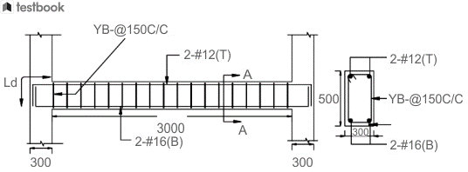

Example of Bar Bending Schedule for Simple Beam

It can be seen from the above example of a simple beam that the clear span of the beam is 3m consisting of 2 numbers of 16mm diameter bars at the bottom and 2 numbers of 12mm diameter bars at the top with 8mm diameter stirrups having a clear cover of 150mm. Let us assume a clear cover of 25mm at both sides and ends of the given beam.

The observations that can be drawn from the above figure are-

* Clear span of the beam= 3000mm
* Development length \Ld\Ld= 50d (assume)
* Clear cover= 25mm at any ends.
* Bottom- 2 numbers @ 16ϕϕ
* Top- 2 numbers @ 12ϕϕ
* Stirrups- 8phiphi @ 150mm clear cover.

**Step 1- Cutting Length of the top bar**

Cutting Length of top bar= Clear span of beam + development length (LdLd) on 2 sides - clear cover on 2 ends

= 3000+(2× 50d2× 50d- (2× 252× 25

=3000 + (2×50×122×50×12) - 50

=4150mm

**Step 2- Cutting Length of Bottom Bar**

Cutting Length of bottom bar= Clear span of beam + development length (LdLd) on 2 sides - clear cover on 2 ends

= 3000+(2× 50d2× 50d- (2× 252× 25

=3000 + (2×50×162×50×16) - 50

=4550mm

**Step 3- The number of stirrups**

Number of stirrups required = (Clear Span of Beam/Spacing of Stirrups) + 1

= (3000/150) + 1= 21 numbers.

**Step 4- Cutting Length of each stirrup**

Let us split the sides as ‘a’ and ‘b’ to make the calculation easier.

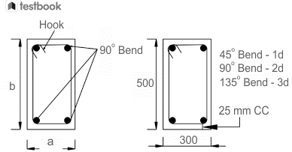

Fig.Stirrups for Simple Beam

Length of one hook = 9d

Cutting Length of stirrup= Perimeter of Stirrup + Number of Bends + Number of Hooks

= 2(a+b) + 3 numbers of 90 degree bends+2 numbers of hooks3 numbers of 90 degree bends+2 numbers of hooks

= 2(300+500)+(3×2d)+(2×9d)2(300+500)+(3×2d)+(2×9d)

= 1600+(3×2×8)+(2×9×8)1600+(3×2×8)+(2×9×8)

=1792mm

**Step 5- Weight of Stirrups**

Total number of stirrups= 21

Total length of stirrups= 21×1.792=37.632m21×1.792=37.632m

Weight of stirrups= d2L162=8×8×37.632162=14.86 kgd2L162=8×8×37.632162=14.86 kg

|  |  |  |  |
| --- | --- | --- | --- |
| Name | **Diameter of Bars (mm)**  **Numbers** | **Cutting Length**  **(mm)** | **Total Length**  **(mm)** |
| Top bars | 12 | 4150 | 8300 |  |
| Bottom bars | 16 | 4550 | 9100 |  |
| Stirrups | 8 | 1792 | 37632 |  |

**By using Python Languages**

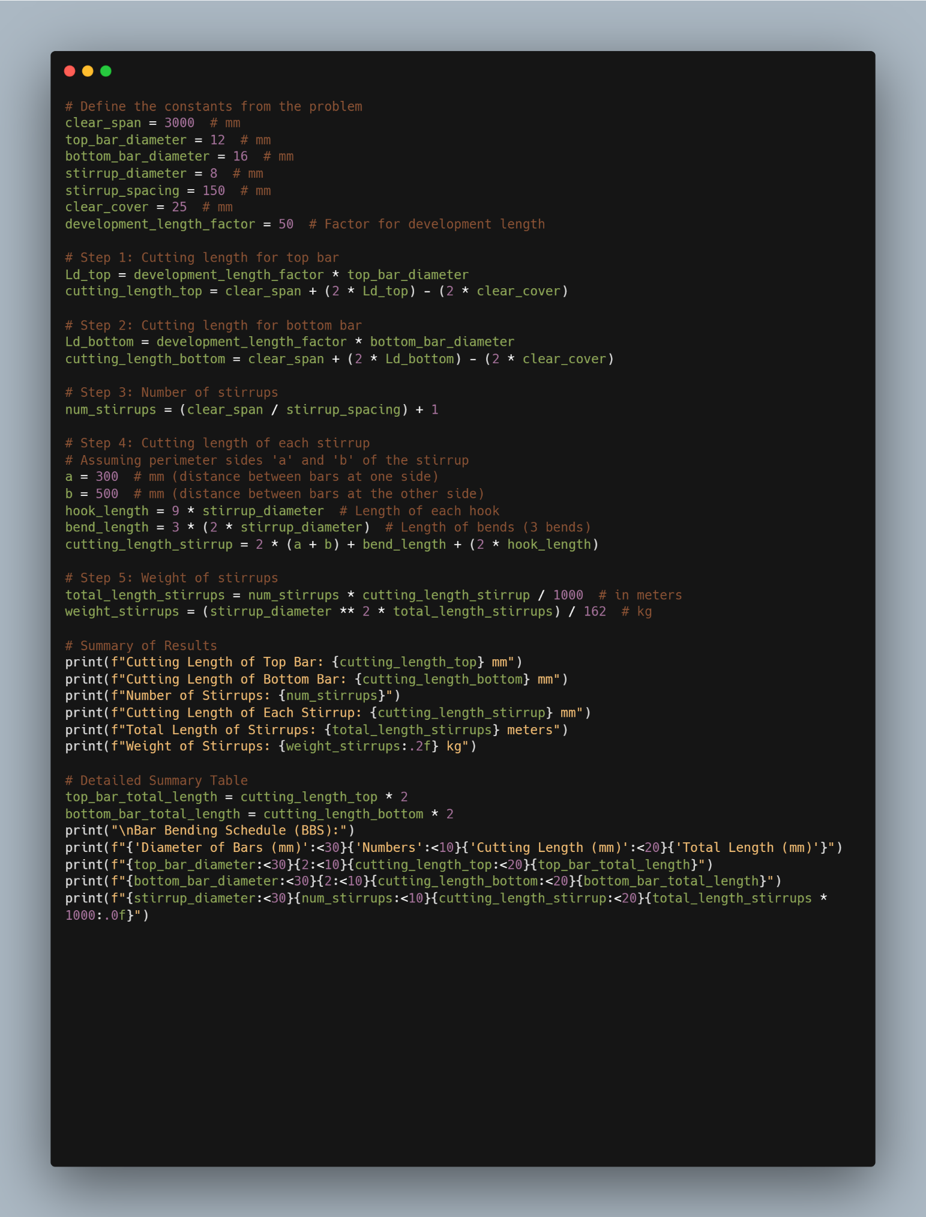

1. **RESULTS AND DISCUSSION**

Result comparison betww

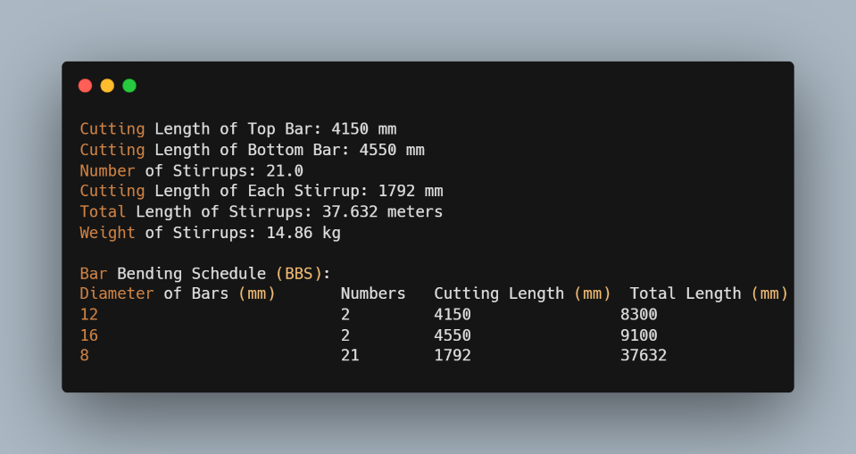

This Python-based approach provides an efficient and accurate method for calculating the Bar Bending Schedule for simple beams. The automation of these calculations eliminates the risk of human error, reduces time spent on manual calculations, and improves the overall efficiency of the design process. The method can be extended to more complex structural elements and different reinforcement configurations by modifying the parameters and formulas. While the calculations provided are based on a specific example, the Python script can be adapted for various beam designs, including different dimensions, bar diameters, and spacing. Further enhancements can include creating user interfaces or integrating with building information modeling (BIM) software for seamless design workflows.

1. **CONCLUSION**

The Bar Bending Schedule (BBS) plays a pivotal role in the design and construction of reinforced concrete structures, as it ensures the correct specification of reinforcement quantities, cutting lengths, and configurations. The Python-based approach introduced in this paper represents a significant advancement in automating the BBS process, making it easier for structural engineers to compute and manage reinforcement details for simple beams with precision. By automating the calculations for cutting lengths, stirrup requirements, and reinforcement weights, this tool not only saves valuable time but also minimizes human errors that could lead to costly design and construction flaws. Moreover, the automation of the BBS process promotes greater material efficiency by helping engineers optimize the quantity of steel used, thus reducing waste and contributing to cost-effective design practices. This, in turn, supports sustainable building practices by ensuring that resources are utilized efficiently while maintaining the structural integrity of the design.

The proposed system is designed to be flexible and user-friendly, empowering engineers to quickly generate accurate schedules that align with project specifications and regulatory standards. It enhances workflow by simplifying a traditionally tedious manual process and reduces the potential for inconsistencies that may arise in larger, more intricate projects.

Looking ahead, future enhancements will focus on adapting the tool to accommodate more complex structural designs, such as multi-span beams, slabs, and columns. Integration with existing structural design software will allow for seamless real-time calculations and instant updates, making it possible to immediately visualize the impact of design changes on reinforcement specifications. Additionally, incorporating machine learning algorithms may further refine the optimization process, enabling predictive analysis and offering suggestions for alternative reinforcement layouts that maximize both structural safety and material savings.

In summary, this Python-based approach for Bar Bending Schedule generation offers a step forward in the realm of structural engineering by facilitating the design process, improving accuracy, and enhancing both material efficiency and cost-effectiveness. As future developments unfold, this tool has the potential to revolutionize the way structural engineers approach reinforcement design, paving the way for smarter, more sustainable construction practices.

1. **REFERENCES**
   1. Jain, A. K., & Sharma, R. (2017). Design of Reinforced Concrete Structures. New Delhi: S. Chand Publishing.  
      This textbook provides comprehensive details on the design principles and methodologies used in reinforced concrete construction, including bar bending schedules and material specifications.
   2. Bureau of Indian Standards. (2000). IS 456:2000 - Indian Standard Code of Practice for Plain and Reinforced Concrete. New Delhi: Bureau of Indian Standards.  
      This code of practice outlines the standards for the design and construction of reinforced concrete structures in India, including the calculation of reinforcement and preparation of bar bending schedules.
   3. Sinha, S. K., & Roy, S. (2012). Reinforced Concrete Design. New Delhi: Tata McGraw-Hill Education.  
      This book provides a detailed exploration of reinforced concrete design, including the calculations of reinforcement quantities, cutting lengths, and other aspects relevant to Bar Bending Schedules.
   4. Kumar, S. (2019). Automation in Structural Design: Tools and Techniques for Optimization. International Journal of Civil Engineering and Technology, 10(3), 567-574.  
      This paper discusses the role of automation in structural engineering, particularly in tasks such as the preparation of bar bending schedules and optimization of reinforcement designs