**HERBAL CREAM : FOR MANAGEMENT OF SPORT INJURY**

**Miss. Deepti Danayya Hiremath**

**Miss. Asavari Sambhaji Bhosale**

**Institute Name: R. C. Patel institute of pharmaceutical education and research , shirpur dis. Dhule Maharastra**

**ABSTRACT:**

Herbal cream is type of topical drug delivery system that can be used to treat sports injury that can allow the topical formulation to be delivered across the skin upon the application ,hence it produce local effect.It contains herbal ingredients such as Fenugreek powder, Turmeric Powder, Dry ginger powder, Acacia pod powder .Fenugreek supplementation has significantly improve muscle strength, Turmeric contains high concentration of curcumin , a polyphenol that has be show to reduce muscle damage. Dry ginger reduce muscle pain, Acacia helps in deep tissue injury.A natural treatment for the sport injury can help us to get back to our sport quickly and safely. The formulation were prepared using a suitable process, ensuring the integration of active ingredients with suitable excipients for stability and skin compatibility. The method involved the preparation of herbal extracts followed by the formulation of the cream using maceration technique. The formulations F1,F2,F3 and F4 of the herbal herbal cream exhibit promising characteristics in terms of physical properties ,stability ,skin compatibility and efficacy.

Key words: cream ,sports injury, fenugreek ,turmeric ,dry ginger, acacia pod , maceration

**INTRODUCTION:**

Sports injuries are a prevalent concern in the realm of athletics, affecting both professional and amateur athletes. These injuries, which encompass a wide range of conditions such as sprains, strains, contusions, and fractures. Topical formulations come in a variety of forms, including oils, creams, pastes, ointments, and gels. Fenugreek powder, Turmeric powder, Dry ginger powder and Acacia pod powder are the main biologically active ingredient which are used in the management of sports injury. Fenugreek may help with exercise -induced injuries and muscle recovery due to its anti-inflammatory properties and ability to improve muscle performance. Turmeric may help with sports injuries by reducing inflammation, pain and muscle damage. Dry ginger shows analgesic and anti-inflammatory effects. Acacia pod powder powder have antibacterial properties which aid in controlling bleeding and infections . The extract Obtained from equal quantity of each of these powders was taken. These active ingredients shows Anti-inflammatory, Anti- edeamatous and Anti-oxidant properties.

**ADVANTAGES:**

1. Easy to use and commonly available.
2. Being natural, they have the least harmful effect on the skin or other body parts.
3. They have no side effects.
4. Easy to manufactures and chief in cost.

**IDEAL PROPERTIES OF HAIR REMOVAL CREAM:**

1. It should be not produced any toxic effect on application

2. They should be optimum particles size.

3. They should produce emollient effect.

4. Thicker than a lotion, maintaining its shape, for example, a 50/50 emulsion of oil and water.

5. They should spread uniformly on the skin surface.

6. Requires preservative to extend shelf life.

7. They should be compatible with skin Ph

**Monograph of ingredients:**

1. **Fenugrrek:**

**Family:** Fabaceae

**Biological Source:**It consists of dried seeds of Trigonella foenum

**Biological name:** Trigonella foenum

**Uses:** Improve muscle strength.

Anti-microbial activity.

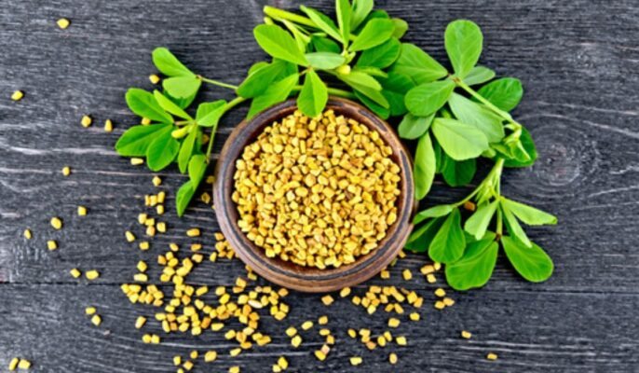

**Fig.1 Fenugreek**

1. **Ginger:**

**Family:**Zingiberaceae

**Biological Source:** It consists of dried rhizomes of Zingiber Officinale

**Biological Name:** Zingiber Officinale

**Uses:** Analgesic

Anti-inflammatory activity

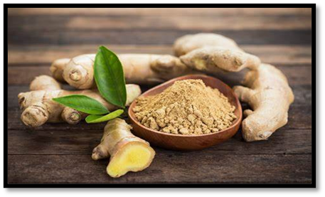

**Fig. 2 Ginger**

**Turmeric:**

**Family:** Zingiberaceae

**Biological Source:** Turmeric is a product of Curcuma longa, a rhizomatous herbaceous perennial plant belonging to the ginger family Zingiberaceae, which is native to tropical South Asia.

**Biological Name:** Curcuma longa

**Medicinal Use:**

1. Use to treat disorders of the skin.

2. Use to treat respiratory tract infection.

3. Use to treat problems in the digestive system.

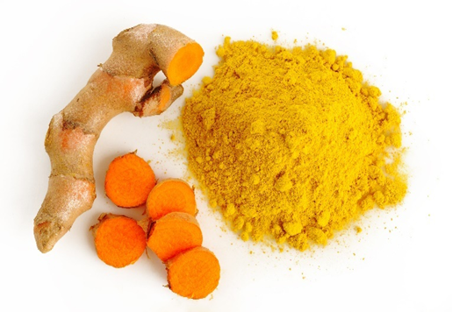

**Fig.3 Turmeric**

**Acacia:**

**Family:** Fabaceae

**Biological Source:** It consists of pods Acacia Auriculiforms.

**Biological Name:** Acacia Auriculiforms.

**Uses:** Helps in deep tissue injury.

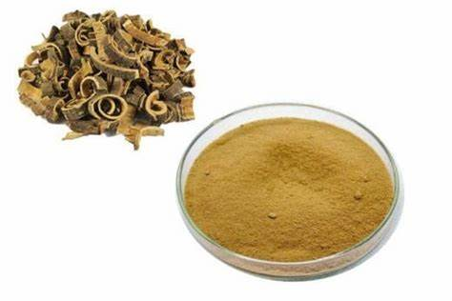

**Fig .4 Acacia**

|  |  |
| --- | --- |
| **INGREDIENTS** | **ROLES** |
| Stearic Acid | Thickening Agent |
| White Bees Wax | Humectant |
| Ceto Stearyl Alcohol | Emulsion Stabiliser |
| Cetyl Alcohol | Emulsifier |
| Liquid Paraffin | Emollient |
| Propylene Glycol | Moisturising agent |
| TEA | Cross linking agent |
| Methyl paraben | Preservative |
| Papain | Permeation Enhancer |
| Gelatin | Gelling agent |
| Fenugreek | Anti-inflammatory, improve muscle performance |
| Ginger | Analgesic, Anti-inflammatory |
| Turmeric | Reduce pain and muscle damage |
| Acacia(pod) | Anti-bacterial property |

**Material and Methods:**

**Materials:**

**Chemicals:** stearic acid, white bees wax, ceto stearyl alcohol, cetyl alcohol, liquid paraffin, propylene glycol, TEA, methyl paraben, papain, gelatin

**Herbal Ingredients:** Fenugreek, Dry ginger, Turmeric, Acacia pod (powder)

**Table No. 1 –** Excipents and herbal ingredients with their roles

**EXPERIMENTAL WORK:**

**Extraction of fenugreek, dry ginger, turmeric and acacia pod (powder):**

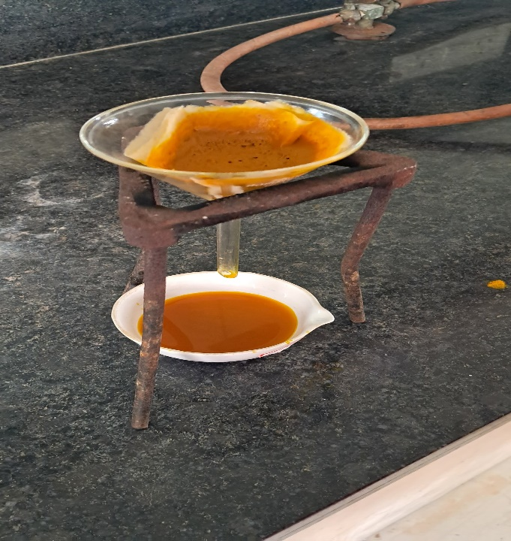

**Fig 5 Filltration process of active ingredients**

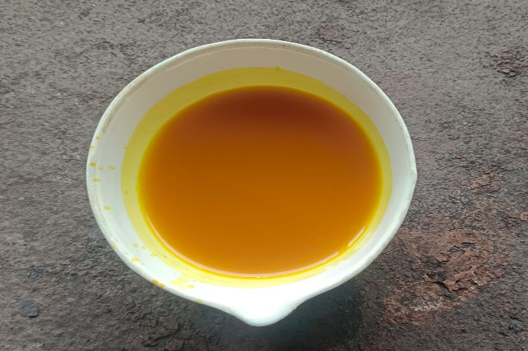

**Fig 6. Extract obtained from Fenugreek, dry ginger, turmeric, acacia pod (powder)**

**PREPRATION OF HERBAL CREAM:**

Heat stearic acid, white bees wax, ceto stearyl alcohol, cetyl alcohol and liquid paraffin in a borosilicate glass beaker at 70 degree Celsius and maintain that heating temperature ( oil phase). Take mortar pestle and mix well fenugreek powder, dry ginger powder, turmeric powder, acacia pod powder. Add this powder mixture in water phase which contains propylene glycol, TEA, methyl paraben , papain, gelatin. Then slowly add oil phase in water phase and stir vigorously until it forms a smooth cream. Stir it properly until proper cream was formed.

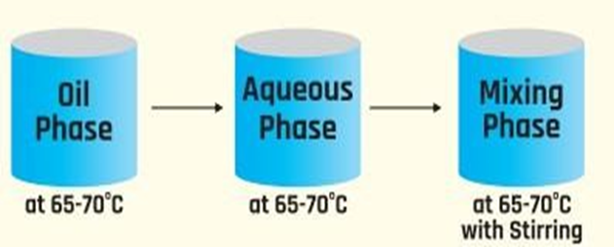

**Fig. 7 Method For Formulation**

**Formula for prepration of cream:**

|  |  |  |  |  |  |  |
| --- | --- | --- | --- | --- | --- | --- |
| Sr. No | Phase | Ingredient s | Batch- 1 | Batch  -2 | Batch  -3 | Batch- 4 |
| 1 | Oil  Phase | Stearic Acid | 3 | 3 | 2 | 2 |
| 2 | White Bees Wax | 3 | 3 | 2 | 2 |
| 3 | Ceto Stearyl Alcohol | 5 | 5 | 4 | 4 |
| Cetyl  Alcohol | 6 | 6 | 5 | 5 |
| 4 | Liquid Paraffin | 10 | 10 | 10 | 10 |
| 5 |
| 6 | Water Phase | Propylene Glycol | 10 | 10 | 10 | 10 |
| 7 |
| TEA | 1 | 1 | 1 | 1 |
| 8 | Methyl paraben | 0.1 | 0.1 | 0.1 | 0.1 |
| 9 | papain | 0.2 | 0.3 | 0.5 | 0.5 |
| Gelatine | 0.5 | 0.8 | 0.7 | 0.7 |
| 10 | Fenugreek  Dry ginger  turmeric  acacia pod(powder) | 10 | 10 | 10 | 10 |
| 11 | Purified Water | Q.S | Q.S | Q.S | Q.S |
|  |

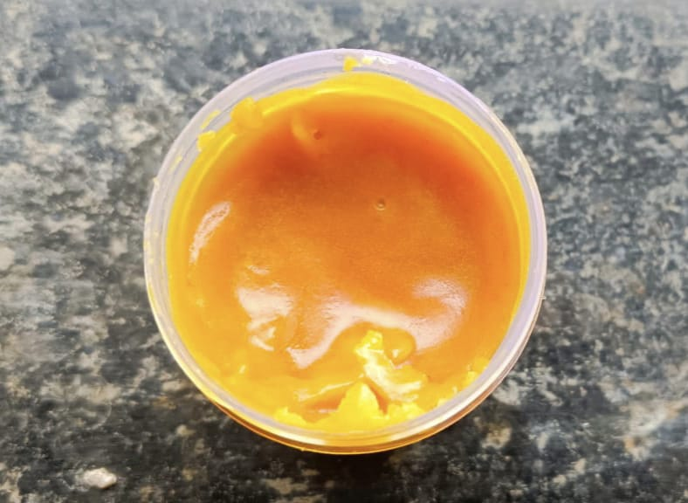

**Fig 8. Formulation of Herbal Cream**

**EVALUATION OF CREAM:**

1. **Determination organoleptic characteristics:**

Evaluation aimed to saw physical appearance of cream which involves color, odour , texture

**a) Colour :**

On a white background, the formulation's colour was examined.

**b) Odour :**

The odour of cream checked by taking a smell.

**c) Texture :**

The texture was assisted by application on the skin.

1. **Determination of Viscosity:**

Viscosity of the formulated cream was determined using Brookfield Viscometer Spindle no. 64 and spindle speed 10 rpm at 25°C was used for cream , the corresponding dial reading on the viscometer was noted.

1. **Determination of pH:**

PH was measured by using pH paper.

1. **Determination of Washability :**

After applying the formulation to the skin, the extent and simplicity of water washing were manually assessed.

1. **Determination of Homogeneity:**

Whenever the gel-like substances have been set in the container, all created creams are visually inspected to determine their homogeneity. They are examined to look for aggregates and assess their appearance.

1. **Spreadability:**

On the wooden block a ground glass slide was mounted. On this ground slide, 2 gram of the prepared gel was put. Thereafter, a second glass slide with the same dimensions as the fixed ground slide was sandwiched between this slide and the gel preparation. The hook is provided on the second glass slide. For five minutes, a weight of 500 mg was placed on top of the two slides to remove air and produce a homogenous gel film between them. A specified amount of weight was added to the pan, which was connected to the pulley. The top slide’s time (in sec) needed to travel a distance of 5 cm was recorded.

Spreadability was calculated by using the following formula

S=M×L /T

Where,

S - Spreadability

M - Weight tied to the upper slide (11gm).

L - Length of the glass (6.5cm).

T - Time in sec.

1. **Irritancy Test:**

Irritancy test was assisted by application on skin.

1. **Dilution Test:**

Dilution test was done by diluting some amount of cream in water (10 times).

1. **Anti-oxidant Test [ DDPH ( 2,2-diphenyl-1-picrylhydrazyl) assay:**

The DPPH assay is a procedure used to evaluate the antioxidant capacity of a sample. Here are some steps for performing a DPPH assay:

1. Prepare the DPPH solution-

Make a fresh, light-protected stock solution of DPPH in methanol or ethanol. Dilute the stock to the desired concentration, which is often 0.1 mM.

2. Prepare the sample-

Prepare the sample and a positive control at different dilutions in a suitable solvent.

3. Combine the solutions-

Mix equal volumes of the sample or control with the DPPH working solution. Include a solvent-only blank.

4. Incubate-

Incubate the mixture in the dark for a set time, which depends on the antioxidant's kinetics.

5. Measure the absorbance-

Use a spectrophotometer to measure the absorbance of each reaction at a specific wavelength, such as 517 nm or 660 nm.

1. Calculate the results

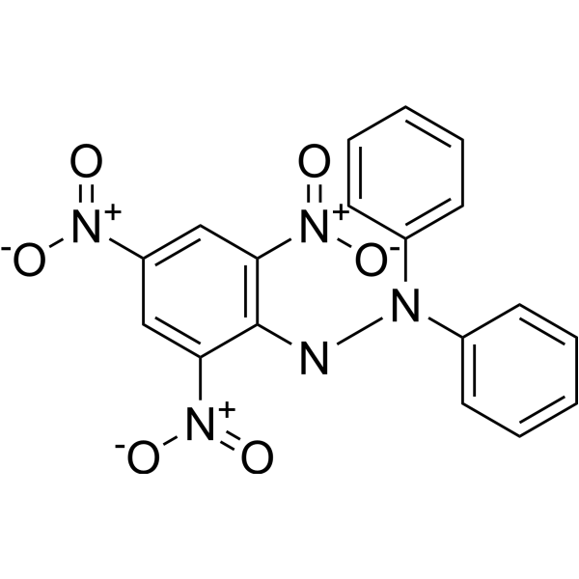

**Fig.9 Structure of DPPH ( 2,2 diphenyl -1-picrylhydrazyl)**

**RESULT AND DISCUSSION:**

**Evaluation of Herbal Cream :**

**Physiochemical Properties-**

Physical evaluation such as color, odor, texture was checked.

**table no. – physiochemical evaluation of herbal cream:**

|  |  |  |  |
| --- | --- | --- | --- |
| **Sr.no** | **Parameter** | **Specification** | **Observation** |
| 1 | Description | Dark Yellow to Yellow Colour | Yellow Coloured gel |
| 2 | Odour | Odourless to Pungent Smell | Pungent Smell |
| 3 | Texture | Must be Homogenous | Homogenous |

**Viscosity :**

Brookfield viscometer spindle no .64 RPM: 10 , Torque :75.4

|  |  |  |  |  |
| --- | --- | --- | --- | --- |
| **Batch** | **Reading-1** | **Reading-2** | **Reading**  **-3** | **Mean (CPS)** |
| 1 | 4455 | 4481 | 4471 | 4469 |
| 2 | 4421 | 4463 | 4425 | 4435 |
| 3 | 4468 | 4462 | 4461 | 4464 |
| 4 | 4466 | 4461 | 4460 | 4462 |

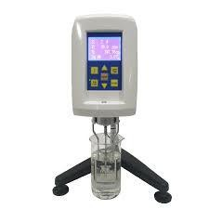



**Fig.10 Brookfield Viscometer**

**pH-**

**pH was determined by using digital pH meter :**

|  |  |  |  |  |
| --- | --- | --- | --- | --- |
| **Batch** | **Reading-1** | **Reading-2** | **Reading-3** | **Mean** |
| 1 | 5 | 5.5 | 5.4 | 5.3 |
| 2 | 5.5 | 5.8 | 5.0 | 5.4 |
| 3 | 5.4 | 5.5 | 5.6 | 5.5 |
| 4 | 6.1 | 6.2 | 6.0 | 6.2 |

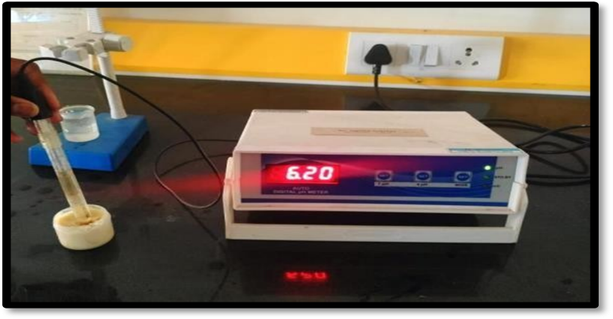

**Fig.11 pH meter**

**Spreadability:**

**table no.10 - determination of spreadability:**

|  |  |  |
| --- | --- | --- |
| **Formulation** | **Time (sec) ( cm/sec)** | **Spreadability** |
| **F1** | 7 | 1.1-1.5 |
| **F2** | 15 | 1.2-1.6 |
| **F3** | 11 | 1.3-1.9 |
| **F4** | 9 | 1.3-1.8 |

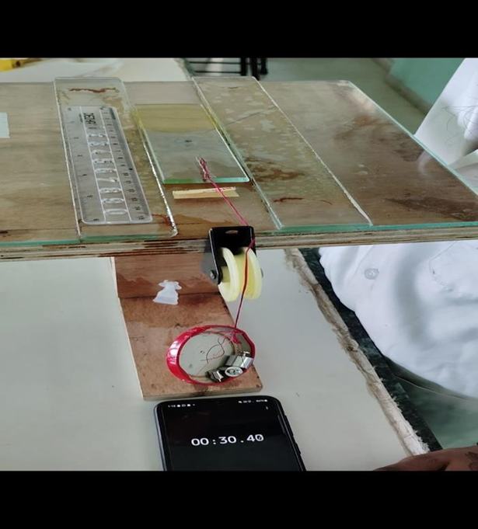

**Fig. 12 spreadability apparatus**

**Anti-oxidant Test [ DDPH ( 2,2-diphenyl-1-picrylhydrazyl) assay:**

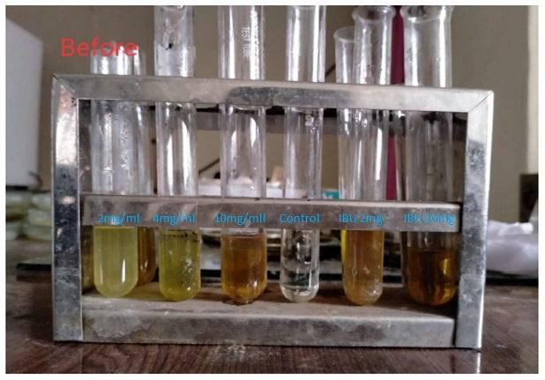

**Fig.13 Anti-Inflammatory Activity of batch VL04 before keep in hot water bath**

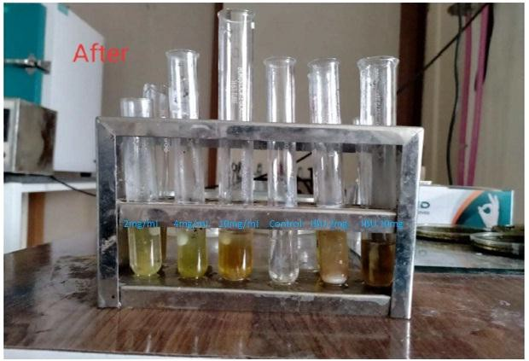

**Fig .14 Anti-Inflammatory Activity of Batch VL04 samples after cooling of the test tubes**

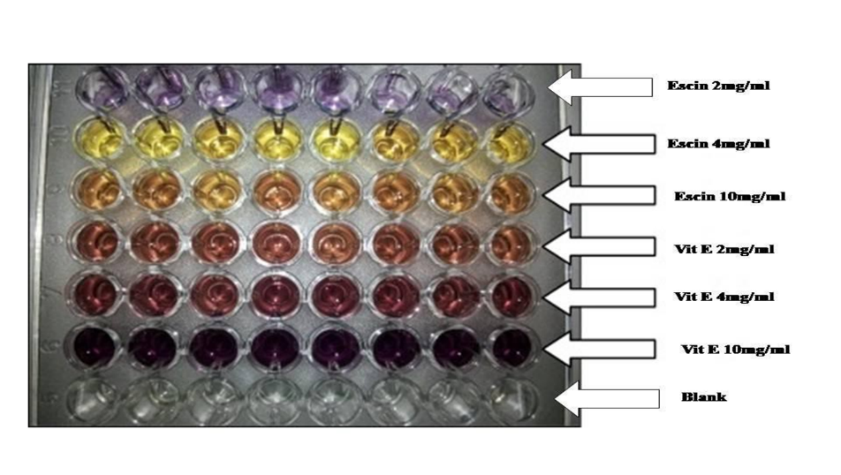

**Fig.15 DPPH Assay of Formulation Batch VL 04**

**Conclusion:**

Fenugreek powder, Dry Ginger powder, Turmeric powder, Acacia pod powder extract which having anti- inflammatory, Anti-oxidant and anti- oedema activity were successfully added into topical cream system for the management of sports Injury .The Characterisation studies provided the good stability of developed topical cream system which can be good basis for scale up of product. Scientifically proven ingredients were combined for unmet need of Management of sports Injury.

**References:**

1. <https://sl.bing.net/cepwPP4Rsf6>
2. <https://sl.bing.net/xIQhyy83tQ>
3. <https://sl.bing.net/frB5QYgbrcO>
4. <https://sl.bing.net/bNuIvuocxq0>