**Maternal Health and Nutrition Indicators among Tribal Women in Andhra Pradesh: An Examination from Secondary Sources** **of Data**

**Appala Naidu Pappala**

Faculty (G), Department of Anthropology, Andhra University, Visakhapatnam, Andhra Pradesh, India,

Email: [panaidu17@gmail.com](mailto:panaidu17@gmail.com); Mobile: 9398243363; 8897412634.

**ABSTRACT**

Tribal women in Andhra Pradesh often receive inadequate maternal health care. They are generally vulnerable to the same diseases as men, yet they also have special health needs: tribal women are more likely to carry a heavier workload than their men and to carry children and breastfeed for many years. Despite these difficulties, the position of women in tribal societies often puts more strain on their health and less access to maternal health care, resulting in inadequate food intake. This has created new awareness of the problems, but the impacts in the lives of many women are yet to be felt. This paper uses the example of Indian tribal women to highlight some of the health and nutrition problems addressed in 2005-2024 and to chart some recent developments. Particularly the tribal women have poor maternal health and nutritional status and have many pregnancies, often very close together. They are also at higher risk of malnutrition, anaemia and reproductive tract infections, but they also make poor use of health services, even when they are available. This is not because women are in less need, but because they do not recognize their need or is unable to overcome social and cultural barriers. The paper draws on experience gained in a program to expand and develop health care delivery in the Indian state of Andhra Pradesh to suggest policies that require special attention if the health and nutrition of tribal women are to improve.

**Keywords:** Maternal Health, Nutrition, Tribal Women, Andhra Pradesh, Body Mass Index.

1. **INTRODUCTION**

Maternal health and nutrition are two crucial and vital factors that drive the development of every individual, community, society or nation. It is recognized by the Sustainable Development Goals (SDGs), which aim to transform our world. They call for action to end poverty and inequality, protect the planet and ensure that all people enjoy health, justice and prosperity. They are critical of leaving no one behind. In 2015, all countries in the United Nations adopted the 2030 Agenda for Sustainable Development. The broad and ambitious goal SDG-3 aims to ensure healthy lives and promote well-being for all at all ages. However, a person’s health and well-being are not only affected by disease and treatment, but also by social and economic factors. Therefore, women who are healthy during pregnancy and after birth are more likely to be healthy later in life and have better birth outcomes, affecting the health of children from infancy to adulthood. The WHO stated that the developed countries have made good progress in improving maternal health; but, maternal mortality rates in some developing countries include India are double time higher than the average rate. To measure India's performance towards the goal of good health and well-being, 10 national-level indicators have been identified, capturing eight of the 13 SDG targets for 2030 outlined under this goal. Target 7 of SDG-3 ensures universal access to sexual and reproductive health-care services, family planning, information and education, and integrates reproductive health into national strategies by 2030. Despite the launch of various schemes and programmes like RCH, improvements in health and nutritional parameters, especially maternal and child health, have not much improved over the years. In 2020, MMR is 97/100,000 live births (SRS, 2018-20), down from 398 per 100,000 in 1997–98.

People of India, especially the Scheduled Tribes, undergoing demographic, socio-economic and health changes in today have interconnected. Out of 1.21 billion, 104.3 million people belong to the STs. India has the largest tribal population in the world, with tribals constituting 8.6% of the country’s total population (Census of India, 2011). Of the 705 tribes in India, about 75 are the most vulnerable, each with its own social and cultural characteristics (Anthropological Survey of India, 2016). However, a percentage is a proportion of the subgroup of interest in the total population. Instead, to understand the magnitude of a health problem, we need to consider the absolute number of people. Generally, women and girls face significant difficulties to care. Although government programs guarantee many free services, including outpatient maternity services, medications, and in-patient maternity services such as comprehensive emergency obstetric care, in practice, care is rarely free. Also, tribal women out of other social groups face problems related to maternal-fetal health, nutrition, education political and economic backwardness (Pappala, A.N. 2020). Few studies have been conducted among tribal populations in India by Samuel et al. 1992; Maiti et al. 2005; Kanitkar T and Sinha RK 1991; ICMR 1998; Kapoor AK and Kshatriya GK 2000. While there is a paucity of data regarding maternal health and their associated indicators among tribal women of Andhra Pradesh, insufficient data exist to allow conclusion on actual rates. Therefore, this study was aimed to conduct an examination on maternal health and nutrition indicators among tribal women in Andhra Pradesh.

1. **METHODOLOGY**

The present study was conducted an extensive secondary data review and analyzed national, state and district level data sets to understand the existing health and nutrition indicators reported by tribal women. It is mainly based on various secondary sources of data in the period of 2005 to 2024. For this study, Government publications such as Census of India, National Family Health Survey (NFHS), National Sample Survey Office (NSSO), Sample Registration System (SRS), District Level Household and Facilities Survey (DLHS) reports are considered mainly sources of data related to maternal health and nutrition. At a glance, State and district sources are website portals used. Also, data on maternal health and nutrition among ST women from various research papers and articles selected in recent years were used.

**2.1 Significance of the study**

The study results will be useful to bridge the maternal healthcare, nutrition status gap and helpful for the medical and health administrators include young researchers to initiate measures to enhance the accessibility and attainment levels among the tribal women of Andhra Pradesh.

**2.2 Limited Remarks**

The unavailability of secondary data and limited fieldwork result in some gaps that prevent in-depth analysis of the issue.

1. **ANDHRA PRADESH: A STATE**

Andhra Pradesh has 51 revenue divisions, 13 districts (recent 26), 670 mandals, 12918 gram panchayats, 17366 habitations including 914 inhabited habitations, 110 municipalities with 12718976 households and a population of 4957 thousand in an area of ​​163 thousand sq km. According to the 2011 census, the ST population in Andhra Pradesh is 27.4 lakh including one lakh population in seven mandals of Khammam district of Telangana state which was included in Andhra Pradesh as per the Reorganisation Ordinance 2014 and constitutes 5.53% of the state's population. Andhra Pradesh accounts for 2.5% of the ST population in India. The share of STs in the state's population has declined from 6.51% in 2001. The rural population of the state's ST population constitutes 88%. The female population (50.3%) is higher than the male population of the STs in the state. 53 percent of the ST population lives in 4764 Scheduled Villages and 12.89 lakh people live in the plains of Andhra Pradesh State.

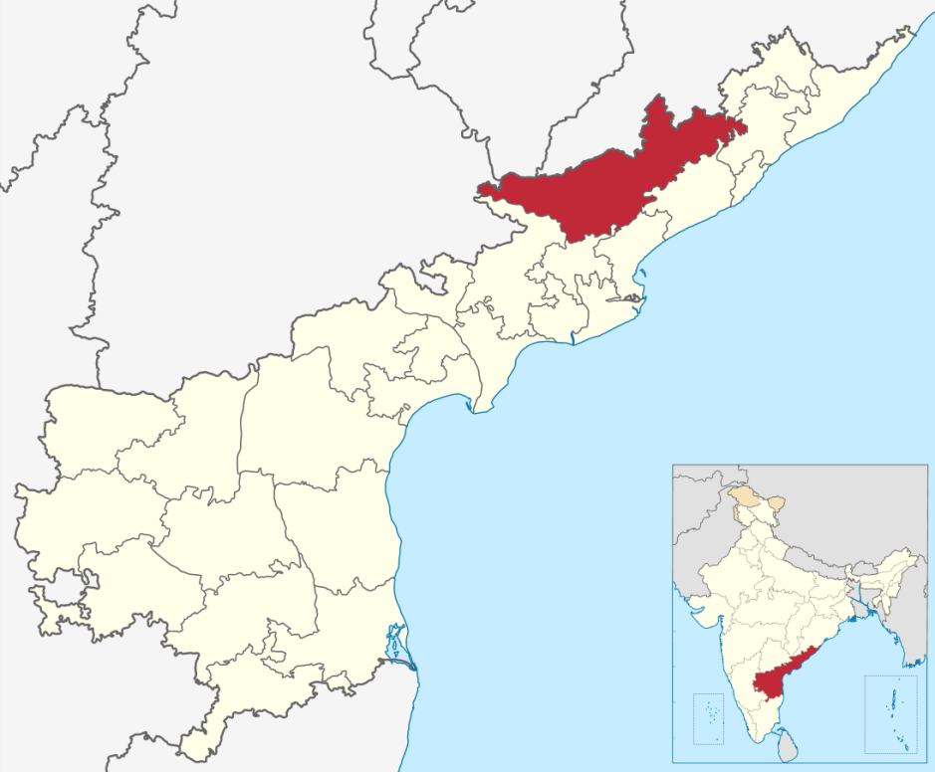

**Figure-1:** India highlighted Andhra Pradesh State and ASR District.

**3.1. Alluri Seetharama Raju (ASR) District**

The population of the ASR district is 9.54 lakhs as per 2011 Census with 11.96% of growth rate and this constituted 1.92% of the population of the state while the Geographical area of the District is 12253 Sq. Km. which is only 7.52% of the area of the state has shown in Figure-1. Out of the total population 4.66 lakhs are Male and 4.88 lakhs are Female. The Sex Ratio is 1046 Females per 1000 Males. As per 2011 census Scheduled Castes constituted 2.49% of the population while Scheduled Tribes account for 82.67% of the population of the district. The district has a work force of 3.93 lakhs constituting about 41.12% of the population besides the marginal workers to a tune of 1.63 lakhs Nos. as per 2011 Census. The cultivators constitute 21.58%, Agricultural Labourers 28.96% and the balance engage in Primary, Secondary and Territory sectors. There are 4.04 lakhs Nos. literates forming 42.34% of the total population of the District. Male literates constitute 57.92% while female literates forming 41.83%. The following MCH services provides to the Public under the Administration of District Coordinator of Hospital Services-DCHS shown in Table-1.

**Table-1.** Availability and Access to 3 Tier Health Facility by Tribal women in ASR District

|  |  |  |
| --- | --- | --- |
| Type of Health Services | Frequency | Location |
| District Hospital | 01 | Paderu – 200 Beds |
| Community Health Centres | 02 | Chintapalli – 50 Beds; Munchingaput – 30 Beds |
| Area   Hospital | 01 | Araku – 150 Beds |
| Blood Bank | 01 | Paderu |

1. **RESULTS AND DISCUSSION**

The Maternal Mortality Ratio-MMR denotes the number of mothers dying per 1 lakh live births, which has shown a significant progress during the last two decades. While there is a decline of 62% in MMR in seven year span for country, Andhra Pradesh recorded a better progress with 67% decline. According to the SRS (2018-20), Andhra Pradesh stands at fourth position with MMR at 45 per 1,00,000 live births, whereas India’s MMR is 97. During this period, the state of Andhra Pradesh has reported 362 maternal deaths with the highest being reported from Kakinada (27), Alluri Sitarama Raju (25), Anantapur (23), and Eluru (23) districts. According to an Indian parliamentary panel dated 10 August 2023, almost half of maternal deaths among the tribal population are due to early marriages, teenage pregnancies, and anaemia as shown in Table-2 and Figure-2. While 30 per cent of tribal girls marry before turning 18, said this committee which expressed concern about the high death rate of young mothers. "Therefore, the government should focus on creating awareness among the tribal population about the necessity to avoid the early marriage of girls, the need to have spacing between children and the importance of educating girls with the help of community leaders, ASHAs, Anganwadi workers and other functionaries at the ground level in tribal areas."

**Table-2.** Decadal Trends in Maternal Mortality Ratio (MMR)

|  |  |  |
| --- | --- | --- |
| Year | Andhra Pradesh | India |
| 2018-2020 | 45 | 97 |
| 2017-2018 | 65 | 113 |
| 2015-2017 | 74 | 122 |
| 2011-2013 | 92 | 167 |
| 2010-2012 | 110 | 178 |
| 2007-2009 | 134 | 212 |
| 2004-2006 | 154 | 254 |
| 2001-2003 | 195 | 301 |

**Figure-2.** Decadal Trends in Maternal Mortality Ratio (MMR)

Table-3 displays the various indicators of maternal health among tribal women of the reproductive age group in Andhra Pradesh. It is observed from the present study that 55.17 per cent of tribal women use modern contraceptive methods and 14 per cent use spacing methods for family planning. It said that 24.4 per cent of tribal men are using contraceptives compared to the national level of 25.8 per cent. Since family planning services have the potential to improve the health of the mother, which in turn assists social and economic upliftment of the family, the Committee recommended the Ministry of Tribal Affairs focus on educating women and their respective husbands about the proper use and benefits of modern contraceptives, the report said.

**Table-3.** Maternal Health Indicators among Tribal Women in Andhra Pradesh

|  |  |  |  |
| --- | --- | --- | --- |
| S.No | Parameters | Per cent (%) | Reference |
| 1 | Tribal women use modern contraceptive methods | 55.17 | NFHS-5, 2019-21 |
| 2 | Tribal women use spacing methods for family planning | 14.0 | NFHS-5, 2019-21 |
| 3 | Tribal women use modern contraceptive methods | 24.4 | NFHS-5, 2019-21 |
| 4 | National level use modern contraceptive methods | 25.8 | NFHS-5, 2019-21 |
| 5 | Tribal girls marry before turning 18 years | 30.0 | NFHS-5, 2019-21 |
| 6 | Early marriages, teen pregnancies, anaemia cause of maternal deaths among tribals | 46.0 | NFHS-5, 2019-21 |
| 7 | Tribal women belong to underweight | 17.4 | NFHS-5, 2019-21 |
| 8 | Tribal women suffering from Malnutrition | 25.3 | NFHS-5, 2019-21 |
| 9 | Tribal women belong to Education till secondary school | 21.9 | NSSO, 2011-12 |
| 10 | Infant Mortality Rate | 62.1 | NFHS-3, 2005-06 |
| 11 | Sources for treatment seeking by private sector | 20.2 | DLHS-3, 2007-08 |

According to some recent studies, malnutrition affects 25.3% of tribal women in India. Table- 4 denotes that the nutritional indicator as BMI levels among tribal women in Andhra Pradesh. Among the tribal women, 19.7% are underweight, 23.5% overweight and 56.8% normal category. The age group 15–24 has the highest percentage of underweight (35.7%; Pappala, A.N. 2020), whereas the age group 35 and beyond has the highest prevalence of overweight and obesity (16.5%; Nayak et al. 2016). The prevalence of underweight is more among married tribal women (41%; Sree Gowrilatha et al., 2022). On the contrary, prevalence of underweight is more in tribal women than overweight.

According to NFHS-4, 22.9 percent of Indian women are underweight and the overall prevalence of underweight among schedule tribe female is found to be 31.7 in this study, which is much higher. Among tribal women, insufficient healthy food consumption causes poor health and severe health consequences. According to the latest National Family Health Survey report (2019–21), nearly 28.3% of tribal women in Andhra Pradesh are underweight, while 21.8% are overweight. In the ASR district level, almost 18.2% of tribal reproductive women belong to underweight. The overall development is changing the trends of the underweight population in Scheduled tribe communities; the trends gradually decline.

**Table-4.** Distribution of Nutritional Status among Tribal Women for BMI levels by District, State, India

|  |  |  |  |  |
| --- | --- | --- | --- | --- |
| Tribal People in | Underweight | Normal | Overweight | Reference |
| ASR District- PVTGs | 35.7 | 56.1 | 8.2 | Pappala, A.N., 2020 |
| ASR District | 18.2 | 65.3 | 16.5 | Nayak et al., 2016 |
| Andhra Pradesh | 28.3 | 49.9 | 21.8 | NFHS-4, 2015-16 |
| Andhra Pradesh | 41.0 | 52.2 | 6.8 | Sree Gowrilatha et al., 2022 |
| Andhra Pradesh | 19.7 | 56.8 | 23.5 | Garg K et al., 2023 |
| India | 31.7 | 58.2 | 10.1 | NFHS-4, 2015-16 |
| India | 17.4 | 66.4 | 16.2 | NFHS-5, 2019-21 |

**Figure-3:** Distribution of Nutritional Status among Tribal Women for BMI levels by District, State, India

1. **CONCLUSION**

The study found significant differences in trends in maternal and nutritional status across regions and tribes. The status of tribal women in the study area varies from one to another. The study found that in this region too, the prevalence of malnutrition or underweight is comparatively high. Changing occupational patterns from traditional methods, exposure to menial work and thus money circulation are factors that contribute to their current situation. Furthermore, there is an urgent need for the studies in future to ascertain the relationship between this high rate of malnutrition and maternal morbidity and maternal mortality among this group.

**ACKNOWLEDGEMENTS**

Before conducting the study, all the included articles were reviewed about the objective and process of study. I would like to thank the individuals and groups who contributed partially or fully to this study, with acknowledgement for their published research contributions. There are no sources of funding. No one has declared any conflict of interest.

1. **REFERENCES**
2. Garg K, Reddy B V, Kakkar R, Aravindakshan R, Gupta A. Prevalence of Undernutrition Among Tribal Lactating Mothers in Andhra Pradesh, India. Cureus. 2023 Nov 2;15(11):e48190. doi: 10.7759/cureus.48190. PMID: 38054136; PMCID: PMC10694381.
3. Government of India. The Report on Maternal Mortality Ratio: Trends and Issues. Parliamentary Committee on 10 august 2023.
4. Indian Council of Medical Research. Health of Tribal Population in India; Results of Some ICMR Studies. Indian Council of Medical Research. New Delhi. p1. 1998
5. Kanit kar T, Sinha RK. A Report on Demographic Study of Tribal Population in Santhal Pargana in Bihar and Phulbani and Kalahandi Districts in Orissa. International Institute for Population Sciences. Mumbai. 1988
6. Kanitkar T, Sinha RK. A Report o n Demographic Study of Tribal Population in Santhal Pargana in Bihar and Phulbani and Kalahandi Districts in Orissa. International Institute for Population Sciences. Mumbai. 198821. Roy AK, Rath EA. Indian tribal fertility patterns from Orissa. Man India. 1991; 71:235.22.
7. Kapoor AK, Kshatriya GK. Fertility and mortality differentials among selected tribal population groups of northwestern and eastern India. J Biosoc Sci 2000; 32:253
8. Kapoor AK, Kshatriya GK. Fertility and mortality differentials among selected tribal population groups of northwestern and eastern India. J Biosoc Sci 2000; 32:253
9. Kupputhai U, Mallika N. Nutritional Status of Adult women belonging to Khond, Gadaba and Porja tribes of Andhra Pradesh. The Indian Journal of Nutrition and Dietetics 1993; 30:173-179.
10. Maiti S, Unisa S, Agrawal PK. Health Care and Health among Tribal Women in Jharkhand: A Situational Analysis. Studies in Tribes and Tribals 2005; 3:37-46.
11. Maiti S, Unisa S, Agrawal PK. Health Care and Health among Tribal Women in Jharkhand: A Situational Analysis. Studies in Tribes and Tribals 2005; 3:37-46.20.
12. National Family Health Survey (NFHS-4) 2015-16: International Institute for Population Sciences (IIPS) and ICF: 2017. India. Mumbai: IIPS.
13. National Family Health Survey (NFHS-5) 2019-21: International Institute for Population Sciences (IIPS) and ICF: 2021. India. Mumbai: IIPS.
14. Nayak MSDP, Sreegiri S. A study on nutritional status of tribal women in Visakhapatnam district, Andhra Pradesh, India. International Journal of Community Medicine and Public Health. 2016. Aug. 3(8): 2049-53.
15. Pappala AN. Tribal women and economic significance: a comprehensive study. International Journal of Research and Review. 2020; 7(11): 68-81.
16. Roy AK, Rath EA. Indian tribal fertility patterns from Orissa. Man India. 1991; 71:235.
17. Samuel LK, Rao PSS. Socio-Economic Differentials in Mothers at Risk Based on Pre-Pregnancy Weights and Heights. Indian Journal of Medical Research 1992; 96:159-67.19.
18. Sree Gowrilatha,C.Rami Reddy C, Amarnath R Das. Anthropometric characteristics and nutritional status based on Body Mass Index of Sugali women, a tribal population of Ananthapuramu District, Andhra Pradesh. International Journal of Research in Social Sciences. Vol. 12 Issue 8, August 2022,ISSN: 2249-2496 Impact Factor: 7.081.