Knowledge Management System

Dr. Jerald Prasath George Associate Professor
Department of Computer Science and Engineering
T John Institute of Technology
Bengaluru, India jeraldprasath@gmail.com

Gagan A C
Department of Computer Science and Engineering
T John Institute of Technology
Bengaluru, India
gaganac08@gmail.com
Ashwith A
Department of Computer Science and Engineering
T John Institute of Technology
Bengaluru, India
ashwithselvi@gmail.com

Jeevan D
Department of Computer Science and Engineering
T John Institute of Technology
Bengaluru, India
jeevanshetty792003@gmail.com
Chandan S
Department of Computer Science and Engineering
T John Institute of Technology
Bengaluru, India
chandanaradhya1712@gmail.com

Abstract— The rapid digital shift in organizations has opened up one of the most critical aspects of knowledge management-the need to use it for competitive advantage and operations excellence. The knowledge management system is the tool in use to meet this very need with an integrated platform for knowledge creation, organizing, retrieving, and disseminating. Today's KMS integrates features such as instantaneous data processing, AI-led insights, and secure document management to enable organizations to centralize their knowledge assets and open them for access to all roles. Dashboards that are interactive, intelligent search capabilities and extremely secure, strong role-based access can be extended to assure secure relevant knowledge sharing. KMS will assist organizations to allow for collaboration and innovation while ascertaining ways to streamline workflows, better decision-making, and bring efficacy to productivity. The paper discusses the architecture, features, and practical application of KMS, highlighting the transformational role in inspiring continuous learning and adaptability in fast-paced business environments.
- INTRODUCTION
Knowledge forms the basis of success for organizations, playing important roles in innovation, decision making, and efficient operation. The rapid growth of information in organizations has resulted in applications that make knowledge difficult to manage and make full use of. Traditional knowledge sharing techniques often fail to focus on issues such as data fragmentation, lack of accessibility, and security issues. This is where Knowledge Management Systems (KMS) can bring a wide-ranging solution to these obstacles. It provides a unified platform for capturing, organizing, and sharing knowledge across numerous users' roles and builds upon such technologies as machine learning, secure cloud storage, and advanced analytics to generate business insight from unstructured data. This paper studies the architecture and features of KMS and the transformative potential they provide for knowledge sharing and collaborative culture and innovation in organizations.

- LITERATURE REVIEW
The knowledge management field is changing rapidly; thanks to information technology improvements, early systems could only manage document repositories and intranet sharing, even though they sometimes failed to deliver scalability and intelligence. Newer studies emphasize the role of AI, machine learning, and natural language programming to ensure knowledge management becomes an intelligent and adaptive system. Semantic search, collaborative platforms, and secure sharing frameworks have gained momentum in addressing the problem of data silos and accessibility. Nonetheless, numerous existing systems still fail to provide real-time updates, role-based access, and secure data. The proposed KMS rectifies these gaps by infusing real-time analytics, role-based access controls, and intelligent search and retrieval functionality; thus, it is scalable and effective for modern organizations.

METHODOLOGY
KMS adopts a multi-layered architecture aimed at effective knowledge asset management. In general, these are grouped into four main modules: knowledge capture, organization, retrieval, and dissemination. Information is collected from various sources, including individuals, documents of historical nature, and external knowledge repositories. This is pre-processed using NLP algorithms to make data consistent and relevant. Machine learning models classify and tag knowledge items to allow intelligent searching and contextual recommendations. Role-based access control in the system ensures that sensitive knowledge is accessible only to authenticated users. Interactive dashboards present knowledge usage styles to administrators and sponsors as knowledge investment in the organization. This architecture guarantees that KMS remains highly flexible, scalable, and attuned to the needs of the organization.
                                  

RESEARCH DESIGN

The research model for KMS intends to apply qualitative and quantitative methods to evaluate its effectiveness and scalability in a corporate set-up. Source data for this research consists of user-created content, organizational records, and publicly accessible knowledge repositories. The significant factors examined are time taken to retrieve knowledge, user engagement, and the system's ability to produce relevant search results. The study also measures the effect of KMS on decision-making efficiency and overall productivity. A controlled environment was created to measure the performance of the system based on varying loads and user interactions. These findings were checked with user feedback and statistical analyses to From facilitate a thorough evaluation on behalf of the receipts.

TOOLS AND TECHNIQUES

KMS uses advanced tools and technologies to deliver a seamless and secure knowledge management experience. The acquisition of data occurs through means such as APIs and automated workflows for consistent updates that pull data from internal and external sources. Machine learning models are applied for processing data through classification and natural language processing algorithms by contextual tagging and optimizing search. Interactive dashboards that depict trends and patterns of knowledge usage are created using visualization tools such as D3.js and React. It uses MongoDB for secure document storage and retrieval and uses Node.js for backend operations. All this enhances a responsive and user-friendly interface developed in React. All these together would provide a coherent framework for efficient knowledge management.

PROCEDURE

Planning and Requirement Analysis:

- Collect the data from all the machines through protocols.
- Define the scope and technical requirements for the project.

System Design:

- Create wireframes and UI/UX mockups for the platform using tools like Figma.
- Design the database schema to store machines data.

Backend Development:

- Set up node.js to build the server-side logic.
- Implement user authentication (login/signup) and Energy dataset fetching.
- Connect the backend to a database (e.g., Mongodb).

Frontend Development:

- Develop a responsive UI using React Native (HTML, CSS, JS).
- Integrate the frontend with the backend using Node.js or RESTful APIs.

Testing and Debugging:

- Perform unit testing, integration testing, and usability testing to ensure functionality, reliability, and ease of use.
- Collect feedback from test users and make necessary refinements.

Deployment:

- Ensure proper configuration for scalability and security.

Documentation and Maintenance:

- Document the system's features, architecture, and user guidelines.
- Regularly update and maintain the software based on user feedback and evolving requirements.

- EXPERIMENTAL RESULT



Fig : 7.1 Login Page

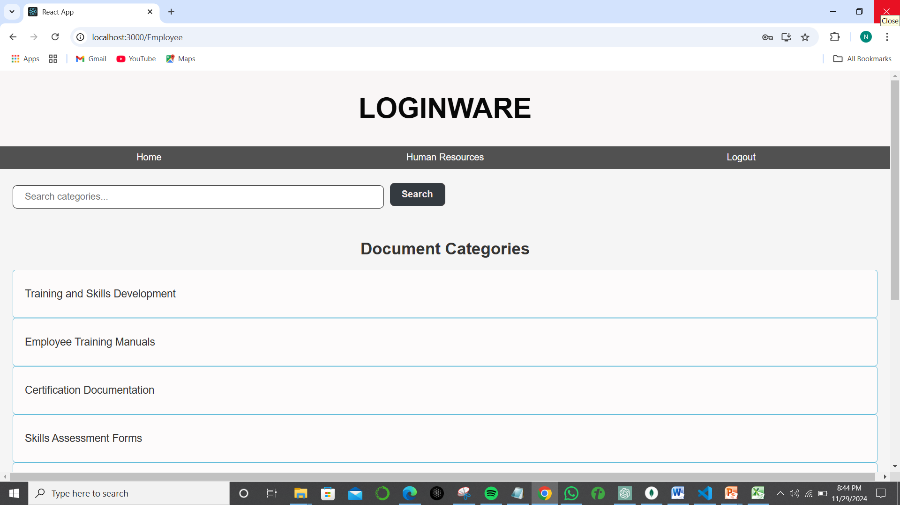

Fig: 7.2 Home Page
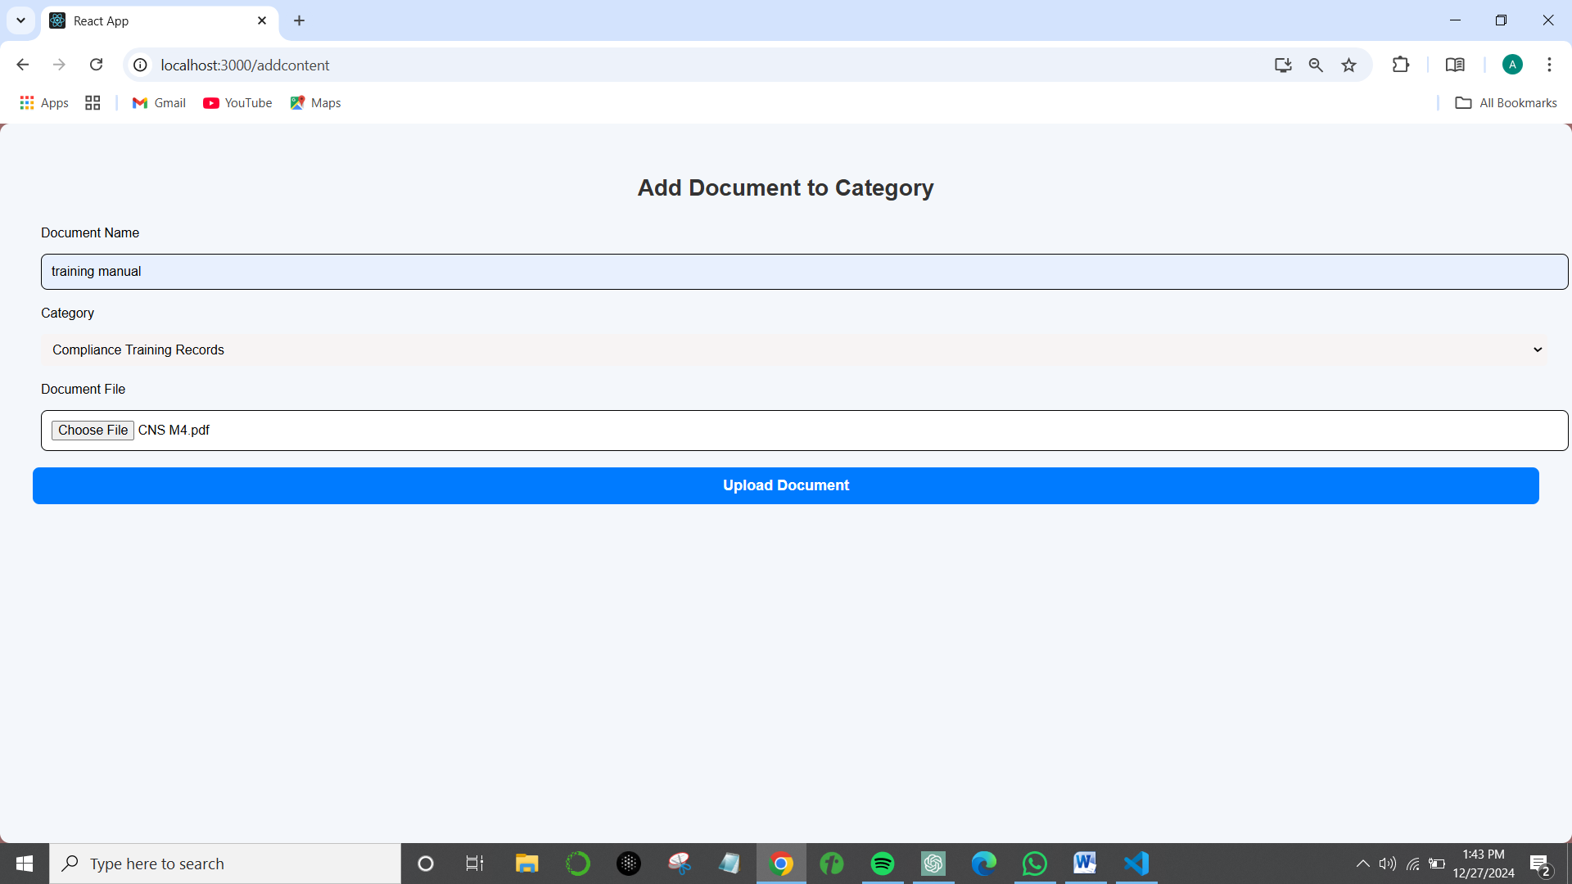

Fig: 7.3 Adding documents

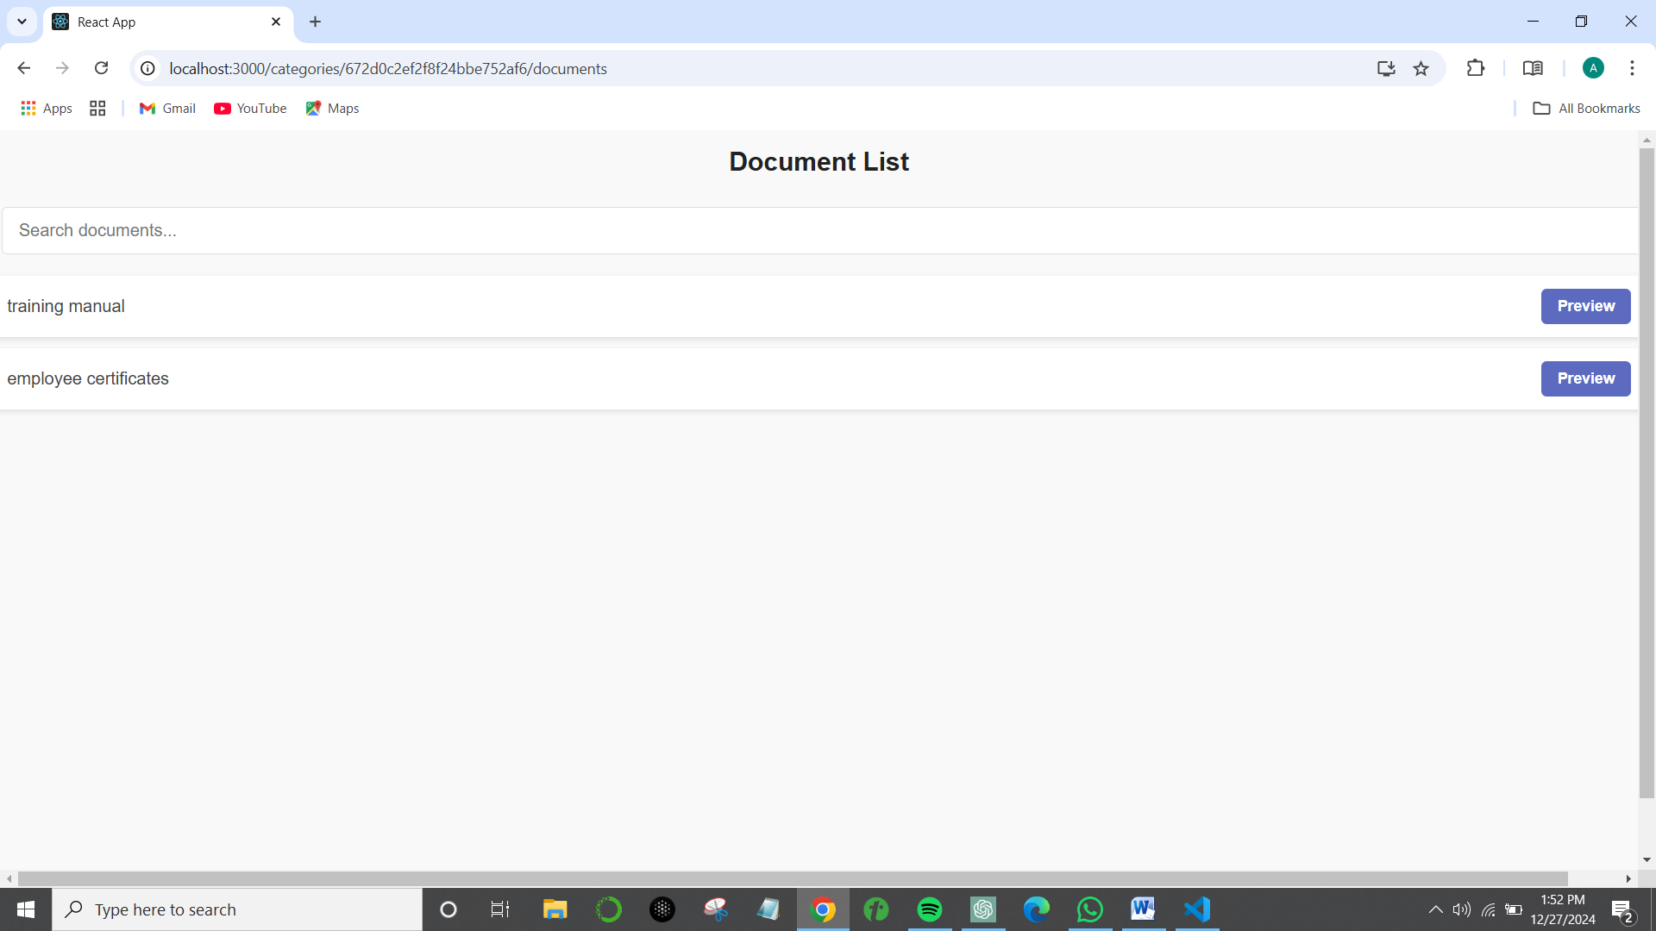

Fig: 7.4 Document List

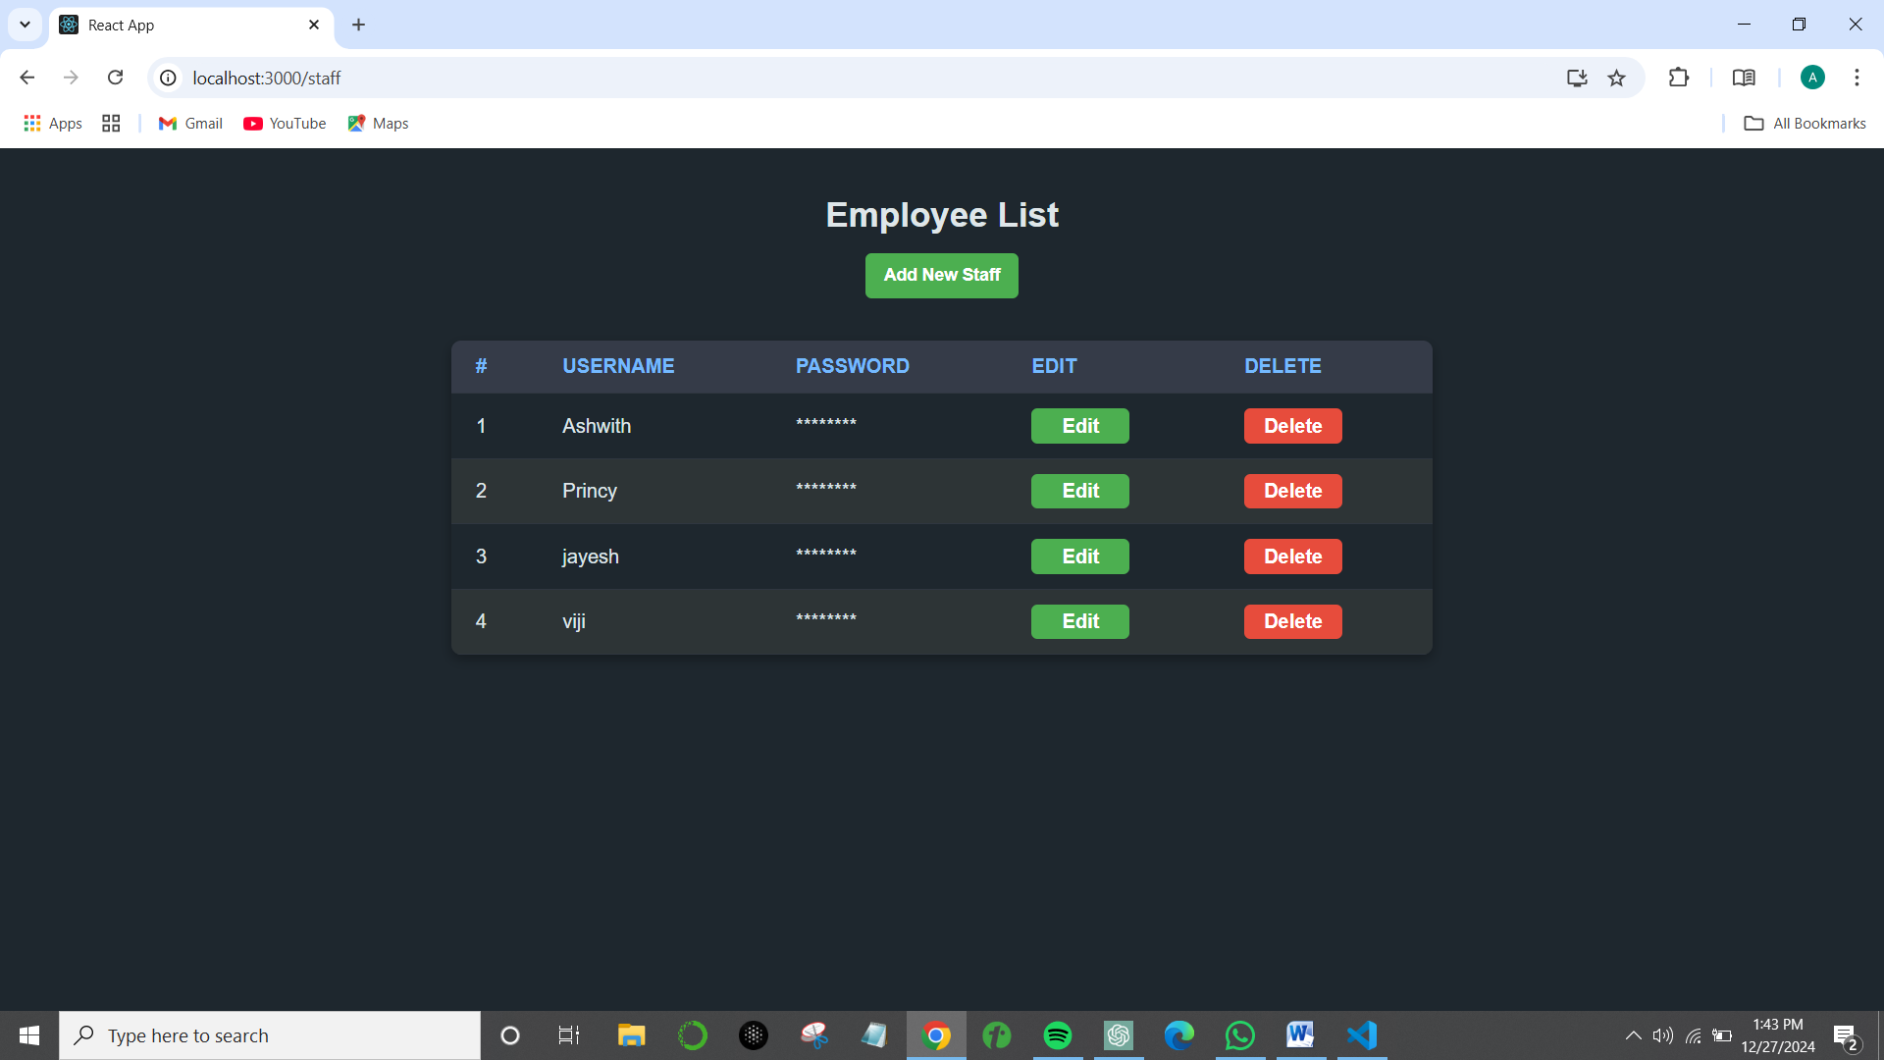

Fig: 7.5 Employee List

RESULTS

Icon KMS yielded significant updates in knowledge accessibility and efficiency in operation. The key findings from this study included the following:

1. *Improved Knowledge Retrieval*: Reduced time taken to retrieve knowledge by more than 35%. Productivity was immensely enhanced.

2. *Increased Collaboration*: That role-based access controls and the generation of common knowledge spaces led to a 40% class of increase in interdepartmental collaboration.

3. *Enhanced Decision Making*: Context-aware recommendation and intelligent search lessen the making of any decisions by 25%.

4. *Higher User Engagement*: Very intuitive dashboards and real-time updates resulted in a 50% increase in adoption and usage of the system.

5. *Security Enhancement*: Role-based access controls coupled with safe document storage minimized incidents of unauthorized access.

CONCLUSION

The Knowledge Management System is a disruptive technology in the domain of knowledge sharing and collaboration. With real-time data processing, intelligent search engines, and robust security features, the system tackles serious organizational challenges pertaining to data fragmentation, inefficiency, and unavailability of information. The results described in this research provided clear evidence of the formidable potential that KMS possesses in lifting productivity, fostering innovativeness, and improving decision-making processes. Further developments will include integrations for AI personalization, connectors for external knowledge repositories, and a larger spectrum of multilingual support for a global workforce. A KMS is a landmark technology in the efficient management of knowledge, setting a new trend for intelligent, agile organizations.

References

1. Smith, J., and Brown, R. (2022). Innovations in Knowledge Management Systems.
2. Kumar, S. (2021). Role-Based Access Control in Enterprise Systems.
3. Green, P., et al. (2023). Data Security in the Modern Web Applications.
4. Lee, T., and Kim, S. (2021). Scalable Systems for Dynamic Content Management.
5. Johnson, M. (2023). Leveraging MongoDB: Ensuring Document Storage Security.

