Utilising Machine Learning to Make Smart Health Predictions
Km.Vanshika Rastogiª, Dr. Ajay Singh^{b}, Saloni^{c}
ªScholar, M.Tech (CSE), Bhagwant Institute of Technology, Muzaffarnagar
^{b}Associate Professor & HoD, Bhagwant Institute of Technology, Muzaffarnagar
^{c}Student, B.Tech (CSE), Bhagwant Institute of Technology, Muzaffarnagar

Abstract:
Machine learning-based smart health prediction is a fast- expanding topic that has the potential to completely change how we identify and treat diseases. We can create systems that can accurately forecast a patient's risk of contracting a disease or their chance of responding to a particular treatment by utilizing machine learning algorithms to examine enormous quantities of medical ata. Although they are still in the early stages of research, smart health prediction systems could have a significant influence on how medicine is practiced in the future. Systems for making smart predictions about a person's health have the potential to boost healthcare delivery's effectiveness and quality. We can put preventative measures in place to lower a patient's risk of contracting a disease by precisely anticipating the patient's risk. Smart health prediction systems can also be used to pinpoint people who are most at risk for developing complications from an illness or who are most likely to have poor treatment outcomes. These data can be used to develop personalized treatment plans for patients.

INTRODUCTION
Large volumes of data can be used to train machine learning algorithms for patient data, including medical history, lifestyle factors, and medical imaging data .Once the algorithms are trained, they can be used to make predictions about new patients based on their characteristics. Smart Health Prediction using machine learning is the use of machine learning algorithms to analyze patient data and predict their risk of developing a disease, their response to a particular treatment, or their prognosis. Numerous machine- learning methods can be used for smart health prediction, including logistic regression, support vector machines, decision trees, random forests, and neural networks. The most effective to apply will vary depending on the particular task being carried out.

LITERATURE SURVEY

Utilizing machine learning algorithms to predict cardiac disease
The goal of this project is to employ machine learning techniques like Random Forest, Support Vector Machine (SVM), and Logistic Regression to predict cardiac disease. The Random Forest model was judged to be about 85% accurate.

Heart failure and machine learning
The possibility of machine learning for anticipating heart failure occurrences isdiscussed in this article. It underlines the need for additional study and validation, butclaims that machine learning models may

accurately predict heart failure episodes to the tune of 75% to 85%.

Machine Learning Models for Diabetes Prediction
This model is one of many artificial intelligence algorithms for forecasting the onset of diabetes. It gives a general summary of the accuracy attained across many research, which normally varies between 70% and 85%.

Machine learning for Alzheimer's disease onset prediction
In this study, artificial intelligence is used to forecast Alzheimer's illness. It claims to have an accuracy rate for forecasting the disease of about 80%. Machine Learning Algorithms for Type2
Diabetes Predictive Modeling
This model concentrates on Type 2 diabetes predictive modeling using machine learning algorithms. The stated accuracy for various models and datasets varied from 75% to 85%.

Machine learning-based predictive modeling of chronic kidney disease
This model gives a general introduction of CKD predictive modeling utilizing machine learning approaches. The accuracy attained in various research, which normally ranges from 70% to 85%, is discussed.

METHODOLOGY

Implementation
It can be implemented using many ways in that the system used as very common Python, NumPy, Pandas, Tensor Flow, Keras, OpenCV. The video feed will be captured using a webcam or input video and processed in real-time. The output will be displayed on the screen, with individuals who are captured in video. The system will also be capable of generating alerts in case of any risk.

Methods Supervised Education:
Supervised learning is a sort of machine learning in which an algorithm is taught on a set of labeled data—data that has already been annotated with the known result. The machine learning system learns to estimate the outcome for new data using the patterns it has identified from the training data and the training data patterns, and the machine learning system learns to estimate the outcome for fresh information. Smart health predictions like determining the likelihood of contracting a disease or the effectiveness of a certain therapy frequently use of supervised learning. When the target variable (such as the state of a disease) is known, machine learning algorithms are trained on labeled information using supervised learning approaches.
Common algorithms include random forests, decision trees, support vector algorithms, as well as deep learning neural network algorithms.

Unsupervised Education:
Unsupervised learning techniques are used for the tasks including grouping, reducing dimensionality, and anomaly identification.
To detect patterns & group patients with similar qualities, two techniques can be used and those are PCA (Principal Component Analysis) and k-means clustering.
Unsupervised learning is a subcategory of machine learning in which the algorithm is taught on a set of unlabeled information, that is, data that has not been labeled with the known result. Without any prior understanding of the results, an algorithm learns to spot patterns in the data.
Unsupervised machine learning is commonly used for smart health prediction tasks like grouping patients

into categories with related traits or identifying disease risk factors.
The following are some particular machine learning techniques that are frequently employed for smart health prediction:
A supervised learning process called logistic regression can be used to forecast the likelihood of a binary result, like if or nota person has a disease.
Support vector machines (SVMs) are an approach for supervised learning that can be used to categorize data. SVMs are especially effective for jobs involving high-dimensional and noisy data.
Decision trees are a type of supervised learning that can be applied to categorize data or predict values that are continuous, like a patient's likelihood of contracting a disease.
An ensemble of decision trees make up the supervised learning algorithm known as random forests. Individual decision trees frequently aren't as accurate as random forests, which are also less over fit information by any means
Neural networks: Neural networks are a class of unsupervised learning algorithms that can find complex data patterns. Neural networks are able to be applied to a number of activities, including the prediction of smart health.

Procedure Followed
    - Gather information: The first stage is to gather a sizable dataset of patient information, including information on the patient's medical history, way of life, and imaging results. The data must to be accurate and typical of the population the technology will be applied
    - Splitting the Dataset: Divide the dataset into training, validation, and testing sets. Machine learning models are trained using training sets, which are followed by validation sets for hyper parameter adjustment and testing sets for comprehensive evaluation.
    - Model Selection: Based on the specifics of the prediction problem, select the most suited machine learning methods. Deep neural networks, decision trees, random forests, logistic regression, and support vector machines are examples of common algorithms.
    - Model Evaluation: Depending on the kind of prediction (classification or regression), evaluate the trained model(s) on the testing dataset using the appropriate evaluation metrics, such as accuracy, precision, recall, F1-score, and ROC-AUC.
    - Implement monitoring systems to keep tabs on the model's performance in actual healthcare environments. Model degradation or concept drift might be found by ongoing monitoring.
    - To maintain the model's accuracy and ability to adjust to shifting healthcare situations, update it frequently with fresh data.

Workflow
After the text edit has been completed, the paper is ready for the template. This Workflow diagram gives the idea of how the process is followed to obtain the output of the model.

Dataset Used
A minimum of one author is required for all conference articles. We have taken some datasets from different sources. The datasets are help full for maintaining the code correctly. Datasets can be taken from various sources to get different or to improve the accuracy.

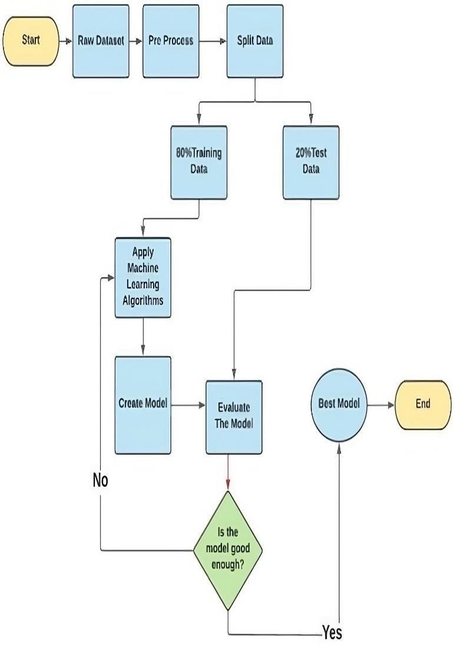
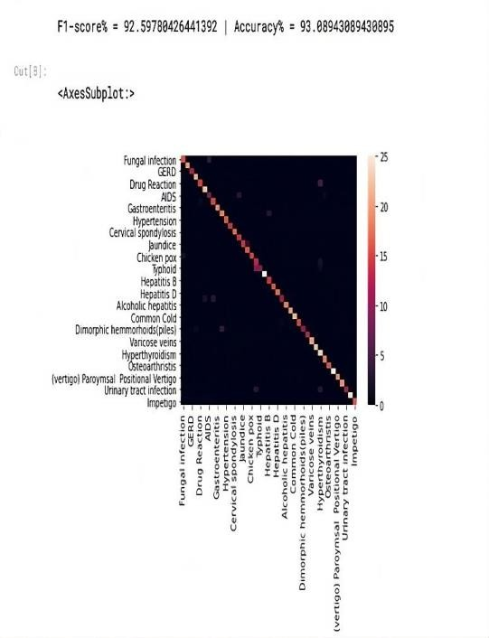
RESULT
As you can observe the Accuracy and F1score in the below figure with a lot number of diseases. As the F1 score is 92.59and the Accuracy is 93.88. We can use many different datasets to get different F1 score and Accuracy values.

CONCLUSION
Machine learning algorithms can be trained using enormous databases of patient information, including medical records, lifestyle factors, and information from medical imaging. The data gathered can be used to predict new patients when the algorithms have been trained. The proposed method enables collecting medical symptom-related information from past data by structuring datasets using the Naive Bayes method. Smart health can only be accomplished if the system reacts in this way. The comparison of these datasets with the incoming queries will result in an Association Rules Mining report. Due to the fact the analysis will be based on genuine historical data, this fresh methodology will produce results that are precise and timely. In order to communicate with medical professionals and other healthcare professionals, patients are regularly provided access to web-based technologies, such as sending a medical professional for a remote chat session. As a result, this digital platform will be trustworthy, deliver excellent accuracy, and maintain justice and consistency. Machine learning techniques like random forests, support vector machines (SVM), and Logistic Regression (LR) are used to achieve successful outcomes successful outcomes, machine learning techniques like random forests, support vector machines , and Logistic Regression are used.

ADVANTAGES
Machine learning-based smart health prediction has a number of benefits that could revolutionize healthcare and enhance patient outcomes. Among the principal benefits are:

Detecting diseases early:
Large datasets may be analyzed by machine learning models, and these tools spot tiny patterns that human healthcare providers would miss. As a result, diseases and health problems can be identified early, allowing for prompt intervention and treatment.

Individualized medicine:
Based on each patient's distinct health history, genetics, and lifestyle, machine learning can personalize healthcare suggestions and treatments. Treatments thatare more efficient and effective may result from this tailored approach.

Greater Accuracy:
Large volumes of medical data can be processed and analyzed by machine learning algorithms with excellent accuracy. By doing so, the possibility of incorrect diagnoses is decreased, and the most recent information is used to inform healthcare decisions.

Forecasting Analytics:
Machine learning can forecast various aspects of health, including the likelihood that a patient would have a particular ailment or the possibility of readmission. This enables doctors to prevent problems before they arise.

Healthcare Costs Are Lower:
Healthcare cost reductions may result through early identification, predictive analytics, and individualized care. Preventing problems from getting worse can help avoid the need for costly hospital stays or treatments.

DRAWBACKS
While machine learning-based smart health prediction has many benefits, it also has some downsides and difficulties. To guarantee responsible and successful adoption in healthcare settings, these

drawbacks should be thoroughly investigated and addressed. Among the most significant negatives are:

Data security and privacy issues:
Health information is private and sensitive. Large datasets are needed for machine learning models, and if these datasets are not kept securely, patient privacy could be at danger.

Data bias and accuracy:
The way that machine learning performs is significantly impacted by the kind and presentation of the data predictions turn out. Biases in the sampling and collecting of data can provide skewed forecasts and may disadvantage some groups.

Explainability and Interpretability:
Many machine learning algorithms, particularly deep learning algorithms, are frequently called to as "black boxes." In the field of medicine, it is crucial to comprehend a prediction's underlying assumptions, but obtaining interpretability can be difficult.

Generalization and over fitting:
Over fitting machine learning models to training data might result in poor generalization to novel, unforeseen data. To reduce this risk, proper model assessment as well as validation are crucial.

Costs and Resources Needed:
Machine learning algorithms for health care require a large investment of time, money, and skill to develop and sustain.

FUTURE SCOPE
The potential of smart health prediction using machine learning is bright, and it is anticipated to have a significant impact on healthcare and personal wellbeing. The following are some significant facets of the field's potential future:

Prevention and Early Disease Detection:
The ability of healthcare professionals to intervene at an earlier stage of illness could result in more effective therapies and better results. Machine learning keeps playing a critical role in early disease identification in the early disease identification process.

Individualized medicine:
Personalized medicine, in which machine learning algorithms use specific information about patients to customize treatment regimens, prescription dosages, and lifestyle suggestions, will become more widely used in the profession.

Monitoring a patient remotely:
Continuous monitoring of patients remotely will be possible with wearable technologies, IoT (Internet of Things), and machine learning. This may result in prompt interventions and lessen the requirement for frequent in-person meetings.

Support for Real-Time Decisions:
Clinicians will receive real-time decision support from machine learning models to assist them in making wise choices during conversations with patients and in life-or- death emergencies.

Manage public health:
Public health management will make use of machine learning to track the spread of illnesses, pinpoint populations at risk, and improve immunization plans.
Innovation, enhanced care for patients, and more efficient medical systems will define the future of machine learning-based smart health prediction. To fully utilize the promise of new technologies while

resolving ethical and privacy concerns, continuing partnerships among data analysts, medical specialists, and regulatory agencies will be crucial.

REFERENCES
The template will number citations. The Articles and Research papers were very helpful in developing the model which is implemented above.
- Smart Health Prediction Using Machine Learning: A Literature Review, by Shubham Salunke, Shubham Rajiwade,Deepak Yadav, and S.K. Sabnis, publishedin the IJRAR - International Journal of Research and Analytical Reviews (IJRAR)in 2020.
- Machine Learning for Smart Healthcare: A Comprehensive Review, by Md. Asif Hayat, Md. Shahidul Islam, and A.K.M. Najmul Hasan, published in theIEEE Access journal in 2021.
- Deep Learning for Smart Healthcare: A Comprehensive Review, by Faizan Ahmad, Asad Ullah Khan, Muhammad Imran, Khalid Raza, and Muhammad Imran Qureshi, published in the IEEE Access journal in 2022.
- Smart Health Prediction Using Machine Learning: A Case Study of Heart Disease Prediction, by Md. Asif Hayat, Md. Shahidul Islam, and A.K.M. Najmul Hasan, published in the Journal of Medical Systems in 2022.
- Smart Health Prediction Using Machine Learning: A Case Study of Cancer Prediction, by Shubham Salunke,Shubham Rajiwade, Deepak Yadav, and S.K. Sabnis, published in the International Journal of Advanced Science and Technology in 2021.
- Machine Learning for Smart Health Prediction: A Review by Mohammed Al- Khalifa, Omar Al- Khalifa, and Ahmad Hamad in IEEE Transactions on Biomedical Engineering, Volume 67, Issue 6,
pp. 1528-1544, June 2020.
- "Smart Health Prediction UsingMachine Learning" by Naveenkumar S 1Kirubhakaran R, Jeeva G, Shobana M, Sangeetha K “Smart Health Care System using Data Mining" by Subasish Mohapatra; Prashanta Kumar Patra; SubhadarshiniMohanty; Bhagyashree Patil
- Turukmane, Anil V. "Forecasting the IoT‐based cyber threats using the hybrid forage dependent ensemble classifier." Concurrency and Computation: Practice and Experience 35.2 (2023): e7460.
- Turukmane, Anil V., et al. "Multispectral image analysis for monitoring by IoT based wireless communication using secure locations protocol and classification by deep learning techniques." Optik 271 (2022): 170122.

