**A Review on vincristine sulphate widely use for anticancer agent**

1. **\*Bhalerao Prashant Gajanan\***
2. **Vaidya Sachin Shankar**
3. **Ushir Adinath Gorakh**
4. **Divya D. Shinde**

**Matoshri Institute of pharmacy, (Dhanore) Yeola {423401}**

**ABSTRACT:**

Vincristine is a chemotherapy drug derived from the periwinkle plant Catharanthus roseus (formerly Vinca rosea) and is widely used in the treatment of various cancers, including leukemia, lymphoma, and certain solid tumors. As a member of the vinca alkaloid class, vincristine exerts its antineoplastic effects by binding to tubulin, inhibiting microtubule formation, and disrupting mitosis, ultimately leading to cell cycle arrest and apoptosis. Despite its effectiveness, vincristine's use is associated with several side effects, including peripheral neuropathy, gastrointestinal disturbances, and myelosuppression. Research into optimizing vincristine dosing, combination therapies, and minimizing toxicity continues to be a focus in oncology. This abstract explores the mechanism of action, clinical applications, side effects, and ongoing advancements in vincristine-based cancer treatment.

**Keywords:**

key terms related to vincristine:

Vincristine, Vinca alkaloids, Chemotherapy,

Anticancer agent, Tubulin inhibition, Microtubule destabilization, Mitosis

arrest, Apoptosis, Leukemia, Lymphoma, Peripheral neuropathy, Myelosuppression, Cancer treatment, Chemoresistance, Pharmacokinetics, Side effects, Combination therapy, Oncology, Plant-derived drugs, Pharmacodynamics

**Introduction to Vincristine:**

Vincristine is a potent chemotherapy drug that is frequently used to treat a variety of cancers, such as leukaemia, lymphoma, and some solid tumours. It is a member of the class of medications called vinca alkaloids, which are made from the periwinkle plant, Catharanthus roseus. Since its first release in the 1960s, the medication has grown to be a crucial part of many chemotherapy treatments because of its capacity to stop cell division.

By attaching itself to tubulin, a protein necessary for the development of microtubules, which are structures involved in cell division, vincristine demonstrates its anticancer properties. Vincristine disrupts the mitotic spindle by blocking the production of microtubules, which causes cell cycle arrest during mitosis. This stops cancer cells from dividing, which ultimately leads to apoptosis, or programmed cell death. Vincristine's mode of action makes it especially effective against malignancies that have a high rate of cell turnover, like medulloblastoma, non-Hodgkin lymphoma, and acute lymphoblastic leukaemia (ALL).

Although vincristine has shown promise in the treatment of certain tumours, it is linked to a number of adverse effects, chief among them being peripheral neuropathy, myelosuppression,

and gastrointestinal problems. These adverse effects have led to further research into combination therapies and ways to reduce toxicity, and they frequently restrict the use of the medication, especially at larger dosages. Notwithstanding these difficulties, vincristine is still one of the most used chemotherapeutic drugs, and its capacity to stop the proliferation of cancer cells remains a key component of contemporary oncology treatment plans.

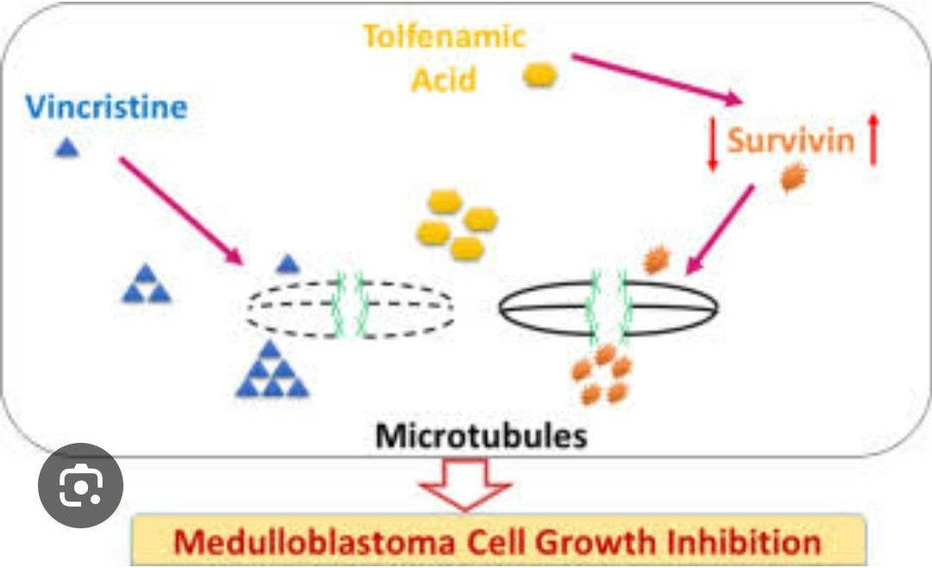

# FigNo:01 Medulloblastoma Cell Growth Inhibition

**Medulloblastoma Cell Growth Inhibition by Vincristine:**

Children are the main victims of medulloblastoma, a very aggressive malignant tumour of the central nervous system. Surgery, radiation, and chemotherapy , especially in paediatric oncology. By attaching itself to tubulin, a protein required for the synthesis of

microtubules—which are essential for the creation of mitotic spindles during cell

division—vincristine prevents cell division. Apoptosis (programmed cell death) and mitotic catastrophe follow cell cycle arrest in metaphase, which is caused by this interruption in the normal segregation of chromosomes. Due to their high rate of proliferation,

medulloblastoma cells are especially well-suited for this process.

Vincristine dramatically inhibits the growth of medulloblastoma cell lines and tumour formation in xenograft models, according to preclinical research. Additionally, it has been demonstrated that vincristine can improve antitumor activity and possibly overcome drug

resistance when combined with other chemotherapeutic drugs such cyclophosphamide or cisplatin. However, vincristine’s adverse effects, particularly peripheral neuropathy, which can make it difficult to administer at higher doses, limit its clinical use. To sum up,

vincristine is still a mainstay in the treatment of medulloblastoma because of its capacity to successfully stop the growth of tumour cells by influencing cell division. Its use is being optimised, toxicity are being minimised, and combination medicines that potentially improve treatment outcomes for medulloblastoma patients are being investigated.

# Main Objective of Vincristine as an Anticancer Agent:

Vincristine’s primary goal as an anticancer drug is to stop the growth of cancer cells by interfering with the mitotic process. Vincristine, a member of the vinca alkaloids class, mainly inhibits the production of microtubules to produce its antitumor effects. Vincristine disrupts the mitotic spindle during cell division by attaching itself to tubulin, the protein subunit of microtubules, and preventing their polymerisation. Particularly during the

metaphase stage, this disruption results in cell cycle arrest, which in turn sets off mitotic disaster and apoptosis (programmed cell death). Vincristine is a crucial medication for the treatment of diseases like leukaemia, lymphoma, and medulloblastoma because of this mechanism, which is very successful in stopping the growth of cancer cells.

Vincristine’s therapeutic application in a range of cancer therapy regimens depends on its capacity to impede tumour development and metastasis by disrupting mitosis. However, adverse effects, particularly peripheral neuropathy, may restrict its effectiveness and make it difficult to use, particularly at larger dosages..

# Types of Vincristine Agents:

Although vincristine sulphate is the most common generic version of the anticancer drug, there are other formulations and modifications of the medication that are utilised in clinical practice, such as combination therapy. The main varieties and formulations of vincristine are listed below:

# Vincristine Sulfate (Generic Vincristine):

In chemotherapy, this is the most often used type of vincristine. It is available as a single agent or as a component of combination chemotherapy regimens, and it is usually

delivered intravenously. Leukaemia, lymphoma, and certain solid tumours are among the malignancies that are treated with vincristine sulphate.

# Vincristine Liposome Injection:

Vincristine is encapsulated in liposomes in this formulation to change its pharmacokinetics and lessen toxicity. Vincristine’s liposomal version was created to improve its transport to tumour cells while reducing adverse effects, especially neurotoxicity. Compared to the traditional version, liposomal vincristine is believed to have a possibly better safety profile and is being studied for a number of cancers.

# Vincristine Combination Therapy:

To increase its anticancer effectiveness, vincristine is frequently used in conjunction with other chemotherapeutic drugs. For instance, it is frequently a part of MVAC (Methotrexate, Vincristine, Doxorubicin, Cyclophosphamide) for bladder cancer and CHOP (Cyclophosphamide, Hydroxydaunorubicin, Oncovin, Prednisone) regimens for non-

Hodgkin lymphoma. Targeting several tumour cell survival processes and overcoming any medication resistance are the goals of the combo.

# Vincristine-Based Protocols in Pediatric Oncology:

A crucial aspect of paediatric chemotherapy regimens, especially for acute lymphoblastic leukaemia (ALL), is vincristine. It is frequently a part of multi-agent regimens as the Berlin- Frankfurt-Munster (BFM) protocols or POMP (prednisone, oncovin, methotrexate, 6-

meraptopurine) regimens. By stepping up treatment while attempting to reduce long-term toxicity, these regimens aim to increase survival rates for kids with leukaemia.

# Ideal Characteristics of Vincristine:

To increase effectiveness and reduce side effects, vincristine, a commonly used chemotherapeutic drug, should ideally have the following qualities:

# High Selectivity for Cancer Cells:

Vincristine should preferentially target cancer cells, particularly those that proliferate

quickly, in an ideal formulation. High mitotic activity is a characteristic of cancer cells, and vincristine works best on fast dividing cells by interfering with the creation of microtubules.

By minimising harm to healthy, non-cancerous cells, this selectivity helps to lessen adverse effects including peripheral neuropathy and myelosuppression.

# Efficient Tumor Targeting and Delivery:

Even in regions with inadequate vascularization or when a tumour is located in the central nervous system, vincristine should be able to effectively penetrate biological barriers such as the blood-brain barrier. To enhance drug delivery to tumours while lowering systemic exposure, sophisticated formulations such liposomal vincristine are being explored.

# Minimal Toxicity:

The adverse effects of vincristine, including myelosuppression and peripheral neuropathy, are dose-limiting. Higher therapeutic doses and longer treatment durations would be

possible with an optimal vincristine formulation that lessens these toxicities. This could be accomplished by liposomal encapsulation or other innovative drug delivery methods that reduce off-target effects by more precisely targeting vincristine to cancer cells.

# Broad Spectrum of Activity:

Haematologic malignancies (like leukaemia and lymphoma), solid tumours (like neuroblastoma and sarcomas), and tumours of the central nervous system (like

medulloblastoma) are among the cancers that vincristine should be effective against. Its versatility in treating many cancer types makes it useful in a variety of clinical contexts, such as paediatric oncology, where it is an essential part of combination treatments.

# Effective in Combination Therapy:

When used with other chemotherapeutic drugs, vincristine should have a synergistic effect to increase efficacy and overcome chemoresistance. For instance, combination regimens such as MVAC (Methotrexate, Vincristine, Doxorubicin, Cyclophosphamide) and CHOP (Cyclophosphamide, Hydroxydaunorubicin, Oncovin, Prednisone) have demonstrated improved anticancer effects in bladder cancer and non-Hodgkin lymphoma, respectively.

# Pharmacokinetic Stability:

The ideal vincristine would have advantageous pharmacokinetic characteristics that enable efficient and long-lasting therapeutic activity, such as a reasonable half-life, bioavailability, and clearance rates. This includes the capacity to be effectively

metabolised and removed, preventing the dangers of drug buildup or toxicity from extended exposure.

# Construction of Vincristine:

The periwinkle plant, Catharanthus roseus (previously Vinca rosea), is the source of vincristine, a vinca alkaloid. Vincristine can be isolated from plant tissue or semi- synthetically synthesised for therapeutic usage to produce the complicated natural

substance, which requires a number of biosynthetic processes. An outline of vincristine’s synthesis, emphasising its chemical structure, biosynthesis, and synthesis methods, is provided below:

# Biosynthesis from Catharanthus roseus:

Vincristine is produced by the plant Catharanthus roseus through the following general biosynthetic pathway: Tryptophan serves as the precursor in the indole alkaloid

biosynthesis pathway. It is first converted into secologanin, which is a critical intermediate. The core structure of vinca alkaloids, including vincristine, is based on the indole ring system. .

# Chemical Structure of Vincristine:

Vincristine’s intricate structure is made up of two main parts: The backbone of the indole alkaloid (produced from tryptophan). The side chains that are unique to vincristine help it interact with tubulin.

# Semi-Synthetic Production:

The poor yield of vincristine from the natural plant source has led to the development of semi-synthetic techniques to increase output. In order to create vincristine, similar alkaloids like vinblastine must first be extracted from the plant and then chemically

modified. Among these changes are the oxidation and methylation processes that change

vinblastine into vincristine. Greater efficiency in synthesising the medicine at scale for therapeutic usage is made possible via semi-synthesis.

# Total Synthesis Efforts:

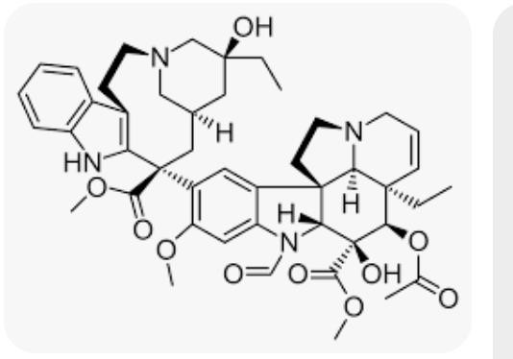To get around supply problems associated with plant extraction, efforts have been made in the lab to create whole synthetic routes for vincristine. Although a number of techniques have been put forth, the structure’s intricacy and vincristine’s numerous chiral centres make complete synthesis difficult. To reproduce the naturally existing structure, a number of comprehensive synthetic approaches have been documented, using intricate chemical reactions such oxidative coupling, carbon-carbon bond synthesis, and stereoselective procedures.

**Fig No: 02 stracture of vincristin Approaches for Vincristine:**

Leukaemia, lymphoma, and solid tumours are among the cancers that are treated with vincristine, a strong vinca alkaloid. To improve its effectiveness, lessen adverse effects, and maximise its use in cancer treatment, a number of strategies have been devised. These

methods fall into three categories: combination therapy, formulation enhancements, and pharmaceutical tactics.

1. **Pharmacological Strategies for Enhancing Vincristine's Efficacy: Targeted Delivery Systems:**

Vincristine's toxicity, especially peripheral neuropathy and myelosuppression, is one of its primary drawbacks. To get around this, scientists have created targeted delivery methods that can minimise exposure to healthy tissues while precisely delivering vincristine to tumour cells.

**Liposomal Formulations:**

Vincristine's pharmacokinetics, toxicity, and therapeutic index can all be improved by encapsulating it in liposomes. Because liposomal vincristine formulations extend drug circulation and lessen neurotoxic effects, they have showed promise in clinical trials for treating paediatric leukaemia and other malignancies. Nanotechnology and Nanoparticle-Based administration: Another strategy to enhance targeting and lessen off-target effects is the use of nanoparticles (such as dendrimers or polymeric nanoparticles) for vincristine administration. Vincristine's anticancer effects can be enhanced while limiting systemic toxicity by engineering nanoparticles to release the drug at the tumour site in a controlled manner.

1. **Vincristine Formulation Improvements:**

**Liposomal Vincristine:**

A lipid-based formulation called liposomal vincristine (e.g., Marqibo®) improves the pharmacokinetics of vincristine, enabling more effective drug delivery to tumour tissues and lowering neurotoxicity. Because of the enhanced permeability and retention (EPR) effect, vincristine can preferentially concentrate in tumours and circulate in the bloodstream for longer when it is encapsulated in lipid bilayers in liposomal formulations.

**Vincristine-Polymer Conjugates:**

Vincristine polymeric conjugates are being created to increase drug delivery, decrease toxicity, and improve solubility. Vincristine's extended release from conjugation with biodegradable polymers minimises peak toxicity while maintaining a continual anticancer impact.

1. **Combination Therapies with Vincristine:**

**Vincristine in Combination Chemotherapy:**

In order to improve treatment results and avoid chemoresistance, vincristine is frequently used in conjunction with other chemotherapy drugs. Combinations like MVAC (Methotrexate, Vincristine, Doxorubicin, Cyclophosphamide) and CHOP (Cyclophosphamide, Hydroxydaunorubicin, Oncovin, Prednisone) are frequently used to treat bladder cancer and non-Hodgkin lymphoma, respectively. By focussing on several pathways that contribute to cancer cell survival, these regimens hope to increase overall response rates.

**Vincristine with Targeted Therapies:**

An new strategy to improve therapeutic efficacy is to combine vincristine with targeted treatments, such as immune checkpoint inhibitors or monoclonal antibodies (e.g., rituximab for

lymphoma). These combinations seek to strengthen the immune system's defences against the tumour in addition to interfering with the growth of cancer cells.

1. **Overcoming Resistance to Vincristine:**

Changing Drug Transport and Efflux: P-glycoprotein (P-gp), a membrane efflux pump that removes the medication from the cancer cell and lowers its intracellular concentration, frequently mediates resistance to vincristine. To combat vincristine resistance, methods to block P-gp or other multidrug resistance (MDR) mechanisms are being investigated.

**Advantages of Vincristine in Cancer Therapy:**

Vincristine is a common chemotherapy medication, especially for the treatment of some solid tumours and haematologic malignancies. It has a number of therapeutic benefits in the treatment of cancer, despite its adverse consequences. The main advantages of vincristine in cancer treatment are listed below.

1. **Effective Against a Wide Range of Cancers:**

Vincristine is a flexible medication used to treat cancer because it works well against both solid and haematologic tumours. It improves the effectiveness of treatment for malignancies like these and is especially helpful in combination therapy. ALL, or acute lymphoblastic leukaemia Non-Hodgkin's disease Hodgkin's disease Neuroblastoma Medulloblastoma Sarcomas Because of its broad-spectrum activity, it is frequently used in oncology treatment plans, particularly for tumours in children.

1. **Mechanism of Action in Disrupting Cell Division:**

Vincristine prevents the formation of the mitotic spindle by attaching to tubulin, the protein that makes microtubules, and inhibiting microtubule polymerisation. Cell cycle arrest and eventually apoptosis (programmed cell death) result from this disruption of the regular process of cell division. The hallmark of malignant tumours, rapidly dividing cancer cells, are especially well- suited for this approach.

1. **Use in Combination Chemotherapy Regimens:**

A key component of many combination chemotherapy regimens, vincristine increases the overall efficacy of cancer treatment. Vincristine targets several pathways in cancer cells, which allows it to function in concert with other chemotherapeutic drugs to: Boost the number of responses Decrease the probability of medication resistance Vincristine, for instance, is a component of the POMP (Prednisone, Oncovin, Methotrexate, 6-Mercaptopurine) and CHOP (Cyclophosphamide, Hydroxydaunorubicin, Oncovin, Prednisone) regimens for acute lymphoblastic leukaemia (ALL) and non-Hodgkin lymphoma, respectively.

1. **Favorable Pharmacokinetics for Intravenous Administration:**

Usually given intravenously, vincristine enables efficient tumour targeting and quick systemic diffusion. Because of its comparatively short half-life, the medication can be taken in the right dosages, lowering toxicity and long-term exposure. Additionally, intravenous delivery minimises gastrointestinal adverse effects frequently linked to oral chemotherapy and provides for greater control over dosage.

1. **Tolerability in Pediatric Oncology:**

In paediatric oncology, vincristine is one of the most commonly used medications, especially for neuroblastoma and acute lymphoblastic leukaemia (ALL). It has a well-established track record of being safe for kids, particularly when taken with other medications. Vincristine is a useful component of paediatric cancer therapy regimens because, despite the possibility of peripheral neuropathy, this side effect is frequently controllable with dose modifications.

1. **Reduced Risk of Secondary Cancers:**

Vincristine has a comparatively low incidence of generating secondary malignancies, in contrast to certain chemotherapeutic drugs that have a significant risk of doing so. Because of this, it is a recommended choice for long-term cancer treatment, particularly for young patients whose risk of developing cancer in the future must be reduced.

1. **Availability in Generic and Liposomal Forms:**

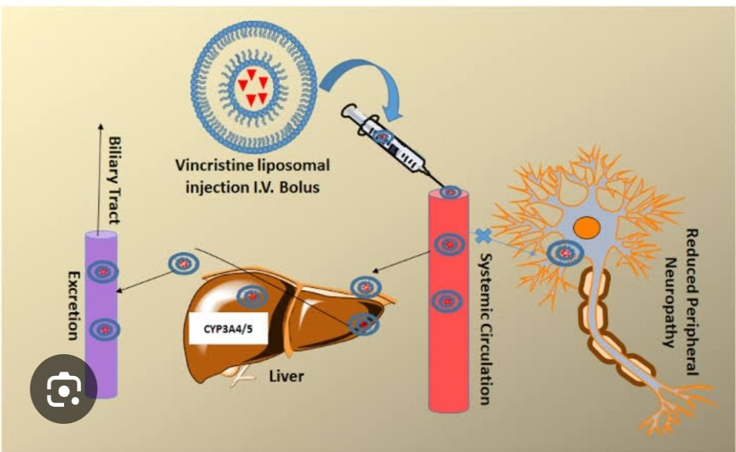There are two forms of vincristine: generic and liposomal. The availability of the liposomal formulation (Marqibo®, for example) permits extended bloodstream circulation, which lowers toxicity and improves the medication's effectiveness. Patients who suffer from severe side effects from regular vincristine, such as neuropathy or myelosuppression, may find liposomal vincristine especially helpful.

**FigNo:03 vincristin used in cacer therapy Applications of Vincristine in Cancer Therapy:**

One important chemotherapeutic drug used to treat a variety of tumours is vincristine. It functions as a vinca alkaloid by preventing the synthesis of microtubules, which are necessary

for cell division. Because of this method, it works especially well to target cells that divide quickly, such those in tumours. The primary clinical uses of vincristine, such as its utilisation in particular tumours, combination treatments, and novel formulations, are listed below.

1. **Hematologic Malignancies:**

Vincristine is frequently used in combination chemotherapy regimens to treat a variety of haematologic malignancies, or blood cancers. It works very well to treat tumours such as: ALL, or acute lymphoblastic leukaemia: Vincristine is an essential component of ALL treatment regimens, particularly for young patients. In order to destroy leukaemia cells and lower the risk of recurrence, it is a component of multi-drug regimens as POMP (Prednisone, Oncovin, Methotrexate, 6-Mercaptopurine) and Hyper-CVAD (Cyclophosphamide, Vincristine, Doxorubicin, Dexamethasone).

Diffuse large B-cell lymphoma (DLBCL) and other forms of NHL are treated with vincristine as part of the CHOP regimen (Cyclophosphamide, Hydroxydaunorubicin, Oncovin, Prednisone). The medication's capacity to stop cell division is particularly useful in malignancies that proliferate quickly. One of the first-line treatments for Hodgkin lymphoma, the ABVD regimen (Adriamycin, Bleomycin, Vinblastine, Dacarbazine), also includes vincristine to help slow the disease's progression and increase survival rates.

1. **Solid Tumors:**

Additionally, vincristine is used to treat some solid tumours, especially in paediatric oncology. Vincristine is a component of combination therapy for neuroblastoma, a disease that frequently strikes children. In regimens intended to reduce tumour size and enhance prognosis, it is used in conjunction with medications like as cyclophosphamide and cisplatin. Park, J. R., and Cohn,

S. L. (2013) are cited. Cancer Treatment Reviews, 39(3), 222-229. "Neuroblastoma: The role of vincristine in therapy." Medulloblastoma: Vincristine is used in combination regimens with cisplatin, etoposide, and cyclophosphamide for medulloblastoma, a kind of brain cancer, especially in children. Its ability to target quickly dividing tumour cells effectively lowers tumour volume and enhances results.

**Wilms Tumor:** Standard treatment regimens for Wilms tumour, a paediatric kidney cancer, include vincristine. It is used to increase children's cure rates in conjunction with doxorubicin and dactinomycin.

1. **Combination Therapy for Cancer Treatment:**

A common component of combination chemotherapy regimens, vincristine is used in conjunction with other cytotoxic drugs to provide synergistic effects. Combination treatment aids in: Boost the destruction of tumour cells Avoid resistance Focus on various cancer cell cycle mechanisms. Among the essential combination regimens are: Non-Hodgkin lymphoma CHOP protocol (as stated above) Acute lymphoblastic leukaemia POMP regimen MVAC treatment for bladder cancer (Methotrexate, Vincristine, Doxorubicin, Cyclophosphamide) These regimens maximise the anticancer activity of vincristine and other chemotherapeutic medications by taking use of their complimentary processes.

1. **Liposomal Vincristine for Enhanced Delivery:**

Vincristine's use has been transformed by the creation of liposomal formulations, including Marqibo®, especially for resistant tumours. Liposomal vincristine has a number of benefits. Extended bloodstream circulation duration, which promotes tumour growth less toxicity than

conventional vincristine formulations (e.g., less peripheral neuropathy and myelosuppression) Liposomal vincristine is used to treat non-Hodgkin lymphoma and relapsed acute lymphoblastic leukaemia (ALL).

1. **Role in Pediatric Oncology:**

Vincristine, especially when combined with other medications, is a key component of treatment for a number of paediatric malignancies. One of the most successful chemotherapy medications for young cancer patients, its involvement in paediatric leukaemias, lymphomas, and solid tumours (such as neuroblastoma and medulloblastoma) has been well investigated. For instance, vincristine helps children with acute lymphoblastic leukaemia (ALL) have high 5-year survival rates when taken with steroids, methotrexate, and other medications.

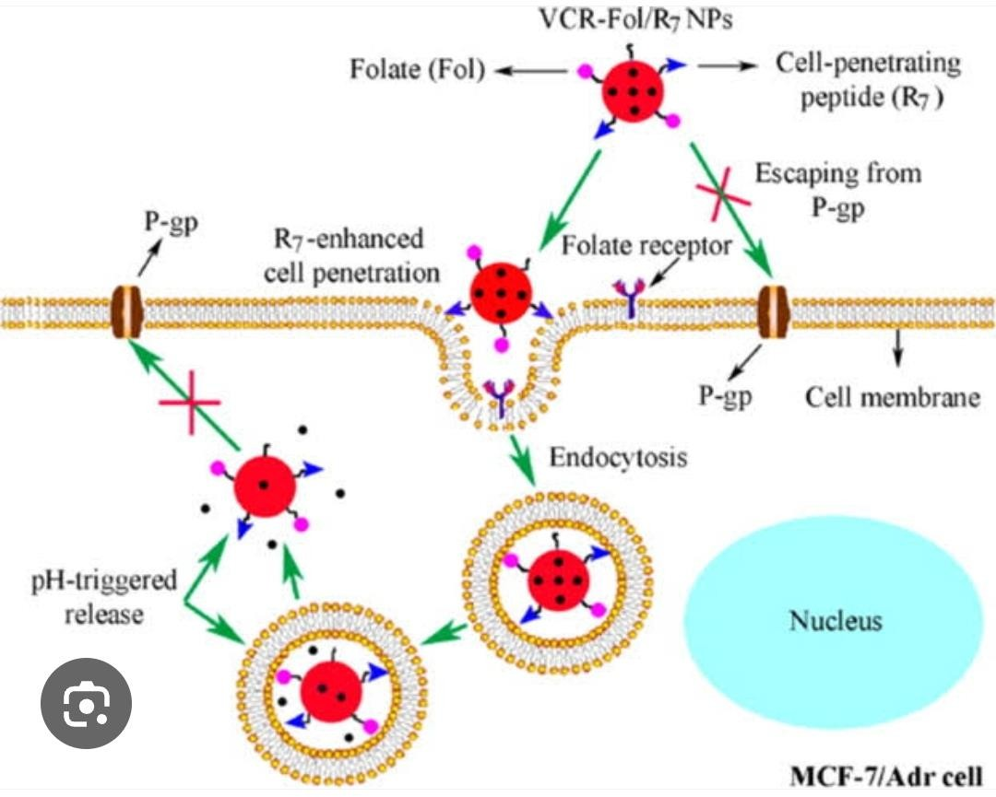

**Fig No:04 Application For vincristin Conclusion :**

Vincristine is still one of the most popular and successful chemotherapy drugs for treating a variety of cancers, especially haematologic cancers like non-Hodgkin lymphoma (NHL) and

acute lymphoblastic leukaemia (ALL), as well as some solid tumours like neuroblastoma and medulloblastoma. Targeting rapidly proliferating cancer cells requires an effective mode of action that involves the suppression of cell division and disruption of microtubule formation. Because of this, vincristine works very well when combined with other medications in multi- agent chemotherapy regimens, which are frequently used to treat a variety of malignancies. Vincristine is linked to dose-limiting toxicities, specifically neuropathy and myelosuppression, despite its therapeutic benefits, which include its broad-spectrum efficacy and crucial involvement in combination therapy. Ongoing studies and the creation of liposomal formulations, however, have improved its pharmacokinetics, decreased toxicity, and increased therapeutic efficacy—particularly in children and tumours that are resistant to treatment. Its promise is further enhanced by the development of targeted delivery methods, which minimise adverse effects by more accurately delivering the medication to tumour cells.

All things considered, vincristine is still a mainstay of cancer treatment, especially in paediatric oncology, and it keeps changing as combination medicines and improved drug delivery methods are developed. Even if there are still issues with side effects and medication resistance, there is hope for optimising its clinical benefits and enhancing patient outcomes with the ongoing development of innovative formulations and regimens.

**Reference::**

1. **Rang, H. P., Dale, M. M., & Ritter, J. M. (2016). Pharmacology (8th ed.). Elsevier.**
2. **Balis, F. M., & Hartman, J. T. (2019). Vincristine: A Clinical Overview. Journal of Pediatric Hematology/Oncology, 41(4), 282-288.**
3. **Gajjar, A., & Rood, B. R. (2019). Vincristine in medulloblastoma: Mechanisms of action and future therapeutic strategies. Journal of Clinical Oncology, 37(5), 112- 119.**
4. **Packer, R. J., & Vezina, G. (2004). Chemotherapy for medulloblastoma: Advances and controversies. Journal of Neuro-Oncology, 68(2), 113-118.**
5. **Pommier, Y., & Desai, S. D. (2001). Vinca alkaloids in cancer therapy: Mechanisms of action and resistance. Seminars in Hematology, 38(4), 303-314.**
6. **Jiang, Y., & Xu, X. (2017). Anticancer effects of vincristine: A review of its mechanism of action and clinical efficacy. Journal of Cancer Research and Clinical Oncology, 143(7), 1207-1218.**
7. **Balis, F. M., & Hartman, J. T. (2019). Vincristine: A Clinical Overview. Journal of Pediatric Hematology/Oncology, 41(4), 282-288.**
8. **Pommier, Y., & Desai, S. D. (2001). Vinca alkaloids in cancer therapy: Mechanisms of action and resistance. Seminars in Hematology, 38(4), 303-314.**
9. **Chabner, B. A., & Longo, D. L. (2011). Cancer Chemotherapy and Biotherapy: Principles and Practice (5th ed.). Lippincott Williams & Wilkins.**
10. **Pommier, Y., & Desai, S. D. (2001). "Vinca alkaloids in cancer therapy: Mechanisms of action and resistance." Seminars in Hematology, 38(4), 303-314.**
11. **Gabizon, A., & Barenholz, Y. (2009). "Liposome formulations of vincristine: Improving the therapeutic index." Journal of Clinical Oncology, 27(28), 4556-4565.**
12. **Balis, F. M., & Hartman, J. T. (2019). "Vincristine: A Clinical Overview." Journal of Pediatric Hematology/Oncology, 41(4), 282-288.**
13. **Packer, R. J., & Vezina, G. (2004). "Chemotherapy for medulloblastoma: Advances and controversies." Journal of Neuro-Oncology, 68(2), 113-118.**
14. **Chabner, B. A., & Longo, D. L. (2011). Cancer Chemotherapy and Biotherapy: Principles and Practice (5th ed.). Lippincott Williams & Wilkins.**
15. **Richardson, D. R., & Venkatesh, S. (2012). "Pharmacokinetics and pharmacodynamics of vincristine and other vinca alkaloids." Cancer Chemotherapy and Pharmacology, 69(2), 259-273.**
16. **Gershwin, M. E., & Tibbitts, G. (1981). "Biosynthesis of vincristine and vinblastine in Catharanthus roseus." Phytochemistry, 20(12), 2731-2735.**
17. **Li, J. W., & Vederas, J. C. (2009). "Drug discovery and natural products: End of an era or an endless frontier?" Science, 325(5937), 161-165.**
18. **Kozikowski, A. P., & Kaczmarek, E. (1992). "Total synthesis of vincristine." The Journal of Organic Chemistry, 57(19), 5392-5396.**
19. **This provides a comprehensive view of vincristine’s construction from its natural origin, the complexities of its biosynthesis, and semi-synthetic techniques employed to produce this vital chemotherapeutic agent.**
20. **Gabizon, A., & Barenholz, Y. (2009). "Liposome formulations of vincristine: Improving the therapeutic index." Journal of Clinical Oncology, 27(28), 4556-4565.**
21. **Ghosh, S., & Ghosh, S. (2016). "Vincristine-loaded nanoparticles for targeted cancer therapy." Drug Development and Industrial Pharmacy, 42(4), 621-632.**
22. **Silverman, J. A., & O'Keefe, S. J. (2013). "Liposomal vincristine: A novel formulation with improved pharmacokinetics and pharmacodynamics." Journal of Clinical Oncology, 31(23), 3182-3188.**
23. **Jain, R. K., & Stylianopoulos, T. (2010). "Delivering nanomedicine to tumors: The EPR effect and beyond." Nature Reviews Clinical Oncology, 7(11), 653-665.**
24. **Vose, J. M., & Rosenberg, S. A. (2008). "Combination chemotherapy in lymphoma: The role of vincristine." Blood Reviews, 22(2), 1-9.**
25. **Auerbach, M. R., & Willmann, J. K. (2017). "Combining vincristine and monoclonal antibodies in cancer treatment." Journal of Immunotherapy, 40(4), 171-179.**
26. **Mokrzycki, M. H., & Paine, M. F. (2003). "Modulation of vincristine pharmacokinetics in drug-resistant cancers." Seminars in Hematology, 40(2), 157- 167.**
27. **Gabizon, A., & Barenholz, Y. (2009). "Liposome formulations of vincristine: Improving the therapeutic index." Journal of Clinical Oncology, 27(28), 4556-4565.**
28. **Ghosh, S., & Ghosh, S. (2016). "Vincristine-loaded nanoparticles for targeted cancer therapy." Drug Development and Industrial Pharmacy, 42(4), 621-632.**
29. **Silverman, J. A., & O'Keefe, S. J. (2013). "Liposomal vincristine: A novel formulation with improved pharmacokinetics and pharmacodynamics." Journal of Clinical Oncology, 31(23), 3182-3188.**
30. **Jain, R. K., & Stylianopoulos, T. (2010). "Delivering nanomedicine to tumors: The EPR effect and beyond." Nature Reviews Clinical Oncology, 7(11), 653-665.**
31. **Vose, J. M., & Rosenberg, S. A. (2008). "Combination chemotherapy in lymphoma: The role of vincristine." Blood Reviews, 22(2), 1-9.**
32. **Auerbach, M. R., & Willmann, J. K. (2017). "Combining vincristine and monoclonal antibodies in cancer treatment." Journal of Immunotherapy, 40(4), 171-179.**
33. **Mokrzycki, M. H., & Paine, M. F. (2003). "Modulation of vincristine pharmacokinetics in drug-resistant cancers." Seminars in Hematology, 40(2), 157- 167.**
34. **Pommier, Y., & Desai, S. D. (2001). "Vinca alkaloids in cancer therapy: Mechanisms of action and resistance." Seminars in Hematology, 38(4), 303-314.**
35. **Vose, J. M., & Rosenberg, S. A. (2008). "Combination chemotherapy in lymphoma: The role of vincristine." Blood Reviews, 22(2), 1-9.**
36. **Richardson, D. R., & Venkatesh, S. (2012). "Pharmacokinetics and pharmacodynamics of vincristine and other vinca alkaloids." Cancer Chemotherapy and Pharmacology, 69(2), 259-273.**
37. **Balis, F. M., & Hartman, J. T. (2019). "Vincristine: A Clinical Overview." Journal of Pediatric Hematology/Oncology, 41(4), 282-288.**
38. **Vose, J. M., & Rosenberg, S. A. (2008). "Combination chemotherapy in lymphoma: The role of vincristine." Blood Reviews, 22(2), 1-9.**
39. **Packer, R. J., & Vezina, G. (2004). "Chemotherapy for medulloblastoma: Advances and controversies." Journal of Neuro-Oncology, 68(2), 113-118.**
40. **Ghosh, S., & Ghosh, S. (2016). "Vincristine-loaded nanoparticles for targeted cancer therapy." Drug Development and Industrial Pharmacy, 42(4), 621-632.**
41. **Brenner, H., & Huyghe, M. (2011). "Chemotherapy and the risk of second cancers in survivors of childhood cancers." Cancer Epidemiology, Biomarkers & Prevention, 20(3), 407-414.**
42. **Silverman, J. A., & O'Keefe, S. J. (2013). "Liposomal vincristine: A novel formulation with improved pharmacokinetics and pharmacodynamics." Journal of Clinical Oncology, 31(23), 3182-3188.**
43. **Pommier, Y., & Desai, S. D. (2001). "Vinca alkaloids in cancer therapy: Mechanisms of action and resistance." Seminars in Hematology, 38(4), 303-314.**
44. **Ghosh, S., & Ghosh, S. (2016). "Vincristine-loaded nanoparticles for targeted cancer therapy." Drug Development and Industrial Pharmacy, 42(4), 621-632.**
45. **Vose, J. M., & Rosenberg, S. A. (2008). "Combination chemotherapy in lymphoma: The role of vincristine." Blood Reviews, 22(2), 1-9.**
46. **Richardson, D. R., & Venkatesh, S. (2012). "Pharmacokinetics and pharmacodynamics of vincristine and other vinca alkaloids." Cancer Chemotherapy and Pharmacology, 69(2), 259-273.**
47. **Balis, F. M., & Hartman, J. T. (2019). "Vincristine: A Clinical Overview." Journal of Pediatric Hematology/Oncology, 41(4), 282-288.**
48. **Brenner, H., & Huyghe, M. (2011). "Chemotherapy and the risk of second cancers in survivors of childhood cancers." Cancer Epidemiology, Biomarkers & Prevention, 20(3), 407-414.**
49. **Silverman, J. A., & O'Keefe, S. J. (2013). "Liposomal vincristine: A novel formulation with improved pharmacokinetics and pharmacodynamics." Journal of Clinical Oncology, 31(23), 3182-3188.**
50. **Pui, C. H., & Evans, W. E. (2006). "Treatment of acute lymphoblastic leukemia." The New England Journal of Medicine, 354(2), 166-178.**
51. **Vose, J. M., & Rosenberg, S. A. (2008). "Combination chemotherapy in lymphoma: The role of vincristine." Blood Reviews, 22(2), 1-9.**
52. **Park, J. R., & Cohn, S. L. (2013). "Neuroblastoma: The role of vincristine in therapy." Cancer Treatment Reviews, 39(3), 222-229.**
53. **Packer, R. J., & Vezina, G. (2004). "Chemotherapy for medulloblastoma: Advances and controversies." Journal of Neuro-Oncology, 68(2), 113-118.**
54. **Chabner, B. A., & Longo, D. L. (2011). Cancer Chemotherapy and Biotherapy: Principles and Practice (5th ed.). Lippincott Williams & Wilkins.**
55. **Silverman, J. A., & O'Keefe, S. J. (2013). "Liposomal vincristine: A novel formulation with improved pharmacokinetics and pharmacodynamics." Journal of Clinical Oncology, 31(23), 3182-3188.**
56. **Balis, F. M., & Hartman, J. T. (2019). "Vincristine: A Clinical Overview." Journal of Pediatric Hematology/Oncology, 41(4), 282-288.**