From a Trade-Based Economy to a Manufacturing-Based Economy: A Theoretical and Conceptual Model for Oil Exporting Economies, with a Focus on the Sultanate of Oman

Rengarajan Veerasamy
Assistant Professor
Faculty of Business Studies,
Arab Open University, Oman
renga@aou.edu.om

Abstract
Nation’s competitiveness is the ultimate goals of all economies around the world. Economies make policies and norms to achieve competitive edge in their economies activities over others. The nation’s competitiveness can be gained through effective and efficient utilization of resources by the existing industries. For any economy, generating and building up this nation’s competitiveness is a major challenge as globalization is widely being practiced. Demand for a product and service always does not remain at one level, but changing rapidly to changes in variables like income, price, substitute products etc. Economies are facing such fast-changing scenarios and make regulatory norms and policies to govern those wide fluctuating demand conditions. Meanwhile, economies can build up nation’s competitiveness with the help of factors of production like land, labor and capital. Utilizing these economic resources and channelizing them in various manufacturing and service sectors is the key for achieving competitiveness. Trade-based economies are in possession of nation’s competitiveness that is gained through exports of its products, say oil in GCC countries. That competitive advantage gained over the years is yielding surpluses for them. Thus, channelizing the resources and surpluses in achieving greater innovations and expanded scale of operations in manufacturing and services sector would help them shift from trade-based to manufacturing-based. Innovations can be achieved through technology adaptation. Economies of scale must be one of the focus areas in diversification process from trade to manufacturing sector. Labor productivity and capital adequacy can be regarded as indicators of economies that an economy will achieve from its largest scalar of operations.
Keywords: Nation’s Competitiveness - Technology adaptation – Innovation - Economies of Scale – Cost leadership.
1. Introduction
An economy can be self-sustaining if adequate levels of goods and services are manufactured within an economy and offered at an affordable equilibrium price. The markets in an economy are functioning based on demand and supply conditions. Buyers and suppliers exchange resources to fulfill their own demands. Economies exchange resources, products and services among themselves, and such exchanges are happening at the cost of competitive advantage that economies are having, then nations are marching towards effective utilization of resources efficiently. Competitive advantage can be built and sustained in an economy, if the available resources within an economy are efficiently and effectively utilized. Factors of production like land, labor, capital must be used well within an economy on the products and services from which economies could gain maximum returns. This offers competitive advantage to the nations and sustainable economic growth and development.
Economic growth and development is not measured only with the help of the value of GDP being produced in a year in an economy, but also through the cost expended on utilizing resources like land, labor and capital. Economies like the Sultanate of Oman is strong and sustainable, since the resources they have in terms of oil reserves are used well and exchanged with other economies. Now, the country has been moving out from oil dependency to non-oil sectors, so a stronger competitive edge can be accumulated and sustained for its future. Oman is moving away slowly from oil exports to non-oil sectoral growth like manufacturing and services sectors, so the competitive advantage and edge can be built so as to earn sustainable and stable returns from growth and development of these sectors and become oil independent.
2. Academic Literature on Trade-Based and Manufacturing-based economies
Fiveablelibrary (2024) defines trade-based economy as an economy wherein trade plays a predominant role in generating revenue for the country. It is an economic system wherein the exchange of goods and services is dominating over other revenue generating economic activities. GCC countries are trade-based economies, wherein the oil is exchanged with other economies for other products and services. GCC countries have been accumulating sustainable competitive advantage over the years since they concentrate and focus on one of their major exportable products, crude oil. Oman’s public revenue comprises contributions from oil and gas sector up to 70% and 30% from other sectors (trade.gov, 2024)

UKknowledge (2024) defines manufacturing economy as the economy wherein goods and services are manufactured in bulk and mass production is the key driving force. The manufacturing sector is predominant and its contribution to total public revenue is vital in those economies. Economies are trying to be self-sustaining by having the right mix of trade and manufacturing value additions, so the needs of those societies can be well met. Wealth of the nations can be built through identifying the competitive advantage of nations and utilizing them well in pursuit of wealth creation. Oman is an economy wherein manufacturing sector is given full attention as the economy is slowly moving away from oil dependency to non-oil sector dependency.
3. Sources of Nation’s Competitiveness – Porter’s Diamond Model
Porter (1990) argues that a nation’s competitiveness depends on the capacity of its industries being innovative and able to upgrade constantly. This definition clearly presents two important characteristics of national competitiveness:
(i) Innovating Capacity of Nations - Industries that are present in a nation or newly entering the markets of those economies must be highly innovative. A nation’s competitive advantage can accumulate if the economy has been able to offer products and services that are innovative and offer distinctive benefits.
(ii) Industries will have to get upgraded constantly - Industries can remain in the market if they are able to adapt to technologies that are being introduced newly which can very well replace old technologies being present. Upgrading facilitates achieving economies of scale and cost reduction in an industry, making industries presence inevitable in an economy.
According to Porter (1990), a nation’s competitive advantage can be gained from the availability and ability of four of its important determinants: (see Fig. 1)
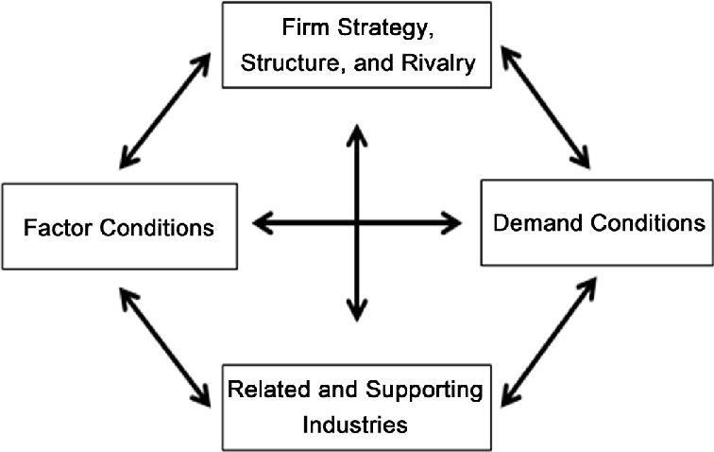
(Source: Porter’s Model of Nation’s Competitive advantage, 1990)
Fig. 1. Porter Diamond Model of Competitive Advantage of Nations
The diamond model given in Fig. 1 above reflects that the demand conditions are an external force and on which an economy will not be having control since they are subject to change, and modifications according to the needs and wants of society. Thus, demand conditions that prevail in an economy for products and services can be regarded as an independent variable since they evolve out of the needs and wants of the people, perceived value of a product or a service, the price at which they are offered, and the level of income people earn in that economy. Meanwhile, addressing such a changing demand condition would highly be possible if industries present in that economy are innovative and in possession of cost leadership (See Fig. 1). Thus, innovation is the key factor for achieving incremental benefits and economies of scale is the source of achieving cost leadership in terms of cost control and cost savings. (Kimiti et. al. (2020)
4. Model for Trade -based economies
Porter’s diamond model (Fig. 1) reinstates that a nation’s competitiveness can gain be through continuous innovations and upgrading happening in industries that are present in an economy. Trade based economies like GCC countries having sufficient resources in terms of capital and technology, a channelized utilization of these resources would help them in moving to manufacturing based economies. Trade based economies will have to focus on effective and efficient utilization of resources that is factor conditions in diamond model (Porter, 1990), so manufacturing value added can be enhanced, through which a shift from trade-based economy to manufacturing based economy can be achieved.
A model that suits out trade-based economies like the Sultanate of Oman can be
Technology
Capacity to innovate

Manufacturing Value Added
Resources available with trade-based economies
conversion
Mass Production – Economies of Scale
Cost leadership from economies of scale

(Source: authors)
Fig. 2. Model for trade-based economies for converting resources to achieve higher manufacturing value added

Trade-based economies could focus on channelizing resources into investments in technologies and mass production activities, so the targets with respect to shift planned to move away from trade to manufacturing business activities can become factual. Resources effectively channelized into capital investments and mass production would facilitate effective innovations and reduced costs as can be seen in Fig. 2. This facilitates nations to gain competitive advantage. Trade-based economies gain nation’s competitiveness through its exports of its value-based resources like Oil and gas. The competitiveness gained out of trade activities must be generating good amounts of public revenues and surpluses. Mobilization of resources would not be a challenge for such economies, rather channelization into technology investments and mass production will be their emerging trials. Thus, competitiveness in trade-based economies can be further enhanced through diversion of surpluses in technology and mass production business activities to achieve a higher manufacturing value added and to become the highest contributor to GDP (See. Fig. 2)
4.1 Scenario in the Sultanate of Oman
The technological advancements and factors that contribute in achieving economies of scale in Oman can be analyzed in detail to establish the capacity of the country in becoming innovative enough in its offerings as well as at the lowest price possible.
4.1.1 Technology Advancements
The technologies being used in Oman are more advanced and latest. The technologies being used in Oman are presented in the following table:
Table 1 – Technologies and the related contributors in achieving shift in economy and gaining competitive edge in Oman
Sl. No. | Technology | Recipient Sector | Initiatives/Strategies/Partners | Competitive Edge
1 | Telecommunications | Communication | (i) Three biggest operators are present in the market  (ii) These market players have shown interest in diversifying their 5G commercial partnerships  (iii) High Speed Internet service to 95% of the population by 2024 | The whole market is served by three major communication operators
2 | Digital Oman Strategy | For all sectors | (i) Business houses are actively moving their data management platform to cloud computing  (ii) Oman Data Park has been an example of public and private sector collaborations happening in information technology sector | Data centers can collect and provide necessary data  Collection of data for analysis and decision making becomes much easier.
3 | Disaster Recovery Services | All sectors | (i) Investments worth OMR 25 million, collected from both private and public sector organizations in establishing a disaster recovery unit, that can offer all assistance in data recovery. | Data recovery task will not pose a big challenge for both private and public sector organizations as there is a recovery center exists for recovering any data lost. This facilitates in data analysis and decision making.
4 | Blockchain/Artificial Intelligence/Internet of Things | All Sectors | (i) Smart cities projects implementation is done with the assistance of AI and block chain tools and technologies. | Effective supervision of smart cities. Project management skills acquired can contribute significantly in achieving desired result in those projects.
5 | FinTech | Banking and Finance | (i) Fintech Regulatory Sandbox Framework (2020) is present for fintech companies  (ii) Payments using apps like Apple Pay and Samsung pay is possible | Regulatory framework for guiding fintech companies will give an edge to fintech companies in their operation in finance sector and will motivate them to innovate extensively in launching innovative financial products and services
6 | Cybersecurity | All sectors | Cybersecurity industry is the target for taking care of cyber security issues | Maximum protection on data is ensured for both private sector, public sector organizations and public.
(Source: trade.gov, 2024)

The above table 1 clearly portrays that Oman is advancing very well in acquiring and implementing latest technologies in all sectors. These technologies are facilitating both private and public sector organizations to implement them effectively. Resources in terms of technologies needed for being innovative are very much present and available for the organizations, both public and private to innovate their offerings. Access to latest technologies is placing an economy in a position which cannot be easily imitated by others so quickly. Table 1 makes it very clear that Oman is having access to all the latest technologies and these technologies are taking them to a position which cannot be simply copied by others so quickly. This technological advancements and access is providing a competitive edge to the economy of Oman. Enterprises that are operating in an economy must be in innovate enough so that development and growth can become achievable targets in an economy (Drucker, 2008)
4.1.2 Economies of Scale in Oman
Andrew (2024) explains that economies of scale is the cost reduction achieved through the mass operations of an organization. Fixed cost per unit gets reduced due to an increase in volume of output being manufactured. Scale of operations can also bring a change in the variable cost as the operational efficiency of an organization increases due to enhanced processes being adopted within an organization.
Economies of scale is a result of labor productivity and capital adequacy achieved in an economy. An increased labor productivity and an enhanced capital adequacy ratio imply that a economy has good amounts of resources which can very well support expansion in the scale of operations of an undertaking. Thus, the labor productivity and capital availability ratio of Oman have been taken as the indictors of economies of scale being present in Oman.
The labor productivity ratio and capital adequacy ratio obtained for the last 10 years have been presented below:

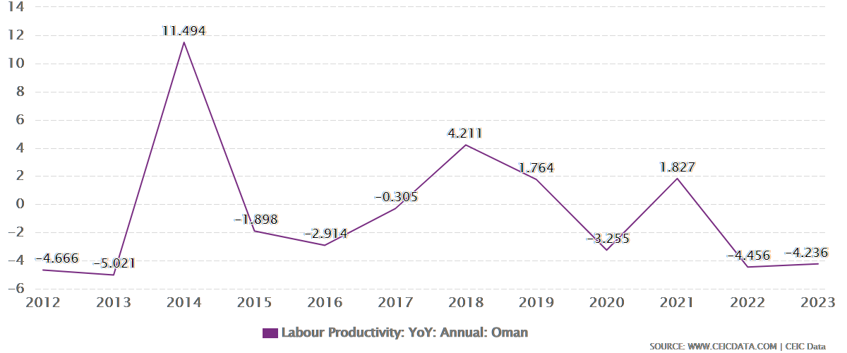
Fig. 3 – Labor Productivity Ratio in Oman from 2012 – 2023
(Source: CEIC Data, 2024)

The above chart (Fig.3) explains that labor productivity of the country has achieved a greater peak in 2013 (i.e 11.494) and had three peaks in 10 years of time. This clearly indicates that labor productivity in Oman has always been a biggest support for the economy. Though there had been falls in the rate in certain periods, but the economy always had the capacity in building it up to make it to move towards upward direction. (See Fig. 3). This chart (Fig. 3) makes it clear that labor productivity has been a driving force and supporting factor for the economy in building up of nation’s competitiveness all these years. Thus, labor as a resource contributing to a greater extent for the economy to grow and accumulate nation’s competitiveness.

Another important factor that can contribute well to achieve greater nation’s competitiveness is the adequacy and availability of capital within an economy. When enterprises want to expand their business activities beyond their current capacity, one of the greatest challenges they face is the availability of finance for financing their expansion and growth plans. An analysis on capital adequacy ratio of Oman is presented below:

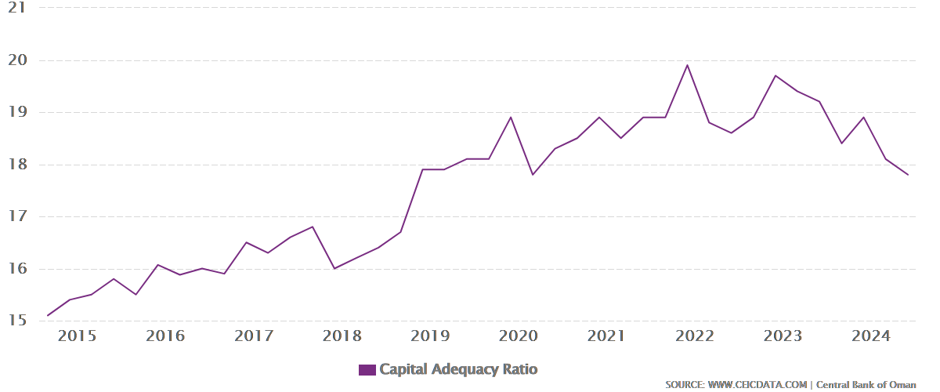
Fig. 4 –Capital Adequacy Ratio obtained in Oman from 2015 – 2024
(Source: CEIC Data, 2024)
The above chart (Fig. 4) indicates that Oman was having ratio 17.4% in 2024. The economy also had an all-time high ratio of 19.9 % in Dec 2021 (see Fig. 4). This chart indicates that banks always keep good amount of money with them in to meet out their liabilities. This indicates banks good standing to finance the business project requests. The chart given above in Fig. 4 makes it clear that CAR has been in rise, reflecting a good stand for the banks. Funding is the greatest challenge in expansion projects, but if banks and financial institutions existing in an economy are operating at a greater efficiency, then this challenge can be well addressed to.
An increasing trend is observed in CAR ratio in Oman (see Fig. 4) which is indicating that Oman is building up nation’s competitiveness through making banks ready for funding the viable and profitable projects. This leads to an economy to build and accumulate nation’ competitiveness.
5. Findings, Discussion and Conclusion

Manufacturing- based economies must have a detailed plan with respect to their allocation of resources to various sectors like Textile, Automobile, Foodstuff, Cosmetics, Electronics etc. since these are economies using all kinds of factors of production say Land, Labor, Capital to a greater extent possible. Trade-based economies receive their public revenue through exports and sale of inventories and use their funds for meeting the societal needs and further industrialization.
Economies like GCC countries are oil exporting and their major source of revenue is Oil exports. These economies are diversifying their resources into non-oil-based sectors extensively as the shift from trade-based to manufacturing-based will offer plenty of other benefits such as producing products locally at a lower cost, raising tax revenue, reducing inflation rates, offering high employment opportunities to the citizens etc. To reap the benefits of manufacturing-based economies and to remain competitive, trade-based economies are diversifying their resources towards manufacturing activities. In such a process, they must identify about their competitiveness and edge, so further investments can be made around factors that offer competitiveness to nations.
Trade-based economies must focus on remaining competitive and innovative. To be more innovative, they must bring in latest technologies into operation. Technology adaptation brings a safe shift from trade to manufacturing sectors and making organizations remain innovative and forward moving. Such forward moving processes give those economies nation’s competitiveness as indicated by Porter (1980)
Trade economies must also think seriously about mass production and economies of scale. These two are the sources of leveraging cost benefits in manufacturing sectors. Trade-based economies can shift to manufacturing sectors wherein economies of scale and competitive edge are achievable. Economies of scale is operational in those economies wherein labor productivity and capital adequacy ratio are showing an upward trend. Economies must work on building up and accumulating nation’s competitiveness through innovation and cost leadership strategies.

6. Acknowledgement
This study is the partial outcome of the Project titled “Industrialization and Services Sector Contribution for achieving Sustainable Economic Growth and Slashing Fiscal Deficit - A Study in line with Vision 2040 of Sultanate of Oman – BFP/RGP/El/22/005” funded by the Ministry of Higher Education, Research and Innovation (MOHERI), Sultanate of Oman

References

1. Fiveablelibrary (2024), Trade-Based Economy, available on https://library.fiveable.me/key-terms/introduction-to-native-american-studies/trade-based-economy, (accessed on 20th December 2024)

2. Trade.gov (2024), Oil and Gas, available on https://www.trade.gov/country-commercial-guides/oman-oil-gas, (accessed on 20th December 2024)

3.UKknowledge (2024), available on https://uknowledge.uky.edu/cgi/viewcontent.cgi? Article =1198 & context=pediatrics_facpub, (accessed on 20th December 2024)

4. Porter (1990), The Competitive Advantage of Nations, Harvard Business Review, Harvard Business School, April 1990, pp. 1

5. Kimiti et. al. (2020) Cost Leadership Strategy, Competitive Advantages and Performance: A Cross – Sectional Study in the context of Milk Processing Firms in Kenya, International Journal of Management, Innovation & Entrepreneurial Research. 6. 64-76. 10.18510/ijmier.2020.627.

6. Trade. Gov (2024), Information and Communication Technology, available on https://www.trade.gov/country-commercial-guides/oman-information-and-communication-technology-ict (accessed on 20th December 2024)

7. Drucker (2008) Innovation and Entrepreneurship, São Paulo: Cengage Learning, USA, 2008,

8. Andrew (2024), Economies of Scale, available on https:// corporatefinanceinstitute.com / resources / economics/economies-of-scale/ (accessed on 20th December 2024)

9. CEICData, (2024), Oman Labor Productivity Growth, available on https:// www. ceicdata.com /en/ indicator/oman/labor-productivity-growth (accessed on 21st December 2024)

10.CEICData, (2024), Oman Capital Adequacy Ratio, available onhttps:// www. ceicdata.com /en/indicator/oman/capital-adequacy-ratio (accessed on 21st December 2024)

