Implementation of VGG-16 Based Learning for Facial Recognition
Authors
Akash Gite Shubham Gethe Saransh Gupta Samyak Pagare

Sandip University, Sandip University, Mahiravani Nashik

Abstract— Facial recognition has become a critical application of computer vision, with widespread use in security, healthcare, and authentication systems. However, achieving high accuracy often requires substantial computational resources and large annotated datasets, posing challenges for developers with limited resources. This paper presents an efficient facial recognition system leveraging transfer learning with the VGG-16 pre-trained deep convolutional neural network. The model is fine-tuned for face detection and recognition tasks, significantly reducing the need for extensive training datasets. The proposed system integrates advanced data augmentation techniques and is deployed as a user-friendly web application using Flask/Django. Experimental results demonstrate the model's high accuracy in recognizing faces, even in constrained environments. This research highlights the potential of combining transfer learning and web technologies to create scalable, accurate, and accessible facial recognition solutions.
Index Terms—Deep Convolutional Neural Network, Image classification, Machine learning, Transfer learning, VGG – 16.

I. INTRODUCTION
Facial recognition has emerged as one of the most significant advancements in the field of computer vision, finding applications in areas such as security, healthcare, and personal authentication. The technology relies on identifying unique facial features to distinguish individuals, making it crucial for systems requiring high accuracy and reliability. However, traditional machine learning and deep learning models demand extensive labeled datasets and significant computational resources for training, which limits their scalability and accessibility.
Transfer learning has revolutionized this domain by enabling the reuse of pre-trained models for new tasks, significantly reducing the dependency on large datasets and computational power. VGG-16, a deep convolutional neural network pre-trained on the ImageNet dataset, is a popular choice for transfer learning due to its ability to extract meaningful features from images. By fine-tuning its layers, the model can be adapted for tasks like facial recognition with remarkable accuracy and efficiency.
This paper proposes a facial recognition system that combines transfer learning using VGG-16 with a web-based application, aiming to provide an accessible and scalable solution. The system incorporates data augmentation techniques to enhance model performance and robustness, even in environments with limited training data. Additionally, the project focuses on a user-friendly interface for uploading images and viewing results, making it suitable for real-world deployment.
The rest of the paper is structured as follows: the background and related work are discussed in Section II, the methodology is presented in Section III, and experimental results are analyzed in Section IV. Finally, the paper concludes with findings and potential future enhancements in Section V.

Example – Suppose the objective is to recognize faces in images within a specific dataset, such as a corporate employee database (Domain1). We collect images of employees from Domain1 and train a facial recognition model using traditional deep learning techniques. The model performs well on test images that belong to the same domain. However, if we attempt to use this model for recognizing faces from a different dataset, such as public surveillance footage (Domain2), we observe significant performance degradation. This happens because traditional deep learning models are heavily reliant on the data distribution and features of the training dataset.
In contrast, using transfer learning with a pre-trained model like VGG-16 can address this challenge. By leveraging its

learned features, such as edges and shapes, the model can be fine-tuned for the new domain (Domain2) with limited additional data. This approach enables robust performance across diverse datasets, demonstrating the power and flexibility of transfer learning in real-world applications.

II. BACKGROUND AND RELATED WORK
Facial recognition is a critical application in computer vision that involves identifying and verifying individuals based on their facial features. Traditional approaches relied on handcrafted features and machine learning models, which often struggled with variations in lighting, pose, and expression. The advent of deep learning has revolutionized this field, enabling the automatic extraction of hierarchical features from images, leading to significant improvements in accuracy and robustness.
Transfer learning has emerged as a powerful technique in machine learning, allowing models pre-trained on large datasets to be fine-tuned for specific tasks with limited additional data. The concept of transfer learning was formally introduced during the NIPS-95 workshop on “Learning to Learn” [1], which emphasized the need for methods that can retain and reuse knowledge across tasks. Unlike traditional machine learning, which requires extensive labeled datasets for each task, transfer learning leverages the knowledge gained from one domain (source) and applies it to another (target).
The VGG-16 model, proposed by Karen Simonyan and Andrew Zisserman in 2014 [2], has been a cornerstone in transfer learning applications. Pre-trained on the ImageNet dataset, VGG-16 is known for its ability to extract rich, hierarchical features from images, making it ideal for tasks such as image classification, object detection, and facial recognition. Studies have demonstrated the effectiveness of using VGG-16 for facial recognition by fine-tuning its layers to adapt to smaller, domain-specific datasets [3].
Recent works have further explored the application of transfer learning in facial recognition. For instance, researchers have employed VGG-16 to enhance recognition accuracy in constrained environments with limited training data by integrating data augmentation techniques [4]. Another study demonstrated the feasibility of using VGG-16 as a feature extractor in combination with lightweight classifiers for efficient facial recognition in real-time applications [5].
This paper builds on the existing research by leveraging VGG-16 with transfer learning to develop a robust, web-based facial recognition system. By fine-tuning the pre-trained model and incorporating advanced data augmentation techniques, this study aims to achieve high accuracy while addressing challenges posed by limited training datasets.

III. SYSTEM MODEL  We designed a facial recognition system using the VGG16 pre-trained CNN model. The implementation was done in Python language, utilizing the open-source machine learning library TensorFlow, which provides robust support for deep learning applications. Additionally, we employed Keras, a high-level neural network API that simplifies model implementation and is built on top of TensorFlow.  The development environment for the project was Jupyter Notebook, offering an interactive platform for coding, testing, and visualization. The application integrates the VGG16 model for feature extraction and recognition tasks, ensuring high accuracy and performance in facial recognition.  - CNN  A Convolutional Neural Network (CNN) is a type of deep  learning model primarily used for processing and analyzing  visual data, such as images and videos. CNNs are particularly  powerful in tasks like image classification, object detection,  and other compute vision applications due to their ability to  automatically learn spatial hierarchies of features | 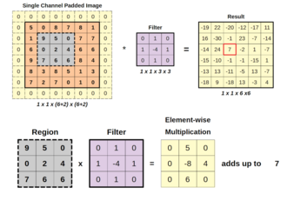  CNNs are also known as shift invariant or space invariant artificial neural networks, based on the shared-weight architecture of the convolution kernels or filters that slide  along input features and provide translation-equivariant responses known as feature maps.

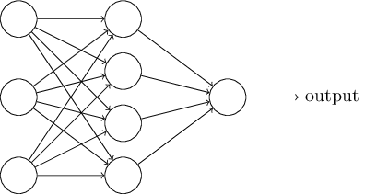  - OUTPUT LAYER  The output layer in a Convolutional Neural Network (CNN) is the final layer that produces the final decision or prediction of the network. This layer is responsible for mapping the high-level features extracted by the earlier layers (convolutional and fully connected layers) into the desired output format, whether it's a class label for classification tasks or a continuous value for regression tasks.  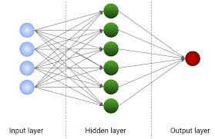  - SIGNIFICANCE OF CNN IN FACIAL RECOGNITION  Convolutional Neural Networks (CNNs) have fundamentally transformed the landscape of facial recognition, enabling far superior accuracy, robustness, and efficiency compared to traditional machine learning methods. Below is a more detailed breakdown of the significance of CNNs in facial recognition, highlighting their unique capabilities and advantages:  FaceNet: This model, which is based on a deep CNN architecture, generates a 128-dimensional embedding for each face image. These embeddings are then used for face verification (matching faces) and identification (recognizing the person). FaceNet was one of the first to show how a triplet loss function (used during training) could greatly improve recognition accuracy.  ResNet: ResNet architectures are very deep, enabling the model to learn complex face representations. The key innovation is the use of residual connections, which help mitigate the problem of vanishing gradients when training very deep networks  5. Transfer Learning and Pre-trained Models  CNNs are highly adaptable due to transfer learning, which allows models to be pre-trained on one dataset and fine-tuned on another. Pre-trained CNN models are often trained on large and diverse image datasets (like ImageNet) and can be transferred to facial recognition tasks with minimal retraining.  Pre-training on large datasets: CNNs trained on ImageNet (with millions of labeled images) have learned to extract features that are relevant across many visual domains, including faces.  Fine-tuning for facial recognition: After pre-training, a CNN model can be fine-tuned on a smaller, task-specific dataset (e.g., a dataset of celebrity faces or security camera footage). This significantly reduces the time and data required to build an effective facial recognition system.  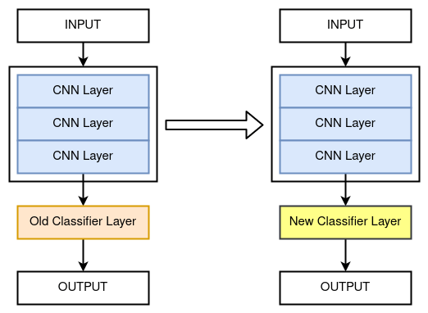 | - Automatic Feature Extraction  Traditional facial recognition techniques relied on hand-crafted features, such as Haar-like features, HOG (Histogram of Oriented Gradients), or SIFT (Scale-Invariant Feature Transform).  CNNs, in contrast, learn to extract features automatically from raw pixel data, which is crucial for processing complex visual data like faces. The hierarchical structure of CNNs allows them to:  Detect low-level features (edges, textures) in the initial layers.  Combine these low-level features into more complex, high-level features (like eyes, nose, mouth) in deeper layers.  2. Robustness to Variations  Real-world facial recognition must handle various challenges, including changes in:  Lighting conditions (e.g., shadows, glare)  Pose variation (e.g., frontal vs. profile view)  Expression changes (e.g., smiling, frowning)  Occlusions (e.g., glasses, hats, scarves)  3. End-to-End Learning  One of the greatest advantages of CNNs in facial recognition is their end-to-end learning capability. Traditional methods of facial recognition often required multiple stages, such as feature extraction, dimensionality reduction, and classification. Each of these steps could introduce errors or require manual tuning.  4. Deep Architectures for Improved Accuracy  Deep learning has led to the development of highly specialized architectures for facial recognition, such as:  VGG-Face: Based on the VGG-16 architecture, VGG-Face uses a deep convolutional network with a relatively simple design to process images and extract facial features  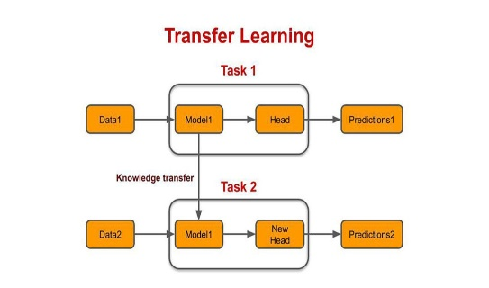  6. Scalability and Performance  CNNs have an outstanding ability to scale with increasing amounts of data. As facial recognition systems are deployed in real-world applications—such as surveillance cameras, social media platforms, or mobile devices—the amount of data grows exponentially. CNNs can be trained on very large datasets of faces, making them highly scalable.  Handling large datasets: As facial recognition systems process more images, CNNs' performance continues to improve. In fact, the more diverse the training dataset, the better the model can generalize across different types of faces, environments, and conditions.  Real-time processing: With advancements in GPU acceleration and optimization techniques, CNNs can perform facial recognition at real-time speeds, even on large databases. This is crucial in applications such as airport security or online banking, where quick decision-making is necessary.  VI . VGG16 Model  The VGG16 model is a widely recognized deep convolutional neural network architecture, developed by the Visual Geometry Group at Oxford University. It consists of 16 layers, including 13 convolutional layers and 3 fully connected layers, designed to extract and classify features effectively. The model employs small 3x3 filters and max-pooling, allowing it to capture intricate patterns in images. Pretrained on the ImageNet dataset, VGG16 is particularly adept at feature extraction, making it highly suitable for facial recognition tasks.  Its layered architecture enables the identification of facial contours, expressions, and unique features essential for distinguishing individuals. By leveraging transfer learning, VGG16 can be fine-tuned to enhance recognition accuracy in diverse scenarios such as authentication, attendance systems, and surveillance.

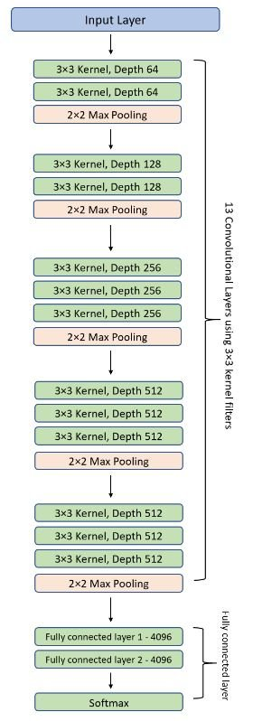  SIGNIFICANCE OF VGG-16 IN FACIAL RECOGNITION  VGG-16, a deep convolutional neural network (CNN) architecture, has gained significant attention in the field of computer vision due to its simplicity, depth, and impressive performance in large-scale image recognition tasks. In the context of facial recognition, VGG-16's ability to extract high-level features and represent complex patterns in images makes it highly effective. Below are key reasons for its significance in facial recognition:  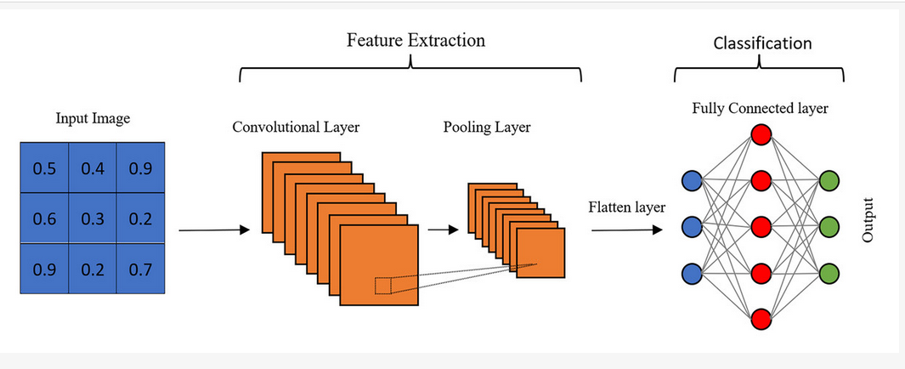  Superior Feature Extraction: VGG-16 utilizes small 3×3 convolutional filters stacked on top of each other, which allows the network to learn and capture intricate details such as edges, textures, and facial features. This feature extraction is crucial in facial recognition, where distinguishing fine-grained differences between faces is necessary for accurate identification.  Robustness to Variations: The architecture of VGG-16 is robust to various challenges in facial recognition, such as changes in lighting, pose, and partial occlusions. By learning a variety of facial representations through its deep layers, VGG-16 can effectively handle the diversity of real-world facial images, ensuring accurate recognition even under non-ideal conditions.  Widespread Adoption and Research: Due to its success in facial recognition, VGG-16 has become a widely adopted model in both academic research and industry applications. It serves as a baseline for many facial recognition studies, allowing researchers to benchmark their methods and explore improvements in areas like feature engineering, network optimization, and model scalability. | VGG-16 MODEL ARCHITECTURE  The VGG-16 architecture was introduced by Karen Simonyan and Andrew Zisserman in 2014 in their paper "Very Deep Convolutional Networks for Large-Scale Image Recognition." This architecture consists of 16 layers, including convolutional and fully connected layers, and is known for its simplicity due to the consistent use of 3×3 convolutional filters stacked on top of each other.  The precise structure of the VGG-16 network, as shown in Fig is as follows:  - The first and second convolutional layers contain 64 feature kernel filters, each of size 3×3. When an input RGB image with a depth of 3 passes through these layers, the dimensions transform to 224x224x64. The output is then passed through a max-pooling layer with a stride of 2.  - The third and fourth convolutional layers use 128 feature kernel filters, each of size 3×3. These layers are followed by a max-pooling layer with a stride of 2, reducing the dimensions to 56x56x128.  - The fifth, sixth, and seventh convolutional layers consist of 256 feature kernel filters, each of size 3×3. A max-pooling layer with a stride of 2 follows these layers.  - The eighth to thirteenth layers comprise two sets of convolutional layers with 512 feature kernel filters, each of size 3×3. These layers are followed by max-pooling layers, reducing dimensions to 7x7x512 after the final pooling operation.  - The fourteenth and fifteenth layers are fully connected hidden layers with 4096 units each. Finally, the sixteenth layer is a SoftMax classifier with 1000 output units for ImageNet classification.  LEVERAGING TRANSFER LEARNING WITHPRETRAINED MODELS  ImageNet is a research project to develop a large database of images with annotations e.g. images and their labels. Pretrained models like InceptionV1, Inception V2, VGG-16and VGG-19 are already trained on ImageNet which comprises of disparate categories of images. These models are built from scratch and trained by using high GPUs over millions of images consisting of thousands of images categories.  Group at Oxford University. It consists of 16 layers, including 13 convolutional layers and 3 fully connected layers, designed to extract and classify features effectively. The model employs small 3x3 filters and max-pooling, allowing it to capture intricate  Deep Architecture: The VGG-16 model consists of 16 layers, including convolutional and fully connected layers, enabling it to learn hierarchical representations of facial features. The depth of the model allows it to capture a range of features, from low-level textures to high-level facial patterns, making it highly effective in recognizing faces under varying conditions such as lighting, orientation, and pose.  Transfer Learning and Pretrained Models: VGG-16 has been pretrained on large datasets like ImageNet, allowing it to learn low-level visual features across a wide range of objects. Through transfer learning, VGG-16 can be fine-tuned with relatively smaller datasets to adapt to specific tasks such as facial recognition. This makes it an attractive option for facial recognition systems, as it can perform well with limited training data by leveraging knowledge from its initial training.  Improved Accuracy and Efficiency: VGG-16 has consistently outperformed traditional machine learning models in facial recognition tasks, offering high accuracy in distinguishing faces. Its ability to process and classify images in a computationally efficient manner makes it suitable for real-time applications in security, surveillance, and personal identification systems.  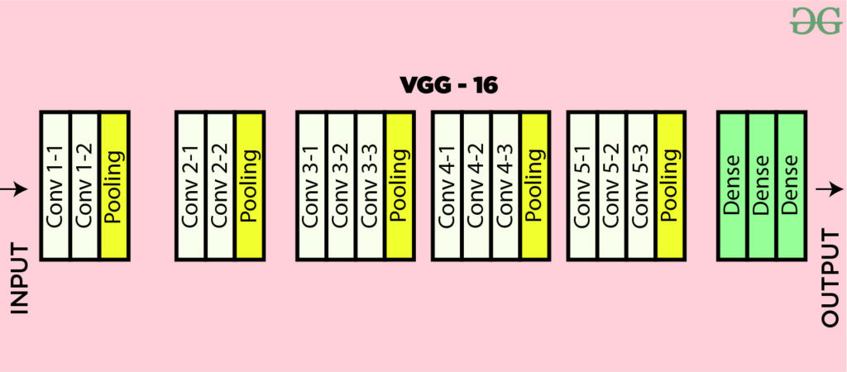  VII. Conclusion  VGG-16's deep, yet straightforward architecture has proven to be a cornerstone in the field of facial recognition. Its ability to extract hierarchical features, adaptability through transfer learning, and robustness to variations in real-world conditions have established it as one of the most reliable models for face detection and recognition. Whether for security, authentication, or healthcare, VGG-16 continues to lead the way, demonstrating the importance of deep learning in advancing facial recognition technology.

REFERENCES

- Srikanth Tammina (2019); Transfer learning using VGG-16 with Deep Convolutional Neural Network for Classifying Images; International Journal of Scientific and Research Publications (IJSRP) 9(10) (ISSN: 2250-3153), DOI: http://dx.doi.org/10.29322/IJSRP.9.10.2019.p9420

- Pan, S. J., & Yang, Q. (2010). A Survey on Transfer Learning. IEEE Transactions on Knowledge and Data Engineering.
- Simonyan, K., & Zisserman, A. (2014). Very Deep Convolutional Networks for Large-Scale Image Recognition.
- Tammina, S. (2019). Transfer Learning Using VGG-16 with Deep Convolutional Neural Networks for Image Classification.
- Lucena, O., & Amadeu, J. (2020). Transfer Learning for Face Recognition with Convolutional Neural Networks.
- Yosinski, J., Clune, J., Bengio, Y., & Lipson, H. (2014). How Transferable Are Features in Deep Neural Networks
- Deep convolutional neural networks for age and gender estimation using an imbalanced dataset of human face images Neural Computing and Applications
İsmail Akgül

