**EXPLORING CHALLENGES IN URBAN WALKABILITY FOR WOMEN IN DAVAO CITY: A NARRATOLOGY APPROACH**

**Candice Louise B. Gomito, Shaina Jane F. Hugo, Jannine Anne L. Locario**

Master of Science in Development Administration Major in Urban and Environmental Planning, University of Southeastern Philippines-Mintal Campus, Davao City, Philippines

**ABSTRACT**

The walkability of urban spaces for women in Davao City, Philippines, is influenced by multifaceted factors, such as the safety, quality of infrastructure, environmental conditions, and social norms. Using qualitative methods, including semi-structured interviews, photovoice, and field observations, this study explores the lived experiences of women navigating urban spaces. Findings include continuously encountered challenges like sidewalks maintained poorly, lack of bright lighting, exposure to harassment, extreme weather conditions, and cultural expectations that hinder movement and access to public areas. The study stresses an urgent need for gender-friendly urban planning, with expectations that shaded pedestrian pathways must be available, street illumination must be improved, anti-harassment measures must be followed, and infrastructure designs and policies should be friendly for everyone. This study addresses these barriers and offers actionable recommendations for creating safer, more accessible, and equitable urban environments and contributing to the broader discourse on sustainable and inclusive city development. Insights generated from this study will guide policymakers, planners, and stakeholders in advancing gender-responsive urban strategies.

**Keywords:** Urban Walkability, Urban Spaces, Photovoice, Gendered-perspective, Davao City

1. **INTRODUCTION**

The importance of increasing urban sustainability has become important in many disciplines, such as urban planning, environmental studies, and public policy management (Cerutti et al., 2019). One dimension of urban planning is walkability, which is an integral part of the mobility structure of a city, defined as the assessment of physical infrastructure that encourages walking but also qualitative aspects that give people a reason to walk in the urban environment (Jayakody et al., 2018). Urban walkability has increasingly been recognized as an important component of urban design, given its significant influence on sustainability, public health, and overall livability in urban environments (Baobeid A, Koç M, and Al-Ghamdi SG, 2021). Urban centers globally are now enhancing their efforts to create pedestrian-friendly environments, with the aim of changing societal attitudes toward walking (Fonseca et al., 2024). To understand the need to enhance the quality and ensure access to active mobility, there should be an understanding of the pedestrians’ perceptions of their walking behaviors and the factors influencing walkability (Domeneghini, Macke, and Alberto, 2022). However, walkability is not uniform. It differs vastly across different demographics, and more often than not, women have to face more obstacles in terms of safety in urban spaces than men (Domeneghini, Macke, and Alberto, 2022). These range from safety, traffic, pedestrian infrastructure, and built environmental features in an urban setting to make walking around safer and easier for people (Sethi & Velez-Duque, 2021; Brookfield & Tilley, 2016). It is because the factors that condition women's walking experiences in urban environments are important to understand, thereby creating an essential area of study for the promotion of fair policy guidelines on urban development (Scarponi et al., 2024).

Walkability in Davao City, a fast-growing urban center in the Philippines, remains an area that needs exploration, especially from a gender perspective. Past studies on walkability in the city, though limited, only consider its status in pedestrian facilities alone (Abaya et al., 2011 & Fabian et al., 2010), streetscape alone (Juanga & Reyes, 2022), and pedestrian mobility alone (IDIS, 2024). As the city continues to expand and develop, it becomes imperative to establish whether its public spaces meet the needs of all women, whose voices are usually ignored in urban development plans (Adefare et al., 2024).

**1.1 Objectives**

The primary objective of this study is to explore and understand the walkability of urban spaces for women in Davao City, with a focus on identifying factors that influence their walking experiences and proposing potential improvements. Specifically, this study aims to:

1. Identify the common challenges and obstacles women face in their daily walks within Davao City's public spaces.

2. Evaluate current projects, policies, and infrastructures that impact walkability for women in Davao City.

3. Recommend urban planning and policy measures that can enhance the walkability and accessibility of public spaces for women in Davao City, promoting a safer and more inclusive environment.

Through these objectives, the study seeks to contribute to the development of gender-sensitive urban planning that addresses the unique needs and perspectives of women in the city.

1. **LITERATURE REVIEW**
   1. **Gender Differences in Urban Walkability**

There are gender differences in the perceptions of walkability. More women tend to walk and use public transport than men (Goel et al., 2022) as the number of women walking for leisure and fun is higher than that of men (Pollard et al., 2017). Walking behavioral patterns across sexes are also affected by the purpose of the trip and the distance traveled. While men are negatively affected by travel distance, women are more likely to be receptive to walking distances such as going to work (Hatamzadeh et al, 2020). It can be suggested that gender may act as an individual factor moderator between the modified environment and one’s habit of physical activity. Women who have access to physical activity spots and engage in regular physical activities tend to be more active during their free time (Bengoechea & al, 2005). There are also disparities in walkability perception in terms of safety. According to a study conducted in Slovakia, women pay extra attention to feeling safe whereas men don’t care so much about safety. Women are more fearful of walking in public spaces in city centers than men especially at night or in dark places (Rišová et al., 2020). While abundant research evidence demonstrates the differences in safety perceptions between women and men, our understanding of gender inequality in other key aspects of walkability remains unclear.

* 1. **Factors Influencing Women’s Walkability**

Research has shown that factors influencing women’s walking differ from those affecting men’s as some women may view walking as the most vulnerable means of transport. Fear of crime, a sense of personal safety, homelessness, and sidewalk cleanliness proved to be the most influential variables in women’s walking during the daytime. This highlights how existing walkability measures may vary depending on what matters most to women such as designing safe streets, emphasizing the importance of gender-specific assessments in urban environments. (Golan et al., 2019). A study conducted by Gorrini et al. (2021) identified interventions to enhance women's walkability by guaranteeing the presence of relevant public services within a walkable distance from their place of residence and installing surveillance and lighting systems to convey a sense of security to city users, especially at nighttime. In the study of Gong et al. (2023), responses revealed that certain street design factors such as street and sky openness have a large effect on the walkability perceptions of women as they are more imageable.

* 1. **Urban Walkability in Davao City**

There is an increase in commuters and roads are becoming more car-centric in Davao City. A recently concluded research study on citizen walkability assessment in Davao City by Interfacing Development Interventions for Sustainability (IDIS, 2024), was conducted to help assess the existing urban walkability and pedestrians’ mobility conditions in the city. The study pointed out factors why Dabawenyos avoid walking. Only 7.4 percent of respondents are satisfied with the 27 assessed walkways in Davao City. Some of the identified barriers include illegally parked vehicles on sidewalks, unclear pedestrian signs, limited amenities for pedestrians, and environmental factors such as heat. Urban greenery, covered walkways, and canopy infrastructures are some of the recommendations to promote walkability in the city. The findings of the study can be used to influence and improve the city’s development planning on sidewalks and pavements to provide opportunities for implementing a walkable and pedestrian-friendly city.

1. **METHODOLOGY**

**3.1 Research Design**

This research utilizes a qualitative approach to investigate and comprehend the walking experiences of women in urban environments in Davao City. The objective of the study is to understand women's perceptions, difficulties, and the influence of urban infrastructure, policies, and social elements on their walking experiences. A mixture of photo and video documentation, semi-structured interviews, and field observations will be employed to collect detailed information regarding women's walkability experiences.

**3.2 Data Collection Methods**

This research utilizes a range of methods to explore the walking difficulties encountered by women. semi-structured interviews will be conducted with up to fifteen (15) women from various backgrounds to gather their individual narratives regarding their walking experiences, concerns about safety, and the challenges they face. Photovoice activities will enable participants to capture their walking routes through photographs or videos, highlighting particular challenges, hazards, and safety issues. These visual representations will enhance the interview data, providing a deeper and real-world context regarding the situations women encounter. Field observations will take place in public areas such as sidewalks and parks at various times throughout the day to evaluate physical conditions, pedestrian activity, and possible obstacles. The observations will be analyzed alongside insights from the interviews to investigate the connection between perceived challenges and actual walkability issues. Participants will be selected using purposive sampling to ensure a diverse representation, specifically targeting women who frequently walk in the public areas of the city. The sample will include women from various age groups, professions, and socio-economic backgrounds, with the selection criteria consisting of women aged 18 and older who reside or are employed in Davao City, and who regularly walk in public spaces for commuting, leisure, or running errands for at least one (1) hour per week.

**3.3 Study Area**

The study will focus on Davao City, specifically its urban core and surrounding areas that are frequently accessed by women. This includes:

* Sidewalks and pedestrian paths
* Public parks and open spaces
* Public transport terminals and busy commercial areas
* High-density residential zones

**3.4 Data Analysis**

In this research, data analysis will include a thematic approach, where transcripts from interviews and observations will be organized to highlight recurring themes, patterns, and significant issues pertaining to walkability. This will yield insights into the difficulties, safety issues, and other elements that influence women’s walking experiences. Furthermore, visual analysis will scrutinize photos and videos from the photovoice activity to pinpoint common barriers and design flaws in public areas, reinforcing the thematic findings with visual support and providing a more comprehensive understanding of the context surrounding these challenges.

**3.5 Survey Questions**

The following are the questions formulated to come up with the results based on the objectives of this study and will guide the discussions to provide comprehensive understanding on the walkability experiences of women in Davao City.

*Question 1*: How would you describe your walking experience in the streets or urban spaces of Davao City?

*Question 2***:** What challenges do you encounter in your daily walks within the city?

*Question 3***:** What projects, policies, or infrastructure improvements can you suggest to enhance the walkability experience and participation for women in Davao City?

**3.6 Photovoice Activity Flow**

The photovoice activity cycle involves a week-long data collection period for the collection of themes. Participants capture a photograph addressing the researchers’ questions and submit it with a brief caption. The researcher confirms receipt and then conducts a 5 to 10-minute interview to discuss the image further as detailed in Figure 1.

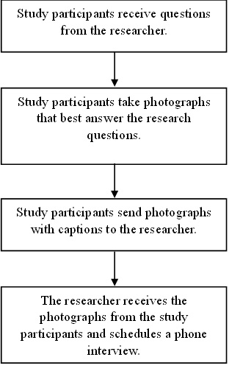

**Figure 1:** Photovoice Activity Flow

1. **RESULTS AND DISCUSSION**

**4.1 Cycle 1: Description of women’s walking experience in the urban spaces of Davao City**

The keywords listed below were identified from the analysis of interview data, which reflect the viewpoints and experiences of the respondents concerning their commuting. Most respondents frequently characterized their commuting experiences with words such as "safe," "clean," "accessible," "good," and "comfortable," emphasizing the positive aspects of walkability and mobility in the urban setting. These keywords surfaced as key themes during the qualitative analysis, shedding light on the factors that enhance a positive walking experience. The word “safe” stood out as the major theme when describing the respondents’ walking experience. The following are some of their responses:

Respondent 1:

“*Sa walo ka tuig nag puyo ko sa Davao, makaingon ko na safe mubaktas sa dalan maski gabii.* (For the past 8 years staying in Davao, I should say it is safe to walk on streets even at night time.)”

Respondent 5:

“*Safe akong paminaw kay naay mga poste sa suga. Naa pud mga police, task force, and checkpoints.* (I find it safe because of the adequate lighting in our posts. There are police auxiliaries, task force, or even checkpoints.)”

Respondent 10:

“*Kalma kaayo mubaklay sa may coastal road, di lang tungod sa kanindot sa view ug dagat, tungod pud sa iyang kalimpyo, kalapad sa sidewalks and kalay-on gikan sa agianan sa mga sakyanan, maong safe sa paminaw mubaklay dire.* (Walking in the Davao City Coastal Road is very calming not just because of the scenery and sea breeze, but also because it is well-maintained—with wide and even sidewalks that make it safe for walkers, away from motorists and cyclists.)”

Most respondents felt safe when walking in the urban spaces of Davao mainly because the streets are well maintained, cleanliness is observed, there are working street lights, most sidewalks are accessible, and the presence of policemen adds a sense of security in their daily walks.

A word cloud was created to visually illustrate the frequency and importance of these themes, as depicted in Figure 2. Word cloud is a useful tool in assessing and investigating patterns in textual responses and a screening tool for large amounts of text data (Wilkinson, 2014). This visual representation provides a quantitative overview of the most commonly mentioned terms, assisting in contextualizing and summarizing the main findings related to participants' walkability experiences.

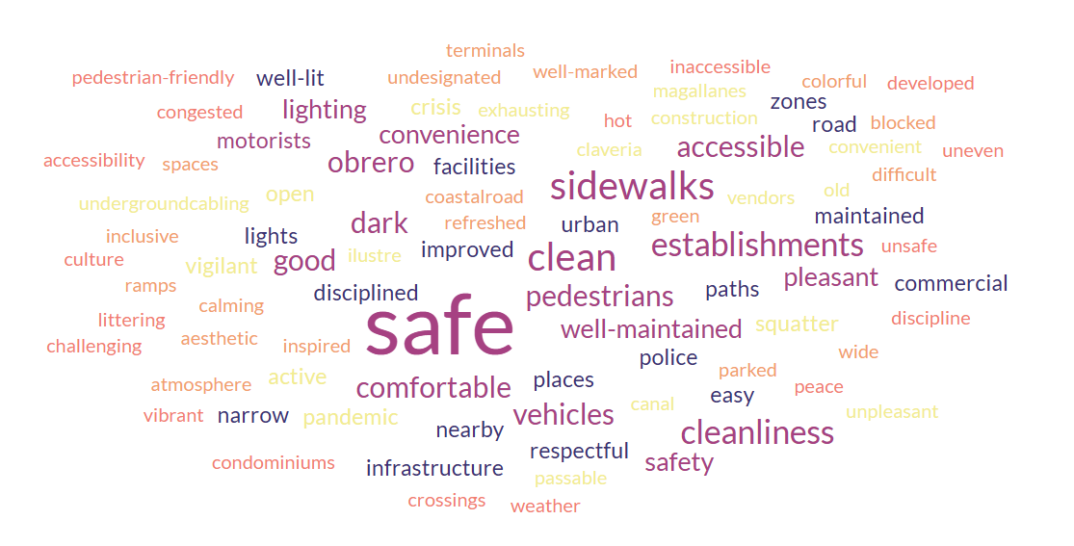

**Figure 2:** Key themes identified from the answers provided by respondents for Question 1. How would you describe your walking experience in the streets or urban spaces of Davao City?

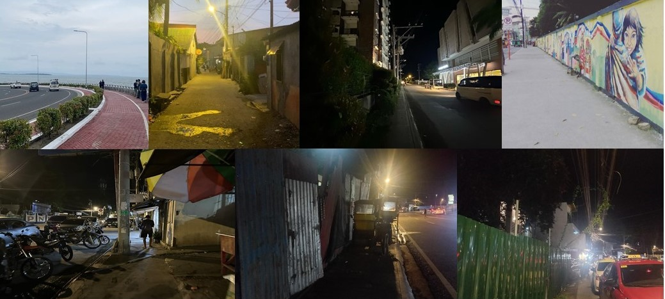

**Figure 3:** Collection of photos submitted by participants to depict their commuting experiences for Question 1.

**4.2 Cycle 2: Challenges encountered by women in their daily walks within Davao City**

Four (4) major themes resulted in the thematic analysis of the challenges encountered by women in their daily walks within Davao City. The themes were (1) Environment and weather-related challenges, (2) Pedestrian infrastructure and safety, (3) Social and cultural challenges, and (4) Accessibility and usability of urban spaces.

***Theme 1: Environment and Weather-related challenges***

Environmental and weather-related challenges are of major concern to pedestrians in Davao City. One of the respondents said, *"Isa gyud sa dakong challenge pag mabaklay sa Davao kay ang kainit labi na inig udto. Kapoy kaayo kay kailangan pa nako mangita og masilungan kay dili tanan areas naay shade.* (While walking around Davao City, I find that the tropical climate is a big challenge. It gets really hot and humid during midday, which makes walking tiring. Most of the time, I have to look for any shade, but not all areas have it.)*"* Extreme heat and humidity make walking uncomfortable during midday, particularly in areas where there is no shaded sidewalk or green space. This agrees with studies indicating that the impact of urban heat islands, air pollution, and lack of tree cover significantly affect pedestrian comfort (Zhu & Kenseck., 2024). This was confirmed through an interview with Ms. J, who mentioned that the extreme heat in Davao City limits her from walking long due to exhaustion and possible health problems.

Additionally, one respondent stated, *"Pag ting ulan, lisod again ang mga sidewalks kay naay uban lugar sa Davao na bahaunon kaayo na lampas tuhod ang tubig, usahay matalsikan pa kag tubig baha sa mga sakyanan.* (During the rainy season, there are certain parts of Davao City that floods, resulting in not accessing the sidewalk at all. You will not be in those areas flooded knee-deep, you will sometimes be hit by droplets from the street.)*”* The sudden rain adds to the difficulty, as it often leads to flooding and muddy walkways, forcing pedestrians to navigate slippery and unsafe conditions. Maintenance issues, such as uneven sidewalks, open manholes, and debris, become even more hazardous during adverse weather. According to this study, if the drainage system is unsatisfactory, it tends to bring some damage or problems for road users and the pavement itself (Sukur et al., 2023). This statement was affirmed by Ms. C and Ms. J during the interview that the flooding problem in Davao City is one of the main problems not just the motorists but also the pedestrians.

***Theme 2: Pedestrian Infrastructure and Safety***

Respondents highlighted several challenges that they face daily, such as encroachment by vehicles, construction-related hazards, and the presence of obstacles on walkways. One respondent said, “*Isa sa mga problema sa dalan sa Davao kay kulang og parking space. Daghang sakyanan pataka lang og parking sa walkways maong mapugos nalang ang mga tao na sa dalan sa sakyanan muagi. Naa pud mga motor gaagi na sa sidewalks tungod sa ka trapik, naay mga gabaligya pud kilid sa dalan, tungod ani makapalisod ug delikado para sa mga gabaklay.* (Lack of private parking space is a problem in the city. Since there are many vehicles parked in walkways, people are forced to walk on the roadway. Other times due to heavy traffic, some motorcycles pass through sidewalks. Aside from vehicles, some stall owners place their goods on the walkways. These situations make walking difficult and unsafe.)” Some expressed concerns regarding obstacles such as parked vehicles on walkways, ambulant vendors on sidewalks, and ongoing construction projects along major roads that impede foot traffic and force them to walk alongside heavy traffic and around cars and motorcycles. This not only creates safety hazards but also discourages them from choosing walking as a viable mode of transportation. Most women interviewed said they experience issues with uneven surfaces, cracked sidewalks, open drainage systems, and damaged manholes. Such conditions make walking unbearable for women, besides exposing them to tripping hazards with possible injuries, the lack of warning signs, and the lack of temporary pedestrian lanes during sidewalk inconveniences increase the chances of accidents. The absence of adequate lighting on most streets is also one concern that affects women's walkability. This agrees with the study of Rišová et al. (2020) that women are more fearful of walking in public spaces in city centers than men especially at night or in dark places as this contributes to unsafe conditions for walking. The statements gathered were affirmed by several respondents that pressing issues regarding women's perspective on pedestrian infrastructure and safety in the city do exist.

***Theme 3: Social and cultural challenges***

The research underscores the influence of societal elements, revealing how issues like catcalling, harassment, and encroachment by vendors adversely affect women’s feelings of safety and their freedom to move within public spaces. One respondent stated: *“Bilang isang babae, hindi ako komportableng maglakad sa mga daan na maraming tao at pa minsan sa mga daan na may mga tambay na bastos.* (As a woman, is it also very uncomfortable to walk with random strangers and men catcalling when women pass the streets.)*”* Ms. S confirmed during the interview that catcalling is her main obstacle in walking through public areas. Numerous respondents voicing concerns about experiencing verbal harassment while walking. This aligns with the findings of Dhillon and Bakaya (2014), which indicate that harassment in public spaces frequently underscores the widespread issue of street harassment, including catcalling, as a notable impediment to women's mobility and comfort in urban settings. In light of these societal challenges, women often opt to protect themselves by distancing from harassers rather than confronting them, due to concerns about potential escalation.

Furthermore, the intrusion of vendors onto sidewalks and pedestrian pathways creates physical obstacles as stated by one of the respondents: *“Usahay lisod muagi sa mga lugar nga daghan gabaligya sa dalan. Naa pud mga gina ayos na kanal maong walay tarong agianan sa tao.* (Ambulant vendors are in the walkways sometimes impeding the foot traffic. Ongoing canalling is inconvenient to pedestrians.)*”* The presence of street vendors occupying public walkways not only blocks physical access but also heightens feelings of vulnerability, especially in crowded locations where women may feel more at risk. This affirms the study of Hine and Mitchell (2001) that states how urban infrastructure challenges, such as sidewalk encroachment, can restrict accessibility for certain groups, particularly women, who may feel unsafe or uncomfortable navigating crowded, cluttered spaces. These issues, rooted in societal and cultural attitudes, profoundly impact women’s everyday experiences and must be tackled to foster safer, more inclusive urban settings.

***Theme 4: Accessibility and Usability of Urban Spaces***

Urban walking conditions in Davao City present significant challenges for women, affecting their mobility and safety. This photovoice study highlights key obstacles, including obstructed walkways, lack of shaded areas, and insufficient pedestrian crossings. As one respondent stated: *“Minsan delikado sa pakiramdam pag naglalakad ako pauwi sa dorm sa Bonifacio kasi walang  maayos na ilaw. May mga daan din na mahirap lakaran kasi may mga nagbebenta ng pagkain sa tabi ng daan.* (Walking going to my dorm in Bonifacio often feels unsafe due to several issues. Many areas lack proper lighting. Also, some streets are used as dining areas for carinderias, leaving little space for pedestrians.)*”* This reflects the study on "Street Vending and Its Impact on Pedestrian Walkability," which shows how encroachments like carinderias reduce space and jeopardize pedestrian safety. The lack of shaded areas is a major concern, especially in hot weather, limiting women's mobility and health. Insufficient pedestrian crossings also pose risks, forcing women to cross busy streets without designated areas. One respondent shared: *“Maliban sa mainit pag naglalakad sa umaga, nakakairita ang mga lubak at maputik na daan at mga sirang drainage.* (Aside from the heat during daytime walking, I find the most challenging and annoying are the uneven surfaces, open/damaged drainage sidewalks occupied by weeds and sometimes mud.)*”* This aligns with the findings of Mazzulla et al. (2024), which suggest that females exhibit greater sensitivity than males regarding various significant factors, including environmental issues such as air pollution and noise, personal security against robbery or theft, as well as the presence of furnishings along pathways and the cleanliness of the surroundings. By addressing these concerns through enhancements to walkways, shaded areas, and crossings, we can significantly improve women's safety and mobility in urban environments.

**4.3 Cycle 3: Development policies and projects for the improvement of urban walkability**

Thirdly, this cycle sought protection measures, projects, policies, and infrastructural development that the participants believed can improve their walking experiences. Davao City women emphasized improvement in infrastructures, cleanliness, security, and pedestrian-friendly design of cities. The results echo a trend in research from across the globe where good-kept, lit, and accessible public spaces are significant aspects of creating a safe and comfortable walk for pedestrians. This discussion involves their views and associates them with relevant studies in an attempt to identify workable solutions for making a place walkable.

Major components of participants' suggestions, therefore, included well-lit streets, installation of CCTVs, and wider covered walkways. One suggested that walking becomes all the more comfortable with shadow-filled wider pavements lined with trees. Studies confirm that effective lighting coupled with pedestrian-centric infrastructure results in enhanced perceptions of personal safety in urban areas, according to Abeygunawardana & Silva (2024).

Maintaining clean and functional pedestrian areas emerged as another priority. One participant shared that crosswalks must be kept clean at all times, with police available to assist vulnerable groups. Addressing flooding issues and preserving traditional streets like Ilustre Street corresponds with research by Mehanna et al. (2019), emphasizing the importance of conserving and maintaining traditional streets and the cities’ urban heritage because of their continuing and organic growth.

Improving safety will require more frequent patrolling, stricter anti-harassment policies, and public education. As noted by one respondent, *“Madisiplina na ning mga bastos sa dalan kung naa na tay mga balaod mahitungod ani. (Policies addressing cat-calling would deter inappropriate behavior.)"* As highlighted in Plan International (2018), sexual harassment and violence constituted the primary reason why young women felt unsafe in public spaces. They will significantly benefit from targeted safety measures, which include visible security personnel and campaigns against harassment.

Positive interventions such as wall paintings in public spaces have the potential to transform urban environments. One respondent stated that: *“May mga daan sa Davao City na may street arts na magandang tingnan, nakaka inspire at refreshing maglakad.* (There are parts of the city that have colorful street art. Finding these places during the walk makes me feel refreshed and inspired.)*”* By creating vibrant, inclusive murals that reflect the diverse culture and experiences of women in the city, these artistic expressions can foster a sense of belonging, safety, and pride. Wall paintings can serve as a visual representation of empowerment and solidarity, helping to challenge traditional gender roles and societal norms. These positive societal and cultural shifts, alongside infrastructural changes, offer a pathway to more inclusive and accessible public spaces. Enhancing walkability for women in Davao City requires both a transformation in societal views and the promotion of creative, artistic interventions like wall paintings, which together foster safer, more inclusive urban environments.

1. **CONCLUSION AND RECOMMENDATIONS**

This study points to the need to improve walkability for women in Davao City. It addresses physical, social, and cultural barriers that stand as obstacles to women's walkability in the city. While participants have agreed on safety as a positive aspect of some places, in this study they also enumerated significant challenges, such as environment and weather-related challenges, pedestrian infrastructure and safety, social and cultural challenges, and accessibility and usability of urban space.

The findings underscore the crucial adoption of a gender-sensitive approach in urban planning, with detailed recommendations on improving infrastructure, assuring safety, and inclusivity. Recommendations include the following:

1. Better lighting at strategic points
2. Shaded walkways
3. Functional drainage systems
4. Provision for anti-harassment measures
5. Policy enforcement to regulate sidewalk usage
6. Enhance pedestrian pathways

This calls for a holistic approach to improving structural conditions, societal shifts, and inclusive policy-making to make urban spaces walkable, safe, and accessible for women. In this way, Davao City can be a model for sustainable and equitable urban development that promotes not only walkability but also the quality of life for all its citizens.

1. **ACKNOWLEDGEMENT**

We would like to express our gratitude to everyone who contributed to this study. Special thanks to Dr. Cherrelyn Campaña, our RM 200 professor, for her invaluable guidance. We also appreciate the respondents for their insights, as this research would not have been possible without them. Finally, we thank our families for their constant support throughout our graduate studies.

1. **REFERENCES**

[1] Abaya, E., Fabian, B., Gota, S., & Mejia, A. (2011). Assessment of pedestrian facilities in major cities of the Philippines. In *Proceedings of the Eastern Asia Society for Transportation Studies Vol. 8 (The 9th International Conference of Eastern Asia Society for Transportation Studies, 2011)* (pp. 243-243). Eastern Asia Society for Transportation Studies.

[2] Abeygunawardana, G., & De Silva, C. (2024). Towards People-Centered Street Designing: Design Proposal for Piliyandala Town Center. *Bhumi, The Planning Research Journal*, *11*(1).

[3] Adefare, T., Adeola, O., Mogaji, E., Nguyen, N. P. & Mogaji, S. A. (2024). Empowering women agriculture entrepreneurs: banks' role in achieving sustainable development goals. *International Journal of Bank Marketing.*

[4] Baobeid, A., Koç, M., & Al-Ghamdi, S. G. (2021). Walkability and its relationships with health, sustainability, and livability: elements of physical environment and evaluation frameworks. *Frontiers in Built Environment*, *7*, 721218.

[5] Bengoechea, E. G., Spence, J. C., & McGannon, K. R. (2005). Gender differences in perceived environmental correlates of physical activity. *International Journal of Behavioral Nutrition and Physical Activity*, *2*, 1-9.

[6] Brookfield, K., & Tilley, S. (2016). Using virtual street audits to understand the walkability of older adults’ route choices by gender and age. *International journal of environmental research and public health*, *13*(11), 1061.

[7] Cerutti, P. S., Martins, R. D., Macke, J., & Sarate, J. A. R. (2019). “Green, but not as green as that”: An analysis of a Brazilian bike-sharing system. *Journal of cleaner production*, *217*, 185-193.

[8] Dhillon, M., & Bakaya, S. (2014). Street harassment: A qualitative study of the experiences of young women in Delhi. *Sage Open*, *4*(3), 2158244014543786.

[9] Domeneghini, J., Macke, J., & Sarate, J. A. (2022). Walkability drivers for sustainable cities: A pedestrian behavior survey. *Journal of sustainable architecture and civil engineering, 30(1), 65-77.*

[10] Fabian, H., Gota, S., Mejia, A., Leather, J., & Center, A. C. (2010). Walkability and pedestrian facilities in Asian cities: state and issues. *Asian Development Bank, Manila, Philippines*, 17-25.

[11] Fonseca, F., Papageorgiou, G., Conticelli, E., Jabbari, M., Ribeiro, P. J., Tondelli, S., & Ramos, R. (2024). Evaluating Attitudes and Preferences towards Walking in Two European Cities. *Future Transportation, 4(2), 475-490.*

[12] Goel, R., Oyebode, O., Foley, L., Tatah, L., Millett, C., & Woodcock, J. (2022). Gender differences in active travel in major cities across the world. *Transportation*, 1-17.

[13] Golan, Y., Henderson, J., Wilkinson, N. L., & Weverka, A. (2019). Gendered walkability. *Journal of transport and land use*, *12*(1), 501-526.

[14] Gong, W., Huang, X., White, M., & Langenheim, N. (2023). Walkability perceptions and gender differences in urban fringe new towns: A case study of Shanghai. *Land*, *12*(7), 1339.

[15] Gorrini, A., Presicce, D., Choubassi, R., & Sener, I. N. (2021). Assessing the level of walkability for women using GIS and location-based open data: The case of new york city. *Findings*.

[16] Hatamzadeh, Y., Habibian, M., & Khodaii, A. (2020). Walking mode choice across genders for purposes of work and shopping: A case study of an Iranian city. *International journal of sustainable transportation*, *14*(5), 389-402.

[17] Hine, J., & Mitchell, F. (2001). Better for everyone? Travel experiences and transport exclusion. *Urban studies*, *38*(2), 319-332.

[18] Interfacing Development Intervention for Sustainability, Inc. (2024). Citizen Walkability Study: Assessing Urban Walkability in Selected Cities in Metro Davao Through Citizen Science

[19] Jayakody, R. R., Keraminiyage, K., Alston, M., & Dias, N. (2018). Design Factors for a Successful Shared Street Space (SSS) Design. *International Journal of Strategic Property Management*, *22*(4), 278-289.

[20] Juanga, J. M. V., & Reyes, M. R. D. (2022). Introspective Visual Quality Assessment of Dual Thoroughfare Streetscapes in Davao City. *Environment and Urbanization ASIA*, *13*(2), 232-246.

[21] Mehanna, W. A. E. H., & Mehanna, W. A. E. H. (2019). Urban renewal for traditional commercial streets at the historical centers of cities. *Alexandria Engineering Journal*, *58*(4), 1127-1143.

[22] Plan International. 2018. Free to be Sydney. Woking: *Plan International.* Accessed 20 December 2024. <https://plan->international.org/publications/free-to-be-country-reports#download options

[23] Pollard, T. M., & Wagnild, J. M. (2017). Gender differences in walking (for leisure, transport and in total) across adult life: a systematic review. *BMC public health*, *17*, 1-11.

[24] Rahman, N. A., Ali, M., & Ghani, I. (2019). Street Design and Human Behaviour Factors towards a Safe Urban Environment for Women. *Asian Journal of Behavioural Studies*, *4*(17), 53-64.

[25] Rišová, K., & Madajová, M. S. (2020). Gender differences in a walking environment safety perception: A case study in a small town of Banská Bystrica (Slovakia). *Journal of transport geography*, *85*,102723.

[26] Scarponi, L., Gorrini, A., & Carpentieri, G. (Eds.). (2024). *STEP UP Walkability for Women in Milan*. FedOA-Federico II University Press.

[27] Sethi, S., & Velez-Duque, J. (2021). Walk with women: Gendered perceptions of safety in urban spaces. *Leading Cities: Boston, MA, USA*.

[28] Sukur, K. M., Nordin, R. M., Jaluddin, S. N., & Yacob, R. (2023). Influence of poor drainage system on durability of the road pavement. In *AIP Conference Proceedings* (Vol. 2881, No. 1). AIP Publishing.

[29] Wilkinson, Kelly. (2014). Get Your Head into the Clouds: Using Word Clouds for Analyzing Qualitative Assessment Data. TechTrends. 58. 38-44. 10.1007/s11528-014-0750-9.

[30] Zhu, Y., & Kensek, K. M. (2024). MITIGATING THE URBAN HEAT ISLAND EFFECT: The Thermal Performance of Shade-Tree Planting in Downtown Los Angeles. *Sustainability*, *16*(20), 8768.