A

PROJECT REPORT (PHASE – I)

ON

## “Crop Disease Detection & Intelligent Fertilizer Recommendation system”



**Submitted by**

**1.Akshita.Dudhanikar.**

**2.Shruti.Chakre.**

**3.Sharmili.Burkule.**

**4.Prajakta.Pise.**

**5.Vaishnavi.Yelshette.**

Of

Computer Science and Engineering Department ,

Shree Siddheshwar Women’s College of Engineering, Solapur.

Under The Guidance Of

### Prof.Y.R.Kalshetty

In partial fulfillment for the award of the degree of

Bachelor of Technology In Computer Science and Engineering

[Dr. Babasaheb Ambedkar Technological University](http://www.sus.ac.in/) ,Lonere (MH)

Academic Year -2024-25

# Certificate by Examiners

This is to certify that the demonstration and the viva of the project phase –I work emitted **“Crop Disease Detection & Intelligent Fertilizer Recommendation System”** is completed satisfactorily by

|  |  |
| --- | --- |
| **Name of the Students** | **Exam Seat No.** |
| **1.Akshita.Dudhanikar.** | 2269381242544 |
| **2.Shruti.Chakre.** | 2269381242560 |
| **3.Sharmili.Burkule.** | 2269381242568 |
| **4.Prajakta.Pise.** | 2269381242576 |
| **5.Vaishnavi.Yelshette.** | 2269381242577 |
|  |  |

In partial fulfillment of the curriculum of “Bachelor of Technology In Computer Science and Engineering” of Dr. Babasaheb Ambedkar Technological University,Lonere during the academic year 2024-25.

**Date:**

**Place: SSWCOE, Solapur.**

|  |  |  |
| --- | --- | --- |
| **Examiner** | **Name** | **Signature** |
| **Internal Examiner**  **SSWCOE, Solapur.** |  |  |
| **External Examiner** |  |  |

**Shree Siddheshwar Women’s College of Engineering, Solapur.**



**CERTIFICATE**

This is to certify that this project work titled as **“Crop Disease Detection & Intelligent Fertilizer Recommendation System”** is the bonafide work of following students from Bachelor of Technology In Computer Science and Engineering Deaprtment

**Name of the Students Roll No.**

1. Akshita.Dudhanikar. 443
2. Shruti.Chakre. 459
3. Sharmili.Burkule. 466
4. Prajakta.Pise. 474
5. Vaishnavi.Yelshette. 475

The students have carried out the project work in the department of “ Bachelor of Technology In Computer Science and Engineering”  [as per the requirement of Dr. Babasaheb Ambedkar Technological University](http://www.sus.ac.in/) ,Lonere during the academic year 2024-25.

**Date:**

**Place: SSWCOE, Solapur.**

**Guide Project Coordinator HOD CSE**

**Principal**

## DECLARATION

We hereby declare that the work embodied in this report entitled **“Crop Disease Detection & Intelligent Fertilizer Recommendation System”**is carried out by us in partial fulfillment of the degree Bachelor of Technology In Computer Science and Engineering from Shree Siddheshwar Women’s College of Engineering, Solapur. during the academic year 2024-25 and we have not submitted the same to any other University/Institute for the award of any other degree.

**Project Members**

|  |  |  |
| --- | --- | --- |
| **Roll No** | **Group Members** | **Signature** |
| 443 | Akshita.P.Dudhanikar |  |
| 459 | Shruti.R.Chakre |  |
| 466 | Sharmili.A.Burkule |  |
| 474 | Prajakta.N.Pise |  |
| 475 | Vaishnavi.S.Yelshette |  |

## ACKNOWLEDGEMENT

It plunges us in exhilaration taking privilege in expressing our heartfelt gratitude to all those who helped, encouraged and foreseeing successful completion of our project. Ecstasies to work under gregarious guidance of Prof/Dr**.Y.R.Kalshetty** to whom we are extremely indebted for his valuable and timely suggestions. We wish to convey our sincere thanks to **Prof. S.M.Gungewale Head of the Dept. of Computer Science & Engineering,** for her support **.** We are also thankful to **Dr. T. A. Chavan**, **Principal, Shree Siddheshwar Women’s College of Engineering, Solapur** for making requisite facilities available to us .We would like to give our thanks to all teaching and non-teaching staff members for their keen interest and excellent support. We would also like to thanks to all those who had directly or indirectly contributed their assistance in finishing out this project successfully.

Finally, we wish to thank our parents and friends for being supportive to us, without whom this project could not have seen light of the day.

**Project Members**

|  |  |  |
| --- | --- | --- |
| **Roll No** | **Group Members** | **Signature** |
| 443 | Akshita.P.Dudhanikar |  |
| 459 | Shruti.R.Chakre |  |
| 466 | Sharmili.A.Burkule |  |
| 474 | Prajakta.N.Pise |  |
| 475 | Vaishnavi.S.Yelshette |  |

## ABSTRACT

In agriculture, the impact of plant diseases and pests on crop yield and quality is significant. Identifying and managing these issues is crucial for sustainable agriculture. Digital image processing techniques have emerged as powerful tools in this regard, with recent advancements in deep learning surpassing traditional methods. This review delves into the application of deep learning technology for the identification of plant diseases and pests, a topic of growing interest among researchers. The review begins by defining the problem of plant diseases and pests detection and compares it with conventional detection methods. It highlights the substantial progress made in recent years, focusing on the superiority of deep learning over traditional techniques. The study categorizes recent research into three aspects based on network structure: classification network, detection network, and segmentation network. Each approach's strengths and limitations are meticulously summarized.

Furthermore, the review introduces commonly used datasets and conducts a comparative

analysis of the performance of existing studies. It provides valuable insights into the effectiveness of various deep learning methods in real-world scenarios. Building upon this analysis, the study identifies potential challenges in the practical application of plant diseases and pests detection based on deep learning. These challenges include issues related to dataset quality, model generalization, and real-time implementation. In addressing these challenges, the review proposes innovative solutions and research directions. These solutions encompass techniques for dataset augmentation, transfer learning, and domain adaptation to enhance model robustness. Additionally, the study suggests exploring interdisciplinary collaborations between agriculture experts and machine learning researchers to develop more holistic and domain-specific solutions.

Finally, the review offers a comprehensive analysis of the future trends in plant diseases and pests detection based on deep learning. It anticipates the integration of advanced technologies such as edge computing and IoT devices to enable real-time monitoring and decision-making. The review underscores the need for continuous research and development to bridge the gap between theoretical advancements and practical agricultural applications.

**Keywords**: Deep Learning, Convolutional Neural Network, Plant Diseases and Pests, Classification, Object Detection, Segmentation.

## LIST OF FIGURES

|  |  |  |
| --- | --- | --- |
| **Sr. No.** | **Figure** | **Page No.** |
| 01 | System Architecture | 12 |
| 02 | DFD diagrams of System Architecture | 12 |
| 03 | Use Case Diagram | 13 |
| 04 | ER Diagram | 15 |
| 05 | Class Diagram | 16 |
| 06 | Sequence Diagram | 20 |
| 07 | Activity Diagram | 24 |

|  |  |  |
| --- | --- | --- |
| **SR. NO.** | **TITLE** | **PAGE NO.** |
|  | **Cover Page** | I |
|  | **Certificate by Examiner** | II |
|  | **Certificate by College** | III |
|  | **Declaration** | IV |
|  | **Acknowledgment** | V |
|  | **Abstract** | VI |
|  | **List of Figures** | VII |
| 1 | INTRODUCTION | 1 |
|  | 1.1 Introduction | 2 |
| 1.2 Project objective | 3 |
| 1.3 Problem statement | 3 |
| 1.4 System proposal | 3 |
| 2 | LITERATURE REVIEW | 5 |
| 3 | SYSTEM DESIGN | 12 |
|  | 3.1 System Architecture | 13 |
| 3.2 Data Flow diagram | 14 |
| 3.3 UML Diagrams | 13 |
| 3.3.1 Use Case Diagrams | 15 |
| 3.3.2 ER Diagrams | 16 |
| 3.3.3 Class Diagrams | 17 |
| 3.3.4 Sequence Diagrams | 18 |
|  | 3.3.5 Activity Diagrams | 19 |
| 4 | CONCLUSION | 20 |
| 5 | REFERENCES | 22 |

**Chapter 1:**

**INTRODUCTION**

### INTRODUCTION

* 1. **General Introduction**

**Introduction to Crop Diseases Detection and Intelligent Fertilizer Recommendation System**

Agriculture is the backbone of global food production, but it faces numerous challenges, particularly crop diseases and inefficient use of fertilizers. These problems not only reduce crop yield but also affect the overall sustainability of farming practices. Addressing these issues through innovative technology can lead to significant improvements in agricultural productivity, reduce resource wastage, and promote environmental sustainability.

**Crop Diseases Detection:** Crop diseases are one of the most critical challenges farmers face, as they can quickly spread and devastate entire fields, leading to significant financial losses. Traditional methods of disease detection often rely on manual inspection and expert judgment, which can be time-consuming and prone to errors. With the advent of advanced technologies like image processing, machine learning, and artificial intelligence (AI), automated systems can now detect diseases early and accurately. By using sensors, drones, and cameras to capture high-resolution images of crops, AI algorithms can analyze these images to identify symptoms of diseases. This allows for early intervention, reducing the spread of diseases, minimizing pesticide usage, and improving overall crop health.

**Intelligent Fertilizer Recommendation System:** The efficient use of fertilizers is crucial for ensuring that crops receive the necessary nutrients while minimizing environmental impact. Overuse or underuse of fertilizers can lead to poor crop growth, soil degradation, and water pollution. Intelligent fertilizer recommendation systems leverage data analytics, soil health monitoring, and crop-specific nutrient requirements to provide personalized fertilizer recommendations. These systems take into account factors such as soil composition, weather conditions, and crop type, helping farmers apply the right amount of fertilizer at the right time. By integrating machine learning models, these systems continuously improve their accuracy, optimizing crop yield while conserving resources and minimizing environmental damage.

Together, crop disease detection and intelligent fertilizer recommendation systems represent a powerful combination of technologies that can revolutionize modern farming. By harnessing the power of data, AI, and real-time monitoring, these systems can help farmers make informed decisions, reduce losses, and improve the overall sustainability and productivity of agriculture.

### Project Objectives

* + - Development of a Crop Disease Detection System.
    - Development of an Intelligent Fertilizer Recommendation System.
    - Integration of Both Systems for Holistic Farm Management.
    - Enhancement of Decision-Making and Resource Efficiency
    - Data Collection and System Optimization.

### Problem Statement

Agriculture is a crucial sector for food security and economic stability. However, crop health is often threatened by diseases that can lead to significant losses in yield and quality. Farmers, especially in remote or underdeveloped areas, face challenges in identifying diseases accurately and promptly due to a lack of expertise and resources. In addition, they often lack access to tailored recommendations for fertilizers based on the specific needs of the soil and crops, which can lead to overuse or underuse of fertilizers, negatively impacting crop productivity and the environment.

### SYSTEM PROPOSAL

* 1. **Existing System**

Crop disease detection and intelligent fertilizer recommendation systems integrate cutting-edge technologies to revolutionize agriculture. Machine Learning (ML) plays a key role in recognizing patterns in complex datasets, while Artificial Intelligence (AI) facilitates intelligent decision-making for effective problem-solving. Computer Vision enables image-based disease identification, enhancing accuracy in detecting crop ailments. Internet of Things (IoT) devices gather real-time environmental and soil data, aiding in timely interventions. Geographic Information Systems (GIS) contribute to large-scale monitoring and mapping, improving precision in resource allocation. Big Data Analytics processes vast amounts of information to deliver accurate predictions and insights. Cloud Computing ensures scalability and remote access to data and tools, making these systems widely deployable. Natural Language Processing (NLP) enhances user interaction by enabling intuitive communication, and mobile applications bring these advanced capabilities directly to farmers, ensuring accessibility and ease of use. Collectively, these technologies optimize agricultural resources, reduce wastage, and significantly improve crop yield, paving the way for precision agriculture and sustainable farming practices.

### Disadvantages

* + - * High initial cost
      * Technical complexity
      * Data dependency
      * Connectivity issues
      * Privacy concerns

### Proposed System

The proposed system aims to integrate advanced technologies to provide farmers with an efficient and user-friendly solution for crop disease detection and intelligent fertilizer recommendation. It leverages Machine Learning models to analyze crop images for accurate disease identification and Artificial Intelligence for personalized fertilizer recommendations based on real-time data. Internet of Things (IoT) devices collect environmental, soil, and crop-specific data, which is processed using Big Data Analytics to generate actionable insights. Geographic Information Systems (GIS) support large-scale monitoring, while Cloud Computing ensures scalability and accessibility. A mobile application serves as the primary interface, incorporating Natural Language Processing (NLP) for seamless interaction and multilingual support to cater to diverse farmer communities. By offering precise, data-driven recommendations and real-time monitoring capabilities, the system optimizes resource utilization, enhances crop health, and increases overall agricultural productivity.

### Advantages

* Early disease detection.
* Intelligent fertilizer recommendation.
* Increased productivity.
* Economic benefits.
* Accessibility & scalability.

**Chapter 2:**

**LITERATURE REVIEW**

### LITERATURE SURVEY

**Title**: Plant Disease Detection using Machine Learning

**Year**: 2020 IRJET

**Author**: Ms. Nilam Bhise1, Ms. Shreya Kathet2, Mast. Sagar Jaiswar3, Prof. Amarja Adgaonkar4

### Methodology

### The paper focuses on disease identification in plants using image processing techniques, showcasing the significance of accurate detection for preventing crop yield loss.

### Advantages:

### Using machine learning (ML) for plant disease detection offers several significant advantages that improve efficiency, accuracy, and scalability in agricultural practices.

### Disadvantage:

### Data Dependent Performance

**Title**: Plant Disease Detection

**Year**: 2022 ICACC

**Author**: Nishant Shelar1 , Suraj Shinde2 , ShubhamSawant3 , Shreyash Dhumal4 , and Kausar Fakir

### Methodology

### They Detect Diseases by applying CNN( Convolution Neural Network).

### Advantage:

### Plant disease detection, whether manual, technological, or AI-driven, offers numerous advantages that contribute to improving agricultural productivity and sustainability.

### Disadvantage:

### Dependence on Technology

**Title**: Plant Disease Detection Using Deep Learning

**Year**: 2021 IRJASH

**Author**: Plant Disease Detection Using Deep Learning

### Methodology

### The article proposes a Deep Learning-based strategy to detect crop diseases and aiming to improve agricultural productivity

### Advantage:

### Deep learning models, particularly Convolutional Neural Networks (CNNs), can accurately recognize complex patterns in plant images, leading to high precision in detecting diseases.

### Disadvantage:

### Data and Computational Requirements.

**Title:** Wheat disease detection using SVM classifier.

**Year:** 2018 JETIR

**Author:** Er.Varinderjit Kaur , Dr.Ashish Oberoi

### Methodology

The paper surveys the application of SVM Classifier techniques for the accurate detection and classification of wheat diseases from visible spectrum images.

### Advantage

* + SVM is effective in high dimensional spaces, making it suitable for classifying complex patterns in wheat disease images, even with a large number of features.

### Disadvantage

* + High Computational Cost.

**Title**: Plant Infection Detection Using Image Processing

**Year**: IJMER-2018

**Author**: 1Dr. Sridhathan C, 2Dr. M. Senthil Kumar

### Methodology

### The paper introduces an efficient vision-based plant disease detection system using color segmentation (K-means) and disease classification (GLCM) for early agricultural disease identification.

### Advantage:

### Plant infection detection using image processing has gained significant attention in agriculture for its ability to detect diseases early and accurately.

### Disadvantage:

### Need for Annotation and Training.

**Title:** Plant diseases and pests detection based on deep learning

**Year:** Plant Methods2021

**Author:** Jun Liu and Xuewei Wang*

### Methodology

### This review emphasizes deep learning's importance in plant disease and pest detection, comparing it to traditional methods. It covers recent advancements, network

### structures, datasets, challenges, and future prospects.

### Advantage:

### Deep learning models can be integrated into automated systems, such as drones, robots, allowing for large scale monitoring of crops with minimal human intervention.

### Disadvantage

* + Large Dataset Requirements.

**Title**: An advanced deep learning models based plant disease detection.

**Year**: frontiersin-2023

**Author**: Muhammad Shoaib1,2† , Babar Shah3 , Shaker EISappagh 4,5, Akhtar Ali 6 , Asad Ullah2 , Fayadh Alenezi 7 , Tsanko Gechev 6,8, Tariq Hussain9 * and Farman Ali

**Methodology**

This paper explores the use of Machine Learning and Deep Learning for early plant disease detection, emphasizing their effectiveness in improving accuracy. It also addresses challenges and suggests solutions for researchers and industry professionals.

### Advantage:

### Once trained, deep learning models can handle large datasets rapidly and efficiently.

### Disadvantage:

Model Complexity and Maintenance

**Chapter 3:**

**SYSTEM DESIGN**

### SYSTEM DIAGRAMS

* 1. **ARCHITECTURE DIAGRAM**

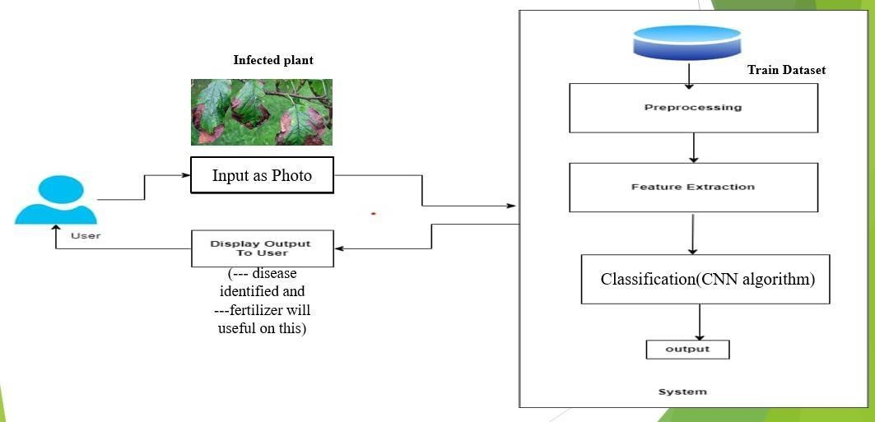

## Figure 3.1.1 :- System Architecture

**3.2 Data Flow Diagram :**

In Data Flow Diagram, we Show that flow of data in our system in DFD0 we show that base DFD in which rectangle present input as well as output and circle show our system, In DFD1 we show actual input and actual output of system input of our system is text or image and output is rumor detected like wise in DFD 2 we present operation of user as well as admin.

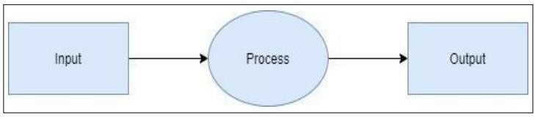

DFD LEVEL 0 DIAGRAM

## Figure 3.2.1 :- DFD LEVEL 0 DIAGRAM

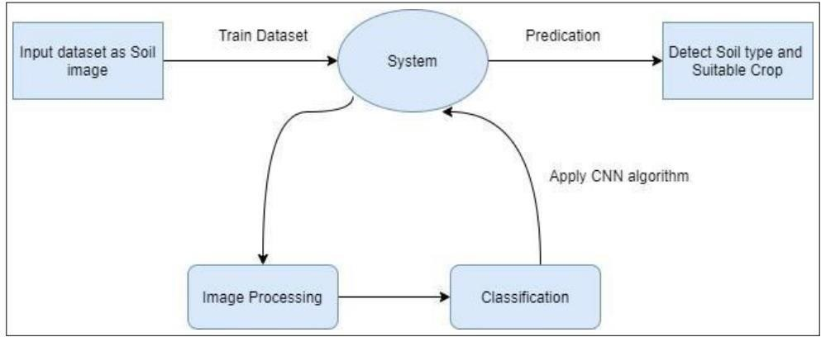

detect crop disease

and recommend

fertilizer.



Input

dataset

as

Infected crop

photo

DFD LEVEL 1 DIAGRAM

## Figure 3.2.2 :- DFD LEVEL 1

**DIAGRAM**

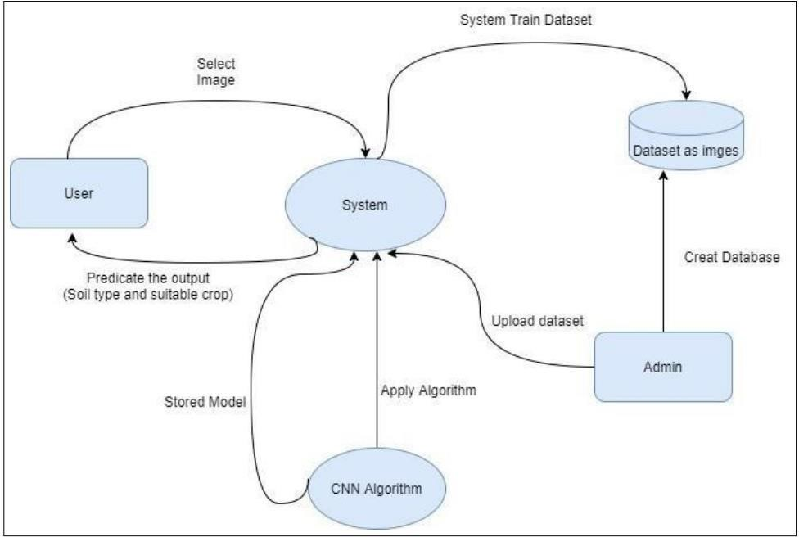

DFD LEVEL 2 DIAGRAM

## Figure 3.2.3 :- DFD LEVEL 2

**DIAGRAM**

**3.3 Entity Relationship Diagrams :**

Explanation: • Entities: 

* User: Represents users of the web application. It contains attributes like UserID, Name, Email, and Location. 
* UploadedPhoto: Represents the photos uploaded by users. It contains attributes like PhotoID, PhotoURL, and UploadDate. 
* DetectedDisease: Represents the diseases detected by the CNN model. It contains attributes like DiseaseID, DiseaseName, and ConfidenceLevel. 
* FertilizerRecommendation: Represents the recommended fertilizers. It contains attributes like RecommendationID, FertilizerType, and ApplicationMethod. 
* Relationships: 
* Uploads: Represents the relationship between users and uploaded photos. A user can upload multiple photos. 
* Detects: Represents the relationship between uploaded photos and detected diseases. Each uploaded photo can be associated with multiple detected diseases. 
* Recommends: Represents the relationship between detected diseases and fertilizer recommendations. Each disease can have multiple recommended fertilizers. 
* Receives: Represents the relationship between users and fertilizer recommendations. Each user can receive multiple fertilizer recommendations. 
* Collaborates: Represents a collaborative relationship between users. This could be used for location-based alerts or community collaboration. 

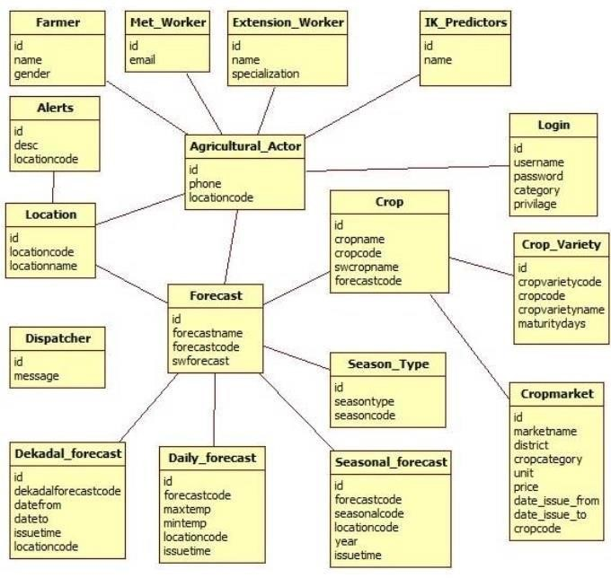

## Figure 3.3.1 :-Entity Relationship

**Diagram**

**3.4 Use Case Daigram :**

• **Class Diagram Explanation:**

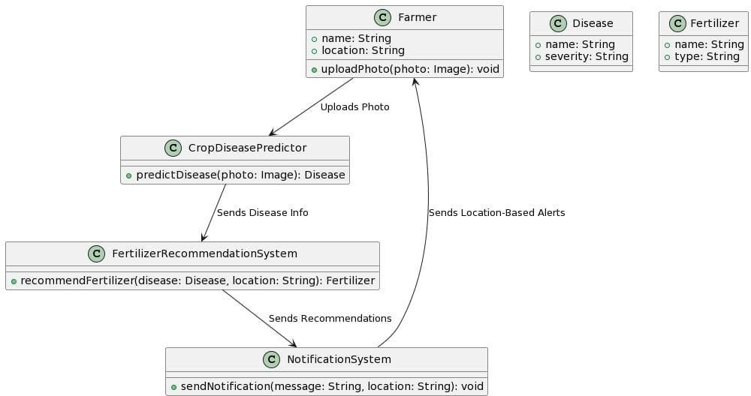

## Figure 3.4.1 :- Class Diagram

* Farmer : Represents individual farmers using the application. They can upload photos, which trigger disease prediction.
* Crop Disease Predictor : Class responsible for predicting crop diseases based on the uploaded photos.
* Fertilizer Recommendation System : Recommends suitable fertilizers based on the identified disease and location.
* Notification System : Sends notifications and alerts to farmers based on their locations.
* Disease : Represents the type and severity of the detected disease.
* Fertilizer : Represents the recommended fertilizer's name and type.

• **Component Diagram Explanation** :

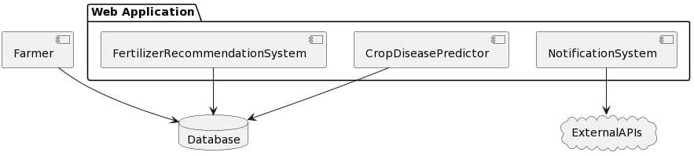

## Figure 3.4.2 :-Component Diagram

* Web Application Package : Contains components responsible for disease prediction, fertilizer recommendation, and notifications.
* Database : Represents the storage system for application data.
* ExternalAPIs : Represents external services used by the application. - Farmer : Represents individual farmers interacting with the system • **Deployment Diagram Explanation :**

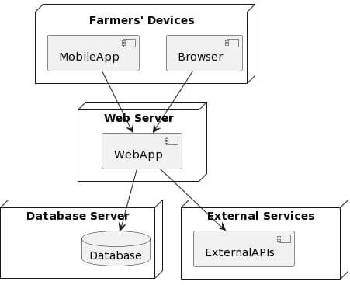

**Figure 3.4.3 :-Deployment Diagram**

* Web Server : Hosts the web application components.
* Database Server : Hosts the application database.
* External Services : Represents external APIs used by the application.
* Farmers' Devices : Devices (browsers and mobile apps) used by farmers to access the web application.

• **Object Diagram Explanation:**

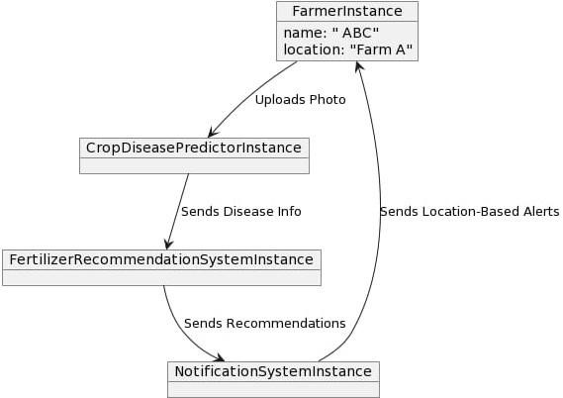

## Figure 3.4.4 :-Object Diagram

* Farmer Instance : An instance of the Farmer class representing a farmer named John Doe located at Farm A.
* Crop Disease Predictor Instance : An instance of the Crop Disease Predictor class.
* Fertilizer Recommendation System Instance : An instance of the Fertilizer Recommendation System class.
* Notification System Instance : An instance of the Notification System class.

• **Use-case diagram :**

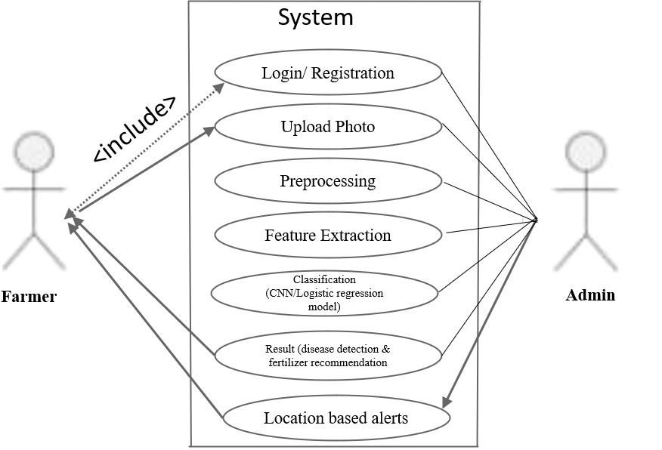

## Figure 3.4.5 :-Use-case Diagram

* Farmer (Actor): Interacts with the system. Use Cases:
* Log in/registration
* Upload Photo: Farmer uploads a photo for disease detection.
* Detect Disease: System detects disease from the uploaded photo.
* Recommend Fertilizer: System recommends fertilizer based on the detected disease. - Send Alerts: System sends location-based alerts to nearby farmers

• **Activity Diagram Explanation:**

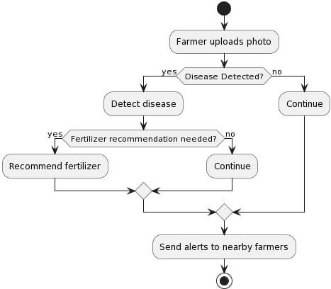

**Figure 3.4.6 :-Activity Diagram** - The farmer uploads a photo.

* If a disease is detected, the system recommends fertilizer.
* Alerts are sent to nearby farmers.
* The process stops.

• **State Machine Diagram Explanation:**

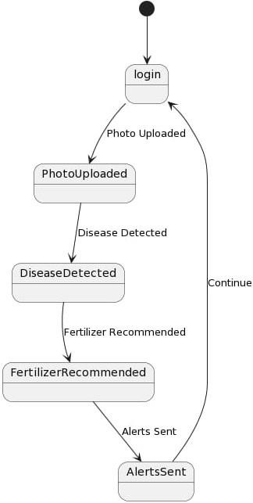

## Figure 3.4.7 :-State Machine Diagram

* login: Initial state.
* PhotoUploaded: Transition when a photo is uploaded.
* DiseaseDetected: Transition when a disease is detected.
* Fertilizer Recommended : Transition when fertilizer is recommended.
* Alerts Sent: Transition when alerts are sent.
* The process loops back to login after completing.

• **Sequence Diagram Explanation:**

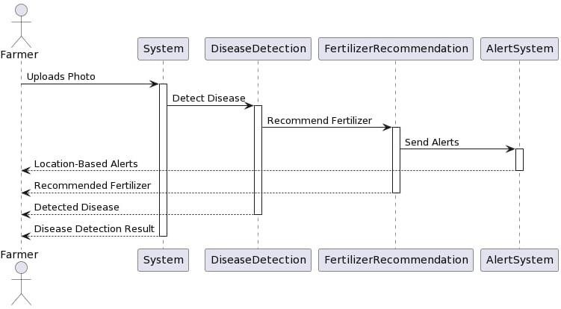

**Figure 3.4.8 :-Sequence Diagram**

* Farmer uploads a photo to the System.
* System detects the disease using DiseaseDetection.
* DiseaseDetection recommends fertilizer through FertilizerRecommendation.
* FertilizerRecommendation sends alerts using AlertSystem. - Results are sent back to the Farmer

**Chapter 4:**

**CONCLUSION**

# Conclusion

1. Holistic Solution for Agricultural Challenges:

Our application stands as a testament to the transformative power of technology in agriculture. By accurately predicting crop diseases, offering personalized fertilizer recommendations, and fostering collaborative community connections, we have created a comprehensive platform that addresses the multifaceted challenges faced by farmers. This holistic approach ensures that farmers receive tailored guidance, enabling them to make informed decisions that positively impact their crop yields and overall productivity.

1. Revolutionizing Sustainable Agricultural Practices:

The successful implementation of our application holds the promise of revolutionizing sustainable agricultural practices. Early detection of crop diseases, precise fertilizer recommendations, and community collaboration empower farmers to optimize their farming techniques. This not only leads to higher crop yields but also contributes significantly to environmental sustainability by reducing the unnecessary use of pesticides and fertilizers. By promoting eco-friendly farming practices, our application aligns with global efforts to conserve the environment and promote responsible agriculture.

1. Vision for the Future:

As we move forward, our vision extends beyond the current achievements. We are committed to refining our system continually. This includes ongoing enhancements to our disease prediction algorithms, further optimizing fertilizer recommendations, and exploring innovative ways to promote community engagement. By embracing emerging technologies and staying at the forefront of agricultural innovation, we aim to expand the impact of our application. Through partnerships, research collaborations, and a dedicated focus on user feedback, we aspire to create a dynamic and evolving platform that caters to the ever-changing needs of farming communities.

1. Enhancing the Well-being of Farming Communities:

At the heart of our initiative lies the well-being of farming communities. By empowering farmers with valuable insights, knowledge sharing, and personalized recommendations, we are not only enhancing their agricultural productivity but also fostering a sense of confidence and self-reliance. Informed farmers are better equipped to tackle challenges and adapt to changing agricultural landscapes, leading to improved livelihoods and strengthened agricultural economies.

**Chapter 5:**

**REFERENCES**

### 5.REFERENCE

[1]-Plant Disease Detection using Machine Learning by Ms. Nilam Bhise1, Ms. Shreya Kathet2,

Mast. Sagar Jaiswar3, Prof. Amarja Adgaonkar4 at [www.irjet.net](http://www.irjet.net/)

[2]-Plant Disease Detection Using CNN by Nishant Shelar1 , Suraj Shinde2 , Shubham Sawant3 ,

Shreyash Dhumal4 , and Kausar Fakir at<https://doi.org/10.1051/itmconf/20224403049>

[3]-Plant Disease Detection Using Deep Learning by Kowshik B1,Savitha V2, Nimosh madhav

M3,Karpagam G4, Sangeetha K5 at [www.rspsciencehub.com](http://www.rspsciencehub.com/)

[4]-Prediction Of crop Yield and fertilizer recommendation using ML by Devdatta A. Bondre Mr.

Santosh Mahagaonkar at [http://www.ijeast.com](http://www.ijeast.com/)

[5]-PLANT LEAF DISEASE DETECTION USING CONVOLUTION NEURAL NETWORK by

Shreya Patil, Soukhya L Deshpande, Soumya Sumbad, Soumya S Kiranagi at [www.ijcrt.org](http://www.ijcrt.org/)

[6]-WHEAT DISEASE DETECTION USING SVM CLASSIFIER by Er.Varinderjit Kaur , Dr.Ashish Oberoi at [www.ijetir.org](http://www.ijetir.org/)

[7]-Plant Infection Detection Using Image Processing by 1Dr. Sridhathan C, 2Dr. M. Senthil Kumar at [www.ijmer.com](http://www.ijmer.com/)

[8]- Plant Disease Detection Using Machine Learning by Shima Ramesh, Mr. Ramachandra Hebbar,

Niveditha M, Pooja R, Prasad Bhat N, Shashank N at:<https://www.researchgate.net/publication>

[9]-Plant leaf disease detection using Convolution Neural Network. By Jun Liu and Xuewei Wang at

|https://doi.org

[10]- An advanced deep learning models-based plant disease detection at https://[www.frontiersin.org/](http://www.frontiersin.org/)

* https://en.wikipedia.org/wiki/Agriculture
* https://openweathermap.org

23