**Navigating the Challenges of RPA Implementation: Strategies for Effective Automation**

Kshitiz Nayyar

Toronto, Ontario, Canada

**Abstract**

Automating repetitive tasks, improving on efficiency and eliminating human error have formed processes of the robotic process automation (RPA) which has transformed the business operations. Nevertheless, there are a number of challenges that will need to be addressed by organizations if they are going to realise the full potential of its implementation. Resistance to change among employees is one of the main obstacles: it’s scary for people who might get fired and adapt to new workflows. The problem can be effectively addressed via robust change management, communication and training programs. The main challenge lies, however, in the selection of suitable processes for automation, since automating wrong tasks can provide no efficiency and even become counterproductive. Process assessments and analytics are used to quantify high impact opportunities. Barriers also include technical issues such as the need to integrate with legacy systems, and ensuring robust security measures. These issues can be mitigated by using scalable and flexible RPA solutions and having collaboration between IT and business teams. Furthermore, poor governance and no clear objectives often make projects fail anyway. Success relies on setting up a solid governance framework, and ensuring that RPA projects are in line with the strategy. Last but not least, resource constraints and the difficulty of supporting bots at scale often make RPA scaling beyond pilot projects hard. However, there are ways by which all these can be addressed like adopting tools for centralized management and embracing continuous monitoring. Solving those challenges proactively will make organizations stand out to automation and reach the value that can be had from RPA.

**Introduction**

Robotic Process Automation (RPA) is a game changing technology that helps automate repetitive, rule based business rule tasks to help your organization to run smoother, with fewer costs, and higher employee productivity. RPA has made its rounds in various sectors including finance, healthcare and retail by mimicking human actions in order to interact with digital systems. RPA plays a key enabler to digital transformation carrying out of tasks at a much faster speed and remarkable accuracy than human can. However, RPA not only lowers the manual workloads but also allows the employees to divert their attention on doing value driven strategic activities that can assist them in boosting innovation and competitive advantage. In today’s fast paced market environment, with organizations leveraging RPA more and more to drive efficiency, RPA has become an indispensable when it comes to lifting customer experience and stretching business agility.

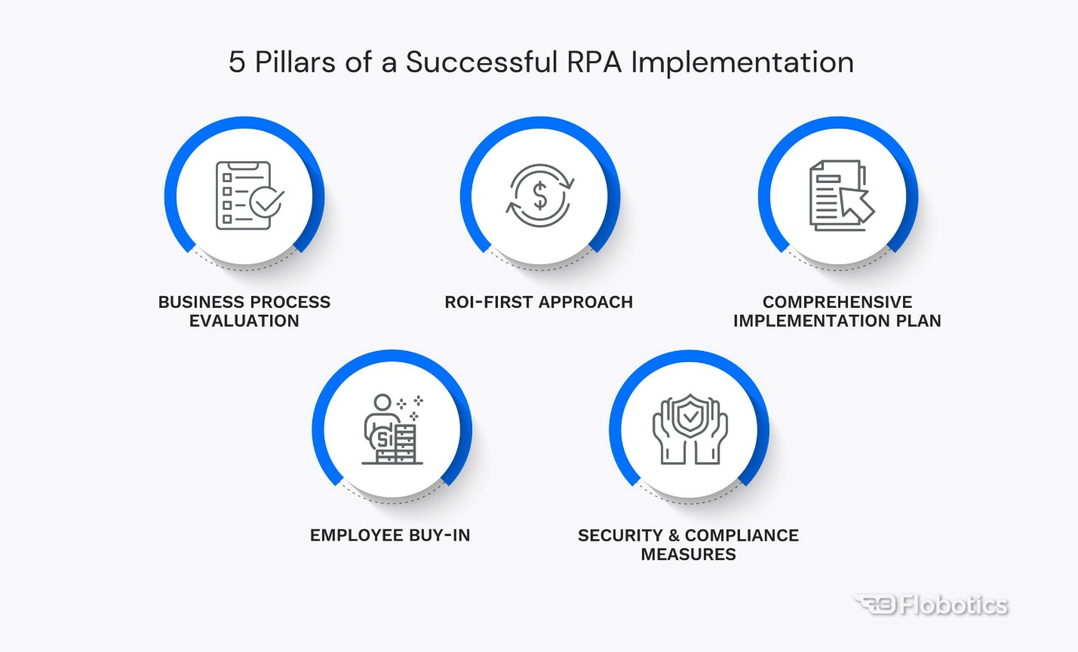

While RPA aims to scale multiple advantages, it is a complex development to undertake. Choosing the right process to be automated, overcoming employee resistance and ensuring smooth integration with existing IT systems are a major challenge for many organizations. Insufficient planning, poor governance and a failure to understand complexity of scaling RPA initiatives can result in sub optimal results, imperiling the intended value of automation. Additionally, concerns of data security and compliance tend to add more layers of complexity. Addressing these hurdles necessitates a strategic approach which mixes technical experience, reasonable goals, and strong change administration practices. Understanding and addressing the common challenges in RPA implementation helps businesses fully leverage the power of this powerful technology and ensure long term success with their automation journey.

**Importance of RPA in modern business operations.**

Robotic Process Automation (RPA) is the cornerstone of modern business operations, and it’s transforming businesses across all industries. Through RPA, organizations can automate repetitive and rule based tasks to streamline workflows, improve productivity and reduce operational costs at supersonic speed and unparalleled accuracy. With this technology, companies can allocate resources better and redirect employee activity from routine tasks to strategic and high value work such as engaging with customers and innovation.

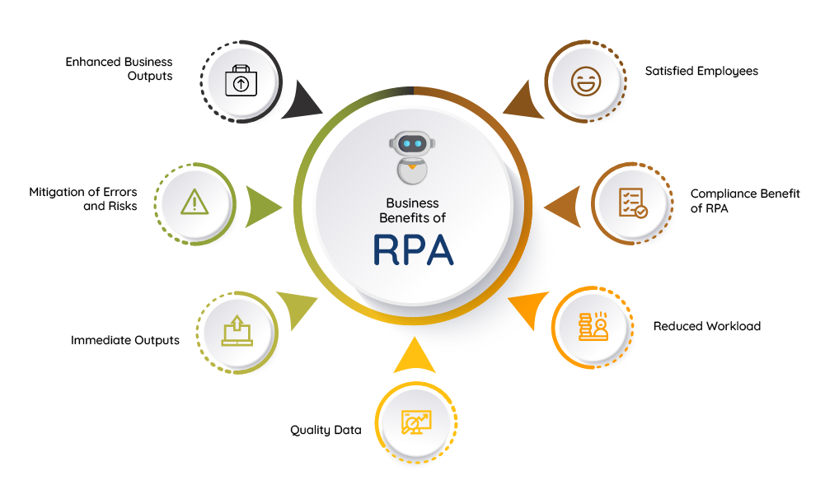

Customer experience is greatly accelerated by RPA, especially when it comes to speeding response times and reducing errors in the delivery of these services. Furthermore, it enables companies to scale up (and down) far more quickly than before, allowing them to quickly adapt to ever changing market conditions and respond to increased workloads without putting a strain on payroll. In areas like finance, healthcare and manufacturing RPA provides evidentially compliant processes. The seamless integration of this technology with existing systems, including legacy infrastructure, also permits cost-effective deployment and minimum interruption to operations. Also, RPA is a bridge to the advanced technologies of artificial intelligence (AI), machine learning (ML) and therefore constitutes intelligent automation. RPA improves both efficiency by reducing human error, and improving process transparency while allowing for 24/7 operations, and decision making. With this ever growing competition and rising business expenditures, the strategic significance of RPA in driving growth, innovation, and operational excellence can’t be ignored.

**Objectives of the research and its relevance.**

The intent of this research is to discover and analyze the top challenges when implementing Robotic Process Automation (RPA) and offer practical means to address them. The research intends to provide organizations with a practical framework for achieving successful RPA deployment, maximizing return on investment and sustaining automation initiatives by addressing these challenges. Technical, organizational, and strategic barriers to RPA adoption are investigated, the root causes for some common implementation pitfalls are uncovered, and best practices that reduce risks and deliver better results are suggested.

This research is relevant as technology and the marketplace continue to become more competitive and RPA becomes the method of choice to improve business processes. As they pour resources into automation to make their organizations more efficient, agile and customer friendly, it's crucial that RPA continues to be an area of challenge and opportunity they learn, lest they suffer painful missteps and delays. This research contributes by offering insights into overcoming resistance to change, what kind of processes can be automated, managing the integration with legacy systems, considerations for scaling, and security. Key findings include:

The findings are highly relevant for decision makers, IT professionals, and business leaders using RPA as a strategic enabler for digital transformation. This research bridges knowledge gaps and provides evidence based solutions so that organizations can traverse intricacies of RPA implementation and gain lasting success.

**Challenges in RPA Implementation**

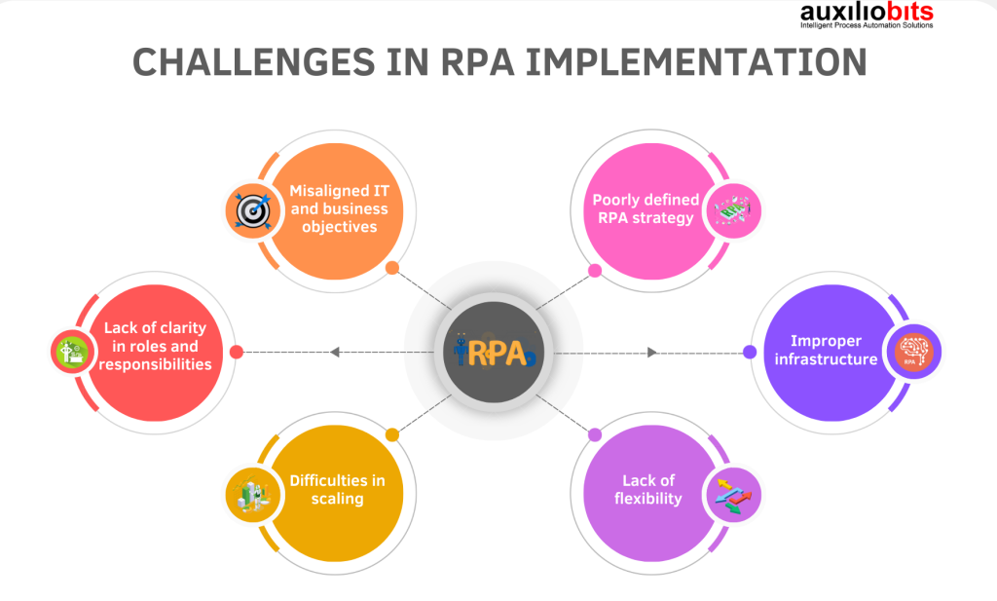

**1. Resistance to Change**

Resistance from employees is a common issue that occurs during RPA implementation as cracks fears of losing their job or jeopardizing their workflow. Automation is seen by many employees as a threat and do not engage or adopt. Poor communication often worsens resistance, and people often misunderstand or fail to see the benefits of using RPA. In doing this organizations must ensure they put change management at the top of their list, by having a collaborative and transparent culture. If employees know how RPA fits into existing human roles, and are trained in ways to adapt or become part of it, worry can be eased. Employees can be early engagers in the process, and painting success stories will help build trust and acceptance.

**2. Selecting the Right Processes for Automation**

The identification of well suited processes for RPA is difficult but crucial. Poor outcomes can result simply from automating inefficient or overly complex tasks. Assessing process readiness for automation presents a big challenge to organizations — with the emphasis on volume, rather than impact. To tackle that, a structured approach is required, where process audits check for task repeatability, rules and value addition. Deployment is efficient if processes have a low frequency but high variability. The selection is further refined further between business and IT teams working together and augmented with the use of data analytics to take advantage of the maximum RPA’s benefits.

**3. Integration with Legacy Systems**

Technically, RPA often has to deal with systems that are themselves outdated and fragmented. Sometimes, legacy systems have no APIs or aren’t compatible with such system. These challenges may slow down implementation, and inhibit scalability. This is where organizations can pick up to choose flexible RPA tools that work across platforms and this allows them to solve a number of problems. The benefit is they communicate regularly withIT teams as well as RPA providers for seamless integration. These challenges are also mitigated using middleware or legacy systems given a chance to upgrade.

**4. Scalability Challenges**

However, scaling RPA beyond the pilot is often a challenge because it is difficult to free up the necessary resources, due to increased complexity and governance issues. Organizations find themselves fighting to manage the growing number of bots using inadequate infrastructure and without a centralized management. There is a need for robust governance frameworks, centralized control mechanisms and scalable RPA platforms to address this. In this episode, I’m sharing how investing in monitoring tools and a phased rollout approach help smooth the way when scaling to ensure that the scaling doesn't disrupt performance.

**Strategies to Overcome RPA Challenges**

**1. Change Management and Employee Engagement**

All the same, resistance to change can block RPA adoption, so effective change management is critical. When it comes to RPA, organizations must have clear communication with their people about the positive reasons for its use and communicate how RPA will augment human jobs, rather then replace them. Engaging employees early in the implementation process is a great way to build trust and facilitate teamwork. Training programs and upskilling programs prep workforce to work along automation tools to remove fear and enable adoption. When you show successful case studies inside the organization, it helps build confidence in the technology.

**2. Process Selection and Prioritization**

When it comes down to RPA success the right processes must be chosen for automation. Organizations should thoroughly audit their underlying processes to identify those tasks that are volume or repetitive, and rule based. With the help of process mining and analytical tools, then, it becomes possible for us to evaluate the automation potentials with respect to different workflows. RPA only delivers measurable value when its automation initiatives are aligned with your business objectives. A strategic approach to success is starting with the small, high impact processes and building on them to the larger, more complex.

**3. Technical Integration and Flexibility**

Typically, integration with legacy systems is a technical challenge. To tackle this problem, organizations should thus opt for RPA platforms that are not rigid, and that can connect through multiple interface types, including screen scraping, APIs and middleware. There is collaboration that both IT teams and RPA vendors must embark on to ensure smooth deployment. It is possible to simplify integration and improve overall system performance by modernizing legacy systems or by using cloud based solutions wherever possible.

**4. Governance and Scalability**

But, due to the nature of RPA, this kind of scale is challenging, and calling RPA ‘easy to deploy’ is false; simply scaling RPA without governance is inefficient and hazardous. Thus, RPA management teams should be created at the centerization level to oversee the entire RPA lifecycle. Meaning, it’s best to use scalable RPA platforms, and invest in monitoring tools so the bots keep on running smoothly as the number grows. By following a phased rollout approach and optimizing continuously, organizations can scale with efficiency, putting quality and performance on the backburner.

**Literature Review**

**Fernandez, D., et al (2021).** While robotic process automation (RPA) still holds the potential for efficiency improvement in global business services, implementing it comes with many difficulties. One major headache, however, is the seemingly intractable complexity of integrating RPA with existing legacy systems: there can be little recourse other than to either customize or receive significant IT support. Additionally, RPA solutions need to be scalable with a wide range of processes and the regulatory environments in which they operate across several geographies. Fearful employees will resist change and companies will struggle to adopt and will need extensive change management initiatives.

**Santos, F., et al (2020).** For long term success, robotic process automation (RPA) should be implemented from an end to end perspective. First off, repetitive tasks that can automate most in the process are determined, prioritizing those with high volume, low variability. Before we automate, it is critical to give an all-encompassing assessment of existing workflows by standardizing them and finding opportunities for greater efficiency. Equally critical is to select the right RPA tools and technology that betters fit organizational goals and IT infrastructure. To implement change, collaboration is needed across departments to manage change effectively, address employee concerns, and provide training. The RPA design must be scaled and be flexible to support new business needs. After implementation, bot operation needs continued monitoring and optimization to continue to keep up performance and correct breakdowns. The perspective is from end to end, not just deploying RPA, embedding it in a broader digital transformation strategy, thereby achieving sustained efficiency and value creation.

**Syed, R., et al (2020).** Currently, Robotic Process Automation (RPA) is gaining popularity in industries by automating repetitive tasks, but it has emerged with a lot of contemporary themes and challenges. RPA and Legacy Integration is a major issue as existing systems, including legacy technologies that weren't built to be automated can be complicated to integrate with RPA to manage your business. Scaling of automation solutions becomes increasingly important as RPA emerges, and tools must be able to support the increasing volume of workflows, rapidly growing across multiple functions without performance degradation. RPA initiatives need to align with organizations’ strategies and ideally maintain governance and compliance while keeping in consideration organizations in regulated environments like the banking sector, where compliance is a necessity. Employees also fear being replaced by RPA due to automation, while resistance to adoption means that organizations need to have effective change management and upskilling programs in place.

**Eulerich, M., et al (2024).** On the one hand, robotic process automation (RPA) promises much in the way of efficiency and cost reduction; on the dark side, it has its risks and pitfalls. First, job displacement emerges as a considerable worry, as it replaces human jobs and either results in unemployment, or, in a more favorable outcome, requires almost nothing short of retraining the entire workforce. Errors can be introduced in badly designed RPA implementations when the bots are introduced into either a complex or dynamic environment where decision making needs to occur. When flexibility in handling exceptions or unstructured data is a lack of flexibility. Nevertheless, RPA increases the chances of data security breach because of bots’ access to sensitive data thereby, agitating privacy and compliance issues. RPA integration with legacy systems can also be daunting, particularly involving resource and expertise. There is potential for over reliance on automation that removes oversight and diminishes, if not eliminates, intervention by a human when critical issues occur. These challenges must be met in achieving responsible and effective RPA adoption.

**Herm, L., et al (2021).** RPA implementation projects require successful planning, coordination and execution. The first step is to find the right processes to automate — high volume, rule based tasks, with few exceptions. Before embarking on an RPA journey, current workflows ought to be well analysed while setting clear objectives, so everything carried out is focused towards the organisation’s goal. It should be decided which RPA tools and vendors should be used, check in terms of system compatibility, and solve technological constraints, if any. Also key are effective changes of management, which are often blockaded by employees resistant to RPA because of fear of technology displacing their jobs. Early engagement with stakeholders, proper training and clear communication of RPA’s benefits is imperative for project managers. However, it is necessary to regularly monitor and evaluate bot performance in order to quickly identify and address issues. Finally, scalability needs to be tackled from the get go, in order for the automation framework to grow along with the organization’s requirements.

**Flechsig, C., et al (2022).** The application of Robotic Process Automation (RPA) in purchasing and supply management presents great promise for increasing efficiency and decreasing costs by automating routine tasks such as order processing, invoice matching and inventory management. Our research using a multiple case study approach discovered that RPA can help streamline repetitive processes, reduce human errors, and accelerate decision making in procurement operations. Several barriers limit the successful implementation. The main challenge is when merging RPA with the legacy enterprise resource planning (ERP) systems for organizations, which may have old hardware. Employees and suppliers resist change, fear of job loss and extensive retraining are all serious obstacles. It’s important to maintain compliance with industry regulations, as well as making sure data stays secure. While this is not an easy task, companies that have successfully implemented RPA in their purchasing processes saw their operational processes get more efficient, and their costs go down. Barriers to change are overcome through strategic planning, stakeholder engagement and continuous optimization, the keys to success.

**Patri, P. (2021).** Banking is a sector in which Robotic Process Automation (RPA) can be used within the provision of automating routine tasks such as transaction processing, compliance checks, and data entry. But there are some challenges to its implementation. Integrating RPA with legacy systems is one of the main challenges: it can be a tricky and expensive proposition. The problem is that banks often rely on outdated technology, which makes automation particularly painful in its absence. One challenge is providing security and compliance as RPA bots access sensitive customer data and the potential for RPA bots to access and manipulate sensitive customer data creates risk of data breaches as well as regulatory compliance. Employees want to resist with fear of their jobs being in danger, or of certain positions being rendered redundant. However, RPA also has its scalability concern, particularly in large complex banking operations that necessitate bots to deal with a wide variety of transactions. Robust change management strategy, smart integration planning, strong cybersecurity policy and continuous bot optimization to maintain performance and efficiency are the solutions to these problems.

**Pramod, D. (2022).** The rise of robotic process automation (RPA) is being adopted across industries to automate repetitive, rule based tasks which makes the tasks faster, more accurate and cost effective. Some of the benefits of RPA include greater operational speed, lower human errors and the ability to grow operations without parallel growth in costs. Automated data entry in banking, invoice processing in medical and manufacturing, and supply chain management in manufacturing have been improved. Though, the adoption of RPA is typically hindered by challenges such as integrating RPA with the existing systems, high upfront costs, and employee resistance due to fear of being displaced by a robot. Data security and compliance with industry regulations continue to be important issues.

**Case Studies**

A notable example of RPA deployment is American Express Global Business Travel (GBT), who has used automation in order to improve its operations. RPA was used by GBT in an attempt to streamline its travel booking and expense management processes. Previously, these workflows were dependent on very manual data entry which was time consuming and error prone. GBT automated the reconciliation of travel invoices using RPA bots and was able to greatly reduce processing times and increase accuracy. Besides, routines inquiries were answered by bots and human agents could work on complex cases. Not only did the automation initiative save millions in operational costs but it also drove up levels of customer satisfaction and speed and accuracy of service. Through this case, we understand how RPA can improve operational efficiency and allow employees to concentrate on high value tasks.

Deutsche Bank is another notable success story in which RPA helps streamline compliance, and back office operations. For regulatory reporting — a complex and error prone process — the bank deployed RPA bots. With these tasks automated, Deutsche Bank improved accuracy, lowered compliance risk, and saved massive time. It also optimized its account closure process using RPA resulting in its time taken to close accounts decreasing from several weeks to just a few hours. This initiative achieved both improved operational efficiency as well as an improved customer experience through faster service. Although the story of RPA at Deutsche Bank is a mixed one, their successful scaling past pilot projects showed how automation can be used to manage high volume, data intensive work in multiple business departments. Along with a scalable governance framework and continual monitoring, the bank has set a benchmark for sustainable automation by incorporating RPA.

Both of these examples show how wide ranging the potential for RPA to change the industries in which it is applicable. GBT and Deutsche Bank were able to leverage automation to achieve operational excellence, cost savings and improved customer satisfaction by strategically solving challenges including process selection, scalability, and employee engagement. Their success showcases that if done right, RPA can be a very strong enabler to drive digital transformation and competitive advantage.

**Insights into overcoming specific challenges.**

However Robotic Process Automation (RPA) success relies on a proactive approach to overcoming these key challenges. However, it’s also one of the biggest barriers involved with this kind of workforce-to-wireframe implementation; if resistance to change exists in your employees, it can be enough to keep adoption from happening and will cause friction within your organization. Concerning this, companies should stick to modifying change administration techniques for instance legitimate correspondence and Employee commitment. It is important to help educate the employees that RPA does not replace them. To ensure employees can work with RPA, training programs and opportunities for upskilling are offered, therefore making them empowered to work alongside automation tools in a collaboration culture that support RPA adoption.

Another common challenge is to pick the right process to automate. A highly automated process can and will yield inefficiencies and unmet expectations on tasks that are unsuitable or too complex for automation. To counter this, organizations should conduct detailed process audits and use process mining tools to find the high volume, repetitive and rule based tasks that are best automated. What better way to build confidence in your RPA initiative and begin laying the groundwork for scaling automation in the enterprise than starting out with pilot projects that deliver quick wins and measurable benefits in a short amount of time.

Yet, technical challenges lie in the way of progress, including integration of RPA with legacy systems. You have to choose flexible RPA platforms, which can have different integration methods, including APIs and screen scraping. IT teams and RPA vendors collaborate on a smooth implementation, and legacy systems can be modernized using a software package or adopting a cloud based approach, saving the effort of integration.

RPA governance and resource allocation are the issues that stand in the way of scaling RPA beyond the initial pilot projects. To get around this, organizations should create overarching governance frameworks with centralized governance that define roles and responsibilities, and performance metrics for automation. Advanced monitoring tools and scalable RPA platforms also ensure bots do their duties properly as the program grows. To scale automation in a way that doesn’t compromise quality, organizations use a phased rollout strategy alongside continuous evaluation and optimization.

**Conclusion**

Key to successful implementation of Robotic Process Automation (RPA) is the overcoming of challenges that can otherwise prevent the technology’s success. However, resistance to change among employees is a common barrier arising from the fear that their jobs will be eliminated, and unfamiliarity with automation. Through effective change management, clear communication, training programs, acceptance and collaboration comes about. The second critical challenge is about choosing appropriate processes for automation, which can become inefficient if the choice is bad. Better to conduct process assessments expensively and start with high impact, repetitive tasks. The flexible RPA platform has to combine with legacy systems and strive to keep security robust while also collaborating with IT teams and modernize the infrastructure, when possible. However, scaling RPA brings additional complexities, such as governance gaps and resource constraints, which can be mitigated with the creation of centralized management, scaleable platforms, and continuous monitoring. Such strategies make it possible for RPA initiatives to be in sync with organizational goals and provide measurable benefits. Proactive resolution of such challenges allows businesses to attain sustainable automation, enhance operational efficiency, and spur innovation, making RPA an integral part of their digital transformation journey. The discussion of insights and solutions draws attention to the significance of transformation options exploiting RPA’s transformative capabilities, from both a structured and an adaptable perspective, to overcome the implementation barriers so as to pave the way for longer term success.

**References**

1. Fernandez, D., & Aman, A. (2021). The challenges of implementing robotic process automation in global business services. *International Journal of Business and Society*, *22*(3), 1269-1282.
2. Santos, F., Pereira, R., & Vasconcelos, J. B. (2020). Toward robotic process automation implementation: an end-to-end perspective. *Business process management journal*, *26*(2), 405-420.
3. Syed, R., Suriadi, S., Adams, M., Bandara, W., Leemans, S. J., Ouyang, C., ... & Reijers, H. A. (2020). Robotic process automation: contemporary themes and challenges. *Computers in Industry*, *115*, 103162.
4. Eulerich, M., Waddoups, N., Wagener, M., & Wood, D. A. (2024). The dark side of robotic process automation (RPA): Understanding risks and challenges with RPA. *Accounting horizons*, *38*(2), 143-152.
5. Herm, L., Janiesch, C., Steinbach, T., & Wüllner, D. (2021). Managing RPA implementation projects. *Robotic Process Automation*, 27-46.
6. Flechsig, C., Anslinger, F., & Lasch, R. (2022). Robotic Process Automation in purchasing and supply management: A multiple case study on potentials, barriers, and implementation. *Journal of Purchasing and Supply Management*, *28*(1), 100718.
7. Patri, P. (2021). Robotic process automation: challenges and solutions for the banking sector. *Prateek Patri, Robotic Process Automation: Challenges and Solutions for the Banking Sector, International Journal of Management*, *11*(12), 2020.
8. Pramod, D. (2022). Robotic process automation for industry: adoption status, benefits, challenges and research agenda. *Benchmarking: an international journal*, *29*(5), 1562-1586.
9. Kedziora, D., Leivonen, A., Piotrowicz, W., & Öörni, A. (2021). Robotic process automation (RPA) implementation drivers: Evidence of selected Nordic companies. *Issues in Information Systems*, *22*(2), 21-40.
10. Waqar, A., Othman, I., Falqi, I. I., Almujibah, H. R., Alshehri, A. M., Alsulamy, S. H., & Benjeddou, O. (2023). Assessment of barriers to robotics process automation (RPA) implementation in safety management of tall buildings. *Buildings*, *13*(7), 1663.
11. Zhang, C., Issa, H., Rozario, A., & Soegaard, J. S. (2023). Robotic process automation (RPA) implementation case studies in accounting: A beginning to end perspective. *Accounting Horizons*, *37*(1), 193-217.
12. Januszewski, A., Kujawski, J., & Buchalska-Sugajska, N. (2021). Benefits of and obstacles to RPA implementation in accounting firms. *Procedia Computer Science*, *192*, 4672-4680.
13. Costa, D. A. D. S., Mamede, H. S., & Silva, M. M. D. (2022). Robotic Process Automation (RPA) adoption: a systematic literature review. *Engineering Management in Production and Services*, *14*(2).
14. Lamberton, C., Brigo, D., & Hoy, D. (2017). Impact of Robotics, RPA and AI on the insurance industry: challenges and opportunities. *Journal of Financial Perspectives*, *4*(1).
15. Kamat, A. (2019). Challenges of robotic process automation adoption in banking and financial services. *International Journal of Research and Analytical Reviews*, *6*(2), 597-606.
16. Andrade, D. (2020). Challenges of automated software testing with robotic process automation rpa-a comparative analysis of uipath and automation anywhere. *Int. J. Intell. Comp. Res.(IJICR)*, *11*(1), 1066-1072.
17. Gotthardt, M., Koivulaakso, D., Paksoy, O., Saramo, C., Martikainen, M., & Lehner, O. (2020). Current state and challenges in the implementation of smart robotic process automation in accounting and auditing. *ACRN Journal of Finance and Risk Perspectives*.
18. Asatiani, A., Kämäräinen, T., & Penttinen, E. (2019). Unexpected problems associated with the federated IT governance structure in robotic process automation (RPA) deployment.
19. Ermolaeva, A. S., Nemtsev, V. N., Solomatin, P. S., & Selivanova, M. A. (2021). The analysis of implementation of robotic process automation RPA: the experience of Russian and foreign companies. In *Modern Global Economic System: Evolutional Development vs. Revolutionary Leap 11* (pp. 1483-1492). Springer International Publishing.
20. Strömberg, K. (2018). *Robotic Process Automation of office work: benefits, challenges and capability development* (Master's thesis).