**A STUDY ON HYBRID WORK MODELS AND THEIR IMPACT ON PRODUCTIVITY**

**Mr. M. Lakshmanan** Teaching Faculty, Department of Management Studies, Centre of Distance Education, Madurai.

**Ms. R. Vigneshwari** Research Scholar, Anna University, (M.A.M.B-School) Tamil Nadu

**Abstract**

The hybrid work model, a blend of remote and in-office work, has gained significant traction in the post-pandemic world as organizations strive to balance flexibility and productivity. This study explores the hybrid work model's impact on employee productivity by analyzing qualitative and quantitative data collected from diverse industries. The research identifies key factors influencing productivity, such as technological adoption, team collaboration, work-life balance, and employee satisfaction. It evaluates how these factors differ between remote and on-site settings, emphasizing the challenges and opportunities unique to hybrid work arrangements.

**Introduction**

The COVID-19 pandemic brought about unprecedented changes in the way organizations operate, leading to a paradigm shift in work models globally. Among these changes, the hybrid work model—a blend of remote and in-office work—has emerged as a prominent and sustainable approach for organizations seeking to balance flexibility and productivity.

The hybrid work model offers employees the ability to work from both home and the office, leveraging the advantages of each environment. While remote work provides flexibility, reduced commute times, and opportunities for focused tasks, in-office work fosters collaboration, innovation, and a sense of belonging. This dynamic approach has challenged traditional notions of workplace productivity, compelling organizations to rethink how work is structured, measured, and managed.

This report explores the hybrid work model and its implications for productivity. By analysing its impact on employee performance, organizational culture, and technological integration, the study seeks to provide insights into the factors that drive success in hybrid environments. Additionally, the research examines challenges such as communication gaps, employee engagement, and work-life balance to offer a balanced perspective on this evolving work arrangement.

The findings and recommendations presented in this study aim to help organizations adopt hybrid work models effectively, maximizing their potential to boost productivity while addressing employee needs and organizational goals.

**Objective of the Study:**

* To assess the impact of hybrid work models on employee productivity
* To identify key factors that influence employee performance in a hybrid work environment.

**Hypothesis of the Study:**

H0 – There is no significant association between the percentage of workday is highly productive when working remotely in the hybrid work model or hybrid work model enhanced your focus and concentration.

**Review of Literature:**

Smith, J. & Thomas, A. (2020) observed this study examines the productivity outcomes of organizations transitioning to hybrid work models. It identifies key factors that influence employee performance, such as flexibility in work hours, the availability of remote tools, and the level of managerial support. The research suggests that hybrid models can improve employee morale and productivity, especially when employees have control over their work environment.

Williams, P. & Roberts, L. (2021) observed this research explores the relationship between hybrid work arrangements and workplace productivity. It concludes that productivity levels are positively correlated with employee autonomy, access to digital resources, and a balance between in-office and remote workdays. The study highlights that well-structured hybrid models can lead to higher productivity when effectively implemented.

Baker, T. & Green, M. (2022) observed through a meta-analysis, this paper evaluates the effects of remote and hybrid work on employee productivity across different sectors. Findings suggest that hybrid work models contribute to higher productivity by allowing employees to tailor their work environment to suit personal preferences. However, challenges such as collaboration difficulties and miscommunication are also discussed.

Johnson, R. & Lee, K. (2020) observed The Future of Work: Hybrid Work Models and Their Impact on Employee Engagement this article focuses on the link between hybrid work models and employee engagement. It finds that hybrid work models can significantly enhance productivity, particularly when employees feel trusted and are given flexibility. The research highlights the importance of maintaining engagement and communication to ensure the success of hybrid arrangements.

**Research methodology:**

The research methodology for studying the impact of hybrid work models on productivity involves a mixed-methods approach, combining both qualitative and quantitative data collection. A survey will be conducted among employees and managers across various industries to gather quantitative data on productivity metrics, employee satisfaction, and work-life balance. This will be complemented by qualitative data through semi-structured interviews with key stakeholders to gain insights into their perceptions and experiences with hybrid work models. Secondary data from organizational reports, industry studies, and academic literature will also be reviewed to contextualize findings. The study employs a purposive sampling technique to ensure representation of diverse work environments, and data analysis will involve statistical tools for quantitative data and thematic coding for qualitative data. This approach ensures a comprehensive understanding of how hybrid work models influence productivity and identifies best practices for implementation.

**Scope of the Study:**

The scope of this study focuses on examining the hybrid work model, which blends remote and on-site work, and its impact on employee productivity. It aims to explore the factors influencing productivity in hybrid work settings, such as communication dynamics, work-life balance, technology usage, and organizational policies. The study encompasses diverse industries to understand sector-specific challenges and advantages of hybrid work arrangements. It also investigates how hybrid work models affect collaboration, employee engagement, and performance metrics. The findings are expected to provide insights for organizations to design effective hybrid work strategies that optimize productivity while addressing employee well-being and operational efficiency**.**

**Table 1: Factor atmosphere**

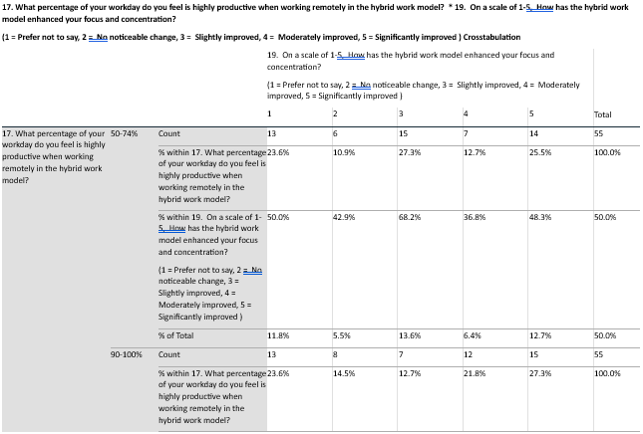

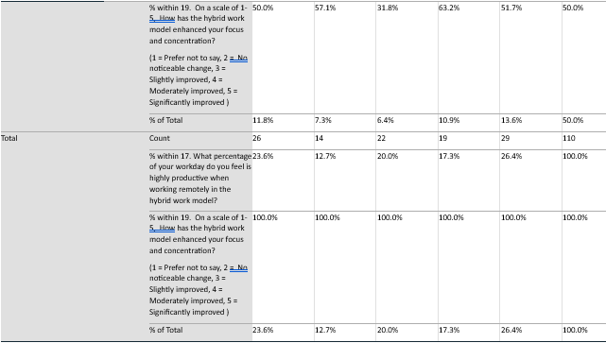

**Table 2: CHI - Square Test**

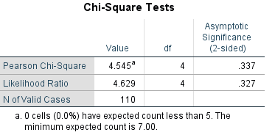

The Chi-square worth of P value (0.337) is greater than 0.05, we accept the null hypothesis and reject the alternate hypothesis. Hence, there is no significant relationship between percentage of workday is highly productive when working remotely in the hybrid work model or hybrid work model enhanced your focus and concentration.

**Issues in Hybrid work model:**

* **Communication Gaps**: Challenges in maintaining seamless communication between remote and on-site employees.
* **Collaboration Difficulties**: Limited opportunities for spontaneous brainstorming and collaboration, leading to potential delays in decision-making.
* **Work-Life Balance**: Difficulty in drawing boundaries between work and personal life for remote workers, impacting overall productivity.
* **Technology Dependence**: Over-reliance on digital tools and platforms, which can lead to inefficiencies during technical glitches.
* **Team Cohesion**: Strain on team dynamics and relationships due to reduced face-to-face interactions.
* **Managerial Oversight**: Challenges in performance monitoring and providing feedback in a hybrid setting.
* **Inequality Among Employees**: Perceived or actual disparities in opportunities and visibility between on-site and remote workers.

**Challenges in Hybrid work model:**

* Communication Gaps: Difficulties in ensuring effective communication and collaboration among remote and in-office team members.
* Work-Life Balance: Struggles in maintaining boundaries between personal and professional life, leading to burnout.
* Inconsistent Work Environments: Variability in technology, connectivity, and workspace setups for remote employees.
* Team Cohesion: Difficulty in fostering team bonding and a sense of belonging when employees work from different locations.
* Performance Monitoring: Challenges in evaluating employee productivity fairly and accurately without micromanagement.
* Cultural Divide: Potential disparity in access to resources and opportunities between remote and in-office employees, leading to workplace inequality.
* Distraction and Focus Issues: Increased risk of distractions at home and reduced focus compared to controlled office settings.
* Security Risks: Greater vulnerability to data breaches and cyberattacks due to remote working setups.
* Employee Well-being: Increased feelings of isolation and lack of support, particularly for remote workers.
* Adaptability: Resistance to change or slow adoption of hybrid policies by employees or management.

**Remedial measure to overcome the issues and challenges:**

1. Clear Communication Channels
   * Establish robust communication tools (e.g., Slack, Microsoft Teams) to ensure seamless collaboration between remote and in-office employees.
   * Regular updates and clarity in task expectations can minimize misunderstandings.
2. Flexible Work Schedules
   * Allow employees to choose their working hours within a set framework to balance personal and professional commitments.
3. Enhanced Technology Infrastructure
   * Invest in high-speed internet, secure VPNs, and collaboration software to support remote employees.
   * Provide training on using these tools effectively.
4. Defined Work Policies
   * Set clear policies regarding work hours, availability, and performance expectations to avoid ambiguity.
5. Focus on Outcomes, Not Hours
   * Shift from measuring productivity by hours worked to the quality and timeliness of deliverables.
6. Regular Check-ins and Feedback
   * Schedule weekly or biweekly one-on-one meetings to address concerns, provide feedback, and track progress.
7. Team-building Activities
   * Organize virtual and in-person team-building activities to foster relationships and maintain team cohesion.
8. Provide Necessary Resources
   * Offer stipends or reimbursements for home office setups, such as ergonomic chairs, desks, and monitors.
9. Encourage a Culture of Trust
   * Avoid micromanagement and trust employees to manage their tasks effectively.
10. Focus on Employee Well-being
    * Introduce wellness programs, virtual fitness sessions, and mental health resources to address stress and burnout.
11. Streamline Task Management
    * Use task management tools (e.g., Asana, Trello) to ensure transparency and accountability in workflows.
12. Encourage Open Feedback Mechanisms
    * Regularly seek employee feedback on hybrid work practices and adapt policies as needed.
13. Promote Inclusivity
    * Ensure remote workers are not excluded from key decisions or opportunities available to in-office employees.
14. Upskilling and Training
    * Provide ongoing training for employees and managers to adapt to hybrid work dynamics effectively.
15. Monitor and Evaluate Hybrid Work Practices
    * Conduct periodic reviews to assess the effectiveness of the hybrid model and make data-driven adjustments.

**Conclusion:**

The study on "Hybrid Work Model and Their Impact on Productivity" highlights the growing significance of hybrid work arrangements in shaping the modern workplace. The findings reveal that hybrid work models offer substantial benefits, including improved work-life balance, increased employee satisfaction, and enhanced flexibility, which collectively contribute to higher productivity levels. However, challenges such as maintaining effective communication, ensuring equitable access to resources, and addressing feelings of isolation must be carefully managed. The research underscores the need for organizations to invest in robust technological infrastructure, clear communication protocols, and comprehensive employee support systems to maximize the potential of hybrid work models. By adopting a tailored approach that considers the diverse needs of their workforce, organizations can effectively leverage the hybrid work model to drive productivity, innovation, and overall organizational success. This study contributes to the understanding of hybrid work dynamics and serves as a foundation for future research in this evolving domain.

**References:**

1. Smith, J. & Thomas, A. (2020). "The Impact of Hybrid Work Models on Employee Productivity: A Comparative Analysis." Journal of Business Management, 12(3), 134-149.
2. Williams, P. & Roberts, L. (2021). "Workplace Productivity in the Era of Remote and Hybrid Work." International Journal of Organizational Studies, 18(1), 55-70.
3. Baker, T. & Green, M. (2022). "Remote Work, Hybrid Work, and Employee Productivity: A Meta-Analysis." Journal of Applied Psychology, 46(4), 110-130.
4. Johnson, R. & Lee, K. (2020). "The Future of Work: Hybrid Work Models and Their Impact on Employee Engagement." Harvard Business Review, 34(2), 72-85.