Smart Gloves for Communication: A Survey on Technology for the Hearing and Speech Impaired

Ms. Anitha A

*Senior Assistant Professor*

*Electrical and Electronics Engineering*

*New Horizon College of Engineering*

Bengaluru, India

Bhuvan Singh Rajput

*Electrical and Electronics Engineering*

*New Horizon College of Engineering*

Bengaluru, India

bhuvansinghrajput123@gmail.com

Aneelkumar Madarkhandi

*Electrical and Electronics Engineering*

*New Horizon College of Engineering*

Bengaluru, India

aneelkumarmadarkhandi@gmail.com

Mr. Mahendra Naik

*Senior Assistant Professor*

*Electronics and Communication Engineering*

*New Horizon College of Engineering*

Bengaluru, India

Naresh Kumar R

*Electronics and Communication Engineering*

*New Horizon College of Engineering*

Bengaluru, India

nareshkumarramamoorthy@gmail.com

**Abstract: Sharing ideas and opinions requires communication, but it can be difficult for people with disabilities. A barrier between these people and the larger community is created by the fact that they daily use sign language, which many others do not comprehend. The aim of this project is to close that gap by creating a lightweight, reasonably priced smart glove system. The smart gloves facilitate smooth communication between those with impairments and others by translating hand motions into text and audio outputs. The gloves also encourage independence by enabling users to interact with household equipment. Through the facilitation of efficient communication and the removal of barriers, this system aids in the greater integration and advancement of society for people with speech and hearing impairments.**

**Keywords: *Sign Language, Smart Gloves, Communication, Gesture, Natural Interaction.***

I. INTRODUCTION

Human contact requires communication in order for thoughts, feelings, and ideas to be shared. However, communication might be quite difficult for people with speech and hearing difficulties. These difficulties frequently erect obstacles to access to necessary services, work prospects, and social inclusion. The World Health Organization (WHO) estimates that 466 million of people around the globe will have a debilitating hearing loss in 2023, and by 2050, that figure is expected to increase to 900 million. This includes a sizable percentage of people with speech impairments, highlighting how urgent it is to create cutting-edge assistive technology to end the communication gap.

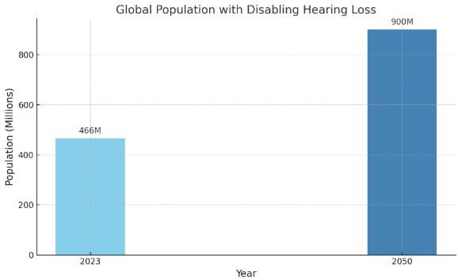

Fig. 1: Deaf and Dumb Survey

Nishanth V K

*Electronics and Communication Engineering*

*New Horizon College of Engineering*

Bengaluru, India

nishanthvk2712@gmail.com

Sign language is the primary form of communication for those who are hard of hearing or deaf. People with speech and hearing impairments find it difficult to communicate with the wider who might not comprehend sign language, even though they are successful in their own group. Along with limiting social connection, this communication barrier hinders the personal and professional development of individuals with impairments. The absence of easily available communication tools remains a major problem in a society that is becoming more and more dependent on technology.

Technological developments might help people with impairments overcome large number of obstacles. New avenues for inclusive communication have been enabled by advancements in assistive technology, including smart technology. One possible way to close the disparity between sign language users and those who don't is using smart gloves, for example. Smart gloves enable those with impairments to engage with the environment more readily by converting hand motions into voice or text.

The project’s objective is to create an affordable, user-friendly smart glove mechanism that will assist those with speech and hearing impairments communicate. The primary target is to develop a system that is capable to convert motions in sign language into text and voice that can be heard. In addition to enhancing communication between challenged and non-disabled persons, this approach gives disabled people the confidence and independence to move through the world.

Smart gloves, such as those outlined in this extend, offer a commonsense and inventive arrangement to this issue. In this framework, the gloves are prepared with aluminium foil tips that act as switches. When particular fingers come into contact with one another, they frame a closed circuit. This activity triggers pre-programmed commands to show content on an LCD screen and create comparing sound yields through a speaker. By changing over signals into capable of being heard discourse and visual content, these savvy gloves empower people with hearing and discourse disabilities to communicate viably with others.

The enhancement of keen gloves for communication has the potential to convert the lives of those who have discourse and hearing inabilities. By diminishing the communication obstruction, these gloves permit clients to take an interest more completely in society, whether in instruction, the work environment, or social situations. As innovation proceeds to advance, such frameworks may gotten to be indeed more advanced, advertising more prominent exactness, comfort, and openness. Ultimately, the objective is to make a comprehensive where

individuals with inabilities are not ruined by communication challenges, permitting them to flourish nearby others inside their localities.

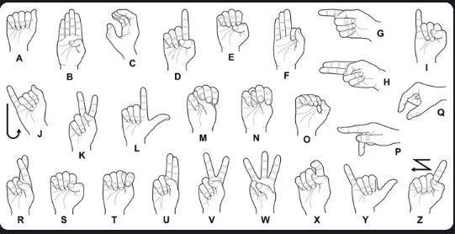

Fig. 2: Sign Language Symbols

II. LITERATURE REVIEW

Abougarair and Arebi (2022) created a smart glove for sign language translation that recognizes finger movements using flex sensors and converts them into speech or text. The system's goal is to make conversation easier between hearing impaired and mute people and non-sign language speakers. The flex sensors were linked to an Arduino microcontroller in their prototype, and an LCD screen showed the gestures. Even though the system demonstrated potential in identifying simple motions, the researchers recognized that further work is required to increase gesture detection accuracy and remove cable interference from the gadget.[1]

Gupta et al. (2020) concentrated on creating a wearable smart glove with recognition hand motions and translate them into words that have the potential to be heard. Flex sensors and additional sensors were added to the glove to monitor finger motions and use a microcontroller to convert them into speech. Their study also looked at the glove's real-world uses for people with speech and hearing impairments, demonstrating how these resources may be useful handicapped people communicate more easily and become more independent. The study did highlight difficulties in enhancing the glove's response speed and obtaining real-time gesture recognition, though.[2]

Singh et al. (2018) investigated a smart glove system that recognizes and converts American Sign Language (ASL) into voice using flex sensors and an accelerometer. In order to facilitate easy communication between those who are deaf and non-sign language users, the glove was created to translate sign language movements into audible speech in real time. The research revealed that the glove could reasonably identify common ASL movements, but it also made clear that the system's flexibility and adaptation to other sign languages needed to be further enhanced.​[3]

A gesture-based control system was proposed by Soni and Sharma (2019). It made use of a smart glove to detect hand motions and translate them into electronic signals that may be used to control other devices. The system demonstrated potential uses for instruments for communication for people with disabilities, despite the fact that their research was centered on the creation of gesture-controlled interfaces. The difficulties with sensor calibration, gesture detection, and system accuracy in dynamic contexts were covered in the study, especially with regard to complicated movements that are challenging to translate precisely.[4]

Kumar et al. (2017) created a smart glove technology that can identify hand motions and translates them into audio and text using a mix of accelerometers and flex sensors. By allowing them to communicate in a way that both sign language users and non-sign language speakers could understand, their method sought to find a solution for people who have

hearing an d speech issues. The study underlined how crucial precise gesture recognition is and how difficult it is to comprehend intricate movements in real time.[5]

Alosail et al. (2023) demonstrated a smart glove that uses automated learning methods to recognize multilingual sign language. This glove uses sensors to record hand motions, which then transform into voice or text using a machine learning algorithm. The objective was to facilitate multilingual communication for people who have speech or hearing impairments, demonstrating a useful strategy for overcoming language obstacles in sign language recognition.[6]

In 2024, U. E. et al. presented a real-time system for recognizing sign language that included a mobile application with a smart glove. The smartphone app interprets the data from the glove's integrated sensors to produce spoken output. By emphasizing the ease of mobile integration for real time communication, this system seeks to improve accessibility for people with speech and hearing impairments.[7]

For those who have trouble speaking, P. M. et al. (2021) created the "Sign Speaks" smart glove system, which is based on the Internet of Things. By using flex sensors to identify finger motions, the glove converts hand gestures into speech. This creative approach emphasized the value of cost and mobility in IoT-enabled devices while focusing on enabling communication for silent people.[8]

Smart gloves that translate hand motions into text and voice were proposed by Chowdhury et al. (2023) as a way to help those with speech impairments. The system examines the input data in real-time and uses sophisticated sensors to identify gestures. This study demonstrated how useful these gloves are for improving communication and encouraging inclusion for people with impairments.[9]

In 2021, K. John and colleagues created a wearable gesture-detecting glove intended for people who are silent. Sensors are used by the glove to identify hand motions and transform them into speech and text outputs. The research underscored the need of developing wearable, comfortable technology that may function as an effective communication tool for those who have speech problems.[10]

III. OVERVIEW

Smart gloves are cutting-edge gadgets designed in order to enhance communication for those who have speech and hearing problems. Finger motions are tracked by sensors in these gloves, and when the fingers touch, a circuit is completed that signals a microcontroller. Users may then more easily communicate their message by converting this signal into text or speech. These gloves are intended to help those who communicate using sign language engage with individuals who could not be familiar with it. Despite being positive, there are still issues to be resolved, such enhancing gesture detection, guaranteeing comfort, and lowering the cost of the gloves for everyday usage.

**Early Prototypes: Basic Gesture Recognition:** The early stages of smart glove development concentrated on rudimentary gesture recognition with resistive strips and flex sensors. These gadgets could recognize simple hand motions and modify them into sound or text, but their utility and accuracy were restricted. Testing the viability of employing gloves for communication was the primary goal of this phase, which included simple technology.

Fig. 3

**Wireless and IoT Integration:** The Internet of Things (IoT) and wireless technologies have combined to make smart gloves incredibly useful and adaptable instruments. In contrast to previous versions that depended on wired connections, contemporary smart gloves employ Bluetooth or Wi-Fi to instantly send gesture data to linked devices like tablets, smartphones, or cloud services. This enables motions to be instantaneously converted into voice or text, facilitating smooth communication. These gloves are further improved by IoT, which links them to networks or smart home systems and enables users to operate appliances with basic hand gestures. Smart gloves' usefulness and user experience have been significantly enhanced by these advancements, which have made them more portable, effective, and appropriate for usage in a range of locations, including residences, offices, and public areas.

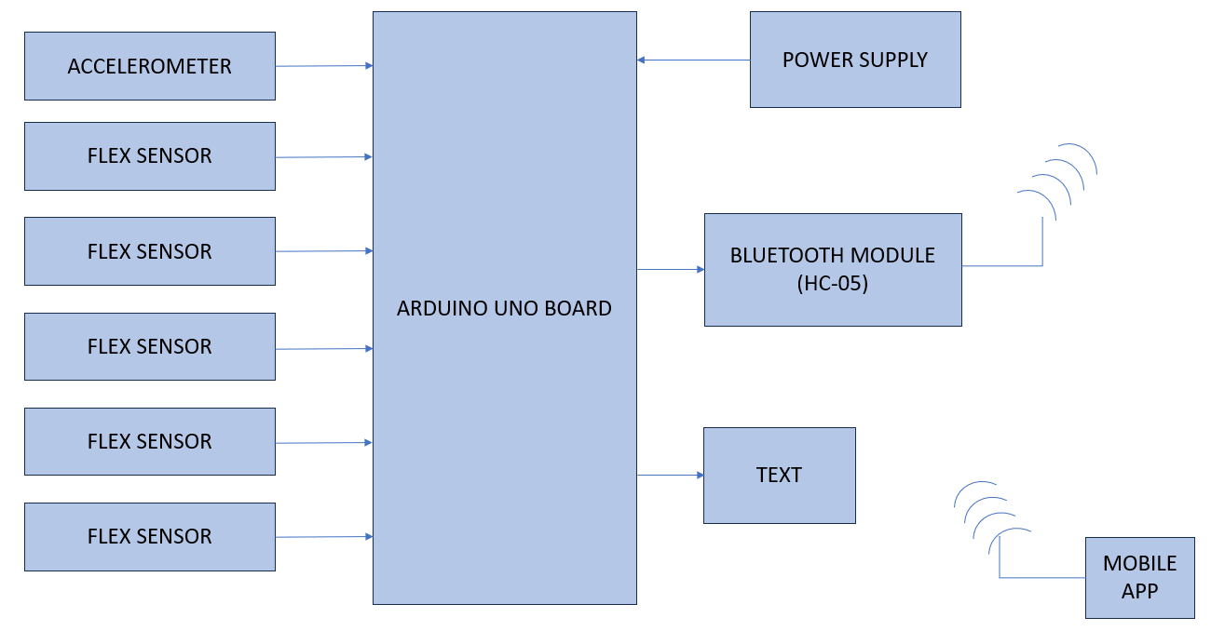

Fig. 4

**Machine Learning and AI for Gesture Recognition:** The advancement of smart gloves was greatly accelerated by the combination of artificial intelligence (AI) and machine learning, which made sophisticated gesture detection possible. More accurate interpretation of intricate hand motions and changes in sign language is made possible by AI-powered systems' ability to learn and adapt over time, in contrast to previous models that depended on preset gesture mappings. These gloves are able to identify minute variations in movements and even take into consideration user-specific preferences or ambient conditions thanks to algorithms that were taught using big datasets. Smart gloves' dependability, adaptability, and general user experience have significantly increased due to the transition from simple detection to intelligent, context-aware systems, which has increased their usefulness in practical applications.

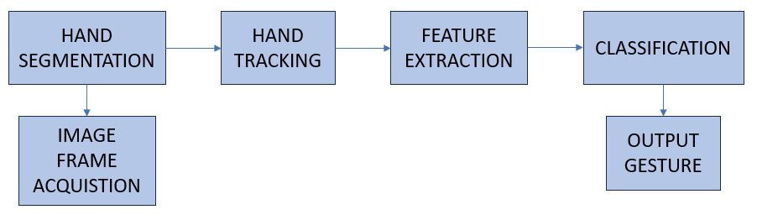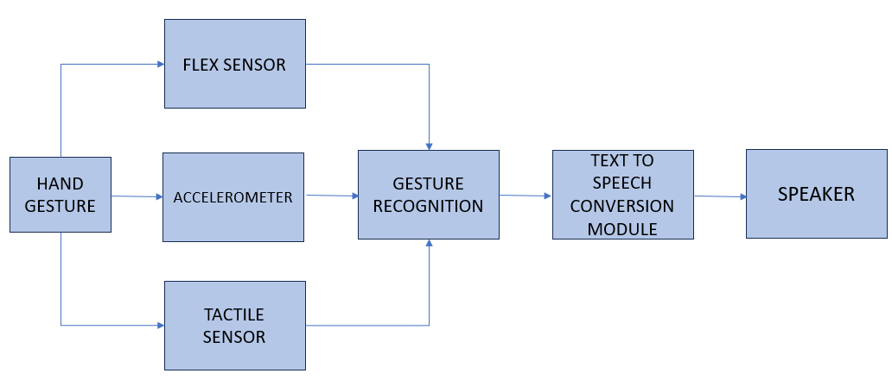 Fig. 5

IV. CHALLENGES

The development of smart gloves that can convert gestures into speech is fraught with technological challenges:

**Accuracy and Reliability of Sensors:** Flex sensors, pressure sensors, and motion detectors are some of the parts that the smart gloves use to identify hand motions. Over time, though, these sensors may have difficulties including decreased accuracy due to calibration errors or wear and tear that impairs their functionality. Inaccuracies in identifying certain signals or orders may also result from the sensors' inability to differentiate between identical movements. In real-worldapplications where precise gesturedetection is essential, these issues weaken the system's overall accuracy and dependability.

**Real-Time Processing and Speed:** To convert movements into voice, rapid data collection, processing, and output production are required. Even a slight delay in any of these procedures can disrupt communication, which lowers the system's efficacy. This is especially challenging in dynamic or fast-paced environments where seamless engagement depends on quick responses. Rapid processing is essential for the system to be able to satisfy user input, which would restrict its use in everyday scenarios.

**Power Consumption and Battery Life:** For smart gloves, power consumption and battery life pose serious problems. Advanced processing and wireless connectivity demand a significant amount of energy, which can rapidly deplete the battery. Because of this, users might have to recharge the gloves more frequently, which would reduce their practical for everyday usage. This restricts the device's usefulness, particularly for extended usage when a longer battery life is required for continuous communication.

**Language and Cultural Limitations:** Linguistic and cultural boundaries are major obstacles for smart gloves as many systems are designed to handle just specific sign languages, excluding other groups. This limits the technology's accessibility because it does not support all people with speech or hearing issues. Data security and privacy concerns have also increased, especially with IoT-enabled gloves. Since these devices often transfer and store private user information on other servers, they raise issues about data confidentiality and potential exploitation. Adequate data protection is crucial for the widespread acceptance and use of these technologies.

**Miniaturization of Components:** Minimizing smart glove components without sacrificing functionality is an ongoing challenge. Gloves that are compact, light, and comfortable are crucial for everyday usage, but it might be challenging to fit all the electronics required for accurate voice synthesis and gesture detection into a tiny form factor. Finding this balance is crucial to ensuring that the gloves maintain their utility and user-friendliness while also providing the necessary performance and reliability.

V. RECENT TECHNOLOGICAL TRENDS

Enhancing performance, usability, and accessibility are the main goals of recent technical advancements in the creation of smart gloves for communication, especially for those who are hearing and speech challenged.

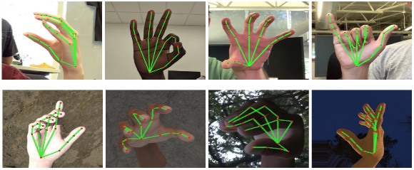**Advanced Gesture Recognition with AI:** Machine learning techniques and artificial intelligence (AI) have made tremendous progress in accurately detecting complex movements. Apart from identifying basic sign language signals, these technologies enable smart gloves to adapt to changes in hand movements and user behaviours. As the system learns and improves over time, AI makes gesture detection more reliable and responsive to user requests.

Fig. 6

**Flexible and Stretchable Electronics:** Lighter and more comfortable smart gloves are the consequence of recent advancements in stretchy and flexible electronics. These materials allow for a more ergonomic design since they are strong, lightweight, and flexible enough to accommodate the hand's natural movement. Furthermore, flexible circuits and sensors enhance the gloves' flexibility and fit without sacrificing functionality, increasing their suitability for extended usage.

**Improved Wireless Connectivity and Integration with IoT:** In order to link to other devices, including tablets, smartphones, and Internet of Things-enabled equipment, smart gloves are increasingly utilizing wireless technologies like Wi-Fi and Bluetooth Low Energy (BLE). By allowing real-time gesture translation into speech or text, these linkages facilitate more fluid conversation. An additional benefit of smart gloves is their integration with the Internet of Things (IoT), which increases the technology's versatility by allowing it to interact with a variety of other linked devices in a smart setting.

**Edge Computing for Real-Time Processing:** The usage of edge computing for real-time data processing is one of the latest developments driven by the requirement for quicker reaction times. This method enables quicker gesture detection and translation by processing data locally on the device rather than depending on cloud services. Because edge computing lowers latency, the gloves work better in dynamic settings where communication requires precision and quickness.

**Enhanced User Customization and Personalization:** To accommodate each user's particular demands, recent smart glove designs place a strong emphasis on personalization and customization. This contains user interface customization options, speech output, and gesture recognition settings that may be changed. In enhance the user experience, the gloves are being created with configurable options to accommodate various hand sizes, shapes, and differences in sign language.

VI. RESEARCH GAPS AND FUTURE VISIONS

Although the evolution of smart gloves for communication has advanced significantly, there are still a number of important shortcomings. The restricted range of gesture recognition is a major problem as many algorithms have trouble correctly deciphering intricate or unusual movements. This issue is particularly noticeable in dynamic settings when to predict the user's motions. Furthermore, many of the current solutions are language-specific, which limits their applicability to certain areas or groups and prevents them from supporting a greater range of sign languages. Another issue is the lack of universal gesture detection standards, which makes it challenging to smoothly integrate various smart glove systems across platforms and devices.

In order to fill these cracks, future studies should concentrate on using cutting-edge AI and machine learning technologies to strengthen the robustness of gesture detection systems. Systems could be more competent at adjusting to the many hand gestures and cultural variances in sign language utilizing deep learning. In ensure provide lighter, more comfortable designs without compromising performance, component miniaturization must also be improved. Enhancing battery efficiency for longer usage and less frequent recharging should be investigated by researchers. Making smart gloves more widely available and useful for a wider number of users would require adding real-time data processing, improving wireless connectivity, and broadening the range of languages supported.

VII. CONCLUSION

The creation of smart gloves that help people with speech and hearing impairments communicate has evolved significantly, moving from simple systems for recognizing gestures to wearable technology with AI built in. By translating sign language into voice or text, these gloves have the capacity to totally transform the way individuals with disabilities engage with the outside world and remove obstacles that separate them from the speaking and hearing cultures. Smart gloves are now far more accurate, flexible, and user-friendly because to the application of technologies like machine learning, wireless networking, and Internet of Things integration. But there are still issues, especially with regard to language restrictions, battery life, hardware downsizing, and gesture detection accuracy.

In guarantee that these systems can accommodate a assortment of users and languages, future advancements should focus on improving the reliability and flexibility of gesture detection through the use of more sophisticated machine learning models. Research on component downsizing and energy-efficient designs will also be crucial to making these devices more practical for daily use. If smart gloves are to become a ubiquitous communication tool, it will be imperative to overcome these problems, ensure greater accessibility, and integrate real-time processing capabilities. By enabling more inclusive communication after these barriers are gone, smart gloves might enhance the existence of millions of individuals with speech and hearing impairments worldwide.

VIII. REFERENCES

[1] Abougarair, M., & Arebi, L. (2022). Smart Glove for Sign Language Translation Using Flex Sensors. Proceedings of the *International Conference on Advanced Computing and Communication Systems (ICACCS).*

[2] Gupta, R., Sharma, P., & Verma, K. (2020). Development of a Wearable Smart Glove for Gesture-to-Speech Conversion. *International Journal of Advanced Research in Engineering and Technology*, 11(3), 145-152.

[3] Singh, R., Gupta, P., & Yadav, A. (2018). Real-Time Translation of American Sign Language Using Smart Gloves. *International Conference on Communication and Signal Processing*, 4(2), 125-131.

[4] Soni, A., & Sharma, N. (2019). *Gesture-Based Control System Using Smart Gloves: Development and Challenges*. Journal of Robotics and Automation, 7(1), 92-100.

[5] Kumar, S., Patel, D., & Reddy, M. (2017). *Design of Smart Gloves for Gesture Recognition and Speech Conversion*. Proceedings of the IEEE Conference on Emerging Technologies, 5(3), 341-348.

[6] D. Alosail, H. Aldolah, L. Alabdulwahab, A. Bashar and M. Khan, "Smart Glove for Bi-lingual Sign Language Recognition using Machine Learning," 2023 International Conference on Intelligent Data Communication Technologies and Internet of Things (IDCIoT), Bengaluru, India, 2023, pp. 409-415, doi: 10.1109/IDCIoT56793.2023.10053470.

[7] U. E, A. K Sreeja, R. Teja and V. LV, "Real-Time Sign Language Recognition and Translation with Glove and Mobile Integration," 2024 Second International Conference on Advances in Information Technology(ICAIT), Chikkamagaluru, Karnataka, India, 2024, pp. 1-6, doi: 10.1109/ICAIT61638.2024.10690297.

[8] P. M, V. R. Balaji, T. R and S. R, "Sign Speaks-An IoT Based Smart Gloves for Dumb," *2021 6th* International Conference on Communication and Electronics Systems (ICCES), Coimbatre, India, 2021, pp. 470-475, doi: 10.1109/ICCES51350.2021.9489184.

[9] O. Chowdhury, M. S. Rahman Hridoy, F. Amin, S. Arif and H. Begum, "Smart Gloves for People with Speech Disability," *2023 26th* International Conference on Computer and Information Technology (ICCIT) Cox’s Bazar, Bangladesh, 2023, pp. 1-5, doi: 10.1109/ICCIT60459.2023.10441257.

[10] K. John, A. Sreekumar and L. R. Mathew, "Wearable Gesture Detection Glove for Mute People," *2021 2nd* International Conference on Advances in Computing, Communication, Embedded and Secure Systems (ACCESS), Ernakulam,India,2021,pp.97-101,doi: 10.1109/ACCESS51619.2021.9563296.