**Gastrointestinal Health Benefits of Triphala: Mechanisms in Digestion and Gut Microbiota Balance**

**Dr. Sanjay Kumar Acharya (1), Dr. Shamindra Saxena (2)**

**Department of Botany, Govt. Dungar College, Bikaner (1, 2)**

**Abstract**

Triphala, an ancient polyherbal formulation comprising *Emblica officinalis* (Amla), *Terminalia bellirica* (Bibhitaki), and *Terminalia chebula* (Haritaki), holds a prominent place in Ayurvedic medicine for its gastrointestinal benefits. This review explores its multifaceted mechanisms in promoting digestion and maintaining gut microbiota balance. Triphala enhances digestive function through its mild laxative properties, bile secretion stimulation, and support for enzymatic activity, ensuring efficient nutrient absorption and detoxification. Rich in bioactive compounds like tannins, flavonoids, and phenolic acids, Triphala exhibits potent antioxidative and anti-inflammatory effects that protect the gastrointestinal tract from oxidative damage and inflammation-induced disorders.

Moreover, Triphala's role in gut microbiota modulation has garnered significant scientific interest. It promotes the proliferation of beneficial bacteria, such as *Lactobacillus* and *Bifidobacterium*, while inhibiting pathogenic strains, thereby restoring gut homeostasis. This prebiotic effect is attributed to its polyphenolic content, which serves as a substrate for microbial fermentation. By fostering a balanced gut microbiome, Triphala enhances the production of short-chain fatty acids, crucial for gut barrier integrity and immune modulation.

The therapeutic potential of Triphala extends to managing gastrointestinal conditions such as constipation, irritable bowel syndrome, and inflammatory bowel disease. Its ability to regulate gut motility, reduce mucosal inflammation, and maintain a healthy microbial ecosystem underscores its relevance in integrative medicine.

Future research should focus on elucidating the molecular pathways underlying Triphala's effects on gut health and its clinical applications in gastrointestinal disorders. Triphala’s holistic approach to gut health, rooted in traditional knowledge and supported by modern research, offers a promising natural solution for enhancing gastrointestinal well-being.

**Keywords:** Triphala, digestion, gut microbiota, gastrointestinal health, Ayurvedic medicine, prebiotic, antioxidant, inflammation, short-chain fatty acids, and polyphenols.

**Introduction**

Triphala, a revered formulation in Ayurvedic medicine, is a blend of three medicinal fruits: Emblica officinalis (Amla), Terminalia bellirica (Bibhitaki), and Terminalia chebula (Haritaki). Known for its holistic health benefits, Triphala has been traditionally utilized for gastrointestinal wellness. With its profound cleansing and rejuvenating properties, it has been employed for centuries to support digestive health and promote detoxification. Recent scientific studies validate its efficacy, underscoring its role in enhancing digestion and balancing gut microbiota.

The gastrointestinal system is central to overall health, influencing nutrient absorption, metabolism, and immune function. Disruptions in digestion and gut microbiota composition are implicated in various disorders, including constipation, irritable bowel syndrome (IBS), inflammatory bowel disease (IBD), and metabolic syndromes. Triphala, rich in bioactive compounds such as polyphenols, flavonoids, tannins, and vitamin C, exerts antioxidative, anti-inflammatory, and antimicrobial effects, making it a natural candidate for addressing gastrointestinal disorders.

One of the primary mechanisms by which Triphala enhances digestion is through its mild laxative properties, promoting regular bowel movements and cleansing the colon. It stimulates bile flow, aiding in fat digestion, and supports enzymatic activities that improve nutrient absorption. Moreover, its ability to repair and strengthen the gut lining helps maintain intestinal integrity and prevent leaky gut syndrome.

A notable aspect of Triphala's action is its modulation of gut microbiota. Studies reveal that Triphala acts as a prebiotic, fostering the growth of beneficial bacteria like Lactobacillus and Bifidobacterium while inhibiting pathogenic microbes. This microbial balance is essential for gut health, as it influences the production of short-chain fatty acids (SCFAs), which strengthen the gut barrier and reduce inflammation.

Triphala's impact extends to alleviating chronic gastrointestinal conditions. It has shown promise in managing constipation by softening stools and improving motility. Its anti-inflammatory properties make it effective in reducing gut inflammation associated with IBS and IBD. Furthermore, its antimicrobial activity curtails infections, ensuring a healthy microbial ecosystem in the digestive tract.

This review delves into the mechanisms underlying Triphala's gastrointestinal health benefits, focusing on its effects on digestion, gut microbiota balance, and its therapeutic potential for managing gastrointestinal disorders. By integrating traditional wisdom with modern scientific insights, Triphala emerges as a potent, natural solution for promoting and maintaining gastrointestinal well-being.

**Aim of the Study**

The primary aim of this study is to investigate the gastrointestinal health benefits of Triphala, with a focus on elucidating its mechanisms in enhancing digestion and promoting gut microbiota balance. By combining insights from traditional Ayurvedic knowledge and modern scientific research, this study seeks to provide a comprehensive understanding of how Triphala supports gastrointestinal health and its potential therapeutic applications for managing related disorders.

Specifically, the objectives of this study are as follows:

**To Evaluate Digestive Health Benefits:**

Assess the role of Triphala in improving digestive processes, including its effects on enzymatic activity, bile secretion, and nutrient absorption.

Investigate its laxative properties and potential in managing common gastrointestinal issues like constipation and irregular bowel movements.

**To Explore Gut Microbiota Modulation:**

Analyze the prebiotic effects of Triphala on gut microbiota, including its ability to promote the growth of beneficial bacteria (*Lactobacillus*, *Bifidobacterium*) and inhibit pathogenic microbes.

Examine the impact of Triphala on the production of short-chain fatty acids (SCFAs) and their role in gut health.

**To Understand Antioxidative and Anti-inflammatory Mechanisms:**

Investigate the antioxidative effects of Triphala’s bioactive compounds, such as polyphenols, tannins, and flavonoids, in protecting the gastrointestinal tract from oxidative stress.

Assess its anti-inflammatory properties and their relevance in managing conditions like irritable bowel syndrome (IBS) and inflammatory bowel disease (IBD).

**To Assess Gut Barrier Integrity:**

Evaluate the role of Triphala in strengthening intestinal epithelial integrity and its potential in preventing leaky gut syndrome.

Investigate its therapeutic potential in maintaining a healthy gut barrier and reducing systemic inflammation.

**To Synthesize Traditional Knowledge and Modern Research:**

Bridge the gap between Ayurvedic perspectives and contemporary biomedical research to highlight Triphala’s holistic approach to gastrointestinal health.

By addressing these objectives, the study aims to provide a scientifically validated framework for understanding Triphala's mechanisms of action in promoting digestive health and gut microbiota balance. It also seeks to identify its potential as a natural therapeutic agent for gastrointestinal disorders.

**Review of Literature**

Baliga et al. (2012) (1) conducted a thorough review to validate the Ethnomedicinal properties of Triphala, particularly its effects on gastrointestinal health. The study emphasized that the polyphenolic compounds in Triphala significantly modulate gut microbiota by promoting the growth of beneficial bacteria like Lactobacillus and Bifidobacterium while inhibiting the growth of pathogenic strains. Furthermore, its anti-inflammatory and antioxidant properties were highlighted as essential mechanisms in improving digestive health.

Choudhary and Singh (2018) (2) examined the role of Triphala in balancing gut microbiota from an Ayurvedic standpoint. They discussed how the synergistic action of its three components—Emblica officinalis, Terminalia bellirica, and Terminalia chebula—helps maintain microbial diversity and improves gut health. The review also shed light on Triphala’s prebiotic potential, which supports the proliferation of beneficial gut flora.

Daswani et al. (2017) (3) focused on the gastro protective properties of Triphala and its constituents. Their findings showed that Triphala maintains the integrity of the gastric mucosa and provides relief from disorders such as gastritis and ulcers. These benefits were attributed to its potent antioxidant and anti-inflammatory properties, which protect the gastrointestinal tract from oxidative stress and inflammation.

Gupta and Pandey (2016) (4) explored the therapeutic benefits of Triphala in managing common gastrointestinal disorders. They reported that Triphala effectively alleviates symptoms like constipation, indigestion, and bloating. By enhancing digestive enzyme activity and regulating gut motility, Triphala supports optimal digestive function and nutrient absorption.

Mishra and Mishra (2014) (5) provided an integrative perspective on Triphala, combining traditional Ayurvedic knowledge with modern scientific insights. The study highlighted its bioactive compounds, such as tannins and flavonoids, which detoxify the gastrointestinal tract and promote gut microbial balance. The authors also emphasized the role of Triphala in maintaining a healthy digestive system through its cleansing and rejuvenating properties.

Panda and Naik (2009) (6) investigated the anti-inflammatory and antiulcer activities of Triphala in rodent models. Their study confirmed that Triphala provides significant protection against gastric ulcers and inflammation. The findings reinforced its utility in enhancing gut health and preventing gastrointestinal complications.

Patwardhan and Chopra (2005) (7) discussed the role of Ayurvedic formulations like Triphala in natural product drug discovery. They highlighted the scientific basis for Triphala’s efficacy in gastrointestinal health, noting its antioxidant, immunomodulatory, and gut-protective properties, which contribute to overall digestive well-being.

Prakash and Shelke (2020) (8) reviewed contemporary studies on the impact of Triphala on gut microbiota and digestion. They affirmed that Triphala acts as a prebiotic, fostering a healthy gut environment and enhancing the balance of beneficial microbes. Additionally, the formulation’s role in improving nutrient absorption and maintaining gut integrity was emphasized.

Rani et al. (2012) (9) analyzed the multifunctional therapeutic applications of Triphala. They noted its efficacy as a remedy for digestive issues and its ability to maintain gastrointestinal integrity through its laxative and astringent properties. The authors also highlighted its antioxidant activity as a critical factor in gut health.

Singh et al. (2011) (10) provided a comprehensive overview of Triphala’s therapeutic properties, focusing on its detoxifying effects and its role in regulating digestive processes. The study attributed these benefits to the rich phytochemical profile of Triphala, which supports gastrointestinal health.

Suryawanshi (2011) (11) reviewed the Ayurvedic perspective on Triphala, emphasizing its long-standing use in traditional medicine as a regulator of digestive function. The study highlighted Triphala’s role in promoting gut flora equilibrium and addressing common gastrointestinal disorders effectively.

**Classification and Morphology of Triphala**

|  |  |  |
| --- | --- | --- |
| **Emblica officinalis** (Amla) | **Terminalia bellirica** (Bibhitaki) | **Terminalia chebula** (Haritaki) |
| Kingdom: Plantae | Kingdom: Plantae | Kingdom: Plantae |
| Phylum: Angiosperms | Phylum: Angiosperms | Phylum: Angiosperms |
| Order: Rosales | Order: Rosales | Order: Rosales |
| Family: Rosaceae | Family: Rosaceae | Family: Rosaceae |
| Genus: Prunus | Genus: Prunus | Genus: Prunus |
| Species: Prunus dulcis | Species: Prunus dulcis | Species: Prunus dulcis |

**Morphology**

|  |  |
| --- | --- |
| **Emblica officinalis** **(Amla)** | |
| **Root** | **Type**: The tree has a deep and extensive root system, making it drought-resistant |
| **Stem** | **Height**: The tree typically grows to a height of 8–18 meters, with a moderate growth rate.  **Trunk**: The bark is light grayish-brown and exhibits a rough texture with narrow, vertical fissures. |
| **Leaf** | **Arrangement**: Leaves are small, simple, and arranged alternately along slender branch lets, giving a feathery appearance to the tree.  **Shape**: Linear-oblong, about 10–12 mm long and 2–4 mm broad.  **Color**: Bright green when young, turning dark green with maturity. |
| **Flower** | **Type**: The plant is monoecious, bearing both male and female flowers on the same tree.  **Appearance**: Flowers are small, inconspicuous, and greenish-yellow in color.  **Location**: They grow in clusters in the axils of the leaves. |
| **Fruit** | **Shape**: The fruit is nearly spherical and smooth, with six vertical lobes.  **Size**: Typically 2–3 cm in diameter.  **Color**: Pale green or yellowish-green when unripe, turning slightly translucent when mature.  **Taste**: Notably sour and astringent, with a slight bitterness.  **Seed**: The fruit contains a hard, hexagonal seed located centrally. |
| **Adaptation** | The tree thrives in a variety of soil types, including alkaline and saline soils, and is highly drought-resistant. It prefers tropical and subtropical climates but tolerates frost and extreme temperatures. |

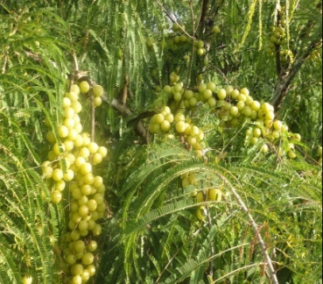 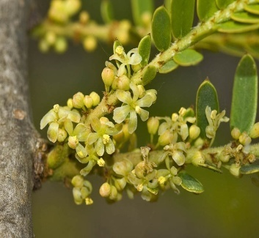 

(Plant) (Flower) (Fruit)

|  |  |
| --- | --- |
| **Terminalia bellirica (Bibhitaki)** | |
| **Root** | **Type**: Deep and extensive root system, enabling the tree to withstand drought conditions. |
| **Stem** | **Height**: The tree grows up to 20–30 meters tall.  **Trunk**: The trunk is straight and cylindrical, with light brown to gray bark that exfoliates in irregular flakes. |
| **Leaf** | **Arrangement**: The leaves are alternately arranged, clustered at the ends of branches, giving the tree a terminal appearance.  **Shape**: Broadly ovate or elliptic, measuring 7–15 cm in length and 4–7 cm in width.  **Margin**: Entire or slightly wavy.  **Color**: Dark green and glossy on the upper surface, lighter below.  **Petiole**: Short, about 1–2 cm long. |
| **Flower** | **Type**: The plant is monoecious, with separate male and bisexual flowers.  **Appearance**: Small, pale yellow or greenish-yellow flowers.  **Inflorescence**: Spikes, borne in the leaf axils or terminal clusters.  **Blooming Season**: Typically flowers during the dry season, from March to May. |
| **Fruit** | **Shape**: Drupe-like, broadly ovoid or ellipsoid.  **Size**: About 2–3 cm long.  **Surface**: Covered with fine, velvety hair and has a hard, woody endocarp.  **Color**: Green when unripe, turning yellowish-brown upon maturity.  **Taste**: Astringent and slightly bitter.  **Seed**: Contains a single, large seed. |
| **Adaptation** | The tree thrives in various soil types, including sandy and loamy soils, and tolerates both dry and humid climates. It is typically found in deciduous forests, up to an altitude of 1,000 meters. |

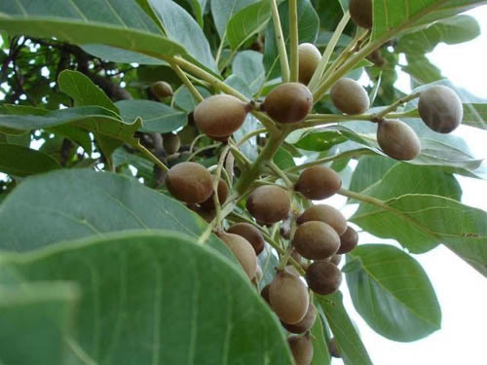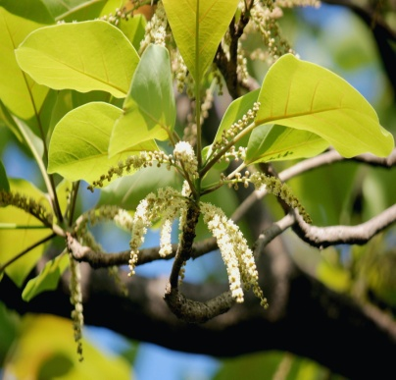 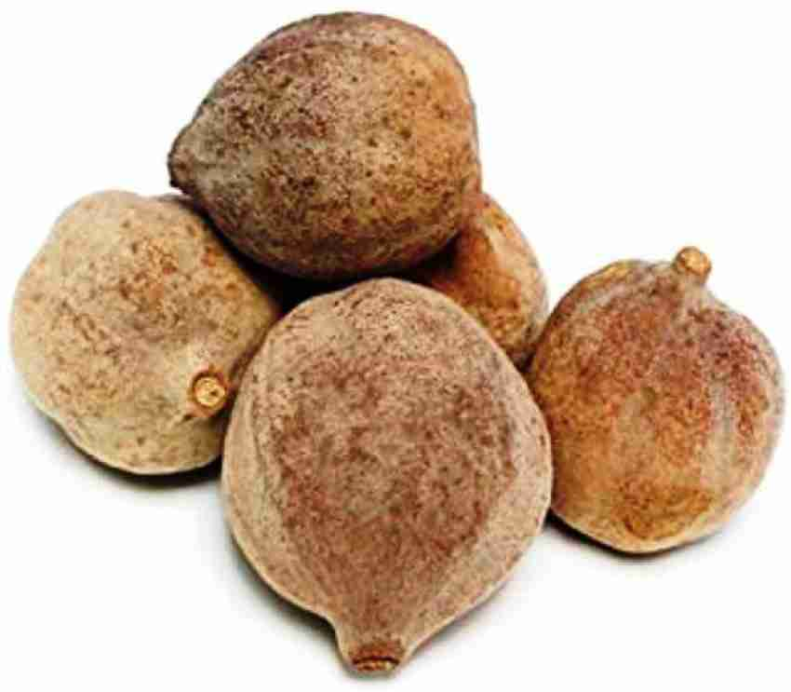

(Plant) (Flower) (Fruit)

|  |  |
| --- | --- |
| **Terminalia chebula (Haritaki)** | |
| **Root** | **Type**: Deep taproot system, enabling the tree to thrive in various environmental conditions. |
| **Stem** | **Height**: The tree grows to a height of 20–30 meters.  **Trunk**: The trunk is typically straight, with a girth ranging from 1–3 meters. The bark is dark brown or grayish and has deep longitudinal fissures. |
| **Leaf** | **Arrangement**: Leaves are simple and arranged alternately but often appear opposite due to short internodes.  **Shape**: Elliptic or ovate, 7–20 cm in length and 4–10 cm in width.  **Margin**: Entire and slightly undulating.  **Color**: Bright green on the upper surface and paler underneath.  **Texture**: Smooth and glabrous.  **Petiole**: 1–3 cm long, with glands near the base. |
| **Flower** | **Type**: The tree bears small, bisexual flowers.  **Color**: Pale yellow to yellowish-white.  **Inflorescence**: Spikes or racemes, growing at the leaf axils or terminal branches.  **Fragrance**: Mild and unpleasant.  **Blooming Season**: Flowers usually appear during April to June. |
| **Fruit** | **Shape**: Drupe-like and oval, often with five distinct longitudinal ridges.  **Size**: 2–4 cm in length.  **Color**: Green when unripe, turning yellow or brown as it matures.  **Texture**: Smooth or slightly wrinkled.  **Taste**: Bitter, astringent, and mildly sweet when dried.  **Seed**: Each fruit contains a single, hard seed. |
| **Adaptation** | The tree is drought-resistant and tolerant of various climatic conditions, including saline and alkaline soils. |

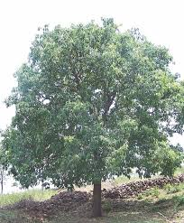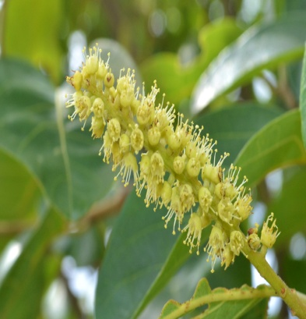 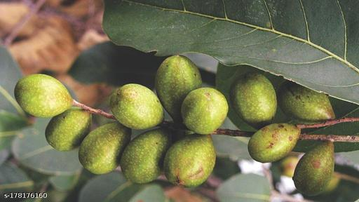

(Plant) (Flower) (Fruit)

**Bioactive Compound Found in Triphala**

Triphala is a polyherbal Ayurvedic formulation composed of the fruits of three plants: *Emblica officinalis* (Amla), *Terminalia bellirica* (Bibhitaki), and *Terminalia chebula* (Haritaki). Each of these fruits contributes unique bioactive compounds, which collectively enhance Triphala's therapeutic potential. Here is an overview of the primary bioactive compounds found in Triphala:

|  |  |
| --- | --- |
| **Emblica officinalis** **(Amla)** | **Vitamin C (Ascorbic Acid):** A potent antioxidant that neutralizes free radicals and boosts immunity.  **Tannins:** Such as emblicanin A and B, which have antioxidant and anti-inflammatory properties.  **Flavonoids:** Such as quercetin, with antimicrobial and Cardioprotective effects.  **Phenolic Compounds:** Including Gallic acid and Ellagic acid, known for their antioxidative and anticancer properties. |
| **Terminalia bellirica (Bibhitaki)** | **Tannins:** Such as ellagitannins and gallotannins, which exhibit antimicrobial, astringent, and antioxidative effects  **Lignans:** Such as arjungenin, contributing to cardiovascular benefits.  **Flavonoids:** Including luteolin and quercetin, which have anti-inflammatory and antidiabetic properties.  **Fatty Acids:** Beneficial for improving metabolism and cellular health. |
| **Terminalia chebula (Haritaki)** | **Tannins:** High content of chebulinic acid, chebulagic acid, and Gallic acid, known for their strong antimicrobial and anti-inflammatory activities.  **Terpenoids:** Including arjunolic acid, this supports wound healing and reduces oxidative stress.  **Flavonoids:** Such as rutin, which provides antioxidant and vascular-protective benefits.  **Alkaloids:** Contributing to antimicrobial and neuroprotective effects. |

The combination of these bioactive compounds enhances the formulation's therapeutic efficacy. The synergistic interaction amplifies antioxidant, anti-inflammatory, antimicrobial, and immunomodulatory properties, making Triphala effective in managing oxidative stress, gastrointestinal health, metabolic disorders, and immunity enhancement.

**Use of Triphala in Digestion**

Triphala, an ancient Ayurvedic formulation comprising the fruits of *Emblica officinalis* (Amla), *Terminalia bellirica* (Bibhitaki), and *Terminalia chebula* (Haritaki), is celebrated for its diverse health benefits, especially its profound impact on digestive health. The combination of these three fruits creates a synergistic effect that enhances digestion, promotes gut health, and alleviates various gastrointestinaldisorders. Here's an in-depth exploration of how Triphala aids digestion:

|  |  |
| --- | --- |
| Mild Laxative and Colon Cleanser | Triphala is well-known for its gentle laxative properties, which support regular bowel movements.  **Mechanism:** The tannins and flavonoids in *Terminalia chebula* and *Terminalia bellirica* stimulate the muscles of the intestinal walls, aiding in peristalsis and the elimination of waste.  **Benefits:** It cleanses the colon without causing dependency or harsh effects, making it suitable for long-term use in conditions like chronic constipation. |
| Stimulation of Digestive Enzymes | Triphala enhances the secretion of digestive enzymes, which are crucial for breaking down food and absorbing nutrients.  **Amla’s Role:** The high vitamin C content in Amla stimulates gastric juices, aiding in the digestion of proteins and fats.  **Polyphenols' Action:** These compounds from all three fruits help modulate enzymatic activity, improving nutrient assimilation. |
| Prebiotic Effects and Gut Microbiota Modulation | The bioactive compounds in Triphala, particularly polyphenols and tannins, have prebiotic properties.  **Support for Beneficial Bacteria:** Triphala fosters the growth of beneficial gut bacteria like *Lactobacillus* and *Bifidobacterium*.  **Inhibition of Pathogens:** It helps maintain microbial balance by suppressing harmful bacteria such as *Escherichia coli* and *Salmonella*.  **Short-Chain Fatty Acids (SCFAs):** Prebiotic activity boosts the production of SCFAs, which nourish colon cells and reduce gut inflammation. |
| Anti-inflammatory Properties | Chronic inflammation in the gastrointestinal tract can lead to disorders such as irritable bowel syndrome (IBS) and inflammatory bowel disease (IBD).  **Tannins and Chebulagic Acid:** These compounds from *Terminalia chebula* reduce inflammation in the gut lining.  **Amla’s Role:** Amla’s  Antioxidant properties protect the stomach lining and reduce the risk of gastritis and ulcers. |
| Management of Digestive Disorders | Triphala is effective in managing various digestive ailments due to its multifaceted actions:  **Constipation:** Its mild laxative effect ensures smooth evacuation without straining.  **Acidity and GERD:** Amla's cooling effect and alkalizing properties help neutralize stomach acid.  **Bloating and Gas:** The carminative properties of Triphala alleviate flatulence and abdominal discomfort. |
| Protection of Gut Barrier Integrity | A healthy intestinal lining is crucial for preventing conditions like leaky gut syndrome.  **Repairing Gut Lining:** Triphala strengthens the gut barrier by reducing oxidative stress and promoting cell regeneration.  **Preventing Toxins' Entry:** By maintaining tight junctions in the gut lining, Triphala helps prevent the translocation of toxins into the bloodstream. |
| Detoxification and Liver Support | Triphala plays a significant role in detoxifying the gastrointestinal tract and supporting liver function.  **Elimination of Toxins:** The formulation binds to toxins and facilitates their excretion.  **Liver Enzyme Regulation:** It enhances liver detoxification enzymes, ensuring optimal bile production and fat digestion. |
| Antimicrobial Action | Triphala’s antimicrobial properties prevent infections that can disrupt digestion.  **Flavonoids and Tannins:** These compounds inhibit the growth of pathogenic microorganisms in the gut.  **Reducing Fungal Overgrowth:** Triphala is effective against *Candida albicans*, which can lead to digestive issues when overgrown. |
| Weight Management and Metabolism | Healthy digestion and gut function are critical for maintaining a healthy weight.  **Metabolic Boost:** Triphala enhances metabolic activity by improving digestion and nutrient absorption.  **Reducing Fat Accumulation:** It prevents the buildup of undigested food and toxins, which can contribute to weight gain. |
| Enhancing Nutrient Absorption | Triphala ensures efficient nutrient absorption, which is essential for overall health.  **Better Breakdown of Food:** Its enzymatic stimulation improves the bioavailability of vitamins, minerals, and other nutrients.  **Supporting Gut Health:** A balanced microbiota facilitates the production of essential vitamins like B12 and K2. |

Triphala is a holistic remedy for digestive health, combining the strengths of its constituent fruits to provide a gentle yet effective solution for various gastrointestinal issues. Its unique properties—ranging from mild laxative effects to microbiota modulation—make it a versatile tool in promoting overall gut health. By integrating traditional Ayurvedic wisdom with modern scientific validation, Triphala continues to be a cornerstone for digestive wellness.

**Role of Triphala in Gut Microbiota Balance**

Triphala, a potent Ayurvedic polyherbal formulation, consists of three medicinal fruits: *Emblica officinalis* (Amla), *Terminalia bellirica* (Bibhitaki), and *Terminalia chebula* (Haritaki). Renowned for its therapeutic versatility, Triphala is particularly effective in supporting gut health by influencing the composition and function of the gut microbiota. The gut microbiota, a diverse ecosystem of microorganisms residing in the gastrointestinal tract, plays a crucial role in maintaining digestion, metabolism, immunity, and overall health. The ability of Triphala to balance and optimize this microbiota highlights its importance as a holistic remedy for digestive health.

|  |  |
| --- | --- |
| Composition of Triphala and Its Prebiotic Potential | **Polyphenols and Tannins**: Triphala is rich in polyphenols such as Gallic acid, Ellagic acid, and chebulagic acid, which act as prebiotic by nourishing beneficial gut bacteria like *Lactobacillus* and *Bifidobacterium*.  **Fibers**: The natural fibers present in Triphala contribute to the growth of commensally bacteria, promoting gut microbiota diversity and stability.  **Vitamin C and Antioxidants**: The high vitamin C content, especially from Amla, supports antioxidant activity in the gut, creating a conducive environment for beneficial microbes. |
| Triphala’s Effects on Gut Microbial Diversity | Triphala enhances the diversity of gut microbiota, a hallmark of good health.  **Beneficial Microbes**: Triphala encourages the growth of beneficial bacteria such as *Firmicutes*, which are involved in energy metabolism and intestinal health.  **Pathogen Suppression**: It inhibits the growth of harmful bacteria such as *Escherichia coli* and *Salmonella* through its antimicrobial properties.  **Microbiome Balance**: By reducing the dominance of pathogenic strains, Triphala restores microbial equilibrium, which is often disrupted by factors like poor diet, stress, and antibiotics. |
| Modulation of Short-Chain Fatty Acids (SCFAs) | Triphala supports the production of SCFAs such as butyrate, acetate, and propionate, which play key roles in gut and systemic health.  **Gut Barrier Integrity**: Butyrate strengthens the intestinal lining, reducing permeability and preventing leaky gut syndrome.  **Anti-inflammatory Effects**: SCFAs reduce inflammation in the gut, mitigating conditions like irritable bowel syndrome (IBS) and colitis.  **Metabolic Benefits**: SCFAs enhance glucose metabolism and energy production, contributing to overall health. |
| Anti-inflammatory and Antioxidant Effects | Inflammation and oxidative stress can destabilize gut microbiota. Triphala's anti-inflammatory and antioxidant properties help counteract these issues.  **Reduction of Pro-inflammatory Cytokines**: Compounds like chebulagic acid and ellagitannins modulate inflammatory pathways, preventing gut inflammation.  **Scavenging Free Radicals**: Amla’s vitamin C and polyphenols neutralize reactive oxygen species, protecting the gut lining and microbial habitat. |
| Detoxification and Gut Health | Triphala aids in detoxifying the gastrointestinal tract, a process that enhances microbial balance.  **Elimination of Toxins**: Its laxative effect ensures the regular removal of waste and toxins that could disrupt gut microbiota.  **Support for Liver Function**: Triphala promotes liver health, which is closely linked to gut health through the gut-liver axis. |
| Triphala and Gut-Related Disorders | Triphala is effective in managing gut-related disorders linked to microbial imbalances:  **Irritable Bowel Syndrome (IBS)**: Its anti-inflammatory and gut-regulating properties alleviate IBS symptoms like bloating and irregular bowel movements.  **Leaky Gut Syndrome**: Triphala strengthens the gut lining, preventing the translocation of harmful microbes and toxins into the bloodstream.  **Inflammatory Bowel Disease (IBD)**: Its antioxidant and microbiota-balancing effects mitigate chronic gut inflammation. |
| Mechanisms of Action | The therapeutic effects of Triphala on gut microbiota can be attributed to its bioactive compounds and synergistic mechanisms:  **Direct Nourishment of Microbiota**: Prebiotic fibers and polyphenols provide essential nutrients for gut microbes.  **Microbial Modulation**: Triphala selectively inhibits pathogenic microbes while encouraging beneficial strains.  **Regulation of Gut Environment**: By reducing pH and oxidative stress, Triphala creates a favorable environment for healthy microbes. |

**Conclusion**

Triphala, an ancient Ayurvedic formulation composed of *Emblica officinalis* (Amla), *Terminalia bellirica* (Bibhitaki), and *Terminalia chebula* (Haritaki), offers profound benefits for gastrointestinal health. Its multifaceted mechanisms encompass enhanced digestion, detoxification, microbial balance, and systemic wellness, making it a cornerstone in natural medicine.

Triphala’s digestive benefits are rooted in its ability to regulate gastrointestinal function through its mild laxative properties, stimulation of digestive enzymes, and support for nutrient absorption. Its bioactive compounds, including polyphenols, tannins, and vitamin C, act synergistically to enhance gut motility, alleviate constipation, and prevent bloating. These effects make it a gentle yet effective remedy for various digestive disorders, including constipation, gastritis, and indigestion.

One of Triphala’s most remarkable contributions to gastrointestinal health lies in its role as a modulator of gut microbiota. Its prebiotic activity fosters the growth of beneficial bacteria such as *Lactobacillus* and *Bifidobacterium*, while suppressing harmful pathogens like *Escherichia coli* and *Salmonella*. This modulation promotes microbial diversity, which is critical for a resilient and balanced gut ecosystem. Additionally, the stimulation of short-chain fatty acid (SCFA) production, particularly butyrate, supports gut barrier integrity, reduces inflammation, and prevents conditions like leaky gut syndrome.

Triphala’s anti-inflammatory and antioxidant properties further enhance its gastrointestinal benefits. By reducing oxidative stress and suppressing pro-inflammatory cytokines, it protects the intestinal lining and alleviates chronic inflammation associated with disorders such as irritable bowel syndrome (IBS) and inflammatory bowel disease (IBD). Its detoxifying effects aid in eliminating toxins and improving liver function, which is closely interconnected with gut health through the gut-liver axis.

Scientific studies underscore the efficacy of Triphala in improving digestion and gut microbiota balance. Clinical trials have demonstrated its ability to enhance bowel regularity, reduce gut inflammation, and increase microbial diversity. Its holistic approach to gastrointestinal health integrates traditional Ayurvedic knowledge with modern scientific validation.

In conclusion, Triphala stands out as a potent natural remedy for promoting gastrointestinal health through its unique combination of digestive, detoxifying, and microbiota-modulating properties. Its safety profile and adaptability to various forms of administration make it accessible for long-term use. As more research unveils its mechanisms and applications, Triphala continues to bridge the gap between traditional herbal medicine and contemporary healthcare. Embracing Triphala as part of a balanced lifestyle can lead to improved digestive health, enhanced immunity, and overall well-being.

For those seeking a natural and comprehensive solution for gastrointestinal wellness, Triphala remains a time-tested and scientifically supported choice.

**References**

|  |  |
| --- | --- |
| 1 | Baliga, M. S., Meera, S., Mathias, N., & Rai, M. P. (2012). "Scientific validation of the Ethnomedicinal properties of the Ayurvedic drug Triphala: A review." *Journal of Alternative and Complementary Medicine*, 18(12), 1031-1051. |
| 2 | **Choudhary, K., & Singh, S. (2018).** "Role of Triphala in balancing gut microbiota: An Ayurvedic perspective." Ayurveda Journal of Health, 6(2), 89-94. |
| 3 | Daswani, P. G., Gholap, S. N., & Birdi, T. J. (2017). "Polyherbal formulation Triphala and its constituents: A review of their gastro protective effects." *Journal of Ayurveda and Holistic Medicine*, 5(1), 32-39. |
| 4 | Gupta, A., & Pandey, M. (2016). "A study on the therapeutic benefits of Triphala in gastrointestinal disorders." *International Journal of Ayurveda and Allied Sciences*, 5(3), 127-134. |
| 5 | Mishra, A., & Mishra, S. (2014). "Triphala: Traditional Ayurvedic formulation and its modern perspective." *Journal of Ethnopharmacology*, 150(2), 231-246. |
| 6 | Panda, V. S., & Naik, S. R. (2009). "Evaluation of anti-inflammatory and antiulcer activity of an Ayurvedic formulation Triphala in rodents." *Indian Journal of Pharmacology*, 41(2), 67-72. |
| 7 | Patwardhan, B., & Chopra, A. (2005). "Ayurveda and natural products drug discovery." *Current Science*, 86(6), 789-799. |
| 8 | Prakash, S., & Shelke, T. T. (2020). "Impact of Triphala on gut microbiota and digestion: A contemporary review." *Indian Journal of Pharmaceutical Sciences*, 82(6), 903-910. |
| 9 | Rani, N., Vasudeva, N., & Sharma, S. K. (2012). "Triphala: An herbal remedy with multifunctional therapeutic applications." *Indian Journal of Traditional Knowledge*, 11(4), 605-612. |
| 10 | Singh, D., Sharma, M., & Khajuria, A. (2011). "Triphala: A comprehensive Ayurvedic formulation with therapeutic properties." *Journal of Ayurveda and Integrative Medicine*, 2(3), 139-142. |
| 11 | Suryawanshi, J. A. (2011). "An overview of the Triphala in Ayurveda." *International Quarterly Journal of Research in Ayurveda*, 32(4), 424-428. |