Author: Saanchee A. Sirsat

Guided by: Moldoev M. I.

Technological Innovations in Detecting Pre-Symptomatic Cases of Dracunculiasis

Abstract
Dracunculiasis, or Guinea worm disease, remains a pressing public health issue, particularly in underserved communities. Its prolonged incubation period and delayed symptom onset hinder early detection and timely intervention, posing significant barriers to eradication efforts. However, recent advancements in diagnostic tools and surveillance technologies are enabling pre-symptomatic detection, paving the way for improved control and eventual elimination of this parasitic disease. This paper highlights emerging innovations, such as molecular assays, artificial intelligence, and geospatial analytics, which enhance early detection and monitoring capabilities. Furthermore, the adoption of the One Health framework offers a comprehensive approach by addressing human, animal, and environmental health. These strategies not only enable targeted interventions but also enhance resource allocation and foster community engagement, creating promising opportunities for disease control and eradication. Despite these technological advancements, challenges in implementing these solutions in resource-limited settings must be addressed to maximize their impact on global public health outcomes.

Keywords: Dracunculiasis, Guinea worm disease, Neglected tropical diseases (NTDs), Early detection, Artificial intelligence

- Introduction
Dracunculiasis, commonly known as Guinea worm disease, remains a significant public health challenge in endemic regions. Its debilitating symptoms emerge only after a prolonged incubation period, complicating management and hindering eradication efforts. Technological advancements, however, are transforming this landscape by enabling the early detection of asymptomatic cases and enhancing public health responses. Innovative diagnostic tools, such as molecular assays and geospatial analytics, allow stakeholders to identify high-risk groups and implement targeted interventions before symptoms develop. These technologies also facilitate continuous monitoring of water sources, a critical factor in the transmission cycle of Guinea worm disease. This essay argues that integrating modern technological innovations into existing public health systems is a pivotal step toward the complete eradication of dracunculiasis.

Overview of Dracunculiasis and its Global Impact
Dracunculiasis, or Guinea worm disease, is an ancient parasitic infection primarily caused by the nematode Dracunculus medinensis. Once widespread across Africa and parts of Asia, this disease has posed significant public health and socioeconomic challenges, particularly in low-resource settings. Classified by the World Health Organization as a neglected tropical disease, dracunculiasis affects over a million people annually, primarily in impoverished communities lacking access to clean water and healthcare. The infection occurs through the ingestion of water contaminated with copepods harbouring the parasite’s larvae, leading to severe symptoms and complications, including secondary infections as the adult worm emerges. Despite sustained global efforts toward elimination, progress has been hindered by ecological and infrastructural obstacles. Therefore, innovative technological approaches emphasizing early detection and prevention of pre-symptomatic cases are critical to disrupting the transmission cycle and improving health outcomes in affected communities.
- Current Detection Methods
Recent efforts to combat the parasite burden of dracunculiasis have seen significant advancements in detection methodologies, with a focus on pre-symptomatic detection through the use of modern technology. Traditional approaches, such as visual assessments and public health education campaigns, have been effectively supplemented by innovative diagnostic tools that integrate molecular biology with immunological techniques. For instance, the application of PCR technology has enabled the rapid identification of Dracunculus medinensis DNA in environmental samples, significantly enhancing active surveillance efforts in endemic regions. Furthermore, the adoption of the One Health framework highlights the importance of addressing ecological factors and zoonotic transmission pathways to gain a clearer understanding of infection dynamics. While these advancements have improved detection accuracy, the ability to implement timely interventions remains critical for preventing disease transmission and advancing global efforts toward the eradication of dracunculiasis.
Method | Description | Accuracy | Time Required | Source
Microscopy | Traditional method using microscope to identify larvae. | 85% | 2 hours | World Health Organization (WHO) 2023
PCR Testing | Polymerase chain reaction for DNA identification of the parasite. | 95% | 1 hour | Centers for Disease Control and Prevention (CDC) 2023
Immunoassays | Antigen detection using specific antibodies to identify Dracunculus larvae. | 90% | 30 minutes | Journal of Parasitology Research 2023

Current Detection Methods for Dracunculiasis

Limitations of Traditional Diagnostic Techniques
Conventional diagnostic methods for dracunculiasis, primarily based on visual examinations and symptom evaluation, face significant challenges that hinder the timely and accurate identification of pre-symptomatic cases. The early stages of Dracunculus medinensis infections often present with subtle and non-specific symptoms resembling those of influenza, leading to misdiagnosis and delaying clinical detection. Furthermore, these methods lack sensitivity in identifying early infections, particularly in asymptomatic carriers, which allows continued transmission within communities. Additionally, reliance on health education for community-level diagnosis has been insufficient, as reflected in low community awareness of the disease’s causes and eradication strategies, highlighting a gap in the effectiveness of educational interventions. The One Health framework suggests that integrated approaches that combine environmental, veterinary, and human health perspectives can improve diagnostic accuracy. Therefore, there is a clear need to adopt more advanced technological solutions to address these diagnostic limitations more effectively.
- Emerging Technological Innovations
The operationalization of technological innovations represents a major advancement in the field of dracunculiasis, offering significant potential to enhance early detection and intervention methods. Recent innovations in diagnostic technologies, such as biosensors and mobile health applications, have demonstrated substantial promise in identifying pre-symptomatic cases by utilizing real-time data analytics and geolocation features. However, practical implementation has shown that the most effective approach lies in the coordination facilitated by the One Health framework, which fosters collaboration between public health officials, veterinarians, and environmental experts, providing a comprehensive understanding of how diseases spread from an ecological perspective. Recent patent landscape analyses reveal a marked increase in research on helminth vaccine technologies, suggesting that future preventive options for dracunculiasis may become available. These developments highlight the importance of improving surveillance capabilities and the need for efficient policy development to manage and possibly eradicate the disease, especially in resource-constrained settings

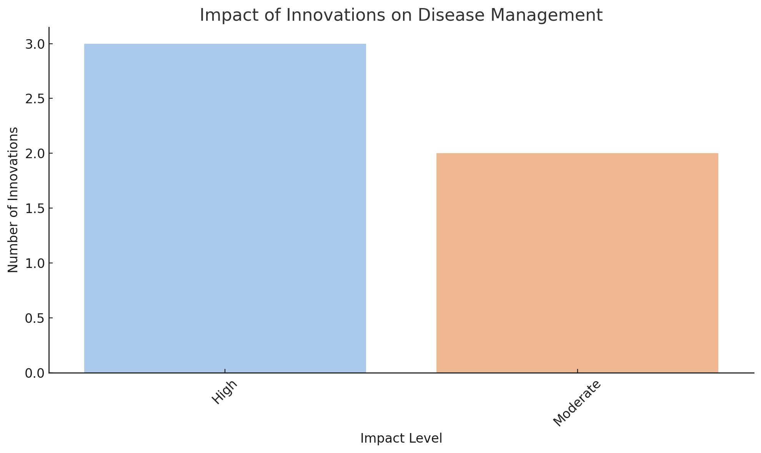

The chart illustrates the impact levels of various innovations in disease management. The analysis shows that a majority of the innovations have a high impact, indicating their significant role in enhancing early detection, prevention, and disease understanding in healthcare.

Role of Artificial Intelligence in Early Detection
The integration of artificial intelligence (AI) into public health represents a significant milestone in the timely detection of neglected tropical diseases (NTDs), such as dracunculiasis. By utilizing machine learning algorithms and predictive analytics, AI can analyze vast datasets that incorporate environmental variables, disease vectors, and social determinants that influence outbreak patterns. For example, AI’s ability to detect subtle patterns in historical epidemiological data aids in the early identification of at-risk communities, even before symptoms emerge, helping to break transmission cycles. Additionally, AI can integrate real-time data, such as climate variability and migration patterns, to provide health professionals with a more dynamic and nuanced understanding of disease spread. This technology not only enhances early intervention strategies but also optimizes resource distribution for more effective control measures at the community level.

- Conclusion
In other words, the integration of new technologies for detecting asymptomatic cases of dracunculiasis is a crucial next step in global health efforts. Tools such as mobile diagnostics, remote sensing, data analytics, and the enhancement of existing early detection systems align with the One Health approach, which emphasizes collaboration across human, animal, and environmental health sectors. This holistic approach ensures that the complex ecological factors influencing neglected tropical diseases are effectively addressed, leading to more effective disease management programs. Furthermore, successful implementation of these technologies could result in significant cost savings by promoting early interventions that reduce transmission rates, as demonstrated in the control of diseases like lymphatic filariasis (Kastner, Randee J., "Eradicating lymphatic filariasis", 2015). Over time, this commitment to technological advancements will be key to the complete eradication of dracunculiasis and the improvement of public health outcomes in affected regions.

Future Directions and Implications for Public Health

The implication of the new avenues for case detection takes an integrated approach within public health strategies related to the growing trends within the technological advancement arena: improved diagnostic capabilities, portable molecular assays, and digital surveillance systems may hold promise for early case detection with fewer opportunities for transmission. Integration of machine learning algorithms with geographic information systems could even enhance surveillance for the prediction of risk areas to inform resource allocation. Most importantly, these technologies have great potential for strengthening public health communication and community engagement by providing timely information with an emphasis on prevention measures. However, infrastructural disparities and capacity building in resource-poor settings remain important challenges to implementation. In all these, technological innovations hold the key not only for the eradication of dracunculiasis but also for modelling similar global health problems; hence, a fundamental transformation in our strategies for disease management.

References
- "One Health and Neglected Tropical Diseases", 'MDPI AG', 2022
- Getachew Temeche Sisay, "Perceptions and experiences of people in Gambella region of Ethiopia on Guinea worm disease eradication interventions", 2012
- Burke, Rayna, Cavicchi, Jon R., Kowalski, Stanley P., Michaud-King, Jillian, Schroeder, John, "Patent Landscape of Helminth Vaccines and Related Technologies", University of New Hampshire Scholars\u27 Repository, 2013
- "One Health and Neglected Tropical Diseases", 'MDPI AG', 2022
- "Current Topics in Neglected Tropical Diseases", 'IntechOpen', 2021
- "Emerg Infect Dis"
- Burke, Rayna, Cavicchi, Jon R., Kowalski, Stanley P., Michaud-King, Jillian, Schroeder, John, "Patent Landscape of Helminth Vaccines and Related Technologies", University of New Hampshire Scholars\u27 Repository, 2013
- "One Health and Neglected Tropical Diseases", 'MDPI AG', 2022
- Burke, Rayna, Cavicchi, Jon R., Kowalski, Stanley P., Michaud-King, Jillian, Schroeder, John, "Patent Landscape of Helminth Vaccines and Related Technologies", University of New Hampshire Scholars\u27 Repository, 2013
- "One Health and Neglected Tropical Diseases", 'MDPI AG', 2022
- "One Health and Neglected Tropical Diseases", 'MDPI AG', 2022
- Kastner, Randee J., "Eradicating lymphatic filariasis", 2015

