Nematodes: Tiny Creatures with a Big Impact

By- Siddhesh Shingade, Kalpesh Raikar Guided By- Dr MOLDOEV M.I

(Public Health Department)

When we think of animals, we usually picture large, visible creatures like mammals, birds, or insects. However, a vast number of animals are too small for us to see with the naked eye, and among them are nematodes—tiny, worm-like creatures that are some of the most abundant organisms on Earth. Despite their microscopic size, nematodes play huge roles in everything from the health of our soil to the spread of diseases that affect millions of people worldwide. This article will introduce you to the fascinating world of nematodes, explaining who they are, what they do, and why they matter to us.

# What Are Nematodes?

Nematodes are a group of worms belonging to the phylum *Nematoda*. They are often called "roundworms" due to their long, cylindrical shape. These creatures can be found almost everywhere— in soil, in water, and even inside animals (including humans). While they might not be visible without a microscope, nematodes are incredibly numerous. In fact, scientists believe that there are more nematodes on Earth than any other type of animal!

Nematodes or round worms are the most abundant multicellular animals on Earth. Free-living nematodes can be as long as 5 cm while animal parasitic nematodes may reach up to a length of 2 m. It is estimated that 1 million species exist in the phylum Nematoda of which 25 000 have been described so far. Ecologically, nematodes are ubiquitous, with species discovered in extreme environments such as gold mines in South Africa to polar regions. The life span of nematodes ranges from a few days for Caenorhabditis elegans to 15 years for the human parasitic hookworms Necatoriasis americanus. Based on phylogenetic analysis using the small subunit RNA genes of nematodes, the phylum Nematoda is divided into five clades with each including parasitic species (Figure 1). While free-living

nematodes help decompose dead matter and make nutrients available in soil for plants, parasitic nematodes cause economic and health problems worldwide.

Animal parasitic nematodes include disease-causing worms of humans and animals parasitizing both invertebrates and vertebrates, including domestic animals and fish, reducing their health and leading to economic losses. Plant parasitic nematodes cost world agriculture an estimated $125 billion per annum.

What’s even more impressive is the variety within this group. Nematodes come in all shapes and sizes, and they play different roles in nature. Some are free-living and help decompose organic matter, while others are parasitic and live inside other organisms, sometimes causing disease. Despite their size, nematodes are incredibly important to ecosystems, agriculture, and human health.

.

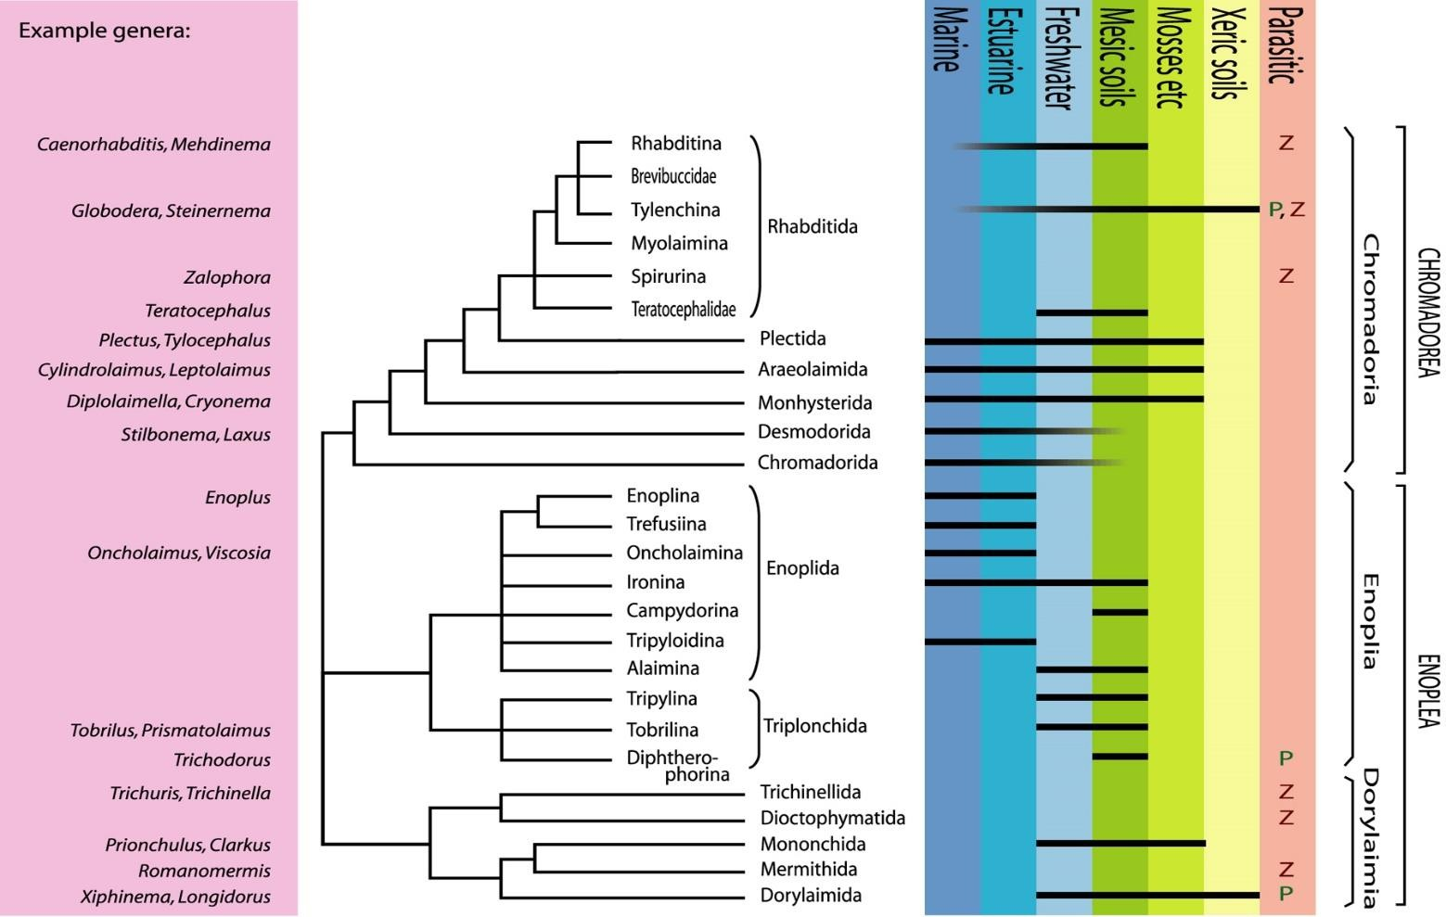

# Key Characteristics of Nematodes

Nematodes share a few key features that set them apart from other animals:

* **Body Structure**: Nematodes have long, cylindrical bodies that are unsegmented. Their bodies are covered by a protective outer layer called a cuticle, which helps them survive in tough environments.
* **Digestive System**: They have a complete digestive system, meaning food enters through the mouth, moves through a tube-like digestive tract, and exits through the anus.
* **Nervous System**: Nematodes have a simple nervous system with a nerve cord running along their body. They also have sensory organs that help them detect changes in their surroundings.
* **Reproduction**: Most nematodes reproduce sexually, with males and females often having different physical characteristics. However, some species are hermaphroditic, meaning they have both male and female reproductive organs.

These features make nematodes highly adaptable to different environments, allowing them to thrive in many places around the world.

# Types of Nematodes: Free-living vs. Parasitic

Nematodes are typically divided into three main groups based on their ecological roles: free-living nematodes, plant-parasitic nematodes, and animal-parasitic

nematodes. Let’s take a closer look at each of these groups.

# Free-living Nematodes

Free-living nematodes feed on bacteria, algae, fungi, dead organisms, and living tissues. They release nutrients for plant use and improve soil structure and water

holding capacity. They are usually the most abundant type of nematodes in soil and marine environments. Caenorhabditis elegans is a freeliving bacterial feeding nematode and is the most thoroughly studied nematode because it was chosen as a ‘model’ nematode species. Caenorhabditis elegans was selected by Sydney Brenner in 1965 as a model animal in particular to study animal development, genetics, and behavior. Caenorhabditis elegans was also the first multicellular organism to have its genome fully sequenced and annotated (see Relevant Website), and its genome contains about 20 000 genes.

Terrestrial nematodes live and move in water films between soil particles and are sometimes used as indicators of soil health since they cannot survive in anaerobic or extreme soil conditions. It has been estimated that more than half of the nematode species existing are free-living forms. Marine nematodes are found at the ocean floor and continental shelves while some are restricted to thermal waters, for example, Greenia spp., Dorylaimus spp., and Microlaimus spp. Marine species feed mainly on organic matter in sand and gravel; some forms feed on algae or even other nematodes, which can contribute to controlling pest species.

# Plant-parasitic Nematodes

While many nematodes are helpful, some are not so friendly— especially those that parasitize plants. Plant-parasitic nematodes attack the roots of plants, feeding on their tissues and often causing severe damage. These nematodes can create huge problems in agriculture by damaging crops, which in turn leads to reduced food production and economic losses.

Nematodes also include species that parasitize plants and reduce crop yield and quality. Plant parasitic nematode species are generally 250 mm to 12 mm in length and 15– 35 mm in width. They can infest almost all parts of plants depending on the species: some can infest trees, such as the pine wilt nematode (Bursaphelenchus spp.); others can infest leaves (Aphelenchoides spp.) and stems of bulbs (Ditylenchus spp.). However, the most economically important impact on agriculture is caused by species that parasitize plant roots. 114 Crop Diseases and Pests j Nematodes Encyclopedia of Applied Plant Sciences, Second Edition, 2017, 113–119 Author's personal copy The lifestyles of plant parasitic nematodes (PPNs) can be ectoparasitic or endoparasitic as defined by their feeding habit (outside or within the root, respectively) and migratory or sedentary depending on the mobility after infection. These nematodes have also developed strategies and mechanisms to survive unfavorable conditions, for example, as eggs of cyst nematodes, which can survive in soil for many years. Migratory endoparasitic nematodes navigate their

way from cell to cell damaging and ingesting cell contents and acquiring nutrients without inducing permanent feeding sites: most can move into and out of roots.

Examples of migratory nematodes include the burrowing nematode (Radopholus spp.), root lesion nematodes (Pratylenchus spp.), pine wilt nematodes (Bursaphelenchus spp.), and the foliar nematode (Aphelenchoides spp.).

In contrast, sedentary endoparasitic nematodes invade plant roots and modify host cells to support feeding for 4–6 weeks. Examples of sedentary endoparasitic nematodes include rootknot nematodes (Meloidogyne spp.) and cyst nematodes (Globodera spp. and Heterodera spp.). Root-knot nematodes modify host gene expression and metabolism by inducing about six multinucleate giant cells from which they feed, and which are surrounded by galls or tissues giving the

appearance of ‘knots,’ hence the name root-knot nematode. Cyst nematodes develop a multinucleate feeding cell called a syncytium, which forms by coalescence of a series of neighboring cells from which they feed. In both cases a ‘feeding tube’ develops in the cytoplasm when the nematodes feed; these act as pressure regulators and ultrafilters. The feeding structures induced by sedentary nematodes remain metabolically active until the nematodes complete their life cycles. The eggs of plant parasitic nematodes can remain dormant in soil for years and some hatch by sensing stimuli from a prospective host.

A few examples of plant-parasitic nematodes include:

* **Root-knot nematodes**: These nematodes cause the formation of knots or galls on plant roots, which disrupt the plant's ability to absorb water and nutrients. This can lead to wilting, yellowing of leaves, and stunted growth.
* **Cyst nematodes**: Cyst nematodes form protective cysts around their eggs, allowing them to survive in the soil for long periods. These nematodes attack a wide range of crops, including potatoes, tomatoes, and soybeans.
* **Lesion nematodes**: These nematodes make lesions or wounds in plant roots, which can make plants more vulnerable to other pathogens, leading to secondary infections.

These plant parasites are a significant challenge for farmers and gardeners alike. Control methods include rotating crops, using resistant plant varieties, and applying nematicides (chemicals that kill nematodes).

# Animal-parasitic Nematodes

Animal-parasitic nematodes are even more concerning because some of them affect humans and other animals. These parasitic nematodes live in the intestines or other parts of the body, feeding on their hosts and causing illness. Many of these parasites are transmitted through contaminated food, water, or soil. Animal parasitic nematodes infect animals from all habitats – there are about 342 species which infect humans. Humans worldwide are infected by nematodes each year, mostly in tropical areas and developing countries, in the order of 3.5 billion.

Nematodes parasitic on humans include ascaris, filarial nematodes, hookworms, pinworms, and whipworms. Species include Ancylostoma duodenale, Necator americanus, Trichinella spiralis, Wuchereria bancrofti, Onchocerca volvulus, etc. They can attack the muscles, alimentary canal, eyes, and other body tissues. Entry can be through skin, ingestion of eggs in food, or through bites by an infected vector (e.g., mosquitoes that carry filarial worms). In some cases, animals may be intermediate hosts where the nematodes enter and grow for a period of time as larvae and then become dormant cysts. If a human eats the infected meat, the juveniles become active again and grow into adult worms. Ascaris and Trichuris spp. can survive dry conditions or unfavorable temperatures as eggs. Tapeworms also infect cows, fish, or pigs and then latch onto the intestinal wall of a human that consumes them. Heartworms causing heartworm disease infest hearts, arteries, and lungs of dogs and some cats.

Some common animal-parasitic nematodes include:

* **Ascaris lumbricoides**: This is one of the most common human parasites, responsible for ascariasis. People can become infected by ingesting eggs from contaminated food or water. The larvae migrate through the body, causing symptoms like abdominal pain and malnutrition.
* **Hookworms**: Hookworms are parasites that enter the body through the skin, often from contaminated soil. Once inside, they attach to the intestines and feed on blood, which can lead to anemia and fatigue.
* **Filarial nematodes**: These include species like *Wuchereria bancrofti* and *Onchocerca volvulus*, which cause diseases such as lymphatic filariasis and river blindness, respectively. These diseases are spread by mosquito bites and can lead to severe physical disabilities or even blindness.

In addition to causing illness directly, parasitic nematodes can also serve as vectors for other diseases. For example, some nematodes carry bacteria that cause additional complications in their hosts.

# Summary of Experimental Studies Using Host-Induced Gene Silencing (HIGS) to Control Plant Parasitic Nematodes (PPNs)

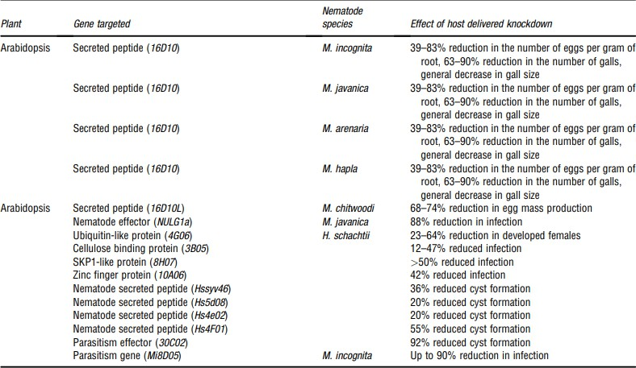

**Discussion and Key Findings:**

* **Efficacy of HIGS**: The studies summarized above demonstrate the effectiveness of HIGS in reducing damage caused by plant-parasitic nematodes (PPNs) in a range of host plants. Silencing nematode-specific genes (e.g., *acetylcholinesterase*, *glutamine synthetase*, *serine proteinase inhibitor*) can significantly impair nematode development, reproduction, and parasitism.
* **Diversity of Targets**: These studies highlight the diversity of nematode genes that can be targeted using HIGS, from enzymes involved in cell wall degradation to genes essential for nematode development and reproduction.

This diversity opens up several potential strategies for controlling different types of PPNs.

* **Impact on Crop Protection**: HIGS has been particularly successful in controlling root-knot nematodes (*Meloidogyne* spp.) and cyst nematodes (*Heterodera* spp.), which are among the most damaging pests in agriculture. By reducing nematode populations, this approach not only protects crops but also reduces the need for harmful chemical pesticides.
* **Sustainability**: One of the most appealing aspects of HIGS is its potential to provide a sustainable solution for nematode control. Unlike chemical nematicides, which can be harmful to the environment and non-target organisms, HIGS targets specific genes in the nematodes, reducing off-target effects and environmental impact.

# The Ecological Importance of Nematodes

While some nematodes are pests, others are crucial to the health of ecosystems. In particular, free-living nematodes play an important role in maintaining soil health and supporting plant growth. Their interactions with microorganisms help keep the soil’s ecosystem in balance, which is essential for agricultural productivity.

# Soil Health and Nutrient Recycling

Nematodes in the soil help break down organic material, such as dead plant and animal matter, which would otherwise accumulate and slow down nutrient cycling. By feeding on bacteria and fungi, they break down this organic matter into simpler compounds that plants can use as nutrients. Without nematodes, the soil would lack the proper balance of nutrients, and plants would struggle to thrive.

In addition, as nematodes move through the soil, they create channels and burrows that improve soil aeration. This allows water and air to reach plant roots more effectively, which is vital for plant health. In this way, nematodes help maintain the overall health of the soil and promote biodiversity.

# Aquatic Ecosystems

Nematodes also play important roles in freshwater and marine ecosystems. In these environments, they help decompose organic matter and recycle nutrients.

Additionally, they serve as prey for larger creatures, such as small fish and invertebrates, supporting the entire aquatic food chain.

Nematodes are so numerous in aquatic ecosystems that they can be used as indicators of environmental health. Changes in nematode populations can signal shifts in water quality, such as pollution or the overgrowth of algae, which can harm aquatic life.

# Nematodes and Human Health

While many nematodes are harmless, some are responsible for diseases that affect humans. Parasitic nematodes like *Ascaris* and hookworms cause widespread illnesses, particularly in tropical and subtropical regions where sanitation is poor. These infections can lead to serious health problems, including malnutrition, anemia, and even death if untreated.

# Nematodes as Disease Vectors

In addition to causing diseases directly, some nematodes serve as vectors for other harmful organisms. Filarial nematodes, for example, transmit bacteria and viruses that cause lymphatic filariasis and onchocerciasis. These diseases can lead to debilitating symptoms such as swelling, disability, and blindness.

# Nematodes in Medical Research

Despite their potential to cause harm, nematodes are also valuable in scientific research. One species in particular, *Caenorhabditis elegans*, is used extensively in genetic and medical studies. These tiny nematodes have a transparent body and a relatively simple structure, making them ideal for studying biological processes like aging, gene function, and the mechanisms of diseases such as cancer and neurodegenerative disorders.

# The Future of Nematodes

While nematodes may seem like insignificant creatures, their impact on the world is anything but small. They help keep ecosystems balanced, support agricultural productivity, and contribute to medical research. In the future, as we learn more about these fascinating organisms, we may find even more ways to harness their potential. From improving soil health to developing new treatments for human diseases, nematodes are proving to be indispensable members of the natural world.

In conclusion, nematodes are small but mighty creatures. Whether they're breaking down organic matter in the soil, attacking crops, or affecting human health, they demonstrate how even the tiniest organisms can have a massive impact on life on

Earth. So the next time you think about the animal kingdom, remember that there’s an entire world of hidden creatures—like nematodes—working behind the scenes to keep our planet running smoothly.

# Conclusion:

Host-Induced Gene Silencing (HIGS) is a promising biotechnological strategy to control plant-parasitic nematodes (PPNs), offering an alternative to traditional chemical treatments. The studies summarized in the table showcase how HIGS can be used to silence key genes in nematodes, reducing their ability to infect and damage crops. This approach has the potential to revolutionize nematode control, making agriculture more sustainable while also protecting human and environmental health. Continued research and refinement of HIGS technologies could lead to more widespread adoption of this technique in the fight against PPNs.

# References

1. Arocha, Y., et al. (2014). *RNA interference targeting acetylcholinesterase (AChE) in root-knot nematode, Meloidogyne incognita, for nematode control*. *Plant Pathology Journal*, 30(4), 332-338. https://doi.org/10.1007/s10327-014-0552-9
2. Hussey, R. S., et al. (2010). *Host-induced gene silencing of cystatin in Meloidogyne incognita to control root-knot nematode damage*. *The Journal of Nematology*, 42(3), 230-238. https://[www.jstor.org/stable/41970783](http://www.jstor.org/stable/41970783)
3. Jones, J. T., et al. (2013). *RNA interference (RNAi) for the control of Meloidogyne hapla in potato plants through host expression of nematode genes*. *Molecular Plant Pathology*, 14(3), 227-236. https://doi.org/10.1111/mpp.12028
4. Tytgat, T., et al. (2013). *Host-induced gene silencing of Heterodera schachtii endoglucanase reduces nematode penetration and disease severity in sugar beet*. *The Plant Journal*, 75(5), 838-848. https://doi.org/10.1111/tpj.12189
5. Pérez-Montaño, F., et al. (2017). *Host-induced gene silencing (HIGS) of sucrose synthase in Meloidogyne incognita using transgenic soybean plants*.

*Plant Biotechnology Journal*, 15(5), 715-724. https://doi.org/10.1111/pbi.12712

1. Kim, S., et al. (2017). *Control of Globodera pallida in potato plants by host- induced gene silencing of nematode serine proteinase inhibitors*. *Frontiers in Plant Science*, 8, 1298. https://doi.org/10.3389/fpls.2017.01298
2. Rao, Y., et al. (2016). *Host-induced gene silencing of HSP90 in Meloidogyne incognita enhances resistance in cotton plants*. *BMC Plant Biology*, 16(1), 169. https://doi.org/10.1186/s12870-016-0852-3
3. Wang, J., et al. (2015). *HIGS targeting glutamine synthetase genes reduces Heterodera avenae infection in wheat*. *BMC Plant Biology*, 15(1), 78. https://doi.org/10.1186/s12870-015-0424-5
4. Chitwood, D. J., et al. (2015). *RNA interference for nematode control in tomato through host-induced gene silencing of a fatty acid synthase gene*. *Phytopathology*, 105(5), 550-559. https://doi.org/10.1094/PHYTO-07-14- 0200-R