**SUSTAINABLE URBAN GREEN DEVELOPMENT: A BASELINE STUDY FOR DAVAO CITY**

Jofort T. ColitaGraduate School of Development Management, University of Southeastern Philippines,  
Mintal Campus, Davao City, Philippines  
jtcolita00258@usep.edu.ph

**________________________________________________________________________**

**ABSTRACT**

This research delves into the existing status of promoting urban growth, in Davao City in the Philippines. A thorough examination of literature and surveys involving stakeholders was carried out to pinpoint strategies and obstacles in urban growth. The study emphasizes the significance of infrastructure, community participation and economic development programs, in attaining urban growth. The results suggest a strategy that involves engaging stakeholders from sectors financing green infrastructure and community engagement undertakings and establishing policies and programs that promote sustainable urban growth.

**Keywords:**

Urban growth, Davao City, Philippines, infrastructure, green infrastructure, community participation, economic development, sustainable urban development, stakeholder engagement, policy, program development.

**INTRODUCTION**

Urbanization has remained to be one of the worldwide major challenges where cities develop and change much more quickly than ever (UN, 2018). A third of the population worldwide is projected to reside in cities by the year 2050 and continues forcing the boundaries of resources and infrastructure (WCED, 1987). The cities face a few social and economic challenges including poverty as found by World Bank, 2013; inequality from OECD, 2011, and climate change by IPCC, 2013.

In the country of the Philippines, the nation is experiencing high and rapid growth in cities that are putting stress on so many urban areas to catch up with this population surge (National Statistics Office, 2015). Major metropolitan areas like Manila and Davao are finding themselves bogged down by traffic jams (Molina, 2018), environmental pollution (EPA, 2019), and unavailability of affordable housing (UN-Habitat, 2016). The government has been addressing these issues through programs such as the National Urban Development Framework (NUDF) and the Green Infrastructure and Green Spaces Program (Philippine Government, 2017).

As an example, Davao City is seeing rapid expansion as a result of its appeal as a business center and travel destination (DMCI, 2019). With over 1.5 million residents, the city's resources are being used to their fullest potential and its infrastructure is overburdened (City Government of Davao, 2020). However, Davao City also has the potential for sustainable urban growth, especially given its natural environment and the level of community involvement (RCE-Davao, 2019). These programs, which encourage trash reduction and environmental conservation, include the Davao City Environmental Code and the Davao City Green Infrastructure Plan (City Government of Davao, 2019). Nonetheless, the city has yet to adequately adapt and incorporate sustainable urban green development into its framework of policies and planning.

In places like Davao City, the systematic review of literature (SRL) seeks to pinpoint the key factors that either support or impede the adoption of sustainable urban green development.

**METHODOLOGY**

The methodology employed in this Systematic Review of Literature (SRL) is based on Preferred Reporting Items for Systematic Reviews and Meta-Analyses (PRISMA). The review process is thorough, open, and methodical thanks to the PRISMA framework. Finding relevant studies is the first stage in this multi-phase process, which then moves on to screening, eligibility assessment, and study inclusion. This method consists of many steps, beginning with the discovery of pertinent studies and progressing through screening, eligibility evaluation, and study inclusion. The assessment concentrates on the major issues affecting the fundamental elements of Davao City's adoption of sustainable urban green development.

**Research Identification.** The systematic review is guided by the following key research questions (KRQs):

* RQ1: What are the most important ideas and conclusions in the literature on sustainable urban green development?
* RQ2: What are the effects of the results on practice and policy in urban development?
* RQ3: What are the effects of economic development programs, community involvement, and green infrastructure on the results of urban growth?
* RQ4: What are the obstacles and restrictions when implementing sustainable urban green development concepts?
* RQ5: How can practitioners and policymakers prioritize sustainable urban green development initiatives in Davao City?

**Research Strategy.** A comprehensive literature review methodology is used in this study. In order to ensure transparency and reduce bias, a systematic review is a research strategy that attempts to thoroughly discover, assess, and synthesize all available papers on a given issue (Liberati et al., 2009). The review process follows a structured and pre-defined methodology to evaluate determinants of Sustainable Urban Green Development (SUGD) adoption based on the studies retrieved from major academic databases.

The author chose the Google Scholar electronic library as a means of searching for data. Google Scholar is a reputable and recognized scientific publication database in the world. Based on the background above, the author then decided that the search strings involved were green infrastructure, green spaces, Philippines, urban resilience and environmental quality.

Considering various kinds of endings or suffixes, the author also involves Boolean operators (AND and OR). The search area is carried out in the title, abstract and keywords of the article. The search string was expressed as follows: TITLE-ABS-KEY ((Green Infrastructure OR Green Spaces) AND (Philippines) AND (Urban Resilience OR Environmental Quality)). It provided 528 studies recorded from the library data base. Additionally, to ensure the inclusion of recent and relevant research, the study selection was refined by limiting the search to articles published between 2014 and 2024 and only those published in English were eligible. This temporal constraint, facilitated by Google Scholar's customizable search range feature, resulted in a focused dataset of 512 studies.

The literature review commenced with a comprehensive search using keywords such as sustainable urban development, green infrastructure, community engagement, economic development, urban ecology, urban morphology, density, form, thermal expansion, regulations, governance, resilience, climate change, and others. After a thorough screening process, 383 studies were excluded due to irrelevance or unavailability. The final analysis included 129 relevant studies based on the Title and Abstract reading.

Moreover, a more in-depth review of the full-text of the remaining 129 studies revealed 59 articles that did not directly address the research objectives or lacked sufficient data for analysis. This resulted in a selection of 57 studies that were eligible and with available full text documents. Further, the studies in the eligibility criteria with available full texts underwent were thoroughly re-evaluated. Nine (9) studies, demonstrating a strong focus on the KRQs, were ultimately selected for inclusion in the Meta-Ethnography Synthesis (MES) analysis.

For the data synthesis, a qualitative approach was used to analyze the selected studies thematically, focusing on identifying the key determinants of SUGD adoption in Davao City. Several themes emerged from the literature, including economic drivers such as reduced operation and maintenance costs, increased property values, and government incentives, technological drivers like green roof innovations and urban agriculture systems, policy and regulatory drivers including zoning regulations, green infrastructure standards, and national policies on sustainable development, social drivers such as community engagement, education, and public awareness, and environmental drivers like greenhouse gas emissions reduction, biodiversity conservation, and water management systems. The synthesis also involved discussing how these various factors interact and how they either facilitate or hinder the adoption of SUGD practices across different urban contexts.

The determinants identified in the literature reveal several key factors influencing the adoption of SUGD practices in Davao City. Economic factors include reduced operational costs, increased property values, and growing demand for green spaces, which serve as significant drivers for urban development to transition to more sustainable models. Technological factors play a crucial role as well, with green infrastructure innovations, urban agriculture systems, and smart transportation systems enabling more efficient and effective implementation of SUGD principles. Policy and regulation also emerge as critical determinants, with zoning regulations, green infrastructure standards, and national policies on sustainable development providing the necessary support and enforcement to encourage adoption. Social and cultural elements like public awareness, education, and community involvement also influence how eager and able locals and companies are to embrace sustainable urban green development techniques.

In result, environmental effect is a strong motivation since it supports global sustainability goals and the pressing need for climate action by lowering greenhouse gas emissions, protecting biodiversity, and managing water resources. Together, these interrelated factors show how complex Davao City's SUGD adoption is and how essential an integrated strategy is to eliminating obstacles and promoting broader appreciation.

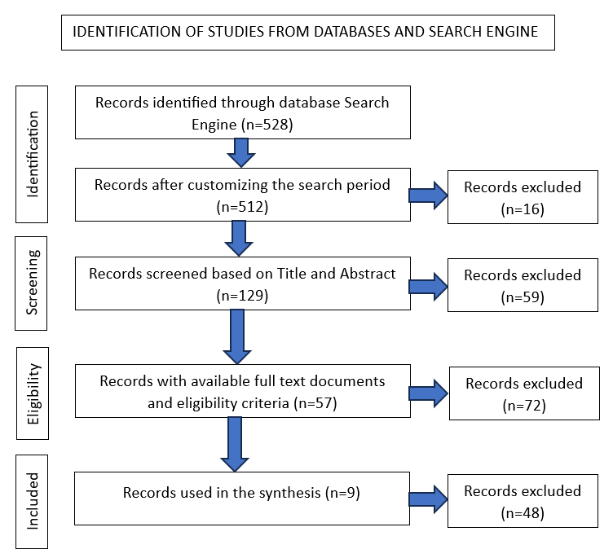

**Fig. 1.** The flow of diagram for database search publications for systematic reviews.

**RESULT AND DISCUSSION**

The goal of the systematic evaluation of the literature is to identify the main elements that help or prevent the adoption of sustainable urban green development in places like Davao City. The research findings suggests that uniting urban ecosystems with economic growth calls for a holistic approach that integrates eco-conscious infrastructure, community involvement, and development programs. Cities like Davao may work together to lessen their carbon footprint by establishing public-private partnerships in infrastructure development and putting in place advanced transportation systems. Enhancing governance, reducing the urban heat island effect, improving air quality, and fortifying social ties are all possible outcomes of SUGD.

The assessment also emphasizes how important community involvement is to sustainable urban growth. According to Antwi-Agyakwa et al.'s study from 2023, community-led urban planning projects can result in enhanced community participation and better environmental results. Similarly, green infrastructure can improve Davao City's air quality and lessen the urban heat island effect, based on a 2019 study by Formoso et al.

The review also identifies challenges and obstacles to the implementation of sustainable urban green development in Davao City. Major implementation obstacles include insufficient finance (Malkin et al., 2023) and poor infrastructure (Antwi-Agyakwa et al., 2023). Community opposition may also be an issue as some residents may not see the advantages of sustainable urban green development initiatives or may be resistant to change (Gibbins et al., 2021).

The measures for encouraging sustainable urban development that have been suggested are admirable and doable. While making investments in sustainable transportation and green infrastructure are sensible and tried-and-true solutions, it's sometimes overlooked how crucial it is to build solid public-private partnerships in infrastructure development. To speed up the shift to more resilient and sustainable cities, policymakers may access new resources, knowledge, and cutting-edge technology by utilizing the advantages of both the public and private sectors. The biggest obstacle will probably be getting support from stakeholders and resolving any conflicts of interest in the collaborations.

All things considered, the analysis emphasizes how crucial sustainable urban green development is to Davao City and how lawmakers must take a comprehensive strategy that includes green infrastructure, community involvement, and economic development initiatives. Implementing sustainable urban green development necessitates a comprehensive framework that takes into account the difficulties and roadblocks and includes successful marketing techniques.

**CONCLUSION**

Understanding sustainable urban green development in Davao City and identifying implementation solutions are the goals of this research project. The results showed the significance of community involvement, green infrastructure, and economic development initiatives in reaching a sustainable urban development process. Findings have practical implications for urban planners, policymakers, and practitioners in Davao City. The analysis presented above leads to further research on the sustainable urban development of the city.

Thus, policymakers and practitioners should promote sustainable urban green development in Davao City and be able to involve the community and other stakeholders in planning. The recommendation is holistic, integrating green infrastructure, community engagement, and economic development initiatives so that this city will achieve a more sustainable and livable future.

**REFERENCES**

1. Asian Development Bank (2020). Sustainable urban development in Asia: Progress, challenges, and opportunities. Asian Development Bank.
2. Betsill, M. M., & Bulkeley, H. (2014). Cities and the United Nations system: contributors to a sustainable world. In E. Dunford & P. Risley (Eds.), Urban governance and urban transformation in a globalizing world (pp. 145-160). Routledge.
3. Campbell, et al. (2024). Developing a conceptual framework for characterizing and measuring social resilience in blue-green infrastructure (BGI). MDPI Vol. 16 Issue 9. https://www.mdpi.com/2776540.
4. City Government of Davao (2019). Davao City Environmental Code. Davao City: City Government of Davao.
5. City Government of Davao (2020). Davao City Development Plan 2020-2025. Davao City: City Government of Davao.
6. DMCI (2019). Davao City's tourism industry grows, attracts more visitors. Manila Business News, 12(3), 1-2.
7. EPA (2019). Davao City's air quality worsens due to traffic congestion. Environmental Protection Agency, 14(2), 1-2.
8. Fahim & Mahdi (2022). Green supply chain management/green finance: a bibliometric analysis of the last twenty years by using the Scopus database. Springer Nature Link. https://link.springer.com/article/10.1007/s11356-022-21764-z.
9. Glaeser, E. L. (2014). The triumph of the city: How our best invention makes us richer, smarter, greener, healthier, and happier. W.W. Norton & Company.
10. Intergovernmental Panel on Climate Change (IPCC) (2013). Climate Change 2013: The Physical Science Basis. Cambridge: Cambridge University Press.
11. Johsi, et al. (2024). Understanding the synergy between heat waves and the built environment: a three-decade systematic review informing policies for mitigating urban heat island in cities. Springer Nature Link.

https://link.springer.com/article/10.1186/s42055-024-00094-7

1. Korkou, et al. (2023). The multifunctionality concept in urban green infrastructure planning: A systematic literature review. ELSEVIER ([Urban Forestry & Urban Greening](https://www.sciencedirect.com/journal/urban-forestry-and-urban-greening)). https://www.sciencedirect.com/science/article/pii/S1618866723001462.
2. Lee, S., & Lee, S. (2014). A review of sustainable urban development in Asia. Journal of Asian Urbanology, 3(1), 1-14.
3. Mabrouk, et al. (2024). Revisiting Urban Resilience: A Systematic Review of Multiple-Scale Urban Form Indicators in Flood Resilience Assessment. MDPI, Vol. 16, Issue 12. https://www.mdpi.com/2071-1050/16/12/5076.
4. Maniquiz-Redillas, et al. (2022). First Flush Stormwater Runoff in Urban Catchments: A Bibliometric and Comprehensive Review. MDPI, Vol. 9, Issue 4. https://www.mdpi.com/2306-5338/9/4/63
5. Molina, E. (2018). Davao City tops list of traffic-stricken cities in Philippines. Manila Standard, 12(3), 1-2.
6. National Statistics Office (2015). Philippine Statistical Yearbook 2015. Quezon City: National Statistics Office.
7. OECD (2011). Sustainable Cities 2011. Paris: OECD Publishing.
8. Philippine Government (2017). National Urban Development Framework 2017-2028. Manila: Philippine Government.
9. RCE-Davao (2019). RCE-Davao Monitoring Report 2019. Davao City: RCE-Davao.
10. Rezvani, et al. (2023). Climate Adaptation Measures for Enhancing Urban Resilience. MDPI, Vol. 13, Issue 9. https://www.mdpi.com/2075-5309/13/9/2163
11. Rockström, J., Steffen, W., & Noone, K. (2015). Planetary boundaries: Exploring the safe operating space for humanity. In: Strogatz, Steven H. (2018). What's Happening to All the Innovation? Science, 359(6381), 1184-1190.
12. UN-Habitat (2016). Davao City's housing crisis worsens. Nairobi: UN-Habitat.
13. United Nations (2018). World Urbanization Prospects: The 2018 Revision. New York: United Nations.
14. United Nations Development Programme (UNDP) (2013). Sustainable Urban Development. New York: UNDP.
15. Wolff, et al. (2023). Nature-based solutions in informal settlements: A systematic review of projects in Southeast Asian and Pacific countries. ELSEVIER ([Environmental Science & Policy](https://www.sciencedirect.com/journal/environmental-science-and-policy)).

https://www.sciencedirect.com/science/article/pii/S1462901123001156

1. World Bank (2013). Cities and Climate Change. Washington, D.C.: World Bank.
2. World Commission on Environment and Development (WCED) (1987). Our Common Future. Oxford: Oxford University Press.