**Leveraging Computational Methods to Examine the Political Economy of Policy-Making in India**

*Hemendra Kumar*

*Assistant Professor*

*Department of Computer Science*

*Maharaja Surajmal Institute*

*hemendrakumar@msijanakpuri.com*

**Abstract**

The intricate interplay of politics, economics, and governance forms the backbone of policy-making in India. This paper explores how computational methods can provide novel insights into the political economy of policy-making in the country. By employing data-driven techniques such as natural language processing (NLP), machine learning, and network analysis, researchers and policymakers can decode complex patterns, assess policy impacts, and understand stakeholder dynamics. This study highlights the potential and challenges of integrating computational approaches into the analysis of India’s policy-making processes, offering a roadmap for future research.

***Key words:*** NLP, Machine learning. network analysis, data driven techniques, policy impacts

1. **Introduction**

India's policy-making ecosystem is a multifaceted domain influenced by diverse political, economic, and social factors. Traditional methods of analysis often rely on qualitative insights or limited quantitative data, which may not capture the complexity of this landscape. Computational methods, however, offer the ability to process and analyse vast datasets, enabling researchers to uncover trends, correlations, and causal relationships that might otherwise remain obscured.

The diversity of India’s policy challenges illustrates the need for advanced analytical approaches. For example, understanding the allocation of funds under the Mahatma Gandhi National Rural Employment Guarantee Act (MNREGA) requires analysing vast amounts of data from rural regions, employment trends, and economic conditions. Similarly, assessing the impact of demonetization on small businesses and informal labour markets involves examining large-scale financial transaction data and correlating it with socio-economic indicators. Electoral strategies also benefit from computational analysis. Political parties craft their campaigns by studying voter behaviour through surveys, social media trends, and historical voting patterns.

For instance, the use of data analytics during the 2014 and 2019 general elections in India showcased how targeted communication strategies, informed by computational models, can influence electoral outcomes. Moreover, the formulation of policies such as the Goods and Services Tax (GST) involves intricate negotiations among states, industries, and central authorities. Computational techniques like network analysis can map these interactions and identify influential stakeholders, shedding light on the power dynamics that shape policy decisions.

This paper investigates the application of computational methods to study the political economy of policy-making in India.

It aims to answer key questions:

1. How can computational tools help analyse the dynamics of policy formulation?
2. What are the potential benefits and limitations of these approaches in the Indian context?

**2. The Political Economy of Policy-Making in India** India’s policy-making process is shaped by its federal structure, diverse socio-economic landscape, and vibrant democratic institutions. Key stakeholders include political parties, bureaucrats, interest groups, media, and the electorate. Policies often emerge as compromises between competing interests, influenced by electoral considerations, economic priorities, and public opinion.

Understanding this interplay requires analysing multiple dimensions:

* **Political Dynamics**: Electoral outcomes, party ideologies, coalition politics.
* **Economic Factors**: Budget constraints, macroeconomic conditions, regional disparities.
* **Social Influences**: Public opinion, activism, and cultural factors.

Traditional methods struggle to encapsulate these dynamics holistically. Computational techniques, by contrast, allow for a more nuanced and integrative analysis.

**Fig 1. Role of Information Technology in Public Policy Formulation and Implementation**

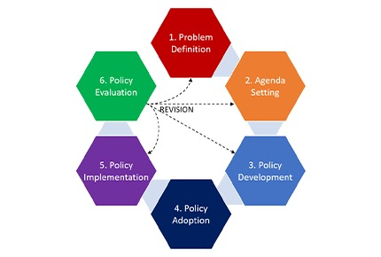

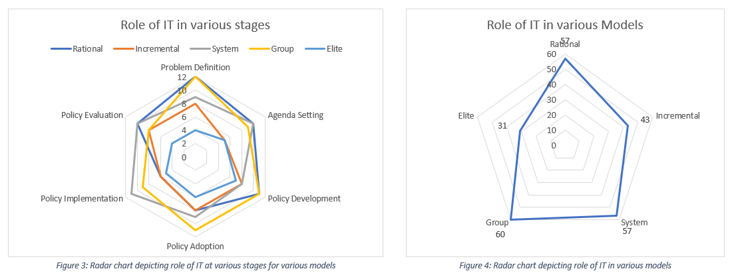

***Source :*** *https://www.nic.in/blogs/role-of-information-technology-in-public-policy-formulation-and-implementation/*

**3. Computational Approaches in Policy Analysis**

**3.1 Natural Language Processing (NLP)** NLP techniques can analyse policy documents, parliamentary debates, and media articles to identify themes, sentiment, and framing. For instance:

* Topic modelling can reveal dominant issues in policy discussions.
* Sentiment analysis can gauge public and political reactions to policies.
* Text classification can track ideological positions of political actors.

**3.2 Machine Learning and Predictive Analytics**

Machine learning models can be used to predict policy outcomes based on historical data. For example:

* Supervised learning can classify policies as successful or unsuccessful based on defined metrics.
* Unsupervised learning can uncover hidden patterns, such as regional variations in policy implementation.

**3.3 Network Analysis**

Network analysis provides insights into the relationships between stakeholders. Applications include:

* Mapping connections between politicians, bureaucrats, and interest groups.
* Identifying influential actors within the policy ecosystem.
* Analysing the flow of information and resources.

**3.4 Geospatial Analysis**

Geospatial tools can assess the regional impacts of policies, highlighting disparities and identifying areas needing targeted interventions.

**4. Applications of computational analysis in the Indian Context**

**4.1 Electoral Policy and Governance** Computational analysis can study the impact of electoral dynamics on policy priorities. For instance, NLP can analyse political manifestos to track promises versus performance, while network analysis can map alliances and coalitions.

**4.2 Economic Reforms** Machine learning models can evaluate the outcomes of major economic policies, such as GST or demonetization. Predictive analytics can help forecast the impact of proposed reforms on various sectors.

**4.3 Social Welfare Programs** Geospatial analysis can identify regions where welfare schemes, like MNREGA or PDS, are most effective, enabling targeted improvements.

**4.4 Legislative Behaviour** NLP techniques can analyse parliamentary debates to understand legislators’ stances, track ideological shifts, and identify key influencers in shaping legislation.

**5. Challenges and Limitations**

While computational methods offer significant advantages, their application in India’s political economy faces challenges:

* **Data Availability**: Access to comprehensive, high-quality datasets remains limited.
* **Bias and Fairness**: Algorithms can perpetuate biases present in the data.
* **Complexity**: The socio-political environment in India is highly nuanced, and computational models may oversimplify.
* **Ethical Concerns**: Issues of privacy and data security need careful consideration.

**6. Future Directions**

To maximize the potential of computational approaches, future efforts should focus on:

* Building comprehensive datasets that include policy documents, electoral data, and socio-economic indicators.
* Developing India-specific models that account for regional and cultural variations.
* Collaborating across disciplines to integrate computational tools with traditional political economy frameworks.
* Ensuring ethical guidelines and transparency in computational research.

**Conclusion**: Computational methods hold immense promise for analysing the political economy of policy-making in India. By leveraging data-driven techniques, researchers can uncover deeper insights into the dynamics of governance, enabling more effective and equitable policy interventions. However, realizing this potential requires addressing challenges related to data, bias, and ethical considerations. As India continues to embrace digital transformation, computational approaches will play a pivotal role in shaping its policy landscape.

**References :**

1. Athique, A., & Parthasarathi, V. (2020). Platform economy and phantomization. In A. Athique & V. Parthasarathi (Eds.), *Platform capitalism in India* (pp. 1–19). Springer International Publishing. doi:10.1007/978-3-030-44563-8_1
2. Brayne, S. (2017). Big data surveillance: The case of policing. *American Sociological Review*, 82(5), 977–1008. doi:10.1177/0003122417725865
3. Bardhan, P. (1984). *The Political Economy of Development in India*.
4. Centre for Internet and Society, India. (2021). Facial recognition technology in India.
5. Citron, D. K. (2007). Technological due process. *Washington University Law Review*, 85, 1249.
6. Cohen, J. E. (2019). *Between truth and power: The legal constructions of informational capitalism*. Oxford: Oxford University Press.
7. Elish, M. C., & Boyd, D. (2018). Situating methods in the magic of big data and AI. *Communication Monographs*, 85(1), 57–80. doi:10.1080/03637751.2017.1375130
8. Economic Times. (2022). India can lead the fourth industrial revolution, says Prime Minister Modi. https://economictimes.indiatimes.com/news/india/india-can-lead-the-fourth-industrial-revolution-says-prime-minister-modi/articleshow/94705225.cms
9. Economic Times. (2021). Government withdraws data protection Bill. https://economictimes. indiatimes.com/tech/technology/government-to-withdraw-data-protection-bill-2021/article show/93326169.cms?from=mdr
10. Gandy, O. H. (1993). *The panoptic sort: A political economy of personal information*. Oxford: Oxford University Press.
11. Gillespie, T. (2020). Content moderation, AI, and the question of scale. *Big Data & Society*, 7(2), 2053951720943234. doi:10.1177/2053951720943234
12. Kuriyan, R., & Ray, I. (2009). Outsourcing the state? public–private partnerships and information technologies in India. *World Development*, 37(10), 1663–1673. doi:10.1016/j.worlddev.2009.03.005
13. Kohli, A. (2004). *State-Directed Development: Political Power and Industrialization in the Global Periphery*.
14. Le Bui, M., & Noble, S. U. (2020). We’re missing a moral framework of justice in artificial intelligence: On the limits, failings, and ethics of fairness. In M. D. Dubber, F. Pasquale, & S. Das (Eds.), *The Oxford handbook of ethics of AI*. Oxford University Press. doi:10.1093/oxford hb/9780190067397.013.9
15. Münnich, S., & Neumayer, E. (2020). "Computational Political Economy: Methods and Applications." *Annual Review of Political Science*.
16. Ministry of Electronics and Information Technology. (2018). A free and fair digital economy, protecting privacy, empowering Indians.
17. Ministry of Electronics and Information Technology. (2022). Artificial intelligence committee reports. https://www.meity.gov.in/artificial-intelligence-committees-reports Ministry of Electronics and Information Technology. (2023). National data governance framework policy (draft). Retrieved from https://www.meity.gov.in/writereaddata/files/National-DataGovernance-Framework-Policy.pdf
18. Saraswati, J. (2012). *Dot.Compradors: Power and policy in the development of the Indian software industry*. Pluto Press. doi:10.2307/j.ctt183p2wx.
19. Sarkar, S. (2014). The unique identity (UID) project, biometrics and Re-imagining governance in India. *Oxford Development Studies*, 42(4), 516–533. doi:10.1080/13600818.2014.924493