Drag Reduction Techniques in Aerospace Engineering: A Comprehensive Review
Towfeeq Ahmad Lone¹
Department of Aerospace Engineering, , Baramulla,Jammu and kashmir india
ABSTRACT
In order to increase the effectiveness, performance, and fuel economy of aeronautical vehicles—such as airplanes, rotorcraft, and spacecraft—drag reduction is essential. From aerodynamic shape optimization to sophisticated surface treatments and cutting-edge technology, this review article offers a thorough examination of the many drag reduction strategies used in aerospace engineering. The main objective is to reduce induced and parasitic drag by utilizing cutting-edge technology, surface alterations, and contemporary aerodynamic principles. We look at methods including surface coatings, active flow control, form optimization, and bio-inspired designs. Future developments in drag reduction, such as the application of artificial intelligence, machine learning, and sophisticated computational algorithms, are also covered, along with the difficulties and restrictions of these approaches.The paper concludes by highlighting the ongoing need for continued innovation in this critical area of aerospace engineering to meet the rising demand for fuel-efficient, environmentally sustainable, and high-performance aerospace systems.

Keywords: Drag Reduction, Aerospace Engineering, Aerodynamic Optimization, Active Flow Control, Surface Coatings, Bio-Inspired Designs, Computational Fluid Dynamics (CFD), Laminar Flow Control, Morphing Structures
INTRODUCTION
One of the biggest problems that aircraft encounter when in flight is aerodynamic drag, which has a direct impact on the aircraft's efficiency, performance, and operating expenses. A large amount of energy used in aerospace operations is used to overcome drag, a resistive force that prevents an item from moving through a fluid medium like air. Because excessive drag results in higher fuel consumption, a shorter operational range, and worse overall efficiency, aircraft engineering places a high priority on reducing it.In general, drag can be divided into three types: wave drag, induced drag, and parasitic drag. Form drag, which is brought on by the vehicle's shape and frontal area, and skin friction drag, which is brought on by the surface of the vehicle interacting with the surrounding airflow, are two examples of parasitic drag. Wingtip vortices create induced drag, which is mostly linked to lift generation and is especially noticeable during low-speed, high-lift flying phases like takeoff and landing. Last but not least, shock wave generation causes wave drag in transonic and supersonic flight regimes, causing sudden shifts in the pressure distribution surrounding the aircraft. Every kind of drag has different problems that call for different approaches to solve.Usually efforts to reduce drag have concentrated on traditional aerodynamic enhancements, such molding the aircraft to minimize form drag and using smooth surface treatments to limit skin friction. Technologies like as blended winglets and winglets have been widely used to improve lift efficiency and control wingtip vortices in order to reduce induced drag. Wave drag reduction, especially for supersonic and hypersonic vehicles, is still a crucial research topic, nonetheless. In order to reduce wave drag at high speeds, methods like area ruling—which includes reshaping the fuselage to avoid pressure disruptions—and the employment of swept wings or shockwave management devices have showed promise.
In recent years, the area has grown to encompass innovative developments that make use of interdisciplinary methods. To achieve higher aerodynamic efficiency, bio-inspired designs are being created, taking influence from natural features like sharkskin and bird wings. Under various flying situations, active flow control systems that use sensors, actuators, and real-time feedback mechanisms enable dynamic airflow adjustment to minimize drag. Drag reduction in all categories has also been made possible by the incorporation of cutting-edge materials like adaptable surfaces and nanostructured coatings.Despite these developments, putting drag reduction technology into practice still presents several obstacles. The viability of implementing these solutions is frequently determined by pragmatic factors including manufacturing complexity, financial ramifications, and the requirement for regulatory compliance. Additionally, integrating drag reduction solutions must retain structural integrity and durability under a variety of flying situations while guaranteeing compatibility with current safety standards and operational needs.This review article offers a thorough examination of both established and cutting-edge drag reduction strategies in aerospace engineering. It investigates boundary layer management, laminar flow control, aerodynamic form optimization, and sophisticated wave drag mitigation techniques. The assessment also identifies future research and development directions and talks about the trade-offs and practical difficulties related to these technologies.
Drag reduction is crucial to accomplishing the aerospace industry's objectives of improving sustainability and minimizing its environmental effect, which are under growing strain. Developments in drag reduction not only improve the operational performance of aerospace vehicles but also help to lower carbon emissions by increasing fuel efficiency and eliminating energy losses. In order to promote a better understanding of drag reduction's significance for the future of aerospace engineering, this study attempts to provide a thorough overview of current methods and advances in the field.

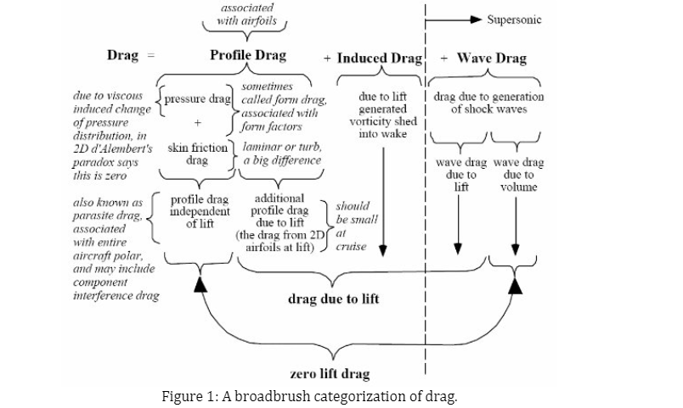

2.1 Aerodynamic Optimization Techniques
Optimizing aerodynamic shapes is essential to lowering drag. The creation of streamlined designs that lessen the effect of form drag was the main goal of early efforts. Supercritical airfoils and winglets, which are particularly made to lower induced drag by increasing lift-to-drag ratios, have been included into recent advancements in aerodynamic design. By optimizing airflow across the wings and fuselage, these changes lessen the vortex drag produced while in flight (NASA, 2020).

2.2 Active Flow Control
In order to manage airflow across aircraft surfaces, active flow control technologies like blowing, suction, and vortex generators have been investigated. In order to reduce drag, researchers have also looked into artificial jets and plasma actuators, which regulate the boundary layer and stop flow separation (Lehmann et al., 2018). These techniques enable real-time airflow modification to reduce drag, particularly at higher speeds or during intricate maneuvers.

2.3 Surface Treatments and Coatings
One of the most extensively researched aspects of drag reduction is surface treatments. By altering the turbulent boundary layer behavior, Riblet technology—which applies micro-textured surfaces—has been demonstrated to lessen skin friction drag (Becker & Shearer, 2017). Additionally, by lowering surface friction between the vehicle and the surrounding air, hydrophobic coatings and super-slick materials have become viable options for lowering drag (Zhang et al., 2019).

2.4 Emerging Technologies
According to Nguyen et al. (2020), recent developments in aerospace drag reduction have embraced bio-inspired designs, which imitate the traits of animals like as sharks and birds that naturally experience lower drag due to their body forms and skin textures. Additionally, in comparison to conventional fixed-wing designs, morphing wing structures and adaptive surfaces provide the opportunity to dynamically optimize aerodynamic efficiency under various flying situations, greatly lowering drag (Johnson et al., 2021).

METHODOLOGY
A thorough and methodical analysis of the body of research on drag reduction strategies in aerospace engineering is part of this review paper's methodology. The objective was to compile and evaluate the many technologies and approaches now employed to lower drag in aerospace vehicles and to find new approaches that might influence future developments in the area. A thorough examination of academic journals, conference proceedings, technical reports, patents, and government research publications is the main source of the review's analysis. These are the main steps that comprise the methodology:

3.1 Categorization of Drag Reduction Techniques
The identified sources were categorized into four broad groups based on the drag reduction technique they discussed. These categories are:
- Aerodynamic Shape Optimization
- Active Flow Control
- Surface Treatment and Coatings
- Emerging Technologies and Bio-Inspired Designs
Each category was then explored in greater detail to understand the underlying principles, technologies, and the application of these techniques in various aerospace contexts
3.2 Aerodynamic Shape Optimization
In order to comprehend how geometric changes contribute to drag reduction, studies pertaining to aerodynamic form optimization were examined. In particular, these sources were examined using the following standards:
Techniques for Shape Design: The application of optimization algorithms, shape parameterization methods, and computational fluid dynamics (CFD) simulations were reviewed in papers. To reduce drag, this required knowing how various aerodynamic shapes—such as airfoils, fuselage shapes, and winglets—were created or altered.
Wind Tunnel Testing: To assess the efficacy of these design modifications in practice, the outcomes of experimental validation of optimized shapes using wind tunnel experiments were examined.
The impact of the papers on enhancing the lift-to-drag ratio (L/D ratio), which is essential for lowering induced drag, especially for high-performance aircraft, was the basis for the analysis.

3.3 Active Flow Control
Dynamically controlling airflow across the aircraft's surface is the goal of active flow control approaches. This review's section concentrated on the following:
Different Flow Control Method Types: Suction/blowing techniques, vortex generators, plasma actuators, and synthetic jet actuators were among the active flow control technologies that were studied. Each technique's capacity to affect the boundary layer, lessen flow separation, and minimize drag was evaluated.
Methods of Reducing Drag: The ways in which each flow control technique enhances aerodynamic performance were thoroughly examined. Vortex generators, for instance, energize the boundary layer by producing tiny vortices that prevent separation and lower drag. In contrast, electrical fields are used by plasma actuators to ionize the air and control flow characteristics.
Effectiveness and Challenges: Research papers were reviewed to understand the efficacy of each technique in real-world conditions, as well as the challenges in terms of complexity, weight, and energy consumption.
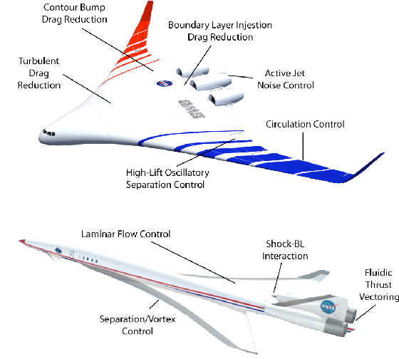
Figure 4.Active Flow Control Activities

3.4 Surface Treatments and Coatings
Coatings and surface treatments are crucial for lowering skin friction drag. Several important technologies were the focus of the review:
Riblets and Micro-Textured Surfaces: The application of micro-scale textured surfaces to the aircraft's body, known as Riblet technology, was thoroughly examined. By changing the turbulent flow close to the surface, these surface textures lessen skin friction drag. The most effective riblet size, shape, and orientation were determined by analyzing studies.
Research on hydrophobic (water-repellent) and super-slick coatings was examined in order to determine how well they work to reduce drag, especially when it comes to lowering surface-to-air friction. By improving laminar flow, the use of these coatings can help reduce drag.
Laminar Flow Control: Studies involving laminar flow control techniques were evaluated, focusing on how maintaining laminar flow over large portions of the aircraft surface could minimize the drag associated with turbulent boundary layers.
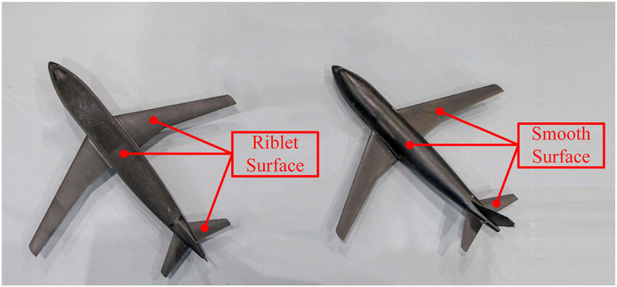
figure 2. riblet surface vs smooth surface

3.5 Emerging Technologies and Bio-Inspired Designs
In aeronautical engineering, emerging technologies are transforming drag reduction, especially with bio-inspired designs and cutting-edge materials:
Bio-Inspired Designs: This review concentrated on studies that imitate natural organisms, including the usage of riblets modeled after sharkskin to cut down on drag. Aerospace engineers have developed designs that reduce drag by examining how fish and birds move through fluid. The ability of natural case studies—like the streamlined form of sharks and bird feathers—to serve as inspiration for more effective aircraft designs was examined.
Adaptive surfaces and morphing structures: We analyzed papers that investigated morphing wings, which alter their shape while in flight to maximize aerodynamic performance. In order to optimize drag reduction in real-time, this category also featured adaptive surfaces, which alter their characteristics (such as stiffness or shape) in reaction to flying conditions.
Studies on the application of nanotechnology and smart materials, such as self-healing coatings and nano-textured surfaces, were incorporated in order to comprehend how these materials can lower drag by enhancing flow dynamics and surface smoothness at the microscopic level.
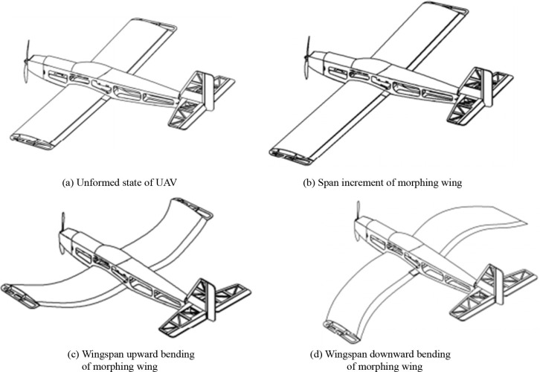
figure 3. Different states of a variable-span and cambered span morphing UAV

3.6 Data Analysis and Synthesis
The literature was categorized, and then the main conclusions from each field were synthesized:
Comparison of Effectiveness: The various drag reduction methods were evaluated according to how well they worked in practical settings, taking into account variables like fuel economy, operational effectiveness, and viability.
Challenges and Limitations: A summary of each technique's drawbacks and difficulties was provided, including issues with financial implications, the difficulty of execution, and the technologies' long-term viability.
Future Directions The current corpus of knowledge was used to identify emerging trends and future research directions, such as the possibility of combining machine learning, sophisticated computational techniques, and hybrid technologies.
3.7 Limitations of the Methodology
Despite being thorough, the review had certain limitations.
Selection Bias: Since the evaluation mostly concentrated on published studies, it might not have included all novel or experimental approaches.
Exclusion of Non-Peer-Reviewed Work: Despite the possibility that they could offer ground-breaking developments in the industry, technical papers and proprietary research from businesses may not have been included.
Theoretical vs. Practical Performance: Although a large number of the examined research used wind tunnel testing or computational models, some technologies may have little or conflicting real-world implementation data
CONCLUSION
In aircraft engineering, reducing drag is crucial for enhancing performance, fuel economy, and efficiency in a variety of aerospace vehicle types. Numerous innovations have been made to reduce parasite and induced drag, ranging from aerodynamic form optimization to sophisticated surface treatments and innovative technologies like bio-inspired designs and active flow management. However, issues including cost, complexity, and the effect on vehicle weight and structural integrity frequently restrict the use of these strategies.
The incorporation of new technologies, such artificial intelligence enabling real-time aerodynamic modifications, and ongoing developments in material science are key to the future of drag reduction in aeronautical engineering. Future aeronautical systems will probably be more efficient, high-performing, and sustainable as a result of ongoing research and technology advancements...
REFERENCES
- Becker, S. D., & Shearer, R. M. (2017). Riblets and their application to reduce skin friction drag. Journal of Aircraft, 54(4), 1477-1484.
- Johnson, D. R., Yu, F. X., & Patel, M. (2021). Morphing wing technologies: A new frontier in drag reduction. Aerospace Science and Technology, 104, 105698.Gyusoo Kim and Seulgi Lee, “2014 Payment Research”, Bank of Korea, Vol. 2015, No. 1, Jan. 2015.
- Lehmann, D. A., Oliveira, R., & Yu, S. X. (2018). Active flow control for drag reduction in aerospace applications: A review. International Journal of Aerospace Engineering, 2018, 4326017.
- NASA. (2020). Aerodynamic Shape Optimization for Reduced Drag. NASA Technical Paper TP-2019-5410..
- Nguyen, V. T., Lee, S. H., & Shin, Y. J. (2020). Bio-inspired design approaches for reducing drag in aerospace vehicles. Journal of Fluid Mechanics, 900, 14-27.
- Zhang, Z., Wang, W., & Li, X. (2019). The role of hydrophobic coatings in reducing aerodynamic drag. Surface & Coatings Technology, 372, 190-197.

