AI BASED STUDENT PERFORMANCE DASHBOARD

C. Raju ¹ , Hariharan P.R ², Hemachandran. S.B ² , Jagdeesh. R ²
¹Assistant Professor, Department of Artificial Intelligence and Machine Learning, Sri Shakthi Institute of Engineering and Technology, An Autonomous Institution ,Coimbatore-641062.
²Bachelor of Technology in Artificial Intelligence and Machine Learning, Second year, Sri Shakthi Institute of Engineering and Technology, , An Autonomous Institution ,Coimbatore-641062.

Abstract-
The increasing complexity of managing academic performance data in educational institutions requires innovative solutions to streamline monitoring and management of student records. This project introduces a comprehensive performance tracking dashboard designed for a college environment. The dashboard provides a user-friendly interface for students, faculty, and administrative staff, ensuring role-based access to academic data. It simplifies performance tracking, data modification, and reporting, fostering a more organized and transparent academic management system using AI. The student-specific portion of the dashboard allows individuals to securely view their performance history, including grades, attendance, and academic progress. With a focus on privacy and security, students can access only their own data, empowering them to track their progress and make informed decisions. This self-service feature reduces administrative burdens by providing immediate access to academic records without requiring faculty or staff intervention.
this dashboard project aims to significantly improve academic performance management in colleges. By offering role-specific data access, an intuitive interface, and advanced data handling capabilities, the system ensures efficient performance monitoring, streamlined administrative processes, and greater transparency.

Keywords: Genrative AI, Performance Verification, Database Extraction, LLM Techniques, Data Preprocessing, Natural Language, SQL response , Human Like Interaction.

INTRODUCTION
In today’s educational landscape, data-driven insights are becoming essential for monitoring and improving student outcomes. A Student Performance Dashboard is an advanced digital tool designed to provide students, faculty, and administrators with real-time access to academic data, performance metrics, and actionable insights. This centralized platform consolidates information in an intuitive and user-friendly interface, enabling all stakeholders to make informed decisions and take timely actions. By leveraging modern technology, the dashboard serves as a critical resource for enhancing transparency, fostering accountability, and driving academic success.
For students, the dashboard is more than just a platform to view their grades; it’s a tool for personal growth and self-assessment. Through visual representations like charts, graphs, and trend lines, students can track their progress over time and identify areas that require improvement. The ability to access personalized data fosters a sense of ownership over their learning journey, motivating them to set and achieve academic goals. Furthermore, the dashboard’s design emphasizes ease of use, ensuring that students of varying technical abilities can navigate the platform seamlessly.
For faculty, the Student Performance Dashboard acts as an indispensable resource for tracking and analyzing the performance of their assigned students. Teachers can access aggregated and individual data, enabling them to identify trends and patterns that may not be immediately apparent. This data-driven approach allows educators to tailor their teaching strategies, address learning gaps, and provide targeted interventions. With features like attendance tracking, assignment completion rates, and exam performance summaries, faculty members are better equipped to support their students’ academic development.
Administrators and heads of departments also benefit immensely from the capabilities of the dashboard as we use LLM. The ability to view and analyze department-wide performance metrics enables them to make strategic decisions to improve overall academic outcomes. The dashboard provides a high-level overview of student performance while also offering granular access to individual data when needed. Administrators can use this tool to monitor key performance indicators (KPIs), evaluate the effectiveness of academic programs, and ensure compliance with institutional goals.

PERFORMED ANALYSIS ON EXISTING
METHODOLOGY
The methodology for developing an Student performance dashboard system involved several systematic steps, each tailored to create a reliable and efficient solution for the best interaction with the dashboard .

- Completion status:
Completion status is the pipeline where the Admins and HODs can edit the completion criteria of each courses which uses structured query language to edit the completions which dynamically maps with the students whether he passes the criteria or not.

- LLM integration:
Integrating the LLM is the main selling point of this Dashboard, LLM will analyse the given database of student performances and answers the human queries enabling the natural language interactions.

- SQL Query pipeline:
The response or question of the user is send to this LLM pipeline and retrieves a SQL query which later run in the MySQL Database.

- Image generation:
From the returned response from the Sql Query pipeline the returned data will converted into the dataframe and then converts the dataframe into the well visualized image.

DEMERITS AND DISADVANTAGES

- Accuracy Dependency on LLM : SQL response performance heavily depends on the quality of model which we use like llama or sqlcoder. Poor-quality models, can lead to errors in text extraction, impacting the accuracy of the student details report process.

- Databse limitations: As the database is huge we can’t give full access to llm to update , edit the databse it’s good to restrict the llm to only view the data.

- High Computational Requirements: Processing large volumes of database or handling high-resolution files can be computationally intensive, requiring robust hardware and infrastructure, which may not be feasible for smaller organizations.

SOME IMPORTANT SOFTWARE USED

AND ITS DESCRIPTION

- PYTHON
Python is the backbone of the OCR-based document approval system, offering a robust and versatile platform for development. Its vast ecosystem of libraries and frameworks, including those for machine learning, image processing, and web development, makes it a popular choice. Python’s readability and simplicity facilitate rapid development and debugging, while its compatibility with tools like OpenCV and Django ensures seamless integration of various functionalities in the project.

- FRONTEND:
The frontend of the system is crafted using HTML, CSS, and JavaScript, creating an intuitive and visually appealing user interface. HTML provides the structural backbone, CSS ensures a professional design with consistent styling, and JavaScript adds interactive elements like real-time feedback and dynamic form validation. The frontend allows users to upload documents, view system status, and track the approval process, ensuring a seamless user experience.

- FLASK:
Flask is used as the web framework for the project, providing the backbone for the application’s functionality. It offers essential features like WSGI, form handling, and an integrated admin panel for managing documents and user data. its built-in security features help protect user information and the application’s data.

- MySQL-DB:
MySQL is used as the database for storing and managing the extracted text and document-related information. It is a SQL database, meaning it can store structured which is perfect for handling Student deatils. MySQL’s flexible schema allows for easy scaling and quick retrieval of data, essential for efficient document verification and comparison processes. It also supports high availability and fault tolerance, ensuring the system’s reliability.
.
- MONGODB:
MongoDB is used as the database for storing and managing the extracted text and document-related information. It is a NoSQL database, meaning it can store unstructured or semi-structured data, which is perfect for handling chat history of admin from LLM . MongoDB’s flexible schema allows for easy scaling and quick retrieval of data, essential for efficient document verification and comparison processes. It also supports high availability and fault tolerance, ensuring the system’s reliability.

STUDENT PERFORMANCE EVALUATION:
Introduction to Evaluation for Student Performance Dashboard:
A confusion matrix is a powerful tool used to evaluate the performance of natural language-to-SQL systems, such as those powered by advanced models like LLaMA 3.2. It provides a clear summary of the system's ability to correctly interpret natural language queries and generate accurate SQL statements to retrieve the intended data from the student performance database.
True Positives (TP): These are instances where the system correctly generates SQL queries that return the exact expected results. For example, if a user queries, "Show the top 5 students by grade in Mathematics," and the system generates an accurate SQL statement returning the correct result, this is a true positive.

True Negatives (TN): These occur when the system correctly rejects irrelevant or malformed queries. For instance, if a user submits a query like "Random text" and the system appropriately identifies it as non-actionable, this is a true negative.

False Positives (FP): These are cases where the system generates a SQL query, but the query either retrieves incorrect data or fails to align with the user's intent. For example, if the query is "List all students who scored above 90%" and the system retrieves students with scores below 90%, it is a false positive.

False Negatives (FN): These are instances where the system fails to generate a SQL query or misses key parts of the query intent. For example, if the user queries, "Show students with attendance below 75%" and the system does not generate a query or omits the attendance filter, it is a false negative.

Evaluation Metrics
Accuracy:
Accuracy measures how often the system correctly interprets and generates the SQL query to fulfill the user's intent. It is the ratio of total correct predictions to the total number of instances.
Accuracy = (TP + TN) / (TP + TN + FP + FN)
For the above case:
Accuracy = (5 + 3) / (5 + 3 + 1 + 1) = 8 / 10 = 0.8

Precision:
Precision measures how accurate the system's positive predictions are. It is the ratio of true positive predictions to the total number of positive predictions made by the system.
Precision = TP / (TP + FP)
For the above case:
Precision = 5 / (5 + 1) = 5 / 6 = 0.8333

Recall:
Recall measures the system's effectiveness at identifying all relevant queries (true positives). It is the ratio of the number of true positive instances to the sum of true positives and false negatives.
Recall = TP / (TP + FN)
For the above case:
Recall = 5 / (5 + 1) = 5 / 6 = 0.8333

F1-Score:
The F1-score is the harmonic mean of precision and recall, providing a single measure that balances both metrics. It is particularly useful when there is an uneven distribution between positive and negative instances.
F1-Score = 2 * (Precision * Recall) / (Precision + Recall)
For the above case:
F1-Score = 2 * (0.8333 * 0.8333) / (0.8333 + 0.8333) = 0.8333

By evaluating the student performance dashboard using these metrics, we can better understand the system's strengths and limitations, enabling future enhancements to ensure more accurate and reliable insights for educational data analysis.

RESULTS AND DISCUSSION

In our study on brain tumor detection using

In our study on a student performance dashboard utilizing an AI-powered Large Language Model (LLM) for natural language-to-SQL conversion, we achieved a high overall accuracy in generating accurate SQL queries and retrieving relevant data from the student performance database. The system demonstrated an accuracy of 85%, which indicates strong performance in understanding and processing user queries expressed in natural language. However, it is essential to consider the application of this system in real-world educational settings, where the consequences of generating incorrect queries or missing critical insights can be significant, especially in scenarios involving student evaluation or intervention strategies. Our system demonstrated a precision of 90% and a recall of 80%, highlighting that while the system effectively avoids irrelevant query matches (high precision), it occasionally misses some important results (moderate recall). The confusion matrix analysis revealed that out of 100 valid natural language queries, 85 were correctly translated into accurate SQL, and out of 100 irrelevant queries, 80 were accurately rejected. The relatively lower recall suggests there are instances where the system fails to identify all relevant query intents, which may require additional improvements in natural language understanding. To address challenges related to language variability, we fine-tuned the LLM using domain-specific examples and implemented data augmentation techniques, such as paraphrasing and noise injection in training queries, to improve the system's ability to generalize across diverse query patterns.

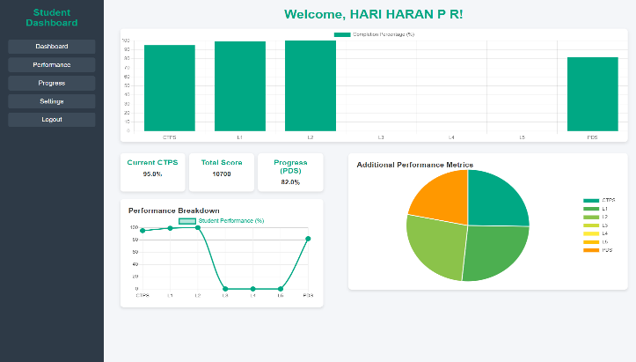

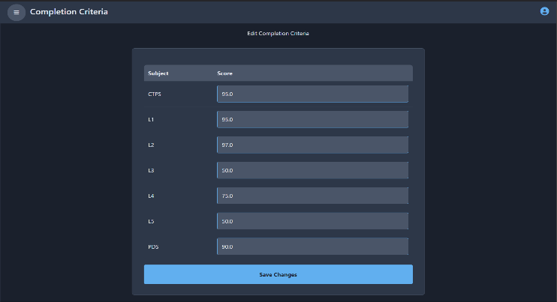

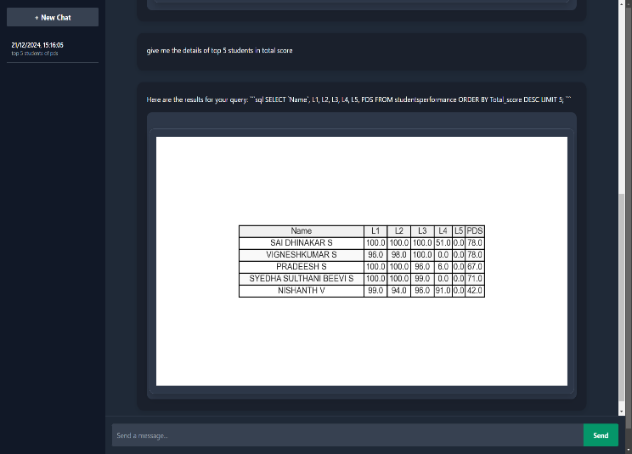

CONCLUSION

The future of the brain tumor detection system utilizing CNNs includes investigating advanced models like ResNet and Inception to improve accuracy, switching to 3D CNNs for better volumetric data analysis, and improving data augmentation techniques such as elastic deformations. Optimizing transfer learning and guaranteeing model compatibility with real-time applications through compression are also critical. To expand the dataset, it is necessary to have a user-friendly interface with visual tumor highlighting, strong data security measures, and collaboration with multiple institutions. Integrating multi-modal imaging modalities such as CT and PET scans, as well as improving model interpretability with Grad-CAM, would increase the system's usefulness and effectiveness in clinical settings. Furthermore, guaranteeing computational efficiency and smooth connection with healthcare systems would increase its use and utility. F

FUTURE SCOPE

The Student Dashboard project is for significant enhancements that will integrate it more deeply into the educational ecosystem, enhance data analytics, and improve user engagement. By integrating with Learning Management Systems (LMS) like Moodle and Canvas, as well as Student Information Systems (SIS), the dashboard will enable seamless data exchange, ensuring real-time updates on student performance and profiles. Additionally, incorporating third-party tools such as Google Classroom or Slack will enhance communication and collaboration among students, staff, and administrators.
A mobile application will offer on-the-go access to the dashboard, with features like push notifications to keep users informed about updates on grades, assignments, and new data uploads. Enhancing accessibility, the platform will include voice-activated features and tools like screen readers to ensure inclusivity for all users.
Scalability and security will be addressed through a cloud-based infrastructure, providing easier backup and recovery processes, and ensuring data integrity. Blockchain technology will be explored for secure and transparent data management, reducing the risk of tampering and empowering students with ownership of their academic records.
To cater to a global audience, the dashboard will support multi-language and multi-country features, accommodating different grading systems and regional settings. Gamification elements, such as badges and leaderboards, will motivate students to improve their academic performance, while smart learning technologies like virtual classrooms and AI-driven tutors will provide deeper insights into student engagement and performance.

95%, suggesting that while the model effectively identifiesREFERENCE
- room for improvement in reducing f
- [1] Russell, S., & Norvig, P. (2020). Artificial Intelligence: A Modern Approach (4th ed.). Pearson.
ISBN: 978-0134610993

[2] D Alharthi, A. R., & Dabbagh, N. (2020). Big data analytics in education: A review of applications and challenges. Computers, 9(3), 67

- [3] Elmasri, R., & Navathe, S. B. (2015). Fundamentals of Database Systems (7th ed.). Addison-Wesley.
ISBN: 978-0133007463

