**The Role of Women in Tribal Resistance: A Perspective from *Choti Munda and His Arrow***

***Dr.Pradnyashailee Bhawan Sawai*** *Assistant professor,Department of English,Government college of arts and science,Chhatrapati Sambhajinagar.*

***Snehal Dattatray Jadhav Mail ID:*** [***sehaljadhav.yashada@gmail.com***](mailto:sehaljadhav.yashada@gmail.com)

***Abstract***

*This paper explores the significant role of women in tribal resistance as depicted in Mahasweta Devi’s Choti Munda and His Arrow. It highlights the intersectionality of gender, class, and ethnicity in tribal struggles, focusing on how women contribute to preserving culture, resisting oppression, and sustaining their communities. Through an analysis of key female characters and their actions, this study examines the nuanced representation of women in the tribal resistance movement and their enduring impact on the narrative.*

***Keywords:*** *Women in tribal resistance, Choti Munda, Mahasweta Devi, cultural preservation, gender and ethnicity, tribal struggles, intersectionality.*

# Introduction

Mahasweta Devi’s *Choti Munda and His Arrow* delves into the lives of marginalized tribal communities, highlighting their resilience in the face of systemic exploitation. While much attention is given to the titular character, Choti Munda, the role of women in the narrative remains an essential yet underexplored aspect. This paper aims to shed light on how women contribute to tribal resistance and the preservation of cultural identity, revealing their indispensable role in sustaining the community’s fight against oppression. Women in the novel are depicted as pillars of strength and reservoirs of hope, acting as both preservers of their traditions and active participants in revolutionary activities. Their actions serve to balance the narrative, ensuring that the focus is not solely on Choti Munda but also on the collective efforts of the community. By resisting not just external oppressors but also internal patriarchal norms, these women redefine their roles and assert their agency in an otherwise male-dominated society. Furthermore, their resilience is intertwined with the broader socio-political struggles of the Mundari people. The novel portrays them not merely as victims but as crucial players in the ongoing resistance, often leading through example and moral courage. Their ability to endure and resist systemic exploitation sheds light on the layered complexities of gender and tribal identity in postcolonial India. These narratives demand recognition for the nuanced ways in which women influence and sustain tribal resistance movements.

# Contextualizing Tribal Resistance

Tribal resistance in India has historically been a collective effort involving both men and women. Women, often sidelined in mainstream narratives, have played a pivotal role in grassroots movements. In *Choti Munda and His Arrow*, Mahasweta Devi weaves their contributions into the larger fabric of the struggle, demonstrating their agency within a patriarchal and oppressive socio-political framework. The resilience of tribal women is central to the movement’s success. Their participation often transcends traditional gender roles, as they take on leadership positions and challenge systemic oppression. The novel underscores the importance of collective memory and oral traditions, which women help preserve to inspire future generations. By highlighting their agency, Mahasweta Devi reveals the often-overlooked contributions of women in shaping resistance movements.

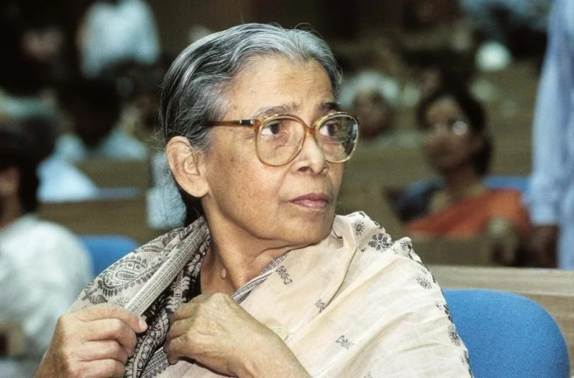

# Author: Mahasweta Devi

Additionally, the novel delves into the personal sacrifices made by these women, showcasing their unwavering commitment to their community. Despite facing intersecting layers of marginalization, their stories emerge as powerful narratives of empowerment and defiance. This exploration sets the stage for a deeper understanding of the dynamics of tribal resistance and the transformative role of women within it.

1. **Representation of Women in *Choti Munda and His Arrow***

The novel features a variety of female characters who embody resilience and resistance. These women are not mere spectators but active participants in the fight for justice. Through their roles as caregivers, cultural preservers, and fighters, they shape the community’s response to external threats.

* + **Women as Cultural Custodians:** Tribal women often act as guardians of tradition, passing down folklore, songs, and rituals that reinforce communal identity. In the novel, their efforts to preserve cultural practices are depicted as a form of resistance against cultural erasure. By ensuring these traditions are remembered and passed on, the women strengthen the community’s collective identity and resistance against systemic oppression. Their roles highlight how culture becomes a tool of survival and defiance in the face of external pressures.
  + **Active Resistance:** The women in *Choti Munda and His Arrow* engage in both overt and covert forms of resistance, from participating in protests to subtly challenging oppressive norms within and outside their communities. Their actions often bridge the gap between tradition and modernity, showcasing their adaptability and strategic thinking. These women not only inspire others to resist but also lay the groundwork for future struggles, ensuring the community’s resilience endures over generations. They exemplify how active resistance can take diverse forms, from physical protests to symbolic acts of defiance that challenge the status quo.

# Intersectionality of Gender and Oppression

Mahasweta Devi’s narrative highlights the layered oppression faced by tribal women, stemming from their gender, tribal status, and socio-economic conditions. This intersectionality adds complexity to their roles in resistance, as they navigate challenges that arise both within their communities and from external forces.

* + **Gender Dynamics within the Tribe:** While tribal societies are often more egalitarian than mainstream ones, women still face limitations. The novel showcases how these women challenge and negotiate these dynamics to assert their agency. By doing so, they redefine traditional roles and create spaces for broader acceptance of their leadership and contributions within the tribe.
  + **Resistance Against External Exploitation:** Tribal women’s struggles against landlords, moneylenders, and colonial forces underscore their dual role as both victims and agents of change. Their resistance often embodies a moral and cultural defiance, ensuring that the fight for justice becomes deeply rooted in the collective memory of the tribe. Moreover, their courage inspires future generations, laying the groundwork for sustainable resistance movements that persist beyond immediate struggles.

# Key Themes in Women’s Resistance

Several recurring themes in the novel illustrate the role of women in tribal resistance:

* + **Sacrifice and Resilience:** Women often bear the brunt of economic and physical exploitation but continue to stand resilient in their fight for justice.
  + **Collective Solidarity:** Female characters in the novel emphasize the importance of solidarity, often leading or organizing collective actions that drive the resistance forward.
  + **Empowerment through Education and Awareness:** The novel touches upon how women’s access to education and political awareness can amplify their roles in tribal movements.

# Comparative Analysis with Real-World Tribal Movements

The portrayal of women in *Choti Munda and His Arrow* reflects real-life instances of tribal resistance, such as the participation of women in the Jharkhand Movement and the Chipko Movement. Drawing parallels between the novel and historical movements enriches the understanding of the roles tribal women have played across different contexts.

These real-world movements demonstrate how women have been at the forefront of resisting exploitation, often leading efforts to protect their communities and natural resources. For instance, the Chipko Movement exemplifies women’s deep connection to the environment and their role in safeguarding it against deforestation. Similarly, the Jharkhand Movement highlights their active participation in advocating for tribal autonomy and rights.

The novel mirrors these movements by showcasing the resilience and agency of its female characters. It sheds light on how women’s resistance extends beyond physical protests, incorporating symbolic acts of defiance and cultural preservation. Their role is not just reactive but proactive, as they often anticipate and mitigate challenges posed by oppressive systems. Furthermore, the integration of historical context in Mahasweta Devi’s narrative reinforces the enduring relevance of women’s struggles in tribal resistance. By drawing these parallels, the novel elevates the understanding of women’s contributions as transformative agents in their communities. This comparative lens emphasizes that women’s roles in resistance movements are both historically significant and critical for future struggles.

# Conclusion

Mahasweta Devi’s *Choti Munda and His Arrow* offers a profound exploration of the role of women in tribal resistance. Through her nuanced portrayal of female characters, Devi highlights their indispensable contributions as cultural custodians, active participants, and resilient leaders. The novel serves as a tribute to the unsung heroines of tribal struggles, reminding readers of the crucial role gender plays in shaping resistance movements. Recognizing and amplifying these voices is essential for a holistic understanding of tribal resistance and its ongoing relevance in contemporary socio-political contexts.

# References

1. Devi, Mahasweta. Choti Munda and His Arrow. Translated by Gayatri Chakravorty Spivak, Seagull Books, 2002.
2. Chakravarti, Uma. "Gendering Caste through a Feminist Lens." Stree, 2003.
3. Omvedt, Gail. Dalits and the Democratic Revolution: Dr. Ambedkar and the Dalit Movement in Colonial India. Sage Publications, 1994.
4. Teltumbde, Anand. The Tribal Question in India. Routledge, 2021.
5. Xaxa, Virginius. "The Political Economy of Tribal Development." Economic and Political Weekly, vol. 34, no. 18, 1999, pp. 101-110.
6. Bama. *Sangati: Events*. Oxford University Press, 2005.
7. Sundar, Nandini. "Subalterns and Sovereigns: An Anthropological History of Bastar, 1854–1996." Oxford University Press, 1997.
8. Shah, Alpa. "Nightmarch: Among India’s Revolutionary Guerrillas." Hurst Publishers, 2018.
9. Das, Veena. "Critical Events: An Anthropological Perspective on Contemporary India." Oxford University Press, 1995.
10. Mohanty, Chandra Talpade. "Feminism Without Borders: Decolonizing Theory, Practicing Solidarity." Duke University Press, 2003.