**Hybrid Mechanism-Based Transient Thermal Analysis of Disk Brake Rotor of Various Materials**

**Mr.Premsingh Tomar and Prof. Ganesh Singh Chauhan \***

*Lakshmi Narain College of Technology(RIT) IndoreM.P.   
[premtomar0703@gmail.com](mailto:premtomar0703@gmail.com); [ganesh.lnct11@gmail.com](mailto:ganesh.lnct11@gmail.com);

**ABSTRACT**

The technology of today surpasses us. In the automobile industry, engine technology advances quickly, affecting not only the bike, vehicle, and luxury or comfort systems, but also every system that results from engineer innovation. Safety is therefore the primary concern that has to be addressed. "Design and Thermal analysis of disc brake rotor of different material" is the title of this research, which examines disc brake rotors by examining various vehicle slot forms. braking rotor with discs. As a result, we may estimate the disc brake rotor's superior heat conductivity by optimizing the number of slot forms..

This study presents the results of thermal analysis performed on an actual disc brake rotor model. Different slot shapes are used for both improved heat conductivity and to lighten the disc rotor's weight. With any luck, this article will make it easier for everyone to comprehend thermal analysis of disc brake rotors and how disc brakes operate more effectively.

**Keywords**: Thermal analysis, Braking rotor, Disc brake

**INTRODUCTION**

In modern cars, disc brakes and drum brakes are the two most common types of brakes. Many cars with front-wheel drive, four-wheel drive, and rear-wheel drive have drum brakes on the back. Most cars produced since the early 1970s have disc brakes on the front wheels, and many have them on the back wheels as well. Brake pads are squeezed on both sides of the rotor disc that is fixed to the wheel in order for a disc brake to work.

By applying pressure to the brake pedal, which modifies the hydraulic circuit's brake fluid pressure, the driver may control when to slow down the car. A booster that employs vacuum is used to raise the hydraulic pressure above the force exerted by the driver. This vacuum is often caused by the combustion engine's intake manifold vacuum in gasoline engines. Instead, a separate vacuum pump is frequently utilized for diesel engines. The booster's increased force enters the master cylinder, which then distributes the pressure to each caliper.

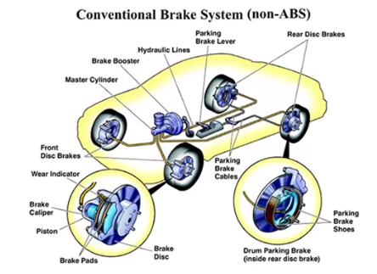

**Figure 1: Disc brake system location in a car**.

The most popular form of disc brake in automobiles is the single-piston floating caliper, however some modern braking systems employ up to six pistons, or three pistons on each side of a fixed caliper braking system.

**BRAKE SYSTEM**

A car's braking system offers the ability to stop it. Many people believe that the braking system is the most crucial component in a vehicle's performance. A vehicle's braking system should be designed to enable the driver to stop it in the least amount of time.

**PROBLEM STATEMENTS**

A device used to slow or halt a vehicle's wheel spinning is the disc brake. Brake pads, or other friction material, are applied manually, hydraulically, pneumatically, or electromagnetically to both sides of the disc to slow or stop the wheel. Brake pads and discs will get stressed when brakes are applied quickly. Because the disc brake started to break, the brake could not stop as well. There are now four different types of disc brake designs: combined drilled and grooved brake disc, drilled disc brake, grooved disc brake, and standard disc brake. Generally speaking, the performance and stress of a disc brake vary depending on its design. This occurs as a result of gas forming between the brake pads and the rotors during the braking operation. Braking efficiency is affected by the disc design, which also affects the rate of stress and consistent wear of the disc and brake pad.

The main goal of this research is to simulate the behavior of different disc brakes when braking-related forces and moments are applied during static conditions. Analysis may be done on the disc's stress distribution based on the simulation results.

To enable a consistent comparison later on, it is crucial to be clear about the established constraints from the start for complicated flow behavior scenarios such as these. It should be noted that this study will only be conducted using a certain mid-sized Volvo vehicle that has standard wheel house equipment and a five spoke rim design. Only the convective flow behavior for the various scenarios will be examined; complete thermal models will not be examined. Since the brake disc temperature is likewise dependent on the braking load scenario, which is best avoided as an additional parameter, it will also be considered to be constant across the surface. However, restrictions in the future will always be discussed with regard to certain situations like temperatures, speeds, and designs. Another drawback is that this study will only look at the front brakes, which are often given priority because of the larger braking torque distribution in the front, which typically results in a lot of heat energy being absorbed. Additionally, this study will only employ steady-state thermal analyses—that is, no transient situations. These kinds of SS simulations are frequently carried out by industrial engineers in order to establish initial values for things like temperatures, thermal gradients, and heat flow rates, prior to transient assessments. Temperature-dependent convective coefficient effects would be impacted by the non-linear analysis, as most material characteristics are temperature-dependent. All of the study's restrictions bring the final result's applicability to a limited range, but it will nevertheless provide a solid foundation for more in-depth research in the future.

**Disc Brake**

Initially, normal disc brakes offer higher braking force because they have a larger surface area contacting the brake pads when the brakes are engaged. However, a common issue with brakes is that during operation, gas builds up between the disc and pad, resulting in brake fade and pad glazing. If the brakes are poorly constructed or the wrong pads are combined with them, the additional heat can potentially damage the discs.

**PROGRAM OVERVIEW**

The ANSYS element collection offers more than 60 elements for static and dynamic analysis, over 20 for the heat transfer analysis and includes various magnetic field and special purpose elements. These many element types are studied as 2D and 3D frame structures, axi-symmetric and 3D shells, piping systems, and nonlinear issues such as cables and contact (interfaces) in the ANSYS software.

Analyzation of any problem in ANSYS has to go through three main steps. They are

1. Preprocessor
2. Solution
3. Postprocessor

The preprocessor is used to prepare the input for an ANSYS analysis. The general preprocessor contains powerful solid modeling and mesh generation capabilities, and is also used to define all other analysis data (geometric properties like real constants, material properties, constraints, loads, stiffness, damping etc.,) with the benefit of database definition and manipulation of analysis data. The ANSYS program offers parametric input, user files, macros, comprehensive online documentation, and graphics capabilities. These features include isoperimetric, perspective section, edge and hidden line displays of 3D structures, x-y graphs of input quantities and results, and contour displays of solution results. Throughout the application, a graphical user interface (GUI) helps novice users get started and offers more seasoned users features like pull-down menus, dialog boxes, numerous windows, and tool-based online documentation.The solve option from the solution menu may be used to solve an ANSYS problem. For a static problem, it specifies the loads and restrictions to be applied; for a dynamic problem, it specifies the kind of analysis to be done. The primary purpose of the ANSYS post processor is to examine the findings in the necessary format once modeling and analysis are finished. A generic post processor plus a time history post processor define the ANSYS post processor. findings that are time- and frequency-invariant can be seen using the general post processor, which also has the capacity to display findings in animated forms and modes that the system's natural frequencies can view. On the other hand, the time history post processor provides findings that change with time or frequency. It also displays the data graphically, making system analysis easier.

**TYPES OF ANALYSIS**

The various analyses that can support by ANSYS are

* Static
* Modal
* Harmonic
* Transient
* Spectrum
* Eigen buckling
* Sub structuring

**METHODOLOGY FLOW CHART**

The research methodology flow is displayed below. Firstly, we must choose a suitable material for the disc rotor. Next, a CATIA V5 cad model must be created. Next, we must conduct transient thermal analyses of various materials and disc rotor types, and we must compare the results with the base case.

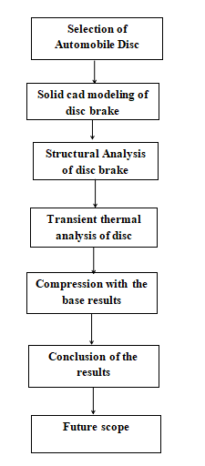

**Figure :2 Methodology Flow Chart**

**MODEL ACCURACY**

It was acknowledged that the time constraints and permissible model complexity would impose restrictions on the model's accuracy. The most important of them has historically been defining the inputs for heat production. Errors will happen even when precautions have been made to guarantee that the stop test and the level of modeling have been established to accuracy commensurate with the kind of expected results.

The impact of disc distortion on the pad pressure distribution and, consequently, the heat input during the stop, has not been taken into consideration. Although the impacts of coning on this can be inferred from the findings, the simulation itself cannot incorporate and quantify the effects of coning. Instead, the simulation must be run with the same radial heat input distribution over the brake face throughout. In addition no measure of the small impacts of caliper flexure and sliding friction are provided for this specific scenario.

CATIAV5, a sketch-based, feature-based, parametric 3D modeling program created by Dassault System, is used to create the CAD model. Extrude, sweep, and pattern tools are used in the development of the CAD model.

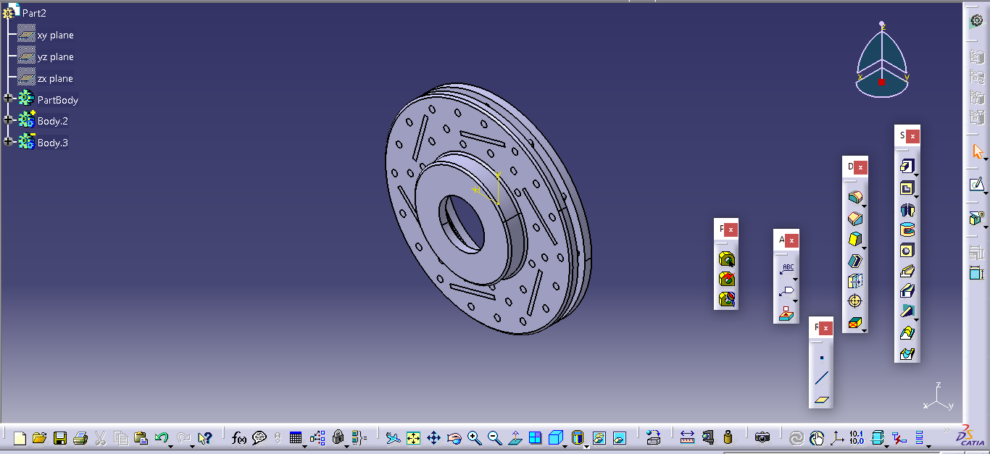

Figure 3: CAD model developed using CATIAV5 software

**TRANSIENT THERMAL ANALYSIS**

A transient thermal analysis computes the fluxes and temperatures in your model during a specified period of time. You can instruct ANSYS Simulate to report temperature loads or complete results at predetermined times

Non-physical temperature values, such as temperatures that are greater or lower than any applied temperature, can occasionally be obtained in thermal FEA models due to decisions made about the size, shape, and arrangement of the components as well as high Biot number convective loads. High-order components in transient models can be amplified by using tiny temporal sub steps.

Inlet and outlet boundary conditions are established for the fluid once the domain has been defined and the fluid attributes have been assigned in the material specification. The boundary condition at the exit is specified at 0 relative pressure, while the input condition is defined at varying mass flow rates at 850C temperature.

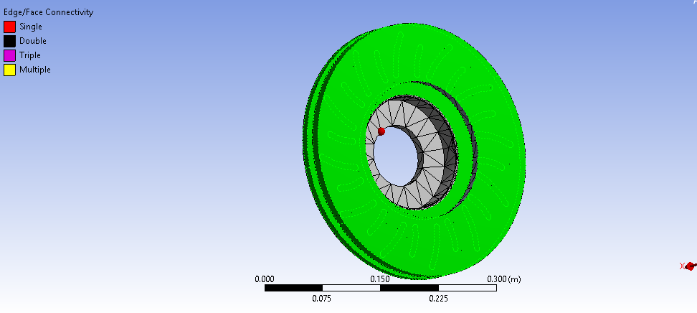

Figure 4: Inlet boundary condition

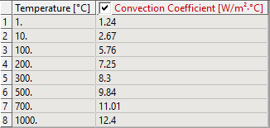

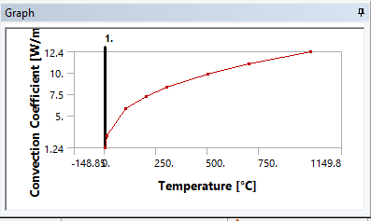

Fig 5 Graphical representation

**SIMULATION**

Tetra elements are used to mesh the CAD model after it is loaded into ANSYS Workbench. The discretization of domain, or the conversion of solid models into finite element models—that is, into nodes and elements with the proper mesh density and size—is the foundation for the meshing process. An excessively fine mesh density will result in a high computational cost, whereas an excessively low mesh density will undermine the solution's accuracy level.385.67 W/m2 of heat flux boundary conditions are used, along with convection values of 7.9 W/m2 for cast iron to air, 11.3 W/m2 for steel to air, and 90 W/m2 for Al-MMC to air. The specified ambient temperature is 280°C. The same model is loaded into ANSYS CFX for CFD simulation. A CAD model enclosure with the dimensions of.1 m x.1 m x.1 m is created. The disc brake volume is deducted from the enclosure volume in a boolean operation. With the air intake boundary set at 2.5 m/sec for low speed and 10 m/sec for high speed, the fluid domain type is selected for analysis. K-epsilon is the chosen turbulence model as it is more manageable and easier to replicate. Zero relative pressure is the outlet boundary condition that is configured. Thermal energy is the energy model used for analysis, and it accounts for temperature changes. Convergence criteria set for analysis is RMS residuals to 1e-4.

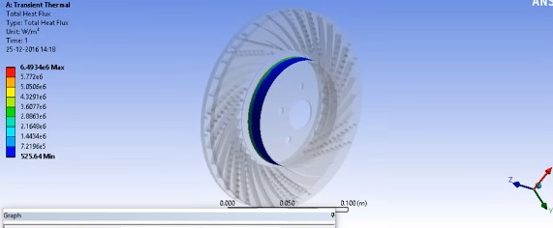

Fig 6

**TEMPERATURE DISTRIBUTION** This result has a selected temperature dispersed on disc brake at a moment of braking at this time we consider temperature is 1000 c. This is the maximum temperature that the disc brake or body has calculated.

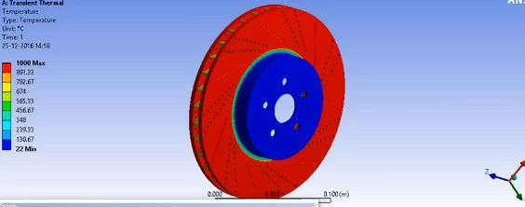

Fig 7 Maximum Temperature distribution

**EXISTING WORK:-**

Transient state temperature distribution for different materials

|  |  |  |  |
| --- | --- | --- | --- |
| Time in seconds | Cast iron temp | Steel temp | AI-MMC temp |
| 1. | 314.91 | 319.60 | 302.45 |
| 2. | 295.65 | 296.63 | 300.74 |
| 3. | 298.17 | 298.17 | 300.85 |
| 4. | 300.83 | 300.83 | 300.01 |

**Conclusion**

While a great deal of this work still has to be implemented, it is anticipated that the causes and mechanisms of brake disc thermal distortion have been clearly illustrated. Disc design will never be a strictly defined process; the designer's judgment and expertise are obviously important, but it is vital to base decisions on reliable information, which is why this thesis has been written. It is essential to consider the intended applications of the disc while designing it, and it is anticipated that sufficient evidence has been provided to support the viability of creating a design with a certain performance in mind. There are several factors that can be altered, and if the effects of each are understood, a disc with the least amount of bulk and very precise goals may be built.

**REFERENCES**

***[1]*** *KENNEDY, F. E., COLIN, F. FLOQUET, A. AND GLOVSKY, R. Improved Techniques for Finite Element Analysis of Sliding Surface Temperatures. Westbury House page 138-150, (1984).*

***[2]*** *A. R. Abu Bakar and H. Ouyang, Wear prediction of friction material and brake squeal using the finite element method. Wear, Vol.264 No.11-12, pp.1069-1076,2008.*

***[3]*** *Muhamad Ibrahim Mahmod, Kannan M. Munisamy, ―Experimental analysis of ventilated brake disc with different blade configuration‖ Department of mechanical Engineering, Vol. 1, PP 1-9, 2011*

***[4]*** *P.F.Gotowicki, V.Nigrelli and G.V.Mariotti, Numerical and experimental analysis of a pegs-wing ventilated disk brake rotor, with pads and cylinders, In: 10th EAEC Eur.Automot. Cong – Paper EAEC05YUAS04– P 5, June, 2005.*

***[5]*** *Hudson, M., Ruhl, R., Ventilated brake rotor air flow investigation, SAE Technical Paper 971033, 1997.*

***[6]*** *Wallis, L., Leonardi, E., Milton, B., Air flow and heat transfer in ventilated disc brake rotors with diamond and tear-drop pillars, Proceedings of International Symposium on Advances in Computational Heat Transfer, Australia, 2002, pp. 643–655.*

***[7]*** *Lee, K. J., Barber, J. R., An experimental investigation of frictionally-excited thermo elastic instability in automotive disk brakes under a drag brake application, Journal of Tribology 116 (1994) 409–414.*

***[8]*** *Lee, K., Barber, J. R., Frictionally excited thermoelastic instability in automotive disk brakes, ASME Journal of Tribology 115 (1993) 607–614.*

***[9]*** *Voldˇrich, J., Frictionally excited thermo elastic instability in disc brakes-transient problem in the full contact regime, International Journal of Mechanical Sciences 49 (2007) 129–137.*

***[10]*** *Zagrodzki, P., Thermo elastic instability in friction clutches and brakes-transient modal analysis revealing mechanisms of excitation of unstable modes, International Journal of Solids and Structures 46 (2009) 2 463–2 476.*

***[11]*** *Zhu, Z. C., Peng, U. X., Shi, Z. Y., Chen, G. A., Three-dimensional transient temperature field of brake shoe during hoist’s emergency braking, Applied Thermal Engineering 29 (2009) 932–937.*