|  |  |  |
| --- | --- | --- |
|  | **INTERNATIONAL JOURNAL OF PROGRESSIVE RESEARCH IN ENGINEERING MANAGEMENT**  **AND SCIENCE (IJPREMS)**  **(Int. Peer-Reviewed Journal)** | **e-ISSN :**  **2583-1062** |
| **Impact**  **Factor :**  **5.725** |
| **www.ijprems.com** |
| **editor@ijprems.com** |

**DESIGN AND ANALYSIS OF G+1 RESINDRNTIAL BUILDING USING STAADPRO**

*aAlampallyPraveenKumar,b,A.Sathish, Kasireddy.PrathapReddy*

abcU.G. Students, Department of Civil Engineering, Guru Nanak Institutions Technical Campus, Ibrahimpatnam, Telangana, India

dAssistant Professor, Department of Civil Engineering, Guru Nanak Institutions Technical Campus, Ibrahimpatnam, Telangana, India

**ABSTRACT**

The primary objective of this project is to gain sufficient knowledge in planning and design of building. Our project deals with the planning and design of a residential building. Planning of structure was done in Auto cadd software and design of structure components like slab, beam, column, footing, staircase etc was done by Stadd Pro software. It is a reinforced concrete framed structure consisting of G+1.IS 456:2000 codes is the basic code for general construction in concrete structures, hence all the structural members are designed using limit state method in accordance with the IS 456:2000 code and design aids. The help of Microsoft Excel and AutoCAD we successfully found the estimated area of Plot area = 193.97sq.m, Ground floor area = 105.02 sq.m, First floor area = 105.02 sq.m,F.S.I Permited = 1.0 ,.

**Keywords:** Autocad,Staad.pro V8i

**1. INTRODUCTION**

The main objective of our project is to know the various design aspects like planning and estimate We have planned to design a residential building consisting of two floors (G+1).The planning is done as per the requirements and regulations given.

1.1.Planning Considerations

The plan and detailing was drawn using Auto CAD. The shape of the building is rectangular in plan. The building consists of ground floor and first floor. The parking space is provided around the building. The staircase is provided with enough safe.

National Building Code (NBC).

1.2.Designing

Designing means Build a method is done in stadd pro software.Staad pro can design a structure for various types of material like Steel,Concrete,Aluminium and Timber. we select IS 456-2000 with limit state method. It gives extensive information on the various aspects of concrete.

**2 LITERATURE REVIEW :**

1. Thompson, D. (2015). Design of Multistory Reinforced Concrete Buildings forEarthquake Motions: Thompson's work focuses on the specific challenges of designing multi-storied buildings to resist seismic forces. It offers practical design strategies, performance evaluation techniques, and case studies, making it an essential reference for engineers working in earthquake engineering and structural design.
2. FEMA. (2009). Designing for Earthquakes: A Guide for Architects and Engineers: This publication provides guidelines for designing buildings that can withstand seismic forces, emphasizing risk reduction and safety. It discusses engineering principles, design strategies, and best practices for creating resilient structures in earthquakeprone regions.
3. Ching, F. D. K., & Binggeli, C. (2018). Building Construction Illustrated: This comprehensive guide provides detailed illustrations and explanations of construction methods and materials, making it an invaluable resource for architects and engineers. It covers various aspects of building design and construction, including structural systems, materials, and environmental considerations, all presented in an accessible format that enhances understanding.

4.Taranath, B. S. (2013). Structural Analysis and Design of Tall Buildings: This book offers in-depth coverage of the principles and practices involved in designing tall buildings, including both steel and composite structures. Taranath emphasizes structural behavior under various loads, providing readers with advanced analytical techniques and design strategies for highrise construction.

2. OBJECTIVES OF THE PROJECT

The objectives of the project are mentioned below

1. To Plan G+1 Structural Residential Building.
2. To draw plan G+1 Residential Building Using Auto Cad

3. To Design G+1 Residential Building Using Staad pro.

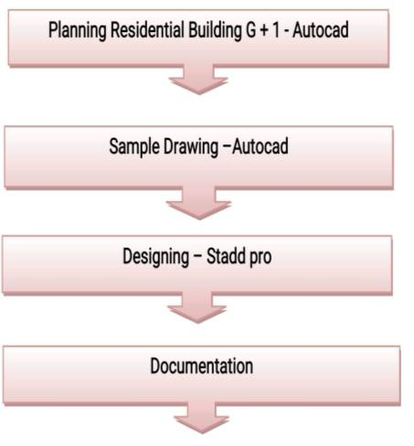

Chart-1: Methodology Chart

**3. METHODOLOGY**

**3.1** **Planning - G+1 Residential Structure**

Planning is the first step of construction project management philosophy of planning, organizing and controlling the execution of the projects. Construction project planning and project scheduling is two separate and distinct function of the project management. Construction project planning is the function in which project and construction managers and their key staff members prepares the master plan

**Fig**

**-**

**1:**

**-**

**Final Line Plan**

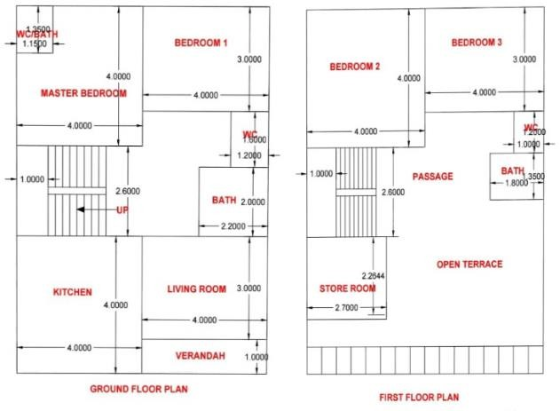

**3.2 Drawing - Auto Cad**

AutoCAD is a computer-aided design software developed by the company Autodesk (hence the name AutoCAD). It allows you to draw and edit digital 2D and 3D designs more quickly and easily than you could by hand. Ground floor consists of Verandah , Living Room , Passage , Bath Room , W.C., Stairecase , Bed room 1 and Master Bedroom.First floor consists of Stairecase, Bedroom 2,Bedroom 3, Open Terrace , Bath Room , W.C.,store room.Front elevation plan consists of ground floor windows , first floor windows , door and chajja . if the plan is cut at A-A' the we get section at A-A'which consists of foundation, step footing , brick work , construction of staircase which is done by using method of dog leg, concert filling in staircase . in foundation plan the column are mark by initial letter C1 or C2 . stie plan consists of the planning of sewer line , water line placement of G.T , I.C , M.H , F.S.I ,E.P ,W.T and Index consists of full form of G.T , I.C , M.H , F.S.I , E.P , W.T . construction notes , schedule of doors and windows , area statement consists of over all information which can not be mention at some place and some detailed information regarding this plan. This are some images of are plan that can easily and with full detailed define the above summary.

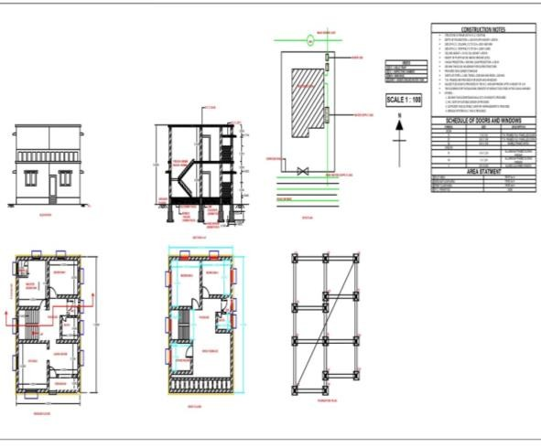

**Fig-2:-Develop Plan, Front Elevation, Site Plan, Foundation Plan, Contruction Nlotes, Schedule Of Doors And Windows, Area Statement**

**3.3.1.Study of Is code 456:2000**

IS 456-2000 Plain and Reinforced Concrete - Code of Practice is an Indian Standard code of practice for general structural use of plain and reinforced concrete. The latest revision of this standard was done in year 2000, reaffirmed 2005. This code uses the limit state design approach as well working stress design approach, However the Code has used limit state design at majority of the places & recommends use of this. It is written for use in India. It gives extensive information on the various aspects of concrete.

**4.EXECUTION OF PROJECT:**

**3.3.2.The Results Shown Are Based on Analysis of Designed Model In STAAD Pro**

Live loads refer to the dynamic forces from occupancy andEXECUTION OF PROJECT intended use. They represent the transient forces that can be moved through the building or act on any particular structural element.

**Salient features:**

1. Utility of Building : Residential
2. No. of floors : G+1
3. No. of flats per floor : 1
4. No. of Stair cases : 1
5. Type of Construction : R.C.C. Framed Structure
6. Types of walls:

External walls = 230 mm

Internal walls = 115 mm

**Geometric design:**

1. Floor to Floor height : 3 m
2. Depth of Foundation : 3 m

**Materials:**

1. Concrete mix : M20
2. Main Steel : Fe415
3. Secondary Steel : Fe415
4. S.B.C. of soil : 400 KN

**Live Load:**

The live load for a residential building is the weight of temporary objects on the building, such as people and their equipment. The average sustained live load for residential buildings is 6 psf, but it can range from 4–8 psf. The average transient live load is also around 6 psf, but it can be as high as 13 psf. A total design live load of 30–40 psf is generally considered conservative

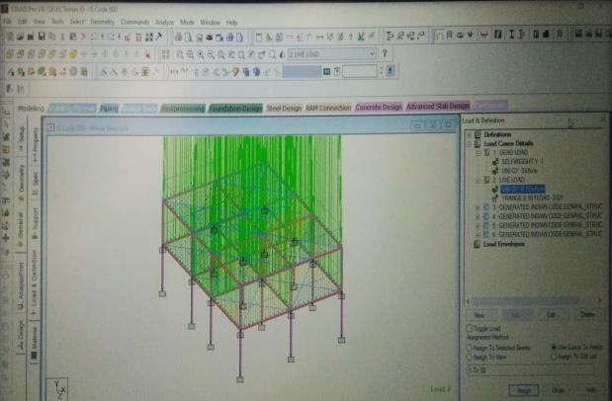

**FIG 3 : Concrete Uniform Forcelive Load**

* **Floor load:**

Many times a floor is subjected to a uniformly distributed load. It could require a lot of work to calculate the member load for individual members in that floor. However, with the AREA or FLOOR LOAD command, the user can specify the area loads (unit load per unit square area) for members. The program will calculate the tributary area for these members and provide the proper member loads. The Area Load is used for one way distributions and the Floor Load is used for two way distributions.

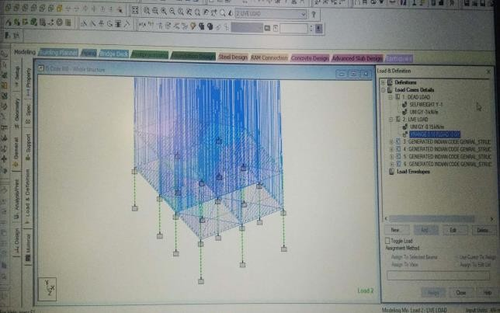

**Fig 4: Concrete Floor Load Liveload**

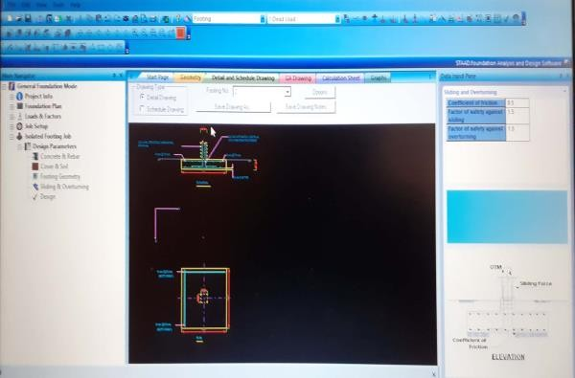

**Fig 5: Schedule Of Footing**

**Live Load**

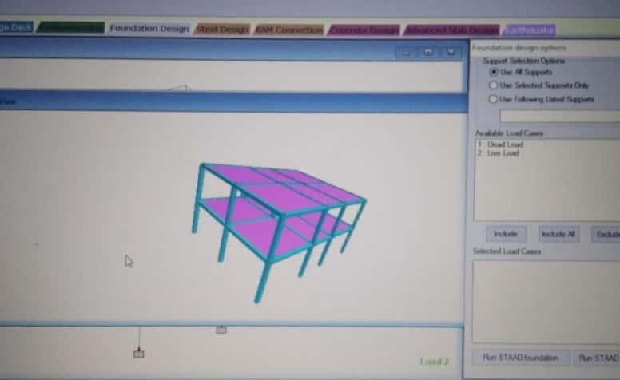

**3D Desgin of Structures**

**5. CONCLUSION**

This project includes the Planning of G+1 residential building using AutoCAD. Designing of G+1 residential building using STAAD Pro.

The Planning of the proposed G+1 residential building is based on a plot area is 193.97sq.m.The ground floor of the building will be used as Living area, kitchen area, wc and bath area and bedroom area while the remaing 1 floors will be divided into 2 bedrooms,1 store room and open terrace.The Ground floor area is 105.02 sq.m, First floor area is 105.02 . All the drafting was done using AutoCAD. Also these drawings made on AutoCAD also served as a base for transfer of the structure for design into STAAD Pro.

The design of the entire structure has been completed using STAAD pro. The results include the various forces acting on various members as well various schedules for various members. Also using the software we got the concrete takeoff as well as the steel take off.The foundation has been designed as an isolated footing using soil condition as medium. The foundation design values were calculated using STAAD Foundation.

**6.REFERENCES:**

[1] Parth Agarwal . Estimation and design of 1.bhk residential . published on May, 2017.

[2] Shishir Shekar . Estimation and design of 1.bhk residential published on May, 2017

[3] Narendra Kumar Adapa Assistant Professor, University college of Architecture and Planning, Acharya Nagarjuna University, AP, India,Static Analysis and Design of Multi- Storied (G+4) Residential Building

[4] B. Gireesh Babu, “Seismic Analysis and Design of G+7 Residential Building Using STAADPRO”, International Journal Of Advanced Research, Ideas And Innovations In Technology, Pg. 924-930, Volume3, Issue3, -2017:

[5] Mahesh Ram Patel, R.C. Singh, ”Analysis of a Tall Structure using Staad Pro providing different Wind Intensities as per 875 Part-III”, International Journal of Engineering Sciences & Research Technology, Pg. 2018-2025, May, 2017

[6] Salehuddin shamshihar, stability of a six story steel frame structure, international journal of civil & environment engineering. Vol 13 no.06, 2011 User manual STAAD Pro.

[7] IS: 456 2000, “ Plain and Reinforced concrete.

[8] Aspects, Prospects and Sizes, “ National building code of India” .

[9] Design of beams, columns, slab and footing BOOK, “ Limit state design by A.K.Jain” .

[10] Design of columns, stair cases, “ Reinforced concrete structures by B.C.Punmia