**Implications of low cost carriers on Indian Aviation Industry**

**Atharv Upadhyay**

Student, HR College of Commerce and Economics, Dinshaw Wacha Road, Churchgate, Mumbai

**Abstract**

This research paper explores the emerging low-cost carrier (LCC) business model within the aviation industry and its impact on various market segments, including customers, competitors, and the broader economy. The study examines the structural differences between LCCs and full-service airlines, with a particular focus on cost efficiency as the key driver behind LCC success. LCCs have reshaped the competitive landscape by significantly reducing operational costs, making air travel accessible to a broader range of income groups. The paper also discusses the broader context of the aviation industry, a rapidly growing sector with a global economic footprint, contributing over $2.7 trillion to the global economy and supporting millions of jobs. In addition to economic considerations, the industry faces increasing pressure to address environmental concerns, with airlines investing in sustainable technologies such as biofuels and electric aircraft. The COVID-19 pandemic's disruption of air travel is also considered, along with the industry's anticipated recovery. Finally, the study highlights the ongoing importance of air safety, underscoring the collaborative efforts between airlines and regulatory bodies to ensure the highest safety standards in a dynamic and complex operational environment.

**1. INTRODUCTION**

In this research paper the author will be discussing the emerging airline business model and how it is affecting the various segments of market, including customers, peers, economy. The study will focus on structure of the low-cost carriers (thereafter referred as LCC), analysis of the cost structures of a LCC compared to a full-service airline. LCCs are leading the market with their cost-efficient approach, lately the competition has been notorious for the airlines, LCCs are a reason for that as they were able to successfully cut down on operational costs and made it possible for several income groups to afford air travel.

The aviation industry is a complex and dynamic field that involves the operation and maintenance of aircraft, as well as the infrastructure and regulations that support air travel.

The aviation industry is one of the largest and fastest-growing industries in the world.

According to the International Air Transport Association (IATA), over 4.5 billion passengers were transported by air in 2019. The global aviation industry is responsible for over 65 million jobs and contributes over $2.7 trillion to the global economy.

The global air cargo industry transports over 50 million metric tons of goods each year, with the majority of shipments being high-value, time-sensitive items such as electronics and pharmaceuticals. The aviation industry is facing increasing pressure to reduce its carbon emissions, and many airlines are investing in new technologies such as biofuels, electric and hybrid-electric aircraft, and more efficient engines to reduce their environmental impact.

The COVID-19 pandemic has had a significant impact on the aviation industry, with many airlines reducing their schedules and laying off staff in response to decreased demand for air travel. However, the industry is expected to recover over the coming years as vaccination programs are rolled out and travel restrictions are lifted.

Air safety should be the top priority for the aviation industry, and airlines and regulatory bodies work together to establish and enforce strict safety standards. Despite the occasional high-profile accident, air travel remains one of the safest forms of transportation.

The aviation industry is heavily regulated, with various national and international bodies overseeing everything from aircraft design and maintenance to pilot training and air traffic control. The future of the aviation industry is likely to be shaped by new technologies such as unmanned aerial vehicles (drones), supersonic aircraft, and space travel. These emerging technologies are expected to revolutionize the way we think about air travel and transportation more broadly.

### TOP AIRLINES IN INDIA

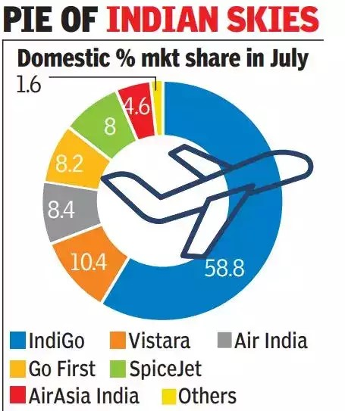

## Literature Review

**"Low-cost carriers in India: A study of business models, strategies, and future prospects"**

### (Nayak & Padhy, 2018)

This study explores the emergence and growth of LCCs in India, including their business models, strategies, and challenges. It also discusses the impact of LCCs on the aviation industry in India, including the growth of air travel, increased competition, and changes in the pricing and service models of traditional airlines.

Nayak and Padhy's (2018) study focused on the business models, strategies, and future prospects of low-cost carriers (LCCs) in India. The study used a mixed-methods approach, including a survey of 300 passengers and interviews with industry experts and airline executives.

The study found that LCCs in India primarily use the point-to-point model, which involves connecting two destinations without any intermediary stops. This model allows LCCs to offer lower fares by reducing the operational costs associated with intermediate stops. The study also found that LCCs in India focus on offering basic services to passengers and generating additional revenue through ancillary services such as baggage fees and in-flight food and beverage sales.

The study identified several key factors that have contributed to the growth of LCCs in India, including the liberalization of the Indian aviation industry, the rise of the middle class, and the emergence of low-cost carriers as a viable alternative to other modes of transportation. However, the study also noted that LCCs in India face several challenges, including high operating costs, regulatory barriers, and infrastructure constraints.

The study identified several strategies that LCCs in India can adopt to overcome these challenges and ensure future growth. These strategies include investing in new technologies to improve operational efficiency, expanding their networks to include more international destinations, and forming partnerships with other airlines to increase their reach and customer base.

Overall, Nayak and Padhy's study provides valuable insights into the business models, strategies, and future prospects of LCCs in India. The study highlights the importance of innovation, efficiency, and strategic partnerships in ensuring the continued growth and success of LCCs in the Indian aviation industry.

**"Impact of Low-Cost Carriers on the Indian Aviation Industry"**

### (Soni & Singal, 2015)

This study analyses the impact of LCCs on the Indian aviation industry, including changes in market structure, pricing, and services. It also examines the financial performance of LCCs and their impact on traditional airlines, airport infrastructure, and air travel demand.

Soni and Singal's (2015) study investigated the impact of low-cost carriers (LCCs) on the Indian aviation industry. The study used both qualitative and quantitative research methods, including a survey of 350 passengers and interviews with airline executives and industry experts.

The study found that LCCs have had a significant impact on the Indian aviation industry, particularly in terms of increasing competition and lowering fares. LCCs have stimulated demand for air travel by making it more affordable for a larger segment of the population, and have also contributed to the growth of regional connectivity by connecting smaller cities and towns with major urban centers.

However, the study also identified several challenges faced by LCCs in India, including high operating costs, regulatory constraints, and infrastructure bottlenecks. LCCs in India have had to adapt their business models to overcome these challenges, including by adopting innovative pricing strategies and developing new revenue streams through ancillary services such as baggage fees and in-flight sales.

The study also found that traditional carriers in India have been impacted by the emergence of LCCs, with some struggling to compete with the low fares offered by LCCs. However, the study noted that traditional carriers have also adopted LCC-like practices, such as offering unbundled pricing options and reducing operating costs, in order to remain competitive.

The study concluded that LCCs are likely to continue to play a significant role in the Indian aviation industry, particularly in promoting regional connectivity and stimulating demand for air travel. However, LCCs will also face ongoing challenges, including regulatory constraints and the need to maintain profitability in a highly competitive market.

Overall, Soni and Singal's study provides a comprehensive analysis of the impact of LCCs on the Indian aviation industry, highlighting both the opportunities and challenges faced by LCCs and traditional carriers in India.

## 2. Research Methodology

This section consists of research of data collection, the sampling technique, statistical tool used for analysis, data representation technique, etc.

• Sources of data

The data for research has been collected from two sources-

A. Primary sources. B. Secondary sources.

**OBJECTIVE**

The objective of this research is to understand consumer perception and the factors important for the decision making related to air travel.

And professional insights on the matter of study.

**Primary Source**

The data which is collected for the first time are called primary source of data. Primary data are collected from primary sources. Here the primary data are collected through observation, direct communication with the respondent and finally by asking them the questions included in the survey.

Data is also collected with the help of one on one interviews with the aviation professionals.

**Secondary Source**

Secondary source of data is those which have already been collected by someone else and have already been passed through statistical process. Here the secondary sources of data are collected through the internet.

**4. RESULTS AND DISCUSSION**

**Following is an one on one interview taken in flight, with a SpiceJet Boeing 737 PILOT:**

**INTERVIEWER:** Why are the airlines shutting down?

**INTERVIEWEE:** Governments are not letting businesses grow, if there is dollar in the eye, government just wants to make money out of it. Aviation is a high-profile thing, there is money laundering, white to black, black to white. So it attracts investments money pumps in, all government has invested into every bloody airline in the country. During elections money comes out and after election money goes back in. IT IS ALL BECAUSE OF POLITICS. For the airlines shutting down it’s the same, kingfisher shutting down they were having maximum loads. If you ask the pilots and crew, the loads were full. Today your answer why jet shut down look at it after jet comes back, seats will go full.

**INTERVIEWER:** But aren’t they coming back with the low-cost carrier model this time?

**INTERVIEWEE:** No full-service only, there is going to be high-breed model, if passenger wants to pay for a full-service ticket they will, if they want low-cost pricing there will be. What is the difference between a low-cost and a full-service airline? You buy some food onboard and you become full-service.

**INTERVIEWER**: What are your thoughts on airlines operating with low-cost model, compromising with safety?

**INTERVIEWEE:** They can’t.

**INTERVIEWER**: Then what about AirAsia? Their SOP says that the pilots needs to perform a flap-3 landing 98% of times or else their bonus will be reduced.

**INTERVIEWEE:** See that is a different thing, every airline asks you to save fuel, cause at the end of the day all the airlines are here to make a profit. Airlines sells the tickets 6 months down the line, they are selling at the price of fuel which is today. So the difference they are bearing it themselves. All this flap 3 or flaps 30 is saves the fuel.

**INTERVIEWER**: But does it create pressure in pilot’s mind?

**INTERVIEWEE**: No, at the end, the decision is of the pilot’s itself if they want to make a flap 3 landing or not if they can justify it.

Backbone of your flight operations needs to be strong, an airline should be run by the flight operations and not the HR.

**INTERVIEWER**: HR runs the airline??

**INTERVIEWEE:** Because HRs are MBA “we know how to do business”. They don’t get it, flight operations is the one because your product is flight operations, the revenue is from the flight operations and not from the HR policies. It’s not low-cost carrier, you can’t point as the model. You can point point as the management. A person sitting for safety cannot take stand for safety.

**INTERVIEWER**: Thank you so much.

Conclusion:

The interview gives the insights on how government is affecting the aviation industry. In-fact when we see AirIndia as today, the government is highly responsible for the it. It was only after the government nationalized the aviation industry; all the decisions were as per the government. JRD warned the government, “Running the airline is not like running a Government department, roads and railways are fine but the airlines are capital intensive they need 35 times more capital, to sustain you need to fly for 2500 hours and the current capacity is just 500 hours”. Things become dirty after a few years ministers used to take their families on vacation under the garb of foreign visits Air India had to foot all of these bills. It was only after 2004 which completely destroy the company financially, the aviation minister planned to buy 111 new aircrafts the total cost of which was 50,000 crores! Air India’s total turnover was Rs. 7000 crores which is more than 7 times less than the money spent on the order. In 2007 the Air India and the Indian Airlines were merged, which is considered one of the worst decisions as Air India never earned a single rupee as profit since then. One of the biggest reasons is mismanagement, the nationalization wasn’t just the issue 1953 was the year the government announced nationalization but the graphs started going from 1970s.

It's not just about the Jet Airways, Air India is the flag carrier and the government airline of India before the 2000s air India was thriving flown by mostly the rich class of India. But now things have changed everything started going downhill for Air India. Air India has been losing millions and millions of dollars annually 20 years later the situation still stands. Air India wouldn’t be flying today if it weren’t for the government sucking in the massive losses. Before the Tatas reacquired the company, the government was losing 20 crores on daily basis.

## Determining age demographic

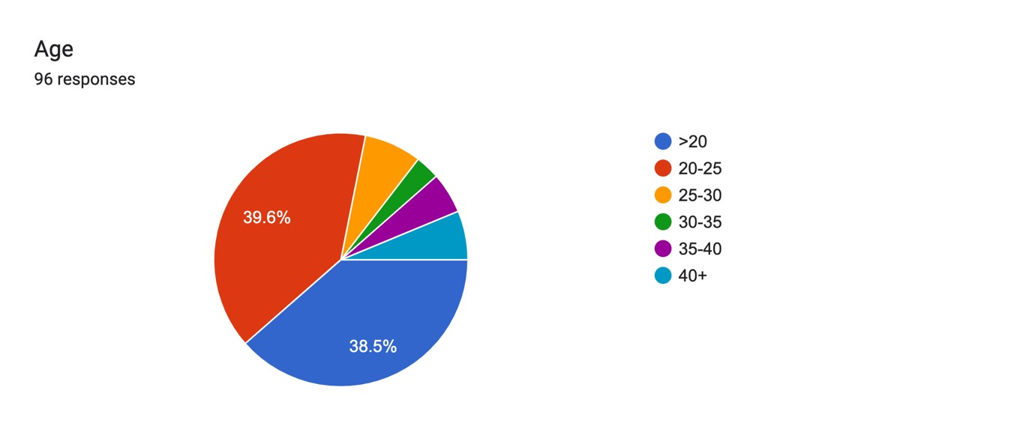

This section determines the age range of the respondents,

I have classified them into 6 groups- Less than 20 , 20-25, 25-30 , 30-35, 35-40 and Above 40

This analysis helps the researcher to formulate and determine the balance or difference between age demographics or what percentage each age group contributes in participating in the automobile industry. The manufacturers can use this data to see which age group is performing well and design or implement their products to fit the needs for the same.

Knowing the age range is essential as it also helps analysers in the aviation industry perform actions such as advertising and broadcasting to reach out new markets or customers.

## Most flown airline, industry dominance, customer preference

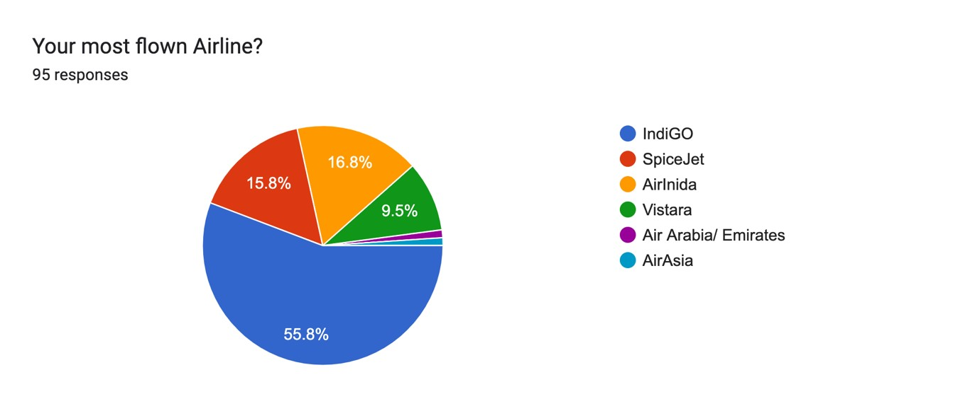

Analysis-

More than 70% of the responses are towards the LCCs, IndiGo being the market leader. IndiGo: IndiGo is the largest airline in India, with a market share of around 55%. It operates over 1,500 daily flights to 87 destinations, both domestic and international.

SpiceJet: SpiceJet is the second-largest airline in India, with a market share of around 14%. It operates over 600 daily flights to 63 destinations, both domestic and international.

Air India: Air India is the national flag carrier of India, with a market share of around 11%. It operates around 500 daily flights to 94 destinations, both domestic and international.

GoAir: GoAir is a low-cost airline that operates over 300 daily flights to 36 destinations, both domestic and international, with a market share of around 9%.

Vistara: Vistara is a full-service airline that operates over 200 daily flights to 33 destinations, both domestic and international, with a market share of around 7%.

The Indian Aviation market is dominated by the low cost airlines, the national carrier that is AirIndia has only 16.8% share.

## Potential of additional services, reliability of other revenue streams, customer’s willingness to spend on additional services, impact of low-cost airlines on such preferences

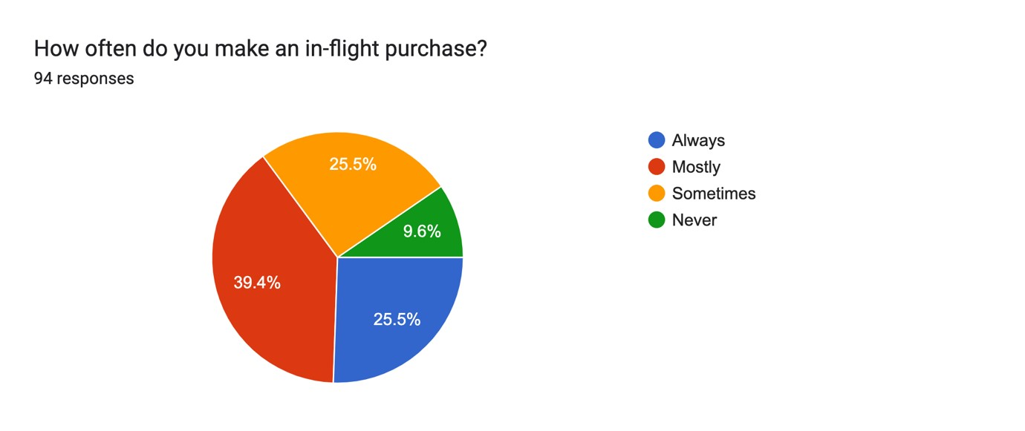

Analysis-

More than 90% of the respondents make in-flight purchases. The concept of such revenue streams is introduced by the low-cost airlines itself, it shows high influence in the consumer preferences. 25% of respondents being a regular consumer of such services, it shows high scope of earning from such streams.

**Industry performance from consumer’s point of view, air travel experience.**

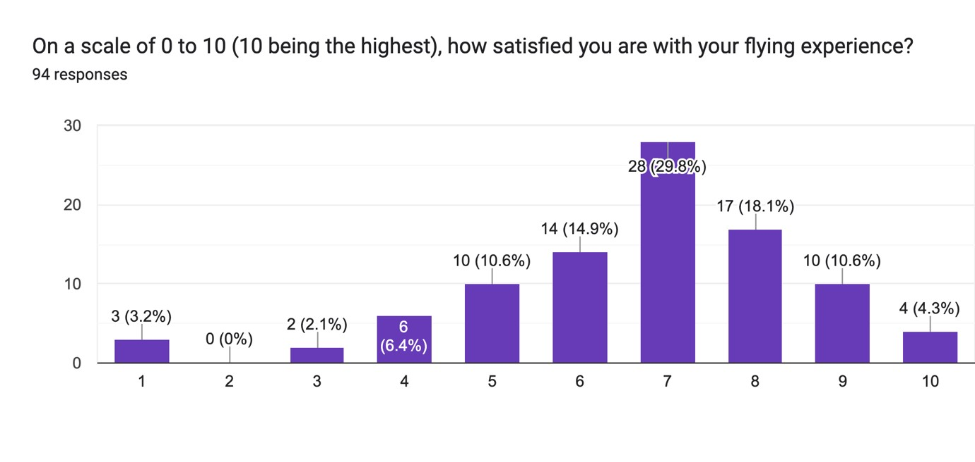

Analysis-

The Average rating being 7, it comes out to be a satisfactory statistic. Lower prices being the major factor behind.

According to the latest Air Travel Consumer Report published by the Directorate General of Civil Aviation (DGCA), the overall satisfaction level of Indian customers with domestic airlines in 2021 was around 78%. This is a slight increase from the satisfaction level of around 75% in 2020. The survey takes into account factors such as on-time performance, baggage handling, check-in experience, and in-flight services.

In terms of specific airlines, IndiGo and AirAsia India ranked highest in customer satisfaction in the DGCA survey, followed by SpiceJet and Vistara. Air India and GoAir ranked lower in customer satisfaction.

## Price sensitivity of consumers

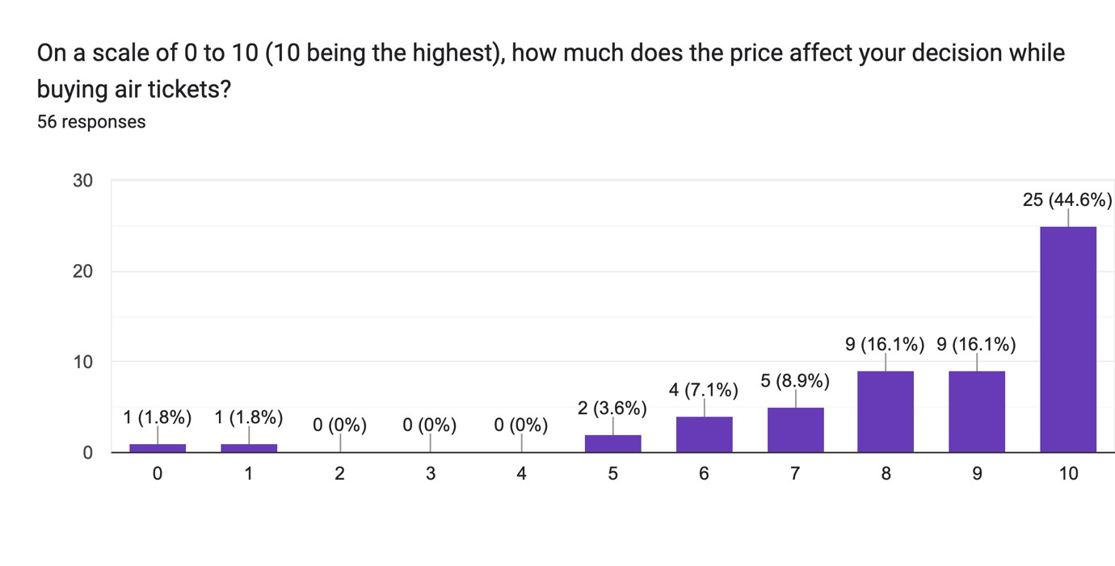

Analysis-

Majority of responses rates the scale as 10, which shows that price is a very crucial factor for consumers while booking their tickets. This is the perfect environment for the low-cost carriers to grow, high price-sensitivity will induce airline to charge the most reasonable price in order to be preferred. This factor can cause a very tough competition in the industry, which isn’t ideal as a large part of airline expenses are towards regulatory and safety compliance, cost-cutting in such areas can lead to serious implications, such as compromise with adequate safety standards, pay-cuts, and even high-pressure working environment for the employees without adequate pay.

### Conclusion

Indian consumers are highly price-sensitive when it comes to air travel. The rise of low-cost carriers and the economic impact of the COVID-19 pandemic have further intensified this trend. Airlines need to strike a balance between offering competitive fares and providing quality services to meet the expectations of price-sensitive Indian consumers.

**Most accepted pricing range, changes in average pricing.**

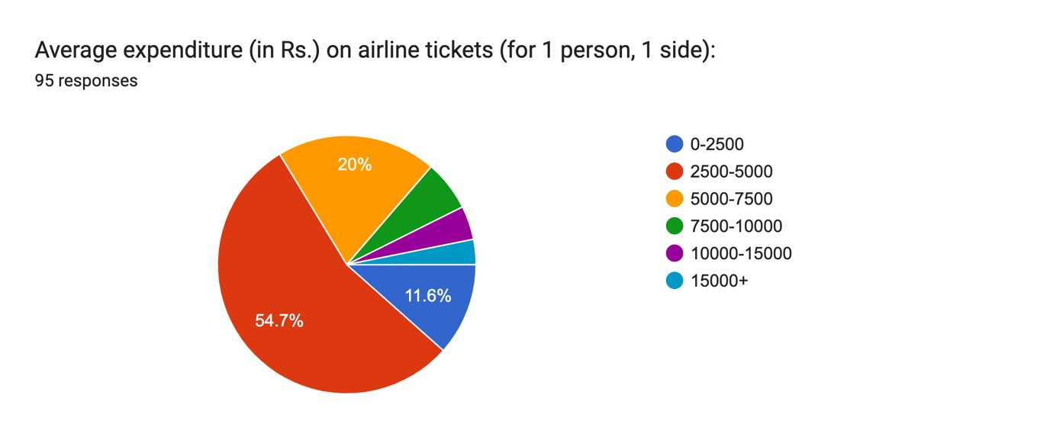

Analysis-

Majority of the universe reports their airfares to be between RS. 2500-5000, which is a significantly smaller number as compared to past figures. While inflation is increasing the cost of air travel is shrinking. As the LCCs are dominating the market, the average cost of an air ticket is now significantly lower. In order to sustain, even the full-service airlines are charging lower fares as compared to past.

The average price of an air ticket in India can vary depending on several factors such as the airline, the route, the class of travel, and the time of year. However, in general, domestic airfares in India are relatively affordable compared to other countries.

According to a report by the Directorate General of Civil Aviation (DGCA), the average domestic airfare in India in 2020 was around INR 4,703 (approximately USD 64) for a oneway ticket. This is a decrease from the average domestic airfare of around INR 5,336 (approximately USD 73) in 2019.

### Conclusion

The average price of an air ticket in India can vary depending on several factors, but domestic airfares in India are generally affordable compared to other countries. The COVID-19 pandemic has had a significant impact on airfares in India, with airlines offering discounted fares to attract travellers.

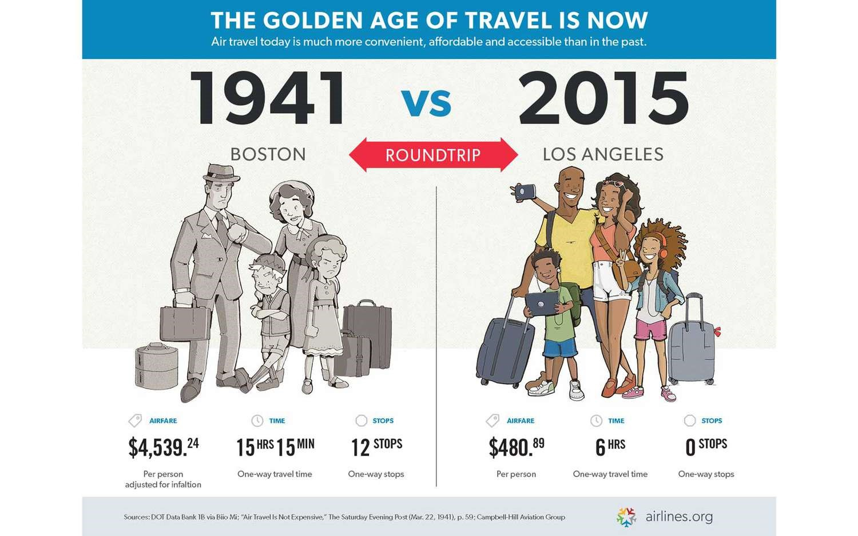

**Market for premium flying classes, percentage of business travellers, and preference towards high budget flying.**

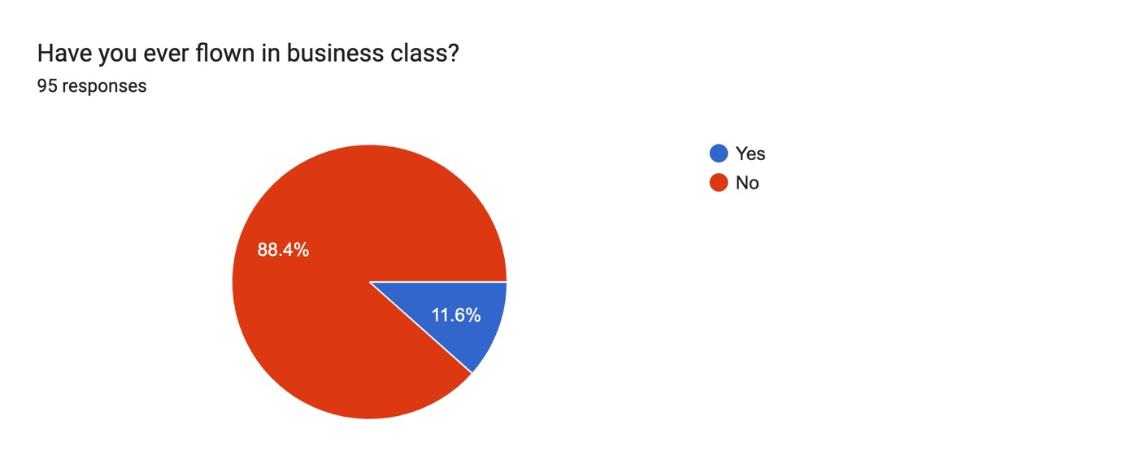

Analysis-

Business class travel the luxurious segment of air-travel, full-service airlines provides these services, charging significantly higher amount. 88.4% of the respondents never flew business class. This shows that the market for the same is extremely small. LCCs do not have a business class onboard, instead more economy seats are fitted in order to acquire more customers. The data supports the same.

**Most common in-inflight purchase, major scope for airlines to expand and grow.**

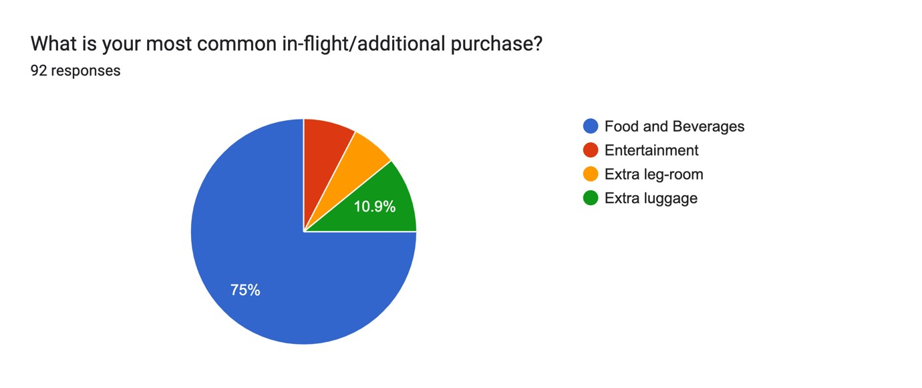

Analysis-

A major chunk of the income, for low-cost airlines comes through the in-flight services. The data above shows that the whopping 75% of the respondents who spend their money in in-flight services, are purchasing food items on board. This is an important data for the airlines, as they accordingly optimise their services. These services, provides some additional margins to the airlines, which allows them to provide an even better price.

Airlines in India offer a wide range of food and beverage options to passengers on board flights. These can include snacks, sandwiches, meals, tea, coffee, soft drinks, and alcoholic beverages. Most airlines have a menu that is available to passengers, and they can place an order for their choice of food and drinks.

**Common airlines in use, acceptance of low-cost airlines in comparison to the full-service.**

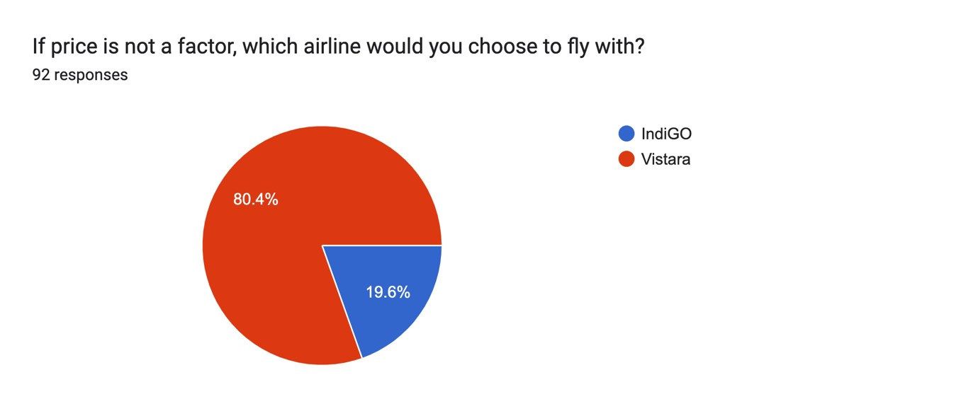

Analysis-

The above data contradicts the actual market share data, the above question is comparing preference in service between a low-cost airline and a full-service airline, IndiGO and Vistara respectively. 80.4% people have chosen Vistara over IndiGo. In reality, IndiGo has more than 5 times of the market share as compared to Vistara.

**Spending on in-flight items, potential for additional revenue streams for the airlines**

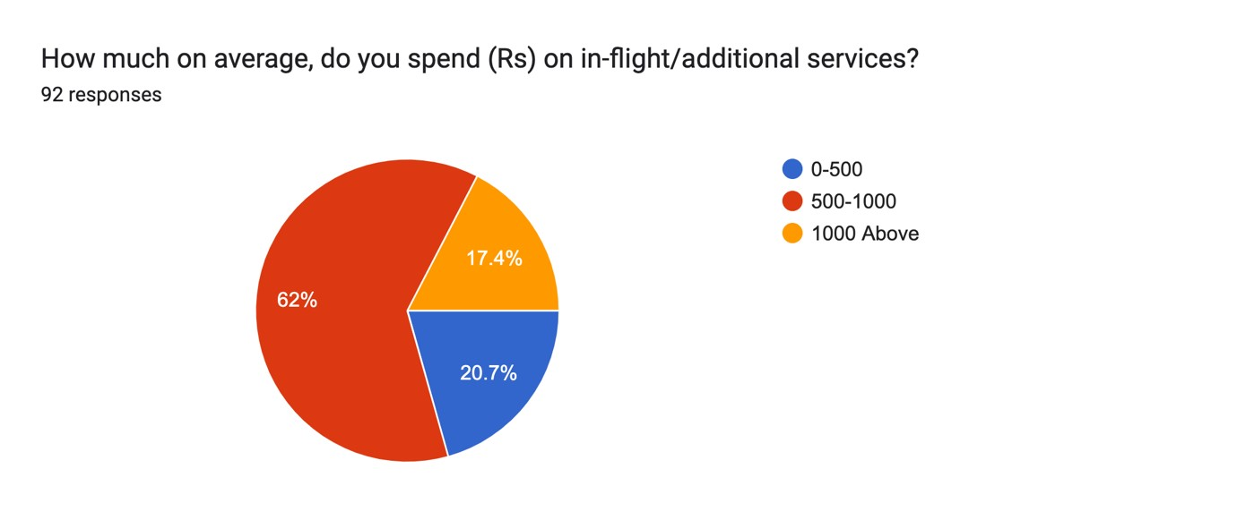

Analysis-

The profits earned from the air-tickets are bare minimum. These in-flight services are the additional source of revenue over the base fare. Above data shows that majority of the purchases are between the value of Rs.500-1000. It is a substantially big number.

Inflight purchases are a common feature of air travel in India, with airlines offering a variety of products and services for passengers to purchase during their flight. These purchases can include food and beverages, duty-free products, inflight entertainment, Wi-Fi access, and magazines and newspapers. However, it is important to note that the availability of these purchases may vary depending on the airline and the flight. Overall, inflight purchases are a convenient way for passengers to enjoy a range of products and services while flying.

**Common airlines , use of low-cost airlines in comparison to the full-service.**

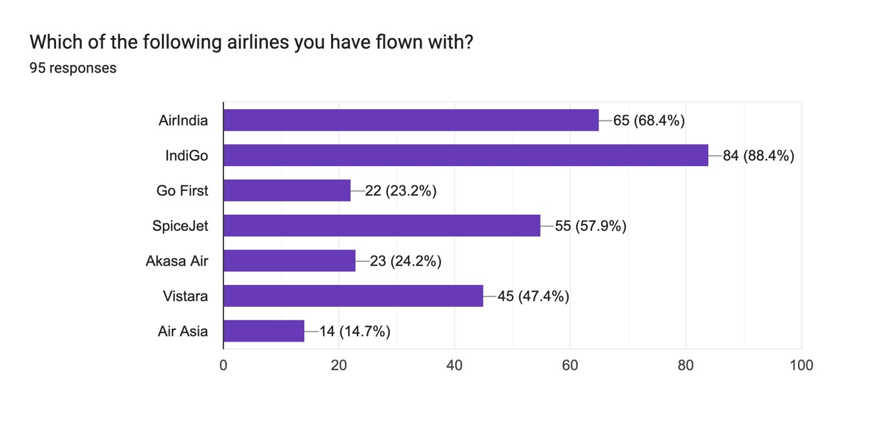

Analysis-

The above data shows 88% of flyers at some point have flown with IndiGo, 68.4% of them have flown with AirIndia, 57.9% with SpiceJet, 47.4% with Vistara. This data shows that majority of flyers have flown with IndiGo, which proves them to be more competitive in market. The above data is also influenced with routes of the airlines, more routes an airline operates with, it’s more likely that, they become an obvious choice for the customers.

**Air travel frequency, demand in comparison to other modes of transport.**

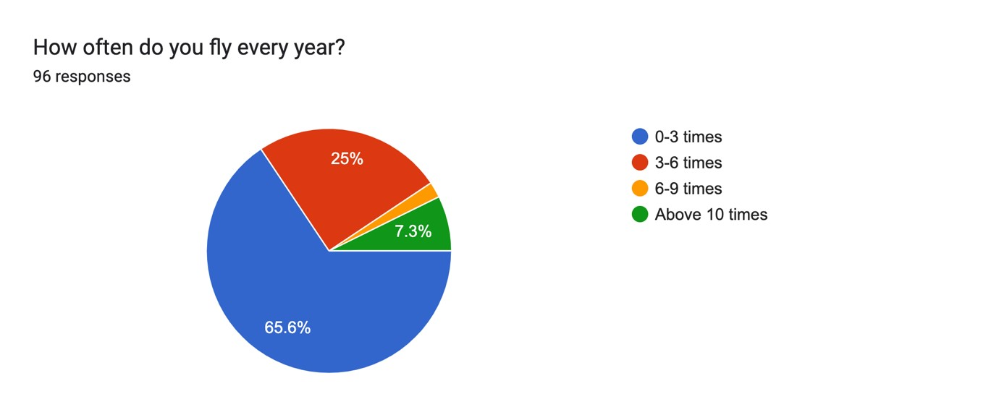

Analysis-

The above data shows that the India is a highly underpenetrated market. Most of the population date could not afford to fly, and one flying are not it much often. Only 7.3% of respondents fly more than 10 times every year, while a whopping 65.6% only flies between 0-3 times. This data shows that there is huge potential in the industry in upcoming years. The growth rate is above 5% yearly which is a very positive number and we might see more and more airlines investing in Indian market. This on the hand can even worsen the safety standards as the increased competition will reduce prices even further, reducing the margins and increasing the sustainability issues.

**Questionnaire number: 2**

## Determining age demographic

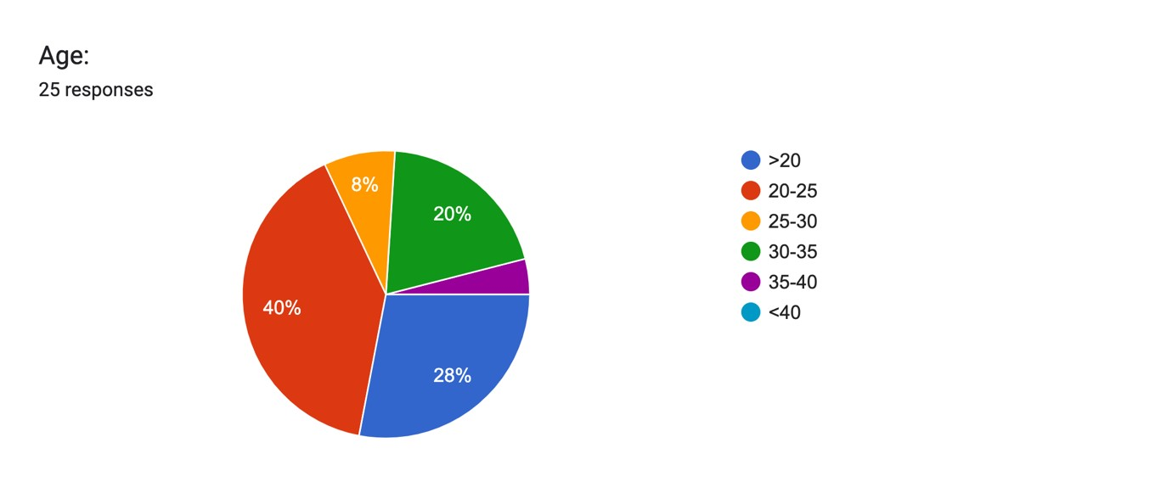

This section determines the age range of the respondents,

I have classified them into 6 groups- Less than 20 , 20-25, 25-30 , 30-35, 35-40 and Above 40

This analysis helps the researcher to formulate and determine the balance or difference between age demographics or what percentage each age group contributes in participating in the automobile industry. The manufacturers can use this data to see which age group is performing well and design or implement their products to fit the needs for the same.

**Demographic on Aviation Professionals and Enthusiasts**

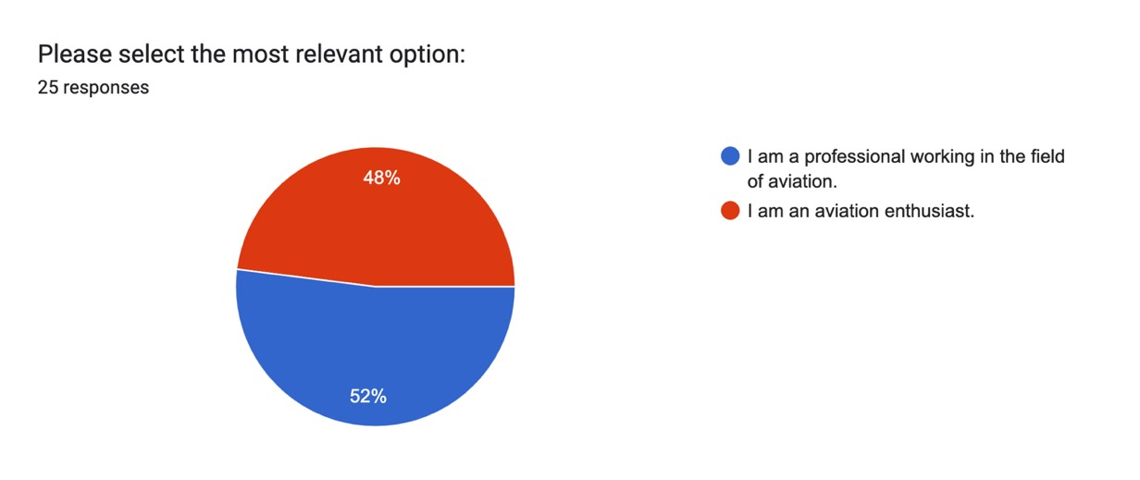

This section determines whether the respondent is a professional working in the industry or an enthusiast with relevant knowledge to comment on the matter.

Classified into the following groups namely- Professional, enthusiast.

**Job availability in the industry, career certainty.**

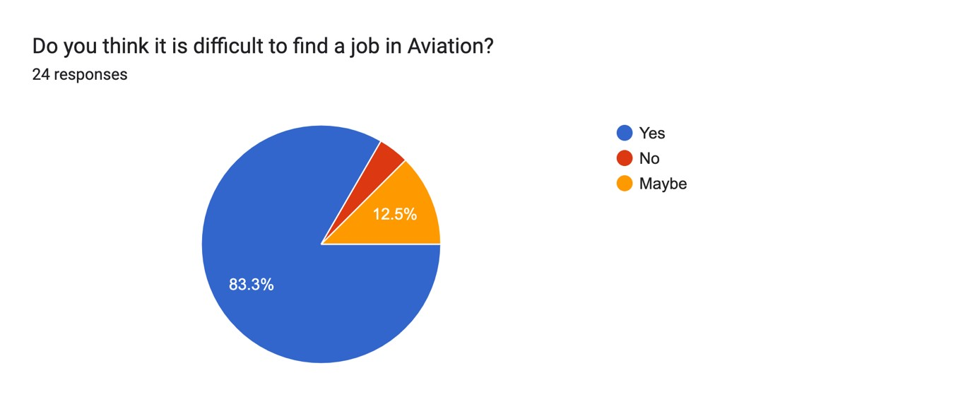

Analysis-

The aviation industry in India has been facing a scarcity of jobs in recent years, due to a combination of factors. One of the main factors contributing to this scarcity is the highly competitive nature of the industry, with many qualified candidates vying for a limited number of job opportunities. Additionally, the COVID-19 pandemic has had a significant impact on the aviation industry, with many airlines and other aviation companies forced to cut back on staff and operations in order to stay afloat.

Another factor that has contributed to the scarcity of jobs in the aviation industry in India is the rapid growth of automation and technological advancements. Many jobs that were once performed by human workers are now being automated, leading to a reduction in the number of jobs available in certain areas of the industry.

Despite these challenges, there are still opportunities available for those looking to enter the aviation industry in India. Candidates with specialized skills and experience in areas such as engineering, maintenance, and operations are likely to have better prospects of finding employment in the industry. Additionally, candidates who are willing to take on entry-level positions and work their way up may also be able to secure jobs in the aviation industry over time.

**Conclusion:**

It is speculated that since the industry is so underpenetrated, the job opportunities are scarce. For the professionals looking forward to find to job in the industry, it becomes highly competitive. The data shows that less that 5% of respondents thinks that it is not difficult to find a job in aviation while 12.5% of respondents says ‘maybe’. And 83.3% of respondents agrees that it is difficult to find a job. This makes it very difficult for the employees, it indicates less demand from the airlines, and so is the pay.

**LCC competition impact, health of the competition.**

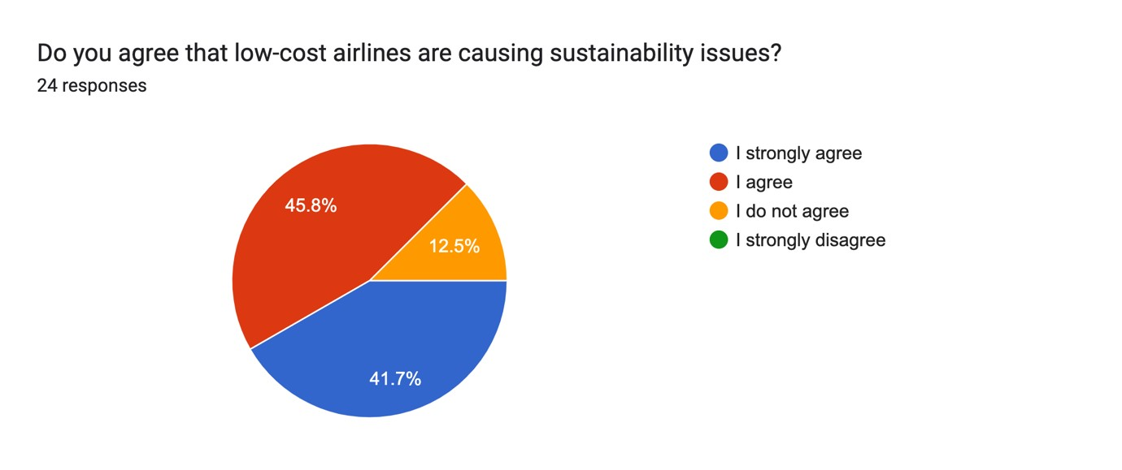

Analysis-

LCCs are known for their reasonable pricing, this makes it difficult for certain airlines to withstand. The data proves that the competition is so unhealthy that it is straight away causing sustainability issues. There are multiple factors that plays multiple roles here. LCCs being a major factor, adding up to the pressure on the full-service airlines.

Low-cost carriers have gained popularity in recent years for their affordable fares and simplified services. However, there are concerns that LCCs may be causing sustainability issues in the aviation industry. Here are some of the reasons why:

Increased air travel: LCCs have made air travel more affordable and accessible, leading to an increase in the number of people traveling by air. This increased demand for air travel contributes to carbon emissions, which can have a negative impact on the environment.

Short-haul flights: LCCs typically operate short-haul flights, which are less fuel-efficient per passenger-kilometre than longer flights. This means that LCCs emit more carbon per passenger-kilometre than full-service carriers operating longer routes.

Cost-cutting measures: LCCs often cut costs by using older, less fuel-efficient aircraft and minimizing in-flight services such as meals and beverages. These cost-cutting measures can impact the quality of the flying experience and contribute to higher carbon emissions.

Overcrowding: LCCs often use smaller aircraft and maximize capacity to keep fares low. This can lead to overcrowding and discomfort for passengers, which can impact the overall sustainability of air travel.

Airport congestion: LCCs operate from smaller, secondary airports to keep costs low. However, this can lead to airport congestion and an increase in carbon emissions from ground transportation.

### Conclusion

LCCs have contributed to making air travel more affordable and accessible. However, the low-cost business model may also have sustainability issues, such as increased air travel, short-haul flights, cost-cutting measures, overcrowding, and airport congestion. It is important for LCCs to adopt more sustainable practices to minimize their impact on the environment and ensure the long-term sustainability of the aviation industry.

**Financial struggles of airlines, poor cash flow.**

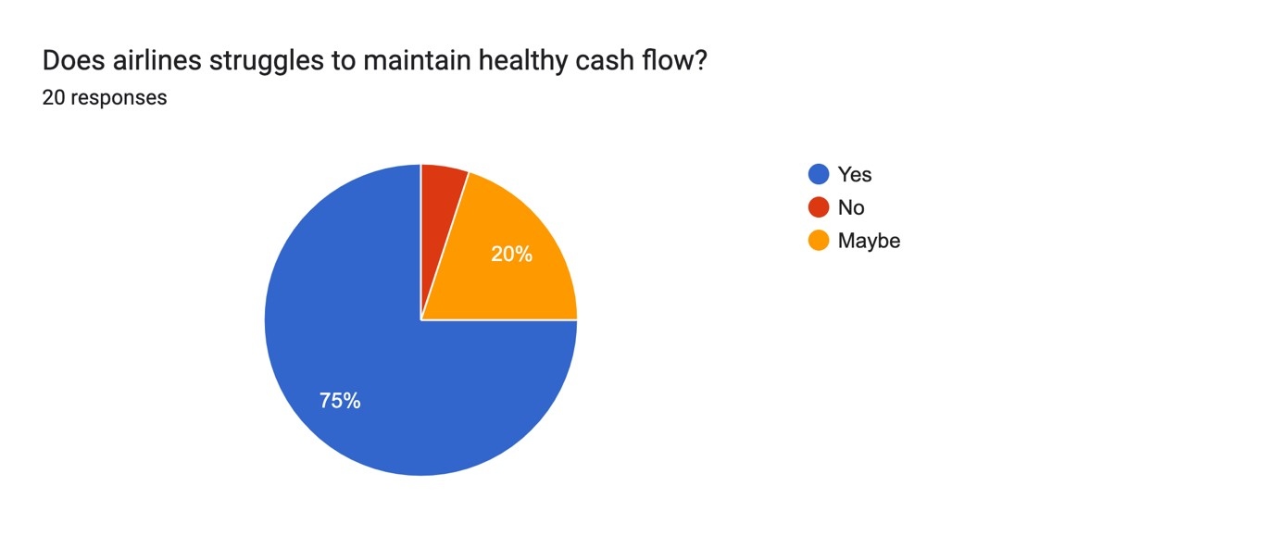

Analysis-

Sufficient cash-flow is necessary in smooth flight-operations. This data convinces that airlines are struggling with that. Maintaining healthy cash flow can be a challenging task for airlines in India due to various reasons. Here are some of the factors that contribute to the difficulty of airlines in maintaining cash flow in India:

Airlines in India face high operating costs due to several factors such as high taxes on aviation fuel, high airport charges, and maintenance costs. These costs can put a strain on the airline's finances and make it difficult to maintain healthy cash flow.

Intense competition: competition can lead to price wars, which can impact the airline's revenues and profitability.

The regulatory environment in India can also impact the cash flow of airlines. For instance, changes in regulations such as the imposition of new taxes or restrictions on routes can impact the airline's operations and revenues.

The infrastructure for air travel in India is still developing, with many airports facing capacity constraints and delays. This can impact the airline's operations and lead to a loss of revenue.

### Conclusion

Maintaining healthy cash flow can be a challenge for airlines in India due to various factors such as high operating costs, intense competition, economic conditions, regulatory issues, and infrastructure challenges. However, with careful planning and effective cost management strategies, airlines can overcome these challenges and maintain healthy cash flow.

**Safety and LCCs**

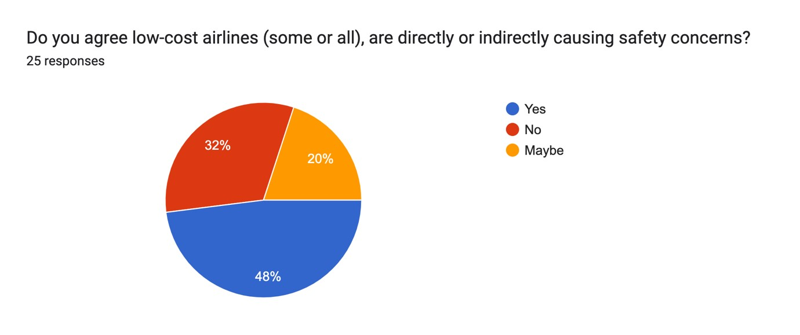

Analysis-

This above data supports the hypothesis H4. 48% of respondents believes that some or all LCCs are causing safety concerns. The stand operating procedure (SOP) laid by LCCs promotes profit maximisation, when meets poor company culture can cause hazards. One of the main concerns is that low-cost airlines may cut corners on maintenance and safety procedures to keep costs low. This can include delaying necessary repairs or maintenance work, using older aircraft, and reducing the number of crew members on flights. Such costcutting measures can compromise the safety of passengers and crew members and increase the risk of accidents and incidents.

Additionally, low-cost airlines may also face challenges in providing adequate training and support to their staff, particularly in relation to safety procedures and emergency response. This can be particularly concerning in emergency situations, where staff members need to be able to act quickly and effectively to ensure the safety of all passengers.

Despite these concerns, it is important to note that low-cost airlines in India are subject to the same safety regulations and standards as other airlines. The Directorate General of Civil Aviation (DGCA) is responsible for ensuring that all airlines operating in India comply with safety regulations and standards and carries out regular inspections and audits to monitor compliance.

**Earning opportunities in the aviation industry.**

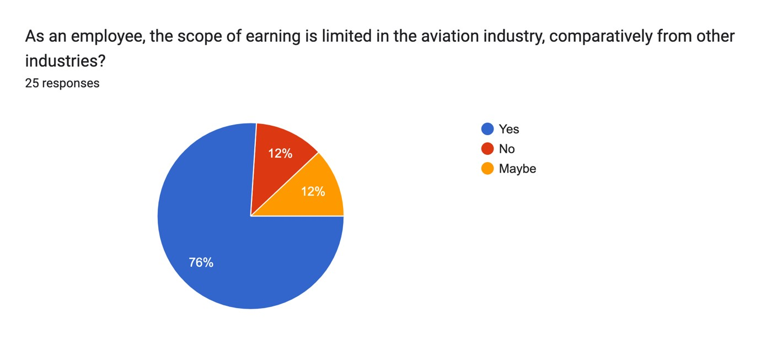

Analysis-

Keeping the operating-cost down is the main priority of any airline. This means carving every area possible. 76% of respondents believes that earning opportunities are restricted in this industry.

Entry-level positions in the aviation industry often offer relatively low salaries. For example, many airlines in India offer lower salaries to entry-level cabin crew members, ground staff, and junior-level engineers. This can make it challenging for individuals to sustain themselves in the industry, particularly in expensive metropolitan areas.

With a large pool of qualified candidates vying for a limited number of job opportunities. This can make it difficult for individuals to secure higher-paying positions, as companies may be able to find equally qualified candidates willing to work for lower salaries.

Additionally, the COVID-19 pandemic has had a significant impact on the aviation industry in India, with many airlines and other aviation companies facing financial challenges and cutbacks. This has led to salary reductions, layoffs, and other cost-cutting measures that have further limited earning opportunities in the industry.

The value of strong partnerships: Jet Airways had a complex ownership structure that made it difficult to make strategic decisions. Airlines must have strong partnerships and clear decision-making structures to operate effectively in the highly competitive aviation industry.

**5. CONCLUSION**

In conclusion, the rise of low-cost carriers in the Indian aviation industry has had a significant impact on the industry, with implications for airlines, consumers, and the economy. Low-cost carriers have disrupted the industry by providing affordable fares and expanding air travel to a broader segment of the population. However, their success has also led to increased competition, which has forced legacy carriers to adopt similar strategies.

While the growth potential of the industry remains high, airlines need to be aware of the evolving regulatory landscape and changing customer preferences to stay competitive. Understanding the implications of low-cost carriers on the Indian aviation industry is crucial for airlines, policymakers, and industry stakeholders to make informed decisions and plan for the future.