# FORMULATION AND EVOLUTION OF HERBAL SHAMPOO OF ALOE VERA

Rushikesh R. Potkule*, Miss. Priti Shirsath Department of Pharmacognosy,

Dr. Naikwadi College of D Pharmacy, Jamgaon, Sinnar, India “Corresponding Author

Rushikesh Rajesh Potkule,

Student of Final year B Pharmacy, Dr. Naikwadi College of D Pharmacy, Jamgaon, Sinnar, MH, India .

# ABSTRACT

Aloe Vera is a characteristic item which is presently a days utilized in the field of cosmetology. Our definition is to detail a home grown cleanser utilizing a plant extract which is utilized as hair washing and molding cleanser to treat balding and block twitch scalp and dandruff. Is effective than the marketed shampoo as we have used essential oils like coconut oil which is derived from the coconut palm fruit, lavender oil which is derived from the flowers of lavender, rosemary oil derived from the flowering tops of rosemary. Eucalyptus oil which is derived from the leaves of eucalyptus plant and some other excepients like antioxidants stabilizers, solubilizing agents, surfactants, cleansing agents, coloring agents and preservatives. All of these are used for the aim to improve the smoothening, shining and growth of the hair. Our study has and Evaluated all the tests like foaming ability test, pH determination, skin irritancy test, conditioning performance, saturated in all those test it has shown good results when compared to the marketed shampoo. Keywords: Aloe Vera, Eucalyptus leaves, Lavender flowers, flowering tops of rosemary coconut oil [1].

# INTRODUCTION

Aloe Vera, scientifically known as Aloe barbadensis miller, belongs to the Liliaceae family. The name “Aloe Vera” is derived from the Arabic word “Allowh,” meaning “shining bitter substances,” while “Vera” comes from Latin, meaning “true.” This plant typically grows to a height of 30 to 60 cm, with some specimens reaching up to 100 cm. Its thick, fleshy leaves, which form a rosette pattern, contain a cooling gel that is often used to soothe the skin, especially in cases of burns. Aloe Vera contains several phytochemicals such as alkaloids, flavonoids, glycosides, phenols, saponins, and tannins, which contribute to its anti-inflammatory and pain-relieving properties.[1] The plant is well-known for its health benefits, including wound healing, skin protection from UV rays, and aiding in digestive health. Aloe Vera is widely used in the cosmetic industry, particularly in products like shampoos and face washes, for its moisturizing and soothing effects. It is also recognized for its ability to condition hair, promote scalp health, and reduce dandruff, grease, and lice. Aloe Vera’s gel can serve as a base for creating shampoos that offer therapeutic benefits, such as treating hair loss, preventing scalp itching, and improving hair texture. The formulation of Aloe Vera-based products, especially when combined with essential oils, is a focus of research aimed at improving their effectiveness compared to commercial products. This includes ensuring that the viscosity and pH levels of homemade formulations are optimal, often surpassing those of commercially available shampoos.[2,3].

|  |  |
| --- | --- |
| **Kingdom** | Plante-plant |
| **Sub-kingdom** | Tracheobionta – Vascular plants |
| **Super – divison** | Spermatophyta -Seed plants |
| **Division** | Magnoliophyta -Flowering plant |
| **Class** | Liliopsida-Monocotyledons |
| **Subclass** | Liliidae |
| **Order** | Liliales |
| **Family** | Aloaceae/Liliaceae-Aloe family |
| **Genus** | Aloe Linn |

# TAXONOMICAL CLASSIFICATION

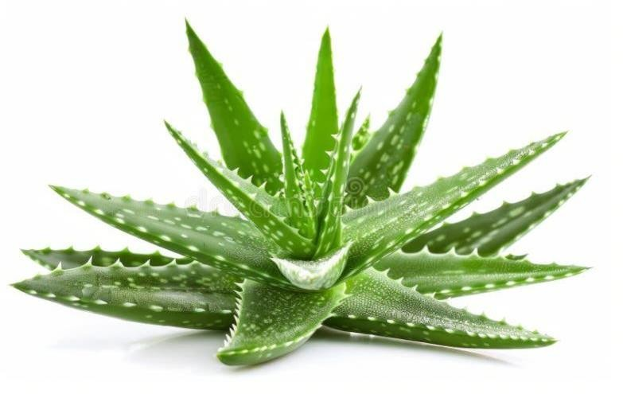

### MATERIAL USED IN PREPARATION OF SHAMPOO

1. **Aloe Vera**

Aloe vera is a succulent plant belonging to the Aloe genus, known for its wide distribution and classification as an invasive species in several regions around the world. It is an evergreen perennial plant, originally native to the Arabian Peninsula but now found growing in tropical, subtropical, and arid climates worldwide. Typically, Aloe vera can grow between 30 and 50 cm in length, with a base width of about 10 cm.

The name “Aloe Vera” comes from the Arabic word “Alloeh,” meaning “shining bitter substance,” and the Latin word “Vera,” meaning “true.”

### Benefits of Aloe Vera:

Soothes an itchy scalp

Effectively cleanses oily hair

Strengthens and repairs hair strands May support hair growth

### Categories of Aloe:

Stone aloe – Aloe petricola Climbing aloe – Aloe ciliaris Cape aloe – Aloe ferox

Coral aloe – Aloe striata Lace aloe – Aloe aristata

Candelabra aloe – Aloe arborescens Spider aloe – Aloe humilis

### Essential oils

* 1. **Coconut oil:** It is a palatable oil gotten from the wick ,meat and milk of the palm natural product. It is a white solid fat, melts at temperature of 25 C, and in summer it is clear liquid form having the coconut aroma quantity of coconut oil used -1drop.

**Terms** : Cocos Nucifera (Coconut):

Coconut oil is commonly used to promote hair growth, helping to make hair healthier, thicker, and longer. It is often blended with Aloe Vera gel to ensure a smooth consistency without lumps.

### Categories

Refined coconut oil Unrefined coconut oil Virgin coconut oil

Hydrogenated coconut oil Organic coconut oil

### Lavender Oil:

Lavender oil is derived through a distillation process from the flowers of lavender. There are over 400 lavender species, each with distinct scents and qualities. Typically, around 15 drops of lavender oil are used for hair treatments.

### Terms

The name Lavender comes from the Latin word "lavare," which means "to wash."

### Benefits

Encourages hair growth

Possesses antimicrobial properties Helps eliminate head lice

### Categories

Lavender flower oil Lavender spike oil

### Cedarwood Oil:

Cedarwood oil is an essential oil extracted from various types of conifer trees, particularly from species in the pine and cypress families. The oil is derived from the wood, roots, and foliage, often from the leftover material after logging. Typically, 8-10 drops of cedarwood oil are used in hair care treatments.

### Terms

The name Cedarwood is derived from the Latin word “Cedrus.”

### Benefits

Helps with hair loss

. Treats scalp conditions, including dandruff

Cleanses the skin by removing dirt and impurities

### Categories

Atlas cedarwood

Chinese cedarwood Himalayan cedarwood Port Orford cedarwood Texas cedarwood

### Rosemary Oil:

Rosemary oil is a potent essential oil obtained from the flowers and leaves of the rosemary plant, commonly used in hair care products, perfumes, and medicinal remedies. Typically, 25 drops of rosemary oil are used for hair treatments.

### Terms

The name Rosemary originates from the Latin phrase “dew of the sea.”

### Benefits

Stimulates hair growth

Helps prevent premature graying and dandruff Alleviates dry or itchy scalp

### Types of Rosemary Oil

Rosmarinus officinalis var. Cineole Rosmarinus officinalis var. Verbenon

### Eucalyptus Oil

Eucalyptus oil is an aromatic essential oil extracted from the leaves of the eucalyptus tree, which is native to Australia. It is widely used for its antiseptic properties and in fragrances. Typically, 2- 4 drops of eucalyptus oil are used in hair treatments.

### Terms

The word Eucalyptus comes from the Greek words “Eu” meaning “good” or “well” and “Kalypto” meaning “to cover” or “conceal.”

### Benefits

Stimulates hair follicles Enhances hair protection Promotes hair growth

Helps soothe and balance the scalp

### Categories

There are approximately 750 species within the Eucalyptus genus, with at least 500 of these producing essential oils. Among the most notable types of eucalyptus essential oils are:

Blue Gum Eucalyptus Essential Oil

Broad-Leaved Peppermint Eucalyptus Essential Oil Eucalyptus Smithii Essential Oil

## Other Excipients

### Antioxidants:

Antioxidants, whether synthetic or natural, are substances that can prevent or delay some types of cellular damage. Aloe Vera gel contains powerful antioxidants that belong to a large group of compounds called polyphenols. These polyphenols, along with other compounds in Aloe Vera, help fight the growth of certain bacteria that may cause harm to humans.

### Examples

Vitamin E

Beta-carotene

Vitamin C and Vitamin A Phytochemicals

### Vitamin E

Vitamin E plays a crucial role in maintaining healthy skin, including the scalp. It protects the lipid layer of the skin by reducing oxidative stress, providing a strong foundation for hair health.

### Terms

Vitamin E is found in vegetable oils such as palm oil, leafy green vegetables, peanut butter, and whole grains.

### Benefits

Acts as an antioxidant that can reduce dandruff Supports hair growth

Helps maintain a healthy scalp Prevents hair loss

Adds shine to hair

### Categories

There are eight compounds of Vitamin E, but the most commonly used are: Tocopherols

Tocotrienols

### Stabilizers:

Stabilizers are ingredients that maintain the effectiveness of products, particularly by controlling factors like pH balance to prevent excessive acidity or alkalinity.

### Purpose of Stabilizers in Hair Care

Helps restore the hair and scalp to a more balanced state after treatment. Improves texture and enhances hair color.

Adds smoothness and shine to hair.

### Examples

Guar gum Inulin

Beetle bean gum Gum acacia

### Guar Gum

Guar gum hydrates the hair by sealing in moisture. It acts as a conditioner, making hair smooth and shiny, while also preventing breakage. It reduces frizz, protects hair from environmental pollution, and prevents static buildup.

### Terms

Guar gum is derived from the seed endosperm of the guar plant, which is primarily cultivated in India and Pakistan.

### Benefits

Prevents product buildup on the hair Adds shine and smooth texture to the hair Seals in moisture, keeping hair hydrated

## Solubilizing Agents:

Solubilizing agents are water-soluble emulsifiers that help bind water and oil together. Polysorbate 20 is a mild, oily liquid additive used in cosmetics as a non- ionic surfactant and wetting agent, enhancing the spread of liquids.

## Purpose

The main function of solubilizing agents is to remove impurities like sebum and solid particles from the hair. They are also essential for creating effervescence, building product thickness, suspending active ingredients, and enhancing the solubility of fragrances.

## Examples

Sodium lauryl sulfate

Sodium lauryl ether sulfate Ammonium lauryl sulfate Ammonium lauryl ether sulfate

## Sodium Lauryl Sulfate (SLS):

Sodium lauryl sulfate is a surfactant, meaning it reduces surface tension between ingredients, which is why it’s used as a cleansing and foaming agent. It is commonly found in beauty and personal care products.

## Terms

It is derived from coconut or palm kernel oil and contains a mixture of sodium alkyl sulfates, primarily lauryl.

## Benefits

Less likely to cause scalp irritation Free from parabens and silicones

## Foaming Agents:

Foaming agents assist in the creation of foam by acting as surfactants. When present in small quantities, they reduce the surface tension of a liquid, allowing the mixture to form stable vesicles.

## Examples

Sodium lauryl sulfate Sodium bicarbonate

## Surfactants:

Surfactants emulsify greasy dirt on the hair and scalp, allowing it to be easily washed away with water.

## Categories

Anionic Surfactants (e.g., Sodium Lauryl Sulfate)

Amphoteric Surfactants (e.g., Cocamidopropyl Betaine) Non-Ionic Surfactants (e.g., Cocamido MEG)

## Benefits

Less likely to cause scalp irritation Free from parabens and silicones

## Cleansing Agents:

Cleansing agents are substances used to remove dirt, grime, and sebum from the hair and skin. These agents help emulsify oils and hold dirt in suspension, allowing for easy washing.

## Purpose

Cleansing agents are used to remove impurities from the surface of the hair and skin.

## Categories

Detergents Acid cleaners Water

Organic solvents

## Examples

Sodium lauryl sulfate Humectants

Silicones Proteins

## Coloring Agents:

Coloring agents are chemicals added to enhance the color of a product, such as shampoo.

## Purpose

These agents are added to the product to improve its color appearance.

## Examples

Para-phenylenediamine Resorcinol

Aminophenol

## Preservatives:

Preservatives are added to personal care products to prolong their shelf life and prevent microbial growth. These agents help protect the product from contamination by inhibiting or killing harmful microorganisms.

## Purpose

Preservatives serve as antimicrobial agents to prevent the growth of bacteria, fungi, and other microbes, ensuring the product remains safe for use over time.

## Examples

Parabens

Formaldehyde releasers Isothiazolinones

Phenoxyethanol Organic acids

# METHODS

### Appearance test

Developed formulation was evaluated for their clarity, colour and Odour. All evaluations were reported and discussed.

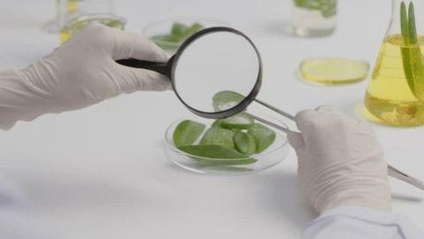

### Foaming ability test

The chamber shake method, with a slight modification, was used to assess the effervescence capacity. A 50ml solution of 1% cleanser was poured into a 250ml graduated measuring cylinder and covered with a hand. The cylinder was then shaken for one minute, and the total foam volume generated was recorded. This process was repeated for a duration of 10 minutes.

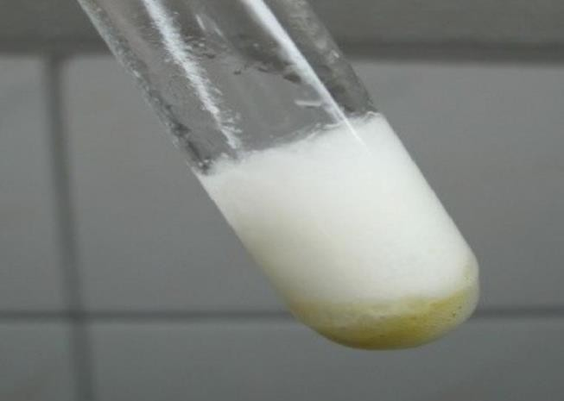

### Establishment of pH

The prepared solution was diluted with distilled water to achieve a 10% concentration. The pH of the resulting sample was then measured using a digital pH meter at room temperature, between 27°C and 30°C.

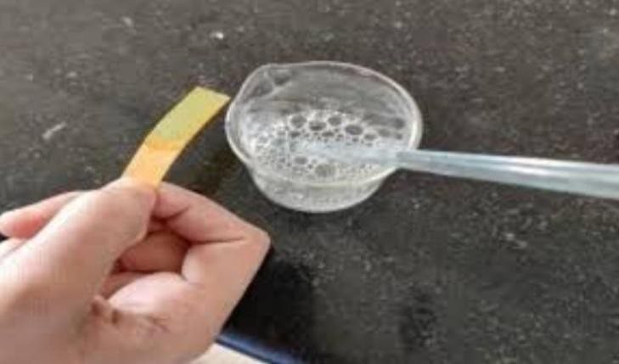

### Skin irritancy

Skin irritancy of a shampoo can be checked by taking small amount of product On skin, after few minute to check whether local irritation or any inflammatory reactions are produce or not.

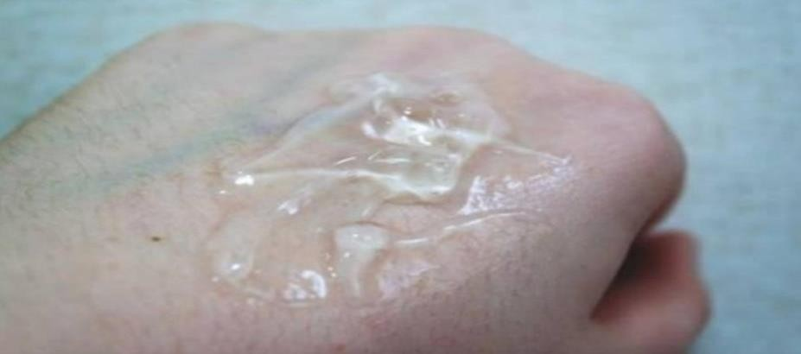

### Conditioning performance :-

The molding impact of the shampoos can be concentrated by washing a mass of trim hair with the details and mentioning actual objective facts. If the mass of the hair looks smooth and silky then it passes the test.

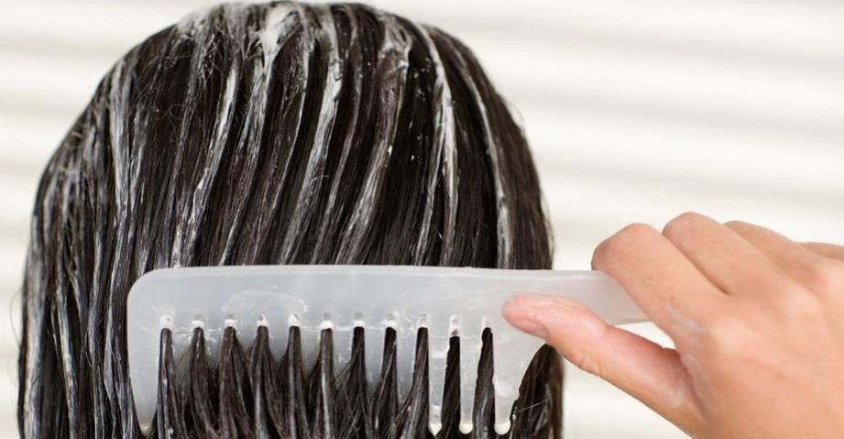

### Wetting ability

The most recommended shampoos are those that have the more limited wetting time. To check the moisten ability we should compare our formulation with the commercial Aloe Vera shampoo, if our formulation have the shorter wetting time than that of the commercial one, then it passes the test.

### Dirt Dispersion

Dirt dispersion is another analytical limit in estimating the purifying activity of shampoos, while top notch shampoos reduce the dirt in the water, low quality ones reduce the dirt in their foams. Any dirt or stains that accumulate in the foam is hard to wash away and can be remain on the hair.

### Viscosity

The regularity upsides of the shampoos went from 22.19(4 ml gel) to 26.86(10 ml gel), So the clarity with higher range of the gel shows higher density. To make the shampoos with improved consistency we must prepare shampoos with higher viscosities.

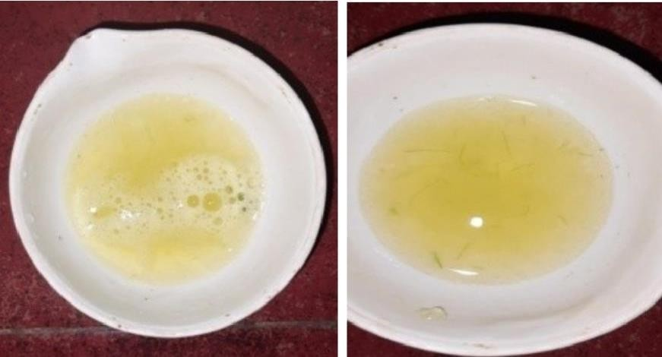

### Solid content

Lower solid content makes the shampoos watery and clear of hair quickly, if solid content is between 20 to 30% then the test will be passed.

### Surface tension

One of the measures in the detergency property is the bringing down of surface tension, and this will give the indication for an acceptable detergency results of the shampoo which should be possible by lessening the surface tension of water from 71.6 dynes/cm to the surface tension of water 31-38 dynes/cm.

## Results And Discussion

Physicochemical study of the Aloe Vera gel Shampoo

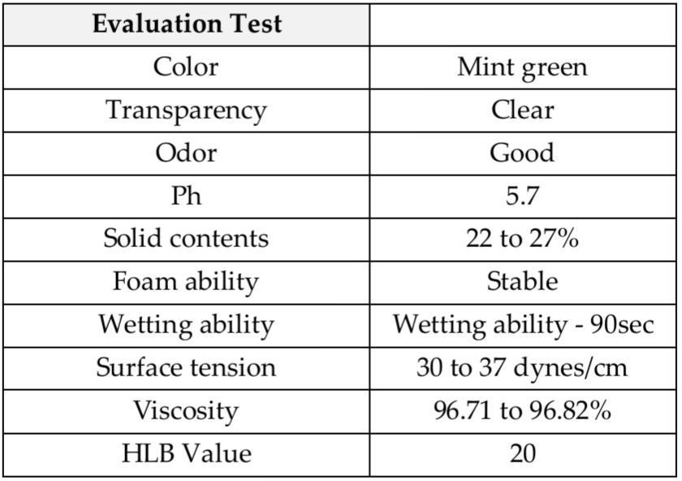

# CONCLUSION

The aim of this investigation was to develop a fully herbal shampoo that competes with commercial synthetic shampoos available in the market. The study focused on using plant extracts known for their hair care benefits to formulate a natural shampoo. All ingredients used in the formulation were chosen for their safety and potential to reduce hair or protein loss during brushing, offering a gentler alternative to synthetic conditioning agents. Various tests were conducted to assess and compare the physical and chemical properties of both the homemade and commercial shampoos. User trials were also carried out, and the results showed that the homemade formula performed better than the retail shampoo. However, further research and development are required to enhance its overall quality.

# REFERENCE

* + 1. 1.Surjushe, A., Vasani, R., & Saple, D. G. (2008). Aloe vera: a short review. Indian journal of dermatology, 53(4), 163.
    2. 2.Surjushe, A., Vasani, R., & Saple, D. G. (2008). Aloe vera: a short review. Indian journal of dermatology, 53(4), 163.
    3. 3.Pandey, A., & Singh, S. (2016). Aloe Vera: A Systematic Review of its Industrial and Ethno- Medicinal Efficacy, International Journal of Pharmaceutical Research & Allied Sciences, 5(1).
    4. 4.Kumar, K. S., & Debjit, B. (2010). Aloe vera: a potential herb and its medicinal importance. Journal of chemical Pharmaceutical Research, 2(1), 21-29. And
    5. 5.Christaki, E. V., & Florou-Paneri, P. C. (2010). Aloe vera: a plant for many uses. J Food Agric Environ, 8(2), 245-249.
    6. 6.Sharrif Moghaddasi, M., & Res, M. (2011). Aloe vera their chemicals composition and applications: A review. Int J Biol Med Res, 2(1), 466-71.
    7. 7.Arora, P., Nanda, A., & Karan, M. (2011). Shampoos based on synthetic ingredients vis- a-vis shampoos based on herbal ingredients: a review. Int J Pharm Sci Rev Res, 7(1), 42- 46.
    8. 8.Surjushe, A., Vasani, R., & Saple, D. G. (2008). Aloe vera: a short review. Indian journal of dermatology, 53(4), 163.
    9. 9.Pounikar, Y. O. G. E. S. H., Jain, P. U. S. H. P. E. N. D. R. A., Khurana, N. A. V. N. E. Ε.

Τ., Omray, L. K., Patil, S., & Gajbhiye, A. S. M. I. T. A. (2012). Formulation and characterization of Aloe vera cosmetic herbal hydrogel. International Journal of Pharmacy and Pharmaceutical Sciences, 4(4), 85-86.

* + 1. 10.Chandegara, V. K., & Varshney, A. K. (2014). Effect of centrifuge speed on gel extraction from aloe vera leaves. J. Food Process. Technol, 5, 1-6.
    2. 11.Ramachandra, C. T., & Rao, P. S. (2008). Processing of Aloe vera leaf gel: a review. American Journal of Agricultural and Biological Sciences, 3(2), 502-510.
    3. 12.Chandran, S., Vipin, K. V., Augusthy, A. R., Lindumol, K. V., & Shirwaikar, A. (2013). Development and evaluation of antidandruff shampoo based on natural sources. Journal of Pharmacy and Phytotheraputics, 1(4), 2321-5895.
    4. Khan, A. W., Kotta, S., Ansari, S. H., Sharma, R. K., Kumar, A., & Ali, J. (2013). Formulation development, optimization and evaluation of aloe vera gel for wound healing. Pharmacognosy magazine, 9(Suppl 1), S6.
    5. Chandegara, V. K., & Varshney, A. K. (2013). Aloe vera L. Processing and products: A review. Int. J. Med. Aromat. Plants, 3(4), 492- 506.
    6. KB, B., NG, H., & T PATIL, R. A. J. E. S. H. (2014). REVIEW ON VERA. International Journal, 2(3), 677-691. ALOE
    7. Goudarzi, M., Fazeli, M., Azad, M., Seyedjavadi, S. S., & Mousavi, R. (2015). Aloe vera gel: effective therapeutic agent against multidrug-resistant Pseudomonas aeruginosa isolates recovered from burn infections. Chemotherapy Practice, 2015.
    8. Sona, F. R. (2018). Formulasi Hair Tonic ekstrak Lidah Buaya (Aloe Vera (1.) Burm. F.) dan uji aktivitas pertumbuhan rambut pada tikus putih jantan (Doctoral dissertation, Universitas Islam Negeri Maulana Malik Ibrahim).
    9. Hashemi, S. A., Madani, S. A., & Abediankenari, S. (2015). 4The review on properties of Aloe vera in healing of cutaneous wounds. BioMed research international, 2015.
    10. Sanghi, S. (2015). Aloe vera: a medicinal herb. International Journal of Research- Granthaalayah, 3(11), 32-34.
    11. Sahu, P. K., Giri, D. D., Singh, R., Pandey, P., Gupta, S., Shrivastava, A. K., ... & Pandey,

K. D. (2013). Therapeutic and medicinal uses of Aloe vera: a Pharmacy, 4(08), 599. Review. Pharmacology &

* + 1. Subasree, S., & Murthykumar, K. (2016). Effect of aloe vera in oral health-A review. Research Journal of Pharmacy and Technology, 9(5), 609- 612.
    2. Samarh, S. N., Khalaf, N. A., & Hajhamad, M. M. (2017). Evidence based medical use of Aloe vera extracts, short review of literature. Int J Res Med Sci, 5(10), 4198-202.
    3. Gupta, A., & Rawat, S. (2017). Clinical importance of aloe vera. Research Journal of Topical and Cosmetic Sciences, 8(1), 30-39.
    4. PATHAK, D., & SHARMA, R. (2017). Review on “Aloe vera-medicinal plant”. International Journal of Advance Research and Innovative Ideas in Education, 3(1), 661.
    5. Vijayalakshmi, A., Sangeetha, S., & Ranjith, N. (2018). Formulation and evaluation of herbal shampoo. Asian Journal of Pharmaceutical and Clinical Research, 11(4), 121-124
    6. Thorat, K. J., Yamgar, T. S., Shirote, P. J., & Deshmane, B. (2018). A Review on Stability of Aloe Vera Gel Research Journal of Topical and Cosmetic Sciences, 9(1), 7-11.
    7. Lanka, S. (2018). A review on Aloe vera-The wonder medicinal plant. Journal of Drug Delivery and Therapeutics, 8(5-s), 94-99.
    8. Pressman, P., Clemens, R., & Hayes, A. W. (2019). Aloe vera at the frontier of glycobiology and integrative medicine: health implications of an ancient plant. SAGE Open Medicine, 7, 2050312119875921.
    9. Gubitosa, J., Rizzi, V., Fini, P., & Cosma, P. (2019). Hair care cosmetics: From traditional shampoo to solid clay and herbal shampoo, a review. Cosmetics, 6(1), 13.
    10. Pegu. A. J., & Sharma, M. A. (2019). Review on aloe vera. Int J Trend Sci Res Dev, 3(4), 35-40.
    11. García, M. H., Juárez, J. A. T., & Jiménez, A. D. (2019). Importance and Properties of Aloe vera in the Production of Hair Shampoo. The Journal of Middle East and North Africa Sciences, 5(7).
    12. Gubitosa, J., Rizzi, V., Fini, P., & Cosma, P. (2019), Hair care cosmetics: From traditional shampoo to solid clay and herbal shampoo, a review. Cosmetics, 6(1), 13.
    13. Laneri, S., Di Lorenzo, R. M., Bernardi, A., Sacchi, A., & Dini, I. (2020). Aloe barbadensis: A Plant of Nutricosmetic Interest. Natural Product 1934578X20932744. Communications, 15(7),
    14. Sawant, P. S., Sankpal, P. B., Jagtap, A. M.. Gavade, A. S., & Vambhurkar, G. B. (2020). Formulation and evaluation of herbal shampoo. Research Journal of Topical and Cosmetic Sciences, 11(1), 01-04.