**A REVIEW ON SELF EMULSIFING DRUG DELIVARY SYSTEM**

**Dr. R. Rama Brahma Reddy1 , P. Sukanya2, D. Mounika.3**

**1**principal& Professor, Dept. Of Phytochemistry, Nalanda Institute of Pharmaceutical Sciences, Kantepudi, Sattenapalli.

2Assistent Professor, Dept. of Pharmaceuticals, Nalanda institute of pharmaceutical sciences, Kantepudi, Sattenapalli.

3Student, Nalanda Institute of Pharmaceutical sciences, Kantepudi, Sattenapalli.

**ABSTRACT:** Around 40-60% of potential drugs in the pharmaceuticals market are lipophilic in nature due to the low aqueous solubility and low permeability and thereby facing problems in their formulation. Their rare-limiting step is the dissolution-rate of the drugs. For BCS class11 drugs which have the therapeutic delivery of lipophilic active moieties receive more attention due to this reason. One of the formulation systems that deal with poor solubility, slow dissolution rate is self-micro emulsifying drug delivery system. The hypothesis between dissolution rate enhancement with SEDDS is the spontaneous formation of the emulsion in the gastrointestinal tract which presents the drug in solubilized from and small size of the formed droplet provide a large interfacial surface area for drugs absorption. Due to small global size the micro/nano-emulsified drug can easily be absorbed through lymphatic pathways, thereby bypassing the hepatic first-pass effect.in practical use, the lipid formulation range from pure oils to blend which contain a strong proportion of hydrophilic surfactants or co-solvents. This review gives a complete summery of SEEDS which may be a promising approach to effectively overcome the problem of poorly soluble molecules.

**KEY WORDS**:

classification of seeds, advantages of seeds, properties, factors affecting of seeds, method of preparation, formulation, evaluation of seeds.

**INTRODUCTION:**

Selfmicroemulsifying drug delivery systems (SMEDDS) are the familiar approaches for their potential as an optional scheme for delivery of hydrophobic drugs which are associated with poor water solubility and low oral bioavailability. The isotropic mixture of an oil, a surfactant, a co-surfactant (or solubilizer), and a drug forms SMEDDS. The basic principle of this system is its ability to form exquisite oil-in-water microemulsions under gentle agitation following dilution by aqueous phases. This spontaneous formation of an emulsion in the gastrointestinal tract presents the drug in a solubilized form and the small size of the formed droplet provides a large interfacial surface area for drug absorption. apart from the solubilization, the presence of lipid in the formulation further helps improve bioavailability by affecting the drug absorption. Selection of a suitable self-emulsifying formulation depends upon the assessment of the solubility of the drug in various components, the area of the self-emulsifying region as obtained in the phase diagram, and the droplet size distribution of the resultant emulsion following self-emulsiﬁcation. These systems are composed of oils, surfactants, and cosolvents, and can produce micro-emulsions or fine oil-in-water emulsions after moderate stirring and dilution by the water phase along the gastrointestinal tract. SEDDS have been developed to address the limited and erratic oral bioavailability of lipophilic drugs, which account for a significant portion of both marketed and new drug candidates. The incorporation of lipophilic drugs into SEDDS, particularly self- nano-emulsifying drug delivery systems (SEDDS), has shown promise in overcoming absorption barriers following oral administration of such compounds. The success of SEDDS depends on the specific physicochemical compatibility of the drug and the nature of the combination of surfactant and oil, the concentration of surfactant, and the ratio of oil and surfactant, as well as the temperature of self-emulsification. The development and evaluation of SEDDS have been the subject of extensive research, with a focus on optimizing the formulation to achieve rapid and efficient self-emulsification, leading to improved drug solubility and bioavailability. The potential of SNEDDS in addressing issues such as inadequate bioavailability and undesired side effects has been demonstrated in various studies, making them a promising strategy for oral drug delivery.

**CLASSIFICATION OF SEEDS:**

1. **SINGLE COMPONENT LIPID SOLUTIONS:**  This is the simplest formulation that consists of the drug solubilized in a single excipient in plant oil or glyceride or a PEG. The evident advantage of this formulation approach is its congeneric simplicity. This formulation depend solvent on the gastrointestinal lipid handling pathways to promote emulsification which is essential for facile drug release and absorption with the exclusion of PEGs. In patients for whom lipid digestion has been determined by age or disease, the drug absorption is lower than the optimal. The single‐component PEG solutions often have high solubilizing power for poorly water soluble drugs. So, the degree of bioavailability enhancement is dose‐dependent, which renders PEG solution formulations poorly effective for high‐dose drugs .

1. **SELF EMULSIFYING FORMULATIONS:**  Self‐emulsifying drug delivery systems are physically stable isotropic mixtures of oil, surfactant, co‐surfactant and solubilized drug substance that are suitable for oral delivery in soft and hard gelatin capsules. Depending on the excipient selection and relative composition of the formulation, aqueous dilution will result in spontaneous formation of lipid droplets ranging in size from approximately 100 nm (SEDDS) to less than 50 nm (SMEDDS). The optimum concentrations or concentration ranges of oil, surfactant and co‐surfactant are necessary to promote self‐emulsification. Since droplet surface area is inversely proportional to diameter, smaller lipid droplets with their associated, greater surface area are thought to facilitate digestion, resulting in more lipid and uniform drug release and absorption. The improved drug absorption provided by self‐emulsifying for utilization is contingent upon the maintenance of the drug in the solubilized state until it can be absorbed from the GIT. In some instances, SMEDDS formulations have proven useful in palliating the enhancing effect that food can have on the absorption of poorly water-soluble drugs

.

1. **SELF-EMULSIFYING SOLID DISPERSION FORMULATIONS:** Liquid self‐emulsifying formulations rely on micelle or solvent to fully solubilize the drug dose, which helps to ensure optimal absorption. However, the utility of these formulations can be limited by their inability to solubilize the entire drug dose in the volume of a single oral capsule. In these instances solid dispersion formulations, which may not fully solubilize the drug in the excipient matrix, can provide a viable, alternative oral formulation. These formulations consist of a dispersion of the drug in an inert excipient matrix, where the drug could exist in either the finely divided crystalline, solubilized or amorphous states or a mixture thereof. This can increase the dissolution rate of the drug and subsequent absorption from, the GI tract relative to the stable crystalline drug substance. These excipients have the potential to further increase the absorption of poorly water‐soluble drugs relative to previously used PEG solid dispersions and may also be filled directly into hard gelatin capsules in the molten state, thus obviating the former requirement for milling and blending prior to filling.

* **ADVANTAGES OF SEEDS:**

1. Enhanced oral bioavailability enabling reduction in doses.
2. More consistent temporal profiles of drug absorption.
3. Selective targeting of drug toward specific absorption window in GIT.
4. Protection of drug from the hostile environment in gut.
5. enhanced oral bioavailability.
6. easy of manufacture and scale up.

* **DISADVANTAGES OF SEEDS:**

1. High production costs.
2. Low stability and portability.
3. Limited drug loading capacity.
4. Potential toxicity of surfactants and co-solvents used in the formulation.

**PROPERTIES OF SEEDS:**

* They form o/w emulsion by gentle agitation by peristaltic movement in the G.I.tract.
* Hydrophobic and hydrophilic drug can be used with an oil surfactant mixture.
* A lower dose of drugs can be used for lipid as well as solid dosage form.
* Clear dispersion of seeds should be formed instantaneously in the G.I tract that remains stable on dilution. Such distribution are either micro or nanoemulsion (100-250nm) or nanoemulsion (less than 100nm) depending upon the globule size of the seeds formulation .
* Dose should not be so high,
* drug should be oil soluble,
* They require lower dose of drug with respect to conventional dosage form.

**ROLE OF CO SURFACTANT IN SEDDS**:

Co-surfactants play a crucial role in self-nanoemulsifying drug delivery systems (SNEDDS) by helping to improve the solubility, dissolution rate, oral bioavailability of hydrophobic drug. The role of co-surfactants in SNEDDS can be summarized as follows:

* **Improving solubility** Co-surfactants help to increase the solubility of drugs in the oil phase for enhancing their bioavailability.
* **Enhancing emulsification** Co-surfactants, along with surfactants, contribute to the emulsification process by reducing interfacial tension and promoting the formation of nanoemulsion.
* **Optimizing formulation** Co-surfactants can help to optimize the formulation of SNEDDS by adjusting the oil/surfactant ratio and the overall composition of the system..
* **Stabilizing emulsions** Co-surfactants can help to stabilize emulsions by reducing droplet coalescence and enhancing the stability of the nanoemulsion.
* **Bioavailability enhancement** The presence of co-surfactants in SNEDDS can lead to improved drug bioavailability, as they can help to overcome absorption barriers and enhance the drug's dissolution rate ZX

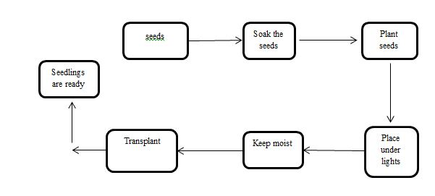

**Fig no :1 Seed germination flow chart**

**METHOD OF PREPARATIONS:**

**1. Spray Cooling:**

The molten droplets are sprayed into cooling chamber, which will set and re-crystallize in to spherical solid particles that fall to the bottom of the chamber and it is subsequently collected as fine powder. The fine powder is then be used for developing solid dosage forms or direct filling into hard shell capsules. Many types of equipment are available to atomize the liquid mixture and to generate droplets: rotary, pressure, two-fluid or ultrasonic atomizers.

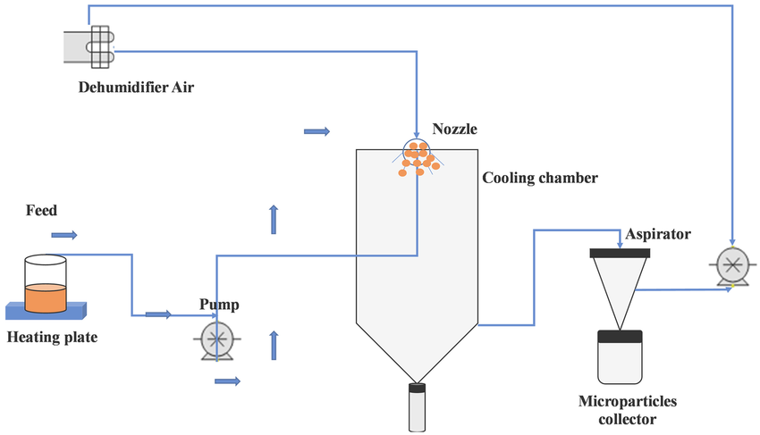

**Fig no: 2 spray cooling method diagram**

1. **Spray Drying:**

Spray drying is defined as a process in which a liquid solution is sprayed into a hot air chamber to evaporate the volatile fraction. Polyoxylglycerides have been used alone or in combination with a solid carrier to form microparticles of etoricoxib and glibenclamide. Dry emulsion technology solves the stability problems associated with classicemulsions during storage and helps also avoid using harmful or toxic organic solvents. Dry emulsions may be re-dispersed into water before use. Medium chain triglycerides are commonly used as oil phase for these emulsions.

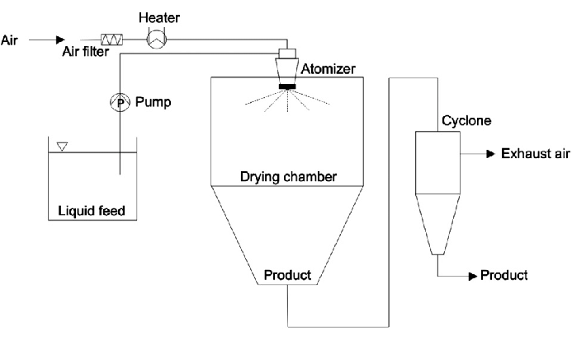

**Fig no: 3 spray drying method**

**3.Adsorption on Solid Carriers:**

Solid carriers are used for the adsorption of liquid formulation to get final solid product and it will be free flowing so that it can be compressed or directly filled in hard gelatin capsules. A significant benefit of the adsorption technique is good content uniformity, as well as the possibility for high lipid exposure.

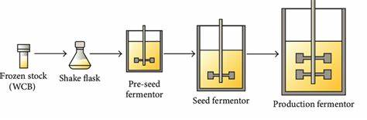

**Fig no: 4 absorption on solid carries method diagram**

**4.Supercritical Fluid Based Method:**

Lipids may be used in supercritical fluid based methods either for coating of drug particles, or for producing solid dispersions. For environmental reasons, the preferred supercritical fluid of choice is supercritical carbon dioxide.

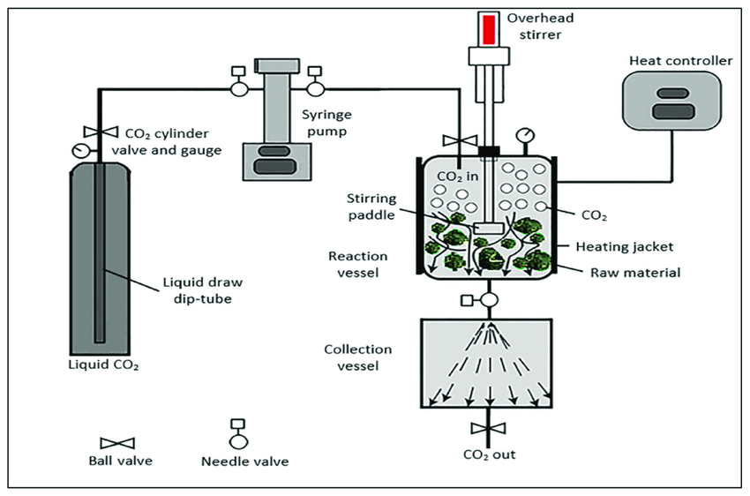 **Fig no: 5 supercritical fluid based method diagram**

**FORMULATIONS OF SEEDS:**

**Oil:** Both long and medium-chain triglyceride (MCT) oils with different for the design of self-dispersing formulations. Unmodified edible oils provide the most ‘natural’ basis for lipid vehicles, but their poor ability to dissolve large amounts of hydrophobic drugs and their relative difficulty in efficient self emulsification. Medium chain triglycerides were Medium chain triglycerides were preferred in the earlier self-emulsifying formulations because of higher fluidity, better solubility properties and self- emulsification ability, but evidently hey are considered less attractive compared to the novel semi-synthetic medium chain derivatives which can be defined rather as amphiphilic compounds exhibiting surfactant properties. In such cases, the more lipophilic surfactant may play the role of the hydrophilic oil in the formulation.

**SURFACTENTS**: Several compounds exhibiting surfactant properties may be employed for the design of self-emulsifying systems, but the choice is limited as very few surfactants are orally acceptable. The most widely recommended ones being the non-ionic. Hence emulsifiers of natural origin are preferred than the synthetic surfactant, but they have a limited self-emulsification capacity. There is a relationship between the droplet size and the concentration of the surfactants being used.

**CO-SOLVENTS:** Organic solvents, suitable for oral administration (ethanol, propylene glycol (PG), polyethylene glycol (PEG), etc.) may help to dissolve large amounts of either the hydrophilic surfactant or the drug in the lipid base. These solvents sometimes play the role of the co-surfactant in the micro emulsion systems, although alcohol free self-emulsifying micro emulsions have also been described in the literature. Indeed, such systems may exhibit some advantages over the previous formulations when incorporated in capsule dosage forms, since alcohol and other volatile co-solvents comprised in the conventional self-emulsifying formulations are known to migrate into the shells of soft gelatin or hard sealed gelatin capsules, resulting in the precipitation of the lipophilic drug. On the other hand, the lipophilic drug dissolution ability of the alcohol free formulation may be limited.

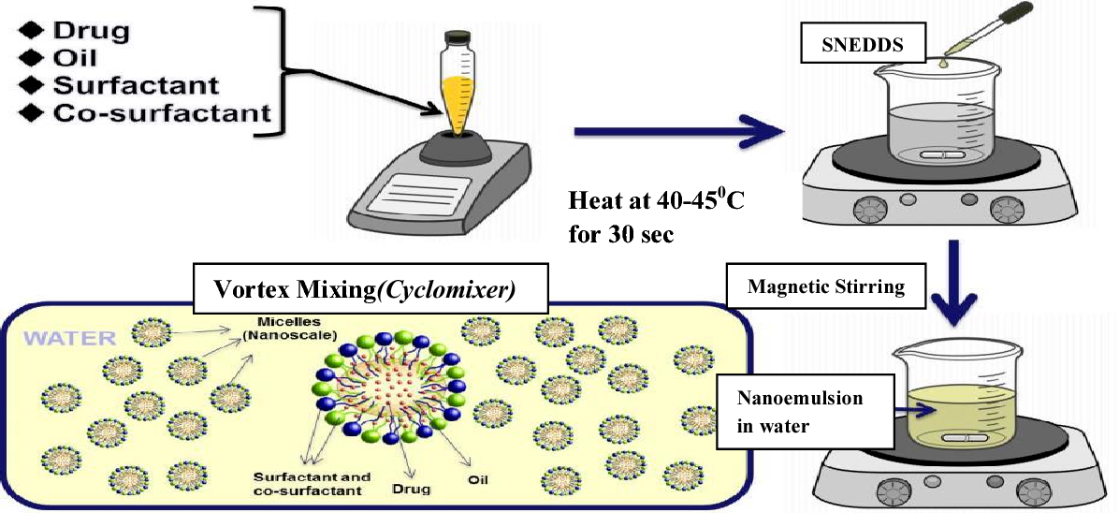

**Fig no 6: solid self nano emulsifying drug delivery system**

**EVALUVATION OF SEEDS:**

* **Dispersibility test:**

The efficiency of self-emulsification of oral nano or microemulsion is assessed using a standard USP XXII dissolution apparatus 2. One milliliter of each formulation was added to 500 mL of water at 37 ± 0.5° C

* **Rheological property estimation**

The SEDDS system is generally administered in soft gelatin or hard gelatin capsules. So, it can be easily pourable into capsules and such system should not too thick. The rheological properties of the micro emulsion are evaluated by Brookfield viscometer.

* **Visibility assessment**

The self-emulsification characteristics of the formulation are assessed visually. Water is added to the formulation, and it is then gently stirred. Immediately following dilution, the effectiveness of the self-emulsification process is monitored to evaluate the drug's appearance (transparency), phase separation, and precipitation .

* **Droplet Size Analysis:**

The size distribution of the nanoemulsion is analysed using techniques like dynamic light scattering (DLS) or nanoparticle tracking analysis.

* **Zeta Potential:**

The zeta potential of the SEDDS formulation is measured to assess its stability and the interaction between the nano emulsions.

* **Stability assessment:**

Stability assessment is a crucial aspect of evaluating Self-Nanoemulsifying Drug Delivery Systems (SEDDS) formulations. Stability assessment involves monitoring the physical and chemical properties of the SEDDS formulation over time to ensure its stability and effectiveness. Some common methods used for stability assessment of SEDDS.

* **Droplet size analysis and particle size measurement:**

This is a crucial factor in self‐emulsification performance because it determines the rate and extent of drug release as well as the stability of the emulsion. Photon correlation spectroscopy, microscopic techniques are mainly used for the determination of the emulsion droplet size. The reduction of the droplet size to the values below 50 µm leads to the formation of SMEDDSs which are stable, isotropic and clear o/w dispersion.

* **Centrifugation Method**

This method involves centrifuging the SNEDDS formulation at a specific speed for certain duration and observing any changes in the formulation.

* **Thermodynamic Stability Studies**

These studies involve checking for any signs of instability among the various SNEDDS formulations prepared. Stability assessment is critical to ensure the effectiveness and suitability of SNEDDS formulations for drug delivery applications. It involves a comprehensive evaluation of the physical, chemical, and biological properties of the formulation to determine its overall performance

**CONCLUSION:**

SEDDS are a viable formulation method for medicinal molecules with low water solubility. SEDDS have been demonstrated to remarkably enhance oral bioavailability, and utilized to orally administer hydrophobic medicines. With future development of this technology, SEDDSs will continue to enable novel applications in drug delivery and solve problems associated with the delivery of poorly soluble drugs. SEEDS substantially improved solubility/dissolution, absorption and bioavailability of poorly water soluble drugs. As improvement or alternatives of conventional liquid SEEDS is superior in reducing production cost, simplifying industrial manufacture, and improving patient compliance and stability. GI irritation is avoidable and controlled/sustained release of drug is achievable. SEEDS are a promising approach for the formulation of drug compounds with poor aqueous solubility. The delivery of hydrophobic drugs can be made possible by SEEDS which have been shown to improve oral bioavailability of substantially.

**REFFERENCE**:

1. Amara S, Bourlieu C, Humbert L, et al. Variations in gastrointestinal lipases, pH and bile acid levels with food intake, age and diseases: possible impact on oral lipid-based drug delivery systems. Adv Drug Deliv Rev 2019 142:3–15.
2. Badadhe S, Dalavi N. Review on self nano emulsifying drug delivery system. Sys Rev Pharm 2022: 13:63–82
3. Betageri GV. Self-emulsifying drug delivery systems and their marketed products a review. Asian J Pharm 2019: 13:73–84.
4. de Oliveira MC, Bruschi ML. Self-emulsifying systems for delivery of bioactive compounds from natural origin. AAPS PharmSciTech2022: 23: 1–1
5. Halder S, Islam A, Muhit MA, et al. Self-emulsifying drug delivery system of black seed oil with improved hypotriglyceridaemic effect and enhanced hepatoprotective function. J Funt Foods2021: 78:104391
6. Halim A, Jindal K, Tarique M. Solubility enhancement of poorly soluble drug by self emulsifying drug delivery system: comprehensive review. World J Pharm Res2021: 10:840–52.
7. Kang J, Yoo K, Park H, et al.. Preparation and in vivo evaluation of a lidocaine self-nanoemulsifying ointment with glycerol monostearate for local delivery. Pharmaceutics 2021:13:1468.
8. Salawi, Ahmad. “Self-emulsifying drug delivery systems: a novel approach to deliver drugs.” Drug delivery vol. 29,1 (2022): 1811-1823.
9. Chatterjee, B., Hamed Almurisi, S., Ahmed Mahdi Dukhan, A., Mandal, U. K., & Sengupta, P. (2020). Controversies with self-emulsifying drug delivery system from pharmacokinetic point of view. Drug Delivery, 23(9), 3639–3652
10. Rathore, C., Hemrajani, C., Sharma, A.K. et al. Self-emulsifying drug delivery system (SEDDS) mediated improved oral bioavailability of thymoquinone: optimization, characterization, pharmacokinetic, and hepatotoxicity studies. Drug Deliv. and Transl. Res. 13, 292–307 (2023).
11. Aungst B.J. Novel formulation
12. strategies for improving oral
13. bioavailability of drugs with poor
14. membrane permeation or presystemic
15. metabolism: J. Pharm. Sci. 1993; 8Salawi, Ahmad. “Self-emulsifying drug delivery systems: a novel approach to deliver drugs.” Drug delivery vol. 29,1 (2022): 1811-1823.
16. Joshi P., Patil P. Effect of Formulation
17. Variables on Preparation and
18. Evaluation of Gelled Self-emulsifying
19. Drug Delivery System (SEEDS) of
20. Ketoprofen: AAPS PharmSciTech.
21. 2004;5 (3):5-8.
22. Joshi P., Patil P. Effect of Formulation
23. Variables on Preparation and
24. Evaluation of Gelled Self-emulsifying
25. Drug Delivery System (SEEDS) of
26. Ketoprofen: AAPS PharmSciTech.
27. 2004;5 (3):5-8.
28. Joshi P., Patil P. Effect of Formulation
29. Variables on Preparation and
30. Evaluation of Gelled Self-emulsifying
31. Drug Delivery System (SEEDS) of
32. Ketoprofen: AAPS PharmSciTech.
33. 2004;5 (3):5-8.
34. Joshi P., Patil P. Effect of Formulation
35. Variables on Preparation and
36. Evaluation of Gelled Self-emulsifying
37. Drug Delivery System (SEEDS) of
38. Ketoprofen: AAPS PharmSciTech.
39. 2004;5 (3):5-8.
40. Joshi P., Patil P. Effect of Formulation
41. Variables on Preparation and
42. Evaluation of Gelled Self-emulsifying
43. Drug Delivery System (SEEDS) of
44. Ketoprofen: AAPS PharmSciTech.
45. 2004;5 (3):5-8.
46. Joshi P., Patil P. Effect of Formulation
47. Variables on Preparation and
48. Evaluation of Gelled Self-emulsifying
49. Drug Delivery System (SEEDS) of
50. Ketoprofen: AAPS PharmSciTech.
51. 2004;5 (3):5-8.
52. Joshi P., Patil P. Effect of Formulation
53. Variables on Preparation and
54. Evaluation of Gelled Self-emulsifying
55. Drug Delivery System (SEEDS) of
56. Ketoprofen: AAPS PharmSciTech.
57. 2004;5 (3):5-8.
58. Joshi P., Patil P. Effect of Formulation
59. Variables on Preparation and
60. Evaluation of Gelled Self-emulsifying
61. Drug Delivery System (SEEDS) of
62. Ketoprofen: AAPS PharmSciTech.
63. 2004;5 (3):5-8.
64. Joshi P., Patil P. Effect of Formulation
65. Variables on Preparation and
66. Evaluation of Gelled Self-emulsifying
67. Drug Delivery System (SEEDS) of
68. Ketoprofen: AAPS PharmSciTech.
69. 2004;5 (3):5-8.