**AI ENABLED ACCIDENT IDENTIFICATION AND ALTERING SYSTEM USING IOT**

# Shivayogappa H J1,Shreya R2,Vaishnavi D Sharma3,Nayana Sanmani4

1Professor*,* 2Final year Student*,* 3Final year Student *,* 4Final year Student*,* Department of Electronics and Communication Engineering, P E S Institue of Technology and Management, Shimoga

***

**Abstract –**Road traffic accidents claim around 1.35 million lives annually, with an additional 20 to 50 million individuals suffering injuries, often with long-term effects. These incidents are primarily caused by inadequate coordination among traffic management and emergency response organizations. Violations of traffic rules further contribute to the issue, escalating accident rates. Key risk factors include speeding, intoxicated driving, distracted driving, inadequate road infrastructure, poorly maintained vehicles, and non-compliance with traffic laws.

**Keywords** - Accident Detection, Long Short-Term Memory, Convolutional Neural Network, RNN.

## INTRODUCTION

## Due to rapid growth of world population, the demand for vehicles has increased tremendously, resultantly problems of traffic congestion and road accidents has also increased. The general population’s life is under high risk, if any accident occurs there’s a long reaction time which increments the number of deaths, therefore an automatic accident detection system must exist to overcome this situation. There can be multiple causes of road accidents, some of them are, driver negligence due to drowsiness, driving while intoxicated over speeding etc. Some studies show that weather conditions can also contribute towards the severity of an accident such as fog, rain, high winds. High winds can directly influence the vehicle which may deviate the vehicle from road, or indirectly due to obstruction dangers present on the roads such as trees, walls etc. Accident detection is one of the key problems in computer vision that has been studied for more than 15 years. It is important because of the sheer number of applications which can benefit from Accident detection.

## Road accidents have become a major cause of death around the world. This increasing rate of consequences due to accidents manifests the thought of improving safety of people. India stands first among most of the countries that has claimed the lives of millions of people per year according to the ministry. The number of traffic collisions and its effects is an rising issue all over the world because of increasing population and vehicle usage. Various factors

## involved in traffic collisions has a considerable effect on one another, which makes it difficult to consider the

## parameters individually while explaining the severity of traffic collisions.

The rapid increase in global population has significantly raised the demand for vehicles, leading to heightened traffic congestion and a surge in road accidents. The lack of timely response in accident scenarios often increases fatalities, underscoring the need for an automatic accident detection system. Various factors contribute to accidents, such as driver fatigue, intoxication, overspeeding, and adverse weather conditions like fog, rain, and high winds. These weather conditions may either directly affect vehicle stability or indirectly cause hazards like fallen trees or obstructed roads.

Accident detection is a critical issue in computer vision, studied extensively over the past 15 years. Its importance lies in its broad range of applications, which aim to enhance road safety through timely detection and response.

**II. RELATED WORK**

Researchers have proposed numerous systems for accident detection. Early methods utilized real-time traffic analysis to predict accidents by monitoring changes in traffic flow. For example, Shuming Tang and Haijiun Gao introduced the Traffic-Incident Detection Algorithm based on nonparametric regression. Similarly, Yong-Kul Ki, Jin-Woo Kim, and Doo-Kwon Baik developed a model for automatic accident detection and reporting at intersections using metadata.

In Jung Lee proposed a highway accident detection system using CCTV to monitor traffic flow through Wigner distribution analysis. However, this method depends heavily on external factors, making implementation challenging. Smartphone-based accident detection systems, like those using On-Board Diagnostics (OBD-II), were explored by Zaldivar et al., while Bin Basheer et al. proposed a motorcycle-specific detection system focusing on acceleration, tilt, and pressure changes. However, such systems are often limited in handling diverse accident scenarios.Other approaches include G. Sasikala's RF-based helmet safety systems and Narong Boonsirisumpun’s use of convolutional neural networks (CNNs) for helmet classification, though these systems face challenges like high false recognition rates.

**III. LITERATURE SURVEY**

3.1 Overview

Many systems have been proposed for accident detection by researchers. The accident detection methods were first based on real time traffic analysis to forecast traffic flow which deals with the change in the traffic before the occurrence of the accident. This detection technique is known as Traffic-incident detection-algorithm based on nonparametric regression which was proposed by Shuming Tang and Haijiun Gao. Similar model for traffic accident automatic detection, recording and reporting at intersection using metadata registry which was proposed by Yong-Kul Ki ,Jin-Woo Kim and Doo-Kwon Baik . An accident detection system on highway, proposed by In Jung Lee makes use of CCTV which view flow of vehicle trace is like as level spacing distribution as Wigner distribution. But this method monitors the whole traffic flow which have many loop holes in its implementation as it depends on many factors such as traffic flow analysis, sensors to monitor this condition. The android based smartphones are also used for detecting accident which monitors the vehicle through an On Board Diagnostics (OBD-II) interface, being able to detect accidents is proposed by Zaldivar,1. Calafate, e.T., Cano, J.e., Manzoni, P. A system proposed by Bin Basheer, F. Alias, J.J., Favas,

C.M., Navas, Y., Farhan, N.K. and Raghu, C.Y. put forward a Design for accident detection and alert system for motor cycles considering three parameters: acceleration! deceleration, tilt of the vehicle and the pressure change on the body of the vehicle. This systems lacks because two wheelers accidents may have a number of scenarios which are not completely covered by this system. The proposed method aims to overcome the above mentioned limitations and utilizes the capability of a GPS device and a proximity sensor to create an intelligent distributed system to detect accidents and alert the emergency services. G. Sasikala.

The article "Highway Accident Detection and Notification using Machine Learning" (2020) by Nancy P., Dilli Rao D., Babuaravind G., and Bhanushree S. talks about how road accidents are a big problem in India and one of the main reasons for many deaths. The number of deaths is increasing because there is often no quick communication or medical help after an accident. To solve this problem, smart systems have been developed to detect accidents and reduce their effects. The article explains two methods: VANET-Based System: This system uses data from a network called VANETs (Vehicular Ad Hoc Networks), where vehicles share information with each other. When an accident happens, the system alerts nearby drivers to prevent further crashes. CCTV-Based System: This method uses security camera footage. A machine learning model called a Convolutional Neural Network (CNN) analyzes every frame of the video and decides if there was an accident or not. This makes it easier to detect accidents quickly.

The article "Traffic Accident Analysis Using Machine Learning Paradigms" (2005) by Miao Chong, Ajith Abraham, and Marcin Paprzycki discusses a system designed to detect car accidents using video recordings from dashboard cameras.This system works by analyzing the video footage captured by the car's dashboard camera. It uses machine learning techniques to process the video and identify patterns that indicate whether an accident has occurred. The system then provides an output, stating if an accident took place or not.By automating the detection process, this system can help in quickly identifying accidents, allowing for faster responses and reducing delays in assistance. It is a simple yet effective method to enhance road safety and improve accident detection using technology.

The article "Accident Detection Using Convolutional Neural Networks" (2019) by Sreyan Ghosh, Sherwin Joseph Sunny, and Rohan Roney introduces a new system for analyzing traffic accidents. This system not only detects accidents but also classifies the severity of injuries resulting from different types of collisions. The authors developed a traffic safety control policy based on roadway patterns, which helps in better managing accident-prone areas. The paper highlights the efficiency of Convolutional Neural Networks (CNNs) for image classification tasks.

CNNs achieved an impressive 95% accuracy when working with smaller datasets, making it a reliable choice for accident detection. Moreover, this system requires less processing time compared to other machine learning architectures, making it faster and more efficient.This approach shows how technology can be used to improve traffic safety, offering both accurate detection and injury severity classification to aid in better emergency response and prevention strategies. The article "Traffic Accident Detection by Using Machine Learning Methods" (2012) by Nejdet Dogru and Abdul Hamit Subasi discusses a system designed to reduce and prevent road accidents using advanced technologies.The paper explores various ideas for preventing crashes, including the use of sensors to detect objects that may lead to accidents. It introduces a system that collects and stores detailed information from nearby vehicles. By analyzing this data, the system uses machine learning techniques to predict and detect potential accidents. Machine learning plays a key role in distinguishing between normal and abnormal driving behaviors. The system examines traffic records and monitors vehicles that display unusual or risky movements, such as sudden swerves or excessive speeding. The algorithm has proven to be effective in detecting accidents by successfully identifying these irregular patterns.

The article "Prototype of Automatic Accident Detection and Management in Vehicular Environment Using VANET and IoT" (2017) by Kishwer Abdul Khaliq, Amir Qayyum, and Jurgen Pannek addresses the growing problem of road accidents caused by increasing vehicle numbers and traffic congestion. The rising death rate from accidents is often due to delays in receiving medical assistance.To address this, the paper presents a prototype system designed to automatically detect accidents and manage emergency responses using VANET (Vehicular Ad Hoc Networks) and IoT (Internet of Things) technologies. The system is equipped with mechanical and medical sensors that detect accidents and assess their severity. These sensors provide crucial information such as the force of impact and any injuries sustained. The rising death rate from accidents is often due to delays in receiving medical assistance.To address this, the paper presents a prototype system designed to automatically.

In the event of an accident, the system sends an emergency message to a hospital using VANET, which is a communication network that allows vehicles to exchange data. The location of the accident is also determined through central servers, which help pinpoint the exact place where the incident occurred. This system aims to reduce response times in emergencies and improve the chances of survival by providing faster medical assistance, ultimately saving lives in critical situations.

The paper "IoT-based Car Accident Detection and Notification Algorithm for General Road Accidents" (2019) by Shivani Sharma and Shoney Sebastian addresses the increasing problem of road accidents due to rising population and vehicle numbers. With accidents being unpredictable, one of the key challenges is ensuring timely help reaches the accident site. Delays in the arrival of emergency services can worsen the situation, potentially increasing casualties. To tackle this, the paper proposes a system that utilizes the Internet of Things (IoT) to detect accidents immediately. This system is designed to integrate smart sensors and a microcontroller within the vehicle. These sensors are sensitive enough to detect impacts from a crash and can activate the system to send an alert. The vehicle's location is tracked using a GPS (Global Positioning System) module, while a GSM (Global System for Mobile Communications) module is used to send the accident alert along with the location details to preset phone numbers of emergency services or designated contacts. This IoT-based framework ensures that as soon as an accident occurs, the system sends real-time alerts, minimizing the time taken for emergency medical teams to arrive at the scene. The integration of GPS and GSM technology ensures that the exact

coordinates of the accident location are sent to the right people without delays. This can significantly improve the chances of timely assistance, saving lives and reducing the severity of accidents.In simpler terms, the system acts as an automatic accident notifier, which detects crashes and immediately informs the necessary emergency personnel about the location of the accident. This reduces human error and response time, ultimately contributing to better road safety.

The paper "Exploiting Image-Trained CNN Architectures for Unconstrained Video Classification" (2015) by Shengxin Zha, Florian Luisier, Walter Andrews, Nitish Srivastava, and Ruslan Salakhutdinov explores how Convolutional Neural Networks (CNNs), which are typically used for image classification, can be adapted and applied to video classification. Videos are essentially a sequence of images, so the challenge is to extend CNNs, which are good at analyzing static images, to work with dynamic video content that involves both spatial (image) and temporal (motion over time) information. Temporal pooling looks at how features change over time between frames. This helps the system understand actions or events that unfold over a sequence of images (frames) rather than just one frame. This technique is used to adjust the features (the information extracted from video frames) so that they are consistent and comparable across different video sequences. This helps the system perform better when analyzing videos with different conditions, such as lighting, motion speed, or background noise. Choice of CNN Layers: Different layers of a CNN are responsible for different types of analysis. Some layers focus on basic features like edges, while deeper layers might focus on more complex patterns or objects. The paper discusses which layers are most effective for video analysis. Choice of Classifiers: After the CNN extracts features from the video, a classifier (like a support vector machine or a softmax classifier) is used to determine what the video represents (e.g., a particular event or action). The paper compares the performance of different classifiers to find which works best with CNN features for video classification. The authors also compare the accuracy of different CNN architectures in terms of how well they can classify video events, and they look at how modifying certain elements of the network, like pooling methods and classifiers, can improve or reduce performance. In simple terms, this paper is about figuring out how to take CNNs, which are great at understanding single images, and adapt them to understand videos. Since videos are just sequences of images, the challenge is how to process both the images in each frame . The system focuses on detecting car accidents in real-time. Once an accident is detected in the dash cam footage, it can automatically trigger a response.

**IV. Problem statement**

Problem statement and objective - implement an automated-system for detection and reporting of unexpected accidents using deep learning.

1. To detect an accident on highways.

2. Provide an alert message to the most proximate control room immediately.

3. Design a low resource consuming accident detection system that can compute on cheap hardware.

**V. METHODOLOGY**

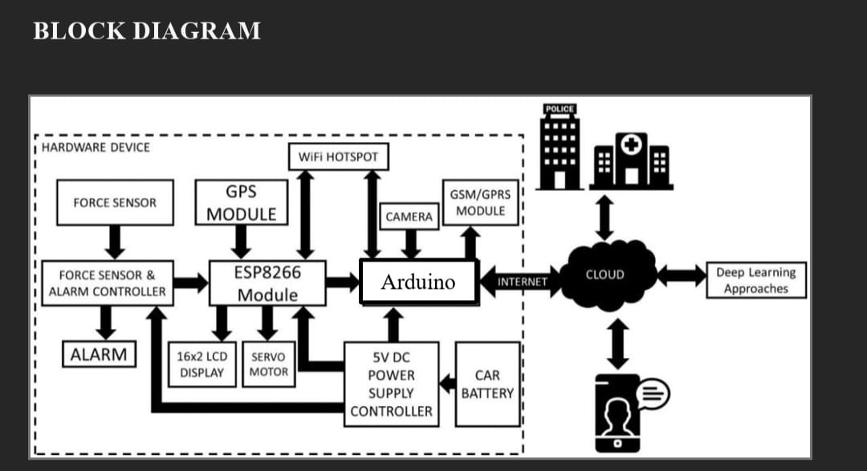

The system appears to be designed for real-time monitoring and response to incidents, likely within a vehicle context. It utilizes various sensors and communication modules to gather information, process it, and trigger actions based on the data. This block diagram represents a comprehensive system that integrates various hardware and software components to perform real-time monitoring, data collection, and intelligent decision-making. The design highlights the flow of information between the hardware, the cloud, and end-user interfaces, showcasing its ability to process data locally while leveraging cloud computing for advanced analytics. Let me provide a detailed description without segmenting it into points.

The system begins with the hardware device, which consists of several interconnected components working together to collect and process data. At the heart of this hardware is a Raspberry Pi, functioning as the central processing unit. The Raspberry Pi interfaces with a variety of sensors and modules, including a force sensor, a GPS module, a camera, and an ESP8266 Wi-Fi module. These components serve distinct purposes, but collectively, they enable the device to sense environmental changes, process information, and communicate with the cloud. The force sensor, for instance, is responsible for detecting the amount of force applied to a specific surface. This information is relayed to a dedicated controller, known as the Force Sensor and Alarm Controller, which processes the input and determines if the detected force exceeds a pre-defined threshold. If the threshold is breached, the system activates an audible alarm, alerting nearby individuals or authorities to potential dangers or emergencies. This mechanism is critical for applications such as structural health monitoring, where excessive force or pressure could indicate a failure. Another integral part of the hardware is the GPS module, which provides real-time location data. This feature is particularly useful in applications where the system needs to track or report its position, such as in vehicle monitoring or emergency response systems.

The data collected by the GPS module is processed by the Raspberry Pi and transmitted to the cloud, where it can be accessed and analyzed by end users or external authorities. The inclusion of a camera enhances the system's capabilities by enabling it to capture visual data. This could be used for surveillance, image recognition, or anomaly detection. The camera's output, combined with the data from other sensors, gives the system a multidimensional understanding of its surroundings. For instance, in a security application, the system could use the camera to detect unauthorized access while the force sensor monitors for physical tampering. A key component enabling communication between the hardware and the cloud is the ESP8266 module. This Wi-Fi module acts as a bridge, allowing the system to transmit data over the internet. It ensures that the processed information, including sensor readings and visual data, is sent to the cloud for storage and further analysis. Additionally, this module enables remote access, allowing users to monitor and control the system from anywhere through a mobile application. The system is powered by a 5V DC power supply controller, which regulates the electrical energy supplied by a car battery. This design choice ensures that the system remains operational even in environments without access to conventional power sources. The car battery not only makes the device portable but also reliable, as it can continue functioning during power outages. The cloud infrastructure is a pivotal aspect of the system. Once the data is transmitted to the cloud via the ESP8266 module, it undergoes advanced processing using deep learning algorithms. These algorithms analyze the collected data to extract meaningful insights, identify patterns, or predict potential issues. For example, in a structural monitoring application, the deep learning model could analyze force data to predict when a structure might fail, thereby enabling preventive measures. In addition to storage and analytics, the cloud serves as a communication hub. It facilitates the exchange of information between the hardware device and external entities, such as law enforcement or healthcare providers. For instance, in the event of an emergency, the system can automatically notify the police or nearby hospitals, providing them with critical information such as location and the nature of the incident. End users interact with the system primarily through a mobile application. This app serves as a user-friendly interface, allowing them to access real-time data, receive alerts, and control certain aspects of the device. For example, a user might receive a notification about an alarm triggered by excessive force and use the app to deactivate the alarm or reset the system. The app also enables users to view the camera feed or track the device's location, providing comprehensive control and monitoring capabilities. The seamless integration of hardware and software in this system enables it to perform a wide range of functions across various applications. In safety and security scenarios, the system can detect and respond to unauthorized access or structural anomalies. In healthcare, it can monitor patients or alert medical personnel during emergencies. In logistics, it can track shipments, ensuring their safety and timely delivery. The versatility of the system makes it suitable for industrial automation, smart home applications, and more.

**Hardware Components:**

1. Force Sensor: Detects sudden impact or force that indicates a possible accident. Sends signals to the Force Sensor & Alarm Controller.

2. Force Sensor & Alarm Controller: Processes the force sensor input and activates the Alarm when necessary.

3. ESP8266 Module: A Wi-Fi-enabled microcontroller that acts as the central control unit. Communicates with connected devices like the GPS module, camera, GSM/GPRS module, and cloud services.

4. GPS Module: Captures the real-time geographic location of the vehicle.

5. GSM/GPRS Module: Facilitates mobile network communication, allowing the system to send alerts to cloud servers, emergency services, and user devices.

6. Camera: Captures visual data from the accident scene for verification or further analysis.

7. 16x2 LCD Display: Displays system status and alerts.

8. Servo Motor: Can control mechanical operations (e.g., opening a safety lock or activating a physical mechanism).

9. 5V DC Power Supply Controller: Ensures stable power is supplied to all components, sourced from the vehicle's Car Battery.

Connectivity and Software Integration:

Wi-Fi Hotspot: Provides internet connectivity to the ESP8266 module, enabling data transfer to the cloud.

Cloud Platform: Receives and processes the data using Deep Learning Approaches for: Analysing accident severity. Filtering false alarms. Routing alerts to relevant parties.

External Communication: Sends alerts and data to: Police for immediate action. Hospitals for medical assistance. User's Smartphone via the internet for real-time updates.

Working Flow:

1. When the Force Sensor detects an impact, the system is triggered.

2. The Alarm is activated, alerting those nearby.

3. The ESP8266 Module gathers data from the GPS, camera, and other components.

4. Data is sent via Wi-Fi or GSM/GPRS to the cloud.

5. The cloud processes the information using deep learning and sends: Real-time alerts to emergency services. Notifications to the user and their family.

**VI. System Architecture**

SRS needed to be represented into pictorial form for better understanding. This chapter is about system design. The system design consists of architecture and the system implementation flow. It includes diagrams like system architecture, data flow diagram, use case diagram, activity diagram, class diagram. These diagrams help in understanding the functioning of the system. A data-flow diagram (DFD) is a way of representing the flow of a data of process or a system (usually an information system). The DFD also provides informationabout the outputs and inputs of each entity and the process itself.

**VII. RESULT**

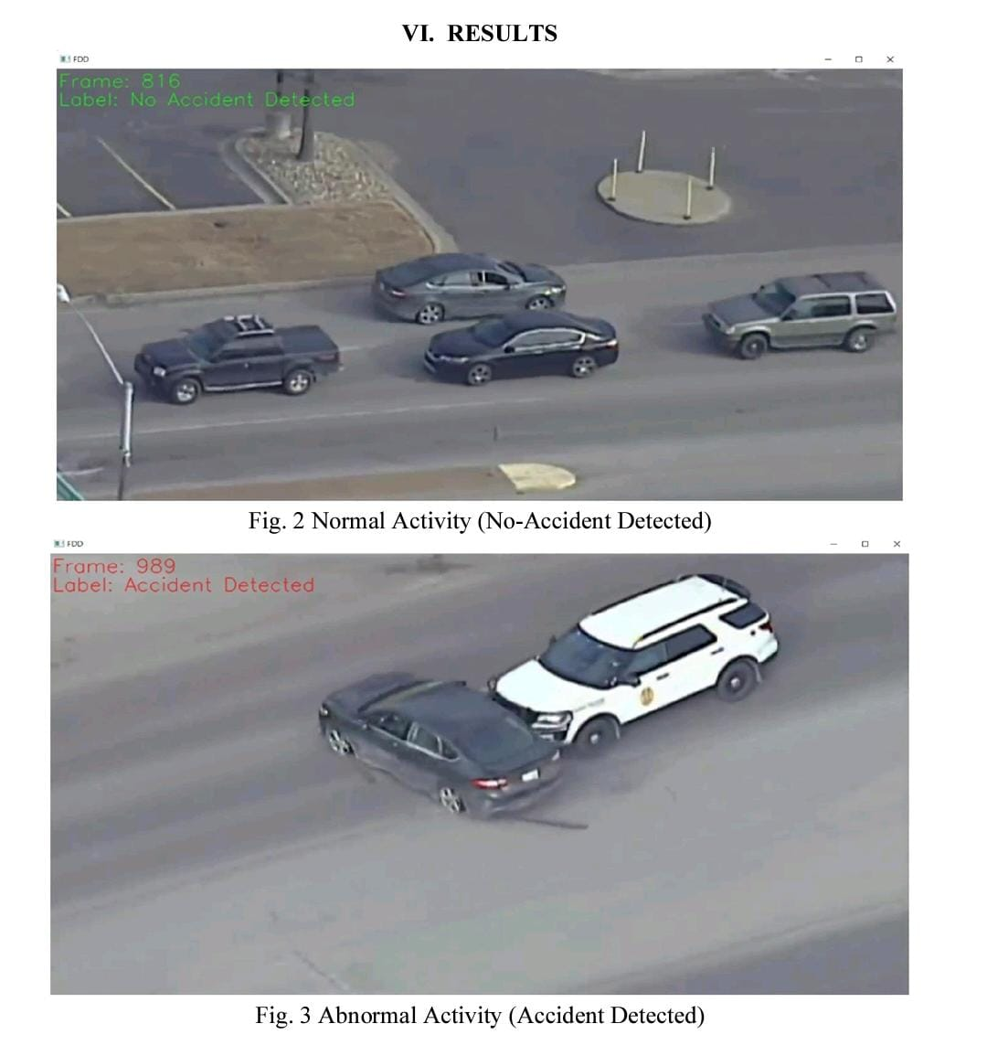

In the modern era, traffic surveillance systems play a significant role in ensuring road safety and monitoring vehicle activity. The images presented illustrate the application of an automated accident detection system, which uses technology to analyze traffic patterns and identify abnormal events such as vehicle collisions. This process is crucial for improving traffic management and ensuring quick responses to accidents.

The first image, labeled as "Normal Activity (No-Accident Detected)," shows a scene of vehicles moving in a typical, orderly manner on a road. This is denoted by a green label stating “No Accident Detected.” In this case, the system identifies that no unusual or dangerous behavior, such as collisions or sudden stops, is occurring. The vehicles maintain a safe distance and follow the expected flow of traffic, allowing the system to classify the activity as normal.

In contrast, the second image, labeled as "Abnormal Activity (Accident Detected)," highlights a collision between two vehicles—a black car and a white SUV. This frame, marked in red, signifies that the system has detected an accident. The black car appears to have collided with the white SUV, indicating an unexpected and abnormal event. Such detection is likely achieved through advanced computer vision techniques, which analyze movement, trajectories, and the spatial relationships between vehicles. When the system identifies irregularities such as sudden impacts, sharp changes in direction, or close proximity, it flags the event as an accident.

This approach to accident detection offers numerous advantages. First, it reduces the reliance on manual monitoring, allowing automated systems to work efficiently around the clock. Second, it ensures that accidents are identified promptly, enabling quick intervention from emergency services. By analyzing real-time data, such systems can also contribute to better traffic flow management, helping authorities address bottlenecks and unsafe driving patterns.

In conclusion, the presented images illustrate the effectiveness of automated systems in detecting both normal and abnormal activities on the road. By leveraging advanced technologies, such as computer vision and frame-by-frame analysis, these systems can improve road safety, reduce response times during accidents, and enhance overall traffic management. As technology continues to evolve, such solutions will become increasingly accurate and essential for modern transportation infrastructure

**VIII. CONCLUSION**

|  |  |  |
| --- | --- | --- |
|  |  |  |

We implemented a system to process CCTV footage to detect any abnormal activity which will help to create better security and less human intervention. Thus it was possible to design a low resource consuming accident detection system that can compute on cheap hardware which can detect accidents and provide an alert message to the most proximate control room immediate.

The AI-enabled accident identification and alerting system using IoT offers a revolutionary approach to enhancing road safety and emergency response efficiency. By leveraging advanced sensors, machine learning algorithms, and IoT connectivity, this system ensures real-time detection of accidents with high accuracy and reliability. The seamless integration of AI and IoT allows for the prompt relay of critical information to emergency services, potentially saving lives by reducing response times. Furthermore, the system's scalability and adaptability make it suitable for a wide range of vehicles and environments. Its ability to predict accident-prone conditions can also play a significant role in preventive measures, contributing to overall traffic safety. this innovative solution not only addresses the urgent need for smarter road safety mechanisms but also paves the way for a future where technology and human welfare are intricately connected. With continued advancements and widespread adoption, such systems can significantly reduce fatalities and improve the quality of emergency responses globally.This system's ability to collect and process data from IoT devices such as accelerometers, GPS modules, and cameras ensures accurate accident detection while minimizing false alarms. Moreover, the use of machine learning algorithms enhances its ability to adapt to various scenarios and continuously improve over time. Features like predictive analytics and early warnings for accident-prone conditions further contribute to reducing the likelihood of accidents.

## 

## 

## REFERENCES

[1] Lee, K. B., & Shin, H. S. (2019). An Application of a Deep Learning Algorithm for Automatic Detection of Unexpected Accidents Under Bad CCTV Monitoring Conditions in Tunnels. 2019 International Conference on Deep Learning and Machine Learning in Emerging Applications (Deep-ML).

[2] Rajvardhan Rishi, Sofiya Yede, Keshav Kunal “Automatic Messaging System for Vehicle Tracking and Accident Detection” Proceedings of the International Conference on Electronics and Sustainable Communication Systems .

[3] Wang Wei, Fan Hanb “Traffic Accident Automatic Detection And Remote Alarm Device” 978 1-4244 8039 5/11/$26.00 ©2011 IEEE.

[4] Venkata Krishna Kota,1 Nagendra Kumar Mangali, Thirumal Kumar Kanakurthi “Automated Accident Detection and Rescue System” 978-1-5090-4442-9/17/$31.00_c 2017 IEEE .

[5] Akanksha Soni,Arun Pratap Singh “Automatic Motorcyclist Helmet Rule Violation Detection using Tensorflow” 2020 IEEE International Students' Conference on Electrical, Electronics and Computer Science.

[6] Gokul Rajesh, Amitha Rossy Benny, Harikrishnan A, James Jacob Abraham and Nithin Prince John “A Deep Learning based Accident Detection System ” 978-1-7281-4988-2/20/$31.00 ©2020 IEEE.

[7] JIAXIN TIAN1 , (Senior Member, IEEE), CHUANG ZHANG1 , XUTING DUAN1 , AND XIXIAN WANG1 “An Automatic Car Accident Detection Method Based on Cooperative Vehicle Infrastructure Systems ” .

[8] Sreyan Ghosh; Sherwin Joseph Sunny; Rohan Roney “Accident Detection using Convolutional Neural Networks” 2019 International Conference on Data Science and Communication