**Sustainability as a Marketing Strategy: How Eco-Friendly Practices Shape Brand Perception**

Swatanshu Shekhar Singh 1

Malaviya National Institute of Technology (MNIT) Jaipur, INIDA 1

Email: [swatanshus@gmail.com](mailto:swatanshus@gmail.com) 1,

**Abstract:**

This study investigates the role of sustainability as a marketing strategy, focusing on how eco-friendly practices shape consumer perception of brands. With a significant rise in environmental awareness, brands that adopt sustainable practices—such as ethical sourcing, waste minimization, and reduction of carbon emissions—are more favorably perceived by consumers. This research examines the ways these practices influence consumer trust, brand loyalty, and purchasing behaviors. Through case studies of established brands and a comprehensive analysis of market trends, this paper highlights sustainability-driven marketing as a crucial tool for brand-building, positioning sustainability not only as an ethical responsibility but as a means to build brand loyalty, secure competitive advantage, and attract socially conscious consumers.

Keywords: Brand perception, competitive advantage, consumer loyalty, eco-friendly practices, green branding, sustainability, Indian market.

1. **Introduction**

In recent years, sustainability has become more than just an ethical commitment for companies; it has evolved into a strategic business approach that shapes consumer perception and purchasing behaviors. Environmental awareness among consumers has significantly increased, especially with greater information access about issues like climate change, pollution, and resource depletion. This heightened awareness has created a demand for brands that go beyond traditional business practices to reduce environmental impact and demonstrate responsible behavior.

A brand’s commitment to sustainability encompasses various practices, including minimizing waste, sourcing materials responsibly, and reducing emissions. For many consumers, supporting a brand that aligns with their environmental values is a priority, especially among younger generations. Millennials and Generation Z are particularly vocal about environmental responsibility and are often willing to pay a premium for products that reflect their values.

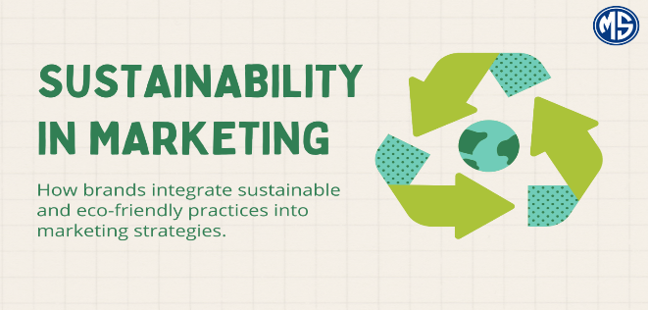

Figure 1: Sustainability in Marketing diagram

The strategic shift towards sustainability is evident across industries, with brands integrating eco-friendly practices to appeal to an environmentally aware consumer base. Research shows that companies that incorporate sustainability into their core values and operations benefit from an enhanced brand image, increased consumer trust, and higher loyalty. An exemplary case is Blinkit, an online grocery delivery service in India, which replaced plastic bags with recyclable paper bags, a simple yet effective step that reinforces its commitment to environmental sustainability. Blinkit’s change not only reduces plastic waste but also strengthens its brand perception as socially responsible, aligning the company with the growing consumer preference for sustainable choices.

This paper examines the impact of eco-friendly marketing strategies on consumer perception, with a particular focus on practices that drive positive brand associations. By exploring both large corporations and emerging brands, this research demonstrates how sustainability can serve as a central pillar of marketing strategy, fostering consumer trust, driving loyalty, and positioning brands competitively in the market.

1. **Literature Review**

The literature on sustainable marketing highlights that adopting eco-friendly practices plays a crucial role in building brand loyalty, improving brand perception, and enhancing competitive advantage. Over the past decade, sustainability has gained prominence as a vital aspect of corporate strategy, particularly as consumers, governments, and investors place increasing importance on environmental stewardship. Researchers such as Ottman (2011) and Peattie (2001) argue that sustainable practices appeal to eco-conscious consumers, allowing brands to distinguish themselves in a highly competitive marketplace. Studies on green marketing reveal that brands that are perceived as environmentally responsible enjoy several advantages, including heightened customer loyalty, competitive edge, and a positive reputation.

Although there is substantial research on sustainability in Western markets, fewer studies have focused on how these practices influence consumer perceptions in developing economies such as India. However, the growing middle class in India, coupled with rising awareness of environmental issues, has led to increased interest in green products. Consequently, Indian companies are increasingly adopting sustainable practices to capture this demand. This literature review examines various approaches to sustainable marketing, including eco-friendly packaging, ethical sourcing, and renewable energy adoption. It explores the factors that drive consumer demand for green products, as well as how these practices contribute to brand loyalty, trust, and differentiation in the marketplace.



Figure 2: Balancing financial profitability with environmental responsibility

Studies indicate that brands that align with consumer values on sustainability are more likely to build long-term loyalty and trust. Key findings suggest that consumers view brands committed to environmental responsibility favorably, often rewarding them with brand loyalty. These insights highlight the importance of sustainability as a strategic marketing tool and underscore the need for further research on how eco-friendly practices influence consumer behavior in emerging markets.

**3. Eco-Friendly Practices in Indian Companies**

In response to growing consumer interest in eco-friendly products, many Indian companies have adopted sustainability as a core component of their marketing strategies. Leading Indian companies, including Tata Group, Dabur, ITC Limited, and Blinkit, have embraced sustainable practices to strengthen their brand equity and appeal to environmentally conscious consumers. By integrating sustainability-driven strategies, these companies have positioned themselves as leaders in green branding within the Indian market.

**3.1 Tata Group**

The Tata Group, one of India’s most respected and diversified conglomerates, has consistently demonstrated a commitment to sustainability across multiple industries, including steel, automotive, and energy. Under the leadership of Chairman Natarajan Chandrasekaran, Tata Power, a Tata Group company, has invested heavily in renewable energy projects, including solar and wind power, to reduce its reliance on fossil fuels and lower greenhouse gas emissions. Tata has also engaged in a wide range of Corporate Social Responsibility (CSR) initiatives, such as rural development, healthcare, and education programs, reinforcing its brand image as a socially responsible company. The failure of Tata Nano was drastic shock for Tata and group. Certainly, taking lesson from that Tata Group has focus more on Sustainability than the comfort ability.

Tata’s sustainability initiatives resonate strongly with Indian consumers who value companies that contribute positively to society and the environment. According to Kapoor and Sandhu (2010), Tata’s approach to CSR has significantly enhanced its brand reputation, fostering consumer trust and loyalty. Tata’s emphasis on renewable energy is not only aligned with its commitment to sustainability but also positions the company as an industry leader in environmental stewardship.

In addition to renewable energy, Tata has taken steps to ensure sustainable practices across its various subsidiaries. Tata Motors, for instance, has introduced electric vehicles (EVs) to reduce carbon emissions and support clean transportation. By investing in EVs and other sustainable technologies, Tata Motors has strengthened its reputation as a forward-thinking brand, appealing to consumers who prioritize sustainability in their choices. This comprehensive approach to sustainability has allowed Tata to differentiate itself in a competitive market, reinforcing its brand image as a socially responsible and environmentally conscious company.



Figure 3:Tata Group plans to launch Tata EV

**3.2 Dabur**

Dabur, one of India’s leading manufacturers of Ayurvedic and natural health products, has embedded sustainability into its brand identity through eco-friendly packaging and ethical sourcing practices. Known for its natural and herbal products, Dabur has positioned itself as a brand that promotes wellness and environmental responsibility. Under the leadership of the Burman family, Dabur has implemented a range of sustainability initiatives, including the use of biodegradable packaging and responsible sourcing of raw materials.

Research on sustainable packaging, such as that by Gupta and Ogden (2009), suggests that reducing packaging waste can strengthen brand identity and consumer loyalty. Dabur’s use of biodegradable packaging aligns with the values of environmentally conscious consumers, particularly in urban areas where awareness of environmental issues is high. Studies by Ghosh (2015) reveal that Indian consumers increasingly prefer natural and eco-friendly products, supporting the effectiveness of Dabur’s sustainable branding approach.

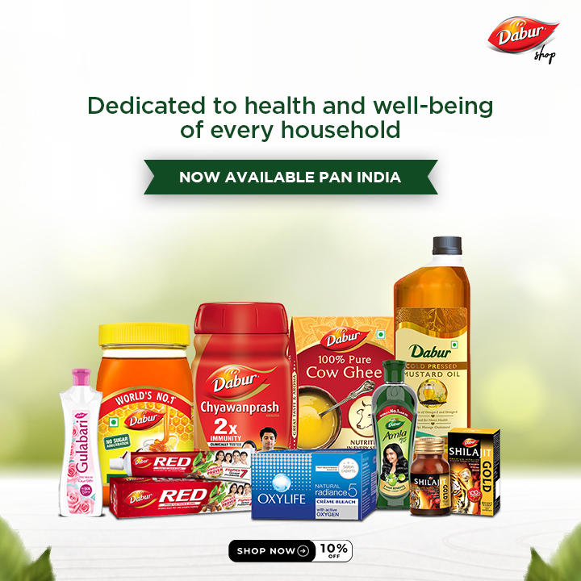

Figure 4: Dabur Herbal Products

Dabur’s focus on ethical sourcing is also integral to its brand strategy. The company sources herbal ingredients responsibly, ensuring that its products are not only natural but also sustainably produced. This commitment to ethical sourcing resonates with consumers who prioritize environmental responsibility and ethical production practices. By integrating sustainable sourcing into its operations, Dabur has reinforced its reputation as a trusted brand, appealing to consumers who value transparency and ethical standards in the products they purchase.

**3.3 ITC Limited**

ITC Limited, one of India’s largest and most diversified conglomerates, has embraced sustainability as a fundamental component of its business strategy. Under the leadership of CEO Sanjiv Puri, ITC has implemented various sustainability initiatives, focusing on sustainable forestry, water conservation, and green building practices. The company’s “Mission Sunehra Kal” program aims to create positive social and environmental impact through initiatives such as promoting sustainable agriculture, enhancing water stewardship, and reducing waste.

ITC’s commitment to sustainability has strengthened its brand perception, particularly among consumers who prioritize corporate social responsibility. Research by Rao and Holt (2005) highlights the benefits of CSR-driven sustainability strategies, especially in emerging markets where consumers are increasingly aware of environmental and social issues. By aligning its business practices with sustainability goals, ITC has built a strong brand reputation, appealing to consumers who prioritize environmentally and socially responsible companies.

ITC’s focus on sustainable forestry is a notable example of its commitment to environmental conservation. The company has implemented a social forestry program that involves planting trees on degraded land owned by rural communities, providing income for local farmers and restoring the land. This program not only supports ITC’s sustainability goals but also helps create sustainable livelihoods for rural communities. Through its sustainability-driven practices, ITC has positioned itself as a brand that actively contributes to environmental conservation and social development, appealing to consumers who value ethical and sustainable brands.

**3.4 Blinkit and Eco-Friendly Packaging**

Blinkit, a popular online grocery delivery company in India, has adopted sustainable packaging practices as part of its commitment to environmental responsibility. By replacing plastic bags with paper bags, Blinkit aims to reduce plastic waste and align its brand with the values of environmentally conscious consumers. Packaging literature, such as Rundh (2005), suggests that sustainable packaging can foster brand loyalty, as consumers are more likely to support companies that take steps to reduce environmental impact.

Blinkit’s decision to use paper bags demonstrates the company’s responsiveness to consumer demand for sustainable packaging solutions. This shift not only enhances Blinkit’s brand image as a responsible company but also appeals to consumers who actively seek alternatives to plastic. By aligning its packaging practices with consumer values, Blinkit has positioned itself as a brand that prioritizes sustainability, attracting customers who prioritize eco-friendly choices.

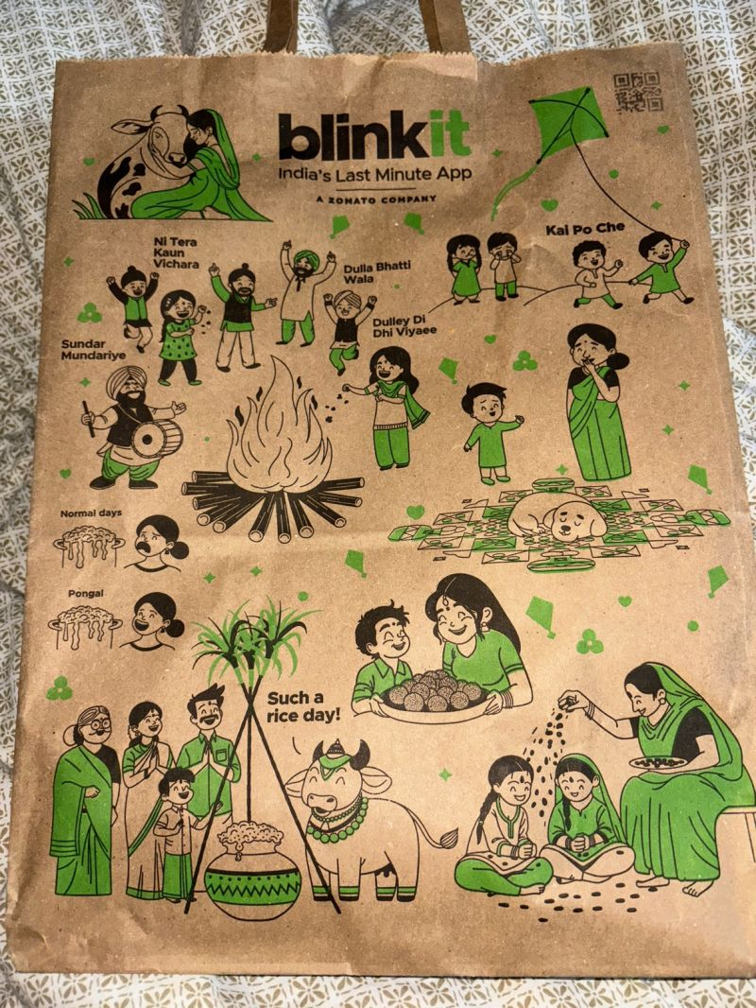

Figure 5: Blinkit using plastic bags for delivering products

**4. Future Scope of Sustainability as a Marketing Strategy**

The increasing awareness and prioritization of sustainability have positioned it as a core aspect of business strategy. Companies that proactively adopt sustainable practices can capitalize on the rising demand for eco-friendly products and services, while those that fail to do so risk reputational damage and market losses.

**4.1 With Sustainability: Opportunities and Growth**

The global demand for sustainable products is expected to grow as consumers continue to prioritize environmentally friendly products. According to a 2023 report by Nielsen, 73% of global consumers are willing to pay more for products that are environmentally responsible, indicating strong market potential for sustainable brands. In India, the Indian Brand Equity Foundation (IBEF) predicts that the green product market will reach $7.7 billion by 2025, with significant growth in sectors such as organic foods, eco-friendly packaging, and sustainable fashion.

Sustainable packaging is particularly popular among Indian consumers. According to a 2022 report by The Times of India, consumers are increasingly seeking brands that use recyclable or biodegradable packaging materials. Brands like Dabur and ITC, which have already embraced sustainable packaging, are likely to benefit from this expanding demand. By incorporating sustainability into their supply chains, from sourcing raw materials to packaging and distribution, brands can not only attract consumers but also improve brand loyalty and retention.

In addition to consumer demand, sustainability is also a significant factor in attracting investment. A 2022 McKinsey study found that 70% of institutional investors consider environmental, social, and governance (ESG) factors in their investment decisions. This trend underscores the financial value of sustainability, as companies that adopt eco-friendly practices are more likely to attract capital and build long-term resilience.

**Conclusion**

The literature on sustainable marketing highlights that adopting eco-friendly practices can significantly impact brand perception and consumer loyalty, especially as environmental awareness grows. Companies like Tata Group, Dabur, ITC, and Blinkit demonstrate how sustainable practices can influence consumer attitudes and strengthen brand trust. By aligning their practices with consumer values, these brands showcase sustainability as not only a responsibility but a powerful brand-building tool.

**References:**

1. Kapoor, S., & Sandhu, H. (2010). Does it pay to be socially responsible? An empirical examination of impact of corporate social responsibility on financial performance. *Global Business Review, 11*(2), 185-208.
2. Swatanshu Shekhar Singh, (2024). Why Tata Nano failed? From ascent to ashes: Unraveling the Tata Nano saga – A chronicle of triumph, tragedy, and missteps. International Journal of Scientific Research in Engineering and Management (IJSREM), 8(9), 5-7.
3. Gupta, S., & Ogden, D. T. (2009). To buy or not to buy? A social dilemma perspective on green buying. *Journal of Consumer Marketing, 26*(6), 376-391.
4. Ghosh, A. (2015). Consumer preferences for natural and eco-friendly products in India. *Journal of Global Marketing, 28*(5), 277-291.
5. Rao, P., & Holt, D. (2005). Do green supply chains lead to competitiveness and economic performance? *International Journal of Operations & Production Management, 25*(9), 898-916.
6. Rundh, B. (2005). The multi-faceted dimension of packaging: Marketing logistic or marketing tool? *British Food Journal, 107*(9), 670-684.