**Recapitulative Metaphoric Introspection of Recent Drilling Fluid Additives in Water Based Muds**

By

**D. I. Egu1; V.C. Amaefule2; O. Akintade3; R.C. Okoloekwe4; A. A. Omeche5; U.J. Eze6**

1,2Department of Petroleum Engineering, Madonna University Nigeria

3Department of Petroleum Engineering and Advanced Practice, USA

4Department of Civil Engineering, Madonna University Nigeria

5Department of Electrical and Electronics Engineering, Madonna University Nigeria

6Department of Computer Engineering, Madonna University Nigeria

**Email:** [daniyke98@gmail.com](mailto:daniyke98@gmail.com)

**ABSTRACT**

Over the years, the increased use of different types of drilling fluids additives for water based mud has increased environmental quandary, technical enigmas during drilling, post drilling problems such as production cramps and increased cost of well development. These complicated conundrums are so difficult to be solved because they lack a robust literature review of recent additives in water based muds and may be the reason for technical failure of most drilling programs. The aim of this research is to carry out detailed comparative analysis of a minimum of ten literature reviews of local additives used in formulation of water based muds by evaluating their prospects and challenges in line with API standard. The objectives are to carry out detailed literature reviews of ten (10) recently published papers on the use of local additives in water based muds in Nigeria and predicting their prospects and gaps and to carry out a comparative analysis of drilling fluid properties and API standards of existing literatures used. The ten (10) recent articles used are Okon et al (2020), Peretomode (2018), Agwu et al. (2018), Jimoh et al. (2020), Odeh et al. (2022), Ekeinde et al. (2018), Duru et al. (2020), Udoh and Okon (2019), Azinta et al. (2021) and Okon et. (2018). The drilling properties evaluated are shear stress, viscosity dial reading, plastic viscosity, gel strength, yield point, mud pH, mud density, filtration loss and mud cake thickness. Comparative results of mud density gave a minimum of 5.99ppg for Agwu et al. (2018) who used soda ash. The maximum mud density of 8.94ppg was observed by Ekeinde et al. (2018) who used guar gum and offor. These results are in line with API standard of a range of 8.65ppg – 9.55ppg. Comparative results of mud filtrate loss gave a minimum of 1.59ml for Duru et al. (2020) who used mucuna solannie. The maximum mud filtrate loss of 16.77ml was observed by Azinta et al. (2021) who used xanthum gum. These values are in line with API specification with a maximum of 15ml. Five (5) out of the nine (9) drilling fluid properties gave results which are in line with API standards which includes the mud pH, mud cake thickness, filtration loss, mud density and plastic viscosity. This is approximately 55.56% success rates in this study while the remaining four (4) properties make up 44.44% failure rate. However, the results of failure rates showed prospects which can be improved upon since some results were close to the API standard. The benefits of this study to petroleum engineering is that a breakthrough will transform the industry in reducing the cost of drilling programs and perhaps save our environment with biodegradable water-based mud additives. The contribution to knowledge is that this study will add spice to the many existing literatures and enhance the choice of selection of additives. It is recommended that more studies are done to discover more additives and maybe blend some the additives used in this research.

**Key words:** Drilling fluid, water based mud, local additive, mud density, filtration loss, mud cake thickness.

1. **Background of Study**

Drilling mud, also called drilling fluid, in petroleum engineering, is a heavy, viscous fluid mixture that is used in oil and gas drilling operations to carry rock cuttings to the surface and also to lubricate and cool the drill bit. Mud plays an important role in the marine ecosystem. The activities of burrowing animals and fish have a dramatic churning effect on muddy sea beds. This allows the exchange and cycling of oxygen, nutrients, and minerals between water and sediment. There are three main types of drilling mud: water-based, oil-based and synthetic-based the components of drilling fluids/mud water-based drilling mud most commonly consists of bentonite clay (gel) with additives such as barium sulfate (barite), calcium carbonate (chalk) or hematite. Various thickeners are used to influence the viscosity of the fluid, e.g. xanthan gum, guar gum, glycol, or starch.

Oil-based muds have become more widely used because of their distinct advantages over water-based muds. They include;

* Thermal stability in deep, high-temperature wells.
* Increased lubricity in deviated offshore wells.
* Hole stability in thick, water-sensitive shales as advantages of oil-based muds.

Oil-based muds can be formulated to withstand high temperatures over long periods of time, however, water-based mud can break down and lead to loss of viscosity and fluid loss control.

Oil-based mud (OBM) cutting is a hazardous by-product generated during oil-well drilling. Its chemical composition suggests that it might be suitable as a raw material in cement manufacturing. Oil-based mud is endowed with better capability to stabilize the wall than water-based mud. Water-based mud can swell shale formation, a brittle mineral, collapse boreholes and impact drilling outcome in the drilling operations. The initial cost of oil mud is high, especially formulations based on mineral or synthetic fluids. Kick detection is reduced when using oil muds (compared to that of water-based muds) due to high gas solubility in oil muds. Oil based muds are costly when lost circulation occurs. Aqueous drilling fluids, generally referred to as water-based muds, are the most common and the most varied of the three drilling fluid types. They range in composition from simple blends of water and clay to complex inhibitive, or clay stabilizing, drilling fluid systems that include many.

In the exploration for hydrocarbons, drilling a successful hole is an integral part of the process and is contingent upon the drilling fluid's performance. Drilling process involves the penetration of the earth's crust to several thousand feet where the hydrocarbons are accumulated in the reservoir using rotary drilling process to create a passage for the discovered hydrocarbon reserves to be produced at the surface. To achieve this cardinal objective of a drilling operation, the formulated drilling fluid used must exert its basic functions. Drilling fluid is also referred to as “drilling mud”, and generally viewed as the “blood” of all drilling operations in the petroleum industry. Drilling fluids are complex heterogeneous fluids, consisting of several additives used in the drilling of oil and natural gas wells since the early 1900s. A complete drilling fluid system must be properly designed to efficiently construct a well. Thus, some of the basic drilling fluid functions include removal of drill cuttings to the surface, bottom-hole cleaning, maintaining the wellbore stability, controlling high-pressure zones, etc. Among the enumerated drilling fluid functions, a major one is to seal the walls of the formation being drilled to prevent filtration. Hence, one of the most desired properties of drilling fluid is the minimum fluid loss volume which can be achieved by the development of a low permeability filter cake on the wellbore. Therefore, every drilling fluid is designed to avoid a continuous fluid loss to the open-hole drilled which is highly undesirable. Drilling fluids are designed to reduce filtrate loss, form thin filter cakes that plaster the walls of the borehole to ensure minimal fluid loss and promote stability of the drilled well.

Over the years, the increased use of different types of drilling fluids additives used in water based mud has increased environmental issues, technical problems during drilling, post drilling problems such as production challenges and increased cost of well development. These complicated problems are so difficult to be solved by the only oil and gas because they lack a robust literature review of recent additives in water based muds. These problems are the reason for technical failure of most drilling programs. However, the increasing recent challenges of most drilling operations in Nigeria are the cost and availability of existing expensive foreign additives used in water based muds. This problem is increased with numerous literatures of local additives without proper assessment of all these additives to boost their choice for drilling.

The aim of this research is to carry out detailed comparative analysis of a minimum of ten literature reviews of local additives used in formulation of water based muds by evaluating their prospects and challenges in line with API standard.

The objectives are to carry out detailed literature reviews of local additives used in water based muds and predicting their gaps, to carry out a comparative analysis of drilling fluid properties and API standards of existing literatures used, and to suggest best technical recommendations based on existing literatures of the way forward on local additives used in water based muds in Nigeria.

The abundance of literatures exist on local additives used in formulation of water based muds, but no researcher has ever done a comparative study of all existing researches before laboratory analysis starts. The development of this study would go a long way to boost existing literatures available in the oil and gas industry which will enhance the choice of local additives used in drilling programs in the Nigeria.

**2.0 Historical Background**

The oil and gas industry is the major contributor of the world’s energy demand. On yearly basis, wells are being drilled to ensure the continuous supply of these resources to meet current demand for fossil fuels. The drilling fluid plays very valuable roles during drilling operations. It is used in removing cuttings from the wellbore, keeping cuttings in suspension, lubricating, cooling and cleaning the drill bit, preventing blow out by ensuring that the hydrostatic pressure of the drilling fluid is greater than the formation pressure, maintaining borehole stability, e.t.c.

However, the success of every drilling program largely depends on the drilling fluid, its additives and the properties of the drilling fluid. The drilling fluid constitutes about 10 – 15% of the overall drilling costs and as such, the mud has to be well formulated to ensure that it carries out its function maximally. If the mud is well formulated, it can reduce the overall drilling cost by 5 – 15%. There are various additives used during drilling programs, each serving different purposes. They are used to either enhance the performance of the drilling fluid or the performance of other additives. These additives include weight agents, viscosifiers, lubricating agents, weighting materials, fluid loss control agents, emulsifiers, corrosion inhibitors, e.t.c.

During the early historical periods of drilling operations, water was used as a drilling fluid to remove drilled cuttings but with time, some degree of viscosity was required in the drilling fluid to meet up with the various demands required in drilling. To achieve this, clay polymers or a combination of both were used. The Nigerian local clays were used for drilling operations not until the late 1960’s when imported bentonite was substituted for the Nigerian local clay. This was attributed to the high calcium content present in the Nigerian clay which negatively affected its rheological properties. It increased water loss, reduced its viscosity and gel strength making it unsuitable for use in preparing drilling fluids. However, the most widely used imported clay is the Wyoming bentonite. It is a highly colloidal clay which hydrates in water and increases the viscosity due to the dominance of the sodium (Na+) ions present.

**2.1 Functions of drilling fluids**

A drilling fluid, or mud, is any fluid that is used in a drilling operation in which that fluid is circulated or pumped from the surface, down the drill string, through the bit, and back to the surface via the annulus. Drilling fluids satisfy many needs in their capacity to do the following:

* Suspend cuttings (drilled solids), remove them from the bottom of the hole and the well bore, and release them at the surface.
* Control formation pressure and maintain well-bore stability.
* Seal permeable formations.
* Cool, lubricate, and support the drilling assembly.
* Transmit hydraulic energy to tools and bit.
* Minimize reservoir damage.
* Permit adequate formation evaluation.
* Control corrosion.
* Facilitate cementing and completion.
* Minimize impact on the environment.
* Inhibit gas hydrate formation

The most critical function that a drilling fluid performs is to minimize the concentration of cuttings around the drill bit and throughout the well bore. Of course, in so doing, the fluid itself assumes this cuttings burden, and if the cuttings are not removed from the fluid, it very quickly loses its ability to clean the hole and creates thick filter cakes. To enable on-site recycling and reuse of the drilling fluid, cuttings must be continually and efficiently removed.

**2.2 Types of drilling fluids**

Drilling fluids are classified according to the type of base fluid and other primary ingredients:

* Gaseous: Air, nitrogen.
* Aqueous: Gasified—foam, energized (including aphrons) Clay, polymer, emulsion.
* Non-aqueous: Oil or synthetic—all oil, invert emulsion.

True foams contain at least 70% gas (usually N2, CO2, or air) at the surface of the hole, while energized fluids, including aphrons, contain lesser amounts of gas. Aphrons are specially stabilized bubbles that function as a bridging or lost circulation material (LCM) to reduce mud losses to permeable and micro-fractured formations. Aqueous drilling fluids are generally dubbed water-based muds (WBMs) as shown in Fig. 1, while non-aqueous drilling fluids (NAFs) are often referred to as oil-based muds (OBMs) or synthetic-based muds (SBMs). OBMs are based on NAFs that are distilled from crude oil; they include diesel, mineral oils, and refined linear paraffins (LPs). SBMs, which are also known as pseudo– oil-based muds, are based on chemical reaction products of common feedstock materials like ethylene; they include olefins, esters, and synthetic LPs.

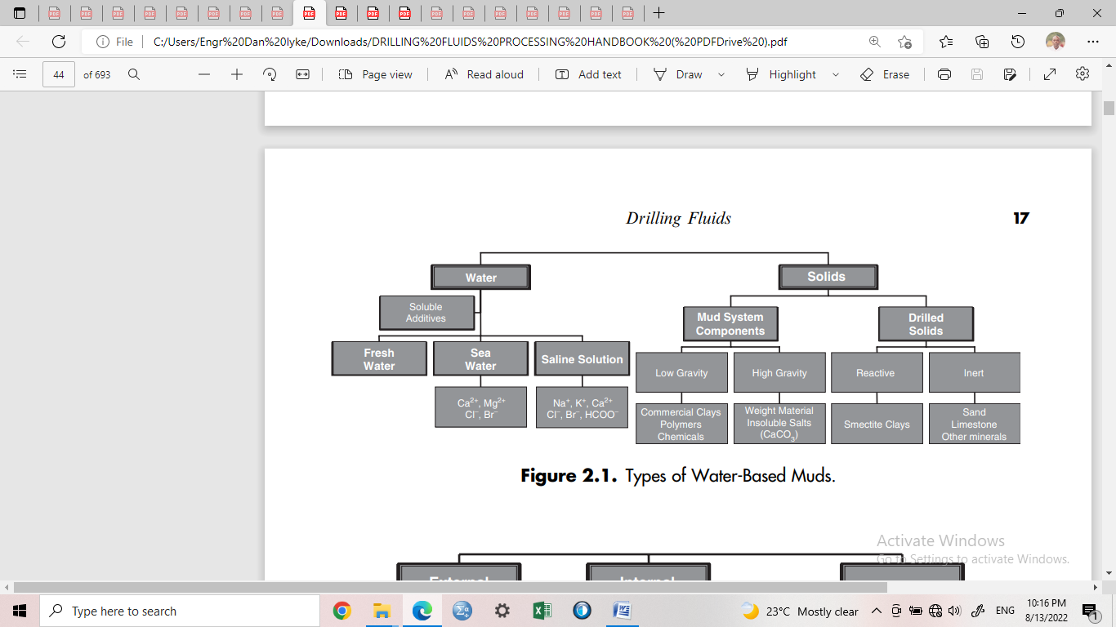

**Fig. 1:** Types of water-based muds

**2.3 Properties of Drilling Fluids**

Drilling fluids are classified into two. There are classified as physical properties and chemical properties. The physical properties of drilling fluids show how efficient the drilling mud is in terms of its physical requirements to ensure safe and adequate use in drilling operations. It consists of yield point, viscosity, gel strength, mud density, fluid loss and mud cake thickness, and the drilling fluids solids content. The chemical properties of drilling fluids are important factor to be considered in terms of monitoring the mud PH, salt formation and corrosion effect which can affect the wellbore stability and performance. The mud PH has to be monitored to make sure that it does not exceed or go above the required range to prevent interference with polymer processes and other chemicals which control fluid loss and viscosity

**2.3.1 Viscosity**

Viscosity plays an important role in drilling fluid rheological properties. Viscosity is known as the internal resistance to flow. It is expressed in Poise. Viscosity is affected by drilling rate, density of mud, pump rate, size of the borehole, etc. Marsh funnel is used for viscosity measurement in the field while viscometer is used for viscosity measurements in the laboratory. In order to increase viscosity of a drilling fluid, addition of bentonite, minimizing drill solids, bentonite flocculation using lime and polymers are used.

**2.3.2 Gel Strength**

Gel strength is an important factor in drilling fluid. Gel strength is measured using a viscometer. It is the measure of the attractive forces of a drilling fluid under static conditions. The gel strength should be capable of suspending cuttings when circulation stops. Poor gel strength in a drilling fluid can lead pipe stuck and the inability to suspend cuttings to the surface thereby causing cuttings to fall to the bottom of the hole when circulation stops (Kamali et al., 2021). This tends to affects the drilling program when the circulation is continued. High gel strength creates high pump pressure that breaks circulation when the mud is under static condition for long. This can cause fractured formation and formation damage. Bacteria, salt, contamination of chemicals such as lime, cement etc., acid gases such carbon dioxide etc., can increase the gel strength of a water-based mud. The measurement of gel strength is made on the viscometer using 2 rpm reading. This will be recorded after breaking the gel which will results from stirring the drilling fluid at 600rpm. The gel strength reading should be taken when the drilling fluid is under static condition (first reading) at 10 seconds while the (second reading) should be taken at 10 minutes.

**2.3.3 Yield Point**

Yield point shows a drilling fluids ability to transport and suspend cuttings to the surface. It is simply the viscosity of the drilling fluid. It is important for drilling fluid to have a good carrying and listing capacity. When the yield point of a drilling fluid is high, it simply shows that the viscosity of the fluid is high or there is contamination of chemicals present.

Yield Point is calculated as;

PV = 600rpm - 300rpm 1

YP = 300rpm - PV 2

Where;

PV is known as the plastic viscosity measured in centipoise.

YP is known as the yield point measured in pascals.

600rpm is known as the dial readings at 600rpm, and is measured in degrees of reflection while 300rpm is known as the dial reading at 300rpm, and is measured in degrees of reflection.

**2.3.4 Plastic Viscosity**

Plastic viscosity shows the total size of the solids present in the drilling mud. It is measured using a viscometer. When the quantity of the solids in the drilling mud is much, the plastic viscosity becomes high. That is to say, the more the quantity of solids presents the higher the plastic viscosity. An increase in the plastic viscosity shows they are solids problems and increase in solid content in the mud. Low plastic viscosity indicates better drilling mud system. High plastic can be reduced by the addition of the drilling fluid or by the use of solid control materials. When mud weight is high, plastic viscosity becomes high.

**2.3.5 Mud Density**

Mud density is generally referred to as the weight per unit volume of the drilling fluid. Mud density is measured in pounds per gallon. The mud density of any drilling fluid should provide sufficient hydrostatic pressure necessary for any drilling operation. Mud density should be between 8.65lbs -9.60lbs of API standard and should not exceed the required range to avoid formation damage, high filer cake (Kelessidis, et al., 2020). Most problems in drilling fluids generally occur as a result of the type and density of the fluid which has to be controlled.

**2.3.6 Filtration Properties**

This is associated with filtration loss. It depends on the mud cake thickness. The mud cake of a drilling fluid should be ideal, impermeable and thin to prevent fluid loss to the formation. An ideal filter cake is needed to prevent borehole instability, excessive torque, pipe sticking problems etc. and to increase productivity. Mud cake formation can prevent fluid loss. The filtration properties can be determined using the standard API press and the mud cake thickness can be determined using a Vernier caliper or millimetric rule. The API standard for fluid loss is 15.0 ml max.

**2.3.7 Mud PH**

The mud PH has to be monitored to make sure that it does not exceed or go above the required range to prevent interference with polymer processes and other chemicals which control fluid loss and viscosity (Table 1). The mud PH is the concentration of hydrogen ion of the drilling fluid. It measures the acidity or alkalinity present in a drilling fluid. It is measured using a PH meter. PH generally falls in the range of 7 to 14. It is acidic when the PH goes below 7, alkalinity is indicated when the PH goes from 7 to 14, while 7 indicates neutral PH. The required PH of drilling fluid ranges from 9.5 to 12.5 (Manea, 2019). The mud PH of water based fluid between 9 to 10 has significant improvement on the rheological and filtration properties of water based fluids. This leads to improve drilling performance, reduction in operation cost, plastic viscosity and efficient cuttings transport to the surface (Mohamadian et al., 2018).

**Table 1: API Requirement for drilling fluids (**Manea, 2019**)**

|  |  |
| --- | --- |
| **Drilling fluid property** | **API requirement** |
| Viscometer reading at 600 rpm, cp | 30 |
| Plastic viscosity, cp | 8-10 |
| Yield point, lb/100ft2 | 3* plastic viscosity |
| Fluid loss (water), ml | 15.0 ml max |
| PH level | 9.5 min- 12.5 min |
| Mud density, lb/gal | 8.65- 9.60 |

**2.5. Previous literatures on water based drilling fluids**

Okon et al., (2020), in their study on evaluating the locally sourced materials as fluid loss control additives in water-based drilling fluid. They stated that in the exploration for hydrocarbons, a successful drilling operation to the desired depth hinges on the effective performance of the formulated drilling fluid. Apart from carrying drill cuttings to the surface, another major function of the fluid is to seal off the walls of the wellbore to prevent fluids from coming into and out of the wellbore while drilling a well. Numerous commercial fluid loss additives: carboxymethyl cellulose (CMC), polyanionic cellulose (PAC), among others have been in existence with their drawbacks and effect on the total drilling cost. This study evaluates the use of locally sourced materials: Detarium microcarpum, Brachystegia eurycoma and rice husk, as fluid loss control additive in the water-based drilling fluid. The materials were prepared, ground and sieved to 125 microns. Four sets of water-based drilling muds were formulated using the local materials and CMC as fluid loss control additives. The mud formulation was based on the American Petroleum Institute (API) standard of 25g bentonite to 350mL of water. Also, the filtration test of the formulated muds was performed using API recommended practice for static filtration test at low temperature - low pressure (LTLP) condition. This result is attributed to the increase in cellulose content in the drilling fluid as the additive content increases. The results obtained showed that Detarium microcarpum and rice husk fluid loss volume and filter cake thickness were comparable with that of CMC from additive content of 10g, while Brachystegia eurycoma was comparable from additive content of 15g. Additionally, the fluid loss volume and filter cake thickness of Detarium microcarpum-rice husk additive were comparable with CMC from 10g content. Also, the results revealed that the fluid loss volume and filter cake thickness obtained from the locally sourced materials were within API specification for fluid loss control agents.

Peretomode (2018) carried out a study on plantain peels powder, burnt palm head powder and commercial sodium hydroxide as additives for water-based drilling mud. He stated that drilling operation efficiency is enhanced by the application of drilling mud constituted with suitable additives. This work investigates the use of locally sourced plantain peels powder (PPP) and burnt palm head sponge powder (BPHSP) in comparison with the use of commercial sodium hydroxide (NaOH) as additives for the enhancement of the pH and rheological properties of water-based mud. The water-based mud samples with and without various amounts (1.0 – 5.0 g) of PPP, BPHSP and commercial NaOH, respectively.

The mud weight of the formulated water-based mud with and without additives is 8.6 Ib/gal and this value remained the same irrespective of the amount of different additives that was added in the formulation. This shows that the addition of the additives had no effect on the density of the formulated water-based mud. Table 2.2 shows that the PV range of 4 – 6cp, 5 - 5cp, and 3 – 4cp; APV range of 6.5 – 12.5cp, 6.5 – 11cp and 6 – 9cp; YP range of 5 – 17, 3 – 12 and 4 – 12 was each obtained when 1.0 – 5.0g of commercial NaOH, The commercial NaOH had the highest percentage of improvement on the mud pH with 22.2 – 50%, followed by that of BPHSP (16.7 – 44.4%) and PPP (11.1 – 33.3%), respectively. Therefore, commercial sodium hydroxide, burnt palm head sponge ash powder and plantain peels powder can respectively be used as additives to enhance or improve the pH and rheological properties (viscosity and yield point) of water-based mud.

Agwu, et al., (2018) in ther study on the activation of local bentonite clays for use as viscosifiers in water-based drilling fluids, stated that activated locally sourced clay can be used as replacement for imported commercial bentonite for use as viscosifiers. Tests and analyses were performed on local clay samples obtained from five (5) locations: Ini, Ibiono, Ikono, Itu and Uyo Local Government Areas in Akwa Ibom State of Nigeria. The mineralogical composition of the unactivated samples determined using X-Ray Fluorescence (XRF), indicates montmorillonite contents less than the American Petroleum Institute (API) standard, so also are the rheological properties and fluid loss characteristics. The activation of the local clays with soda ash (Na2CO3) resulted in improved montmorillonite content. In addition, the activation process increased the clay yield and swelling power. Mud rheological properties and fluid loss potential improved more in the Ikono and Uyo than other clays. On the other hand, the activated clay samples’ XRF results indicate that the montmorillonite content of the local clays were improved close to API standard range for bentonitic clay. Consequently, the same result is also observed with the oxides content of the activated bentonitic clay samples. Also, the Al2O3/SiO2 ratio of the activated local bentonitic clays ranged between 0.35 - 0.41. However, Ini clay with 0.38, Ibiono 0.37 and Uyo 0.36 can be said to be within the API requirement of 0.38 for bentonite. This implies, technically speaking that the local bentonitic clays have met the required standard as drilling mud viscosifiers in water-based mud formulation for drilling purposes.

1. **Methodology**
   1. **Materials**

Materials used in this study are previous published literatures on different locally sourced additives used in water-based drilling muds with emphasis on comparative approaches from 2018 till date. These materials are sourced from high impact journals, conference papers and published papers on the internet.

**3.2 Method**

The methodology of this study involves;

(i) Highlighting existing literature in water based muds and extracting their gaps through thorough analysis of their works.

(ii) Carrying out detailed comparative analysis of published rheological and filtration properties for both water based mud and API specification.

(iv) Suggesting the best technical approach to selection of drilling fluids.

(v) To develop process flow chart of the way forward from the defects of these published works.

**3.2.1 List of published literatures used**

1. Okon, et al. (2020). Evaluating the locally sourced materials as fluid loss control additives in water-based drilling fluid.
2. Peretomode, J. P. (2018). Plantain peels powder, burnt palm head powder and commercial sodium hydroxide as additives for water-based drilling mud.
3. Agwu, et al. (2018). Activation of local bentonite clays for use as viscosifiers in water-based drilling fluids.
4. Jimoh, et al. (2020). Rheological study of a new water-based drilling fluid using Ubakala clay in the presence of natural polymers.
5. Odeh, et al. (2022). Effects of cassava starch and sodium carbonate on the properties of local drilling mud: Beneficiation to improve the rheology and flow properties of locally formulated mud.
6. Ekeinde, et al. (2018). Optimizing aqueous drilling mud system viscosity with green additives.
7. Duru, et al. (2020). Performance evaluation of mucuna solannie as a drilling fluid additive in water-based mud at cold temperature.
8. Udoh, and Okon (2019). Formulation of water-based drilling fluid using local materials.
9. Azinta, et al. (2021). Analysis of effects of foreign clay and local clay additives on viscosity of water-based drilling mud.
10. Okon, et al. (2018). Evaluation of rice husk as fluid loss control additives in water-based drilling mud.

**3.2.2 List of drilling fluid properties evaluated from the published literatures**

1. Shear stress (pa)
2. Viscosity dial readings at 600rpm and 300rpm (cp).
3. Plastic viscosity; PV (cp).
4. Gel Strength; GS (pa)
5. Yield point; YP (pa)
6. Mud pH
7. Mud density (ppg)
8. Filtration loss (ml)
9. Mud cake thickness (mm)

**4.0 Re-evaluation of published water based mud additive results**

A detailed review of the ten (10) previous literatures of local additives used in water-based muds in Nigeria was evaluated using 9 drilling fluid properties. They include the shear stress (pa), average viscosity dial readings at 600rpm and 300 rpm (cp), plastic viscosity (cp), gel strength (pa), yield point (pa), mud pH, mud density (ppg), filtration loss (ml) and mud cake thickness (mm).

**4.1 Comparative results of published literatures of the impact of shear stress**

Comparative results of the 10 reviewed literatures shows that a minimum of 1.98pa shear stress was observed by Odeh et al. (2022) who used marshed cassava roots additives, while the maximum shear stress of 15.52pa was recorded by Duru et al. (2020) who used mucuna solannie additives as shown in Fig. 2 below. The API specification is a minimum of 18pa for both 600rpm and 300rpm. These results fall below the recommended industry standard.

**4.2 Comparative results of published literatures of the impact of viscosity dial readings at 600rpm and 300rpm**

Comparative results shows that the average minimum viscosity dial readings of 3.5cp at 600rpm and 300rpm was observed by Okon et al. (2020) who used detarium microcapum additives while an average maximum viscosity dial reading of 15.72cp was observed by Ekeinde et al. (2018) who used guar gum and offor additives (Fig. 3). These are below the recommended API standard of a minimum of 18cp for both 600rpm and 300rpm dial readings.

**4.3 Comparative results of published literatures of the impact of plastic viscosity**

Comparative results of the impact of plastic viscosity (PV) shows that Okon et al. (2020) gave a minimum of 0.76cp while the maximum viscosity of 10.83cp was recorded by Okon et al. (2018) as shown in Fig. 4. However, only Ekeinde et al. (2018) with a maximum viscosity of 10.02cp and Okon et al. (2018) with a maximum of 10.83cp are in line with the API standard of a range of 8cp – 10cp.

**4.4 Comparative results of published literatures of the impact of gel strength**

Comparative average results of 10min and 10sec gel strengths gave a minimum of 1.11pa for Okon et al. (2020) as shown in Fig. 5. The average results of 10min and 10sec gel strengths gave maximum of 14.73pa for Okon et al. (2018). The API standard range is from 4pa – 20pa which shows that all previous studies are below the API standards.

**4.5 Comparative results of published literatures of the impact of yield point**

Comparative results of yield point gave a minimum of 0.22pa for Okon et al. (2020) as shown in Fig. 6. The maximum yield point of 8.15pa was observed by Duru et al. (2020) who used mucuna solannie additives. The estimated yield point values are below the standard API range of 3pa – 10pa.

**4.6 Comparative results of published literatures of the impact of mud pH**

Comparative results of mud pH gave a minimum acidic value of 4.54 for Odeh et al. (2022) who used mashed cassava roots as shown in Fig. 7. The maximum alkaline mud pH of 10.74 was observed by Azinta et al. (2021) who used xanthum gum. These mud pH values are in line with the recommended API standard of a range of 9.5 – 12.5.

**4.7 Comparative results of published literatures of the impact of mud density**

Comparative results of mud density gave a minimum of 5.99ppg for Agwu et al. (2018) who used soda ash as shown in Fig. 8. The maximum mud density of 8.94ppg was observed by Ekeinde et al. (2018) who used guar gum and offor. These results are in line with API standard of a range of 8.65ppg – 9.55ppg.

**4.8 Comparative results of published literatures of the impact of filtration loss**

Comparative results of mud filtrate loss gave a minimum of 1.59ml for Duru et al. (2020) who used mucuna solannie as shown in Fig. 9. The maximum mud filtrate loss of 16.77ml was observed by Azinta et al. (2021) who used xanthum gum. These values are in line with API specification with a maximum of 15ml.

**4.9 Comparative results of published literatures of the impact of mud cake thickness**

Comparative results of mud cake thickness gave a minimum of 0.03mm for each of the following authors; Okon et al. (2020), Duru et al. (2020) and Okon et al. (2018) as shown in Fig. 10. The maximum mud cake thickness of approximately 0.09mm was recorded by the following authors; Agwu et al. (2018), Ekeinde et al. (2018) and Azinta et al. (2021). These values are also in line with the API industry standard of a minimum of 0.05mm.

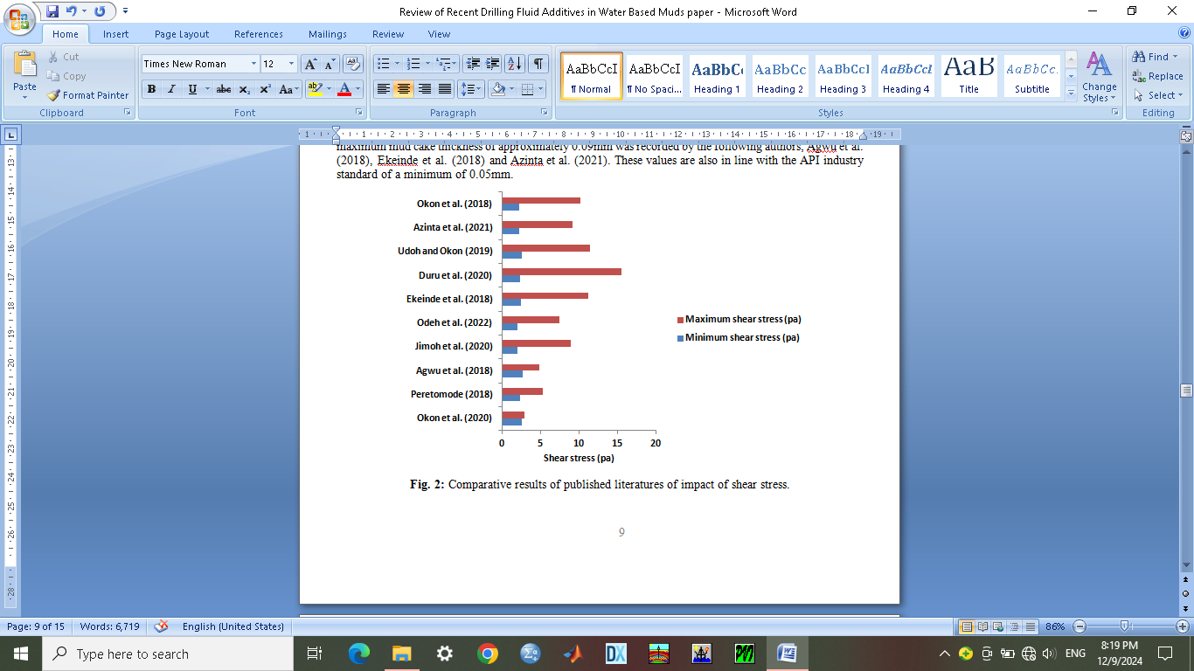

**Fig. 2:** Comparative results of published literatures of impact of shear stress.

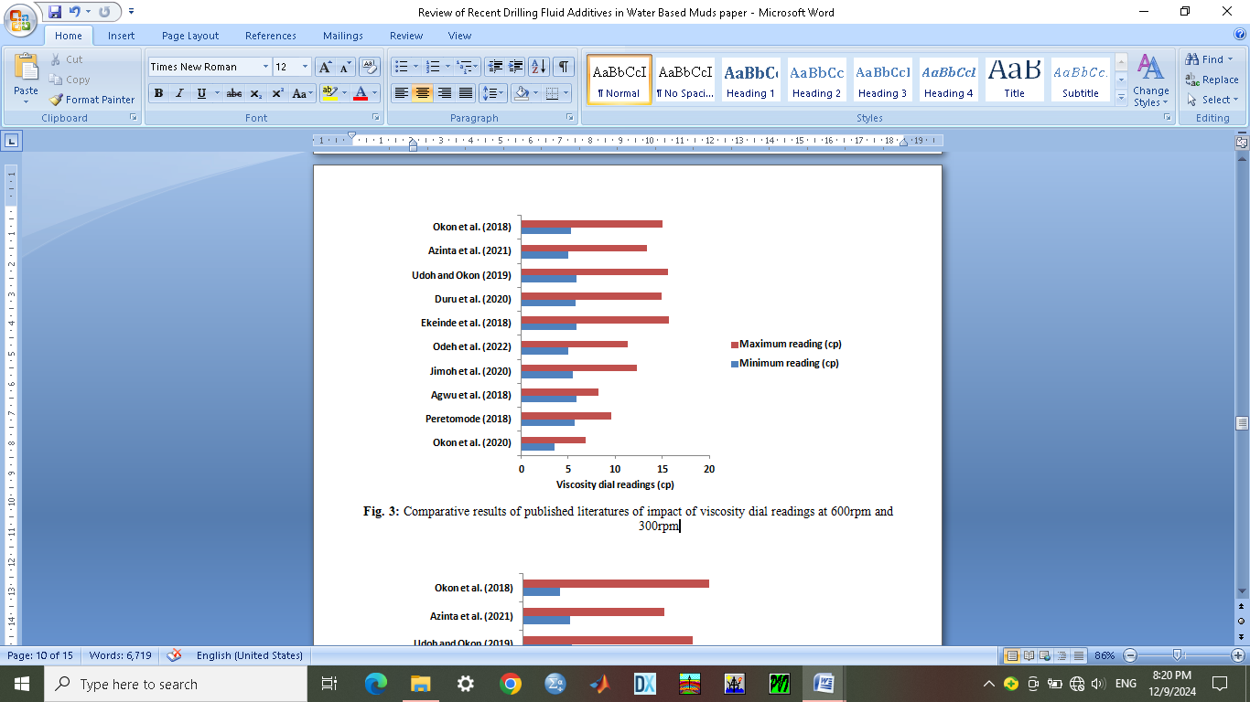

**Fig. 3:** Comparative results of published literatures of impact of viscosity dial readings at 600rpm and 300rpm

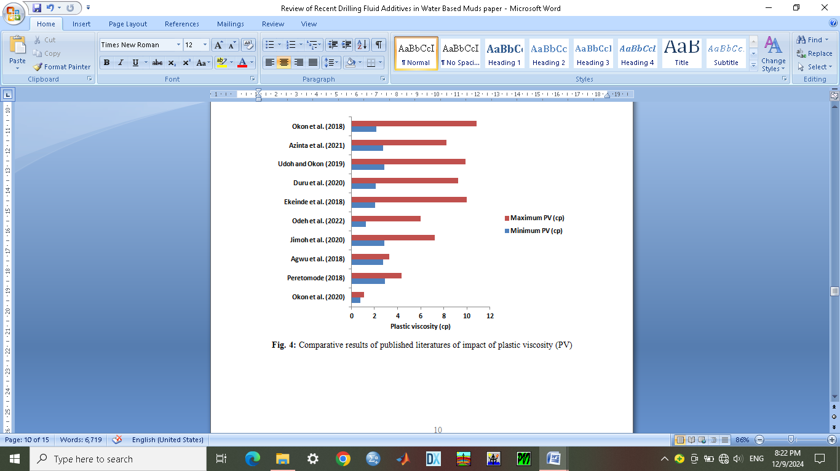

**Fig. 4:** Comparative results of published literatures of impact of plastic viscosity (PV)

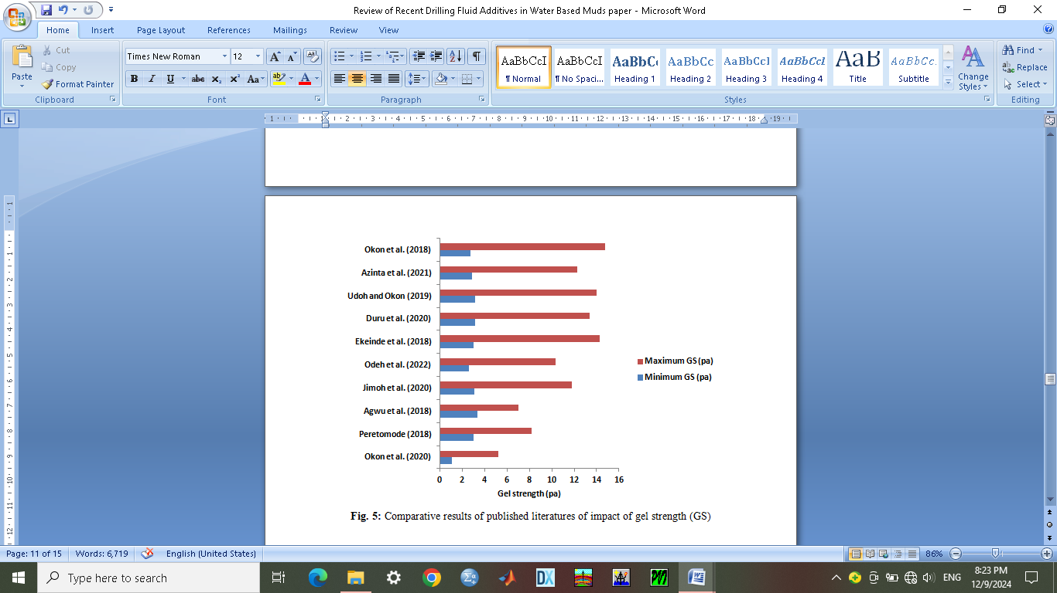

**Fig. 5:** Comparative results of published literatures of impact of gel strength (GS)

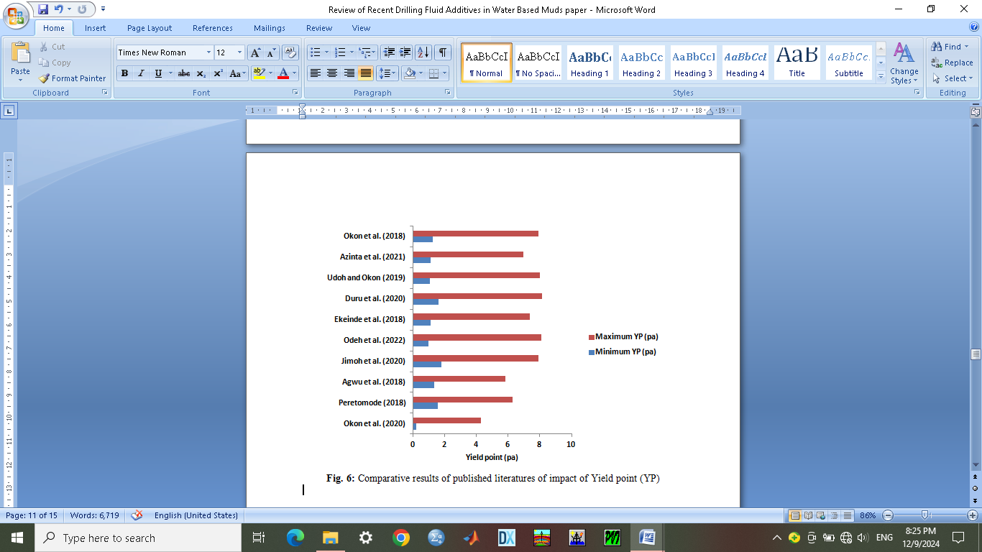

**Fig. 6:** Comparative results of published literatures of impact of Yield point (YP)

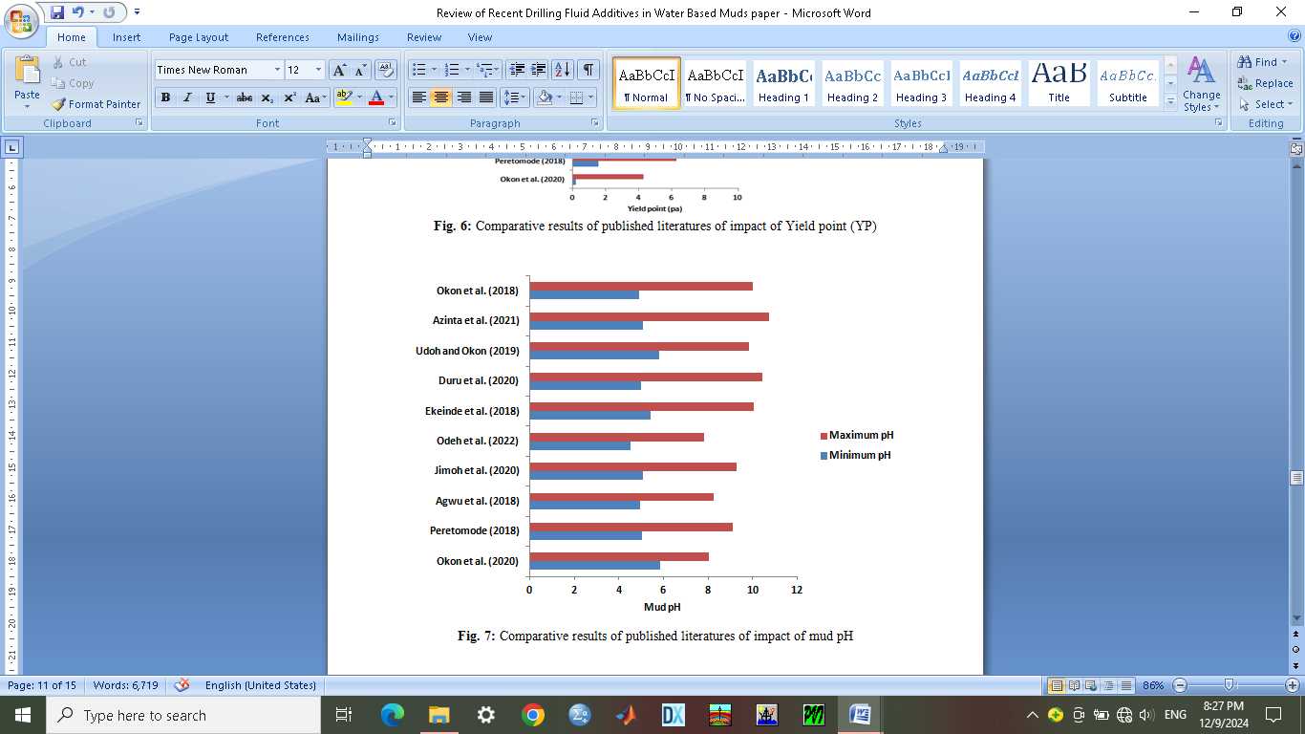

**Fig. 7:** Comparative results of published literatures of impact of mud pH

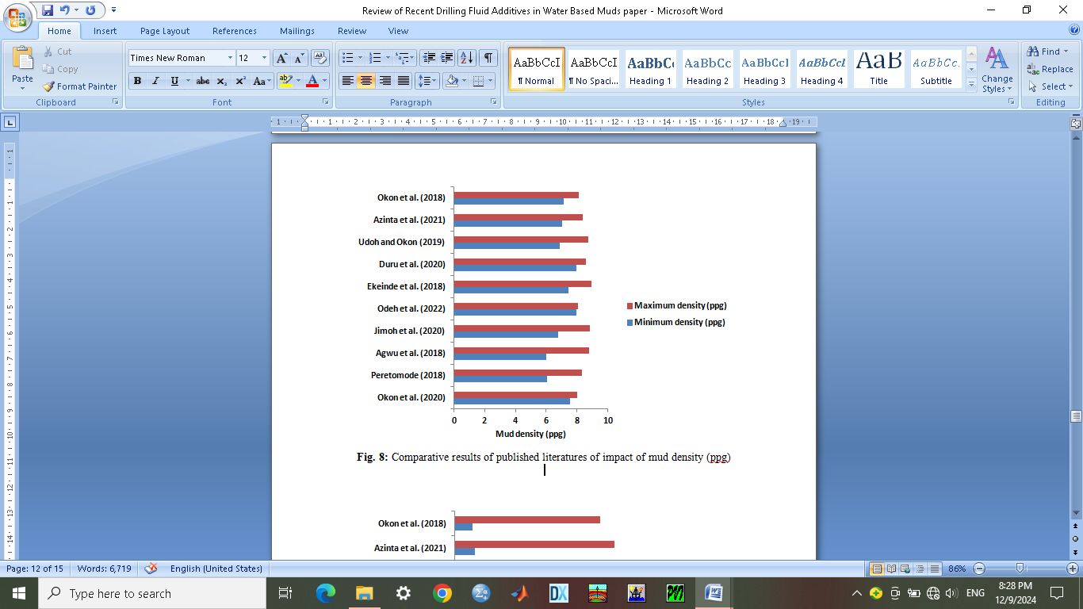

**Fig. 8:** Comparative results of published literatures of impact of mud density (ppg)

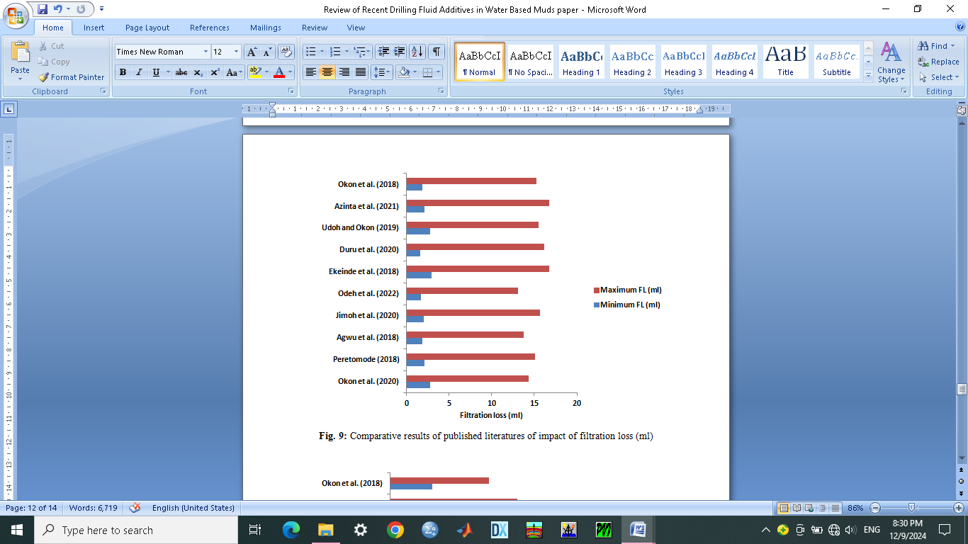

**Fig. 9:** Comparative results of published literatures of impact of filtration loss (ml)

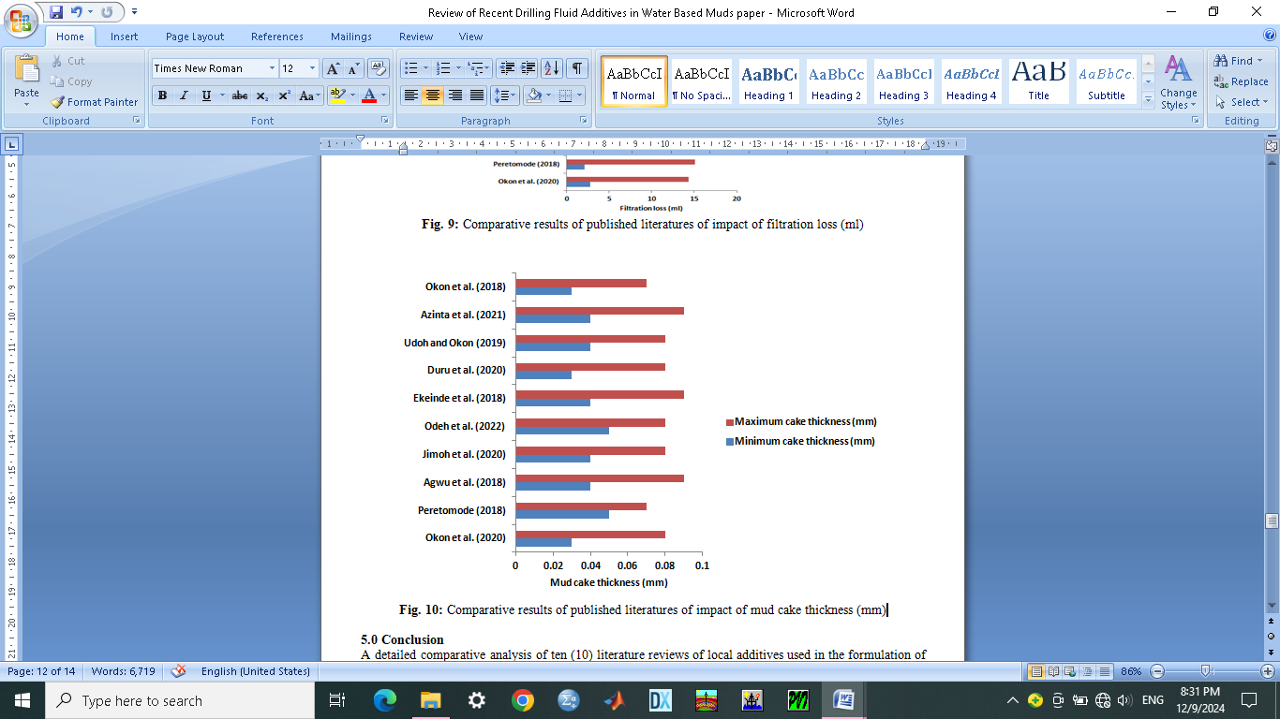

**Fig. 10:** Comparative results of published literatures of impact of mud cake thickness (mm)

**5.0 Conclusion**

A detailed comparative analysis of ten (10) literature reviews of local additives used in the formulation of water-based muds by evaluating their prospects and challenges using the API standards was carefully carried out in this study by also illustrating the minimum and maximum estimates of their drilling fluid properties criteria.

A total of nine (9) drilling fluid properties was also evaluated which includes shear stress, viscosity dial reading at 600rpm and 300rpm, plastic viscosity, gel strength, yield point, mud pH, mud density, filtration loss and the mud cake thickness. They all gave appreciable and promising prospects of good additives. Five (5) out of the nine (9) drilling fluid properties gave results which are in line with API standards which includes the mud pH, mud cake thickness, filtration loss, mud density and plastic viscosity. Altogether, they make up approximately 55.56% success rates in this study while the remaining four (4) properties make up 44.44% failure rate.

However, the results of failure rates showed prospects which can be improved upon since some results were close to the API standard. This can be done with more researches in local additives. The benefits of this study to petroleum engineering is that a breakthrough will transform the industry in reducing the cost of drilling programs and perhaps save our environment with biodegradable water-based mud additives. The contribution to knowledge is that this study will add spice to the many literatures and enhance the choice of selection of additives. It is recommended that more studies are done to discover more additives and maybe blend some the additives used in this research. More local additives can be blended with cheap and minute foreign additives for more efficient results.

**Reference**

Adebayo, T.A., Osiwi, A. and Nwafor-Orizu, E.N. (2018). Laboratory study effect of 1.0mm sawdust with various types of viscosifier additives on properties of oil-based mud. Int. J. Sci. Eng. Res. 3 (8), 156–198.

Adebayo, T.A. and Chinonyere, P. (2019). Sawdust as a filtration control and density additives in water-based drilling mud. Int. J. Sci. Eng. Res. 3 (7), 176–204.

Ademiluyi, T., Joel, O. F. and Amuda, A. K. (2019). Investigation of Local Polymer (Cassava Starches) as a Substitute for Imported Sample in Viscosity and Fluid Loss Control of Water Based Drilling Mud. ARPN Journal of Engineering and Applied Sciences. 6(12), 43-48.

Agwu, O.E. and Akpabio, J.U. (2018). Using agro-waste materials as possible filter loss control agents in drilling muds. J. Petrol. Sci. Eng. 163, 185–198.

Agwu, O. E., Okon, A. N. and Akpanika, O. I. (2018). Activation of local bentonite clays for use as viscosifiers in water-based drilling fluids. Journal of scientific research and reports, vol. 12(2), pp. 1 – 11. <https://doi.10.9734/JSRR/2016/28719>

Agwu, O.E., Akpabio, J.U. and Archibong, G.W. (2019). Rice husk and saw dust as filter loss control agents for water-based muds. J. Heliyon.

Amanullah, M. and Tan, C.P. (2021). Embedment modulus of mudcakes - its drilling engineering significance. In: Paper Presented at the American Association of Drilling Engineers 2001 National Drilling Conference. Houston, Texas, USA, 27-29 March.

Anawe-Paul, A.I. and Adewale, F.J. (2018). Experimental investigation of fluid loss and cake thickness control ability of zirconium (IV) oxide (ZRO2) nano particles in water based drilling mud. Int. J. Eng. Technol. 7 (2), 702–707.

Anawe-Paul, A.I., Efeovbokhan, V.E., Adebayo, T.A. and Nwaogwugwu, M.M. (2014). The effect of rice husk and saw dust on the properties of water-based mud at varied temperatures. J. Energy Technol. 4 (2), 267–309.

API 13A, (2010). Specification for Drilling Fluids – Specifications and Testing. API Specification 13A, 18th Edition.

Azar, J.J. and Samuel, G.R. (2019). Drilling Engineering. PennWell Books – Technology and Engineering, p. 486

Azinta, C. O., Mbah, G. O. and Omotioma, M. (2021). Analysis of effects of foreign clay and local clay additives on viscosity of water-based drilling mud. Journal of Engineering research and report, vol. 21(4), pp. 60 – 67. <https://10.9734/JERR/2021/v211417459>

Azizi, A., Ibrahim, M.S.N., Hamid, K.H.K., Sauki, A., Ghazali, N.A. and Mohd, T.A.T. (2017). Agarwood Waste as a New Fluid Loss Control Agent in Water-Based Drilling Fluid. Int. J. Sci. Eng. 5 (2), 101–105.

Bageri, B.S., Al-Mutairi, S.H. and Mahmond, M.A. (2018). Different techniques for characterizing the filter cake. In: Paper Presented at the Society of Petroleum Engineers Unconventional Gas Conference and Exhibition. Muscat, Oman, 28-30 January.

Bazarnova, N.G., Chubik, P.S., Khmelnitskii, A.G., Galochkin, A.I. and Markin, V.I. (2020). Carboxymethylated wood as a chemical reagent for preparation of drilling fluids. Russ. J. Appl. Chem. 74 (4), 681–686.

Bourgoyne, A.T., Millheim, K.K., Chenevert, M.E. and Young, F.S. (2021). Applied Drilling Engineering, 2. Textbook Series, Society of Petroleum Engineers, Richardson, Texas. Caenn, R., Chillingar, G.V., 1996. Drilling fluids: state of the art. J. Petrol. Sci. Eng. 14, 221–230.

Chinwuba, I.K., Princewill, O.N. and Vivian, O.C. (2016). Evaluation of the fluid loss properties of pleurotus and its commercial availability. Int. J. App. Innov. Eng. Manag. 5 (5), 259–264.

Dagde, K.K. and Nmegbu, C.G.J. (2020). Drilling fluid formulation using cellulose generated from groundnut husk. Int. J. Adv. Res. Tech. 3 (6), 65–71.

Davoodi, S., Ahmed Ramazani, S.A., Jamshidi, S. and Jahromi, A.F. (2018). A novel field applicable mud formula with enhanced fluid loss properties in high pressure

Duru, U. I., Onyejekwe, I. M., Isu, D. O., Uwaezuoke, N. and Arinkoola, A. O. (2020). Performance evaluation of mucuna solannie as a drilling fluid additive in water-based mud at cold temperature. Journal of petroleum and gas engineering, vol. 11(1), pp. 1 – 8. <https://doi.10.5897/JPGE2019.0321>

Ekeinde, E. B., Okoro, E. E., Dosunmu, A. and Iyuke, S. (2018). Optimizing aqueous drilling mud system viscosity with green additives. Journal of petroleum exploration and production technology, vol. 1, pp. 1 – 5. <https://doi.org/10.1007/s13202-018-0481-0>

Jimoh, M. O., Salawudeen, T. O., Arinkoola, A. O. and Daramola, M. O. (2020). Rheological study of a new water-based drilling fluid using Ubakala clay in the presence of natural polymers. Journal of chemical engineering communications, vol. 4, pp. 1 – 11. <https://doi.10.1080/00986445.2020.1774374>

Odeh, A., Edegbe, R. and Oyedoh, E. (2022). Effects of cassava starch and sodium carbonate on the properties of local drilling mud: Beneficiation to improve the rheology and flow properties of locally formulated mud. Journal of advances in chemical engineering and sciences, vol. 12, pp. 13 – 25. <https://www.scirp.org/journal/aces>

Okon, A. N., Udoh, F. D. and Bassey, P. G. (2018). Evaluation of rice husk as fluid loss control additives in water-based drilling mud. SPE-172379-MS paper presented at the SPE Nigeria annual international conference and exhibition (NAICE) held in Lagos, Nigeria, 5 – 7 august.

Okon, A. N., Akpabio, J. U. and Tugwell, K. W. (2020). Evaluating the locally sourced materials as fluid loss control additives in water-based drilling fluid. Heliyon journal, vol. 6, pp. 1 – 16. <https://doi.org/10.1016/j.heliyon.2020.e04091>

Oludare, A. S. and Macdonald, I. S. (2020). Variation in the Physical, Chemical and Physico-Functional Properties of Starches from Selected Cassava Cultivars. New York Science Journal, 3(4), 48-53.

Oriji, A. B. and Joel, O. F. (2018). Suitability of Beneficiated Local Starch under Elevated Temperature as a Fluid Loss Control Additive Used in Petroleum Industry. Scientia Africana, 11(1), 77-83.

Peretomode, J. P. (2018). Plantain peels powder, burnt palm head powder and commercial sodium hydroxide as additives for water-based drilling mud. Journal of applied science and environmental management, vol. 22 (7), pp. 1009 – 1012. <https://dx.doi.org/10.4314/jasem.v22i7.1>

Udoh, F. D. and Okon, A. N. (2019). Formulation of water-based drilling fluid using local materials. Asian journal of microbiological, biotechnology and environmental science, vol. 14(2), pp. 167 – 174