**Quadrated Flow Regime Models for Pellucid Reservoir Quality Scholium**

By

**D. I. Egu1; V.C. Amaefule2; O. Akintade3; R.C. Okoloekwe4; A. A. Omeche5; U.J. Eze6**

1,2Department of Petroleum Engineering, Madonna University Nigeria

3Department of Petroleum Engineering and Advanced Practice, USA

4Department of Civil Engineering, Madonna University Nigeria

5Department of Electrical and Electronics Engineering, Madonna University Nigeria

6Department of Computer Engineering, Madonna University Nigeria

**Email:** [daniyke98@gmail.com](mailto:daniyke98@gmail.com)

**ABSTRACT**

A total of seven new reservoir quality index (RQI) flow correlations were developed from a combination of steady, pseudo-steady and transient state models for improved quality assessment of an undersaturated oil rim reservoir. Mathematical sensitivity modeling of existing models was done and built with Microsoft excel spreadsheet. Comparative behavioural pattern of modified steady and pseudo-steady state models are the same with convergent inversions at end points of results for flow rate, pressure, reservoir thickness, oil viscosity, oil formation volume factor, wellbore radius with average squared regression of R2 = 0.85. The study shows that the new correlations gave better reservoir quality assessment in terms of RQI directly from flow rate measurements. The transient effects reversed the patterns of the steady and pseudo-steady state models. This may perhaps be due to the complexity of the transient flow equation, presence of time variable, dual permeability variables and reservoir thickness constraint. The study also ranked steady state models as the best among the seven correlations.

**Key words:** Reservoir quality index, flow models, characterization, production rates.

**1.0 Introduction**

There are various methods for the calculation of volumes of hydrocarbons in place in petroleum reservoirs and potential recoveries. These methods do not provide the Engineer with techniques for estimating the flow rates at which the hydrocarbon reserves could be produced (Egu, 2014; Andrea et al., 2019). Determination of achievable production rates is a critical element in the economic evaluation of hydrocarbon resources. If the predicted production rates are low due to geologic barriers and/or rock and fluid properties, economic development of the hydrocarbon resource may be delayed or in some cases abandoned if these factors that limit capacity to produce are not resolved in favor of the project (McBride, 2018; Ahmed et al., 2020). This requirement is especially important in high cost environments, such as deepwater reservoirs, where high production rates are generally required for economic viability of the project. The rate of fluid production at the wells is controlled by the rate of fluid flow in the reservoir. The three main types of fluids that are considered under the radial form of the Darcy flow equation for single phase are incompressible fluids, slightly compressible fluids, and compressible fluids (Shim et al., 2011; Ilozobhie and Egu, 2023). During fluid flow, the state of pressure distribution in the reservoir depends on duration of the flow (time) and distance from the well. Depending on flow time and size of the reservoir, three flow regimes can be distinguished. These are transient flow (or unsteady-state flow), pseudo-steady-state flow (or semi-steady state flow), and steady-state flow. The continuity equation that governs fluid flow in a porous medium such as petroleum reservoirs is derived. From the continuity equations, diffusivity equations for slightly compressible fluids and compressible fluids are derived (Scholle and Schluger, 2017; Asquith and Gibson, 2020). Mathematical solutions to the diffusivity equations for the two types of fluids are presented for transient and pseudosteady-state flow regimes. The theory and application of the principle of superposition exist for a single-well, multi-production rates case; the multi-well reservoir system case; and the single well near a sealing boundary case (Elizabeth et al., 2009; Consonni et al., 2014).

However, reservoir flow regime (or flow pattern) is essentially a description of the flow structure or distribution of one fluid phase relative to the other. Flow regimes are associated with different boundary conditions (Brown, 2019; Khalil et al., 2021). The flow regime depends on the boundary condition, and it can be identified by the rate of change in pressure with time. The [steady state flow](https://www.sciencedirect.com/topics/engineering/steady-state-flow) regime corresponds to a system in which the [mass flow rate](https://www.sciencedirect.com/topics/engineering/mass-flowrate) is constant everywhere, and pressure is constant with respect to time (*dP*/*dt* = 0). An example of a system that exhibits steady state flow is a reservoir connected to an infinite-acting aquifer (Stacy et al., 2016; Ilozobhie and Egu, 2020). The corresponding boundary condition is referred to as the [constant pressure boundary](https://www.sciencedirect.com/topics/engineering/constant-pressure-boundary). The pseudosteady state regime applies to a system in which both the [wellbore](https://www.sciencedirect.com/topics/engineering/wellbore) and the average [reservoir pressure](https://www.sciencedirect.com/topics/engineering/reservoir-pressure) change with time. Pressure changes at a constant rate (*dP*/*dt* = constant) in the pseudosteady state regime. The system behaves like a closed system, and there is no fluid movement across boundaries (Davies and Vessell, 1997; Gorbovskaia et al., 2017). An example of this type of reservoir is a reservoir with closed boundaries and no fluid encroachment from sources such as aquifers or leaking faults. The final regime is the transient state, which is the flow regime in which pressure changes as a function of time (*dP*/*dt* = *f*(*t*)). In this case, there are no restrictions on fluid movement. Identifying the appropriate method for analyzing a [pressure transient test](https://www.sciencedirect.com/topics/engineering/pressure-transient-test) depends on correctly identifying flow regime (Craig et al., 2011; Egu, 2020).

Meanwhile, the porosity and permeability components of sandstone and carbonate reservoirs (known as reservoir quality) are also essential inputs for successful oil and gas resource exploration and exploitation. Reservoir quality in both sandstones and carbonates is studied using a wide range of techniques: log analysis and petrophysical core analysis, core description, routine petrographic tools and, ideally, less routine techniques such as stable isotope analysis, fluid inclusion analysis and other geochemical approaches (Keelan, 2016; Gerard et al., 2019). Sandstone and carbonate reservoirs both benefit from the study of modern analogues to constrain the primary character of sediment before they become a hydrocarbon reservoir. Prediction of sandstone and carbonate reservoir properties also benefits from running constrained experiments to simulate diagenetic processes during burial, compaction and heating (Wilson and Pittman, 2017; McDonald and Surdam, 2019). The challenge of not attributing production rates problems to reservoir quality assessment particularly amidst dwindling resources is the reason of inconsistency in production, reservoir management and hydrocarbon evaluation. Perhaps accurate prediction of reservoir qualities directly from flow rates during oil production is the missing technical link. Existing flow regime models falls short of the intended technical quality assessment due to the vast unpredictable complex heterogeneous properties of the reservoir (Wardlaw, 2017; Schmidt and McDonald, 2018).

The aim of this study is to develop modified flow regimes of the transient, steady and pseudo steady state correlations for improved quality assessment of an under-saturated oil rim reservoir in the Niger Delta using python software. The objectives are; to carry out a mathematical remodeling of existing flow regime models using the reservoir quality index (RQI) correlation, to validate and develop sensitivity analysis of the modified reservoir quality index models with some critical reservoir parameters such as reservoir thickness, porosity, flow rates and pressure drawdown, to develop simple flow regime models of the RQI correlation as a viable option for the complex existing flow regime models, to develop a quick and easier computer application of the new models using Microsoft excels spreadsheet, matlab and python software.

**2.0 Previous Works and Gaps on Improving Reservoir Quality Assessment**

Ahmad et al (2020) in their research on improving reservoir quality prediction of microporous carbonates using a multi-scale geophysical data analysis approach tried to reduce the complexity of improved reservoir recovery by explaining the impact of microporosity on reservoir quality and accurately predicting the spatial distribution of microporosity at the reservoir scale. They utilized an integrated data analysis approach applied to multi-scale geological and geophysical datasets from micrometer scale SEM imagery to decameter scale seismic data and predicted the distribution of microporosity at the reservoir grid-block scale. Final results showed that the key reservoir depositional lithofacies identified from core descriptions are bioturbated mudstones intercalated by packstones and grain dominated rudstones and floatstones. The gap in their study is that the data used was from neighboring field outcrop and applying this technique to other reservoir zones is so rigorous and would definitely give errors in microporosity interpretation.

Craig et al. (2011) studied appraising unconventional resource plays: separating reservoir quality from completion effectiveness. They stated that applying appropriate technologies for unconventional reservoirs and a holistic approach are essential to properly separate reservoir quality from completion effectiveness. The North American model of assessing unconventional reservoirs by drilling and completing a large number of wells may not be economically feasible in areas with insufficient hydraulic fracturing, drilling, and completion infrastructure. This holistic approach reduced the number of wells required to assess the economic viability of unconventional resources and reliably separates reservoir quality from completion effectiveness. The gap in their study is that a holistic reservoir quality evaluation from dynamic parameters such as flow rates and reservoir pressures was not available.

Andrea et al. (2019) studied high resolution reservoir quality prediction at the reservoir scale through diagenetic modeling. Reservoir quality prediction was carried out at the exploration scale through software that try to model the diagenetic evolution of the reservoir. The input data are quantitative petrographic data, core analysis results and the burial and thermal history of the wells either 1D or 3D (PSM). They calibrated the model on a well with cores or sidewall cores for petrographic-diagenetic data and RCA and with a calibrated burial and thermal history. The reservoir quality maps provided trends for properties distribution in the reservoir model obtaining remarkably different results compared to the inversion-based distribution and providing additional data for uncertainty analysis. The gap in this study is that the work-flow analysis did not encompass all data in a collaboration space in order to produce a valuable tool for reservoir models.

Consonni et al. (2014) in their work on new methods for quantitative reservoir quality prediction in sandstones stated that the efficiency of a sandstone reservoir is a function of the initial depositional parameters (grain-size, sorting and composition) and of the post-depositional evolution during burial. The reservoir quality of sandstone was appraised qualitatively using two methodologies. The case-study showed the pros and cons of applying the two methodologies. The two methodologies are limited one by the fact that is deterministic, the other by its ability to model only some of the diagenetic events that take place during burial. In order to overcome these problems, transport-reaction models may be used. A first attempt to apply these models, already used in carbonate diagenesis and reservoir quality prediction, to sandstones showed that there are way forward in applying this methodology. The gap in this holistic approach is that there was no reservoir statistical quality evaluation while it is only restricted to porosity and permeability data.

**3.0 Methodology**

**3.1 Materials**

Data used are both reservoir and production data such as porosity, permeability, oil formation volume factor, oil viscosity, initial reservoir pressure, well flowing pressure, total compressibility, skin factor, reservoir radius, wellbore radius, skin factor and flow rate.

Sample sizing of the various reservoir and production data used was done effectively using the statistical platform of Microsoft Excel spreadsheet. Binomial regression trend analysis would be done for every comparative analogy. The sampling procedure used is the probability sampling of mathematical correlations for both the old and new models using statistical analysis. The production and reservoir data to be used was checked for errors to ensure they conform to actual measurements in the Niger Delta.

**3.2 Method**

This research is structured as shown in the process flow chart in Fig. 1with details outlined below;

* Mathematical re-modeling of reservoir flow regimes which includes; transient, steady state and pseudo-steady state flows with the reservoir quality index (RQI) model.
* Test and validate the new models using the reservoir and production data supplied by NPDC, Benin.
* To carry out sensitivity analysis of the new models using Microsoft Excel spreadsheet.
* Development of computer programs for quick estimation of flow rates for the three flow regimes.
* Development of computer program for estimation of new RQI models for the three flow regimes.
* Comparison of results of reservoir parameters with the existing and modified correlations.
* Conclusion and recommendation.

Quantitative mathematical and computer based techniques of evaluation was used. The re-modeling of the transient, steady state and pseudo-steady state flow regimes was done analytically while sensitivity analysis was done on Microsoft Excel spreadsheets. Comprehensive data analysis was done using the univariate and multivariate analysis to examine the data distribution, descriptive statistics of continuous variables and frequency distribution. Multiple and linear regression analysis was used to develop correlations for the new and existing models.



Fig. 1: Process Flow Chart

**3.2.1 Model development**

The flow patterns of the reservoir is a major characteristics of the physical behavior of the reservoir and dependent on the reservoir and fluid properties such as the oil viscosity, formation volume factor, oil flow rate, reservoir and wellbore radius, skin factor, porosity, reservoir thickness and pressures of the wellbore and reservoir.

Reservoir quality index (RQI) is a quick indicator of the flow behavior. This was inputed into the steady state, pseudo-steady state and transient/unsteady state flow models to produce new hybrid reservoir flow equations as a function of the RQI as shown below;

$RQI=0.0314\sqrt{\frac{K}{∅}}$ (1)

Where, K = permeability (md) and ɸ = porosity

For steady state flow;

$Q_{S}=\frac{Kh(P_{e}-P_{wf})}{141.2μB\left[In\left(\frac{r_{e}}{r_{w}}\right)+S\right]}$ (2)

From equation 1, by make K the subject formular, we have;

$K=\frac{∅{RQI}^{2}}{0.0314}$ (3)

By substituting equation 3 into equation 2, we have,

$Q_{S}=\frac{∅{RQI}^{2}h(P_{e}-P_{wf})}{\left(0.0314\right)(141.2)μB\left[In\left(\frac{r_{e}}{r_{w}}\right)+S\right]}$ (4)

Similarly for pseudo-steady state flow,

$Q_{p}=\frac{Kh(P_{e}-P_{wf})}{141.2μB\left[In\left(\frac{0.472r_{e}}{r_{w}}\right)+S\right]}$ (5)

By substituting equation 3 into equation 5, we have;

$Q_{p}=\frac{∅{RQI}^{2}h(P_{e}-P_{wf})}{\left(0.0314\right)(141.2)μB\left[In\left(\frac{0.472r_{e}}{r_{w}}\right)+S\right]}$ (6)

Finally, for transient/unsteady state flow,

$Q_{T}=\frac{Kh(P_{i}-P_{wf})}{162.6μB}\left[Logt+Log\left(\frac{K}{ɸμC_{t}r_{w}^{2}}\right)-3.23\right]$ (7)

By re-arranging equation, we have in terms of porosity;

$∅=\frac{0.0314K}{{RQI}^{2}}$ (8)

By substituting equation 8 into equation 7, we have;

$\left(\frac{162.6μβq_{t}}{Kh(P_{i}-P_{wf})}+3.23\right)=\frac{Kt}{∅μC_{t}r_{w}^{2}}$ (9)

${RQI}^{2}=\left[\frac{0.0314μC_{t}r_{w}^{2}}{t}\right]×{10}^{\left[\frac{162.6μβq_{t}}{Kh(P_{i}-P_{wf})}+3.23\right]}$ (10)

These new equations were used to carry out sensitivity analysis of the flow relationships between the RQI and some critical reservoir properties common to all the correlations which includes the oil flow rate (q), the pressure drop (ΔP), reservoir thickness (h), viscosity (µo), oil formation volume factor (Bo) and the wellbore radius (rw).

**4.0 Results**

Comparative results of RQI of steady state, pseudo-steady state and transient state with flow rates revealed the same pattern of increasing RQI with increased flow rates for steady state and pseudo-steady state flows, while the transient state gave a reversal of reduced RQI with increased flow rates as shown in Fig. 2. This means that transient state shows reduction in the RQI while it increases for steady and pseudo-steady state flow conditions. This may perhaps be due to the time factor and the presence of dual porosity/permeability factors in the modified transient state model. Comparative results of RQI of steady state, pseudo-steady state and transient state with pressure drop shows that both the steady state and pseudo-steady state flows gave declining similar curve patterns as shown in Fig. 3, while the transient state model gave an increasing straight line pattern with increasing RQI. This means that for prediction of RQI from pressure drops, the RQI reduces for increased pressure drops for steady state and pseudo-steady state but rather increased for transient state. Comparative results of RQI of steady state, pseudo steady state and transient state with reservoir thickness (h) showed that both RQI for steady and pseudo-steady states all declined with increasing reservoir thickness as shown in Fig. 4 while the transient state gave a positive linear increasing straight line pattern on a bi-logarithmic scale suggesting perhaps that this reversal may be due to the effects of time and permeability factors in the transient model. Comparative results of RQI of steady state, pseudo-steady state and transient state with the oil viscosity (Uo) showed that both RQI’s for steady and pseudo-steady state gave linear increasing positive straight line pattern as shown in Fig. 5, while the transient state RQI gave a reversed exponential profile of decreasing RQI with increasing oil viscosity. These variant results may also be due to the effects of time and dual porosity/permeability properties in the modified transient model. Comparative results of RQI of steady state, pseudo-steady state and transient state with the oil formation volume factor (Bo), showed that both RQI’s for steady and pseudo-steady states gave linear straight line increases with increased oil formation volume factor (Bo) as shown in Fig. 6, while the transient state RQI gave a declining curve with increased oil formation volume factor (Bo). This suggests that Bo is also sensitive to transient flows and affected by time and permeability. Comparative results of RQI of steady state, pseudo-steady state and transient state with wellbore radius (rw) showed both slight reductions in RQI with increased wellbore radius (rw) for steady and pseudo-steady state flows as shown in Fig. 7. The transient state RQI gave a linear increasing straight line pattern. This may be due to the effects of time and permeability in the modified transient state model.

Results of modified reservoir quality index of steady and pseudo-steady state flows gave similar patterns with slight variations in the RQI values with increased flow rates. The RQI values of pseudo-steady states were slightly higher than that of the steady state model. The range of pseudo-steady state value is from 4.837246 to 8.72047, while steady state is from 0.676109 to 1.218873 as shown in Table 1, while the modified model for both steady state and pseudo-steady state has a range from 2.756678 to 4.969671 as shown in Fig. 8. The predicted model is given as $Mod-{RQI}_{SP}=-1.0×{10}^{-9}q_{sp}^{2}+0.753$ with squared regression coefficient of $R^{2}=0.996$.

However, when the steady state model was combined with the transient state model, the range of RQI was from a maximum of $4.64×{10}^{13}$ to a minimum of 14.5463 for increased flow rates as shown in Table 2. The predicted modified model gave a similar declining pattern with the transient declining curve model given as $Mod-{RQI}_{ST}=-1.0×{10}^{11}q_{sT}^{-23.6}$ and a squared regression coefficient of $R^{2}=0.971$ as shown in Fig. 9. Results of modified RQI with flow rates for pseudo-steady state and transient state gave a similar pattern with the steady state and transient state results but the modified RQI for pseudo-steady state and transient state has a range from a maximum of $4.64×{10}^{13}$ to a minimum of 18.2971 as shown in Table 3, while the predicted model gave $Mod-{RQI}_{PT}=4×{10}^{11}q_{PT}^{-23.5}$ with squared regression coefficient of $R^{2}=0.97$ as shown in Fig. 10. Results of modified steady state, pseudo-steady state and transient state showed the strong effect of transient state where the modified RQI gave a range of a maximum of $3.09616×{10}^{13} at 20,000bbl/day$ to a minimum of $12.60435771 at 65,000bbl/day$ as shown in Table 4, while the predicted model gave $Mod-{RQI}_{SPT}=2×{10}^{11}q_{SPT}^{-23.5}$ and a squared regression coefficient of $R^{2}=0.969$ as shown in Fig. 11.

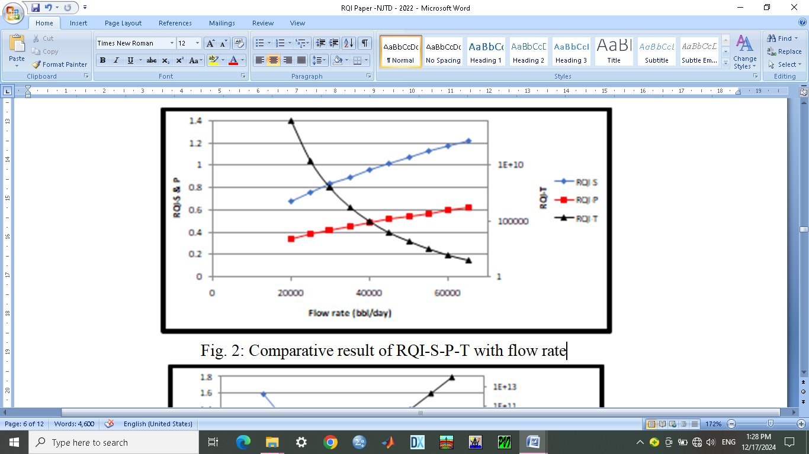

Fig. 2: Comparative result of RQI-S-P-T with flow rate

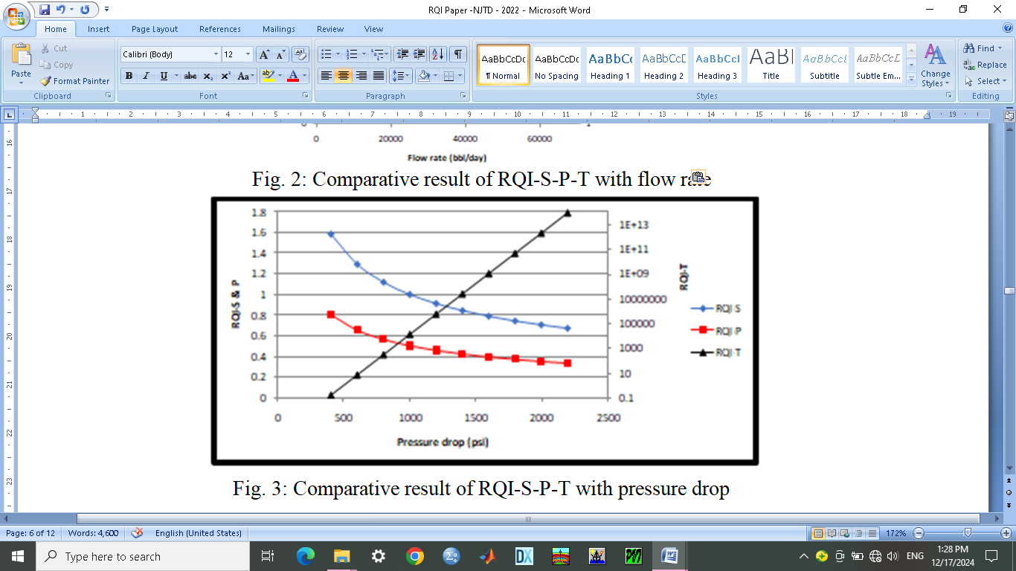

Fig. 3: Comparative result of RQI-S-P-T with pressure drop

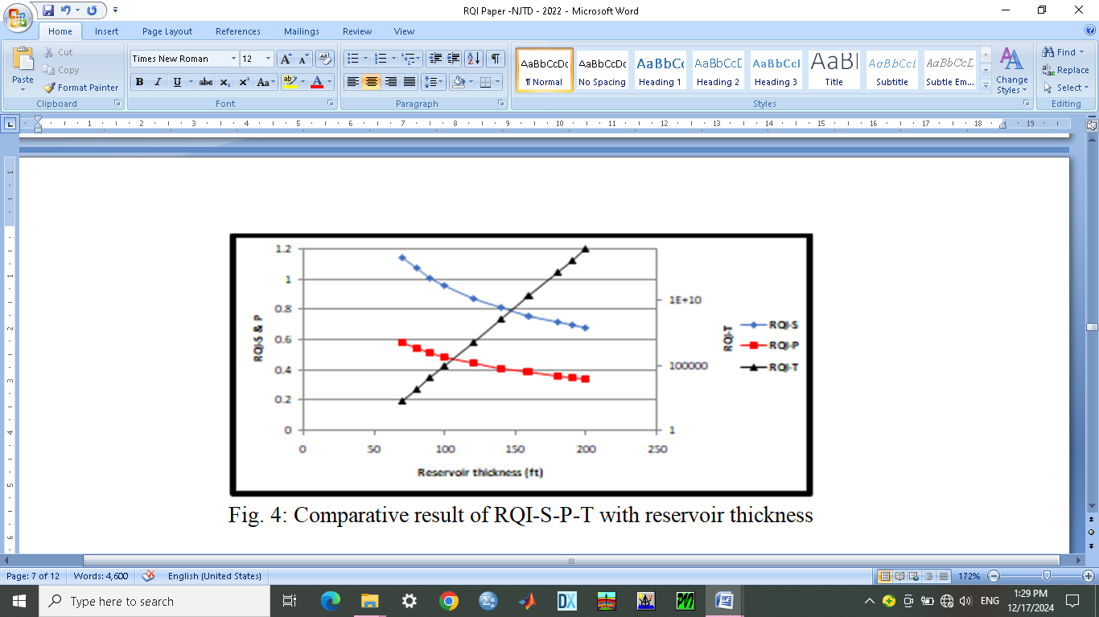

Fig. 4: Comparative result of RQI-S-P-T with reservoir thickness

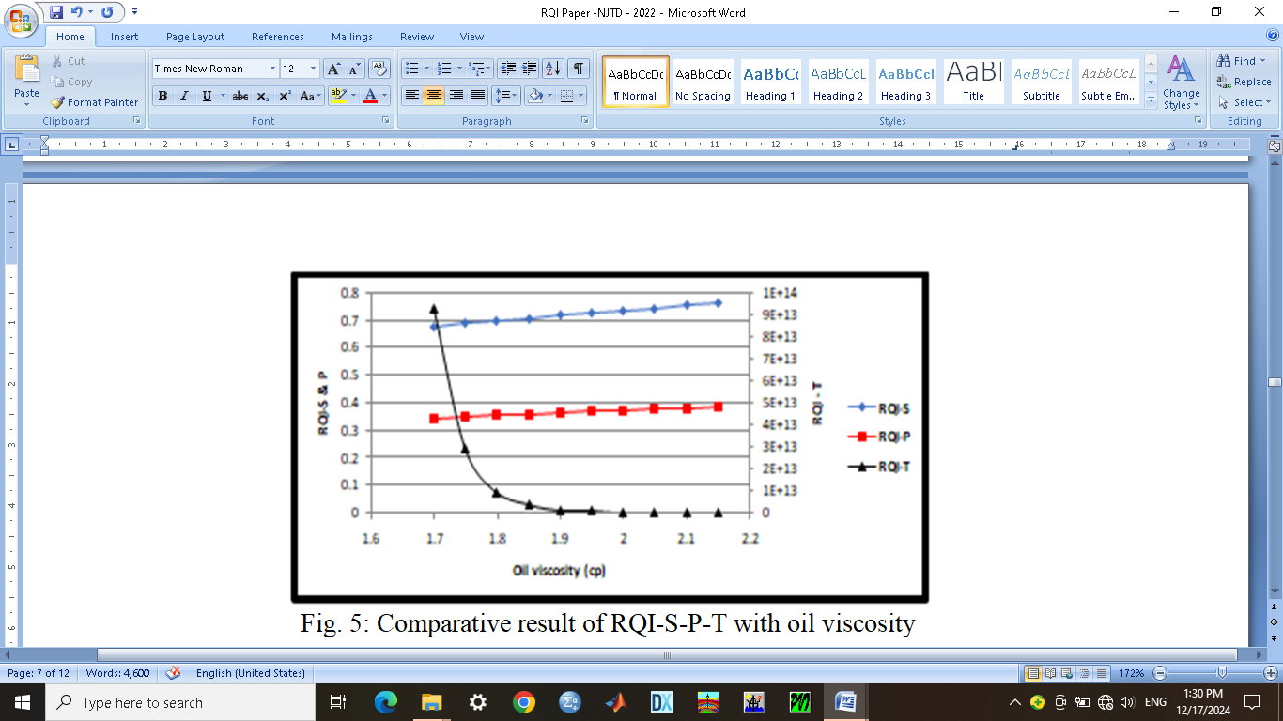

Fig. 5: Comparative result of RQI-S-P-T with oil viscosity

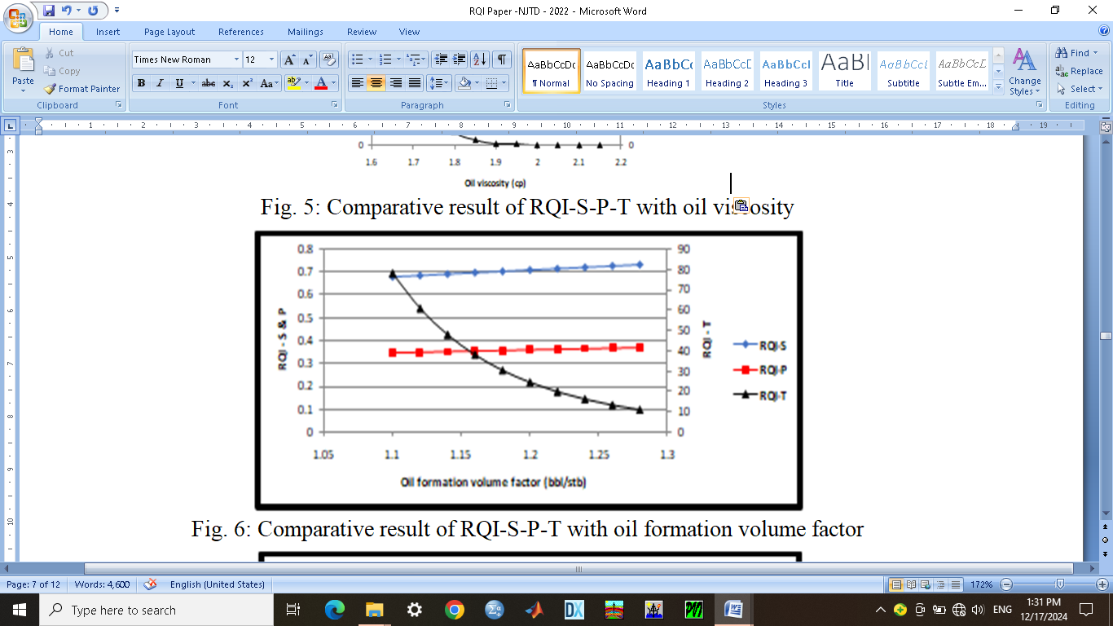

Fig. 6: Comparative result of RQI-S-P-T with oil formation volume factor

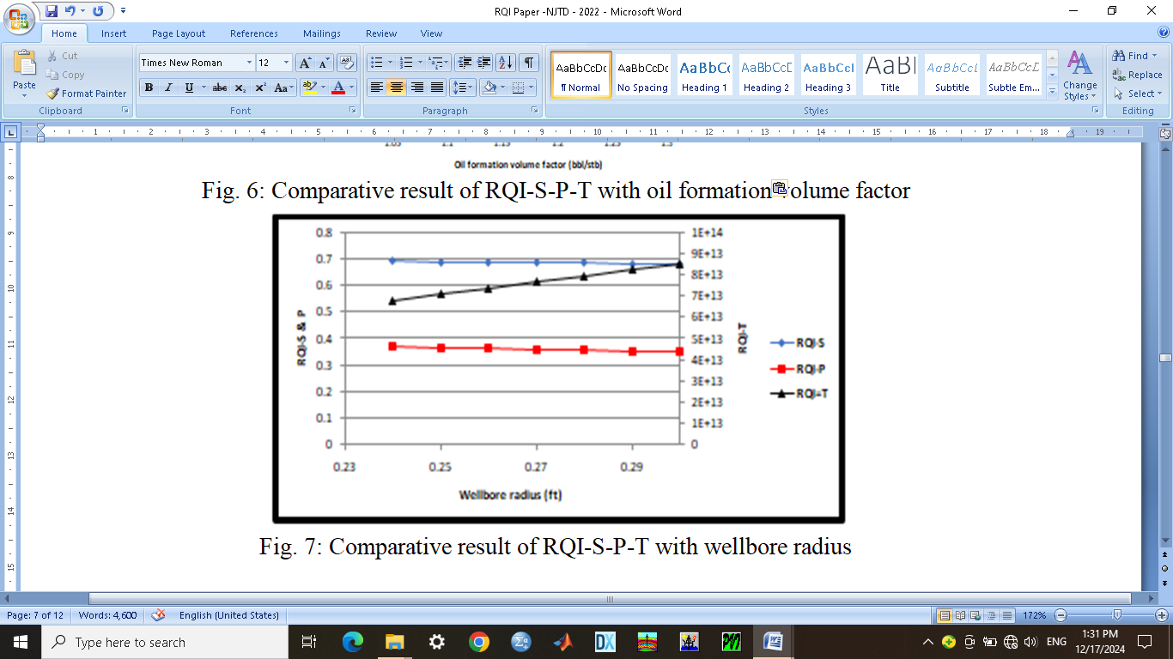

Fig. 7: Comparative result of RQI-S-P-T with wellbore radius

**Table 1: Modified Steady-Pseudo-Steady (SP)**

|  |  |  |  |
| --- | --- | --- | --- |
| **q** | **RQI-S** | **RQI-P** | **Mod-RQI-SP** |
| 20000 | 0.676109 | 4.837246 | 2.756678 |
| 25000 | 0.755913 | 5.408206 | 3.082059 |
| 30000 | 0.828061 | 5.924392 | 3.376227 |
| 35000 | 0.894408 | 6.399075 | 3.646742 |
| 40000 | 0.956162 | 6.840899 | 3.898531 |
| 45000 | 1.014163 | 7.255869 | 4.135016 |
| 50000 | 1.069022 | 7.648358 | 4.35869 |
| 55000 | 1.1212 | 8.021665 | 4.571432 |
| 60000 | 1.171055 | 8.378356 | 4.774706 |
| 65000 | 1.218873 | 8.72047 | 4.969671 |

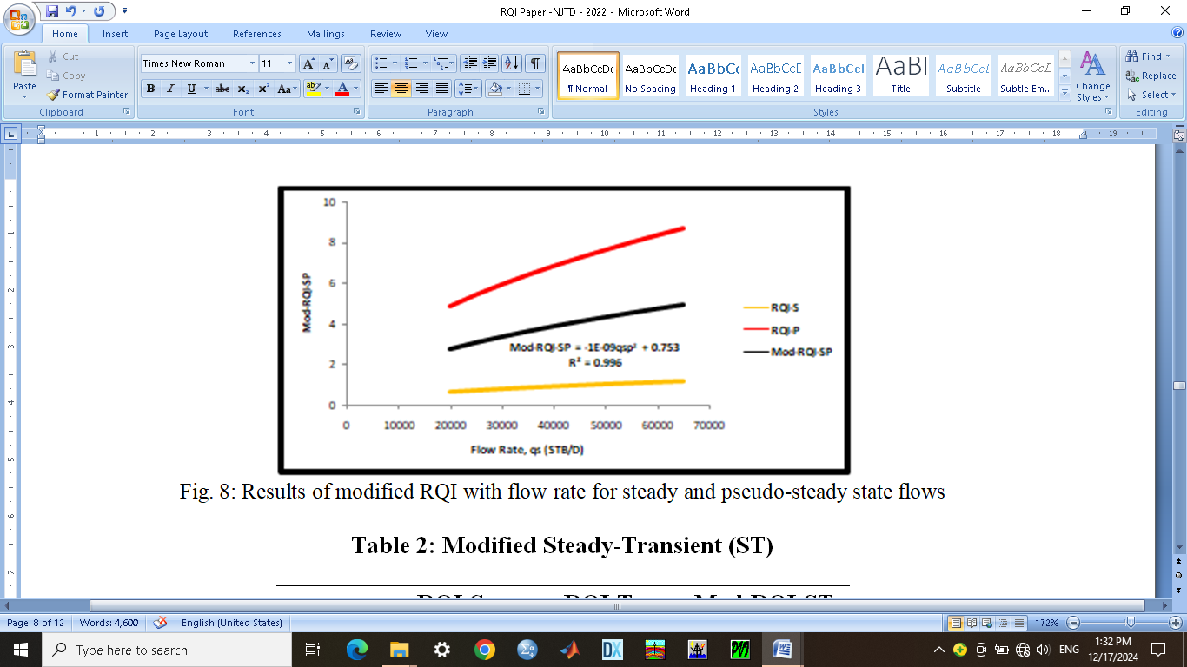

Fig. 8: Results of modified RQI with flow rate for steady and pseudo-steady state flows

**Table 2: Modified Steady-Transient (ST)**

|  |  |  |  |
| --- | --- | --- | --- |
| **q** | **RQI-S** | **RQI-T** | **Mod-RQI-ST** |
| 20000 | 0.676109 | 9.29E+13 | 4.64E+13 |
| 25000 | 0.755913 | 2.24E+10 | 1.12E+10 |
| 30000 | 0.828061 | 86790603 | 43395302 |
| 35000 | 0.894408 | 1643487 | 821744.2 |
| 40000 | 0.956162 | 83895.12 | 41948.04 |
| 45000 | 1.014163 | 8295.158 | 4148.086 |
| 50000 | 1.069022 | 1302.852 | 651.9605 |
| 55000 | 1.1212 | 286.5065 | 143.8138 |
| 60000 | 1.171055 | 81.09623 | 41.13364 |
| 65000 | 1.218873 | 27.87373 | 14.5463 |

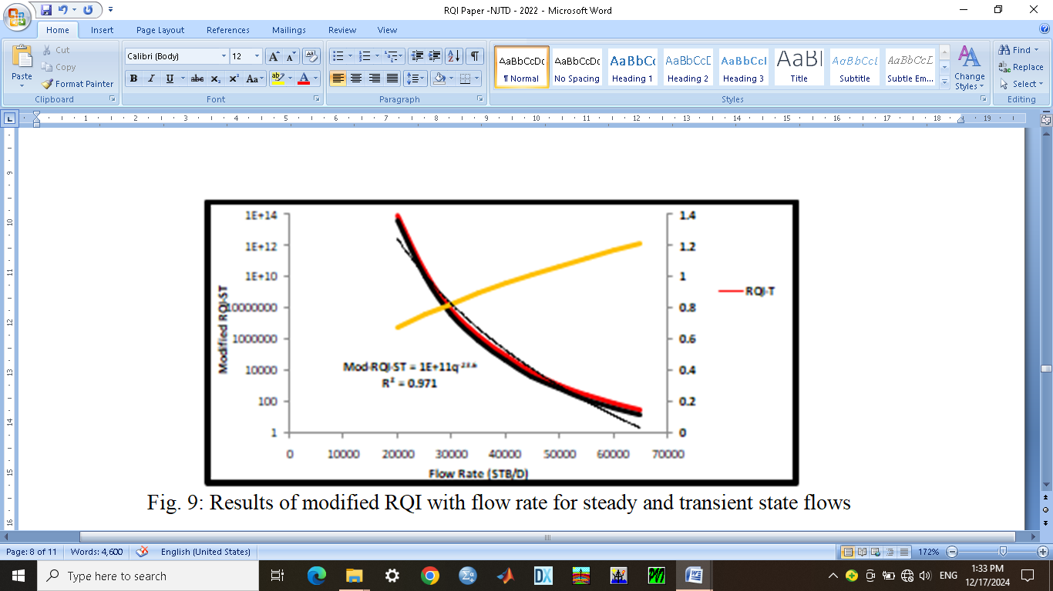

Fig. 9: Results of modified RQI with flow rate for steady and transient state flows

**Table 3: Modified Pseudo-Transient (PT)**

|  |  |  |  |
| --- | --- | --- | --- |
| **q** | **RQI-P** | **RQI-T** | **Mod-RQI-PT** |
| 20000 | 4.837246 | 9.29E+13 | 4.64E+13 |
| 25000 | 5.408206 | 2.24E+10 | 1.12E+10 |
| 30000 | 5.924392 | 86790603 | 43395305 |
| 35000 | 6.399075 | 1643487 | 821746.9 |
| 40000 | 6.840899 | 83895.12 | 41950.98 |
| 45000 | 7.255869 | 8295.158 | 4151.207 |
| 50000 | 7.648358 | 1302.852 | 655.2501 |
| 55000 | 8.021665 | 286.5065 | 147.2641 |
| 60000 | 8.378356 | 81.09623 | 44.73729 |
| 65000 | 8.72047 | 27.87373 | 18.2971 |

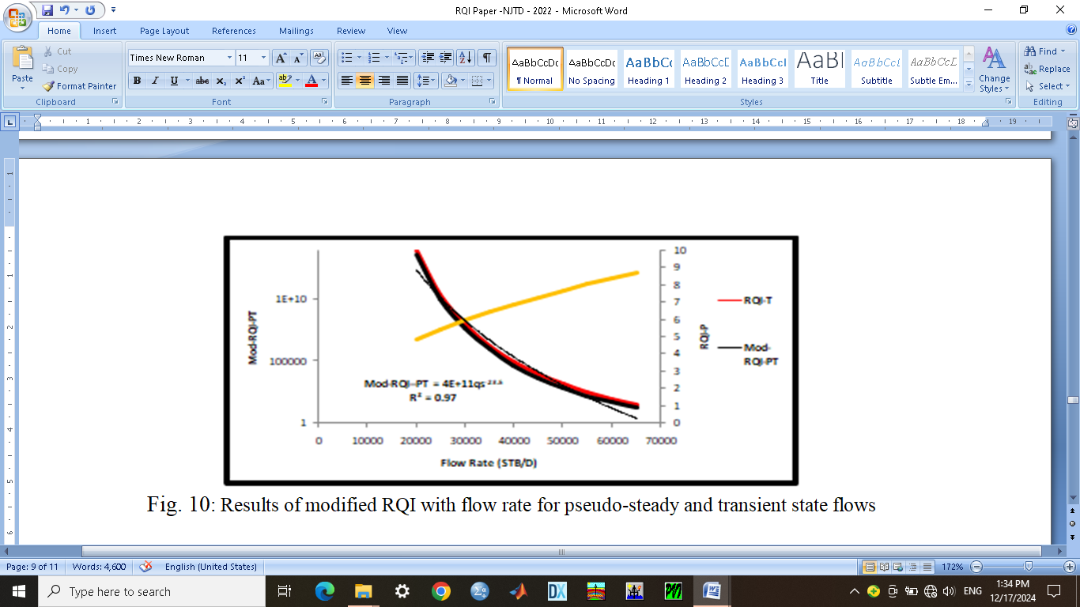

Fig. 10: Results of modified RQI with flow rate for pseudo-steady and transient state flows

**Table 4: Modified Steady-Pseudo-Transient (SPT)**

|  |  |  |  |  |
| --- | --- | --- | --- | --- |
| **qs** | **RQI-S** | **RQI-P** | **RQI-T** | **Mod-RQI-SPT** |
| 20000 | 0.676109 | 4.837246 | 9.29E+13 | 3.09616E+13 |
| 25000 | 0.755913 | 5.408206 | 2.24E+10 | 7466898993 |
| 30000 | 0.828061 | 5.924392 | 86790603 | 28930203.36 |
| 35000 | 0.894408 | 6.399075 | 1643487 | 547831.597 |
| 40000 | 0.956162 | 6.840899 | 83895.12 | 27967.63761 |
| 45000 | 1.014163 | 7.255869 | 8295.158 | 2767.809377 |
| 50000 | 1.069022 | 7.648358 | 1302.852 | 437.1897691 |
| 55000 | 1.1212 | 8.021665 | 286.5065 | 98.54978661 |
| 60000 | 1.171055 | 8.378356 | 81.09623 | 30.2152126 |
| 65000 | 1.218873 | 8.72047 | 27.87373 | 12.60435771 |

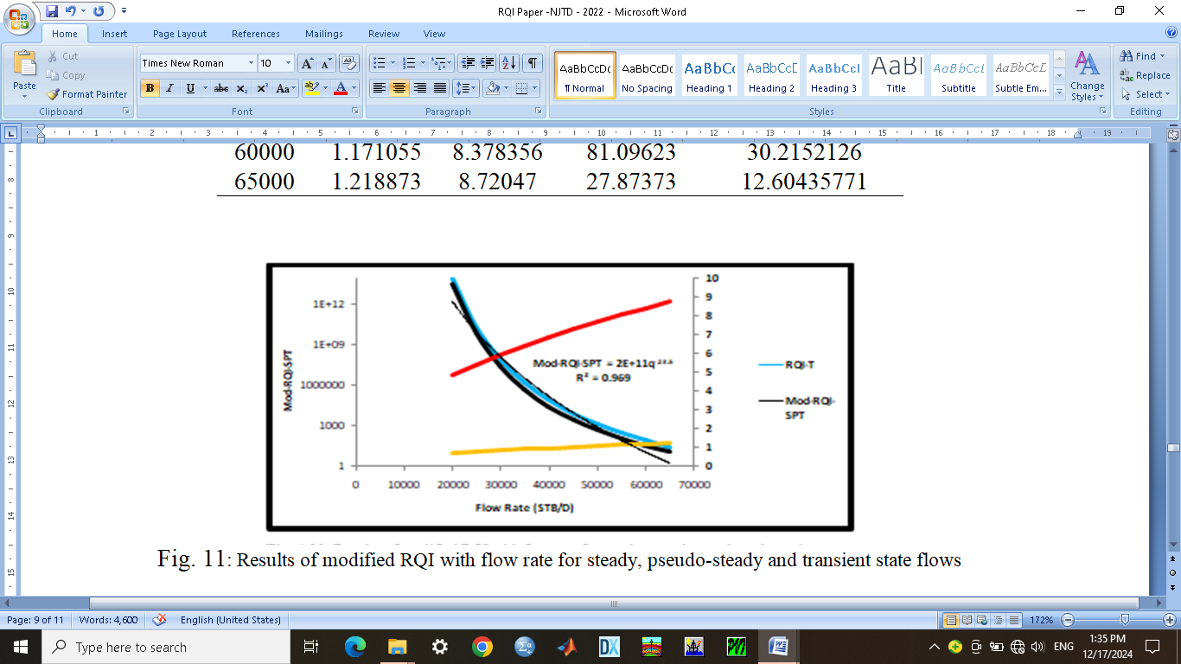

Fig. 11: Results of modified RQI with flow rate for steady, pseudo-steady and transient state flows

**5.0 Conclusion**

The aim of this study which is to develop modified flow regimes of the transient, steady and pseudo steady state correlations for improved quality assessment of an under-saturated oil rim reservoir in the Niger Delta using python software has been carefully achieved. Detailed mathematical remodeling of existing flow regime models using the reservoir quality index (RQI) correlation was done. Furthermore, the behavior of the reservoir quality has been effectively characterized using this new technique of RQI flow regimes with five critical but common reservoir parameters to steady state, pseudo-steady state and transient state flow models which includes the flow rates (qo), pressure drop (P), reservoir thickness (h), oil viscosity (Uo), oil formation volume factor (Bo) and wellbore radius (rw). From all analyzed results, they showed that the patterns were all similar for both steady state and pseudo-steady models while the pattern was reversed or different for transient state model. This implies an indication of degree of reservoir flow complexity and a function of well and reservoir parameters used. The implication is that perhaps during the reservoir characterization of the five properties used, the RQI trend should follow similar pattern for each established reservoir flow model.

Meanwhile, for complex flow behaviours, such as steady state with pseudo-steady state, steady state with transient state, pseudo-steady state with transient state and lastly steady state, pseudo-steady and transient state models, a modification of the RQI was done. The modified steady state and pseudo-steady state RQI correlation gave similar patterns with both steady and pseudo-steady models.

The major finding from this study is the effect of transient flow on the steady state, pseudo-steady state and combined steady state and pseudo-steady state flows. The transient effects reversed the patterns of the steady and pseudo-steady state models. This may perhaps be due to the complexity of the transient flow equation, presence of time variable, dual permeability variables, e.t.c. This flow pattern describes the true flow conditions of the reservoir with time with its quality description.

In order to achieve full potential of the RQI characterization, thorough reservoir evaluation of its properties is necessary while the RQI technique can be used only if all parameters required are from the well and reservoir of study. It is also recommended to infuse the RQI into all reservoir flow models to improve its characterization potentials for effective analysis. More studies should be done with improved and increased data volume to boost the quality of future researches in this area.

**Reference**

Ahmad, R., Viswasanthi, C., Thomas, F., Pankaj, K., Volker V. (2020): Improving reservoir quality prediction of microporous carbonates using a multi-scale geophysical data analysis approach. SPE paper 19972-MS presented at the International Petroleum Technology Conference, Dhahran, Kingdom of Saudi Arabia, January 13. <https://doi.org/10.2523/IPTC-19972-MS>

Andrea, O., Davide, C., Cristina, D., Claudio, G. Marco, P. and Antonio, V. (2019): High resolution reservoir quality prediction at the reservoir scale through diagenetic modeling. SPE Paper SPE-197923-MS presented at the Abu Dhabi International Petroleum Exhibition & Conference, Abu Dhabi, UAE, November 2019. <https://doi.org/10.2118/197923-MS>

Asquith, G. and Gibson, C. (2020): Basic well log analysis for geologists. (http://archives.datapages.com/data/altbrowse/aapg-special-volumes/me3.htm): AAPG Methods in Exploration Series 3, 216 p.

Brown, A. R. (2019): Interpretation of three-dimensional seismic data: AAPG Memoir, vol. 42 (http://store.aapg.org/detail.aspx?id=1025), 194 p.

Craig, L. C., Richard, E. L., Shawn, C. M. and Mark, G. M. (2011): Appraising unconventional resource plays: separating reservoir quality from completion effectiveness. SPE paper IPTC-14677-MS presented at the International Petroleum Technology Conference, Bangkok, Thailand, November. <https://doi.org/10.2523/IPTC-14677-MS>

Consonni, A., Ortenzi, A. and Geloni, C. (2014): New methods for quantitative reservoir quality prediction in sandstones. SPE paper IPTC-17364-MS presented at the International Petroleum Technology Conference, Doha, Qatar, January. <https://doi.org/10.2523/IPTC-17364-MS>

Davies, D. K. and Vessell, R. K. (1997): Improved prediction of permeability and reservoir quality through integrated analysis of pore geometry and open-hole logs: Tar zone, Wilmington Field, California. SPE paper SPE-38262-MS presented at the SPE Western Regional Meeting, Long Beach, California, June. <https://doi.org/10.2118/38262-MS>

Egu, D.I. (2014). Effective Field Development Management of a gas field in the Niger Delta. SPE-172425-MS paper presented at the 2014 NAICE conference, 5-7 August, Lagos, Nigeria. <https://doi.org/10.2118/172425-MS>.

Egu D.I. (2020). Retrospective Sagacity of Pristine Tacks in Aquifer Influx Computations for Finite Aquifer Nexus. SPE-203605-MS paper presented at the SPE Nigeria Annual International Conference and Exhibition, 11-13 August, Nigeria.

<https://doi.org/10.2118/203605-MS>

Elizabeth, D., Boaz, N., Avrami, G., Henrique, T., Amos, N. and Guoping, L. (2009): Bridging the gap in reservoir quality predictions: Replacing single point reservoir properties with topological data analysis. SPE paper IPTC-13729-MS presented at the International Petroleum Technology Conference, Doha, Qatar, December. <https://doi.org/10.2523/IPTC-13729-M>

Gerard, R. E., Philipson, C. A., Ballentine, F. M. and Marschall, D. M. (2019): Petrographic image analysis: An alternate method for determining petrophysical properties, in I. Palaz and S. Sengupta, eds., Automated Pattern Analysis in Petroleum Exploration: New York, Springer-Verlag, pp. 249-263.

Gorbovskaia, O. A., Pischuleva, A. V. and Belozerov, B. V. (2017): Integrated analysis of reservoir architecture and quality for effective production: A low permeability reservoir in lower Jurassic sandstones, West Siberian basin. SPE Paper SPE-187301-MS presented at the SPE Annual Technical Conference and Exhibition, San Antonio, Texas, USA, October. <https://doi.org/10.2118/187301-MS>

Ilozobhie, A.J. and Egu, D.I. (2020). Dynamic Reservoir Sand Characterization of an Oil Field in the Niger Delta from Seismic and Well Log Data. Arabian Journal of Geosciences. *Arabian Journal of Geosciences* 14 (10), 853 <https://doi.org/10.1007/s12517-020-05741-9>

Ilozobhie, A.J., Egu, D.I., Obalola, H.A. and Mzough, O.M. (2023): Improving Resolution Qualities in Low P-impedance Sand Channels with Synthetic and Recursive Seismic Modeling Techniques. Australian Journal of Basic and Applied Science, 17(12): 20-28. <https://doi.org/10.22587/ajbas.2023.17.12.3>

Keelan, D. K. (2016): A critical review of core analysis techniques. Journal of Canadian Petroleum Technology, vol. 2, pp. 42–55.

Khalil, A. A., Martin, W. and Nigel, C. (2021): Prediction of reservoir quality & deliverability of the tight Barik formation in Khazzan field, Oman. SPE paper SPE-208132-MS presented at the Abu Dhabi International Petroleum Exhibition & Conference, Abu Dhabi, UAE, November. <https://doi.org/10.2118/208132-MS>

McBride, E. F. (2018): Compaction in sandstones influence on reservoir quality. (<http://archives.datapages.com/data/bulletns/1984> 85/data/pg/0068/0004/0500/0505.htm): AAPG Bulletin, v. 68, p. 505.

McDonald, D. A. and Surdam, R. C. (2019): Clastic Diagenesis. (http://archives.datapages.com/data/altbrowse/aapg-special-volumes/m37.htm): AAPG Memoir, vol. 37, pp 434.

Schmidt, V. and McDonald, D. A. (2018): Secondary Reservoir Porosity in the Course of Sandstone Diagenesis. (http://archives.datapages.com/data/alt-browse/aapg-special-volumes/cn12.htm): AAPG Continuing Education Course Note Series, No. 12, 125 p.

Scholle, P. A. and Schluger, P. R. (2017): Aspects of Diagenesis: SEPM Special Publication. Vol. 26, pp 443.

Shim, Y. H., Keith, A., Jeffrey, K., Jason, B. and David, I. (2011): Defining reservoir quality for successful shale gas play development and exploitation. SPE paper SPE-147518-MS presented at the Canadian Unconventional Resources Conference, Calgary, Alberta, Canada, November.

Stacy, L. R., Paul, R. C., Erik, R., Iain, P., Richard, E. L., Ravinath, K., Andrew, E. P. (2016): Reservoir producibility index: A metric to assess reservoir quality in tight oil plays from logs. Petrophysics 57 (02).

Wardlaw, N. C. (2017): Pore geometry of carbonate rocks as revealed by pore casts and capillary pressure. (http://archives.datapages.com/data/bulletns/1974-76/data/pg/0060/0002/0200/0245.htm): AAPG Bulletin, vol. 60, pp. 245–257.

Wilson, M. D. and Pittman, E. D. (2017): Authigenic clays in sandstones—recognition and influence on reservoir properties and paleoenvironmental analysis. Journal of Sedimentary Petrology, vol. 47, pp 3–31.