**AN OVERVIEW ON OCULAR DRUG DELIVERY SYSTEM**

**Dr. Rama Brahma Reddy1, P. Sukanya2**

**T. Sri Vallika3**

1Principal & Professor, Department of Phytochemistry, Nalanda Institute of Pharmaceutical Sciences, Sattenapalli Kantepudi, Andhra Pradesh, India

2Assistant Professor, Department of Pharmaceutics,Nalanda Institute of Pharmaceutical Sciences, Sattenapalli Kantepudi, Andhra Pradesh, India

3Student, Department of B. Pharmacy, Nalanda Institute of Pharmaceutical Sciences, Kantepudi, Sathenapalli Kantepudi, Andhra Pradesh, India

**ABSTRACT:** Ocular drug delivery system is used to treat eye diseases or eye infection that is caused by different reasons. There are many eye ailments such as dermatomycosis, orbital cellulitis, endophthalmitis, allergic conjunctivitis that affects the eye. There are many limitations of conventional ocular drug delivery systems such as rapid elimination of drug, lachrymal drainage, and limited permeability to cornea leading to low bioavailability. To overcome these problems the novel approaches of drug delivery systems come in rescue. Ophthalmic insitu gels are used to increase the retention time of drug within eye. Ophthalmic insitu gels are the viscous polymer‐based liquids applied as solutions or suspensions that exhibit sol‐to‐gel phase transition when come in contact with the eye due to change in a specific physicochemical system such as pH and temperature induced insitu gel systems. This is very effective in emergency therapy. It delivers the drug to target site and prevents the drug from loss by reaching the drug to other ocular tissues.

**Key Words**: Barriers, Drug delivery, Ocuserts, Dosage forms, approaches to enhance ocular delivery.

**INTRODUCTION:**

Human eye is a complex structure, both anatomically and physiologically, that makes it a unique organ consisting of its physiologically independent functions. Its wide range of varied structures also challenges to develop drug delivery systems for it. The major problem in the conventional ocular drug delivery system with eye drops is their fast and extensive elimination from the eye, causing extensive loss of the drug. In eye drops, only a small portion of a drug penetrates through the corneal layer and arrives in the internal tissues present in the eye. Broad classification of ocular drug delivery results in two types, those concerned with the anterior and posterior segments. For vision-threatening ocular diseases, conventional drug delivery systems, such as eye drops, suspensions and ointments, cannot be used for optimal treatment. About 90% of the ophthalmic formulations in the market are available in the form of eye drops and the sites of action are diseases occurring in the anterior segment of the eye [5-7]. Topical delivery of drugs through conventional approaches is unable to make it reach the posterior segment of the eye1.

**Advantages of ocular drug delivery system:**

1. Increased accurate dosing. To overcome the side effects of pulsed dosing produced by conventional systems.

2. To provide sustained and controlled drug delivery.

3. To increase the ocular bioavailability of drug by increasing the corneal contact time. This can be achieved by effective adherence to corneal surface.

4. To provide targeting within the ocular globe so as to prevent the loss to other ocular tissue

**Disadvantages of ocular drug delivery systems:**

1. The drug solution stays very short time in the eye surface.

2. It shows poor bioavailability.

3. Shows instability of the dissolved drug.

4. There is a need to use preservatives

**Limitations of ocular drug delivery system:**

1. Dosage form cannot be terminated during emergency.

2. Interference with vision.

3. Difficulty in placement and removal.

4. Occasional loss during sleep or while rubbing eyes.

**HUMAN ANATOMY AND PHYSIOLOGY:**

The human eye, elegant in its detail and design, represents a gateway to the process we call vision. The eyeball is spherical in shape and about 1 inch across. It houses many structures that work together to facilitate sight. The human eye is comprised of layers and internal structures, each of which performs distinct functions. The detailed description of each eye part is given below.

**Sclera:** The sclera (white portion of the eye) is the tough white sheath that forms the outer layer of the ball. It is a firm fibrous membrane that maintains the shape of the eye as an approximately globe shape.

**Conjunctiva**: The conjunctiva is a thin transparent mucous epithelial barrier, lines the inside of the eyelids, and covers the anterior one-third of the eyeball.

**Cornea:** The cornea is a strong clear bulge located at the front of the eye. Surface of the adult cornea has a radius of approximately 8mm. It has an important optical function as it refracts light entering the eye which then passes through the pupil and onto the lens.

**Pupil:** Pupil generally appears to be the dark "centre" of the eye but can be more accurately described as the circular aperture in the centre of the iris through which light passes into the eye.

**Iris:** The iris is a thin circular contractile curtain located in front of the lens but behind the cornea. The iris is a diaphragm of variable size whose function is to adjust the size of the pupil to regulate the amount of light admitted into the eye.

**Ciliary Muscle**: The ciliary muscle is a ring of striated smooth muscles in the eye’s middle layer that controls accommodation for viewing objects at varying distances and regulates the flow of aqueous humour into schlemm’s canal.

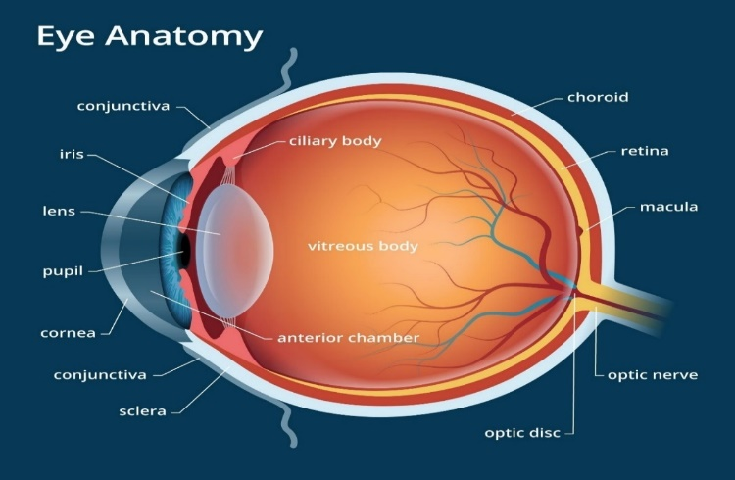**Retina:** Theretina is located at the back of the human eye. The retina may bedescribed as the "screen" on which an image is formed by light that has passed into the eye via the cornea, aqueous humour, pupil, lens, and finally the vitreous humour before reaching the retina.

**Choroid:** The choroid is a thin layer of tissue that contains many tiny blood vessels that supply oxygen and nutrients to the retina. The choroid contains many pigment producing cells called melanocytes. These cells help absorb any excess light and minimize reflections withinthe eye2.

Figure 1

**BARRIERS FOR OCULAR DRUG DELIVERY SYSTEM:**

Ocular drug delivery suffers from the following barrier effects:

**Drug loss from the ocular surface:**

After using the dosage form of the drug in the ocular system, flow of lacrimal fluid wipes out a portion of the drug from its surface and its turnout rate is only about 1 μl/min, whereas a major portion of the drug is wiped out through the nasolacrimal duct quickly within minutes. Other sources of drug removal include the systemic absorption of the drug, instead of being absorbed through the ocular route**.**

**Lacrimal fluid-eye barriers:**

Absorption of the drug from the lacrimal fluid can be limited by the corneal epithelium present in the eye. Tight junctions formed from corneal epithelial cells limit the permeation of the drug paracellularly. Lipophilic drugs show higher permeability in the cornea as compared to hydrophilic drugs.

**Blood-ocular barriers**:

The blood–ocular barrier system is formed by two main barriers: the blood–aqueous barrier and the blood–retinal barrier (BRB). One of these barriers, the BRB, is particularly tight and restrictive and is a physiologic barrier that regulates ion, protein, and water flux into and out of the retina3.

**ROUTES OF OCULAR DRUG DELIVERY:**

There are several possible routes of drug delivery into the ocular tissues. The selection of the route of administration depends primarily on the target tissue.

**Topical route:**

Typically, topical ocular drug administration is accomplished by eye drops, but they have only a short contact time on the eye surface. The contact, and thereby duration of drug action, can be prolonged by formulation design (e.g. gels, gelifying formulations, ointments, and inserts).

**Subconjunctival administration:**

Traditionally subconjunctival injections have been used to deliver drugs at increased levels to the uvea. Currently this mode of drug delivery has gained new momentum for various reasons. The progress in materials sciences and pharmaceutical formulation have provided new exciting possibilities to develop controlled release formulations to deliver drugs to the posterior segment and to guide the healing process after surgery.

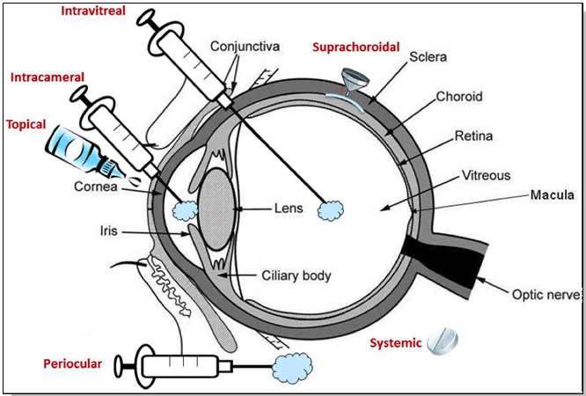

**Figure-2**

**Intravitreal administration:**

Direct drug administration into the vitreous offers distinct advantage of more straightforward access to the vitreous and retina. It should be noted; however, that delivery from the vitreous to the choroid is more complicated due to the hindrance by the RPE (Retinal Pigment Epithelium) barrier. Small molecules are able to diffuse rapidly in the vitreous but the mobility of large molecules.

**Scleral administration:**

Due to its large surface area, easy accessibility and relatively high permeability to macromolecules, the sclera recently has become a potential vector for posterior segment drug delivery. Scleral drug delivery has been attempted by different ways, such as scleral plugs and implants, sun conjunctival injection, subtenon injection. Trans-scleral administration of drugs offers a promising therapeutic approach for the treatment of various posterior segment diseases4.

**MECHANISM OF OCULAR DRUG ABSORPTION**

Drugs administered by instillation must penetrate the eye and do so primarily through the cornea followed by the non-corneal routes. These non-corneal routes involve drug diffusion across the conjunctiva and sclera and appear to be particularly important for drugs that are poorly absorbed across the cornea.

**Corneal permeation:**

The permeation of drugs across the corneal membrane occurs from the precorneal space.

**Various Barriers to drug Absorption:**

In tears have a direct bearing on efficiency of drug absorption into the inner eye. The productive absorption of most ophthalmic drugs results from diffusional process across corneal membrane. The efficiency of absorption process is a function of rate and extent at which the transport processes of eye. The flux of any drug molecule across the biological membrane depends on the physicochemical properties of the permeating molecule and its interaction with the membrane. The extent to which the transport or absorption process occurs is also function of physiological mechanism of precorneal fluid drainage or turnover. In terms of transcorneal drug permeation, the cornea can be considered to consist of three primary layers (epithelium, stroma and endothelium).

**Non-corneal permeation:**

Primary mechanism of drug permeation is the sclera is likely to be diffusionacross the intercellular aqueous media in the case of structurally similar corneal stroma. Therefore, the possibility of partitioning mechanism cannot be eliminated. Although like cornea, the conjunctiva is composed of an epithelial layer covering an underlying stroma, the conjunctival epithelium offers substantially less resistance than does the corneal epithelium5.

**DOSAGE FORMS:**

**Eye Drops:** Eye drops represent more than 95% of the marketed ocular products. They deliver the medication into the anterior part of the eye. Their advantages include easy administration and accepted stability. However, their disadvantages include low retention time.

**Eye Suspensions**: Ocular suspensions represent dispersions of hydrophobic drug in aqueous solvent. They have enhanced contact time because of drug retention in the conjunctival cul-de-sac. Particle size, solubility, and dissolution rate in the tear fluid are extremely important during the preparation process.

**Eye Emulsions:** An emulsion is a solubilized biphasic system due to the inclusion of surfactants or stabilizers. Advantages of eye emulsions include ability to deliver hydrophobic drugs; oil-in water (O/W) emulsion is less irritant to the eye, enhanced contact time and bioavailability.

**Semisolid Dosage Forms:**

**Eye Gels:** Eye gels are a semisolid dosage form containing high water quantity. They have enhanced retention time and bioavailability because of their viscosity. Although gels contain large quantity of water, blurred vision could still result. Various polymers could be used to prepare ocular gels like polyacrylic acid, acrylic acids, hydroxypropyl methylcellulose, and carboxymethyl cellulose.

**Eye Ointments**: Eye ointments are semisolid dosage form containing white petrolatum and mineral oil. They are administrated to the lower eyelid only at bedtime due to its interference with vision. They are commonly used among young patients. They have anhydrous nature making them a good choice for lipophilic and moisture sensitive drugs.

**Solid Dosage Forms:**

**Eye Powders:** They are sterile solid dosage form of water-sensitive drugs. They are administrated in injectable forms as intracameral injection of cefuroxime, moxifloxacin, and voriconazole. Cefuroxime and moxifloxacin are reconstituted in saline, while voriconazole is reconstituted in water. Both cefuroxime and voriconazole solutions are stable for 7 days after reconstitution. However, moxifloxacin solution is stable for 24 weeks sustained contact time compared to simple solution6.

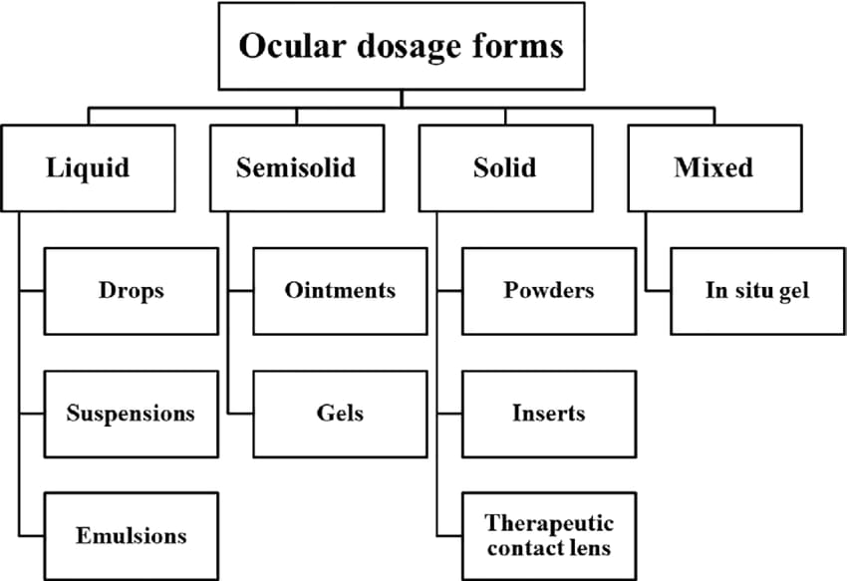

Figure 3

**OCCUSETS:**

Ocuserts are sterile controlled-release formulations that extend medication residence duration and prevent nasolacrimal leakage. They are sterile, solid or semisolid formulations designed for ocular delivery. They're drug filled polymers. Ocuserts are put in the eye's lower cul-de-sac. Ocuserts enhance medication contact time with conjunctival tissue to sustain continuous dosage release. Ocusert is a drug reservoir sandwiched between two microporous membrane sheets. Lachrymal fluid penetrates the membrane, controlling medication release. Internal pressure is high enough to force medication from the reservoir. Diffusion controls medication delivery rate. Ocusert is a drug reservoir sandwiched between two microporous membrane sheets. Ocuserts extend medication duration, improve bioavailability, and decrease dosage frequency, improving patient compliance. The regulated release of the medication allows for ocular administration. Ocuserts save time for doctors and patients. Ocusert is a drug reservoir sandwiched between two microporous membrane sheets. Lachrymal fluid penetrates the membrane, controlling medication release. Internal pressure is high enough to force medication from the reservoir. Diffusion controls medication delivery rate7.

**Advantages of Ocuserts:**

Various advantages of Ocuserts are as follows:

* Increased contact time with the ocular surface can be obtained and hence bioavailability is also increased
* Sustained and controlled drug delivery can be achieved
* Due to extended drug release, better efficacy is obtained Accurate
* dosing can be done
* Less systemic side effect
* Increased comfort and patient compliance
* Handling is easy
* Vision and oxygen permeability are not interfered
* Reproducible release kinetics
* Sterile preparation

**Disadvantages of Ocuserts:**

* Various disadvantages of Ocuserts are as follows:
* Accidental loss of ocusert can occur while sleeping or rubbing the eyes
* For a while, the patient feels like there is some foreign body in their eye
* Removal of ocusert can get difficult due to unnecessary relocation of the ocusert to the upper fornix of the eye
* Not as easy to administer the Ocuserts in the eye and also difficult removal in case of insoluble Ocuserts
* Dislocation of the ocusert in front of the pupil can occur
* Ocusert can twist in the eye which can decrease the rate of drug delivery
* Leakage can happen8

**CLASSIFICATION OF OCUSERTS:**

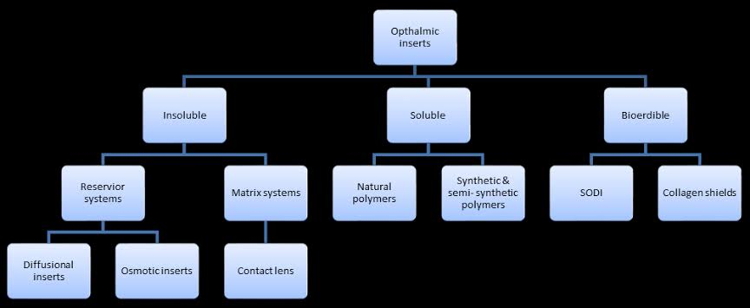

Figure 4

**Insoluble Ocuserts:** This type of delivery system gives drugs at a controlled rate and in different ways, but the delivery system needs to be removed once it’s empty.

Insoluble ocuserts are divided into 2 categories:

* **Reservoir system:** In this system, diffusion or osmosis release drugs. It may be colloid, gel, semisolid, liquid, solid matrix, or carrier**.**
* **Diffusional inserts:** In this form, drug release is diffusional. The ocular insert is a permeable membrane medication delivery method**.**

**Osmotic inserts:** These consist of a centre component surrounded by a part and may be classed into two groups**:**

* **Type 1** -: The innermost section is a drug reservoir surrounded by polymer, which may contain osmotic solute. Semi-permeable, insoluble polymeric membrane forms the periphery. Due to osmotic pressure, matrix apertures leak drugs**.**
* **Type 2:** This kind has a two-compartment centre. One compartment contains medicine, the other osmotic solute. A semipermeable membrane surrounds the solute compartment. The medication compartment is impermeable**.**

**Matrix systems:**

This system includes contacts and insoluble ophthalmic equipment. A 3-D matrix holds water, aqueous preparations, or solids. This system contains hydrophilic or hydrophobic cross-linked polymers e.g. vision correction contact lenses. This mechanism corrects eyesight while releasing medicines**.**

**Soluble ocuserts:**

Soluble inserts are homogenous polymeric ocuserts that gradually dissolve and release the medicine in the eye. Hydrolysis of enzymes or chemicals causes dissolution and erosion. Owing to tear fluid penetration, ocuserts drug content is released due to swelling and chain relaxation, resulting in drug diffusion. It's not necessary to remove it after administration**.**

According to the type of polymer source, they can be further divided into two groups**:**

* **Natural polymers:**

Collagen is utilised to manufacture soluble ophthalmic inserts. Ocusert is soaked, dried, then rehydrated before application. The amount of medicine in ocusert depends on the preparation's concentration, soaking time, and binding agent concentration. The medication is released when the collagen dissolves**.**

* **Synthetic and semi-synthetic polymers**

Ophthalmic inserts are made from synthetic and semisynthetic materials. Cellulose derivatives and synthetic polymers like polyvinyl alcohol may be used to make it. Coating the ocusert with eudrilid might slow release**.**

**Bio-erodible ocuserts:** Bio-erodible ocuserts employ cross-linked gelatin and polyester derivatives. These polymers' key benefit is that their final structure may be changed during manufacture or by adding anionic or cationic surfactants to limit erosion. They include:

* **Soluble ophthalmic drug insert:**

(SODI) SODI is a small oval wafer, which is made to use in weightless conditions as eye drops cannot be used in these conditions.

* **Collagen shields:**

Collagen is found bone, tendons, ligaments, and skin. It makes about 25% of mammalian body proteins. This intestine collagen protein has several biological uses, including catgut suturing. This insertion must be applied with anaesthetized cornea and blunt forceps9.

**APPROACHES TO ENHANCE OCULAR DRUG DELIVERY SYSTEM:**

**Improvement of Corneal Permeability:**

One of the approaches to enhance drug bio availability following topical administration is increasing corneal permeability. For example, changing membrane components and/or disrupting epithelial tight junctions using surfactants, permeation enhancers, calcium chelating agents and modifying physicochemical characters of the ionized drug using ion pairs. On the other hand, enzymatic transformation of prodrug would convert it into the active after appropriate permeation. Finally, applying a low-intensity electrical current (iontophoresis) would enhance drug permeation by electro repulsion and electroosmosis effects.

One of the techniques to increase corneal retention time is inclusion of excipients. Excipients could be a viscosity increasing polymers. However, high viscous eye drops are irritating for many patients, do not provide an accurate dose and result in blurred vision. In situ gel has sustained contact time compared to simple solutions. There are three types of in situ gel according to the transition properties: temperature, ionic, or pH sensitive. In situ gel of ciprofloxacin with hydroxypropyl methyl cellulose and sodium alginate (ion-sensitive) showed enhanced residence time and sustained drug release10.

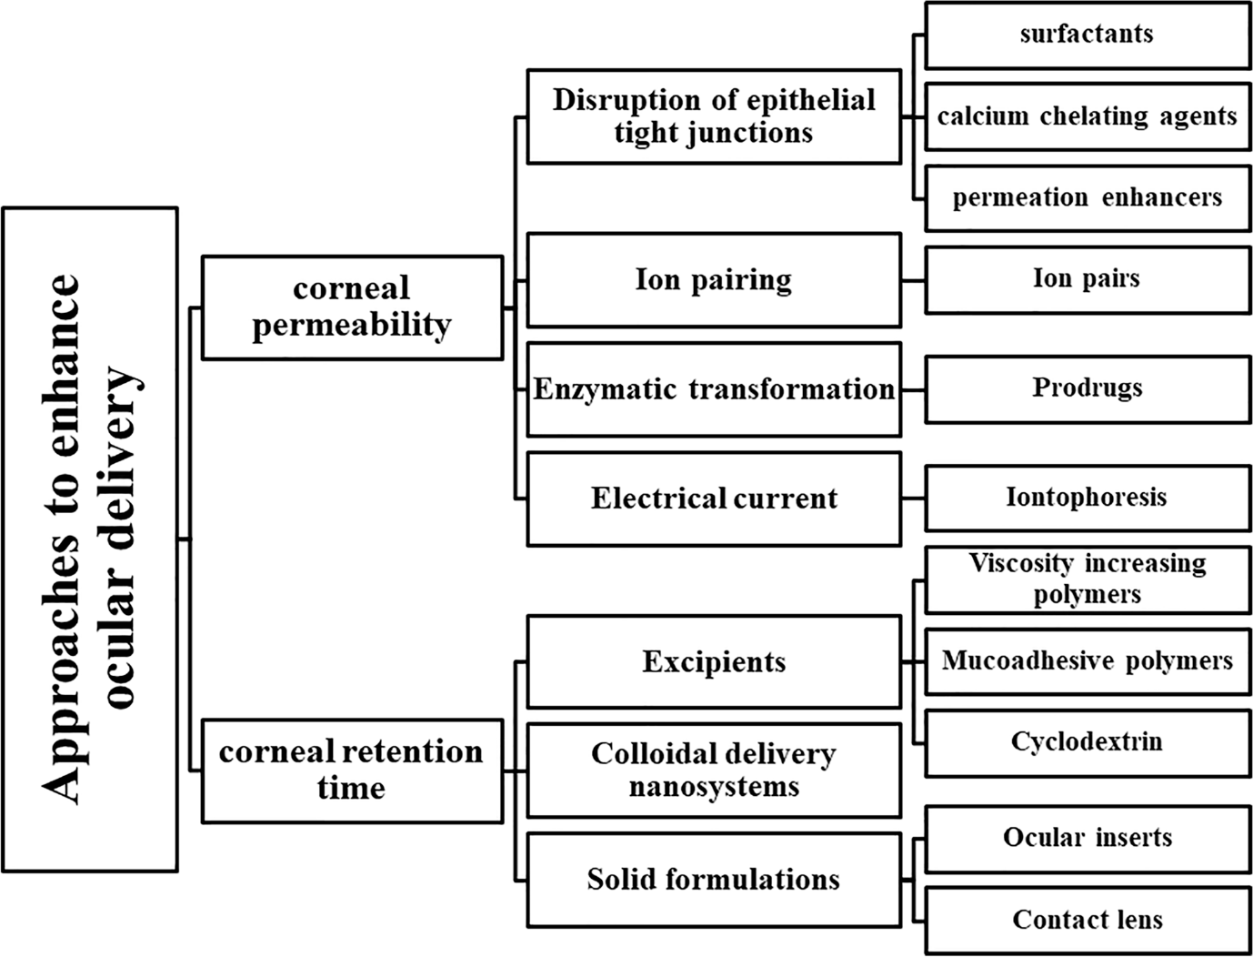

**Figure-5**

**CONCLUSION**:

The effective management of ophthalmic diseases remains a difficult mission as a result of existence of many ocular obstacles in the anterior and posterior sections of the eye. There are many ocular routes of administration that are used in order to deliver the medication into the targeted site of action such as topical, intraocular, periocular, or in conjugal tion with ocular devices. Several approaches and technologies have been adopted in order to minimize dosing interval, administrated dose, and unwanted effects and to enhance ocular retention time, drug permeation efficacy, and ocular bioavailability via controlled and sustained drug delivery systems. These advanced technologies have improved drug efficacy and shown good biocompatibility which suggest that they might have wide applications in the management and treatment of ocular diseases.

**REFERENCE:**

1. Aprajita Shifali, Pravin Kumar, Vinay Pandit, Recent trends in Ocular Drug Delivery System: A Review, Asian Journal of Research in Pharmaceutical Sciences, 11 [01], 2021, 71-72.
2. Saman Fatma, Durgesh Sharma, Priyanka Maurya, Dr Jai Narayan Mishra, Ashutosh Kushwaha, Ocular Drug Delivery System: An Overview, IJRDO - Journal of Applied Science, 8 [11], 2022, 26-28.
3. Vishal Kumar Raj, Rupa Mazumder, Monika Madhura, International Journal of Applied Pharmaceutics, Ocular Drug Delivery System: Challenges And Approaches, 12[05], 2022, 49-57.
4. Ramaiyan Dhanapal and J. Vijaya Ratna, Ocular Drug Delivery System, International Journal of Innovative Drug Discovery, 4[13], 2022, 1-15.
5. Navneet Nagpal, Sukh Manpreet Singh, Prince Ahad Mir, Mandeep Singh Chhina, Manisha Arora, Ocuserts: A novel ocular-drug delivery method: An update, World Journal of Biology Pharmacy and Health Sciences, 13(01), 2023, 470–477.
6. Sadek Ahmed, Maha M. Amin, Sinar Sayed, Ocular Drug Delivery: A Comprehensive Review, American Association of Pharmaceutical Scientists, 11[2], 2023, 20-35.
7. Krishnaswami V, Kandasamy R, Alagarsamy S, Palanisamy R, Natesan S. Biological macromolecules for ophthalmic drug delivery to treat ocular diseases. Int J Bilo Macromol, 10[4], 2018, 7–16.
8. Author links open overlay panelLee, AnnRemingtonOD, MS, FAAO: Clinical Anatomy and Physiology of the Visual System, 3[2], 2019, 10-39.
9. Sasaki H, Yamamura K, Nishida K, Nakamura J, Ichikawa M. Delivery of drugs to the eye by topical application. Progress in Retinal and Eye Review, 15(2), 2020, 553-620.
10. Yerikala Ramesh, Chandrasekhar B. Kothapalli, Jayachandra Reddy Peddappi Reddigari, A Novel Approaches on Ocular Drug Delivery System, Journal of Drug Delivery and Therapeutics, 7[6], 2023, 117-124.