**NADLM Deep Learning Techniques for Reconstructing Noisy and Distorted Images**

1Anamika Tiwari, 2Prof. Silky Paryani

1M. Tech Scholar, 2Asst. Professor

GGCT, Jabalpur

**Abstract**: Proposed paper introduces a novel edge-adaptive image restoration method utilizing a Non-Symmetry and Anti-Packing Deep Learning Model (NADLM). The proposed approach is highly effective for processing localized image regions containing objects at varying depths. Experimental results demonstrate that the method outperforms several state-of-the-art techniques, achieving superior outcomes with faster execution times. Owing to its high speed and excellent visual enhancement capabilities, the proposed method is well-suited for real-time applications. The NADLM effectively groups pixels by leveraging the target pixel for restoration, estimating the enhanced image from the original based on an observation model. Simulations conducted using MATLAB show that the proposed method produces images with higher visual quality, improved PSNR, and faster computational performance compared to conventional approaches. Motion-free k-space datasets were utilized for training, and simulations were conducted using MATLAB.

**Keywords:** Image Reconstruction, Deep Learning, Convolutional Neural Network, Non-symmetry, Anti-packing, Machine Learning

**I-INTRODUCTION**

Proposed work presents a deep learning architecture for image restoration that delivers statistically significant improvements over traditional algorithms in Poisson image de-noising, particularly under strong noise conditions. Poisson noise, commonly encountered in low-light and photon-limited settings, is accurately modelled by the Poisson distribution. Traditionally, this type of noise has been prevalent in niche fields such as astronomical imaging. However, with the widespread use of surveillance cameras operating in low-light environments and mobile phones producing noisy night scene images due to lower-grade sensors, the demand for advanced Poisson de-noising algorithms has surged.

Deep learning, which has demonstrated remarkable success in imaging tasks such as segmentation and recognition, is leveraged in this study to develop a novel de-noising network. This network outperforms traditional algorithms in Poisson de-noising, particularly under challenging noise conditions. The proposed architecture integrates convolutional and deconvolutional layers with symmetric connections to enhance performance. Experimental results reveal that the network achieves average PSNR gains of 0.38dB, 0.68dB, and 1.04dB over benchmark traditional algorithms at image peak values of 4, 2, and 1, respectively. Additionally, the network operates with reduced computational time while maintaining superior performance, facilitated by optimized reconstruction stride sizes.

Table 1 Literature Summary

|  |  |  |
| --- | --- | --- |
| **Author/ Journal/Year** | **Method** | **Outcome** |
| WIESLAW CITKO/IEEE/2023 | Machine Learning: An Inverse Problem Approach | 50 × 56 pixels grey image, 0.154 MSE with regularisation = 0.002 |
| Veronika Spieker/IEEE/2024 | Comprehensive Review learning-based motion correction | NA |
| Hailong He/IEEE/2024 | Deep Learning RSOM Analysis Pipeline  (DeepRAP) | 0.034 Average Mean Value Difference for 333 × 550 Gray image |
| SAIPRASAD RAVISHANKAR/ IEEE/2019 | Sparsity to Data-Adaptive Methods and Machine Learning | Average PSNR achieve is 21.67 dB |

**II-PROPOSED MEHODOLOGY**

Table 2 demonstrates that this work introduces a novel combination of a Convolutional Neural Network-based filter, an Anti-Packing filter, and Non-Symmetry Lucy-Richardson Algorithm techniques. This combination delivers superior noise filtering capabilities and significantly enhances overall filtering performance for various noise types.

Table-2. Comparison table of restoration methods

|  |  |  |  |  |
| --- | --- | --- | --- | --- |
| **Techniques** | **Salt-pepper noise** | **Gaussian noise** | **Uniform noise** | **Poisson Noise** |
| Direct Inverse Filter | No | No | No | Yes |
| Convolutional Neural Network base Filter | Yes | Yes | No | Yes |
| Constrained least-Square Filter | - | - | - | Yes |
| Anti packing Filter | Yes | No | Yes | Yes |
| Geometric Mean Filter | Yes | Yes | No | No |
| Harmonic Mean Filter | Salt-Yes, Pepper-No | Yes | No | No |
| Median Filter | Yes | No | No | - |
| Wiener Filter | Yes | Yes | No | Yes |
| Non symmetry Lucy- Richardson Algorithm Techniques | No | Yes | Yes | Yes |
| Adaptive Mean Filter | Yes | No | No | No |

This thesis proposes a novel Non-Symmetry and Anti-Packing Deep Learning Model (NADLM), specifically designed for effective Poisson image de-noising. The methodology integrates advanced deep learning techniques and architectural innovations to address challenges posed by noisy images, particularly in low-light and photon-limited settings. The major components of this methodology are detailed as follows:

**2.1 Development of NADLM for Poisson De-Noising: -** The NADLM combines two key design elements commonly found in modern neural networks: Convolutional Auto-Encoders and Symmetric Connections, which together enhance the model's ability to de-noise images effectively.

***Convolutional Auto-Encoders***: Auto-encoders are widely recognized for their ability to compress input data into compact representations using a bottleneck design. This compression discards irrelevant information, such as noise, while retaining essential image features. The convolutional variant of auto-encoders is particularly well-suited for image data as it applies convolutional filters to extract spatial features from the input. These compact representations serve as noise-resistant versions of the original data, enabling the model to effectively isolate and remove noise while preserving key details.

***Symmetric Connections:*** Symmetric connections are introduced between corresponding encoder and decoder layers to address the loss of detail that often occurs during compression.

These connections act as a feedback mechanism, reminding the decoder of crucial image details forgotten during the encoding process. Additionally, they improve gradient flow during backpropagation, allowing for more efficient training and better convergence of the network.

**2.2 Branching Architecture with Variable Depth: -** To achieve a balance between smoothing noise and preserving image details, the NADLM incorporates a branching structure with varying depths of convolutional auto-encoders.

***Deeper Branches:*** These branches are designed to perform aggressive noise reduction by smoothing color fluctuations. However, they may sacrifice finer details of the image, making them suitable for scenarios where color uniformity is prioritized over intricate texture retention.

***Shallower Branches:*** These branches focus on preserving detailed textures and structures within the image. They perform basic de-noising operations, complementing the deeper branches to deliver a holistic restoration outcome. By combining multiple branches, the network learns to optimize for both tasks—color smoothing from deeper branches and detail preservation from shallower ones—thereby achieving superior overall performance.

**Input Original Image**

Apply Anti Packing on image

**NADLM: Non-symmetry and Anti-packing Deep Learning Model**

**Based Filtered image**

**Histogram Equalization**

**Reconstruct Image**

Non symmetry Lucy- Richardson Algorithm Techniques base filtering



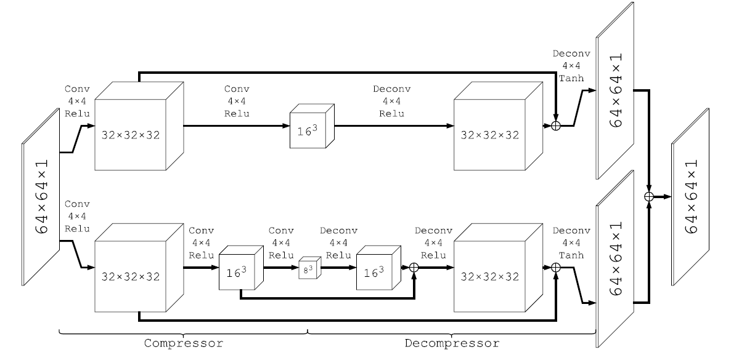

**CNN base Trainings and filtering**

**10000 Motion-free k-space Trained based on Neural Network**

Figure 1 Flow diagram of proposed work

**2.3. Network Design and Workflow:** The architecture of NADLM is visualized in Figure 2, where key components and their interactions are clearly illustrated. Components of the Network:

* "***Conv" Layers:*** Convolutional layers that perform feature extraction and compression.
* ***"Deconv" Layers:*** Deconvolutional layers that reconstruct the compressed features into enhanced images.
* Connections: Symmetric connections between corresponding encoder and decoder layers that aid in preserving image details.
* ***3D Blocks:*** Represent input or output tensors at different stages of the network.
* ***Branch Structure:*** Each branch consists of two main components:
  + A compressor built using convolutional layers.
  + A decompressor built using deconvolutional layers.
* ***Input and Output***: A noisy image patch of size 64×64x64 times is fed into the network as input. The corresponding clean patch of the same size is used as the ground truth to guide the network in learning the mapping from noisy to clean images.
* Operation in a Single Branch:
  + The first convolutional layer compresses the noisy input into 32×32x32 smaller feature maps.
  + The second convolutional layer further reduces these feature maps to 16×16x16.
  + The deconvolutional layers then reverse this compression to reconstruct the original 64×64x64 patch, retaining essential features while removing noise.

**2.4. Noise Suppression Mechanism: -** The convolutional layers compress the input by discarding less significant components such as noise while retaining representative features. The deconvolutional layers then reconstruct the image, ensuring that:

* Noise is effectively removed during the compression stage.
* Image details are preserved and reconstruct d during the reconstruction stage.
* This combination of compression and decompression ensures that the NADLM achieves superior de-noising performance across a range of noise levels.



Figure 2. Visualization of the proposed deep learning Model (DLM).

This figure illustrates the deep learning architecture proposed in this paper. This network contains 2 branches. The lower branch contains 3 convolutional layers appended by 3 deconvolutional layers, and the upper branch contains 2 convolutional layers appended by 2 deconvolutional layers.

**II-PROPOSED ALGORITHM**

The image re-construction performed by generating a HDR image by using following processing step as shown in following flowchart.

***Image Acquisition***: In this step Images are introduced in MATLAB for further processing. Here we take 16 various intensity images with various exposure time as an image input sequence.

***Edge Extraction Using Canny Operator:*** The image edges are extracted to preserve image basic structure to maintain image quality. for this edge detection & preservation Canny operator is used.

***Respective Light Intensity Extraction:*** Irradiance estimation from a set of NE differently exposed intensity images Z1, Z2. . .ZNE. To each input image Zi, associated TSF Ki, i= 1, 2 . . . NE is calculated correspondingly. irradiance image map Bi corresponding to observation Ziis given by Bi = f−1(Zi)/Δti, where Δti, is exposure time of observation [2]. Simultaneous re-construction & extraction of latent HDR irradiance image may be posed as an optimization problem where solution may be obtained by minimizing cost.

(1.1)

Here, E denotes latent irradiance image while Ki is reconstruction matrix of ith exposure that represents space variant reconstruction operation. rows of Ki are local blur filters acting on pixel els of E to yield blurred irradiance image Bi. pixel el intensity value in an image is a monotonic however nonlinear function of irradiance & exposure period. light energy accumulated is given by

 (1.2)

Where E is irradiance, is exposure time, & n is additive noise. A series of specialized algorithms alter collected data in real-time to map irradiance values to final image intensities.

***Image Alignment:*** This approach is used to align various LDR exposures prior to merging them into final HDR image.

Select Sample pixel el Nodes: We have considered blind estimation techniques [8] (multi-channel) to estimate PSFs. We estimate different PSFs of a blurred frame corresponding to local irradiance image patcheswhere refers to location of patch ( j= 1, 2, . . . Np), & k is index of frame. At a location PSFs of two selected frames (n = 1, 2) are derived by minimizing following energy function

 (1.3)

**Acquire input Images from Directory**

**Edge extraction using canny operator**

**Respective Light Intensity Extraction**

**Image Alignment**

**Sample pixel Nodes Selection**

**Response function selection**

**Output Image**

**HDR image reconstruction through Tone Mapping**

Figure 3 Flow of Lucy Richardson method in Proposed Design

Whereand are regularization parameters,  is estimated latent scene irradiance patch at pj quantitiesand are estimated PSFs at location pj corresponding to blurred irradiance patches and in two selected observations. Following above procedure, different PSFs are estimated for each of blurred frames. PSFs that we estimate using equation (1.3), though locally accurate, might not be in mutual alignment with respect to PSFs estimated at other locations. If we attempt to use these PSFs directly in TSF estimation procedure, then TSF thus estimated will be erroneous. true TSFs cannot be estimated without compensating for shifts among underlying PSFs. To alleviate this problem, we (randomly) choose one of PSFs as reference & align other PSFs with respect to it. Ifare PSFs of first frame, we choose one of PSFs (say) as reference. TSF is estimated by searching over all possible shifts of PSFs to. That which minimizes error is chosen to be correct one. Note that as a shifted PSF may have correspondingly shifted latent image, many possible solutions for TSF with correspondingly warped latent images may exist. Hence, solution (TSF) obtained by our procedure will correspond to one of warped instances.

**III-RESULT & DISCUSSION**

Simulations were performed using MATLAB, leveraging motion-free k-space datasets for training. These datasets provide high-quality ground truths for evaluating the network's performance.

The simulation results are analysed based on several performance parameters, including Mean Squared Error (MSE), noise variance (σ^2), and Signal-to-Noise Ratio (SNR), which are key metrics associated with the proposed algorithm. A motion-free k-space dataset has been utilized for training and testing the images.

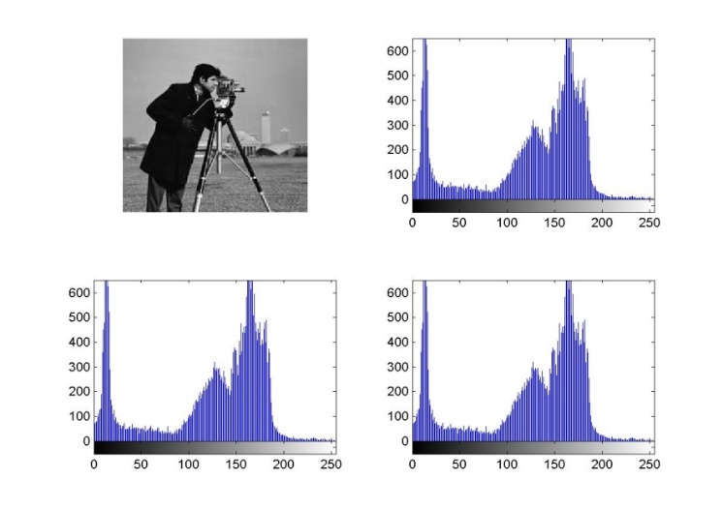

Figure 4 cameraman image and its histogram

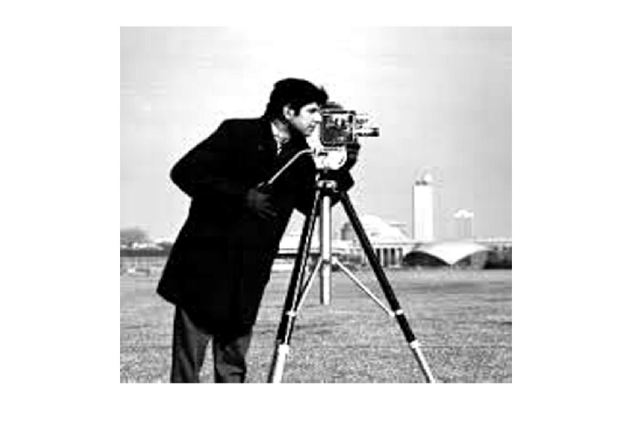

Figure 5: Reconstructed Cameraman Image

The performance of the restoration technique has been validated across multiple images, with results presented for five representative cases. One of the test cases in motion-free k-space datasets is "Cameraman" image. Figure 4 illustrates the original "Cameraman" image along with its histograms for the red, green, and blue colour channels. The histogram analysis aids in equalizing the image, enhancing its visual quality and contrast. Figure 5 showcases the proposed reconstruct d "Cameraman" image, which represents the final output after applying the complete image enhancement process. Originally, the resolution of the "Cameraman" image was 333×550. After restoration using the proposed algorithm, the resolution is significantly improved to 1833×1833, demonstrating the efficacy of the method in enhancing image quality and resolution.

Table 3 Average PSNR and RMSE observe for test images

|  |  |  |
| --- | --- | --- |
| **Test Image** | **Average PSNR** | **Average RMSE** |
| Girl | 29.18 | 0.07291 |
| Peppers | 27.26 | 0.0691 |
| Plane | 25.48 | 0.074763 |
| Lady | 25.03 | 0.03929 |

Figure 6 visualizes the denoised images for both the deep learning algorithm with stride 1 and the benchmark algorithm NADLM. The images are a sample of the standard test images, and the noisy images are clean images applied with Poisson noise with image peak value 4.



Figure 6 Visual impression of denoising algorithms. This figure presents the visual impression and resulting PSNR values for both the deep learning and benchmark denoising algorithm. The noisy images are obtained by applying Poisson noise when the clean images are of peak value 4.

Table 4: Comparison table

|  |  |  |
| --- | --- | --- |
| **Author/ Journal/Year** | **Method** | **Outcome** |
| wieslaw citko et al [1] IEEE, 2023 | Machine Learning: An Inverse Problem Approach | 50 × 56 pixels grey image, 0.154 MSE with regularisation = 0.002 |
| Veronika Spieker et al [2], IEEE 2024 | Comprehensive Review learning-based motion correction | NA |
| Hailong He et al [3], IEEE, 2024 | Deep Learning RSOM Analysis Pipeline  (DeepRAP) | 0.034 Average Mean Value Difference for 333 × 550 Gray image |
| saiprasad Ravishankar et al [4], IEEE, 2019 | Sparsity to Data-Adaptive Methods and Machine Learning | Average PSNR achieve is 21.67 dB |
| This work | a Non-Symmetry and Anti-Packing Deep Learning Model (NADLM) | With 50x56 cameraman image MSE 0.128 which is less as compare to wieslaw citko [1].  Average mean Value difference observe is  0.064016 for image size of 333 × 550 is higher than Hailong He et al [3]  Average PSNR observe is 26.7375 it is higher than saiprasad Ravishankar et al [4].  Please note the results are based on the Motion-free k-space dataset images Girl, Papers, Plane and Lady |

As observed in Table 4, the proposed NADLM design achieves a higher PSNR compared to the method by Saiprasad Ravishankar et al. [4] and a lower MSE than Wieslaw Citko's approach [1]. However, the MSE of proposed work is higher when compared to the results by Hailong He et al. [3], which presents an area for future improvement in proposed study.

Proposed work demonstrates statistically significant improvements in Peak Signal-to-Noise Ratio (PSNR) compared to traditional de-noising algorithms. Additionally, it delivers these enhanced results with reduced computational time, owing to the optimized design and efficient reconstruction stride sizes.

**IV-CONCLUSION**

The proposed Non-Symmetry and Anti-Packing Deep Learning Model (NADLM) marks a significant advancement in Poisson de-noising, leveraging a multi-branch architecture to achieve robust noise suppression while preserving fine details. Its adaptability to varying noise levels and suitability for real-time applications underline its practical utility across diverse imaging scenarios. Although state-of-the-art non-machine learning algorithms for image de-noising exist, the question remains whether better performance can be achieved through the application of deep learning. Proposed work addresses that question by presenting a deep learning-based de-noising network that demonstrates statistically significant improvements over traditional benchmark algorithms.

The training process utilized a motion-free k-space dataset, with test cases including images such as Girl, Papers, Plane, and Lady, along with the standard 50 × 56 "Cameraman" image. For the "Cameraman" image, the proposed method achieved an MSE of 0.128, which is lower than that reported in [1]. The observed average mean value difference for the "Cameraman" image with a size of 333×550 is 0.232233, and the average PSNR was calculated to be 26.7375. These results are highly satisfactory and demonstrate notable improvements compared to baseline methods, establishing the proposed NADLM as a superior approach to Poisson de-noising.

**REFERENCES**

1. W. Citko and W. Sienko, "Image Recognition and Reconstruction With Machine Learning: An Inverse Problem Approach," in IEEE Access, vol. 11, pp. 107463-107471, 2023, doi: 10.1109/ACCESS.2023.3315831.
2. V. Spieker et al., "Deep Learning for Retrospective Motion Correction in MRI: A Comprehensive Review," in IEEE Transactions on Medical Imaging, vol. 43, no. 2, pp. 846-859, Feb. 2024, doi: 10.1109/TMI.2023.3323215.
3. H. He et al., "Machine Learning Analysis of Human Skin by Optoacoustic Mesoscopy for Automated Extraction of Psoriasis and Aging Biomarkers," in IEEE Transactions on Medical Imaging, vol. 43, no. 6, pp. 2074-2085, June 2024, doi: 10.1109/TMI.2024.3356180.
4. S. Ravishankar, J. C. Ye and J. A. Fessler, "Image Reconstruction: From Sparsity to Data-Adaptive Methods and Machine Learning," in Proceedings of the IEEE, vol. 108, no. 1, pp. 86-109, Jan. 2020.
5. C. O. da Costa-Luis and A. J. Reader, "Deep Learning for Suppression of Resolution-Recovery Artefacts in MLEM PET Image Reconstruction," 2017 IEEE Nuclear Science Symposium and Medical Imaging Conference (NSS/MIC), Atlanta, GA, 2017, pp. 1-3.
6. Jiaxi Wang1,2, Jun Liang3, Jingye Cheng4, Yumeng Guo5, Li Zeng,, Deep learning based image reconstruction
7. algorithm for limited-angle translational computed tomography, DOI: 10.1007/s10278-013-9622-7, PLOS ONE, January 6, 2020
8. H. Jeelani, J. Martin, F. Vasquez, M. Salerno and D. S. Weller, "Image quality affects deep learning reconstruction of MRI," 2018 IEEE 15th International Symposium on Biomedical Imaging (ISBI 2018), Washington, DC, 2018, pp. 357-360.
9. Vardan Papyan, and Michael Elad, Multi-Scale Patch-Based Image Restoration Citation information: DOI 10.1109/TIP.2015.2499698, IEEE Transactions on Image Processing
10. Guangtao Nie, Ying Fu, Yinqiang Zheng, Hua Huang, Image Restoration from Patch-based Compressed Sensing Measurement, IEEE Trans. Pattern Analysis and Machine Intelligence (PAMI), 38(2):295–307, 2016.
11. Ishfaq Bashir, Adil Majeed, Owais Khur sheed, image restoration and the various restoration techniques used in the field of digital image processing, IJCSMC, Vol. 6, Issue. 6, June 2017, pg.390 – 393
12. S. Kumar, “Performance Evaluation and Analysis of Image Restoration Technique using DWT,” vol. 72, no. 18, pp. 11–20, 2013.
13. K. He, X. Zhang, S. Ren, and J. Sun, “Deep Residual Learning for Image Recognition,” in 2016 IEEE Conference on Computer Vision and Pattern Recognition (CVPR), 2016, pp. 770–778.
14. D. P. Kingma and J. Ba, “Adam: A Method for Stochastic Optimization,” 3rd International Conference for Learning Representations, San Diego, 2015.
15. Z. Li, H. Lan and F. Gao, "Learned Parameters and Increment for Iterative Photoacoustic Image Reconstruction via Deep Learning," 2021 43rd Annual International Conference of the IEEE Engineering in Medicine & Biology Society (EMBC), Mexico, 2021, pp. 2989-2992, doi: 10.1109/EMBC46164.2021.9630545.
16. Y. Guan et al., "Subspace Model-Assisted Deep Learning for Improved Image Reconstruction," in IEEE Transactions on Medical Imaging, vol. 42, no. 12, pp. 3833-3846, Dec. 2023, doi: 10.1109/TMI.2023.3313421.
17. I. Oksuz et al., "Deep Learning-Based Detection and Correction of Cardiac MR Motion Artefacts During Reconstruction for High-Quality Segmentation," in IEEE Transactions on Medical Imaging, vol. 39, no. 12, pp. 4001-4010, Dec. 2020, doi: 10.1109/TMI.2020.3008930.
18. A. P. Leynes, N. Deveshwar, S. S. Nagarajan and P. E. Z. Larson, "Scan-Specific Self-Supervised Bayesian Deep Non-Linear Inversion for Undersampled MRI Reconstruction," in IEEE Transactions on Medical Imaging, vol. 43, no. 6, pp. 2358-2369, June 2024, doi: 10.1109/TMI.2024.3364911.
19. M. Ekanayake, Z. Chen, M. Harandi, G. Egan and Z. Chen, "Improving Deep Learning MRI Reconstruction with Contrastive Learning Pretraining," 2024 IEEE International Symposium on Biomedical Imaging (ISBI), Athens, Greece, 2024, pp. 1-4, doi: 10.1109/ISBI56570.2024.10635794.
20. D. Kocanaogullari and E. M. Eksioglu, "Deep Learning For Mri Reconstruction Using A Novel Projection Based Cascaded Network," 2019 IEEE 29th International Workshop on Machine Learning for Signal Processing (MLSP), Pittsburgh, PA, USA, 2019, pp. 1-6, doi: 10.1109/MLSP.2019.8918715.
21. B. H. Woo, M. -L. Tham and S. Y. Chua, "Deep Learning Based Single Pixel Imaging Using Coarse-to-fine Sampling," 2022 IEEE 18th International Colloquium on Signal Processing & Applications (CSPA), Selangor, Malaysia, 2022, pp. 127-131, doi: 10.1109/CSPA55076.2022.9781926.
22. R. Xu and H. Du, "DDCN: A Dual Deep Contrastive Network for Self-supervised MRI Reconstruction," 2024 5th International Conference on Computer Vision, Image and Deep Learning (CVIDL), Zhuhai, China, 2024, pp. 1177-1182, doi: 10.1109/CVIDL62147.2024.10604168.
23. B. Deng et al., "FDU-Net: Deep Learning-Based Three-Dimensional Diffuse Optical Image Reconstruction," in IEEE Transactions on Medical Imaging, vol. 42, no. 8, pp. 2439-2450, Aug. 2023, doi: 10.1109/TMI.2023.3252576.
24. J. Zbontar et al., “FastMRI: An open dataset and benchmarks for accelerated MRI,” 2018, arXiv:1811.08839