**ANALYSIS OF THE STABILITY OF THE SLOPES BY GEOMETRIC ANALYSIS**

**MIR ZAHID AMIN1, Er. ABHISHEK2**

**1** M Tech Scholar, GGGI Ambala Haryana, India

2 Assistant Professor, GGGI Ambala Haryana, India

## **ABSTRACT**

Geotechnical engineering places great importance on the stability of slopes, since it directly affects the safety and longevity of various structures like embankments, dams, and natural hillsides. The assessment of slope stability is significantly influenced by geometric analysis, which involves the examination of the physical configuration, size, and direction of the slope. This method entails assessing the geometry of the slope, which includes its height, angle, and the stratification of the soil or rock strata, in order to identify possible failure mechanisms. Geometric parameters, such as the inclination and curvature of a slope, have a direct impact on the distribution of stress inside the slope material and the probability of sliding or collapse. Typically, a comprehensive geometric analysis includes techniques such as the limit equilibrium approach, which evaluates the equilibrium between driving forces (such as gravity and seismic activity) and resisting forces (such as soil shear strength and cohesiveness) to determine the factor of safety. Furthermore, the analysis takes into account the influence of external variables such as water infiltration, which can decrease the soil's effective stress and shear strength, so further compromising its stability. The precise modelling of slope geometry enables engineers to forecast failure surfaces and pinpoint crucial areas susceptible to instability, therefore simplifying the development of mitigation strategies such as retaining walls, drainage systems, or slope reinforcement. Ultimately, geometric analysis offers crucial insights into slope stability, therefore aiding in the prevention of landslides and ensuring the structural soundness of civil engineering projects.

**Key words:** Slope Stability, Geometric Analysis, Limit Equilibrium Method, Slope Geometry, Failure Mechanisms

Stress Distribution, Factor of Safety, Soil Shear Strength

# INTRODUCTION

Whether man-made or natural, a slope refers to an inclined ground surface. Stability of a slope is the capacity of an inclined surface to sustain the external forces and its own weight without failing. The fundamental concepts of rock/soil structure, and geotechnical engineering, are applied to the stability of slopes. Case studies involving the behavior of the slope have contributed in a great understanding of the stability of slopes evaluations, the establishment of complex constitutive mathematical equations/models, an understanding of lab work as well as in-situ assessment limitations, in addition to the construction of new equipment to evaluate the slope's response.

When the stability requirements fail to be fulfilled, the rock or soil mass of the slope can undergo a downward shift that could be catastrophically quick. The term for this type of event is failure of slope or landslide. A landslip can be initiated due to an earthquake, precipitation that exceeds the pressure caused by pore water, or the deterioration of the surface mechanical properties. Every year, failure of slopes systemically deteriorates human constructions and can cause numerous deaths.

In several regions of the world, slope instability has become a pervasive problem that annually outcomes in innumerable deaths. Even though slope failure can occur as a consequence of development operations, numerous instances of slope failure have been observed on both non- excavated soil slopes and explored slopes due to the penetration of rainwater into the stable slopes. This is due to a reduction in suction matrix values or an increase in pressure induced by pore water as water percolates into unsaturated soil in a slope. Utilizing geosynthetics on slopes is an excellent method for achieving slope stability. Alternately, it is possible to combine the drainage properties of a geotextile that is non-woven with the stiffness or strength of a more robust reinforced geosynthetic, such as geogrid, to produce a mixed geosynthetic, also known as a geo-composite.

The province of Shimla is often impacted by landslides, which are regarded among one of the nature's most destructive hazards. When it overflows in the region during monsoon seasons, the scenario becomes so dire. Large quantities of surface materials moving downslope under the impact of gravity pose a significant environmental concern in the study area. Slow motion can be expensive, but it poses a lower risk of mortality than rapid motion, which causes damage and death. On rain-soaked, poorly drained slopes, Analysis of an appropriate approach for minimizing the pressure of pore water and soil deformation was done. A hybrid geosynthetic has been produced by combining the permeability of the non-woven geotextile along with the strength of the woven geogrid. The highland ecosystem constitutes one of the worst-affected ecosystems in the world, as it is vulnerable to a variety of natural and anthropogenic hazards and environmental issues (Martha et al., 2012). Landslides are among the most destructive events that occur in mountainous regions and alter the geomorphology of the surface (Gupta and Joshi, 1990). Figure 1.1 depicts the failures of slopes that occur due to rainfall.

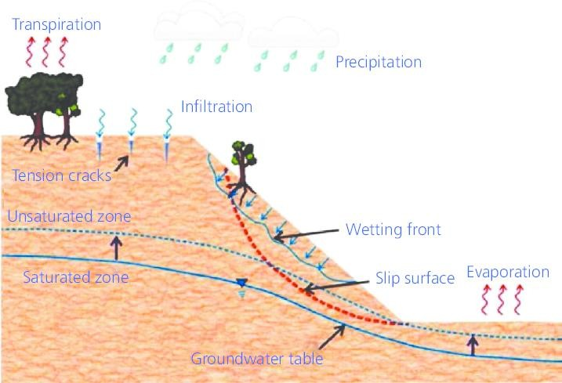

Figure 1.1 Slope failures due to rainfall

**Causes of Failure of slope**

The failure of the slopes can occur due to the natural or human-induced factors, or both. Gravitational forces which tend to destabilize the ground, saturation of water, erosion, seismic activity (e.g., earthquakes), the abrupt increase in the groundwater level, and weathering caused by the cycles of freezing and thawing are all natural causes of landslides.

A high concentration of water serves as one of the greatest causes of landslides. Heavy precipitation, snowmelt, or variations in the ground water level, all of this can result in the saturation of water. Shear strength of the soil is diminished by soil saturation. In particular, it reduces the normal effective stress acting along the granules, thereby decreasing the frictional resistance. Mohr-Coulomb failure criterion states that the shear strength of the soil corresponds to the normal effective stress as follows:

𝑆 = 𝐶 + 𝜎𝑛𝑡𝑎𝑛𝜑 (1)

𝜎𝑛 = 𝜎 − 𝑢 (2)

Here, S corresponds to shear strength, is normal effective stress, u is the pressure caused by pore water, σ gives total stress, C is cohesion, & φ is angle of friction.

**Effect of rainfall on the stability of slope**

During rainfall, numerous slope collapses occur on steeply soil slopes having a high groundwater level. Steep residual soil slopes are typically characterized by a considerable depth of an unaltered soil layer above the water level. The negative pressure created by the water in the pores in unsaturated soil is significantly affected by the boundary flux modifications (i.e., permeability, evaporation, and transpiration) caused by climatic conditions that varies. Alternatively, negative pore-water pressure adds to that of the unsaturated soil's shear strength. As water percolates into a slope, pore-water pressure increases (matric suction decreases), while the enhanced shear strength produced by matric suction diminishes or disappears, making the slope more prone to the failure. Both transpiration and evaporation will restore the slope's lost matric suction. In another word, unsaturated region is a connection between the slope and the atmosphere, and consequently, the safety factor of the slope is dynamically influenced by the climate change. Figure 1.2 depicts the process of the precipitation-induced slope failure with the effect of infiltration, evaporation & transpiration.

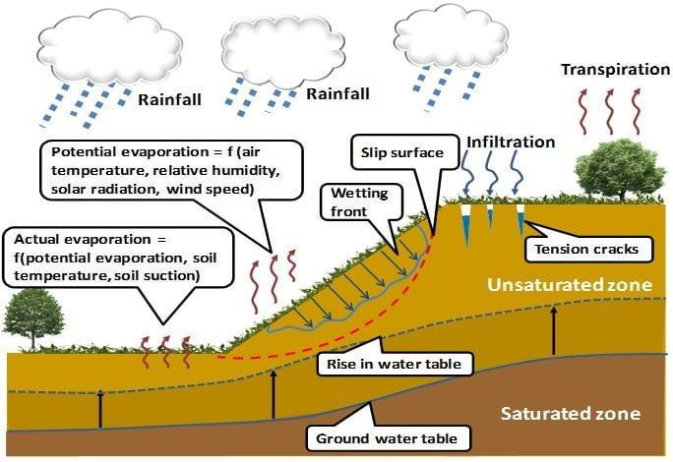

Figure 1.2 Mechanism of precipitation-induced slope instability

**Overview of Slope/W of GeoStudio software**

SLOPE/W employs the limit equilibrium method to evaluate the stability of a given geometry. In limit equilibrium technique, a trial slip interface slices a sliding mass into several vertical segments. An iterative method is used to calculate (prior to failure) the variable that determines the shear strength of each segment should be reduced in order to make the sliding mass nearly on the state of static equilibrium. This reduction factor is referred to as the safety factor. Moment as well as force equilibrium could be employed to determine equilibrium. Consequently, SLOPE/W computes two safety variables: one for moment equilibrium while another one for horizontal force stability. In the current Analysis, the interslice force operation is represented as half of the sine function using the Morgenstern-Price method.

# OBJECTIVES

# To analyses the impact of variation of angle on the slope stability.

# To analyze the effect of rainfall on the stability of slopes using numerical modelling.

# To study the effect of geosynthetics for the stability of slopes.

# LITERATURE REVIEW

Jiao Wang, Guanhua Sun, and Hongming Luo (2024) introduced a comprehensive method for analyzing three-dimensional slope stability under the combined effects of rainfall and seismic activity. Their study emphasizes the critical interaction between these factors, which significantly impact slope integrity. The authors developed a simplified formula that links rainfall intensity to variations in groundwater levels, addressing the influence of water infiltration on slope stability. Additionally, they proposed a global analysis approach that incorporates both seepage effects and seismic forces, providing a holistic perspective on slope failure mechanisms. This innovative methodology was validated through a case study conducted in the Three Gorges Reservoir area, showcasing its practical applicability in real-world scenarios. By combining hydrological and seismic factors, this research offers valuable insights for improving slope stability assessments and designing effective mitigation strategies, contributing to the prevention of landslides in geotechnically challenging regions.

Zhang-xing Wang (2024) review advancements in the parametrization of hydrological and mechanical processes in landslide modeling. This work explores the importance of accurately representing these interconnected processes to enhance landslide prediction and risk assessment. The study examines various modeling approaches, focusing on hydrological influences such as rainfall infiltration and groundwater dynamics, as well as mechanical factors like soil shear strength and slope stability. It highlights the challenges in coupling these processes within models and emphasizes the need for precise parameterization to reflect complex real-world interactions. By improving the integration of hydrological and mechanical processes, the authors aim to refine landslide models, increasing their predictive reliability. This review provides valuable insights for researchers and engineers, facilitating the development of advanced tools for understanding and mitigating landslide risks in regions prone to such hazards.

Muhammad Ali, Bilal Haider, and Shafqat Hussain (2023) the use of machine learning (ML) techniques in slope stability assessment, highlighting the growing role of these methods in geotechnical engineering. The authors discuss various ML algorithms, such as artificial neural networks (ANN), support vector machines (SVM), decision trees, and random forests, and compare their performance against traditional slope stability analysis methods. These ML approaches have proven effective in improving prediction accuracy by processing large datasets, which would otherwise be complex or time-consuming for conventional models to handle. The paper emphasizes that ML techniques can account for non-linear relationships between slope parameters and failure mechanisms, offering superior flexibility and adaptability. Case studies from real-world applications are reviewed, showcasing the benefits of using ML in complex terrain and dynamic environments. The authors conclude that machine learning techniques, when integrated with traditional methods, hold significant promise for advancing slope stability predictions and enhancing the safety and efficiency of geotechnical projects.

Pooneh Shah Male-kpoor, Amirali Behnia, and Alireza Hamedani (2023) This study delves into the stochastic nature of seismic input motion and its influence on slope stability analysis. The authors focus on the variability of seismic data and the associated uncertainties that impact the accuracy of stability predictions. Traditional slope stability models often rely on deterministic seismic input, which may not fully capture the uncertainties inherent in real-world seismic events. The paper proposes a stochastic framework to account for the variability in seismic forces, enabling more reliable and robust stability analyses under uncertain seismic conditions. By incorporating probabilistic methods, the study emphasizes the importance of considering the variability of input motion to improve the predictability of slope failure under earthquake loading. The authors demonstrate that stochastic models can significantly enhance the precision of stability assessments, providing a more realistic approach to geotechnical engineering in earthquake-prone regions. This approach helps mitigate the risks associated with seismic-induced slope failures.

Jing Li, Wei Zhang, and Haibo Zhang (2023) This paper presents a fuzzy comprehensive evaluation method for assessing the stability of loess slopes, a common geotechnical challenge in regions with loess soil conditions. The authors combine fuzzy logic with the analytic hierarchy process (AHP) to improve the accuracy and reliability of slope stability assessments. Loess soils, known for their high compressibility and sensitivity to moisture changes, present unique challenges in slope stability analysis. Traditional methods often struggle to account for the uncertainty and complexity inherent in such soils. By applying fuzzy logic, the authors introduce a more flexible approach that can handle vague or imprecise information, while the AHP helps prioritize the factors influencing slope stability. The proposed method provides a comprehensive and systematic evaluation, ensuring that all relevant factors are considered in the stability assessment. This approach offers more precise predictions for loess slope stability, which is critical for the design and safety of civil engineering projects in loess-rich regions.

**Peng Chen, Weiwei Zhang, and Zhiwei Xu (2022)** In this review, the authors discuss the application of geometric methods in slope stability analysis, focusing on the influence of slope geometry, such as height, inclination, and curvature, on stability. They emphasize the importance of understanding the geometry of a slope in predicting failure surfaces and stress distributions within the material. The review highlights how geometric characteristics directly affect the distribution of internal forces and how these can be modelled through techniques such as the limit equilibrium method. Furthermore, the study outlines the importance of precise geometric data in assessing the risk of landslides and the role of external factors like rainfall and seismic forces. The review concludes by suggesting that a combined approach of geometric analysis with other stability methods can enhance the prediction accuracy of slope stability under various conditions.

**Yuqiang Li, Shuang Liu, and Xinyu Zhang (2022)** This review paper explores the integration of geometric methods with limit equilibrium techniques for assessing slope stability. The authors emphasize the importance of slope geometry—specifically the angle of inclination, height, and the layering of soil or rock materials—in determining the factor of safety. They discuss how geometric parameters play a critical role in influencing the distribution of internal forces within a slope, which directly impacts its stability. The paper compares various approaches, from traditional methods like the infinite slope model to more modern techniques, such as advanced numerical modeling and finite element methods. These methods incorporate complex geometric characteristics to predict potential failure zones more accurately. The authors also explore how geometric analysis, when combined with limit equilibrium methods, provides a more comprehensive and reliable assessment of slope stability. By reviewing both established and emerging techniques, the paper highlights the ongoing evolution of slope stability analysis in engineering geology.

**Haoyang Zhang, Zhenyu Liu, and Yifeng Li (2021)** This review highlights the critical role of geometric parameters in slope stability analysis. The authors focus on how factors such as slope angle, height, and soil stratification influence the distribution of internal forces and the potential for slope failure. By analysing the geometry of a slope, the paper demonstrates how these factors contribute to determining the factor of safety and predicting failure mechanisms. The review also emphasizes the integration of geometric analysis with other established stability assessment methods, such as limit equilibrium and numerical modelling techniques, to provide a more comprehensive and robust approach to landslide prediction and prevention. The authors suggest that considering the geometric features of a slope in combination with other geotechnical data can enhance the accuracy of stability assessments. The paper concludes by advocating for a multi-faceted approach that incorporates geometric analysis into broader stability evaluation frameworks, improving the reliability of landslide risk management strategies.

**João P. F. de Lima, Pedro F. G. Carvalho, and Ricardo A. B. R. Almeida (2021)**

This review provides an in-depth discussion of the integration of geometric analysis and limit equilibrium methods in slope stability assessments. The authors focus on the relationship between slope geometry, material properties, and failure mechanisms, explaining how specific geometric features, like slope height and angle, influence the safety factor of slopes. The review also evaluates various limit equilibrium methods that incorporate geometric data to determine factors of safety for slopes. It highlights the importance of considering geometric parameters, such as the curvature of slopes and the layering of soil or rock strata, in predicting potential failure zones. Additionally, the paper explores advancements in computational methods, allowing for a more accurate representation of slope geometry in stability models. The authors conclude that a combined geometric and limit equilibrium approach provides a more reliable and comprehensive assessment of slope stability in both natural and engineered settings.

**S. M. Pradhan, M. L. M. Shrestha, and S. K. Tiwari (2020)**

In this review, the authors focus on the role of geometric characteristics in slope stability analysis. They examine the impact of slope angle, soil stratification, and curvature on the distribution of stress and the potential for slope failure. The paper explains how the geometry of a slope influences both the driving and resisting forces acting on the material, highlighting the importance of geometric parameters in determining the critical failure surface. The authors also discuss different geometric modelling techniques, such as the method of slices and finite element methods, which can incorporate complex geometries into slope stability assessments. By integrating geometric analysis with other methods, such as limit equilibrium or finite difference methods, more accurate predictions of slope failure can be achieved. The paper concludes that geometric analysis remains a crucial component in the study of slope stability and should be applied alongside other stability assessment techniques for more reliable results.

# METHODOLOGY

**Experimental Studies**

Various laboratory Analysis were done on soil to know the characteristics of the soil and different methodologies for different tests are discussed below:

**Particle Size Distribution Analysis**

The particle size evaluation test was carried out to figure out the proportion of every grain size evident in a sample of soil as per IS:2720 (Part 4)-1985, and the outcomes of the test are used to create the distribution curve of grain size. These data were used to categories and foresee the behaviour of soil. The two common methods for evaluating particle size distribution are:

• Sieve method for grain size greater than 0.075 mm

• Hydrometer method for grain size less than 0.075 mm

Sieve testing is a technique used to identify the distribution of the size of grains of soil in relation to particle sizes larger than 0.075 mm. This is typically used for gravel and sand, but it cannot be used by itself to determine the percentage of particle sizes of finer soil. This test employs sieves formed by wires that are woven with shape of square. A known quantity of material, whose quantity is based on the largest size of material, is positioned at the top of a series of stacked sieves (topmost sieve possesses the biggest openings, and the opening dimensions reduce with each subsequent sieve down towards bottom sieve that has least size screen) and shaken for some time. Following the shaking of the material across the stacked sieves, the total material retained on every sieve is measured.

For particle size analysis, 1 kg of soil sample was taken and passed through a set of sieves i.e. 4.75 mm, 2 mm, 1.18 mm, 600 μ, 425 μ, 300 μ, 150 μ and 75 μ sieves with the help of mechanical sieve shaker. Then after shaking for some time, then weight of the soil sample retained on every sieve is taken and with the help of this gradation analysis chart is being made. The data could also be used to establish relationships between porosity and packaging. The soil is classified based on the information derived from the analysis of particle sizes (uniformity indicator Cu, the coefficient of curvature Cc, effective size D10, etc.).

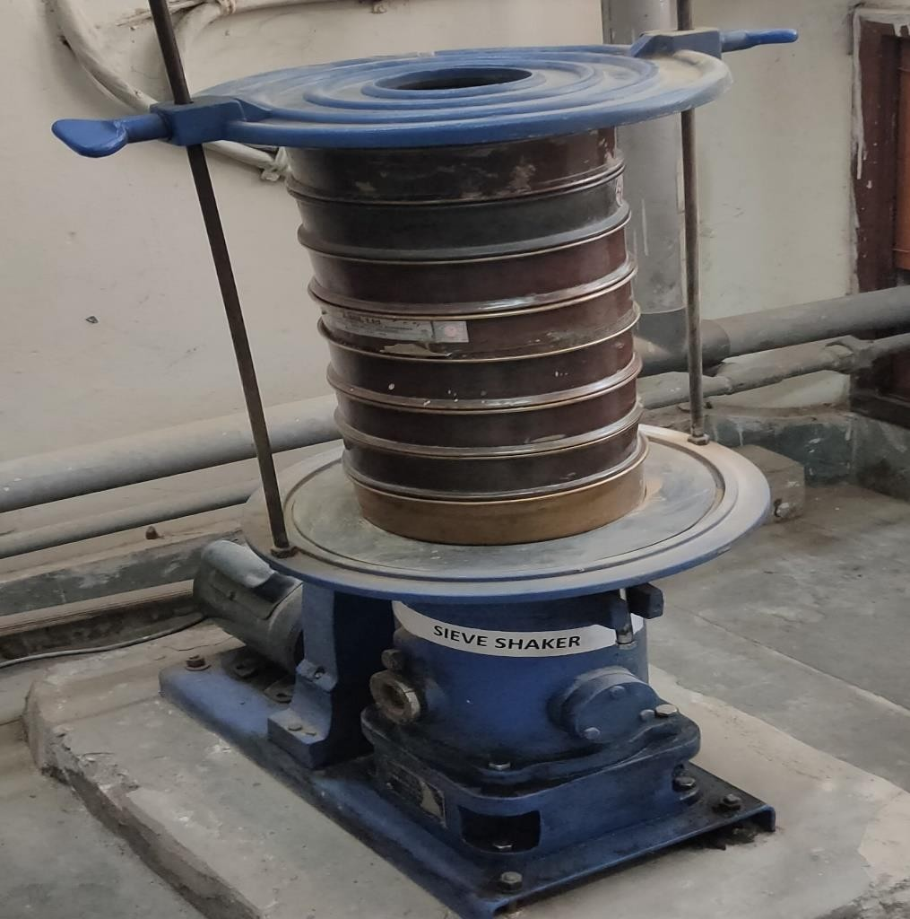

Figure 4.1 Set of sieves arranged and placed in a mechanical shaker

**Determination of Specific Gravity**

Specific gravity represents a dimensionless quantity described as the ratio of soil solids density to water density at a given temperature. Using the pycnometer method, specific gravity of a soil sample was evaluated in accordance to IS: 2720 (Part 3/Sec 2) -1980. A 100-gram oven- dried specimen is analyzed in this test. Calculate and record the pycnometer's unfilled weight, M1. Fill that pycnometer with 100 grammes of oven-dried specimen and weigh it as M2. Fill the pycnometer with distilled water up to the top, and weigh it as M3. Empty, clean, and fill the pycnometer to the mark with water. This must be measured as M4. The specific gravity will then be determined using the following relationship:”

M2 − M1

G =

(M2 − M1) − (M3 − M4)

**Atterberg Limits Test**

The Atterberg limits, referred to "consistency limits," are actually a set of laboratory tests required to ascertain water content when a fine-grained soil shifts state. IS:2720 (Part 5)-1985 was being used to identify the soil's liquid limit as well as plastic limit. For the analysis, 120 g oven-dried sample of soil passing a 425μ IS sieve is collected. The sample of soil is thoroughly mixed using enough water to create a homogenous substance. A small quantity of prepared sample of soil was moved to the brass container of Casagrande's Apparatus and levelled to a height of 1 cm at the deepest point. Using a suitable grooving instrument, an incision is created in the soil sample while the crank is turned at the rate of two revolutions every second. When the groove created in the soil specimen came into contact at an interval of 12 mm, the no. of blows is recorded. A part of the sample of soil is taken from a position perpendicular to that of the groove, specifically from the region of the groove that came into contact due to flowing, in order to evaluate its water capacity. The experiment is repeated four to five times, and a graph between the log of the no. of blows and the water content is created. The soil sample's liquid limit is analysed by water content which corresponds with 25 blows. After determining liquid limit, approximately 8 g of sample of soil is then rolled between the fingertips on the glass plate until a thread having diameter 3 mm is formed. The procedure is then repeated until cracks emerge on the exterior of the soil thread when it is rolled to a diameter of 3 mm. A representative sample of soil is taken from the fractured portion of the thread to assess its moisture content. The determined moisture content reflects the plastic limit of the sample of soil.

**Compaction Test**

Compaction is a method of soil densification through the elimination of air voids. “The dry density of soil sample is used to determine its degree of compaction. The MDD (maximum dry density) occurs at optimal water content. To determine maximum dry density (MDD) & optimum moisture content (OMC), a graph is drawn among the dry density along with the water content. In this research, Light compaction evaluation has been done in accordance to IS:2720 (Part 7)-1980 to find MDD & OMC. In a light compaction evaluation, a 5 kg sample gets compressed in a compaction Mold having volume 938 cc after it passes through a 20 mm IS sieve. Some quantity of soil is taken and is mixed with a fixed percentage of water, consider it as an initial moisture content of soil taken. The specimen will then be packed into the compaction frame in three phases, with each receiving 25 number of blows from a 2.6 kg hammer with a 310 mm falling height. The technique is repeated with the soil sample, this time varying the water content to ascertain the dry density relating to various water contents and to calculate the OMC and MDD. Record the initial water content, the MDD (maximum dry density), and the OMC

**Direct Shear Test (DST)**

This laboratory Analysis is used to estimate the parameters for soil’s shear strength. It is a straightforward and rapid test that could be carried out on cohesive and non-cohesive soils.

The direct shear method is a straightforward and usually employed measure in the geotechnical engineering. For the stability evaluation of slopes, foundations, as well as retaining walls, it is frequently utilized to calculate the shear strength characteristics of soils. The soil’s shear strength, cohesion, & internal friction angle are the parameters for the shear strength that is calculated from the measurement. Cohesion quantifies the strength of soil particles, whereas the internal friction angle quantifies the resistance of soil to sliding under shear stress. The shear parameters of the sample of soil were calculated in accordance with the IS:2720 (Part 13)-1986.

The samples were collected by inserting a 60mm x 60mm x 25mm sampling device into the sampler's collected samples. The specimens have been cut and flattened before testing. All of the samples were sheared in a direct shear machine at the rate of 1.25 mm/min. Maximum shear stress values were calculated at normal stress levels of 0.5 kg/cm2, 1 kg/cm2, & 1.5 kg/cm2. Normal stress was then plotted as abscissa along with shear stress as ordinate on a graph between normal stress and maximal shear stress. Intercept of the graph at the Y-axis depicts cohesion (c), & the slope of the line specifies the angle of internal friction (φ).

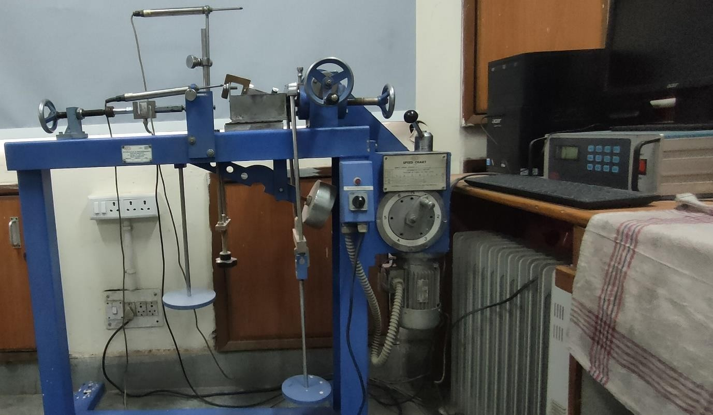

Figure 4.2 Shows the Direct Shear Test Assembly

# RESULT

**Specific Gravity Test**

Table 5.1 Specific Gravity of soil

|  |  |  |  |  |
| --- | --- | --- | --- | --- |
|  | | **Sample 1** | **Sample 2** | **Sample 3** |
| **Mass of empty Pycnometer** | **M1 (gm)** | 698 | 698 | 698 |
| **Empty Pycnometer**  **+ Dry Soil** | **M2 (gm)** | 798 | 798 | 798 |
| **Empty Pycnometer**  **+ Dry Soil +Water** | **M3 (gm)** | 1632 | 1636 | 1634 |
| **Empty Pycnometer**  **+Water** | **M4 (gm)** | 1572 | 1572 | 1572 |
| **Specific Gravity** | **G** | 2.50 | 2.77 | 2.63 |

Average value of specific gravity of Soil sample = (2.50 + 2.77 + 2.63)/3 = **2.63**

**Atterberg Limits Test**

Table 5.2 Atterberg Limits

|  |  |  |
| --- | --- | --- |
| **S. No** | **Parameters** | **Values** |
| **1.** | Liquid Limit (%) | 31 |
| **2.** | Plastic Limit (%) | 21.24 |
| **3.** | Plasticity Index (%) | 9.76 |

In this research, value of curvature coefficient (Cc) and uniformity coefficient (Cu) came out to be 1.6098 and 6.7273. As value of Cc is between 1 & 3, and value of Cu is larger than 6. Also, the percentage of sample of soil passing from 4.75 mm sieve is greater than 50%. Therefore, the sample of soil is well graded sand (SW) and as liquid limit is less than 35% the soil is low plastic in nature and soil contains some proportion of clay and some proportion of silt.



40

35

30

25

20

No. of blows

15

10

5

0

45

40

35

30

25

20

15

10

5

0

Water content vs No. of blows

Figure 5.1 Variation of water content with No. of blows

**Compaction Test**

|  |  |  |
| --- | --- | --- |
| **S. NO.** | **DRY DENSITY, ϒd (KN/m3)** | **WATER CONTENT, w (%)** |
| 1 | 11.20 | 7.48 |
| 2 | 13.66 | 10.83 |
| 3 | 11.48 | 15.74 |



γd vs w (%)

16

14

12

10

8

6

4

2

0

6

8

10

12

water content %

14

16

18

Figure 5.2 Variation of Dry density with water content

γd kN/ m3

# CONCLUSION

The district of Shimla is frequently impacted by landslides, that are considered as one of the environment's most hazardous and devastation risks. An Analysis is done to examine the effect of percolation of rainfall into the different slope profiles with varying slope angle and their failure mechanism with the help of numerical modelling.

• The varied slope profiles were studied in order to see the effect of pre-monsoon and after rainfall effect on these profiles.

• The safety factor before pre-monsoon was found to be greater than 1 establishing a stable slope.

• The safety factor was less than 1 at the maximum rainfall for the slopes with slope angles of 37.65° and 42°, indicating an unstable slope.

• The failed slopes caused by precipitation were stabilized using geosynthetics in 3, 4, 5, and 6 layers.

• The FOS for the geosynthetic reinforced slopes after rainfall was greater than 1 indicating the stable slope.

• With the increase in the number of layers of geosynthetics, the safety factor of the slopes also increased.

The rainfall limit for an area can be determined using the outcomes of this study. This study confirms the significant sensitivity of the Himachal Pradesh region to rainfall-induced landslides and identifies key slip surfaces that could be helpful for future mitigation strategies. The utility of numerical modelling for analysis in the Indian Himalayan regions was also confirmed by this study.

# REFERENCES

1. D. Bhattacherjee and B. V. Viswanadham, “Centrifuge model studies on performance of hybrid geosynthetic–reinforced slopes with poorly draining soil subjected to rainfall,” Journal of Geotechnical and Geoenvironmental Engineering, vol. 145, no. 12, 2019.
2. T. R. Martha, N. Kerle, C. J. van Westen, V. Jetten, and K. Vinod Kumar, “Object-oriented analysis of multi-temporal panchromatic images for creation of historical landslide inventories,” ISPRS Journal of Photogrammetry and Remote Sensing, vol. 67, pp. 105– 119, 2012.
3. R. P. Gupta and B. C. Joshi, “Landslide hazard zoning using the GIS approach—a case study from the Ramganga catchment, Himalayas,” Engineering Geology, vol. 28, no. 1–2,

pp. 119–131, 1990.

1. C. Prakasam, R. Aravinth, V. S. Kanwar, and B. Nagarajan, “Landslide hazard mapping using geo-environmental parameters—a case study on Shimla Tehsil, Himachal Pradesh,” Lecture Notes in Civil Engineering, pp. 123–139, 2019.
2. B. V. S. Viswanadham and D. Bhattacherjee, “Studies on the performance of geo-composite reinforced low-permeable slopes subjected to rainfall,” Japanese Geotechnical Society Special Publication, vol. 2, no. 69, pp. 2362–2367, 2016.
3. Q. Zhai and H. Rahardjo, “Determination of soil–water characteristic curve variables,” Computers and Geotechnics, vol. 42, pp. 37–43, 2012.
4. H. Rahardjo, T. H. Ong, R. B. Rezaur, and E. C. Leong, “Factors controlling instability of homogeneous soil slopes under rainfall,” Journal of Geotechnical and Geoenvironmental Engineering, vol. 133, no. 12, pp. 1532–1543, 2007.
5. B. Krishnan and P. A. Vasantha, “Numerical modeling for the selection of coir geotextile for erosion control application based on the universal soil-loss equation,” Journal of Computing in Civil Engineering, vol. 29, no. 6, 2015.
6. J. S. Dhanya, A. Boominathan, and S. Banerjee, “Performance of geo-base isolation system with Geogrid reinforcement,” International Journal of Geomechanics, vol. 19, no. 7, 2019.
7. A. Mirzaali mohammadi, M. Ghazavi, S. H. Lajevardi, and M. Roustaei, “Experimental Analysis on pullout behavior of Geosynthetics with varying dimension,” International Journal of Geomechanics, vol. 21, no. 6, 2021. doi:10.1061/(asce)gm.1943-5622.0002051
8. S. Vadivel and C. S. Sennimalai, “Failure mechanism of long-runout landslide triggered by heavy rainfall in Achanakkal, Nilgiris, India,” Journal of Geotechnical and Geoenvironmental Engineering, vol. 145, no. 9, 2019.
9. N. Tiwari, N. Satyam, and A. J. Puppala, “Effect of synthetic geotextile on stabilization of expansive subgrades: Experimental study,” Journal of Materials in Civil Engineering, vol. 33, no. 10, 2021.
10. F. Bessa Ferreira, P. Pereira, C. Silva Vieira, and M. Lurdes Lopes, “Long-term tensile behavior of a high-strength geotextile after exposure to recycled construction and demolition materials,” Journal of Materials in Civil Engineering, vol. 34, no. 5, 2022.
11. P. Ering and G. L. Babu, “Characterization of critical rainfall for slopes prone to rainfall- induced landslides,” Natural Hazards Review, vol. 21, no. 3, 2020.
12. W. Tan, S. Qu, and D. Gao, “Stability analysis on highway slopes in Rainy Region,” Slope Stability and Earth Retaining Walls, 2011.
13. R. Collins, M. Zhang, L. Hulsey, and X. Zhang, “Stabilization of erodible slopes with Geofibers and nontraditional liquid additives,” Ground Improvement and Geosynthetics, 2014.