**DESIGN AND IMPLEMENTATION OF BOOST CONVERTER FOR BLDC MOTOR**

**Srinivasan S1, Logavani K2**

1PG Scholar,Power Electronics and Drives, GCE, salem, Tamilnadu,India

2Assistant professor,EEE,GCE,Salem,Tamilnadu,India

**ABSTRACT**

This project of the Brushless DC motor (BLDC) is developed and the closed-loop Fuzzy PID controller has been simulated in MATLAB-Simulink environment. The three-phase (BLDC) is developed and the DC power is supplied to this machine though six step inverter whose switching state is controlled by the hall signal. The hall effect sensor senses the rotor position of the motor and it generates binary digit number which is decoded and given to the six-step inverter.so sinusoidal pulse width modulation (spwm) developed to use reduce harmonics of the BLDC motor. The PI controller doesn’t operate properly during dynamic state and hence the fuzzy-PID-controller is better option to control and regulate the speed of the BLDC motor which has high performance in comparison to the PI controller. And, we can get the smooth speed-torque characteristics using Fuzzy PID controller.

**Keywords:** PID controller,BLDC motor,Electric Drive,Fuzzy logic.

1. **INTRODUCTION**

The DC motor considered as having good torque and speed characteristic and efficiency. The DC motor are preferable than AC motor in any area like aircraft, robotics, industries and home appliances. But the brushed dc motor has some disadvantage which lead to introduce the brushless dc motor instead of the brushed-dc machine. The operation and maintenance cost of the dc motor is too high due to the presence of the commuter brushes and the brush gear and can’t operate in huge hazard conductions because sparks may occur and may lead to the fire. The speed will change as the load changes, as there is variable speed not only by controlling the resistance but also by the load current.

The speed control could be impossible for rapidly changing loads. Brushless dc motor does not any brushes, so they don’t undergo any commutation, Brushless dc motor have a significantly higher efficiency and performance and compare to that it also has a very low susceptibility to mechanical parts than their brushed counter parts. Due to advantage of BLDC motor over dc motor and other ac motor control of BLDC motor is very essential. Many control techniques of BLDC motor are in the use but to improve the performances of the motor we are going to deal with the PID-fuzzy control method.

1. **METHODOLOGY**

**2.1 BLOCK DIAGRAM OF THE PROPOSED SYSTEM**

. 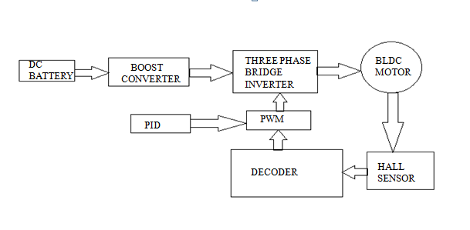

**2.2 BOOST CONVERTER**

Boost converters are used in electronics to generate a DC output voltage that is greater than the DC input, therefore boosting up the supply voltage.Boost converter sare often used inpower supplies for white LEDs,battery packs for electric auto mobiles,and many other applications.

Boost converters are a type of DC-DC switching converter that efficiently increase (step-up) the input voltage to a higher output voltage. By storing energy in an inductor during the switch-on phase and releasing it to the load during the switch-off phase, this voltage conversion is made possible.

Boost converters are widely used in portable electronic devices, such as smartphones, tablets, and laptops, where they step up the battery voltage to required levels. These devices often require multiple voltage levels for different components, and boost converters efficiently provide these higher voltages from a single battery source. Their high efficiency and compact size make them ideal for extending battery life and reducing the size of power management circuits in portable electronics.

**2.3 TOPOLOGY**

The circuit diagram of the boost converter shown in Fig 2.1 consists of supply voltage, semiconductor switch, diode, inductor, capacitor, and load.

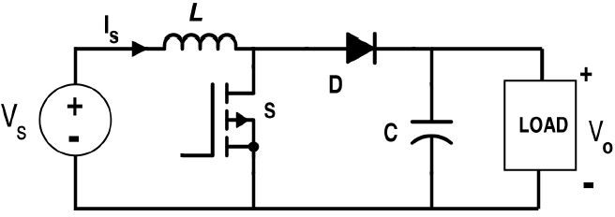

**Figure 2.1 BoostConverter**

A boost converter is a type of DC-DC converter that steps up the input voltage to a higher output voltage. It begins with a DC voltage source that provides a lower input voltage.An inductor is connected in series with the input voltage source and the switch, storing energy when the switch is closed.

The switch, typically a transistor, alternates between open and closed states, controlled by a pulse-width modulation (PWM) signal.When the switch is closed, current flows through the inductor, causing it to store energy in its magnetic field.Adiode is placed in series with the output and prevents the backflow of current from the capacitor to the inductor when the switch is open.

When the switch opens,the inducto releases the stored energy,which adds to the input voltage, thereby boosting the voltage. A capacitor connected across the output terminals smooths the output voltage by storing and supplying energy. The output voltage is higher than the input voltage and is maintained by the combined action of the inductor and capacitor.

In continuous conduction mode, the inductor current never falls to zero,providing a continuous output voltage. The output voltage is regulated by adjusting the duty cycle of the PWM signal, which controls the proportion of time the switch is closed versus open.

**2.4 MODE OF OPERATION:**

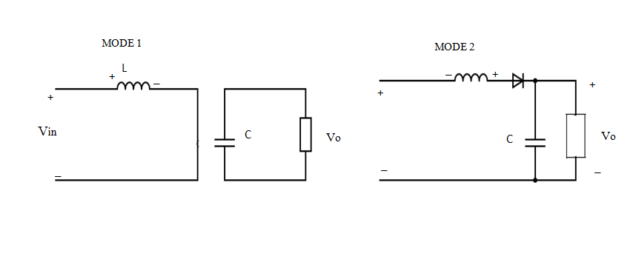

**2.4.1 MODE-1**

The switch is closed, causing the inductor to store energy as the current through it increases linearly.The diode is reverse biased,preventing current from flowing to the output, and the input voltage is directly applied across the inductor.

**2.4.2 MODE-2**

The switch is open, causing the inductor to release its stored energy.The inductor voltage reverse, forward biasing the diode, and allowing current to flow to the output. The inductor current decreases, transferring energy to the output capacitor and load.

To obtain the input–output voltage relationship, apply the volt-second balance rule to the inductor. This implies that the area under the inductor voltage curve in one period under steady state conditions should be zero.

**2.4 DESIGN CALCULATION OF BOOST CONVERTER**

${ v}_{in}$ = Input voltage

${ v}_{in}$ = 100 volt

${ i}_{in}$ =input current

$${ i}_{in=6Amps}$$

$$Required output voltage = 250 V$$

$Duty cycle D=1-\frac{V_{IN}×ƞ}{V_{out}}$

$Inductance L=\frac{V_{in}×({V_{out}}_{-^{V_{in)}}}}{Δ_{IL×f_{s ×}}V_{out}}$

Capacitance, $C=\frac{I_{out}×({V_{out}}_{-^{V_{in)}}}}{Δ_{Vout×f_{s ×}}V_{out}}$

$${ f}_{s} = Switching frequency Hz$$

$${ f}_{s}= 10 Khz$$

Inductance value 𝐿=0.003𝐻

Capacitor value ,𝐶=0.0018F

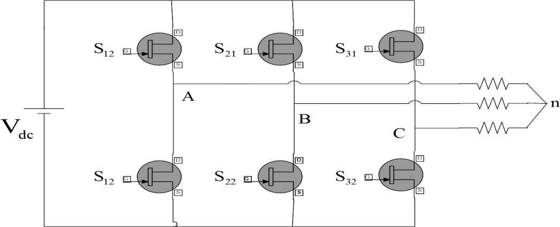**3.THREE PHASE INVERTER**

**Figure 3.1** Voltage Source Inverter

BLDC motor drives are mostly used three-phase bridge inverters for supplying power to it. The circuit diagram of a six-step VSI is as shown in Figure , it comprises of three half- bridges, and these three are phase shifted by 120 degree to produce the three phase voltages.

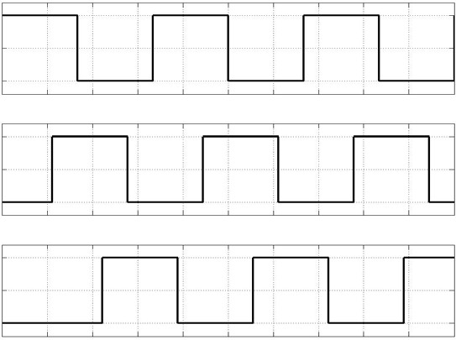

S11

S21

S31

Time

**Figure.3.2 Pulse waveform of 120 degree mode**

**3.1 PWM TECHNIQUES**

Pulse-width modulation is a technique in which the ON-OFF time of switches is controlled by reference wave. In this the intersection between a reference wave and a carrier wave produces the pulses according to which the switches are switched ON and OFF.

PWM have a wide field of applications such as motor speed control, converters, communication, etc. For example PWM is used to control the switches of inverter to control the power supplied to the motor.

By controlling the ON-OFF time of the switches we can control the speed of the motor. When we need more speed we increase the ON time of the switches similarly when we need to slow down the motor we decreases the OFF time of the switches. Higher switching frequency for the switches so that the power losses is insignificant as compare to the power supplied by the source.There are different PWM techniques used for motor control application. We use the following techniques:

* + 1. Sinusoidal PWM
    2. Space Vector PWM

**3.2 BRUSHLESS DIRECT CURRENT MOTOR**

A BLDC motors is a permanent magnet synchronous motor. Position sensors are used to sense the rotor position according to the rotor position inverter control the stator currents thus the speed of motor. The term dc comes in the name of BLDC because its torque speed characteristics are similar to that of dc motors. BLDC requires an electronic commutation circuit instead of mechanical or brushed commutation used in dc motor.

BLDC motor are divided into mainly two types based on the shape of back-emf waveform induced in the stator are sinusoidal type and trapezoidal type. Sinusoidal motor have a sinusoidal shaped back-emf and its require phase current to be sinusoidal for torque ripple free operation on the other hand trapezoidal motors need rectangular shaped current for torque ripple free operation.

The trapezoidal motor requires position sensors to sense the position of rotor at every instant of time. It’s requires a complex hardware for smooth operation. The trapezoidal motor is more popular for most of the application due to its simple operation, low price and high efficiency.Many different configurations of BLDC motor exists three phase motors with star connected windings are most popular in use today because of its high efficiency and lower torque ripple.

Brushless DC motor has the rotor containing a permanent magnet and its stator consists of three solenoids connected in a star topology and positioned 120° from each other. The rotor electromagnetic field changes with the rotation so that in order to keep the load angle as close to 90° as possible, the stator electromagnetic field is constantly changed according to the position of the rotor below show the structure and working principle of a brushless DC motor.

## 3.3 SIX-STEP ALGORITHM

The six-step algorithm is a driving operation of three-phase BLDC motors. In six- step, there are six current directions running through two of the three phases, which created six discrete directions of magnetic field for the stator .To acquire the position of the rotor, the hall-effect sensors are used for sensored BLDC motors and BEMF feedbacks are used for the sensorless counter- parts. Eventually, the correct step is applied accordingly to the known rotor posi- tion and the intended rotation direction.

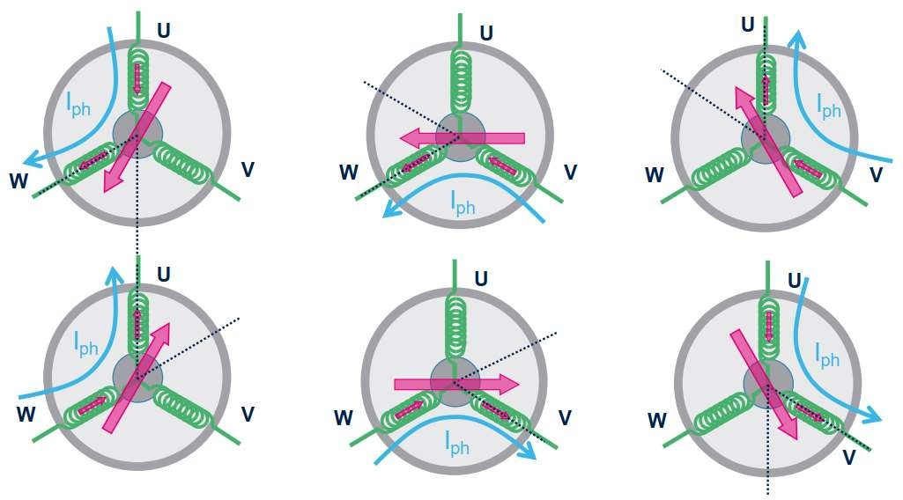

**Figure 3.2 Six combinations in six-step algorithm**

**3.4 Principle of Operation of Brushless dc motor**

The three phase BLDC motor is operated by energizes two phase at a time, i.e. the only two phase are energized at an instant of time while the third phase is off to produce the highest torque. The two phases which are energized determine by an electronic commutation circuit. depends on the output of the sensors. Hall-effect sensors are most commonly used to sense the rotor position and feed it to the controller.

The signal from the sensors changes every 60° (electrical degree) as shown in figure.. Each interval starts with the rotor and stator flux is 120° apart and ends when they are 60° apart. Highest torque is reached when the field are perpendicular to each other. Commutation is done by a Voltage source inverter. The switching devices used are MOSFET or IGBT.

**3.5 SPEED CONTROLLER STRUCTURE**

Electronic commutation circuit guarantee proper rotation of BLDC motor, but the speed of the motor depends on the amplitude of the voltage fed to the motor. PWM techniques are used to control the magnitude of voltage fed to the motor thus control the speed of the BLDC motor.

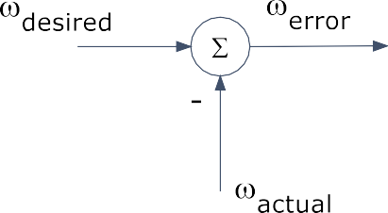

**Figure 3.3 Schematic Diagram of Speed Controller**

**4.PID CONTROLLER**

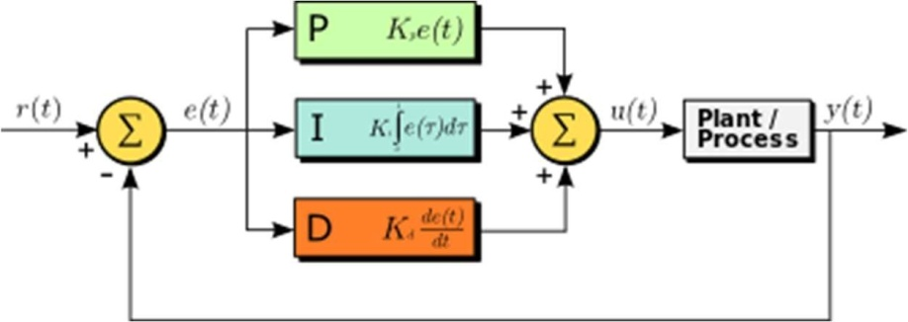A proportional-integral-derivative controller(also known as a PID controller or three-term controller) is a closed loop control mechanism that is widely used in industrial control systems. It uses the three control terms of proportional, integral and derivative to calculate the output from the error value, which is the difference between the designated target value called a setpoint (SP) and the measured feed- back value called a process variable (PV).

**Figure 4.1 PID controller**

**5.SIMULATION DIAGRAM**

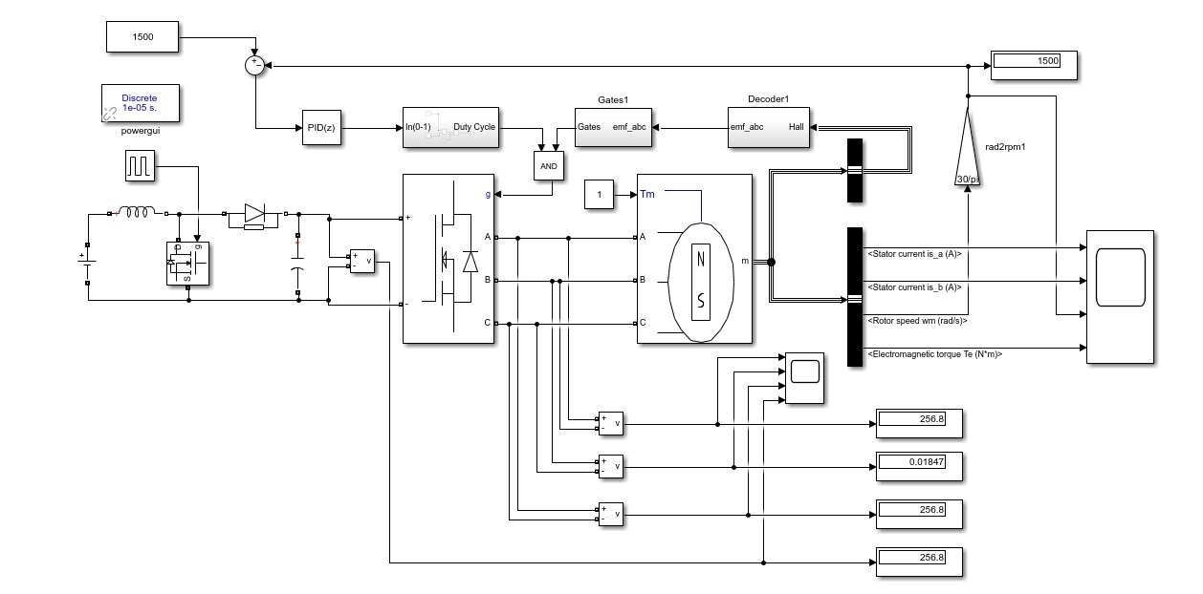

* 1. **Simulation diagram of proposed system**

**5.2 WAVEFORM FOR BOOST CONVERTER OUTPUT AND INVERTER OUTPUT**

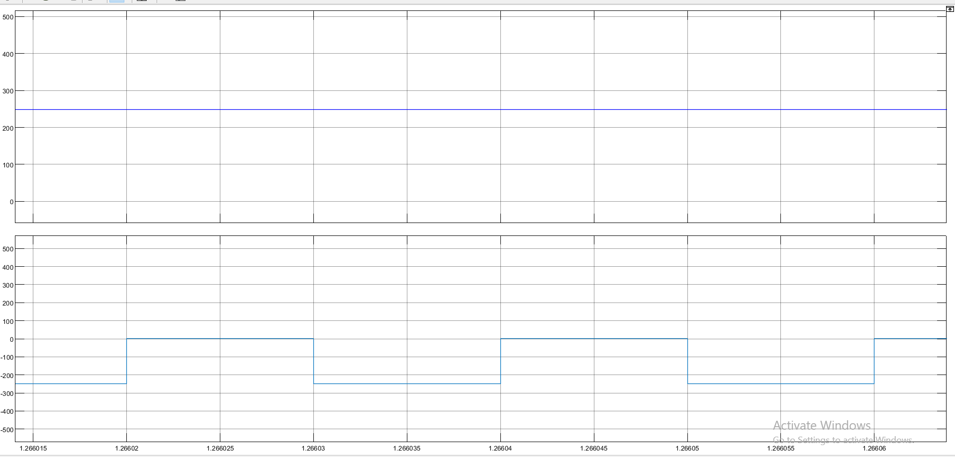

**5.2 Waveform for boost converter output and inverter output**

**5.3 WAVEFORM FOR SIMULATION OUTPUT**

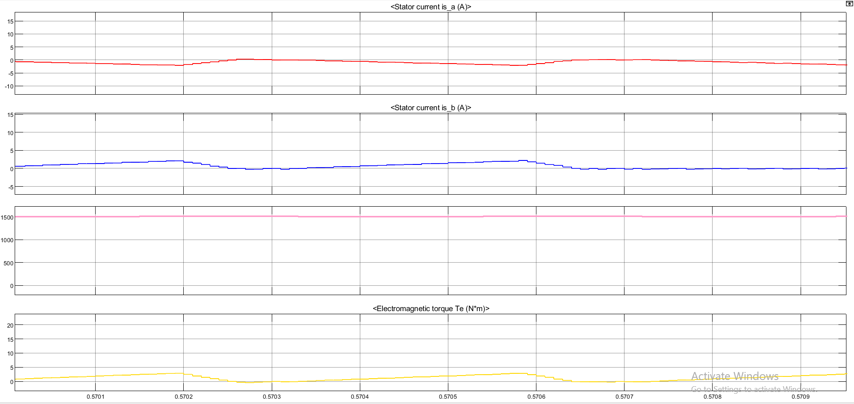

**Figure 5.3 waveform for simulation output**

**6.CONCLUSION**

This paper presents the development and simulation of a Brushless DC (BLDC) motor control system using a closed-loop Fuzzy PID controller. The system was designed and tested in the MATLAB-Simulink environment, integrating key components such as a three-phase BLDC motor, a six-step inverter, Hall effect sensors for rotor position detection, and Sinusoidal Pulse Width Modulation (SPWM) for harmonics reduction. The main objective of the study was to evaluate the performance of the Fuzzy PID controller in comparison to the traditional PI controller for regulating the speed and torque characteristics of the BLDC motor.

**7.REFERENCES**

[1] Federico M. Sera, Francisco D. Estebana, Control of DC-DC boost converter in discontinuous conduction mode feeding a constant power load. 20 August 2024 2590-1230/2024TheAuthor(s). Published by Elsevier B.V.

[2] L. Kong et al. Improved Proportional Integral (PI) controller for water level control in open channel systems. 2 January 2024 2214-5818/ 2024 The Authors. Published by Elsevier B.V.

[3] Huazhang WANG, Design and Implementation of Brushless DC Motor Drive and Control System. 2011 Published by Elsevier Ltd

[4] Muhammad NajmiBinRoslan, KishoreBingi, Design and Development of Complex-Order PI-PD Controllers2024 by the authors. Licensee MDPI, Basel, Switzerland.

[5] Kaspars Kroi cs and A B umanis, BLDC Motor Speed Control with Digital Adaptive PID-Fuzzy Controller and Reduced Harmonic Content. 2024 by the authors. Licensee MDPI, Basel, Switzerland.

[6] Singh, S., Singh, B.: A voltage-controlled PFC CUK converter based PMBLDCM drive for air-conditioners. IEEE Trans. Ind. Appl. 48(2), 832–838 (2018).

[7] Chen, Y., Chiu, C., Jhang, Y., Tang, Z., Liang, R.: A driver for the single-phase brushless DC fan motor with hybrid winding structure. IEEE Trans. Ind. Electron. 60(10), 4369–4375 (2017).