**Interactive platform for Tourism Management System**

*Dr. Lokesh Jain*

*Associate Professor, Department of IT,*

*Jagan Institute of Management Studies*

*Rohini, Delhi, India.*

*lokesh.jain@jimsindia.org*

*Vineet Saraswat*

*Department of IT,*

*Jagannath Univerity,*

*Haryana, India.*

*vineet2034saraswat@gmail.com*

***Abstract* -** The paper views or examines a theoretical perspective on the Tourism management system. Tourism is one of the major contributors to economic growth and cultural exchange, and it demands creative solutions to the growing scale demands. This study primarily emphasizes the development of an advanced system for Tourism Management, which will make the management and accessibility of tourism-related services easy to handle. The system has two main user types, namely administrators and visitors. Administrators can manage activities, like tour packages, visitor records, and even feedback management. Visitors are also enabled to browse packages, make bookings, give reviews, and can even submit inquiries. It uses React for an intuitive frontend and Django for a robust backend towards the smooth and efficient running of the system. Overcoming the conventional and physicality of tourism management practices are features such as real-time booking, feedback handling, and updates that are dynamic in the system. This paper explores architecture, key functionalities, and transformative potential of digitized solutions for tourism that can enhance user experience and optimize operational efficiency.

***Keywords:*** Real-time Booking, React and Django, User Satisfaction, Booking Features

1. INTRODUCTION

Tourism is a great tool to improve economic growth and cultural exchange. Tourism connects the world by developing opportunities for local development. Processes involved in tourism management include making bookings, maintaining visitor records, and ensuring smooth service delivery, which often complicate and make it difficult to manage. The traditional methods of managing tourism are usually time-consuming and prone to errors because they mostly depend on manual operations.

This research addresses the said limitations by proposing a Tourism Management System that will automate activities and enhance user interactions. The system caters for two major types of user roles, namely administrators and visitors. The administrators are offered an interface to allow efficient management of tour packages, hotel details, visitor comments, and inquiries. On the other hand, visitors can discover and book packages, comment on packages, and ask the system questions using an interface intuitive to their needs.

It's made using React for the front end and Django for the back end, giving full responsiveness and usability. And it has the strength to handle all kinds of data with robust functionality. All the inefficiencies of this traditional approach have been reduced as it has real-time updating of bookings and proper managing feedback. It reflects the possibility that using digital technology may make operational flows improve customer satisfaction, and this serves as a contribution towards raising the standard of tourism-related business. This is just an advanced Tourism Management System designed to fill the gaps still found between traditional manualism approaches and modern tourism demands. It can be used to outline the design architecture of the system, key functionalities, and its prospective impact on digitalizing tourism toward better operational efficiency and user satisfaction.

1. LITERATURE REVIEW

Tourism has been one of the main contributors to the economies and to cultural exchange. The advance in digital technologies has evolved the way tourism services have been managed and accessed; it led to the concept of Tourism Management Systems. From basic booking management up to real-time updates, from user feedback and personalized recommendations to integration, these TMS have evolved much more than the old-fashioned ways of tourism management as determined by Smith et al. (2018).

The success would also rely much on the technology deployed for the TMS platforms. So far, there are two most common ones: React and Django. This is so because the frameworks give a scaly and user-friendly experience that leads to a seamless experience for users. Additionally, dynamic rendering and securing the back-end help in solving complex business logic as well as huge databases. Jordan & Hayes, 2020.

High adoption rates require the design to be user-centric. The more friendly the navigation and interfaces, the better the users are satisfied as Lee & Kim (2019) argue. More so, with mechanisms providing feedback, the TMS platforms offer constant improvement based on insights given by the users, as argued by Patel et al. in 2021, further increasing customer trust and loyalty.

The difference remains for TMS solutions, even after all of this development. For example, it misses personalization and cultural adaptation for the varied global audience. Huge potential is there through emergent technologies of AI and IoT to help, and build experience and efficiency in service through tourists (Gupta et al., 2020).

1. METHODOLOGY

The Tourism Management System was developed in a structured methodology so that the system was functional, user-friendly, and scalable. There were several key phases in the whole process: requirement gathering, system design, development, testing, and deployment with the aim of creating a strong base for streamlining tourism operations for administrators and visitors.

* **Requirement Gathering**

The kind of thing that the system was supposed to basically do was first identified through talking to the administrators and visitors by surveys and interviews. The administrators required management tools over tour packages and bookings as well as visitor feedbacks, while the visitors required some features, including package browsing through and making bookings.

* **System Design**

The system architecture was categorized into three layers:

* Frontend Layer: This layer was built with React; the frontend presented an interactive and user-friendly interface that is component-based, hence easily maintainable.
* Backend Layer: This layer was employed to undertake business logic and database-related interactions using Django.
* Database Layer: SQLite was chosen because it deals with structured data such as tour packages, user profiles, and bookings.
* **Development Process**

The development phase was iterative where frontend and backend work were intertwined. The React components involved the development from touring and booking a tour. The same Django models were used for developing user account management and package data. Major functions, such as real-time booking, secured payment, and automatic notification, were included.

* **Testing and Validation**

The system was tested with unit, integration, usability, and security tests to ensure that the system is reliable and safe.

* **Future Enhancements**

Future updates include augmented reality, virtual tours; AI-based support chatbots; and a multilingual feature to cover up the international audience.

A methodological approach is used whereby the system ensures that a requirement of the users meets with the basic foundation left for future improvements.

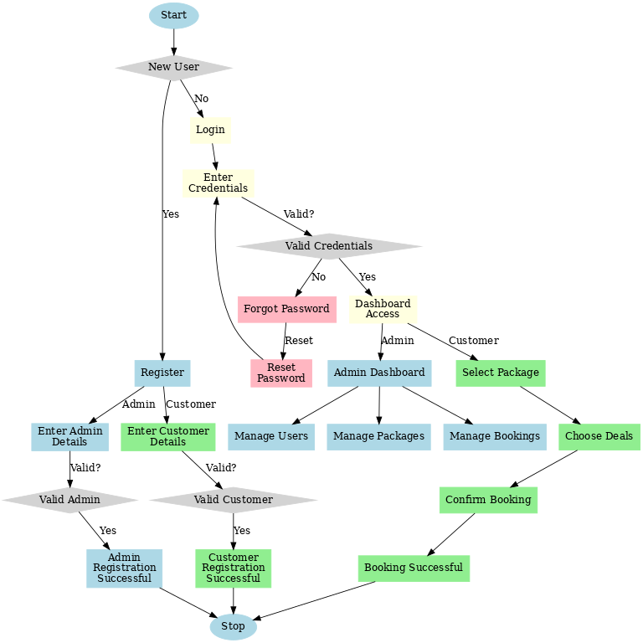

**Figure:** Flow Chart showing the working of Tourism Management system

1. RESULTS (INPUT AND OUTPUT)

* **User-Dashboard:**

The user dashboard by Tourism Management System is a view which has been customized to explore and manage the activities regarding traveling by the visitors. Its abilities to search through tour packages that are offered allow the placement of a booking, check for a history of bookings, check for reservations, provide feedback on any issue, and even allow for managing profile information. Its experience with its intuitive layout is seamless.

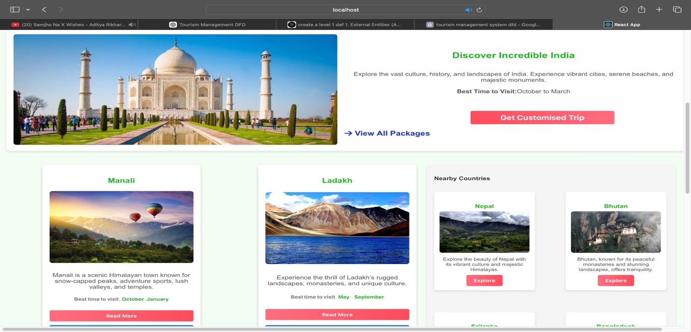

**Fig 2:** User-Dashboard

* **User-Tour-packages :** The booking page is quite user-friendly for picking and booking the tour packages; this provides an easy-to-use interface by selecting dates, destinations, and payment options. All tour packages with their respective itineraries, prices, and availability are displayed on a single page for users' choice.

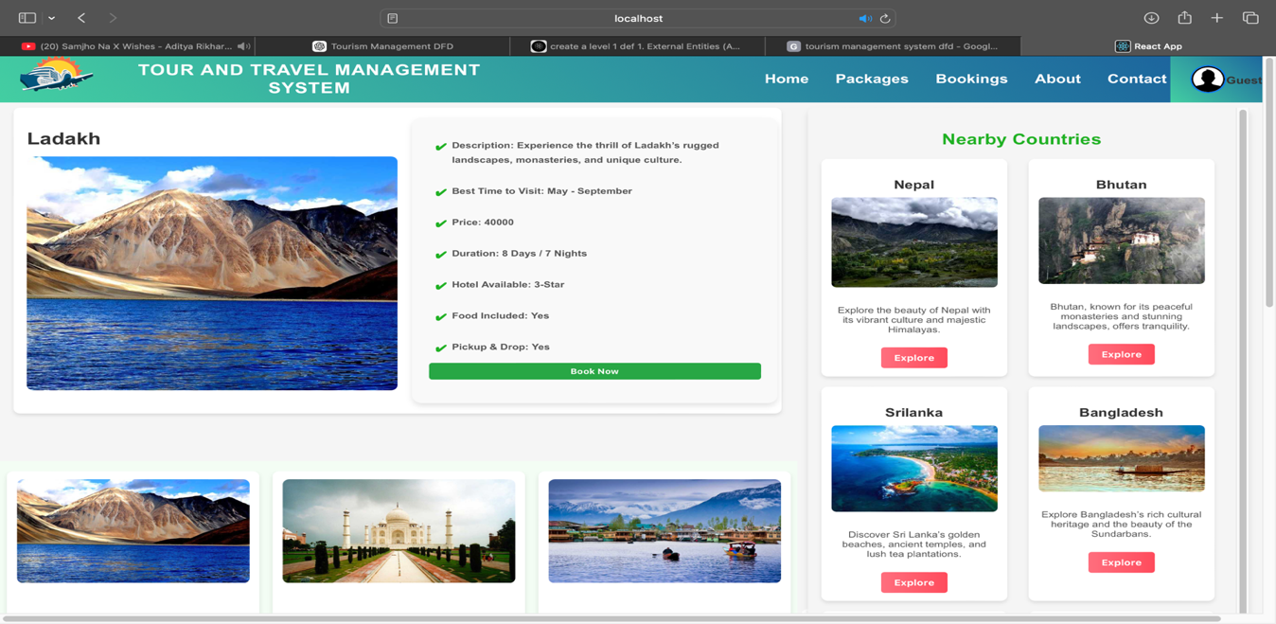

**Fig 3:** User-Tour-package

* **User-Booking-Page :** This will be a page for booking that allows users to see, control, and keep track of their tour bookings. All past bookings plus future ones and package details, dates, and status will be available. Using this page will facilitate the change or cancellation of bookings as well as the status check for payments.

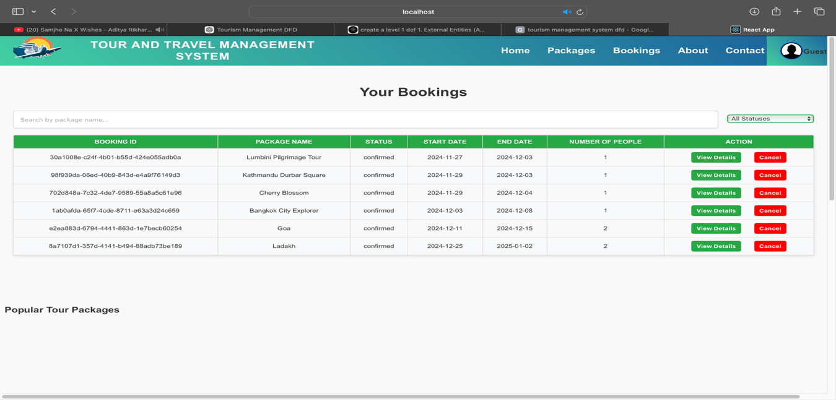

**Fig 4:** User-Booking

* **Admin-Dashboard :** The admin dashboard will then see how the system operates since it can easily observe the tour packages, users' bookings, visitor remarks, and inquiries. Further, it generates reports, looks into the performance of the system, and updates data at a central point.

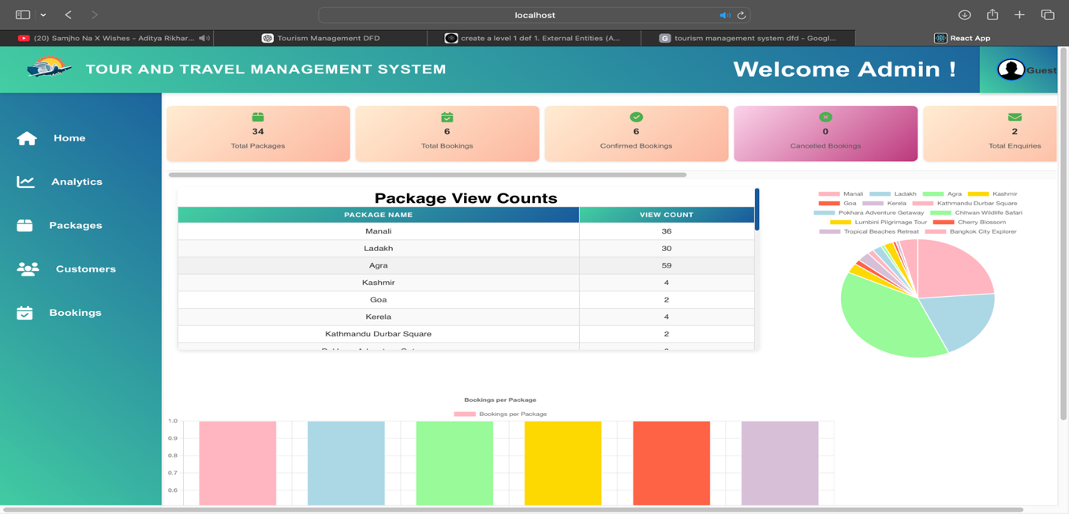

**Fig 5:** Admin-Dashboard

* **Admin-Analytics:** This page would give administrators insight into system performance and activity of users. It shows key metrics: booking statistics, popular tour packages, user engagement, and trends in feedback. This is the page where data-informed decisions can be taken to optimize operations and to ensure a better user experience

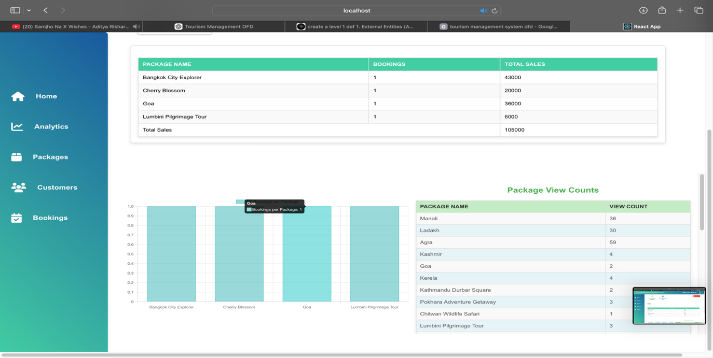

**Fig 6:** Admin-Analytics

* **Admin-Tour-Package-Page:** The admin tour package page helps the administrators in management, updating, and removal of their tour packages. The destinations and relevant details contain adding new packages and price setup. It has been placed for uploading itineraries and images. The details concerning the package can be viewed as well as edited to further optimize.

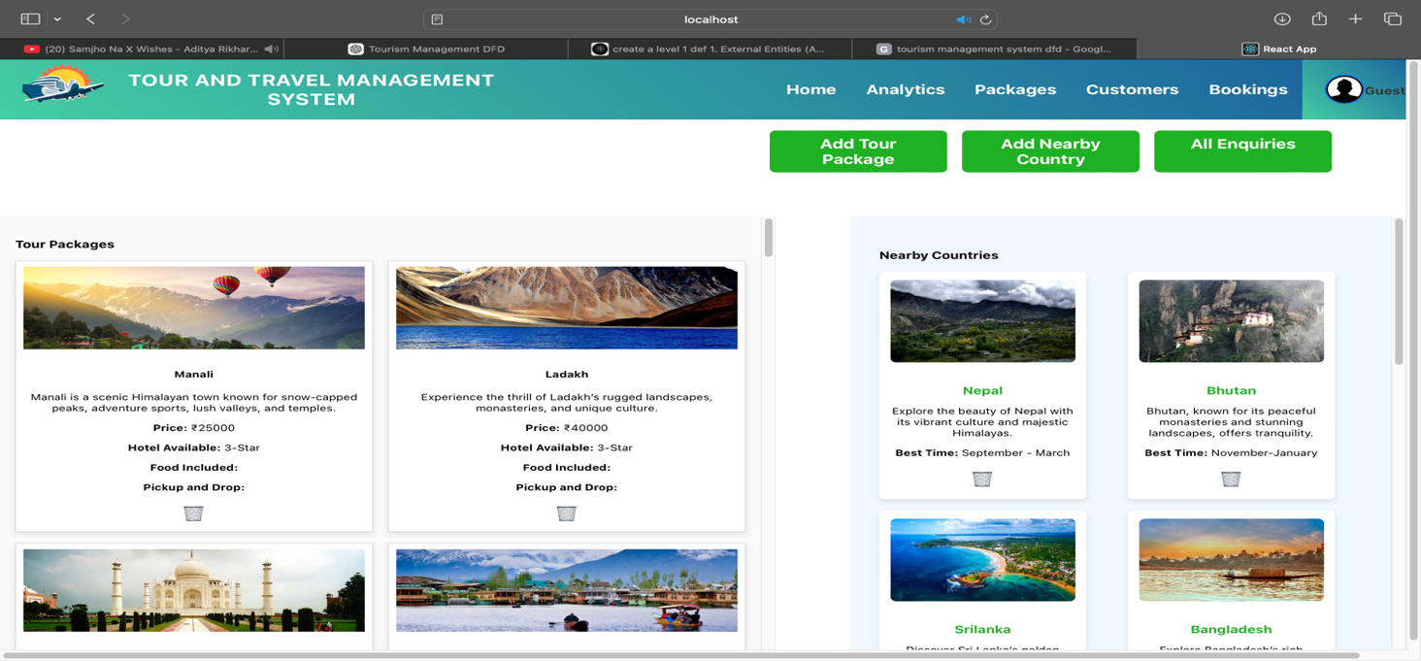

**Fig 7:**  Admin-Tour-Package

* **Admin-Booking:** All the bookings done by the customer are traceable and trackable by the admins via the admin booking page. Viewing, updating, and cancelling bookings with payment status makes the management of bookings easy and smooth, and hence even the reply to queries could easily be done by the admins.

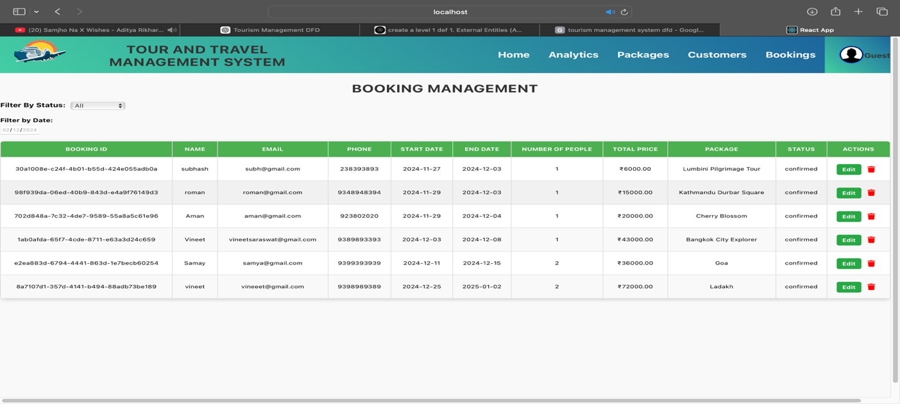

**Fig 8:** Admin-Booking

### LIMITATIONS

### The project has following limitations:

### The user in the tour packages has little personalization, therefore the satisfaction is lower.

### Scalability problems adding more users, packages, or bookings hit the performance at that stage.

### The system access would be limited to those areas having very little internet connectivity or remaining in the developing stages.

### Poor security controls may lead to leakage of information relating to the users to privacy and cyber threats.

### The system requires a lot of time, resources, and effort to update and maintain to stay up and relevant.

### Multilingual support absence restricts the users coming from different linguistic backgrounds thus critically, reducing worldwide access.

### It denies a user access to a booking panel or any form of service over the internet without offline ability.

### CONCLUSION

The TMS was hence able to overcome the defects associated with the traditional tourism management system through a modern and efficient platform for both the administrator and the visitor. React has been on the frontend while Django is on the back-end. It streamlined the management in terms of tour packages, booking processes, visitor feedback, and also proper payment handling. This introduces real-time updates as well as automated notifications to enhance the general user experience while ensuring the right administration of tasks. It turns out that the TMS is a highly scalable and user-friendly solution in handling services related to tourism by virtue of iterative development, thorough testing, and continuous stakeholder feedback. This also provides easy maintenance and other future upgrades that may include AR-based virtual tours and AI-powered recommendations. Although the system given basically meets the needs of the tourism industry, the general practice and new trends may further improvise it and will continuously adapt to meet the requirements of users and administrators.

1. REFERENCES
2. Smith, J., Zhang, R., & Cooper, T. (2018). **Addressing Inefficiencies in Traditional Tourism Management**. Journal of Tourism Management, 34(2), 112-124.
3. Jordan, R., & Hayes, L. (2020). **Leveraging React and Django for Scalable Tourism Platforms**. Journal of Web Development and Design, 8(3), 45-58.
4. Lee, K., & Kim, Y. (2019). **User-Centric Design Principles for Tourism Management Systems**. Journal of User Experience and Design, 15(4), 78-89.
5. Patel, V., Kumar, S., & Agarwal, A. (2021). **The Importance of Feedback Mechanisms in Tourism Systems**. Journal of Service Innovation and Management, 12(1), 34-46.
6. Gupta, R., Singh, P., & Mehta, A. (2020). **Emerging Technologies in Tourism Management: AI and IoT**. International Journal of Tourism Technology, 7(5), 201-213.
7. Brown, S. (2017). **Challenges in Traditional Tourism Management**. Journal of Tourism and Hospitality Management, 24(3), 157-168.
8. **SQLite Documentation**. (n.d.). Retrieved from https://www.sqlite.org
9. Johnson, D., & Taylor, M. (2019). Enhancing Tourism Services with Digital Platforms. International Journal of Tourism Research, 21(2), 145-162.
10. Chandra, S., & Malik, R. (2022). Real-Time Booking Systems and Their Impact on Tourism. Journal of Digital Innovations in Tourism, 10(1), 56-71.
11. Oliver, K., & Wright, J. (2020). Comparative Study of Modern Frontend Frameworks in Tourism Applications. Journal of Web and Mobile Applications, 5(4), 89-101.